MARKETING ESSENTIALS BMIH 4005

A comparison of the marketing methods of two multinational hotel brands

Six Senses and Holiday Inn

Student name: Ipsita Patra
Student ID:2231297
Module Title: Marketing Essentials BMH4005
Lecturer name:Scott James
Word count: 1550

Marketing refers to the activities of enhancing the products or services of a business
organisation which include advertising and research regarding the company. Marketing
Essentials focuses on the transportation, distribution of resources and services of a certain
business organisation and so on. As the business strategy has grown, traditional methods have
given place to distinctive, more engaging digital ones. In the past, trade shows, radio,
television, and direct sales were examples of offline methods of attracting customers and
utilising the phrase around unique products (Blagoev, Nikolskaya and Popov, 2019).
Businesses like as Resort Consequences use social media platforms like Facebook, Google,
and a few others to advertise their videotape yields, drawing customers to stay at the resorts
while on business vacations or excursions. In this essay, Holiday Inn and Six Senses will both
be discussed. The two multinational companies' trading strategies, situational analysis, and
STP marketing will be covered in this essay

SWOT analyses of two different hotels are here. Six Senses Hotel is known as a British multinational company in the category of hospitality. It was established in 1995 in London. It has been declared as the best hotel globally. Major strengths of the company include its location, transport systems, international collaboration, diversity in the products and high-quality services. Six Senses Hotels is dedicated to wellness, community services and
maintaining sustainability (Bohdanowicz, Zientara and Novotna, 2013).
It has services including spa, and wellness as a form of welcoming the guests and ensuring the quality so that their customers can enjoy luxury comfort.

Holiday Inn has an excellent position in brand advertising in the contemporary business environment. As Six Senses Hotels, Holiday Inn has more than 1200 hotels globally and now it is targeting to enter the new markets. On average, Holiday Inn provides services to more than 100 million per night which is an indication of their customer satisfaction. Six Senses Hotels has comparatively fewer rooms, with lower reviews on various on-line platforms like Face-book, You Tube, and Twitter. It should work seriously on on-line advertising (Buttle et al., 2016).

Holiday Inn has a vast number of competitors. It can limit their chance of the market share.
Another weakness of Holiday Inn is trying its best till now to enhance its economy.
Six Sense Hotels has on-line booking services. It reduces customer hassle which leads to profit maximisation for the hotel. It has an enriching spa and wellness services which refers to customer satisfaction (Camilleri, 2017).

To introduce the opportunities of Holiday Inn, it has been shown that the hotel has not its branches all over the world and customers or travellers are still searching for new destinations. Holiday In should emphasise the particular offers seasonally on the basis of region. Six Senses has emerging competitors nowadays. It should focus on marketing strategies in order to increase its profit and maintain its market position in the hospitality industry (Dalton, 2016).

The major threats to Holiday Inn refer to the decrease in the tourism industry due to epidemiological diseases like COVID-19 and natural disasters. The strong competition is increasing day by day as the number of hotels and their strategies are also being increased. The third and most severe threat for Holiday Inn is the growing operational cost which has an
influence on the rates of the hotel (Dev, 2013).

PESTEL analyses of two different hotels are here. Political factors generally refer to the influence of the government and political parties on the hospitality industry. In every nation, the hotel business highly depends on the percentage of tourism and therefore if the government keeps a higher tax on the hotel or hospitality industry, the rule of the tourism industry will also be affected (Guillén and Rubio, 2019). Six Senses Hotel has an effect on the election or any other changes like this. Holiday Inn Hotels has faced some changes in its
tax which may affect the overall profit of the hotel. It is more likely that the exit of this hotel from the EU may create hinders to trade internationally.

Six Senses Hotel is affected by several economic factors such as employment, instability and many more. People prefer luxury hotels, which increases revenue for them when the economy is doing well. People attempt to cut back on their travel expenses when they have less money in their pockets. Their inclination then shifts to low-cost lodging. Unemployment, inflation, and other economic instability all have a direct effect on the hotel business (Ivanov,
2014). In prosperous economic times, luxury hotels see an increase in revenue as a result of consumer preference. When they are struggling financially, many try to reduce how much they travel. Then, they start to gravitate toward inexpensive hotels.

Holiday Inn is also limited to foreign currency compared to the Six Senses Hotel. There are thousands of people who get employment through Holiday Inn and Six Senses Hotel. Apart from this, the exchange rate of the currency can affect the hotel's trade and investment.
Social factors refer to the factors to which the travellers or the customers belong. There are various people who travel independently all over the world several times. Six Senses Hotels can maximise its profit and achieve business goals by providing its customer with their local culture except for the hotel location (Jauhari, 2014).
The demographic changes for example increased number of elderly people can also affect Holiday Inn's business and demand for travelling.

Holiday Inn needs to develop its technological sectors and global distribution of its systems. As a hospitality industry, it should develop kitchen tools or modern kitchen equipment to increase the food service and achieve customer satisfaction.

Six Senses Hotels need to emphasise online marketing and advertisement to reach more customer and enrich its website to reduce the hassle of the clients and target audience (Oskam and Boswijk, 2016). Legal factors in the hospitality industry include disability and discrimination laws, low wages of the staff, and the increasing demands of the hotels in recycling. Six Senses Hotels provides a competitive salary to its employees and staff.

Holiday Inn should focus on the employment laws and the safety laws of the customers. It can be affected by the regulations related to the building permission and existing property development (Sarsby, 2016). Environment is one of the most effective elements of PESTAL analysis for both Six Senses Hotels and Holiday Inn. It is related to ensuring a safe and healthy environment for the customers. Six Senses Hotels and Holiday Inn Hotels should ensure the specific target to make a healthy and safe environment and therefore meet the organisational profits.

The Marketing Mix of Six Senses Hotels is mentioned here. Six Senses Hotel has luxurious services for their customers and they train their employees in a good system so that they can satisfy their customers and clients. It provides different types of room service. The cheapest one is £1152 in their hotels and the most popular one is £1283. They include breakfast and another item in his price. It is in the London. It includes 3500 sf with 65 fee swimming facilities. It is located on the roadside so that people can easily visit there (Sharma and
Bhartiya, 2023). It promotes its business on websites and social media sites. People give their feedback on the websites about their opinions.

The Marketing Mix of Holiday Inn is here. Holiday Inn Hotel provides different facilities .according to their customer demand and they provide digital items to their customers. Employees and staff also behaved well with them (Murniati and Bawono, 2020). It includes £118 per night and it provides different types of rooms. The popular room is £139 in this hotel (Sigala and Gretzel, 2017). It is located in London with a very friendly environment so that people can enjoy themselves there with their family and friends. It has websites and they add their daily updates here. People share here opinions on the websites.

SEGMENTITON TARGETING AND POSITIONING
It is one of the most familiar business styles in the contemporary business environment. It is also important to detect the target audience, build effective marketing of the brand and hold the market position. Six Senses Hotels and Holiday Inn need to make a segmentation of their customer in terms of
region, psychology geography and behaviour. Regional segmentation indicates age, gender, and income. However, psychological means lifestyles, and values. Geographic and behavioural segmentation refers to location, climate and loyalty, using percentages respectively (Westphal, 2017). Targeting includes choosing the segments to provide a high-quality marketing mix. The Six Senses and Holiday Inn should consider the potential growth,
resources, capabilities and competitive salaries. Positioning means assessing the strengths and weaknesses of the hotels, maintaining transparency, understanding the contemporary business demands and making effective communication.

The marketing methods of the two multinational company that is, Six Senses Hotel and Holiday Inn have been discussed above through SWOT and PESTAL analysis. SWOT analysis of these two companies identified the strength, weakness, opportunities as well as threats for their business functions. The PESTEL analysis of these two hotels showed their
macro business factors and these factors has direct impact on their business operation. The marketing mix strategy has also been discussed from which the companies’ marketing strategies are evaluated. Several segmentations, targets and positioning have also been covered. All of these factors are crucial to boosting the business and achieving the goals by maximising the profit.


References
Blagoev, V., Nikolskaya, E.Y. and Popov, L.A. (2019) THE HOSPITALITY INDUSTRY: Understanding Hotel Business. Varna University of Management.

Bohdanowicz, P., Zientara, P. and Novotna, E. (2013) 'International hotel chains and
environmental protection: an analysis of Hilton’swe care!programme (Europe, 2006–2008),'
Journal of Sustainable Tourism, 19(7), pp. 797–816.
https://doi.org/10.1080/09669582.2010.549566.

Buttle, F. et al. (2016) Hospitality marketing. Taylor & Francis

Camilleri, M.A. (2017) Travel Marketing, tourism Economics and the airline product: An
Introduction to Theory and Practice. Springer

Dalton, C. (2016) Brilliant strategy for business: How To Plan, Implement And Evaluate Strategy At Any Level Of Management. Pearson UK.

Dev, C.S. (2013) Hospitality branding. Cornell University Press.

Guillén, M.J.Y. and Rubio, N. (2019) Customer loyalty and brand management. MDPI.

Ivanov, S. (2014) Hotel Revenue Management: From Theory to practice. Zangador.

Jauhari, V. (2014) Managing sustainability in the hospitality and tourism industry: Paradigms and Directions for the Future. CRC Press.

Oskam, J. and Boswijk, A. (2016) 'Airbnb: the future of networked hospitality businesses,'
Journal of Tourism Futures, 2(1), pp. 22–42. https://doi.org/10.1108/jtf-11-2015-0048
Sarsby, A. (2016) SWOT analysis. Lulu.com.

Sharma, S. and Bhartiya, S. (2023) Technology and social transformations in hospitality, tourism and gastronomy: South Asia Perspectives. CABI.

Sigala, M. and Gretzel, U. (2017) Advances in social media for travel, tourism and hospitality: New Perspectives, Practice and Cases. Routledge.

Westphal, N. (2017) Analysis of the UK Package Holiday Industry and its Environment. GRIN Verlag.

Appendices
SWOT Analysis

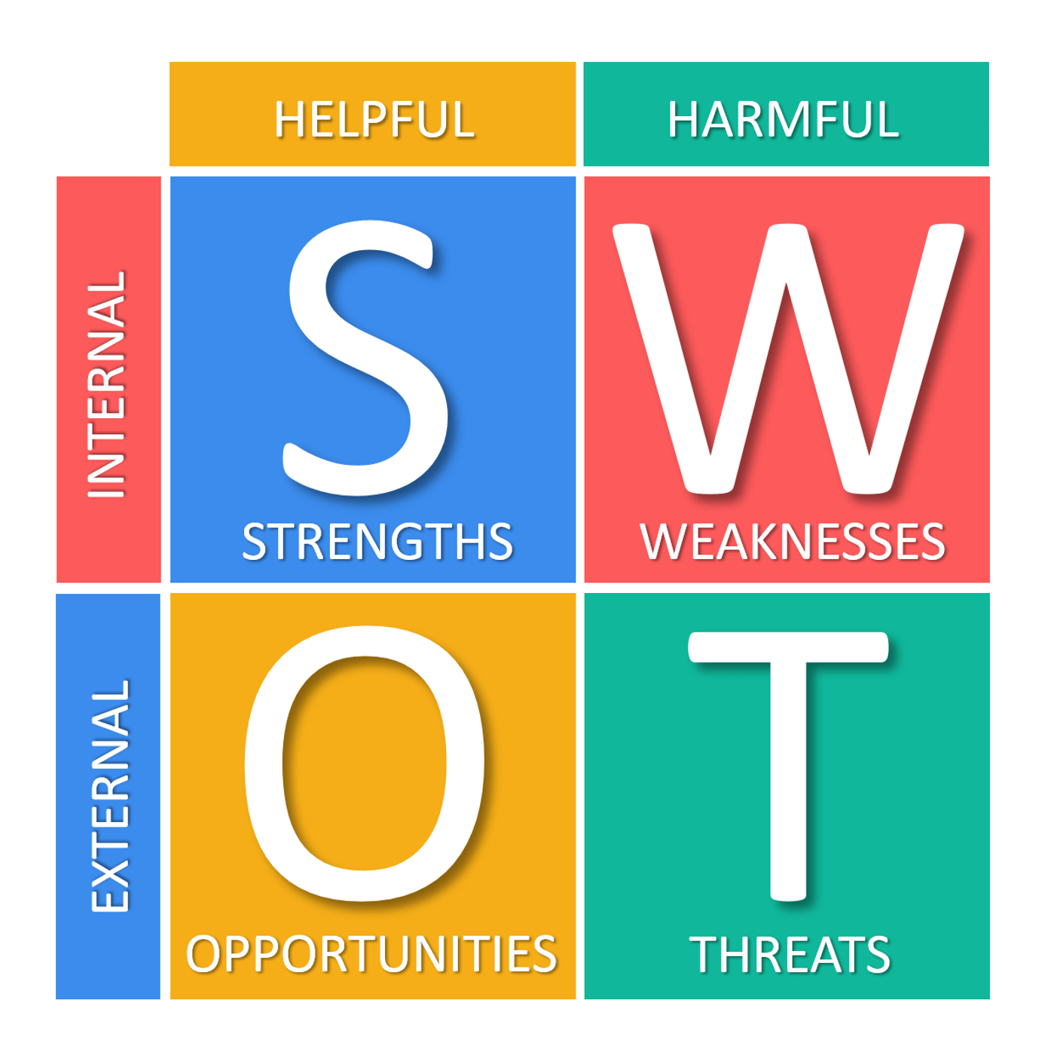

PESTEL ANALYES



