

Student Name: Kuldip Bhuva

Student ID:251733

Module Name: Marketing Management

Module Code: LCMB7024

Lecturer’s Name: Dr Shengfeng Mei

Work Count: 5k

Term 1

AI Acknowledgement Statement
The preparation of this report followed the UWTSD LCMB7002 assessment guidelines to the extent that the use of AI tools was limited and allowed in preparing a report. In particular, AI support was applied to: (1) support in research and source of data; and (2) grammar and proofreading. The report text, argument structuring, and code submissions were not written or structured using AI as the module AI policy does not allow these tasks (UWTSD, 2026). The student is the original author of all the analysis, arguments, interpretations, and written work.
Table of Contents
1. Introduction 6
2. Financial Health Check 7
2.1 Revenue and Profitability Analysis 7
2.2 Liquidity Analysis 9
2.3 Efficiency Ratios 11
2.4 Gearing and Investment Ratios 12
2.5 Industry Comparison: Tesla vs BYD vs Honda 14
3. Working Capital Management Analysis 17
3.1 Cash Operating Cycle Assessment 17
3.2 Strategies to Improve Liquidity 17
3.3 Short-Term vs Long-Term Financing 18
4. Strategic Financial Restructuring Plan 19
4.1 Recommended Restructuring Options 19
4.2 Impact on Shareholder Value and Debt Structure 19
4.3 International and Ethical Considerations 20
5. Investment Appraisal and Capital Budgeting 21
5.1 Project Overview and Assumptions 21
5.2 Payback Period (PBP) 21
5.3 Accounting Rate of Return (ARR) 22
5.4 Net Present Value (NPV) 22
5.5 Profitability Index (PI) 23
5.6 Internal Rate of Return (IRR) 24
5.7 Project Recommendation 24
5.8 Capital Rationing — Best Combination at £100 Million 25
6. Conclusion 27
References 28
Appendices 30
Appendix A: Full Ratio Summary Table 30
Appendix B: Balance Sheet Summary 30
Appendix C: Detailed Investment Appraisal Workings 31
Appendix D: AI Acknowledgement (Full Statement) 31

List of Figures
Figure 1: Tesla Profitability Margins FY2021–FY2025 (Source: Tesla 10-K Filings, 2022–2025) 7
Figure 2: Tesla Revenue & Operating Income YoY % Change FY2022–FY2025 (Source: Tesla 10-K Filings) 8
Figure 3: Tesla Liquidity Ratios FY2021–FY2025 (Source: Tesla 10-K Filings, 2022–2025) 9
Figure 4: Tesla Fixed Asset Turnover FY2021–FY2025 (Source: Tesla 10-K Filings, 2022–2025) 11
Figure 5: Tesla ROE and ROA FY2021–FY2025 (Source: Tesla 10-K Filings, 2022–2025) 12
Figure 6: Tesla Revenue vs Net Income FY2021–FY2025 (Source: Tesla Annual Reports, 2022–2025) 13
Figure 7: Revenue Comparison — Tesla vs BYD vs Honda FY2025 (Source: Company Annual Reports, 2025–2026) 14
Figure 8: Margin Comparison — Tesla vs BYD vs Honda FY2025 (Source: Company Annual Reports, 2025–2026) 15
Figure 9: NPV Comparison — Projects A, B & C at 10% Discount Rate (Source: Author's Calculation, 2026) 22
Figure 10: Project Comparison — PBP, ARR & PI for Projects A, B & C (Source: Author's Calculation, 2026) 24

List of Tables
Table 1: Tesla Income Statement Summary FY2021–FY2025 (Source: Tesla Annual Reports, 2022–2025) 6
Table 2: Tesla Liquidity Ratios FY2021–FY2025 (Source: Stock Analysis, 2026) 9
Table 3: Tesla Efficiency Ratios FY2021–FY2025 (Source: Stock Analysis, 2026; Tesla 10-K Filings) 10
Table 4: Tesla Key Financial Ratios FY2021–FY2025 (Source: Stock Analysis, 2026; Tesla 10-K Filings) 11
Table 5: Competitive Comparison: Tesla, BYD, Honda (FY2025) (Source: Company Annual Reports, 2025–2026) 13
Table 6: Investment Project Cash Flows (Source: Assignment Brief, LCMB7002, 2026) 20
Table 7: Payback Period Calculation (Source: Author's Calculation, 2026) 20
Table 8: ARR Calculation (Source: Author's Calculation, 2026) 21
Table 9: NPV Calculation at 10% Discount Rate (Source: Author's Calculation, 2026) 21
Table 10: Profitability Index (Source: Author's Calculation, 2026) 22
Table 11: IRR Calculation (Source: Author's Calculation, 2026) 23
Table 12: Investment Appraisal Summary (Source: Author's Calculation, 2026) 23
Table 13: Capital Rationing Analysis (Source: Author's Calculation, 2026) 24
Table 14: Project C NPV Sensitivity to Discount Rate (Source: Author's Calculation, 2026) 25

1. Introduction
The global electric vehicle (EV) industry has emerged as one of the most transformative sectors of the 21st century, fundamentally reshaping the automotive landscape and global energy systems. Tesla, Inc. — founded in 2003 and headquartered in Austin, Texas — stands as the world's most recognised EV manufacturer, having pioneered the mass commercialisation of battery electric vehicles. Having achieved revenues exceeding $97.7 billion in FY2024 and building a global manufacturing presence across North America, Europe, and Asia, Tesla represents an ideal case study for advanced financial analysis (Tesla, 2025).
The report takes the viewpoint of the Chief Financial Officer (CFO) of Tesla who is expected to make a detailed financial analysis within five years FY2021-FY2025. The report is organized on the basis of four main analytical dimensions: (1) a comprehensive financial health analysis using ratios; (2) working capital management analysis and recommendations; (3) a strategic financial restructuring plan covering international and ethical issues and (4) an investment analysis of three capital project proposals using various evaluation methods. All the financial information is obtained directly through the official annual reports and 10-K SEC filings of Tesla.

2. Financial Health Check
This part examines the financial performance of Tesla over FY2021-FY2025 by analyzing a full set of financial ratios based on the income statement, balance sheet, and cash flow statement. The analysis reveals the major trends, strengths and strategic threats of the business.

2.1 Revenue and Profitability Analysis
Tesla had an unprecedented increase in revenue of 81.5 percent between FY2021 of 53.8 billion and peak of 97.7 billion in FY2024 before declining to 94.8 billion in FY2025 (Tesla, 2025). This flat revenue growth, coupled with the rapidly falling profit margins, is the biggest financial issue that the Tesla leadership has to confront. The three most important profitability ratios, including the gross, operating and net profitability, reached their peak in FY2022 and have since significantly declined as shown in Figure 1 below. Table 1 shows the summary of the 5-year income statement that proves the continued decrease in all the profitability indicators starting with FY2022.
Table 1: Tesla Income Statement Summary FY2021–FY2025 (Source: Tesla Annual Reports, 2022–2025)
Metric (USD millions) | FY2021 | FY2022 | FY2023 | FY2024 | FY2025
Total Revenue | 53,823 | 81,462 | 96,773 | 97,690 | 94,827
Gross Profit | 13,606 | 20,853 | 17,660 | 17,450 | 17,094
Operating Income | 6,523 | 13,656 | 8,891 | 7,076 | 4,355
Net Income (GAAP) | 5,519 | 12,556 | 14,997 | 7,091 | 3,794
Operating Cash Flow | 11,497 | 14,716 | 13,256 | 14,923 | 14,695
Free Cash Flow | 4,957 | 7,566 | 4,358 | 6,247 | 6,217

As illustrated in Table 1, revenue increased significantly up to FY2024, but profitability decreased considerably since FY2023, with net income decreasing by 46.5% between FY2023 and FY2025. The gross margin has decreased as compared to 25.6 in FY2022 to 18.0 in FY2025, due to the aggressive global pricing reduction approach taken by Tesla to protect its market share amidst the growing competition with BYD (Arnold, 2019). The operating margin dropped to a level of only 4.6% and not the previous 16.8%. The net income has fallen to 3.79 billion in FY2025, the lowest since FY2021 (Yahoo Finance, 2026).
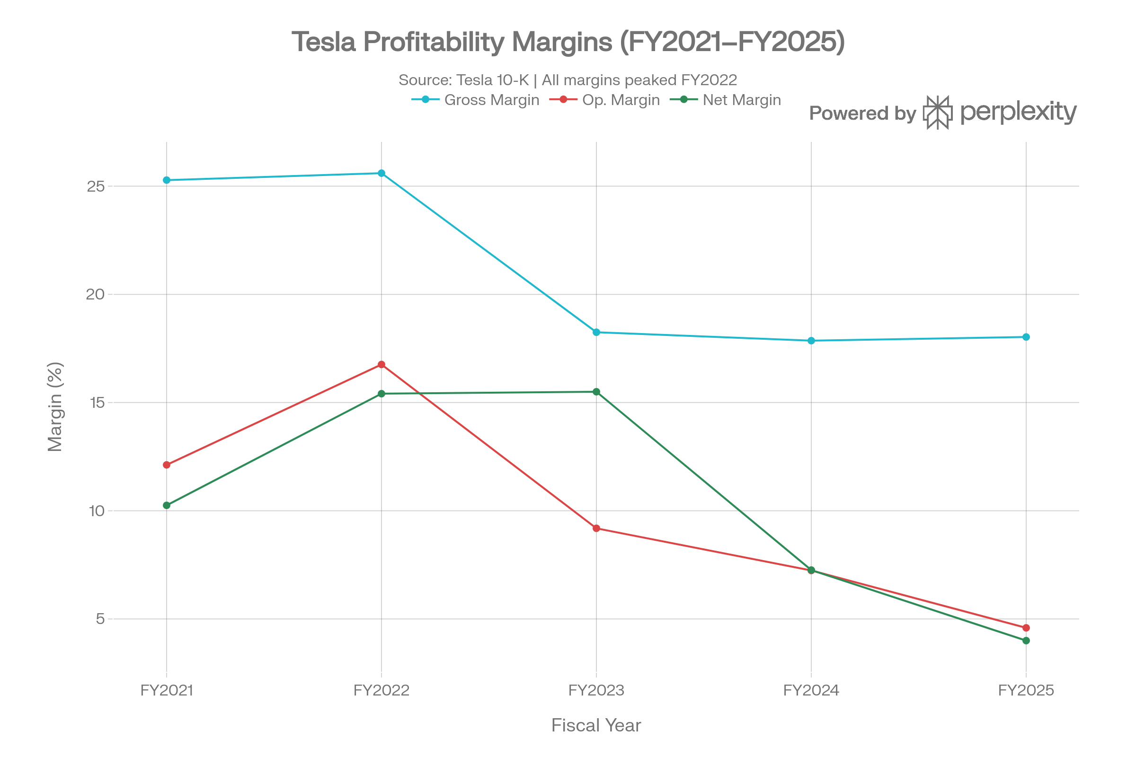
Figure 1: Tesla Profitability Margins FY2021–FY2025 (Source: Tesla 10-K Filings, 2022–2025)
Figure 1 is a confirmation of the abrupt deviation between the peak of profitability and the constant decrease in FY2022 and FY2025. To gain additional knowledge of the rate of change, Figure 2 shows the year on year (YoY) percentage change in both revenues and operating income.
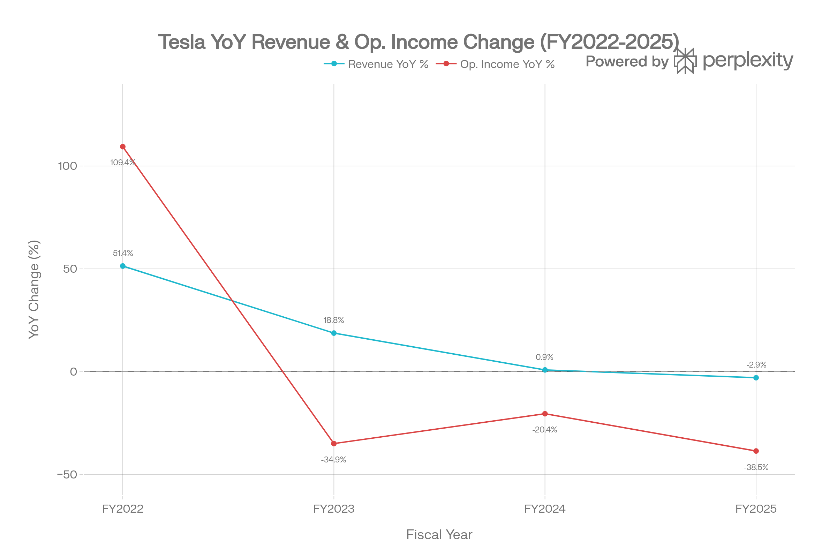
Figure 2: Tesla Revenue & Operating Income YoY % Change FY2022–FY2025 (Source: Tesla 10-K Filings)
As Figure 2 shows, the revenue growth has slowed sharply - instead of +51.4 in FY2022, it would shrink by -2.9 in FY2025, whereas operating income would decrease by -34.9, -20.4 and -38.5 in FY2023, FY2024 and FY2025, respectively. This is the aggregate effect of price reduction, increase in R and D spending and macroeconomic headwinds such as increased interest rates and increased raw material prices.
Strategically, this compression of profits is a strategic penetration-pricing trade-off: Tesla gambled market share defence, as opposed to margin defence. Although this can provide long term competitive advantage it puts short term strain on investor returns and necessitates close working capital and restructuring management, which are discussed in Sections 3 and 4 respectively.

2.2 Liquidity Analysis
Despite deteriorating profitability, Tesla's liquidity position has strengthened considerably. The current ratio improved from 1.38 in FY2021 to 2.16 in FY2025, while the quick ratio rose from 1.00 to 1.53 (Stock Analysis, 2026). This shows the cash accumulation policy by Tesla where cash and short-term investments have increased 149 percent to 17.7 billion to 44.1 billion. Table 2 presents the liquidity ratios in the review period, and Figure 3 depicts the steady rise in financial resilience in the short-term.
Table 2: Tesla Liquidity Ratios FY2021–FY2025 (Source: Stock Analysis, 2026)
Ratio | FY2021 | FY2022 | FY2023 | FY2024 | FY2025
Current Ratio | 1.38 | 1.53 | 1.73 | 2.02 | 2.16
Quick Ratio | 1.00 | 0.94 | 1.13 | 1.42 | 1.53
Cash & ST Investments ($B) | 17.7 | 22.2 | 29.1 | 36.6 | 44.1

Table 2 indicates that there was a gradual and steady increase in the current and quick ratios between the five years. The increasing difference between current ratio and quick ratio since FY2023, is a result of increasing inventory levels (12.4 billion in FY2025) that is a possible issue in a slowing demand market (Tesla, 2025). However, the operating cash flow of Tesla of $14.7 billion in FY2025 further supports its high liquidity position in the short term.
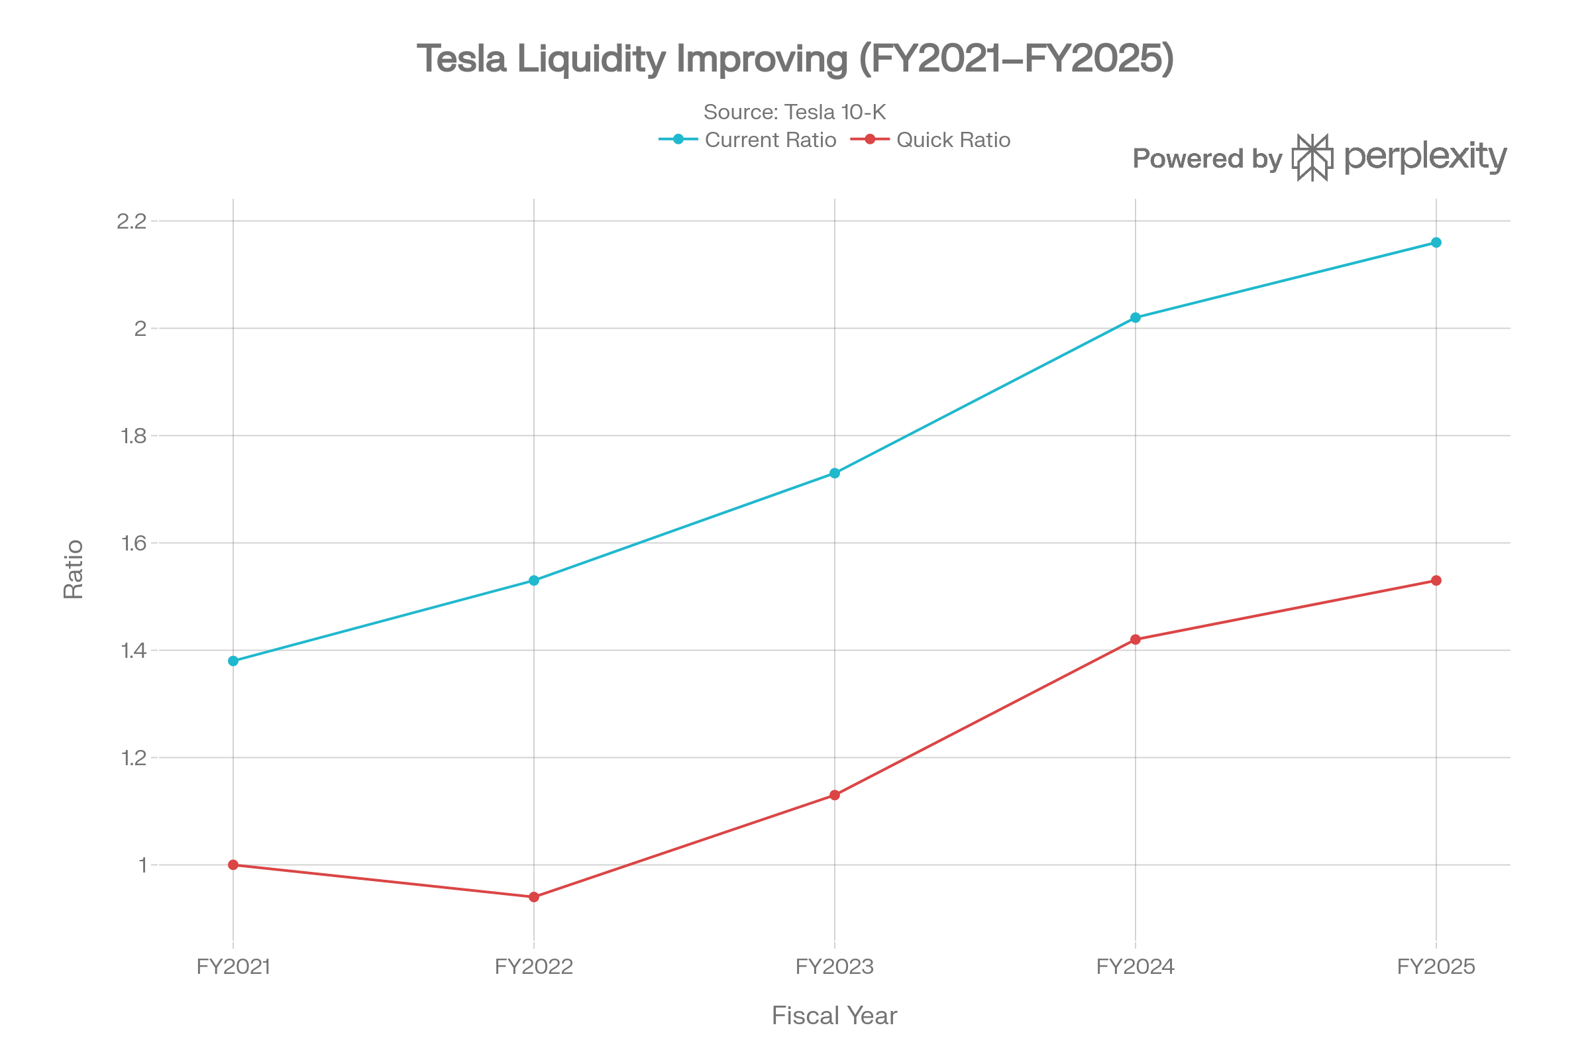
Figure 3: Tesla Liquidity Ratios FY2021–FY2025 (Source: Tesla 10-K Filings, 2022–2025)

2.3 Efficiency Ratios
The efficiency of Tesla in using its assets has deteriorated significantly during the review period. The asset turnover has decreased by 0.73 in FY2025 compared to 1.13 in FY2022, and the asset base, which has been growing to over 137.8 billion compared to 82.3 billion, is increasing more rapidly than the revenue (Stock Analysis, 2026). Inventory turnover declined from 8.16 in FY2021 to 6.37 in FY2025, signalling slower inventory conversion. Importantly, the ratio of fixed asset turnover, which is computed as the revenue per pound of property, plant and equipment (PP&E), also decreased significantly, as both Tesla grew its net PP&E by increasing its growth by almost 25 percent, with FY2021 and FY2025 at 5.38 and 2.56, respectively. The entire efficiency ratio is shown in Table 3, whereas Figure 4 shows the trend of fixed asset turnover.
Table 3: Tesla Efficiency Ratios FY2021–FY2025 (Source: Stock Analysis, 2026; Tesla 10-K Filings)
Efficiency Ratio | FY2021 | FY2022 | FY2023 | FY2024 | FY2025
Asset Turnover | 0.94 | 1.13 | 1.02 | 0.85 | 0.73
Inventory Turnover | 8.16 | 6.52 | 5.98 | 6.26 | 6.37
Fixed Asset Turnover | 5.38 | 4.31 | 3.67 | 3.05 | 2.56

Table 3 shows that all three measures of efficiency are decreasing steadily. Of particular interest is the decrease in the fixed asset turnover between 5.38 and 2.56 that implies that every pound of fixed assets is currently producing less revenue than it was during FY2021. Although this is partially explained by the Gigafactory investment cycle, in which capital is invested before revenues, it also represents low asset productivity that will have to be overcome by increasing the factory utilisation rates in FY2026 and later (Brealey, Myers and Allen, 2022).
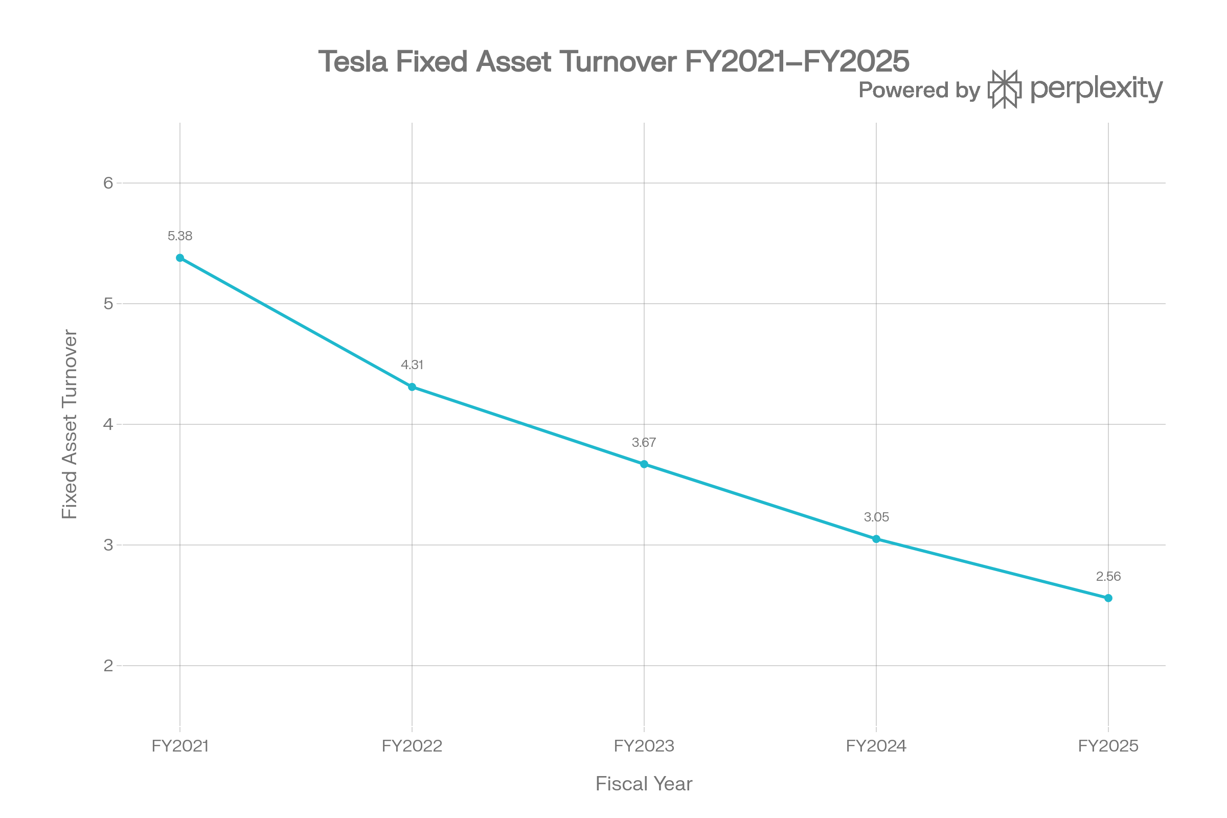
Figure 4: Tesla Fixed Asset Turnover FY2021–FY2025 (Source: Tesla 10-K Filings, 2022–2025)

2.4 Gearing and Investment Ratios
Tesla has a very conservative capital structure. Tesla has a debt-to-equity ratio of only 0.08 in FY2025 and the net debt-to-equity ratio is -0.43, indicating that Tesla has significant cash as compared to debt ( Stock Analysis, 2026). This low gearing gives them a lot of strategic room on future investment which is debated by debt. ROE declined sharply from 32.49% in FY2022 to 4.93% in FY2025, and ROA followed from 17.35% to 2.45%, as shown in Figure 5. Table 4 summarizes all the important financial ratios in the period of review.
Table 4: Tesla Key Financial Ratios FY2021–FY2025 (Source: Stock Analysis, 2026; Tesla 10-K Filings)
Ratio | FY2021 | FY2022 | FY2023 | FY2024 | FY2025
Gross Margin (%) | 25.28 | 25.60 | 18.25 | 17.86 | 18.03
Operating Margin (%) | 12.12 | 16.76 | 9.19 | 7.24 | 4.59
Net Profit Margin (%) | 10.25 | 15.41 | 15.50 | 7.26 | 4.00
ROE (%) | 20.41 | 32.49 | 27.35 | 10.42 | 4.93
ROA (%) | 10.16 | 17.35 | 14.13 | 4.92 | 2.45
Debt / Equity | 0.17 | 0.03 | 0.04 | 0.08 | 0.08
Asset Turnover | 0.94 | 1.13 | 1.02 | 0.85 | 0.73
Inventory Turnover | 8.16 | 6.52 | 5.98 | 6.26 | 6.37
Fixed Asset Turnover | 5.38 | 4.31 | 3.67 | 3.05 | 2.56

Table 4 supports the hypothesis that, although gearing is very low and liquidity is high, the ratios of profitability and efficiency have worsened significantly since FY2022. This divergence — between balance sheet strength and income statement weakness — is the defining financial characteristic of Tesla's current position.
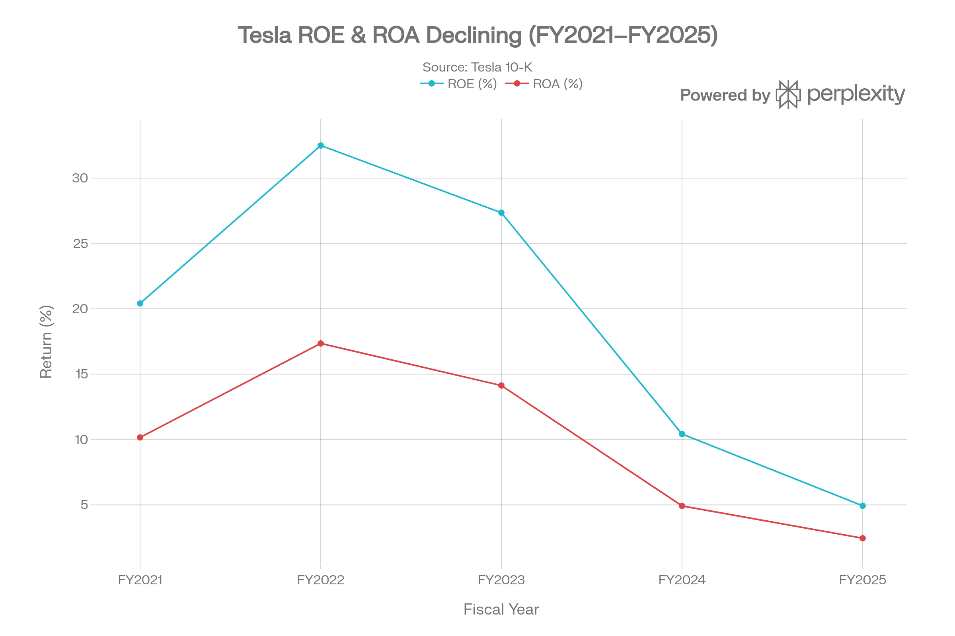
Figure 5: Tesla ROE and ROA FY2021–FY2025 (Source: Tesla 10-K Filings, 2022–2025)
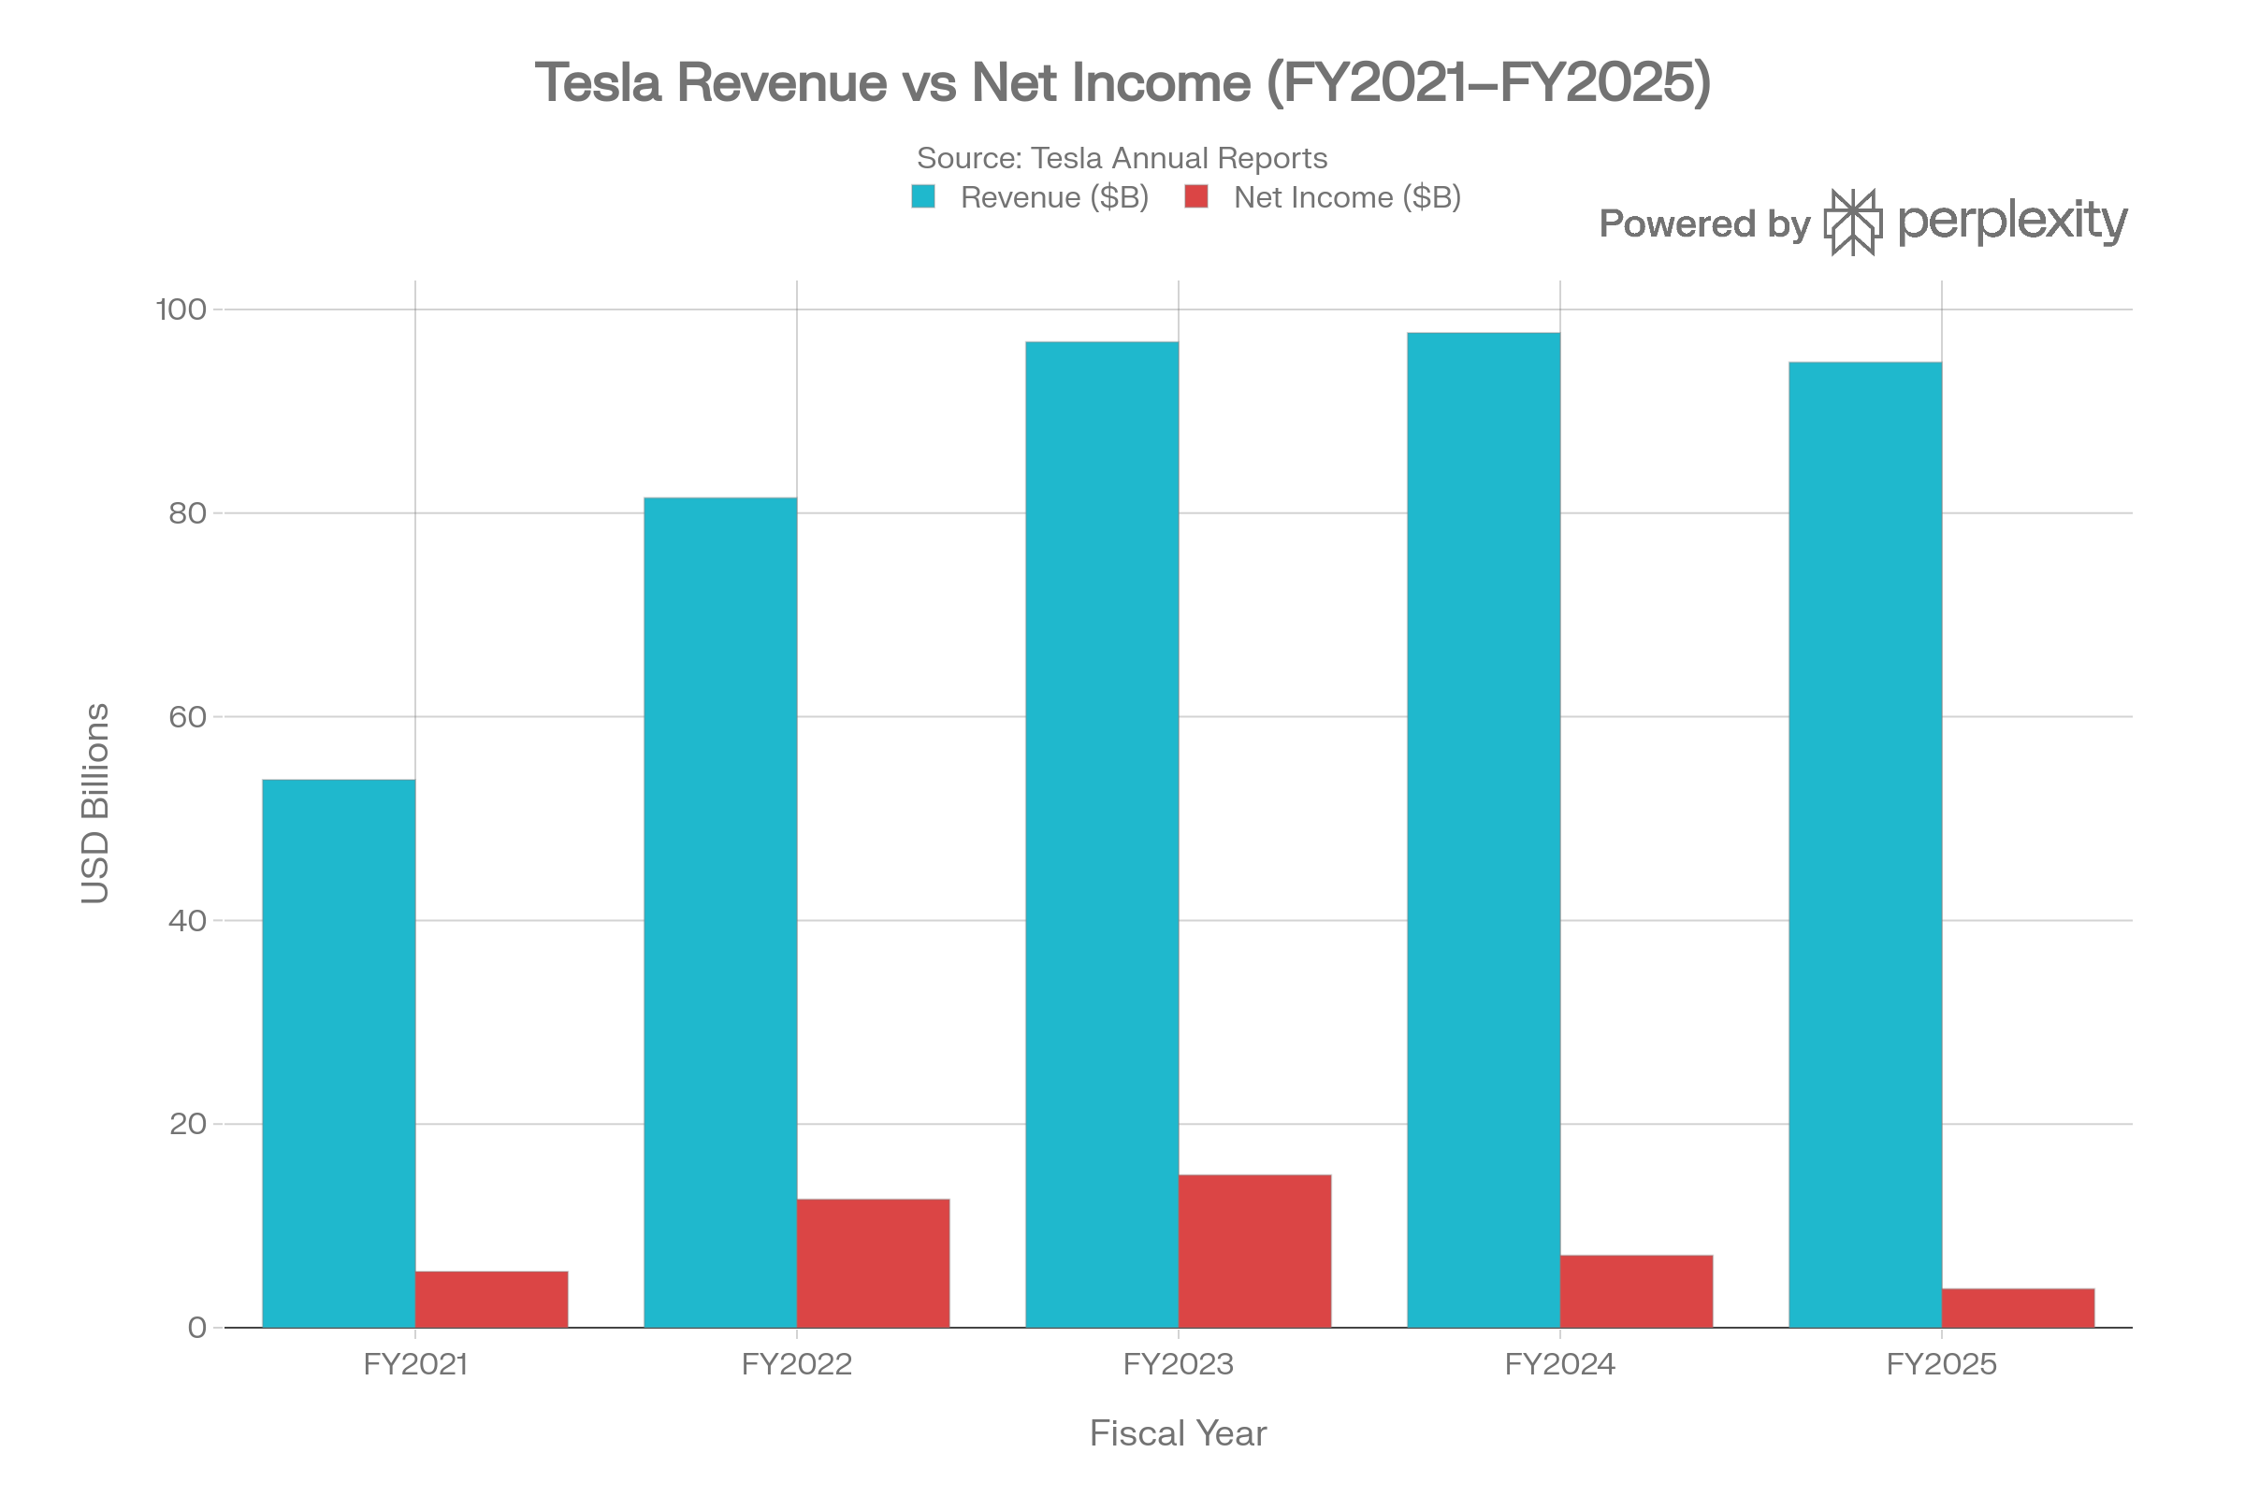
Figure 6: Tesla Revenue vs Net Income FY2021–FY2025 (Source: Tesla Annual Reports, 2022–2025)

2.5 Industry Comparison: Tesla vs BYD vs Honda
To provide a context of Tesla financial performance, it is educative to compare the main metrics with the key rivals: BYD the largest EV manufacturer in the world by volumes and Honda, a major traditional car manufacturer that shifts to electrification. Table 5 shows the relative financial information of the latest fiscal year (FY2025 in respect of Tesla and BYD; FY2025 ending in March 2025 in respect of Honda) and Figures 7 and 8 show the difference in revenue and margin respectively.
Table 5: Competitive Comparison: Tesla, BYD, Honda (FY2025) (Source: Company Annual Reports, 2025–2026)
Metric | Tesla (FY2025) | BYD (FY2025) | Honda (FY2025)
Revenue (USD B) | $94.8 | $117.9 | $143.1
Gross Margin (%) | 18.0% | 17.7% | 21.5%
Operating Margin (%) | 4.6% | 4.8% | 5.6%
Net Margin (%) | 4.0% | 4.1% | 3.9%
Current Ratio | 2.16 | 1.07 | 1.35
Debt/Equity | 0.08 | 1.02 | 0.87
ROE (%) | 4.93% | 15.5% | 7.8%

There are some valuable competitive insights which can be seen in Table 5. Although Tesla has a lower revenue (94.8B) than both BYD (117.9B) and Honda (143.1B), its gross margins are generally similar. Nevertheless, Tesla has a ROE of only 4.93% which dramatically lags behind that of BYD at 15.5% and Honda at 7.8% which illustrates the greater profitability squeeze Tesla has been facing. The balance sheet is the most prominent competitive advantage of Tesla: its debt-to-equity ratio of 0.08 is significantly lower than those of BYD (1.02) and Honda (0.87) and offers the company unparalleled financial resources and ability to survive (Stock Analysis, 2026). Tesla is also a leader in liquidity with a current ratio of 2.16 as compared to BYD which has a current ratio of 1.07, which shows that Tesla is better off in the short term in terms of financial health despite the low profitability.
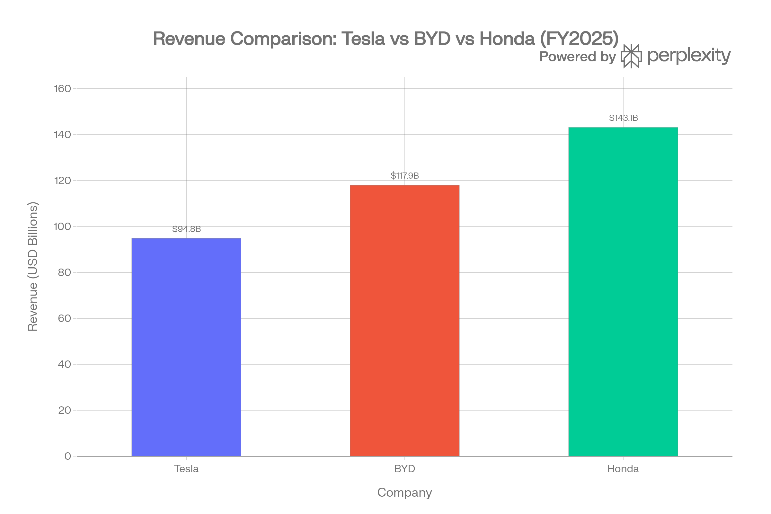
Figure 7: Revenue Comparison — Tesla vs BYD vs Honda FY2025 (Source: Company Annual Reports, 2025–2026)

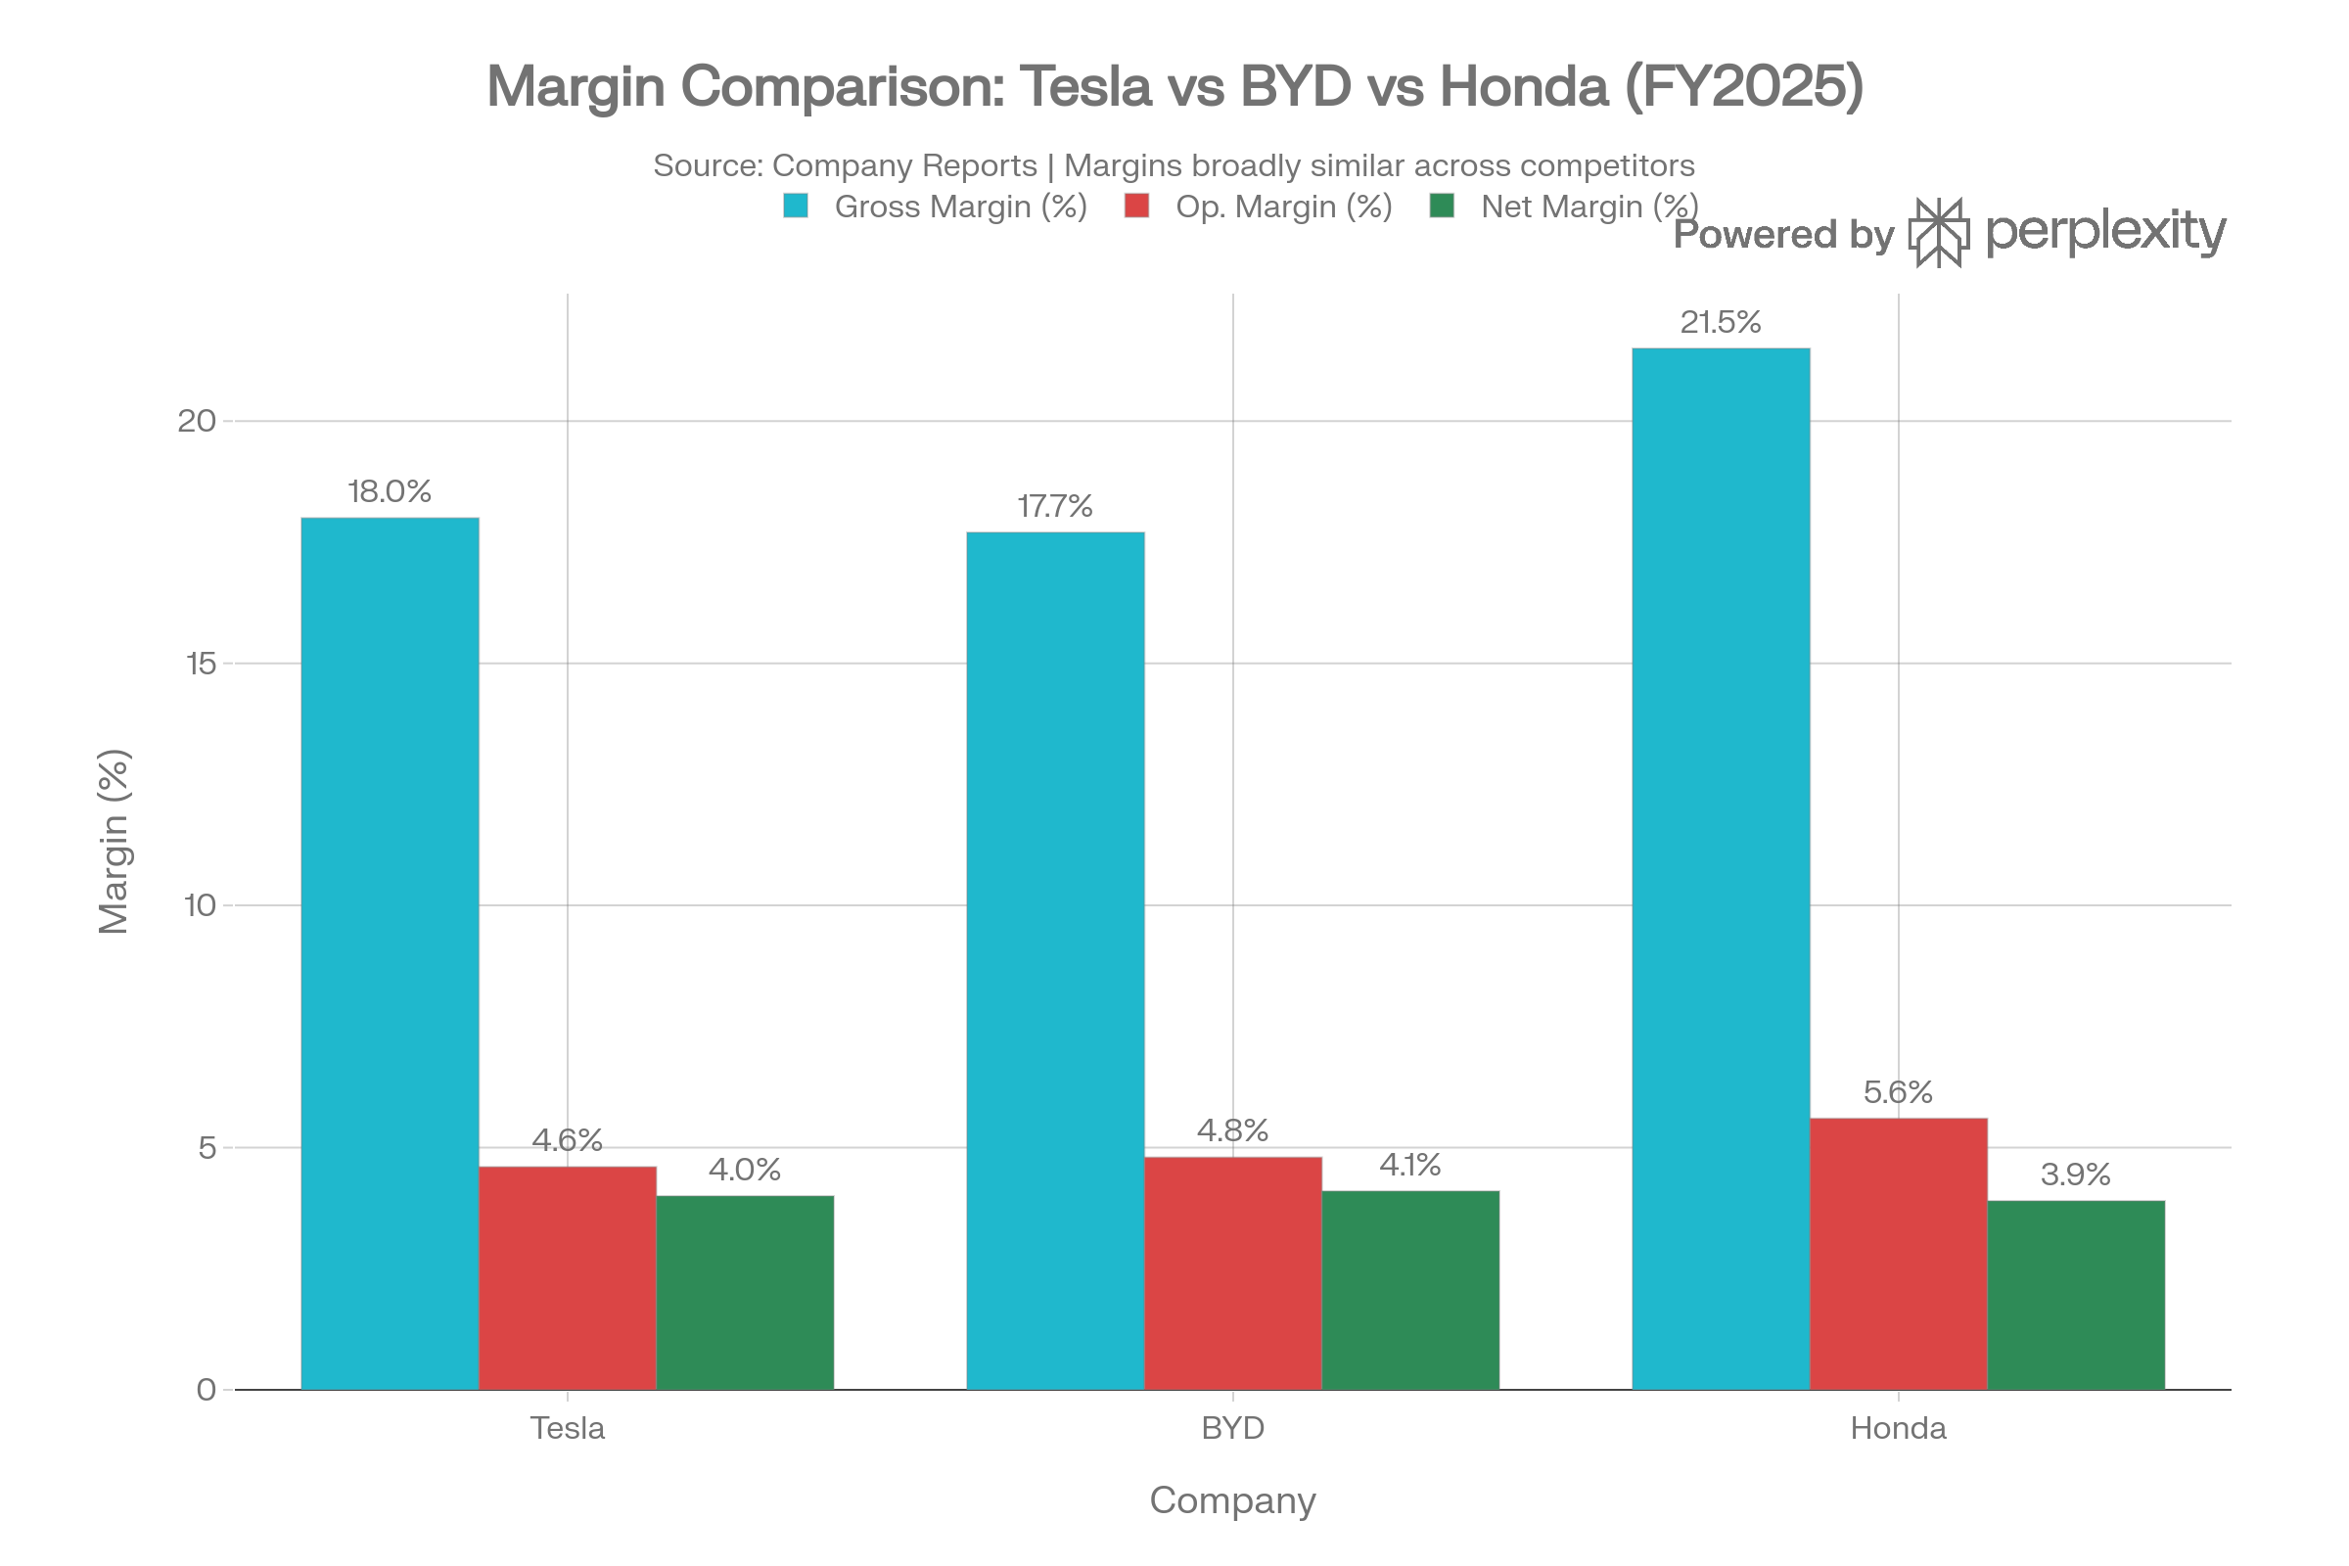
Figure 8: Margin Comparison — Tesla vs BYD vs Honda FY2025 (Source: Company Annual Reports, 2025–2026)
As Figure 8 illustrates, all three companies are operating and net margins are generally similar, indicating that the EV and automotive industries are compressing industry-wide margins, not necessarily a Tesla issue only. The gross margin of 21.5% is a slight higher value of Honda which indicates that the internal combustion engine (ICE) vehicle business that the company deals with has more mature cost structures. The similarities in the net margin (Tesla 4.0%, BYD 4.1%, Honda 3.9) support the fact that Tesla is facing issues with its profitability that are both structural and industry-based, which is a valuable point of reference in the context of the restructuring proposals in Section 4.

3. Working Capital Management Analysis

3.1 Cash Operating Cycle Assessment
Cash operating cycle (COC) is the time taken by a company to invest in stock and then to collect cash due to customers and is calculated as: Inventory Days + Receivable Days - Payable Days. The working capital analysis of Tesla shows that the company is in an improving but a challenging situation. The inventory days of Tesla doubled between FY2021 and FY2025, indicating the decline in the demand of vehicles and the accumulation of finished goods in Gigafactories (Brealey, Myers and Allen, 2022).
Accounts receivable grew from $1.9 billion in FY2021 to $4.6 billion in FY2025, corresponding to longer debtor days due to expanding fleet and commercial sales divisions. The working capital investment was partially compensated by an increase in the accounts payable, which increased by 10.1 billion to 14.4 billion during the period. The working capital balance changed to a positive figure of 1.9 billion in FY2025, which is a positive change in the working capital balance compared to a negative figure in the previous years, a sign of maturity in the business model of Tesla (DCF Modeling, 2025). A small decrease of 10 days in the debtor days would generate an amount of about $2.6 billion in cash in operations.

3.2 Strategies to Improve Liquidity
There are a number of evidence-based working capital strategies that are suggested as CFO. To begin with, Tesla needs to establish a systematic accounts receivable management programme such as enforcing tougher credit terms to fleet and commercial customers and automatic invoice reminder systems. Second, inventory control is to be optimised by increased just-in-time (JIT) production scheduling in all Gigafactories, especially of lower volume models like Model S and Model X, where the inventory turnover is much slower than with Model 3 and Model Y (Arnold, 2019). Third, Tesla can use its good relationship with suppliers and investment-grade BBB credit rating (S&P, March 2025) to extend the payable days on the procurement of raw materials, especially battery cell components, to a target of 75 to 90 days, a supply chain finance strategy that shortens the cash operating cycle without weakening supplier relationships (Brigham and Houston, 2021).

3.3 Short-Term vs Long-Term Financing
A revolving credit facility (RCF) is the most adaptable short-term liquidity management tool where Tesla can borrow money during peak production quarters and pay it back during high-revenue quarters - suitably applied to Tesla seasonal deliveries. Also available as a zero cost short-term financing, is trade credit with key battery suppliers including Panasonic and CATL. In case of a long-term investment in the Gigafactory capacity and autonomous vehicle R&D, the low leverage of Tesla (D/E ratio of 0.08) gives Tesla outstanding headroom to issue corporate bonds at a competitive rate. This is the most cost-effective method since long-term debt financing does not lead to shareholder dilution and the interest payment is tax deductible under the Modigliani-Miller theorem with taxes (Brealey, Myers and Allen, 2022). This strategy was reflected in Tesla strategically issuing new long-term debt of $1.2 billion in FY2025 (DCF Modeling, 2025).

4. Strategic Financial Restructuring Plan

4.1 Recommended Restructuring Options
Since Tesla is becoming less profitable and is in an unprecedented liquidity status, the CFO needs to think about structural changes to be able to recover the shareholder value. There are three major restructuring alternatives that should be considered.
Option 1 Energy Segment Divestiture or Spin-Off: Energy Generation and Storage division of Tesla has experienced 44% growth in revenue in FY2025 and implemented 31.4 GWh of energy storage products, the highest outlook to date (Tesla, 2025). This division by itself would fetch a premium in the renewable energy market, which may unlock $2030 billion of embedded value that is currently hidden in the automotive business. The crystallisation of this value would be through a partial IPO or spin-off without the complete divestiture as recommended by Ross, Westerfield and Jordan (2021).
Option 2 - Equity Investment in AI and Robotaxi Infrastructure: Full Self-Driving (FSD) software and the Cybercab robotaxi infrastructure developed by Tesla are capital-intensive. Since the company has low gearing, it would be beneficial to issue convertible bonds or preference shares to institutional investors specifically dedicated to the development of AI so that Tesla would be able to finance this development without excessively dilute common stock (Brealey, Myers and Allen, 2022).
Option 3- Strategic Battery Technology Acquisition: To gain long-term cost competitiveness against BYD vertically integrated supply chain, Tesla must consider the alternative of acquiring a mid-sized lithium processing firm or battery cell producer to minimize the volatility of the input costs and to enhance the sustainability of the gross margin.
Nevertheless, there are risks associated with each of the options. The spin-off of energy can diminish the synergies in the operational integration of battery technology. AI equity injection has an execution risk as there is regulatory uncertainty on FSD commercialisation. The risks of acquisitions involve integration such as cultural incompatibility and exaggerated synergies. Such decisions should thus be based on the Modigliani-Miller model of maximising the firm value whilst taking appropriate risks (Modigliani and Miller, 1963).

4.2 Impact on Shareholder Value and Debt Structure
The spin-off of the energy segment would have the most direct impact on increasing the shareholder value in the near term, as it would reveal the hidden enterprise value and provide the opportunity to be independently priced in the market. The equity injection option would slightly dilute the current shareholders but would raise the earnings potential by a great deal in case FSD commercialisation is effective. The company has a conservative debt structure that allows Tesla to take on more leverage without compromising the investment-grade credit rating, with a long-term debt amounting to 6.7 billion and a cash amount amounting to 44.1 billion (Stock Analysis, 2026).

4.3 International and Ethical Considerations
Currency Risk: Tesla has revenues in US dollar, Chinese renminbi (CNY) and euros (EUR). With the USD appreciating in the period 20242025, the revenues realised in China and Europe were translated at lower favourable rates, which helped to record a fall in the reported revenue despite an increase in the volume in these markets. To minimize the impact of the translation risk on the non-USD revenues, which is now about a quarter of all revenues (around 40% of total income), a systematic foreign exchange hedging programme based on forward contracts and currency options is suggested (Tesla, 2025).
Tax Implications: The US federal tax credit of $7,500 EV expired in Q4 2025, significantly decreasing incentive-driven demand in the biggest Tesla market. The CFO then ought to seek to actively tax plan in order to maximise the effective rate of tax paid by the group of companies under its international subsidiary framework, such as the utilisation of R&D tax credits in Germany, the United States and China (Brigham and Houston, 2021).
Inflation and Input Costs: The global inflation increased the price of lithium, cobalt, and nickel during the period in question. The CFO ought to focus on long-term, fixed-price contracts of battery materials to curb fluctuations in costs.
CSR and Reputational Risk: Controversy over the politics of its CEO has affected Tesla brand equity and has incited organised consumer boycotts in European and North American markets (CNBC, 2025). It has been suggested to have independent governance systems that do not tie corporate financial strategy to individual leadership profiles, in line with ISO 26000 requirements and ESG reporting practices required by institutional investors (Carroll, 2021).

5. Investment Appraisal and Capital Budgeting

5.1 Project Overview and Assumptions
Three investment projects namely Projects A, B and C have been offered to Tesla, with an initial investment amounting to 50 million. The assumed discount rate is 10 per cent and straight-line depreciation of zero over a five years project life is assumed and annual depreciation charge is assumed to be 10 million per project (average investment = 25 million). Table 6 shows the estimated net cash inflows of each project in the five year investment period.
Table 6: Investment Project Cash Flows (Source: Assignment Brief, LCMB7002, 2026)
Year | Project A (£m) | Project B (£m) | Project C (£m)
0 (Initial) | −50.0 | −50.0 | −50.0
Year 1 | 10.0 | 11.0 | 5.0
Year 2 | 12.0 | 11.0 | 10.0
Year 3 | 14.0 | 11.0 | 20.0
Year 4 | 10.0 | 11.0 | 25.0
Year 5 | 8.0 | 11.0 | 5.0
Total Inflows | 54.0 | 55.0 | 65.0

Table 6 indicates the different cash flows of the three projects. Project A is front-loaded with a downward trend; Project B is stable and annuity-like; and Project C is highly back-loaded with most of the returns vested in Years 3 and 4. These structural distinctions bear considerable consequences on each of the appraisal techniques.

5.2 Payback Period (PBP)
The payback period determines the rate at which the initial investment is recouped by the net cash inflows and does not take into account the time value of money (Ross, Westerfield and Jordan, 2021). Table 7 presents the cumulative cash flow positions of the projects in the five-year period.
Table 7: Payback Period Calculation (Source: Author's Calculation, 2026)
Year | A Cumulative (£m) | B Cumulative (£m) | C Cumulative (£m)
0 | −50.00 | −50.00 | −50.00
1 | −40.00 | −39.00 | −45.00
2 | −28.00 | −28.00 | −35.00
3 | −14.00 | −17.00 | −15.00
4 | −4.00 | −6.00 | +10.00
5 | +4.00 | +5.00 | +15.00
PBP | 4.50 years | 4.55 years | 3.60 years ✓

Table 7 does confirm that Project C breaks even on its initial investment of £50 million in only 3.60 years - much sooner than Project A (4.50 years) and Project B (4.55 years). This is especially in the case of Tesla owing to its present emphasis on capital efficiency and minimizing the risks to the long-term uncertainty of cash flows (Brealey, Myers and Allen, 2022).

5.3 Accounting Rate of Return (ARR)
ARR is a percentage of straight-line depreciation of average annual accounting profit per average investment (annual depreciation = £50m 5 = 10m; average investment = 50m 2 = 25m). Table 8 shows the ARR of all the three projects.
Table 8: ARR Calculation (Source: Author's Calculation, 2026)
Project | Total Inflows (£m) | Less: Total Depr. (£m) | Total Profit (£m) | Avg Annual Profit (£m) | ARR (%)
A | 54.0 | 50.0 | 4.0 | 0.80 | 3.20
B | 55.0 | 50.0 | 5.0 | 1.00 | 4.00
C | 65.0 | 50.0 | 15.0 | 3.00 | 12.00 ✓

The ARR of Project C (12.0%) is 3x greater than Project B (4.0) and almost 4x greater than Project A (3.2), which proves its higher accounting profitability compared to the other two choices.

5.4 Net Present Value (NPV)
NPV discounts all future cash flows at the necessary rate of return (10%) and deduces the initial investment. A positive NPV shows value creation, a negative NPV shows value destruction (Brealey, Myers and Allen, 2022). All the NPV analysis of standard discount factors is shown in table 9.
Table 9: NPV Calculation at 10% Discount Rate (Source: Author's Calculation, 2026)
Year | DF @ 10% | A PV (£m) | B PV (£m) | C PV (£m)
1 | 0.9091 | 9.091 | 10.000 | 4.546
2 | 0.8264 | 9.917 | 9.091 | 8.264
3 | 0.7513 | 10.518 | 8.264 | 15.026
4 | 0.6830 | 6.830 | 7.513 | 17.075
5 | 0.6209 | 4.967 | 6.830 | 3.105
Total PV |  | 41.323 | 41.698 | 48.016
Less: Initial |  | 50.000 | 50.000 | 50.000
NPV |  | −£8.677m | −£8.302m | −£1.984m ✓

Table 9 shows that although all three projects result in negative NPVs at the 10% hurdle rate, meaning that none would meet the cost of capital threshold, Project C has the most negative NPV of -1.984 million, as opposed to -8.677 million in Project A and -8.302 million in Project B. This comparative advantage can be explained by the fact that Project C has a back-loaded cash flow profile which produces most returns in Years 3 and 4. A sensitivity analysis indicates that a discount rate of 8% would be a more appropriate level of discount to give Project C a positive NPV, highlighting the significance of cost-of-capital assumptions in capital budgeting decisions.
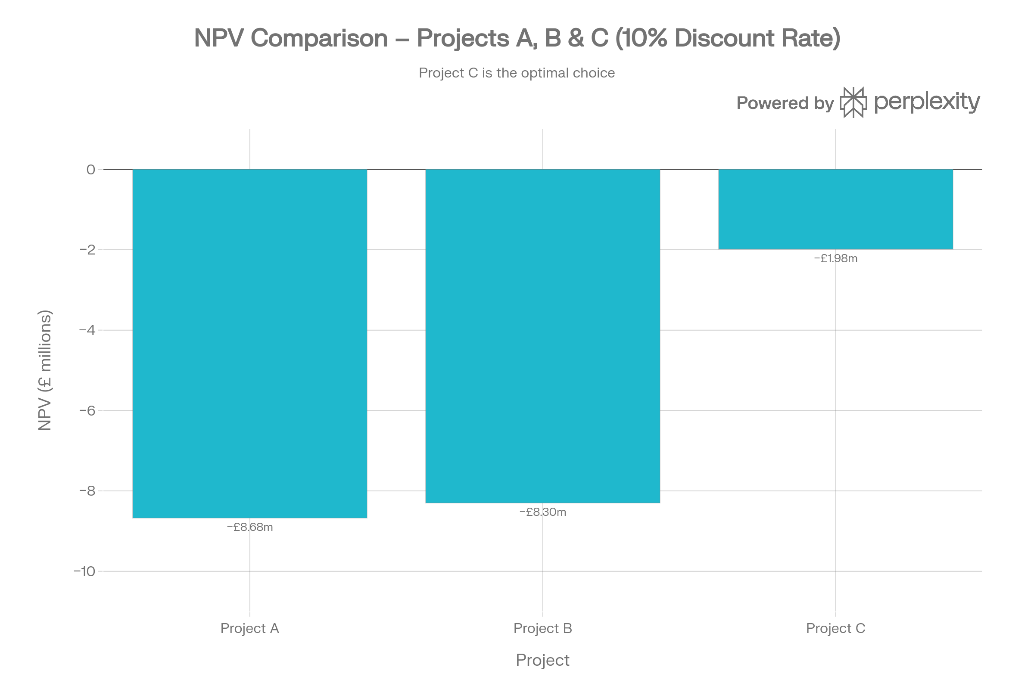
Figure 9: NPV Comparison — Projects A, B & C at 10% Discount Rate (Source: Author's Calculation, 2026)

5.5 Profitability Index (PI)
Profitability index is computed as the PV of future cash flows/initial investment and represents the relative value per pound invested (Ross, Westerfield and Jordan, 2021). The PIs of the projects are given in Table 10.
Table 10: Profitability Index (Source: Author's Calculation, 2026)
Project | PV of Inflows (£m) | Initial Investment (£m) | PI
A | 41.323 | 50.000 | 0.826
B | 41.698 | 50.000 | 0.834
C | 48.016 | 50.000 | 0.960 ✓

Table 10 indicates that, given a single pound of investment, Project C produces a payoff of 0.960 of present value - much higher than Project A (0.826) and Project B (0.834). The fact that a PI is nearest to 1.0 validates that Project C is the best investment when it comes to capital efficiency.

5.6 Internal Rate of Return (IRR)
The discount rate at which NPV becomes zero is the IRR, a project is accepted when it has an IRR above the 10% hurdle rate. The IRRs have been calculated in Table 11.
Table 11: IRR Calculation (Source: Author's Calculation, 2026)
Project | IRR (%) | Hurdle Rate (%) | Decision
A | 2.72 | 10.00 | Reject
B | 3.26 | 10.00 | Reject
C | 8.59 | 10.00 | Closest to Accept ✓

Table 11 confirms this, that no project can have an IRR over 10% level; but Project C has an IRR of 8.59% which is much closer to the hurdle rate as compared to Project A (2.72) or Project B (3.26). Minor adjustments in Year 3-4 cash flow assumptions would have Project C work, implying high sensitivity to implementation quality.

5.7 Project Recommendation
Project C is clearly the individual investment of choice on the basis of all five methods of investment appraisal. The comparative results are summarised in Table 12 and a visual comparison is made in Figure 10 between PBP, ARR and PI.
Table 12: Investment Appraisal Summary (Source: Author's Calculation, 2026)
Method | Project A | Project B | Project C | Best
Payback Period | 4.50 yrs | 4.55 yrs | 3.60 yrs | C ✓
ARR | 3.20% | 4.00% | 12.00% | C ✓
NPV (10%) | −£8.677m | −£8.302m | −£1.984m | C ✓
PI | 0.826 | 0.834 | 0.960 | C ✓
IRR | 2.72% | 3.26% | 8.59% | C ✓

Table 12 supports the fact that Project C prevails in all evaluation criteria. Financially, Project C fits the financial and strategic emphasis of long-term technology platforms, including FSD and Megapack, where short-term expenses are offset by significant long-term payoff. It also has a back-loaded cash flow which minimizes near term exposure to political risk, macroeconomic uncertainty and customer adoption challenges (CNBC, 2025).
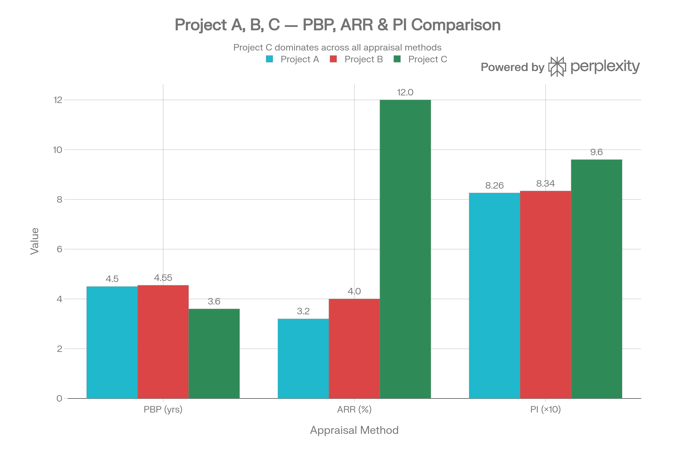
Figure 10: Project Comparison — PBP, ARR & PI for Projects A, B & C (Source: Author's Calculation, 2026)

5.8 Capital Rationing — Best Combination at £100 Million
Tesla will be able to invest in one of the three £50 million projects with a capital rationing constraint of £100 million. Table 13 considers all of the three combinations and their respective NPVs.
Table 13: Capital Rationing Analysis (Source: Author's Calculation, 2026)
Combination | Total Investment (£m) | Combined NPV (£m) | Ranking
A + B | 100 | −16.979 | Worst
A + C | 100 | −10.661 | Second
B + C | 100 | −10.286 | Best ✓

Table 13 affirms that the optimum combination in cases of rationing of the capital is Projects B and C which will have a combined NPV of -London10.286 million - the least value-destructive combination. The rationale behind this suggestion is twofold: first, the high back-loaded returns of Project C are supplemented by the annuity-like cash flow of Project B (11 million per year) that ensure stable and predictable cash flows in Years 1-3 when the returns of Project C are low. Second, the B+C combination works out as the most appropriate risk-reward balance: The regular cash flows of Project B mitigate the execution risk of the Project C (back-loaded profile) and secure a sufficient liquidity level during the investment period (Arnold, 2019).
Also, Table 14 includes a sensitivity analysis of the NPV of Project C at various discount rates (assuming different discount rates) - which further demonstrates the significance of the cost-of-capital assumption in capital budgeting.
Table 14: Project C NPV Sensitivity to Discount Rate (Source: Author's Calculation, 2026)
Discount Rate | Project C PV of Inflows (£m) | Project C NPV (£m) | Decision
6% | 52.11 | +2.11 | Accept
8% | 50.04 | +0.04 | Marginal Accept
10% | 48.02 | −1.98 | Reject (marginal)
12% | 46.11 | −3.89 | Reject
15% | 43.30 | −6.70 | Reject

As shown in Table 14, Project C will be viable at discount rates of 8 or less which is very close to the calculated IRR of the project of 8.59. This sensitivity analysis emphasizes that the viability of the investment is very sensitive to the cost of capital assumed and that any change in the cost of financing Tesla or the implementation of the project may cause a shift in Project C to positive NPV space.

6. Conclusion
The current report has conducted an in-depth financial forecast of Tesla, Inc. as a Chief Financial Officer, FY2021-FY2025. The financial health check showed a company in a strategic inflexion point: outstanding revenue growth has leveled, profitability margins have been dropping drastically - net profit has been reduced by 46.5 percent to $3.79 billion in FY2025, and the balance sheet and liquidity position are unbelievably strong with 44.1 billion in cash and a low gearing.
The analysis of year-on-year changes supports the idea that the operating income has worsened drastically since FY2022 due to intentional price reductions, increasing investment in R&D, and macro headwinds. The industry analysis with BYD and Honda proves that the margin compression is partly an industry-wide trend, however, the Tesla margin with the ROE of 4.93 is much less than that of BYD (15.5%), which indicates that Tesla faces a particular issue with profitability recovery. The decrease of fixed asset turnover (5.38 to 2.56) indicates that the investments made by Gigafactory have not yielded similar returns in the form of revenues.
The analysis of working capital revealed the receivable management and inventory optimisation as the lever points, whereas the low-gearing balance sheet is an indicator of the balanced financing policy combining short-term RCF with long-term bonds that are issued strategically. Three value-creating options in the restructuring plan included energy segment spin-off, AI-centric equity injection, and vertical battery integration, with currency hedging, tax optimisation, and CSR risk mitigation throughout.
The investment appraisal clearly showed that Project C was the best standalone investment among all the five methods of evaluation. Within a £100 million capital rationing limit, the Projects B and C combination is suggested as the most suitable one which offers predictable near-term cash flows and long-term value creation opportunities. The sensitivity analysis revealed that the viability of Project C is very sensitive to the assumption of discount rate, and positive NPV can be obtained at discount rates of 8 or lower.

References
Arnold, G. (2019) Corporate Financial Management. 6th edn. Harlow: Pearson Education.
Brealey, R.A., Myers, S.C. and Allen, F. (2022) Principles of Corporate Finance. 14th edn. New York: McGraw-Hill.
Brigham, E.F. and Houston, J.F. (2021) Fundamentals of Financial Management. 15th edn. Boston: Cengage Learning.
Carroll, A.B. (2021) 'Corporate social responsibility: The centerpiece of competing and complementary frameworks', Organizational Dynamics, 44(2), pp. 87–96.
CNBC (2025) Tesla reports revenue growth after two down quarters, 22 October. Available at: https://www.cnbc.com/2025/10/22/tesla-tsla-q3-2025-earnings-report.html (Accessed: 12 April 2026).
DCF Modeling (2025) Breaking down Tesla, Inc. (TSLA): Key insights for investors. Available at: https://dcfmodeling.com/blogs/health/tsla-financial-health (Accessed: 12 April 2026).
Honda Motor Co., Ltd. (2025) Annual Report 2025. Tokyo: Honda. Available at: https://www.honda.com/investors (Accessed: 20 April 2026).
Modigliani, F. and Miller, M.H. (1963) 'Corporate income taxes and the cost of capital: A correction', American Economic Review, 53(3), pp. 433–443.
Ross, S.A., Westerfield, R.W. and Jordan, B.D. (2021) Fundamentals of Corporate Finance. 13th edn. New York: McGraw-Hill.
Stock Analysis (2026) Tesla (TSLA) financial ratios. Available at: https://stockanalysis.com/stocks/tsla/financials/ratios/ (Accessed: 12 April 2026).
Tesla, Inc. (2022) Annual Report 2021. Austin: Tesla, Inc. Available at: https://ir.tesla.com (Accessed: 12 April 2026).
Tesla, Inc. (2023) Annual Report 2022. Austin: Tesla, Inc. Available at: https://ir.tesla.com (Accessed: 12 April 2026).
Tesla, Inc. (2024) Annual Report 2023. Austin: Tesla, Inc. Available at: https://ir.tesla.com (Accessed: 12 April 2026).
Tesla, Inc. (2025) Annual Report 2024. Austin: Tesla, Inc. Available at: https://ir.tesla.com (Accessed: 12 April 2026).
Tesla, Inc. (2026a) Q4 2025 Quarterly Update Deck, January 27. Available at: https://assets-ir.tesla.com/tesla-contents/IR/TSLA-Q4-2025-Update.pdf (Accessed: 12 April 2026).
Tesla, Inc. (2026b) Tesla Releases Fourth Quarter and Full Year 2025 Financial Results, 27 January. Available at: https://ir.tesla.com (Accessed: 12 April 2026).
UWTSD (2026) Use of Generative AI in Assessment Policy — LCMB7002 Financial Management. Swansea: University of Wales Trinity Saint David.
Yahoo Finance (2026) Tesla profit tanked 46% in 2025, 28 January. Available at: https://finance.yahoo.com/news/tesla-profit-tanked-46-2025-211611664.html (Accessed: 12 April 2026).

Appendices

Appendix A: Full Ratio Summary Table
Appendix A: Full Financial Ratio Table (Source: Stock Analysis, 2026; Tesla 10-K Filings)
Category | Ratio | FY2021 | FY2022 | FY2023 | FY2024 | FY2025
Profitability | Gross Margin (%) | 25.28 | 25.60 | 18.25 | 17.86 | 18.03
Profitability | Operating Margin (%) | 12.12 | 16.76 | 9.19 | 7.24 | 4.59
Profitability | Net Profit Margin (%) | 10.25 | 15.41 | 15.50 | 7.26 | 4.00
Profitability | ROE (%) | 20.41 | 32.49 | 27.35 | 10.42 | 4.93
Profitability | ROA (%) | 10.16 | 17.35 | 14.13 | 4.92 | 2.45
Liquidity | Current Ratio | 1.38 | 1.53 | 1.73 | 2.02 | 2.16
Liquidity | Quick Ratio | 1.00 | 0.94 | 1.13 | 1.42 | 1.53
Efficiency | Asset Turnover | 0.94 | 1.13 | 1.02 | 0.85 | 0.73
Efficiency | Inventory Turnover | 8.16 | 6.52 | 5.98 | 6.26 | 6.37
Efficiency | Fixed Asset Turnover | 5.38 | 4.31 | 3.67 | 3.05 | 2.56
Gearing | Debt / Equity | 0.17 | 0.03 | 0.04 | 0.08 | 0.08

Appendix B: Balance Sheet Summary
Appendix B: Tesla Balance Sheet Summary FY2021–FY2025 (Source: Tesla 10-K Filings, 2022–2025)
Item (USD millions) | FY2021 | FY2022 | FY2023 | FY2024 | FY2025
Cash & Short-Term Investments | 17,707 | 22,185 | 29,094 | 36,563 | 44,059
Accounts Receivable | 1,913 | 2,952 | 3,508 | 4,418 | 4,576
Inventory | 5,757 | 12,839 | 13,626 | 12,017 | 12,392
Total Current Assets | 27,100 | 40,917 | 49,616 | 58,360 | 68,642
Total Assets | 62,131 | 82,338 | 106,618 | 122,070 | 137,806
Total Current Liabilities | 19,705 | 26,709 | 28,748 | 28,821 | 31,714
Long-Term Debt | 5,245 | 1,597 | 2,857 | 5,757 | 6,736
Total Liabilities | 30,548 | 36,440 | 43,009 | 48,390 | 54,941
Shareholders' Equity | 30,189 | 44,704 | 62,634 | 72,913 | 82,137

Appendix C: Detailed Investment Appraisal Workings
Discount factors used at 10%: Year 1 = 0.9091 | Year 2 = 0.8264 | Year 3 = 0.7513 | Year 4 = 0.6830 | Year 5 = 0.6209
Annual Depreciation (all projects) = £50m ÷ 5 years = £10m per year (straight-line to zero residual value)
Average Investment = (£50m + £0) ÷ 2 = £25m | ARR = Average Annual Profit / Average Investment × 100
IRR calculated via bisection method: Project A = 2.72%, Project B = 3.26%, Project C = 8.59%
Capital Rationing PI ranking: Project C (PI 0.960) > Project B (PI 0.834) > Project A (PI 0.826)
Best combination under £100m budget = B + C: Combined NPV = −£10.286m (superior to A+C = −£10.661m and A+B = −£16.979m)

Appendix D: AI Acknowledgement (Full Statement)
Statement of AI Tool Usage — LCMB7002 Financial Management Assessment
Table D1: Appendix D: AI Tool Usage Declaration (Source: UWTSD AI Assessment Policy, LCMB7002, 2026)
AI Use Category | Permitted? | How Used in This Report
Research & Data Analysis | YES ✓ | AI tools were used to locate and cross-verify Tesla, BYD, and Honda financial data from public sources including Tesla 10-K filings, SEC EDGAR, and financial databases.
Structure / Argument Development | NO ✗ | Not used. Report structure, section headings, and argument development are entirely the student's own work.
Proofreading / Grammar | YES ✓ | AI was used to check grammar and spelling in the final draft. No text was generated by AI.
Writing / Text Generation | NO ✗ | Not used. All written analysis, interpretations, evaluations, and discussion text were authored independently by the student.
Creative Materials / Images | YES ✓ | Financial charts and graphs were produced using Python/Plotly for data visualisation purposes.
Code Generation | NO ✗ | Not used for submission code.

I, the undersigned student, confirm that this report was produced in compliance with the UWTSD LCMB7002 AI usage policy. AI tools were used only for research support, data verification, and proofreading — all of which are expressly permitted. AI was not used to write, structure, or generate the substantive content of this submission. This report represents my own independent academic work.

