Targedau / Targets | Sut rydych wedi gweithio ar hwn /  How you have worked on this | Ceir enghraifft ar /  An example can be found on
Targed/Target 1 | When writing critically, aim to compare and contrast literature. | First paragraph, page 7.
Targed/Target 2 | Avoid descriptive writing | In the introduction, discussing the school context.

ECAD 6009 – Part 2.
How a school develops one aspect of its SDP: a report that critically reflects on the actions, impact and evidence base.

Hayley Clark
1907913
Word count: 2904

Table of Contents
How a school develops one aspect of its SDP: a report that critically reflects on the actions, impacys and evidence base 3
References 11
Appendix One – A typical school development plan cycle. 14
Appendix Two – Meeting with School A’s Head Teacher. 14
Appendix Three – The front page of School A’s development plan. 16
Appendix Four – Care, Support and Guidance section from School A’s development plan. 16

How a school develops one aspect of its SDP: a report that critically reflects on the actions, impact, and evidence base.

This assignment will look at how a school creates its school development plan (SDP). It will discuss and critically reflect on one of the action points from the SDP and its impact. The school will be referred to as school A to keep the school anonymous according to BERA guidelines (2018). The school is an English medium school with 253 pupils (My Local School, 2021) and is a Church of Wales voluntary controlled primary School situated in a small village in Wales (School A, 2022a). All pupils speak English as their first language and are of white British ethnicity. (ESTYN, 2019). 3.2% of pupils receive free school meals, below the national average of 21.3% (My Local School, 2021), indicating a low poverty level within the catchment area (Groves, West-Burnham, 2020). The school identifies around 10% of pupils as having additional learning needs, which is significantly lower than the national average of 21% (ESTYN, 2019).
The area of the SDP that will be critically discussed will be 'Care, Support and Guidance, which has one overriding priority, to 'Design and begin to implement a new curriculum in line with national requirements. The desired outcome for this area is to implement a personalised and cohesive curriculum, with the objective of pupils becoming responsible, active citizens in the local community (See appendix 4). The Welsh curriculum is changing, with all primary schools currently moving towards implementing the Curriculum for Wales by September 2022. Secondary schools will also be required to implement this for year seven and then be expected to roll out the curriculum to their older learners on a year-by-year basis through to Year 11 by September 2026 (WAG, 2020).
An SDP is a strategic improvement plan. Since 2015 all maintained schools are required to have an SDP, which is renewed every three years (WAG, 2016). A strategic plan is what a school wants to achieve in the future and how it plans to get there. It identifies the targets they are going to focus on to improve students' experience and attainment at school and how the school will achieve this. From these action points, milestones and assessment methods can be identified, which will be used to evaluate progress (Office for Government School Education, 2010). Strategic planning should include:
- the goals and objectives
- a detailed action plan to achieve them
- the key people for each action
- how the impact will be measured
- details of the cost and resources required for each action point
(Halladay, 2021)
School A's SDP is written in a table with a box for all these aspects; however, the boxes for impact and evaluation are empty throughout the SDP. It is indicating now that evaluation has taken place. However, it does say who will be responsible for this monitoring but does not specify how it will occur.
Once decisions have been made on the school's strategic plan, the SDP can be developed. An SDP should be seen as a working document reviewed at least annually (WAG,2016). A School development plan starts with a vision which is decided in collaboration with stakeholders. This is then used to develop the school's strategic planning. This is often broken down into a four-stage cycle: self-evaluation, strategic planning, making improvements, and reviewing impact (WAG, 2014). A vision is an aspiration of where the school want to get to (Williams, 2021).
The governing body plays a significant role in the school's strategic planning. They monitor and review the progress made by the school during each school year against the SDP. The governing body must provide each member of the governing body and school staff with a copy of the plan. They are required to make the plan available to parents/carers and the wider community, which includes high-level priorities, targets and action points for the academic year (WAG, 2016).
When developing an SDP, it should break down how it plans to achieve the school's vision (The Key, 2021). A school vision should incorporate the views of the whole school community, including the learners, staff, parents, carers, school governors, local groups, or churches that have connections to the school. It should answer what they perceive as the school's strengths and weaknesses and what they want learners' experience of school to be (Williams, 2021). Once the vision is finalised, the process of self-evaluation begins. Staff members reflect on their practice and identify what needs to be altered to achieve the school's vision. Self-evaluation should be a process which collects a range of data from varied sources (Chapmans and Sammons, 2013). School A's SDP began by discussing the vision with staff, the governing body, and the student council, which was then followed by process of self-evaluation by staff. All leaders, staff, learners, parents, and the community should share the same vision (Groves and West-Burnham, 2020). From this process, the school created their strategic plan, from which the School's SDP was created.
When reviewing the impact of action points on the SDP, school A uses a variety of assessments such as feedback from the student council, academic progress, observations, and parent questionnaires to rate progress termly using a traffic light system (see appendix 4). Schools should review their SDPs annually. However, School A also do this termly using a rating system to measure the progress of each action point.
The new curriculum is the overall priority because of the curriculum change in Wales. In advance of September 2022, all schools will be required to design their curriculum, including the supporting assessment arrangements, ready for its adoption. The WAG (2016) states that an SDP must also take account of the national priorities. To prepare for this, they should develop the vision and methodology detailed in the 'Designing your curriculum' guidance (WAG, 2020). The curriculum change is a priority in the SDP in all four areas (see appendix 3). The school identified what they needed to change to meet the new curriculum requirements during a series of staff meetings and governor meetings. From these discussions, the objective and action points were chosen (see appendix 2). The area of the SDP that will be critically discussed will be 'Care, Support and Guidance, which has one overriding priority, to 'Design and begin to implement a new curriculum in line with national requirements. This assignment will focus on the desired outcome for this area is 'to implement a personalised and cohesive curriculum', which is broken down into two objectives. This assignment's focus' is on one of these, that 'all children will have the opportunity to become responsible, active citizens in the local community (See appendix 3). This has three actions points to achieve the objective:
- For each class to identify a charity or community project as a focus for the academic year.
- To map community-based projects within the curriculum plan and collective worship schedule for the following year.
- To map fund-raising /raising awareness events for the chosen area of focus.
All of these action points focus around and rely on the first, for each class to have a charity and community project as a focus. This will be part of providing a curriculum which supports learners to become ethically informed citizens, which is one of the four purposes of the Curriculum for Wales 2022.
The school is currently in the process of beginning to implement the action plan. They are collecting pupil voices in each class before a final project is chosen, ready to start in September when the learners all move up a year group. This is not ideal as they will choose a project with their current teacher but will have a new teacher run the project in September. However, the new curriculum must be fully implemented by September 2022 (WAG, 2019). Therefore, to allow sufficient time to plan the project, it will need to be chosen before the end of the current term. The milestone chosen to begin assessing the progress and impact of this action point will be term five, which is the term beginning January 2023. The rating for this is amber as they are on track but have not yet fully implemented this into their curriculum (see appendix 4).
The curriculum for Wales 2022 was published following a review of the Welsh Curriculum by Professor Donaldson, who wrote the report - Successful Futures (Donaldson, 2015). His report suggested four core purposes for Wales, which are now the foundations of the curriculum. These four purposes state that every school's curriculum will support children and young people to be:
- ambitious, capable learners, ready to learn throughout their lives
- enterprising, creative contributors, ready to play a full part in life and work
- ethical, informed citizens of Wales and the world
- healthy, confident individuals, ready to lead fulfilling lives as valued members of society
(WAG, 2015a; Donaldson, 2015)
Guidance for the Curriculum for Wales was published in January 2020. It was written to support schools in developing their curriculum. Supporting learners to develop towards the four purposes of the curriculum, which is the starting point and aspiration for every child and young person in Wales (WAG, 2020). The chosen action point for this assignment is part of the objective that 'all children will have the opportunity to become 'responsible, active citizens in the local community. This directly links to one of the four purposes for learners to become ethical, informed citizens of Wales and the world. The four purposes are broken down into smaller elements; this action point directly addresses one element, for children to become ethical, informed citizens who: Are knowledgeable about their culture, community, society and the world, now and in the past, respect the needs and rights of others, as a member of a diverse society are ready to be citizens of Wales and the world. It also has the opportunity to meet elements from other four purposes, such as enterprising, creative contributors who give their energy and skills so that other people will benefit
and are ready to play a full part in life and work (WAG, 2015a). As well as the four purposes, this action point could also be a starting point for a cross-curricular lesson with an authentic context, which will then meet parts of the curriculum's six areas of learning and experiences (AoLE's).
The priority of implementing the curriculum 2022 covers all four areas of the SDP; for the chosen area of 'Care, Support and Guidance', perhaps additional priority should have been included. In the last ESTYN report (2019), one of the recommendations for this area was to "Ensure that all staff have appropriately high expectations of pupils that are more able and meet their needs with suitably challenging learning experiences". However, this need is not considered in any of the action points on the school's SDP.
By working with the community, an opportunity is utilised to understand others' needs and become ethical and active citizens (Griggs, 2010). Being part of the community provides a sense of identity and a real experience of human networks (Rajan, 2019). Epstein et al. (2002) developed a model containing three overlapping circles to explicate the interactions of school, family, and community on positive child outcomes (cited in Leonard 2011). One consideration is that community projects or charity by nature are voluntary endeavours. According to Deci and Ryan's cognitive evaluation theory study (1985), when individuals are controlled externally, they lose enthusiasm for the projected behaviours that are being promoted. What the school may have to consider is will making these activities part of the curriculum has an adverse effect on learners' long-term motivation to be part of these types of activities in the future. One positive thing the school are currently doing is collecting learners' opinions, so they have some control over what project each class are to support. Pupil's voice can increase pupil engagement, improve communication between learners and staff, and provide the right environment for the school to become a learning community (Mitra, 2001; Rudduck et al., 2003).

In an Estyn good practice report, an independent school for pupils aged two and a half to eighteen in Wales has fostered learners' sense of community and understanding of service to others through a range of community work `and working with charities. One example this school does is its project for the charity 'Action for Children.' For this project, pupils devise and organise a range of activities in school to spend time with local young carers. The impact of these types of activities is a significant contribution to pupils' personal and social development. One benefit is that learners have better recognition and understanding of different social and cultural backgrounds in the school and wider community, which helps them respect and value diversity (ESTYN, 2020). This school is independent, which suggests that learners are not from deprived backgrounds; therefore, these learners may not have been able to experience different social and cultural backgrounds without these projects. School A has a low number of EFSM, which suggests a low level of deprivation within the school; therefore, some learners may not experience different social and cultural backgrounds. Therefore, it becomes more important for the school to provide these experiences. Having these experiences helps learners to become better citizens in the community (Drexel University, 2022).

An ESTYN effective practice report (2019b) found that a secondary school that raises significant amounts of money for charity provided learners and staff with beneficial opportunities to develop a strong sense of social responsibility. The school's vision is focused on providing learners with extensive opportunities to become ethically informed citizens who demonstrate a strong sense of social awareness and responsibility and are part of a culture where diversity and equality are celebrated. Although this is a secondary school, the vision is the same to provide opportunities to help others, which supports the core purpose of learners becoming ethically informed citizens. Research suggested that 78% of young people think that charities play an important role (Charity Aid Foundation, 2013). This indicates that a significant majority see helping charities as a meaningful activity. This will support learner engagement as learners will feel their work is meaningful in some way (Groves and West-Burnham, 2020)

One consideration of each class supporting a charity or community project is cost. In the academic year starting 2020, the school had a budget of £4088 per pupil, which is below the average for the local authority, which was £4320 (My local School, 2021). This is £232 less per pupil, which, although it may not seem a considerable amount, based on 253 pupils, equates to a deficit of £58,696 for the school. This could be attributed to a low number of children receiving free school meals, so a reduced pupil development grant (PDG). The PDG is to improve outcomes for learners eligible for free school meals (FSM) and Looked After Children (LAC). The school receives £1150 for each eligible pupil. Only eligible learners may receive PDG-funded support from individualised programmes; however, it may also be used for whole-school strategies that disproportionately benefit eFSM and LAC learners (WAG, 2015b). Bronfenbrenner (1997) believed that for disadvantaged learners, from an ecological point of view, the connection within the local community was more important for positive development outcomes (cited in Chen, Anderson and Watkins, 2016). This could suggest that the school could use the allocated grant for these projects. Because the school has a low number of learners who are eFSM, this suggests it is not in an area of high deprivation (Grove and West-Burnham, 2020). Therefore, parents may be able to contribute voluntarily; however, the implications of this still need to be considered. There are 3.2% of pupils who are eFSM, which, although this is a low number, these families may not have spare funds and may feel pressured. Research suggests that a third of young people already give to charity in a typical month (Charity Aid Foundation, 2013). If a parent has multiple children in the school supporting different causes, this could become expensive. A solution for this could be a decision that all funds will be raised by each class, rather than asking for donations. This would also be part of one of the other four purposes by creating an opportunity for learners to become enterprising. Another solution for this could be for the school to choose one organisation at a time, rather than one for each class.
In conclusion, the SDP of school A does reflect the national requirements of the Curriculum for Wales 2022. However, it does not appear to consider its' last ESTYN report. Regarding the focus action point under care, support and guidance, the action point of each class identifying a charity or community project to support meet the priority of designing and implementing the new curriculum. It meets one of the four purposes of children becoming ethically informed citizens. It also has the opportunity to meet one of the other four purposes by creating the opportunity for learners to become enterprising. It is also something which could be used as a cross-curricular opportunity for the AoLE's.
A school development plan is part of a strategic plan to meet the school's vision and address any areas the school needs to improve on. It is a reflective and collaborative process which should include all stakeholders. Over my career as a teacher, I will be part of the discussion, planning and designing of the SDP and implementation and evaluation of this process.

References
BERA (2018) Ethical Guidelines for Educational Research, 4th edn. Available at: https://www.bera.ac.uk/publication/ethical-guidelines-for-educational-research-2018-online#consent. (Accessed: 8 November 2021)
Chapman, C. and Sammons, P. (2013) School self-evaluation for school improvement: what works and why? Available at: https://www.educationdevelopmenttrust.com/EducationDevelopmentTrust/files/d8/d87c1064-51bf-4b7c-b984-85ccb46a54d1.pdf (Accessed: 3 May 2022)

Charity Aid Foundation (2013) Growing up giving. Insights into how young people feel about charity. Available at: https://www.cafonline.org/docs/default-source/about-us-publications/growing_up_giving.pdf (Accessed: 1 May 2022)

Chen, M., Anderson, J.A. & Watkins, L. (2016) "Parent Perceptions of Connectedness in a Full Service Community School Project", Journal of Child and Family Studies. 25(7) pp. 2268-2278. DOI:10.1007/s10826-016-0398-5

Deci, E.L. and Ryan, R.M. (1985) Cognitive Evaluation Theory. In: Intrinsic Motivation and Self-Determination in Human Behaviour. Perspectives in Social Psychology. Available at: https://link.springer.com/chapter/10.1007/978-1-4899-2271-7_3 (Accessed 2 May 2022)

Donaldson, G. (2015) Professor Graham Donaldson talks about his review of the National Curriculum and assessment arrangements in Wales – Successful Futures. Available at: https://www.ewc.wales/site/index.php/en/about/blog-archive/91-graham-donaldson-successful-futures.html (Accessed: 30 April 2022)

Drexel University (2022) The importance of diversity and cultural awareness in the classroom. Available at: https://drexel.edu/soe/resources/student-teaching/advice/importance-of-cultural-diversity-in-classroom/ (Accessed: 11 May 2022)

ESTN (2019b) Using school programmes to support equality and diversity. Available at: https://www.estyn.gov.wales/effective-practice/using-school-programmes-support-equality-and-diversity (Accessed: 1 May 2022)

ESTYN (2020) Pupils’ life skills develop from their community work. Available at: https://www.estyn.gov.wales/effective-practice/pupils-life-skills-develop-their-community-work (Accessed: 1 May 2020)

Estyn. (2019) A report on Cleddau Reach VC Primary School June 2019. Available at: https://www.estyn.gov.wales/system/files/2021-08/Inspection%20report%20Cleddau%20Reach%20VC%20Primary%20School%202019.pdf (Accessed: 13 April 2022)

GROVES, M. and West-Burnham, J. (2020) Flipping Schools. Why it’s time to turn your school and community inside out. Woodbridge: John Catt Educational ltd.
Halladay, D. (2021) School Strategic Planning - How To Ensure Success. Available at: https://www.privateschoolreview.com/blog/school-strategic-planning-how-to-ensure-success (Accessed: 3 May 2022)

Leonard, J. (2011). “Using Bronfenbrenners ecological Theory to understand community partnerships: A historical case study of one urban high school.” Urban Education, 46(5), 9871010. DOI: http://dx.doi.org/10.1177/0042085911400337

Mitra, D. (2001) “Opening the floodgates: Giving students a voice in school reform” Forum. 43(2), 91–94. Available at: https://www.researchgate.net/publication/238449124_Opening_the_Floodgates_giving_students_a_voice_in_school_reform (Accessed: 13 April 2022)

My Local School (2021) Cleddau Reach VC School. Available at: https://mylocalschool.gov.wales/School/6683040?lang=en#0 (Accessed: 13 April 2022)

Office for Government School Education (2010) What is a strategic plan? Available at: https://www.education.vic.gov.au/Documents/school/principals/management/strategicplan.pdf (Accessed: 3 May 2022).
Rajan, R. (2019) The Third Pillar: the revival of community in a polarised world. London: William Collins.

Rudduck, J. and Demetriou, H. (2003) “Student perspectives and teacher practices: The transformative potential.” McGill Journal of Education, 38(2), 274–288. Available at: https://mje.mcgill.ca/article/view/8685 (Accessed: 13 April 2022)

School A (2022a) Welcome to Cleddau Reach. Available at: https://www.cleddaureachschool.org.uk/Welcome/ (Accessed: 13 April 2022)

The Key (2021) How to embed your school’s vision. Available at: https://schoolgovernors.thekeysupport.com/school-improvement-and-strategy/strategic-planning/values-ethos/embedding-your-schools-vision/ (Accessed: 3 May 2022)

Welsh Assembly Government (2014) School development plans. Available at: https://gov.wales/sites/default/files/publications/2018-03/school-development-plans.pdf (Accessed: 12 April 2022)

Welsh Assembly Government (2015a) Four Purposes for Wales poster. Available at: https://gov.wales/sites/default/files/publications/2018-03/the-four-purposes-of-the-curriculum-for-wales.pdf (Accessed: 30 April 2022)

Welsh Assembly Government (2015b) Pupil Deprivation Grant Essential guidance. Available at: https://gov.wales/sites/default/files/publications/2018-03/pupil-deprivation-grant-essential-guidance.pdf (Accessed: 30 April 2022)

Welsh Assembly Government (2016) School Development Plans. Available at: https://gov.wales/sites/default/files/publications/2018-03/28-school-development-plans.pdf (Accessed: 3 May 2022)

Welsh Assembly Government (2019) Education is changing. Available at: https://gov.wales/education-changing (Accessed: 2 May 2022)
Welsh Assembly Government (2020) Curriculum for Wales: Overview. Available at: https://gov.wales/curriculum-wales-overview (Accssed: 30 April 2022)

Williams, C. (2021) Looking to the Future: Developing a Whole-School Vision Statement. Available at: https://www.twinkl.co.uk/blog/looking-to-the-future-developing-a-whole-school-vision-statement (Accessed: 3 May 2022)

Appendix One – A typical school development plan cycle.
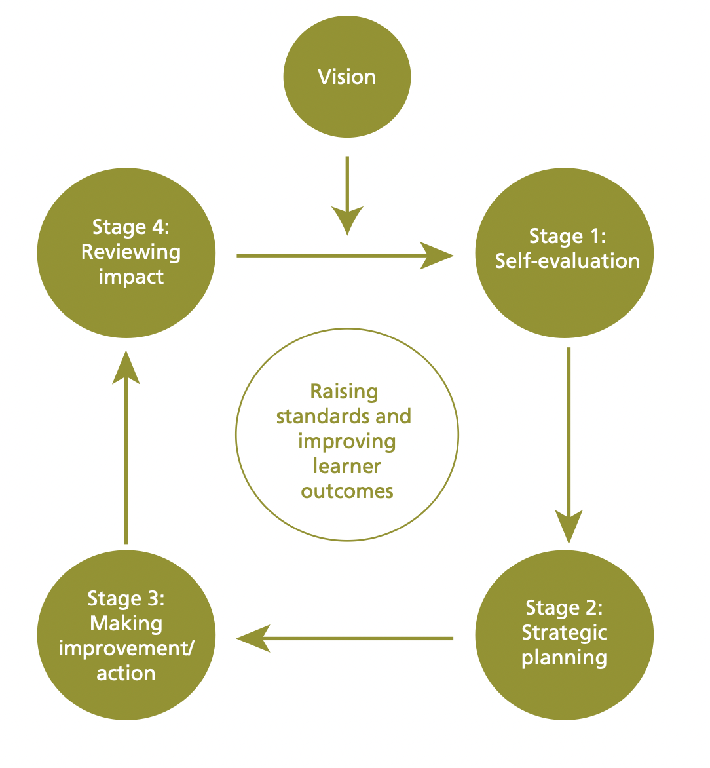

Appendix Two – Meeting with School A’s Head Teacher.

How does the school work with the community?
- class DoJO
- twitter
- friends of the school
- the governing body
- the local church/vicar
- parent talks
- police talks
- the school nurse
- other outside agency, such as speech and language
Under care and support one of the action points is for each class to identify a charity or community project to support. Have you started this process yet? If so, what are you doing?
The classes are in the process of collected pupil voice to choose projects, in the hope it will begin in September.
How does this link to the four purposes?
This links in with the children being ethical, thinking about the needs of others, becoming responsible citizens. It also links to being enterprising individuals.
How is the SDP developed?
Through consolation with staff, the governing, body, feedback from parents, the student council. We start with our vision, from this we evaluate what we are already doing well and then identify what we need to work on, then we create action points to achieve this.
We held a series of staff meeting and governors meeting to develop this before the SDOP was written.
What did you identify for the correct SDP?
The new curriculum had to be a main focus and has been a priority in all areas this year. This is mainly because we are behind where we would like to of been for the new curriculum due to covid.
We also have a second priority for teaching and learning and that was to improve the consistency and quality across the school.
We have three priorities under leadership, as well as the new curriculum we also have improving teaching an learning across the school and to further develop the role of the governing body. This was chosen as during covid the governing weren’t coming into the school and meetings were online. Now covid restrictions are beginning to lift we want to increase their role.
How do you assess progress?
The SDP runs for a 3-year period, but each year we evaluate and might change some of the action points. We use a rag rating system, which is updated throughout the year, about once every term.
Some of the actions are already green and some are still red. This helps the SDP be a usable, easy to read document.

Appendix Three – The front page of School A’s development plan.

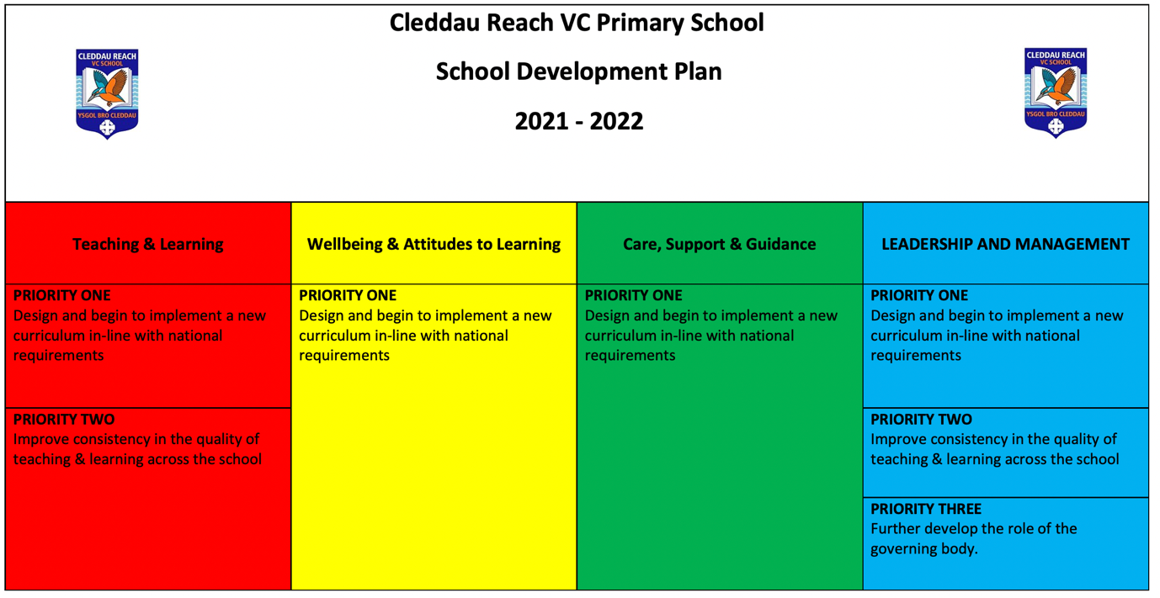

Appendix Four – Care, Support and Guidance section from School A’s development plan.


