

Ultrasonic Attenuation Coefficient Determination and Probability of Sizing Analysis

Student
Iriney Svilen Georgiev - 1900719
Course
MSc Motorcycle Engineering
Module
Structural Integrity & Materials Evaluation - ACEA7013
Lecturer
Peter Charlton
Date
January 2023

Abstract
This report discusses ultrasonic flaw detection experiments conducted on mild steel and cast-iron samples. A time-of-flight method was used to determine the attenuation coefficient values of the materials. The two different attenuation coefficient answers demonstrate the difference between wave propagation in different materials. In the second part of the report, a spreadsheet containing measurements of through-wall thickness taken as part of a larger study was analyzed. The sizing accuracy of the equipment and procedure, as well as the individual technicians involved, was evaluated using mean, standard error, standard deviation and linear regression analysis. For both tasks, possible solutions are also discussed in order to minimize uncertainties and achieve better results.

Apparatus
According to research conducted by R. Alam and M. Joy [1], an ultrasound flaw detection experiment typically involves the following apparatus:
- A pulser / receiver is an electronic device that generates high voltage electrical pulses that drive the transducer.
- A transducer, usually a piezoelectric crystal, that converts electrical signals into mechanical vibrations through the use of high frequency ultrasonic energy.
- An oscilloscope is an electronic test instrument that plots one or more signals graphically as a function of time to display varying electrical voltages.
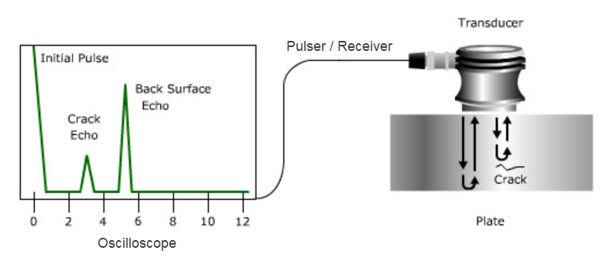
Figure 1: Ultrasonic flaw detection principle [1].

As shown in figure 1, some of the wave energy will be reflected back from the flaw surface when there is a discontinuity in the wave path, such as a crack. The transducer converts the reflected wave signal into an electrical signal and displays it on a screen. Information about the location, size, orientation and other properties of the reflector can often be derived from the signal. The ultrasound transducer is typically separated from the test object by a couplant, such as gel, oil or water in order to improve the transmission of ultrasound waves.

Contents
1 Introduction 1
2 Measurements and Graphs of Raw Measurements 1
3 Calculations and Error estimates 5
3.1 Attenuation Coefficient 5
3.2 Statistical Analysis 6
4 Results and Discussion 8
4.1 Attention Coefficient Determination 8
4.2 Through Wall Sizing Accuracy Analysis 10
5 Conclusion 13
References 14

Introduction
Nondestructive testing (NDT) is a group of analysis techniques used to evaluate the properties of a material without causing damage. The goal of NDT is to identify any defects or abnormalities that could compromise the integrity or performance of the system. It is used in a variety of industries including aerospace, automotive, manufacturing, petrochemical, power generation and transportation. Inaccurate or faulty NDT testing can lead to serious problems or disasters, such as structural failures, equipment malfunctions or safety hazards [2].
In this report, an ultrasonic experiment was conducted on two material samples: a mild steel rectangular block and an automotive cast-iron brake disc. The test used 1 ultrasonic, zero-degree, 5 MHz probe and applied time of flight methods to determine the material attenuation coefficient values for both samples. Ultrasonic testing is a common NDT method that involves the transmission of high-frequency sound waves through a material to detect internal flaws or measure material thickness. P. Gong et al. [3] stated that the attenuation coefficient is a measure of how much ultrasonic waves are absorbed or scattered as they pass through the material. This can provide valuable information about the structural integrity and performance of the two selected materials.
The second part of this experimental report involves the use of linear regression and statistical analysis techniques to evaluate the accuracy of sizing for individual technicians, as well as for the equipment and procedure as a whole. A spreadsheet containing 21 defect measurements obtained by 10 technicians using a newly developed procedure and equipment was provided as part of a larger study. The data was analyzed using linear regression and statistical analysis techniques to determine the accuracy of the measurements and to identify any potential sources of error. Ensuring the accuracy of NDT measurements was critical in ensuring the safety and reliability of materials.

Measurements and Graphs of Raw Measurements
Ultrasonic testing was conducted on a rectangular mild steel block and an automotive cast-iron brake disc using a single ultrasonic, zero-degree 5 MHz probe and an ultrasonic flaw detector.

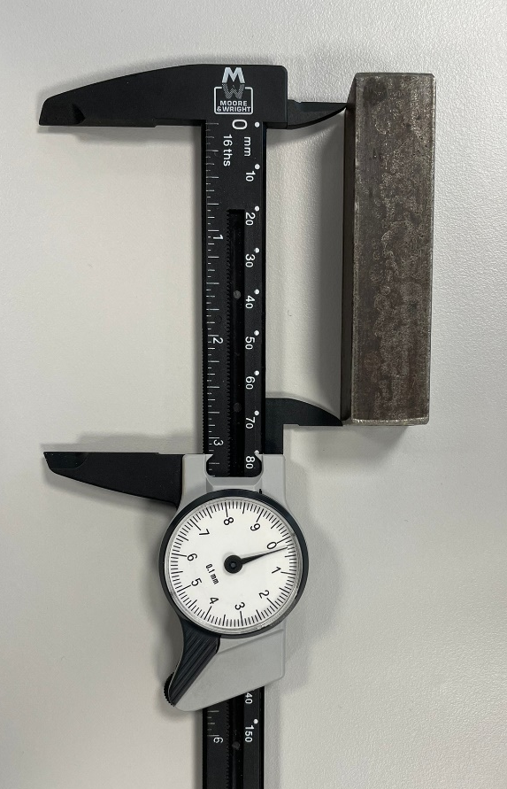
Figure 2: Length of mild steel rectangular block.

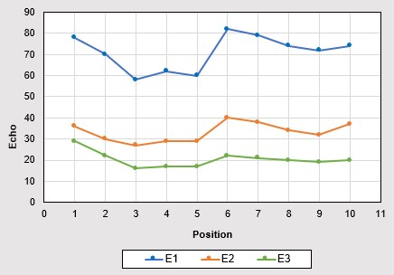
The steel block had a length of approximately 80 mm, as shown in figure 2. Both sides of the block were about 19 mm thick. Five different positions along the length of the rectangular piece were used to record the first, second and third echoes. On the adjacent side of the steel block, the experiment was performed again. The flaw detector was calibrated to an optimal gain of 36 to provide the best display of backwall echoes.
Figure 3: Echo 1, 2 and 3 of mild steel rectangular block.

The raw measurements obtained from the ultrasonic experiment were plotted on a graph to visualize the data as displayed in figure 3. The x-axis represents the different positions on the steel block, whereas the y-axis represents the amplitude of the propagating wave in dB. Three separate lines on the graph indicate the first, second and third echoes, respectively. Compared
to the rest of the data, the mechanical wave returns quicker in positions 3, 4 and 5. However, the difference is too small to be regarded as a defect. It is more likely that the material is a little thinner at this location.
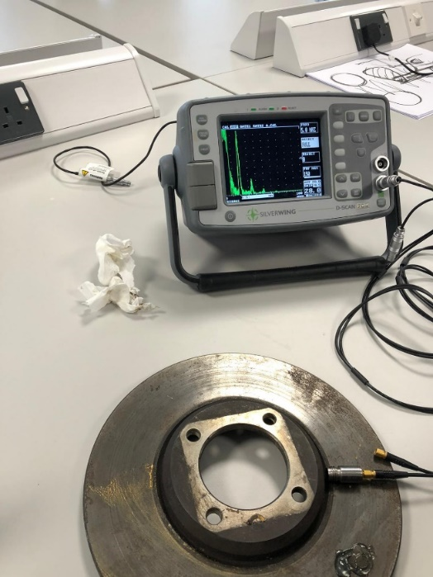
Figure 4: Ultrasonic testing on cast-iron brake disc.
.

Figure 4 depicts an ultrasonic test conducted on the friction surface of the brake disc. The component had a thickness of around 12.6 mm, as echoes were acquired from five different points. The mounting hub of the brake disc with a thickness of approximately 18.4 mm underwent the same measurement procedure.
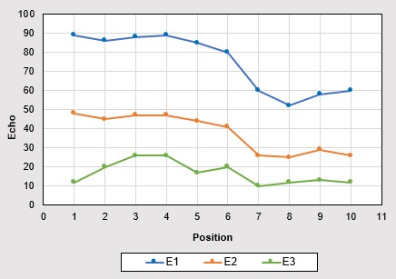
Figure 5: Echo 1, 2 and 3 of cast-iron brake disc.
.

Due to the different thicknesses of the tested sections as illustrated in figure 5, the echo amplitudes are significantly different between the first five measurements and the last five measurements. Based on the echo results in the first five positions, the selected component has an uneven wear pattern on its friction area. However, there is a noticeable difference between positions 6 and 10, especially at position 8, which indicates a potential defect around the mounting hub. The continuous environmental exposure to brake discs may cause rust to form, resulting in surface holes.
In general, the raw measurements indicated that the ultrasonic testing procedure was successful in detecting any potential flaws or imperfections in the rectangular block and brake disc. The echoes were clear and relatively consistent and no anomalies were observed. The results of the ultrasonic flaw detection experiment can be used to determine the integrity and quality of both components.
The second part of this report focuses on the use of statistical analysis techniques to analyze and interpret data to support informed decisions. A dataset with 21 defects measurements were gathered by 10 technicians with the objective of evaluating the accuracy of the technicians' sizing, the equipment and the overall procedure.
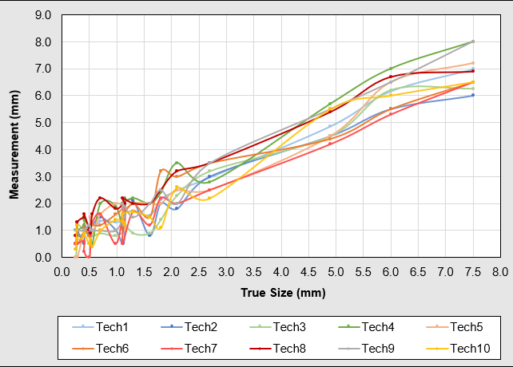
Figure 6: Technicians measurement against true size defects.

As displayed in figure 6, the technical gauging results are compared to the real defect size, where defects are sorted from smallest to largest. Observation shows that most technicians' results are off by roughly 1mm from the true defect size. All measurements show a similar trend without drastic errors. Accordingly, the results obtained from this new ultrasonic thickness gauging procedure can be analyzed in greater detail.

Calculations and Error estimates

Attenuation Coefficient
The first step in this study was to determine the attenuation coefficient of the two selected sample materials. According to G. Zhang et al. [4], the ultrasonic attenuation coefficient is a measure of the rate at which the intensity of an ultrasonic wave decreases as the wave travels through a material.

$$α=-\left(\frac{20}{d×4}\right)×\log_{10}\left(\frac{E3}{E1}\right) \text{Equation 1: Attenuation Coefficient [4].}$$

Insertion loss is determined by the voltage ratio between the echo amplitude and the emitted burst, expressed as a logarithm [4]. For equation 1, the insertion loss is divided by the distance traveled by the echo, resulting in the mean attenuation coefficient in bB/mm. Consequently, this equation was used to calculate the attenuation coefficient of both rectangular block and brake disc.
There are several sources of error in the measurements provided in the above section that could affect the accuracy of the calculation of the ultrasonic attenuation coefficient. A potential source of error could be the uncertainty in measuring the intensity of the ultrasonic wave before and after it passes through the material. This uncertainty may arise from the accuracy of the ultrasonic transducer or oscilloscope. Additionally, the accuracy of the thickness measurement tool may also contribute to errors. As an example, a plastic vernier caliper was used in this experiment, which is likely to exhibit some flex and hence inaccurate readings.

Statistical Analysis
Mean, linear regression, standard error and normal distribution are all important concepts in statistical analysis [5]. For second part of this study, these techniques were applied in order to assess uncertainty, make predictions and draw conclusions from data.
As explained by A. Schneider et al. [6], linear regression is a statistical method used to model the linear relationship between a dependent variable and one or more independent variables. It involves finding the line of best fit that minimizes the sum of the squared residuals between the observed responses in the dataset and the responses predicted by the line.

$$Y=b\text{0}+b\text{1}×x+b\text{2}×x^{2}+...+b\text{n}×x^{n} \text{Equation 2: Linear Regression [6].}$$

In equation 2, $b\text{0}$ represents the intercept, while $b\text{1}$, $b\text{2}$, ..., $b\text{n}$ represent the coefficients for the independent variables $x$, $x^{2}$, ..., $x^{n}$. Based on the least squares method, the coefficients are estimated by finding the line that minimizes the sum of squared differences between the observed and predicted responses. Since the experiment for the ultrasonic thickness gauging procedure was conducted by humans, there was a high likelihood of poor replication. Using equation 2 as a model, linear regression was applied in order to determine the mean performance of this innovative measuring technique.
Standard deviation refers to a measure of the spread of a distribution. Essentially, it measures how close the provided numbers are to the mean. When the standard deviation is large, the data is considered "diverse" or "distributed" [7].

$$σ=\sqrt{\frac{\sum{{\left(X-μ\right)}^{2}}}{n}} \text{Equation 3: Population Standard Deviation [7].}$$
$$σ=\sqrt{\frac{\sum{{\left(X-μ\right)}^{2}}}{n-1}} \text{Equation 4: Sample Standard Deviation [7].}$$

The main difference between equations 3 and 4 is that when calculating the standard deviation of a population, all data points are used, while for a sample, only a subset of data points is used. In both equations, $X$ represents each data point and $μ$ is the mean of the sample/population. In the data provided for the ultrasonic procedure, ten technicians were engaged to measure defects. As only a small sample of the population conducted this experiment, equation 4 was used to calculate the standard deviation.
Standard error is a measure of the variability or dispersion of a sample statistic from the true population parameter according to C. Andrade’s work [7]. It is often used to estimate sampling error in the event that a sample is drawn from a population.

$$SE=\frac{σ}{\sqrt{n}} \text{Equation 5: Standard Error [7].}$$

In equation 5, $σ$ is the standard deviation and $n$ is the sample size. A larger sample size implies a smaller standard error and hence a more accurate estimate. Using the standard error equation, confidence intervals were constructed for the second part of this report, which indicate the range of possible values for the true population parameter.
$$f(x)=\left(\frac{1}{\sqrt{2×π×σ^{2}}}\right)×e^{-\left(\frac{{\left(x-μ\right)}^{2}}{2×σ^{2}}\right)} \text{Equation 6: Normal Distribution [8].}$$

The normal distribution, also known as the Gaussian distribution, is a continuous probability distribution that is symmetrical around the mean [8]. The bell-shaped curve of the distribution is defined by its mean and standard deviation as shown by equation 6. The $e$ variable in the above equation is the Napier's constant which is equal to approximately 2.71828. According to P. Mishra et al. [8], approximately 68% of the data are within one standard deviation of the mean, approximately 95% are within two standard deviations and approximately 99.7% are within three standard deviations. The new ultrasonic gauging procedure was analyzed using equation 6 to predict the likelihood of certain events occurring within the normally distributed population.

Results and Discussion

Attention Coefficient Determination
As previously discussed, ultrasonic beams attenuate when passing through different media, similar to other forms of energy. The amount of ultrasonic energy lost through materials is influenced by two major factors as researched by B. Zoofan [9]. Firstly, the microstructural characteristics of the material, including grain sizes, their orientations, the presence of any impurities at grain boundaries, microporosity and previous heat treatment. Secondly, the characteristics of the ultrasonic beam, namely the frequency and the beam profile along its path of propagation.
Based on the raw measurements obtained in section 2 and equation 1 presented in section 3, the attenuation coefficients of the two selected components were calculated. As both experiments were conducted using the same equipment and under the same circumstances, the results from the attenuation coefficient can be used to identify the characteristics of the two materials.

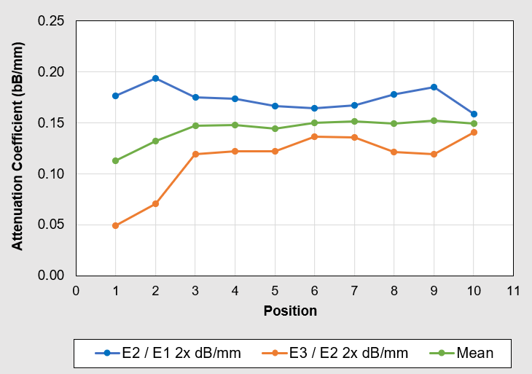
Figure 7: Attenuation coefficient of mild steel rectangular block.
Attenuation coefficients between backwall echoes 1-2 and 2-3 are presented in figure 7, as well as the mean value between them. There is evidently less energy loss between echoes 1-2 as compared to echoes 2-3. It is a result of the beam divergence that occurs in propagation of an ultrasonic beam inside a material as a result of the double distance law [9]. In figure 7, it can also be seen that the coefficients of attenuation for the first and second measurements differ significantly from the rest of the calculated parameters. Based by figure 3, where the third echo took longer to return, it was concluded that the material in this region was thicker and hence, more energy losses would be expected. Using the average attention coefficient from all 10 positions, it was determined that the attenuation coefficient of the rectangular mild steel block was 0.14 dB/mm. Y. Hwang et al. [10] investigated ultrasonic beam behavior in a dissimilar-metal weld utilizing one ultrasonic, zero-angle, 5MHz transducer.
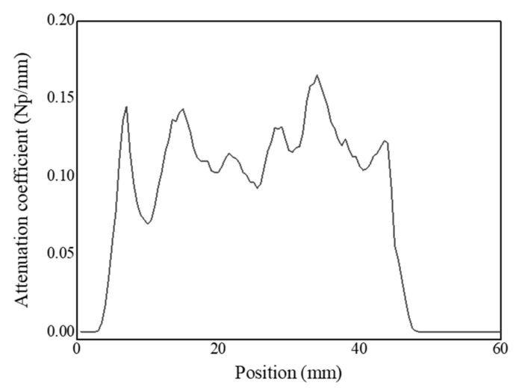
Figure 8: Attenuation coefficient of dissimilar-metal weld [10].

A rectangular block of 15 mm thickness and 50 mm length was used as a sample in study [10] where a weld was made between a carbon steel and stainless-steel piece. The modified grain structure around the weld, the sound speed and the thickness of the metal would differ slightly from those in this report and hence the attenuation coefficient [11]. According to figure 8, the attenuation coefficient of the stainless-steel portion of the block is approximately 0.12 dB/mm. The average attenuation coefficient of mild steel was calculated to be 0.14 dB/mm, which was deemed acceptable.
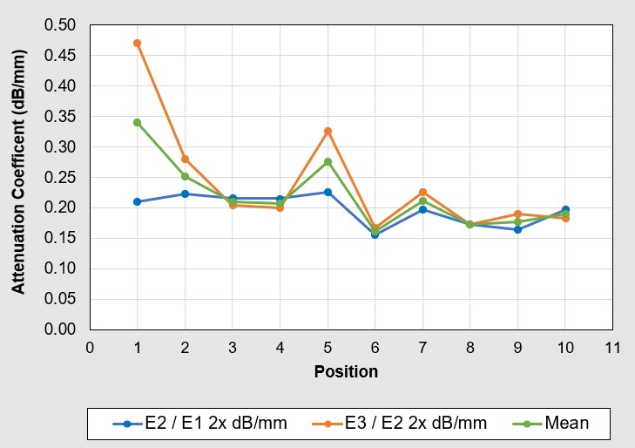
Figure 9: Attenuation coefficient of cast-iron brake disc.
In order to effectively record the echoes on the screen, the gain of the oscilloscope was changed at each position during the brake disc experiment. Figure 9 shows the attenuation coefficient of the cast-iron brake disc. The brake disc had some obvious wear on its surface, as previously noted in section 2 and this accounts for the inconsistency of the results shown in figure 9. It was estimated that the brake disc had a mean attenuation coefficient of 0.22 dB/mm.

Through Wall Sizing Accuracy Analysis
For the second task of this report, all relevant information was provided, so descriptive statistics were used to summarize and organize the characteristics of a data set. First, the mean measurement of each defect size was determined by averaging the measurements taken by the technicians. The 21 defect sizes were listed in order of smallest to largest.
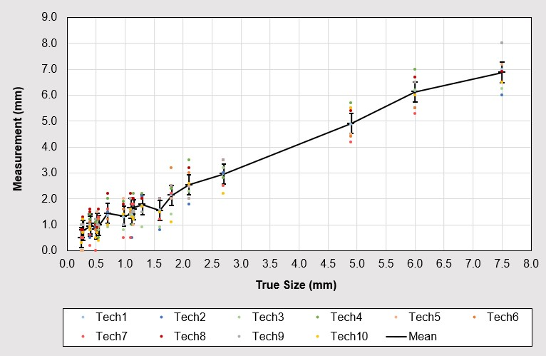
Figure 10: Technicians and mean measurements against true size defects.
Using equation 5, the standard error of the mean was calculated to determine how different the population mean is likely to be from a sample mean. Thus, if the ultrasonic gauging procedure were repeated with the same equipment but with different samples and technicians, the mean of the end results would fall within the error bars illustrated in figure 10.
A percentage was calculated based on the difference between the measurements obtained from the technicians and the actual defect sizes. Using the standard deviation formula from section 3, a normal distribution curve was plotted to determine how far the set of data was from the mean.
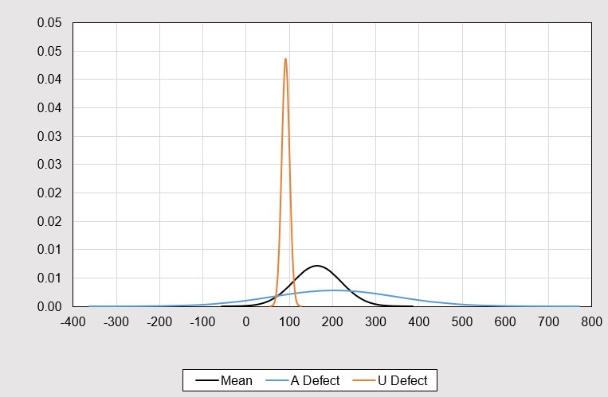
Figure 11: Normal distribution of error percentage difference.

Figure 11 shows that defect A, the smallest defect, is characterized by a broad spread curve with a low peak. The majority of technicians received results that were either far from the actual defect size or had not noticed it at all and there is a high probability that it will occur again. According to the comparison of defect A and U curves in figure 11, the larger the defect, the greater the chance that it will be noticed and accurately measured.
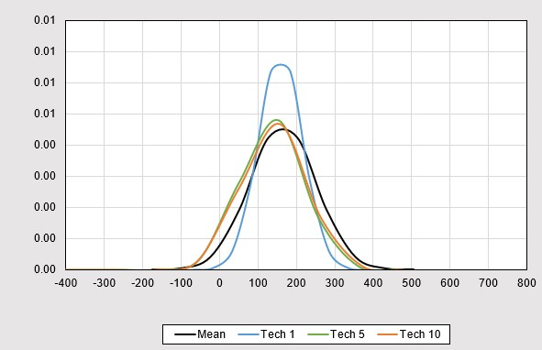
Figure 12: Normal distribution of technicians’ performance.

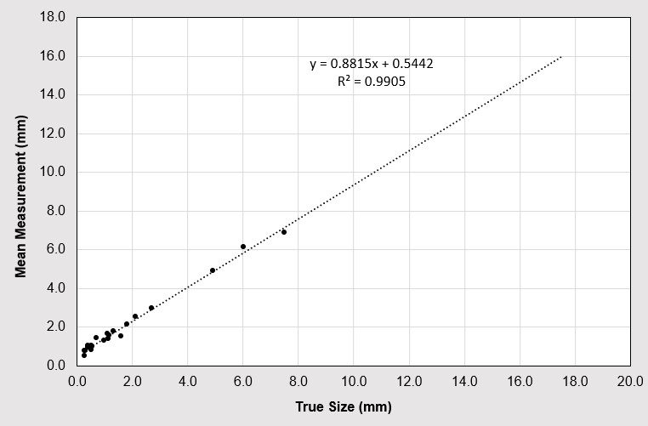
Similarly, the standard deviation calculation method was used to assess the performance of each technician. As shown in Figure 12, the potential of a sample of technicians in this experiment indicates that there is some human error involved. With practice, the mean of technicians' measurements can be improved to the point where the first technician performs measurements leading to more accurate results.
Figure 13: Linear regression of mean technicians’ measurements.
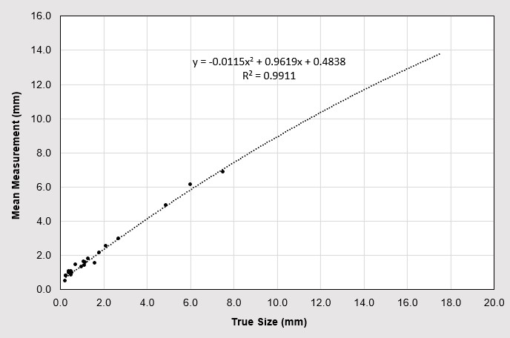
Figure 14: Polynomial regression of mean technician measurements.
Regression analysis was performed on the mean technician measurements of each defect in order to identify potential relationships between the dependent and independent variables. A linear regression and polynomial regression were conducted as shown in figures 13 and 14, following which the model was forecast with another ten potential defects. In comparison with linear regression, the polynomial follows the dataset more closely, allowing for more accurate predictions within these guidelines. The polynomial line, however, shows a decreasing trajectory curve, which means linear regression would be a better method of predicting future performance.

Conclusion
According to the results from the first part of the report, the attenuation coefficient of the mild steel rectangular block was 0.14 dB/mm and that of the brake disc was 0.22 dB/mm. The results were supported by an identical method but different material that was used to assess the attenuation coefficient. However, there is always room for improvement in any experimental method. For example, the experiment might involve the use of new materials to prevent surface imperfections, a larger sample size or a wider range of frequencies that would result in a higher degree of measurement accuracy.
A number of conclusions have been drawn based on the mean, standard error, standard deviation and linear regression analysis of the new ultrasonic gauging procedure experiment in part two of this report. The equipment used in the procedure had difficulty measuring defects smaller than 0.5 mm accurately. It was found that some technicians performed significantly better than others, with an estimated 80% chance of generating a 100% match with the actual defect size. In addition, the overall procedure was able to predict the measurement of defects with accuracy of approximately 95%. This procedure can be improved by calibrating the equipment regularly to ensure consistent performance and training technicians to improve consistency and accuracy.

References

[1] | R. Alam and M. I. J. Joy, "A REPORT ON INDUSTRIAL TRAINING IN CENTRE FOR RESEARCH REACTOR (CRR), INSTITUTE OF NUCLEAR SCIENCE and TECHNOLOGY(INST), NON-DESTRUCTIVE TESTING UNIT OF BANGLADESH ATOMIC ENERGY COMMISSION(BAEC), and SAJ ENGINEERING AND TRADING COMPANY, DHAKA," Military Institute of Science and Technology, 2022.
[2] | S. K. Dwivedi et al., "Advances and Researches on Non Destructive Testing: A Review," Elsevier, Bhopal, 2018.
[3] | P. Gong et al., "System-Independent Ultrasound Attenuation Coefficient Estimation Using Spectra Normalization," IEEE Trans Ultrason Ferroelectr Freq Control, 2019.
[4] | G. Zhang et al., "Investigation of frequency-dependent attenuation coefficients for multiple solids using a reliable pulse-echo ultrasonic measurement technique," Elsevier, 2021.
[5] | AQA, A2-Level Maths for AQA - Statistics 2, Coordination Group Publications, 2012.
[6] | A. Schneider et al., "Linear Regression Analysis," Dtsch Arztebl, 2010.
[7] | C. Andrade, "Understanding the Difference Between Standard Deviation and Standard Error of the Mean, and Knowing When to Use Which," Indian Psychiatric Society, vol. 42, no. 4, pp. 409-410, 2020.
[8] | P. Mishra et al., "Descriptive Statistics and Normality Tests for Statistical Data," Wolters Kluwer, 2019.
[9] | B. Zoofan, "Measuring the Attenuation Coefficient of Ultrasonic Beams in Materials," The American Society for Nondestructive Testing, 2017.
[10] | Y.-I. Hwang et al., "Propagation and Attenuation Characteristics of an Ultrasonic Beam in Dissimilar-Metal Welds," MDPI, 2020.
[11] | S. Wagner et al., "Modification of the grain structure of austenitic welds for improved," MPA Universität Stuttgart , 2012.

