Philip Bourke - 2027844@student.uwtsd.ac.uk
BMMB7026 Managing Marketing Change
The Changing Landscape of Marketing in Hospitality: A Personal Exploration and Application

Executive Summary

This report will provide a critical examination of emerging trends in marketing in the hospitality sector based on the authors research and observations.

It describes an experiment social media marketing campaign for a hospitality business in the west of Ireland, Clew Bay Hotel. Innovative marketing methods were utilised including using AI to create content, Influencer partnerships to create and promote User-Generated Content and Data Analytics.

Further analysis is conducted on emerging Marketing trends including; Artificial Intelligence and Technology, Data Driven Decision Making and leveraging Influencers to create User-Generated Content.

The report creates a case study analysing a hospitality brand, Hilton Hotels Group, with the focus on how they have adapted to emerging trends. Their success and challenges are listed for each one.

The author reflects on these analyses and insights how the lessons will impact his future career and marketing strategies. A conclusion is followed by a series of recommendations based on the findings in this report tailored for both smaller and larger scale businesses.

Table of Figures

Figure 1 Clew Bay Hotel, Westport 3
Figure 2 Clew Bay Hotel Logo 4
Figure 3 Influencer posts. 7
Figure 4 Promotional offer and music festival social media posts. 7
Figure 5 Hilton Hotel Group 9
Figure 6 Examples of Hilton Instagram posts with Influencers. 11
Figure 7 Hyatt VR Experience 14

Contents
Executive Summary 1
Table of Figures 1
1. Introduction 3
2. Personal Engagement - Marketing Campaign 3
2.1 Campaign Objectives 3
2.2 Critical Activities 4
2.2.1 Pre-Campaign Analysis and planning: 4
2.2.2 Content Creation: 5
2.2.3 Social Media Platforms: 5
2.2.4 Influencer Partnerships: 5
2.2.5 Promotional Campaigns: 5
2.2.6 Analytics and Reporting: 5
2.3 Campaign Goals and Expected Outcomes 6
2.4 Execution and Evaluation 6
2.5 Campaign Results 7
3. Emerging Marketing Trends 8
3.1 Artificial Intelligence and Technology: 8
3.2 Data Driven Decision Making: 8
3.3 Creating Authentic Content leveraging Influencer Marketing 9
4. Case Study Analysis - Hilton Hotel Group 9
4.1 AI and Technology: 10
4.2 Data-Driven Decision Making: 10
4.3 Creating Authentic Content via Influencer Marketing: 10
5. Reflection on Marketing Insights 11
5.1 Importance of Analytics and Data-Driven Decision Making 11
5.2 Value of High-Quality and User-Generated Content 12
5.3 Leveraging Social Media and Influencer Partnerships 12
5.4 Adapting to Emerging Technologies 12
5.5 Balancing Technology with Human Touch 12
6. Conclusions 12
7. Recommendations 13
7.1 Small to Medium-Sized Enterprises: 13
7.2 Large-Scale Enterprises: 13
References 15

Introduction
This report will provide a critical examination of emerging trends in marketing within the hospitality sector, in addition to my own experiences and observations.
To showcase that the analysis is relevant and practical, this report includes a short marketing experiment. It is a mini marketing campaign for a hospitality business. The campaign’s goals, objectives, and key activities are documented in this report with the achieved objectives.
I chose the marketing experiment as my personal engagement topic for several reasons including.
- Conducting my own research allows me to delve deeply into the topics on this module. I can explore the various sources, analyse data, and form my own conclusions.
- While interviews can provide valuable insights, I can learn more by researching multiple perspectives.

Personal Engagement - Marketing Campaign
This marketing campaign was designed for a medium sized hospitality business in the west of Ireland called the Clew Bay Hotel. They have a small marketing team who ran the campaign for a duration of 4 months from May to August 2023.
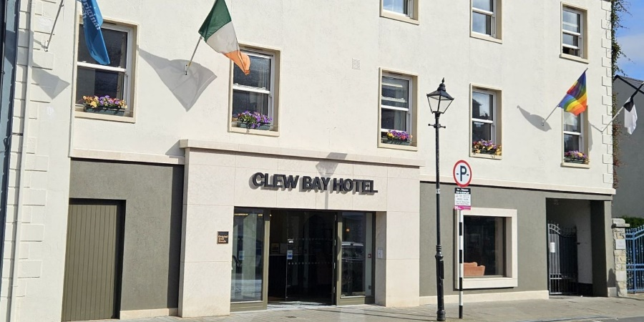
Figure 1 Clew Bay Hotel, Westport

2.1 Campaign Objectives
Increase brand awareness, drive bookings, and enhance customer engagement for the Clew Bay Hotel.
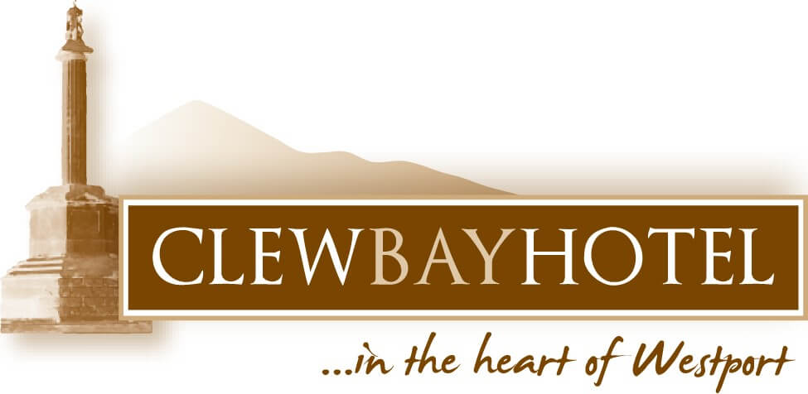
Figure 2 Clew Bay Hotel Logo

2.2 Critical Activities

2.2.1 Pre-Campaign Analysis and planning:
As stated by (Kotler, et al., 2019) “In any competitive activity, marketing managers need to research carefully the field of play and the strength of the competition”.
A SWOT was conducted to identify Clew Bay Hotel’s internal and external strengths, weaknesses, Opportunities and Threats. Good marketing according to (Kotler, et al., 2019) again, is the art of finding and profiting from opportunities. This led to further analysis conducted by Clew Bay Hotel on the internal and external data available to them relating to consumer behaviour and their competition. The marketing team also reviewed the external marketing environment conducting a PESTLE analysis to ensure their campaign aligned with the business strategy. No trends or issues were identified that may adversely impact their campaign strategy e.g. West of Ireland tourism figures had returned to pre COVID-19 pandemic levels.
The marketing mix was reviewed to ensure it was a successful campaign per (Kotler, et al., 2019):
- Product: The Campaign would differentiate its products, their quality, and customer services from other local competition highlighting it with quality content.
- Price: Analysis was performed on the market to determine the price customers would be willing to pay for staying at Clew Bay Hotel. It adjusted seasonally and by day of the week.
- Placement: The hotel’s own website, multiple travel booking sites like Booking.com and social media and review sites like Tripadvisor were leveraged to reach potential guests.
- Promotion: Quality visuals and User-Generated content would be used to showcase the Hotel. Social media and email marketing would be the primary methods to drive promotion.

2.2.2 Content Creation:
The rationale for investing in quality content was because visual content is highly engaging and essential for highlighting the appeal of the Clew Bay Hotel. User-Generated Content also builds authenticity and trust with consumers as noted by (Hochstein, et al., 2023).
- Visual Content: High-quality photos and videos were commissioned showcasing the hotel’s rooms, amenities, popular local attractions, and guest experiences as according to (Chambers, et al., 2020) “Content is King”.
- User-Generated Content: Hotel guests were encouraged to share their experiences on social media with a branded hashtag (#ClewBayHotel) and they featured these posts on social media pages. There are locations on the hotel grounds with beautiful scenic views and there is a hashtag sign available for customers to get photographs with for their own content creation.

2.2.3 Social Media Platforms:
The campaign will focus primarily on Instagram, YouTube and Facebook as these platforms are largest and better suited to visual storytelling and community building as identified by ( Sprout Social Inc., 2024), with TikTok also included to reach a younger demographic.

2.2.4 Influencer Partnerships:
The hotel will collaborate with travel and/or hospitality social media Influencers to stay at the hotel and share their experiences with their followers. Some Irish celebrities were engaged to visit the hotel and share content with their followers of their stay. Per (Okonkwo & Namkoisse, 2023) Influencers have a trusted voice and can significantly expand our reach to potential guests.

2.2.5 Promotional Campaigns:
Seasonal Offers: Promote special offers and packages tailored to holidays and local events. Mayo has several events that run over this period including traditional and folk music festival and a few fishing and sea angling festivals that attract global visitors.

2.2.6 Analytics and Reporting:
The team will track key metrics such as engagement rates, reach, impressions, and conversion rates. The results and insights generated by this will be used to refine strategies and improve future campaigns as data-driven decisions ensure the effectiveness of the campaign and help in achieving our goals. As noted by (Kotler, et al., 2019) if we do not track metrics “marketing and business plans are ineffective”.

2.3 Campaign Goals and Expected Outcomes
- Increase Clew Bay Hotel’s brand awareness: The goal is to achieve a 20% increase in social media followers delivering an outcome of greater visibility and in the market. (Bilgin, 2018) explains that social media marketing has a significant on brand awareness. Therefore, more followers will increase the Hotel’s brand awareness.3
- Drive more bookings and revenue: Deliver a 15% increase in direct bookings through social media channels. Higher occupancy rates will return increased revenue for the hotel.
- Enhance customer engagement: Boost the Hotel’s social media engagement rates such as likes, comments, shares by 20% to create stronger relationships with guests and potential customers.
- Promote User-Generated Content about Clew Bay Hotel: Collect and share at least ten items of User-Generated Content per month as User-Generated Content enhances authenticity and trust in the hotel’s brand. Clew Bay Hotel User-Generated Content can, according to (Ciasullo, et al., 2021), “foster loyalty of customers and influence future booking decisions”.
- Monitoring progress through the plan: There were regular reviews of progress against the goals and intended outcomes during the campaign to determine if corrective action was required to ensure the plan met its outcomes.

2.4 Execution and Evaluation
- Over the 4-month period of the plan, high-quality content was consistently posted on Instagram, TikTok and Facebook. Other platforms were also updated but not as frequently.
- Social Media Influencers, most of whom were micro-Influencers, were successfully engaged and shared User-Generated Content (as in Figure 3 below) about their stays and offers.

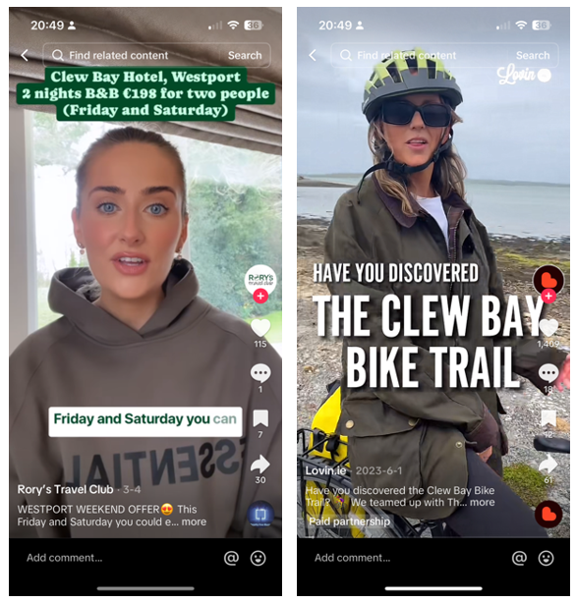
Figure 3 Influencer posts.

- Seasonal offers were promoted with free stays for couple or the family as the main prizes, attracting significant participation from the hotel’s social media followers.

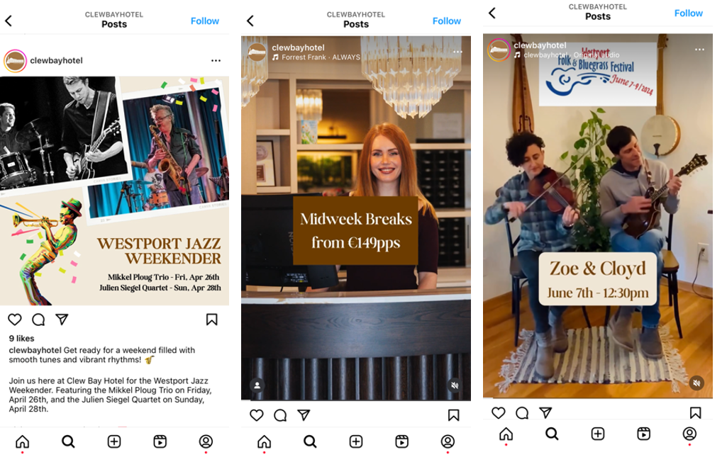
Figure 4 Promotional offer and music festival social media posts.

- The marketing team maintained active engagement with their followers and potential customers, and prompt responses were given to inquiries.

2.5 Campaign Results
- The campaign successfully boosted Clew Bay Hotel’s online presence and reputation. Their followers increased by 35% enlarging their brand’s awareness in the market and engagement rates rose by 30%.
- The increase in direct bookings and engagement metrics reflected positively on revenue and also on customer loyalty. It was noted that the increase in bookings was also supported by a summer with good weather.
- The positive response to User-Generated Content and influencer partnerships highlighted the hotel's appeal and trustworthiness to their followers and potential future customers.
As you can see above, the campaign met and exceeded its stated goals, demonstrating the effectiveness of a well-planned and executed social media strategy. Per (Kotler, et al., 2019) it addressed all 4P’s of the marketing mix; Product, Price, Placement and Promotion to achieve a successful market campaign.

Emerging Marketing Trends

3.1 Artificial Intelligence and Technology:
(Arya & Pal, 2023) highlights hospitality businesses are leveraging AI and other developing technologies to enhance a wide variety of customer services and guest experiences. These range from chatbots for personalized interactions such as check-ins and check-outs, to data analytics for informed decision-making, marketing technology plays a crucial role in hospitality businesses.
The marketing campaign conducted by Clew Bay Hotel leveraged online AI tools such as Canva.com in assisting with content creation and others like Lumen5.com to create video content quickly without the costly expertise required to create video content from scratch. These technologies are invaluable to marketing teams and driving down costs with improvements in efficiency gains per (Greenleaf, 2023). Their cost is relatively low, yet they are packed with features enabling teams to keep costs to a minimum while creating content to their requirements quickly and easily.

3.2 Data Driven Decision Making:
Per (Nkatekho, 2024) Data Analytics drives personalization. Understanding your guest preferences and behaviours helps hospitality businesses to tailor both their services and marketing activities effectively.
As noted by (Booking Success, 2024) the impact of this can be seen in a business’s bottom line. (Tufft, et al., 2024) also shows that Business’s data may provide additional value when combined with other sources of data enabling the creation of new revenue streams for hospitality businesses.
Clew Bay’s marketing team managed their data analysis requirements such as conversion analysis, segmentation, sentiment analysis and reporting with the online Brandwatch.com platform. This was essential for the marketing team to monitor and report on progress of their campaign, if they were meeting their goals, and make informed corrective actions when required.

3.3 Creating Authentic Content leveraging Influencer Marketing
(Sarin & Sharma, 2023) confirms that social media remains a powerful engine to build trust in a brand. Hotels are sharing genuine stories, connecting with audiences, and building brand loyalty. Influencer marketing is growing and (Foster, 2024) reports that every $1 spent on influencer marketing results in $6.50 in revenue and that Influencer marketing is now the fastest growing online marketing channel. The NEOREACH (2024) platform gives a case study showing five times Return on Investment.
The report from (Influencer Marketing Hub, 2024) shows Influencer marketing spend is continuing to grow quickly with an estimated $24 billion expected in 2024. However, Influencer Marketing is now primarily used to generate User-Generated Content rather than generate sales!
Clew Bay Hotel again used Brandwatch.com AI tools to identify the right Influencers to engage based on the data analysis of our target audience. As Brandwatch.com provided the data analysis solution also kept costs to a minimum. As the campaign ran over the summer, some Influencers took a complimentary stay for them and their family as payment, with others a mix of a stay and/or payment.

Case Study Analysis - Hilton Hotel Group
Hilton Hotels Group, a global hospitality brand with multiple subsidiaries (per Figure 5 below), has successfully navigated the dynamic marketing landscape by embracing emerging trends. In this case study, we explore how Hilton has capitalized on AI, data analytics, and influencer marketing to enhance guest experiences, drive brand awareness, and stay competitive.
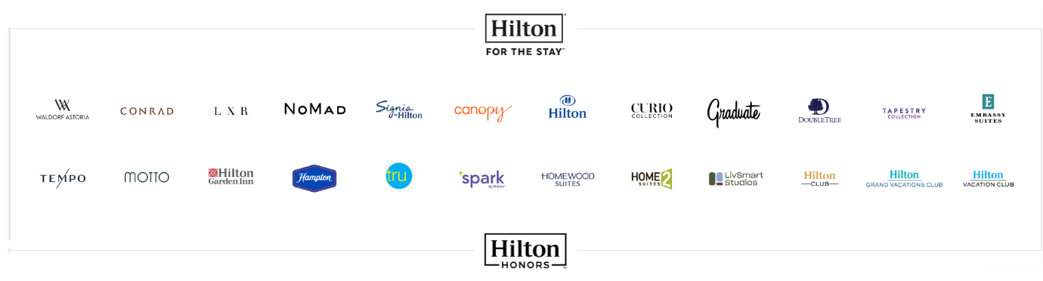
Figure 5 Hilton Hotel Group

4.1 AI and Technology:
- As can be seen in their 2024 Trends report (Hilton, 2024) Hilton has embraced technology to enhance guest experiences. They offer contactless check-in and check-out, digital keys and many other services which can be personalised to appeal to their different customer segments.
- Chatbots deal with routine queries quickly and consumers can seamlessly book everything they need online. (Fahy & Jobber, 2019) lists “responsiveness” as one of the core dimensions of service quality.
- AI algorithms create personalized recommendations based on guest preferences.
- Success: Hilton’s technology integration has improved convenience and efficiency for guests.
- Challenges: Balancing technology adoption without completely losing their personal touch can be a significant challenge and as stated by (Bowes, 2023) “Emotional engagement, personalized service, cultural sensitivity, language skills, problem-solving abilities, and flexibility offered by human staff are indispensable in providing exceptional guest experiences”. (Fahy & Jobber, 2019) also lists “empathy” as one of the core dimensions of service quality.

4.2 Data-Driven Decision Making:
- As noted by (hotelgrowers.com, 2024), Hilton uses data analytics with its rewards programs to personalize services and recognise guest needs.
- Leveraging its rewards program “Hilton Honors”, they analyse guest behaviour, booking patterns, and feedback to continually refine its product offerings.
- Success: Data-driven insights lead to better guest satisfaction and operational efficiency and per (Kusuma, et al., 2023) higher occupancy rates.
- Challenge: Ensuring data privacy has been an issue for Hilton Hotels with Hilton Holdings company suffering from a cyber breach with (Stempel, 2017) reporting Credit cards being stolen, and further breaches in the loyalty program in 2023.

4.3 Creating Authentic Content via Influencer Marketing:
- Hilton collaborates with Influencers to showcase authentic travel experiences, with credibility and trust being key to success per (Tabor, 2020).
- They leverage social media to engage audiences and highlight unique aspects of their properties.
- Hilton leverages User-Generated Content by encouraging their guests to share their experiences using branded Hilton hashtags, creating a sense of community.
- Success: Influencer partnerships create relatable content and per (Chambers, et al., 2020) drive traffic, grow customers and sales.
- Challenge: Maintaining authenticity while working with Influencers.

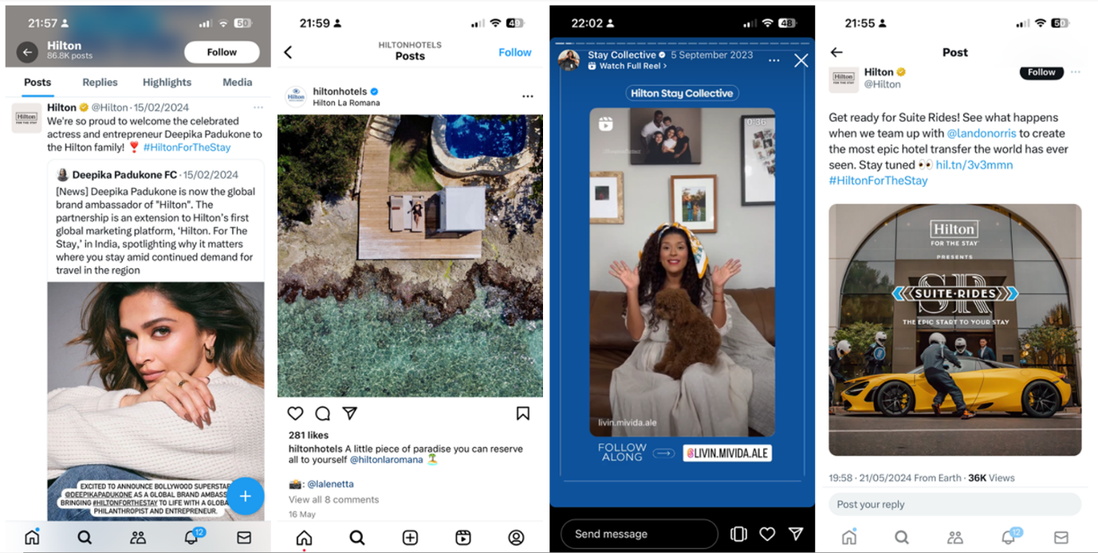
Figure 6 Examples of Hilton Instagram posts with Influencers.

Hilton Hotels Group’s strategic approach to AI, data analytics, and influencer marketing positions them as a leader in the hospitality industry. By addressing challenges and staying attuned to guest needs, Hilton continues to thrive in an ever-evolving marketing landscape.

Reflection on Marketing Insights
Analysing the Clew Bay Hotel marketing campaign has been insightful. It’s given me practical lessons that will stand to me in my career and in future marketing strategies. See some insights listed below I have gains from conducting this campaign experiment.

5.1 Importance of Analytics and Data-Driven Decision Making
The campaign highlighted the crucial role of data analytics. It's clear that being proficient in data analysis tools is essential in many walks of life these days, not just marketing. Moving forward, I will continue to prioritise developing strong analytical skills and using platforms like Brandwatch.com to create personalized and effective marketing strategies.

5.2 Value of High-Quality and User-Generated Content
The success of the campaign with high-quality visual and User-Generated Content shows just how important engaging and authentic material is. I’ve learned that focusing on producing visually appealing and relatable content, while also encouraging user participation, is key to successful marketing. Hilton Hotel Group are also extremely strong in this area.

5.3 Leveraging Social Media and Influencer Partnerships
The strategic use of social media and Influencer partnerships demonstrates their effectiveness in reaching target audiences. Understanding the demographics and reach of various social media platforms and knowing how to engage the right Influencers will be integral to my future strategies. Again, I will prioritise knowing the right tools to leverage for this.

5.4 Adapting to Emerging Technologies
The use of AI tools like Midjourney, Canva and Lumen5 for content creation showed me how technology can streamline content processes and reduce campaign costs. Staying updated on AI technological advancements and seeking innovative tools will be crucial for maintaining a competitive edge.

5.5 Balancing Technology with Human Touch
The Hilton Hotel Group case study above highlights the challenge of balancing technology adoption with maintaining a personal touch. The Clew Bay Hotel team ensured they were responding to queries promptly and were active in their engagement with potential customers. From this, I learned the importance of ensuring that technological solutions enhance rather than replace human interactions, which is essential for customer satisfaction and loyalty.

Conclusions
Reflecting on the campaign experiment it has provided me with insights that include various contemporary marketing practices that drive business growth, foster customer engagement, strengthen Brand equity in addition to underscoring the importance of adapting to evolving trends and technology.

As I continue to move forward in my career, these lessons will undoubtably guide me in developing innovative and effective marketing strategies, that achieve my business’s goals, and foster strong customer relationships.

Recommendations
Based on the insights from the Clew Bay Hotel marketing campaign, the Hilton Hotel Group Case study and broader research, here are tailored recommendations for innovative marketing approaches across different scales of business.

7.1 Small to Medium-Sized Enterprises:
- Micro-Influencer Collaborations: Small to Medium Enterprises (SMEs) can partner with local Influencers or if budgets are tight and business can find the right micro-Influencers who align with the brand’s values, have been shown by (Yanti & Sulhan, 2023) to have positive brand impacts and assist hospitality brands achieve their marketing goals. As covered earlier in the report this approach this value for money approach not only enhances authenticity but also ensures relevance to niche markets.

- Encourage User-Generated Content Reviews: SMEs can launch campaigns encouraging customers to share their reviews and experiences on review sites and social media. (An, et al., 2020) shows that reviewers post more photos in higher service hotels and post more content when they enjoy their stay. However, SMEs must ensure transparency and ethical guidelines are met in these campaigns, particularly respecting user privacy and creator’s intellectual property rights.

- Community Engagement Initiatives: SMEs can invest in community-focused initiatives that demonstrate their corporate social responsibility strategies. Supporting local causes, participating in community events, and communicating these efforts clearly to build trust and loyalty among their customers while per (Camilleri, 2021) add value to their business.

7.2 Large-Scale Enterprises:
- AI-Driven Personalization: Large Scale Enterprises (LSEs) can implement AI-powered tools to analyse big data and deliver personalized experiences at scale. Again, and per (Josifovski, 2023) LSEs must ensure transparency in data usage and provide customers with control over their personal information to uphold ethical standards in data privacy.

- Virtual Reality Experiences: LSEs, like Hyatt Hotels (Figure 7 below), have developed immersive VR tours that offer realistic and transparent representations of their properties, products, and amenities. (Bettencourt, 2023) shows Hyatt also use it to attract prospective employees by showcasing what working in the Hyatt might involve.

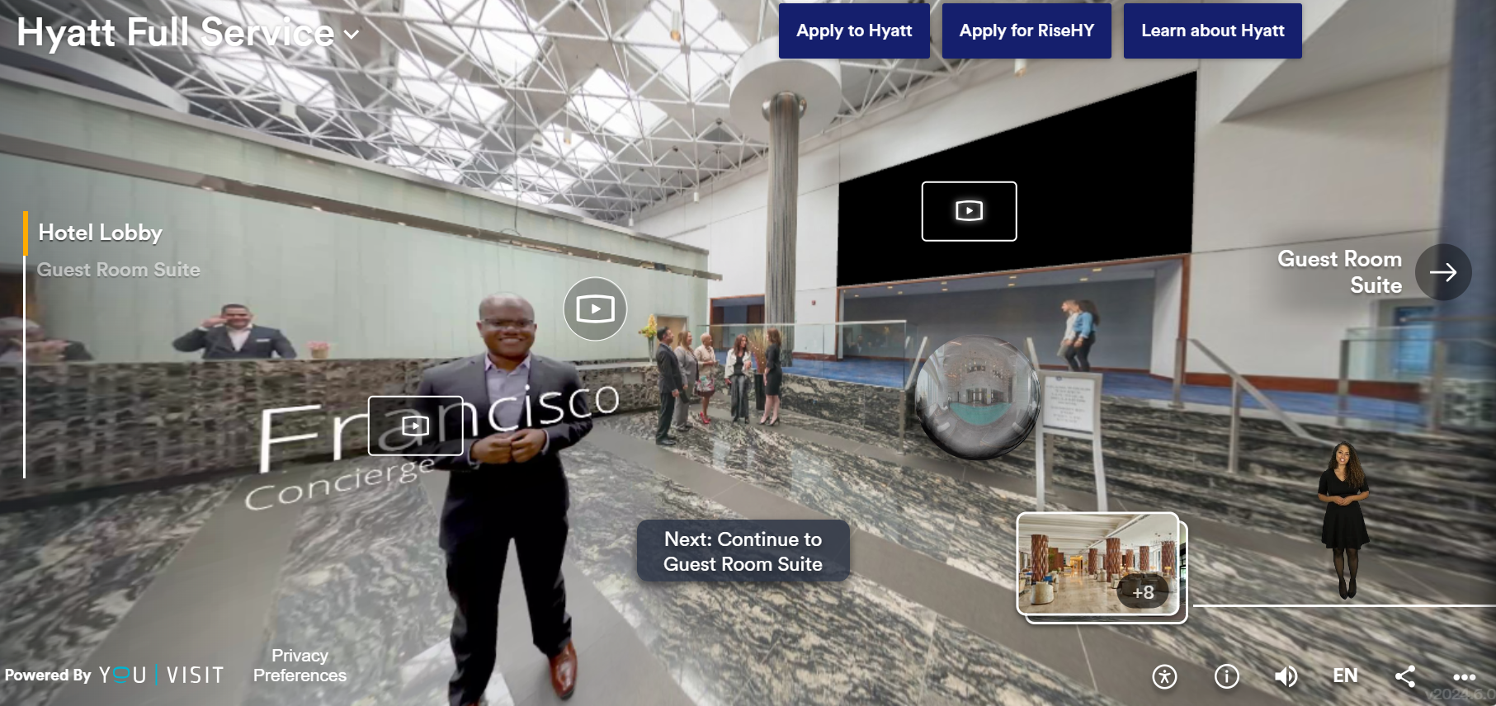
Figure 7 Hyatt VR Experience

- Sustainability as a Marketing Priority: LSEs can integrate sustainability into brand messaging and operations, emphasizing environmental stewardship and ethical business practices as marketing is shown by (Kepmer & Ballantine, 2019) to have positive impacts on product and promotion of consumption, both of which impacts environmental and social conditions.

References
An, Q. et al., 2020. Role of user-generated photos in online hotel reviews: An analytical approach. Journal of Hospitality and Tourism Management, 45(1), pp. 633-640.
Arya, V. K. & Pal, K., 2023. Reshaping the Hospitality Industry by the adoption of Robotics, Artificial intelligence and Service automation (RAISA). In: D. R. K. Saran, M. Khiria & S. Thori, eds. Bridging Boundaries Exploring Interdisciplinary Research. Singapore: Notion Press, pp. 90-106.
Bettencourt, J., 2023. How the hospitality industry is using AR, VR for the guest experience. [Online]
Available at: https://www.hotelmanagement.net/tech/how-hospitality-industry-using-ar-vr-guest-experience
[Accessed 4 July 2024].
Bilgin, Y., 2018. THE EFFECT OF SOCIAL MEDIA MARKETING ACTIVITIES ON BRAND AWARENESS, BRAND IMAGE AND BRAND LOYALTY. Business & Management Studies: An International Journal, 6(1), pp. 128-148.
Booking Success, 2024. How to Use Data Analytics to Improve Hotel Revenue Management. [Online]
Available at: https://www.linkedin.com/pulse/how-use-data-analytics-improve-hotel-revenue-management-wjjrc/
[Accessed 4 July 2024].
Bowes, J., 2023. The Human Touch: Why Hotels Need to Take a Step Back from Robots and Prioritize Personal Interaction. [Online]
Available at: https://upkeeply.medium.com/the-human-touch-why-hotels-need-to-take-a-step-back-from-robots-and-prioritize-personal-15507de1ec0a
[Accessed 4 July 2024].
Camilleri, M. A., 2021. Corporate sustainability and stakeholder management in tourism and hospitality. Sustainable Development, 30(12), pp. 1-2.
Chambers, L., Morehead, J. & Sallee, H., 2020. Make Your Business Social : Engage Your Customers with Social Media. 1st ed. New York: Business Expert Press.
Ciasullo, M. V., Montera, R. & Palumbo, R., 2021. Online content responsiveness strategies in the hospitality context: exploratory insights and a research agenda. The Total Quality Management Journal, 19 January, ahead of print(ahead of print), p. ahead of print.
Fahy, J. & Jobber, D., 2019. Foundations of Marketing. 6th ed. London: McGraw-Hill.
Foster, J., 2024. Why Influencer Marketing is Creating Huge Returns for Businesses. [Online]
Available at: https://www.convinceandconvert.com/influencer-marketing/influencer-marketing-for-businesses/
[Accessed 4 July 2024].
Greenleaf, J., 2023. Marketing Strategies and Content Creation: Generative AI’s Role. [Online]
Available at: https://www.ndash.com/blog/marketing-strategies-and-content-creation-generative-ais-role
[Accessed 4 July 2024].
Hilton, 2024. Travelers Will Value Connectivity and Personalization. [Online]
Available at: https://stories.hilton.com/2024trends-connectivity-personalization
[Accessed 4 July 2024].
Hochstein, R. E., Harmeling, C. M. & Perko, T., 2023. Towards a theory of consumer digital trust: Meta-analytic evidence of its role in the effectiveness of user-generated content. Journal of the Academy of Marketing Science, 0(0), pp. 1-21.
hotelgrowers.com, 2024. The Blueprint of Excellence: Decoding Hilton Hotels’ Marketing Strategy. [Online]
Available at: https://hotelgrowers.com/the-blueprint-of-excellence-decoding-hilton-hotels-marketing-strategy/
[Accessed 4 July 2024].
Influencer Marketing Hub, 2024. The State of Influencer Marketing 2024: Benchmark Report. [Online]
Available at: https://influencermarketinghub.com/influencer-marketing-benchmark-report/
[Accessed 4 July 2024].
Josifovski, V., 2023. The Future Of AI-Powered Personalization: The Potential Of Choices. [Online]
Available at: https://www.forbes.com/sites/forbestechcouncil/2023/07/03/the-future-of-ai-powered-personalization-the-potential-of-choices/
[Accessed 4 July 2024].
Kepmer, J. A. & Ballantine, P., 2019. What do we mean by sustainability marketing?. Journal of Marketing Management, 35(10), pp. 1-33.
Kotler, P. et al., 2019. Marketing Management. 4th European ed. Harlow: Pearson.
Kusuma, D. K. et al., 2023. Implementation of Digital Marketing in Increasing Room Occupancy Rate at Hilton Bali Resort Hotel. International Journal of Glocal Tourism, 4(1), pp. 1-10.
NEOREACH, 2024. How FanDuel achieved a 5:1 ROI with NeoReach.. [Online]
Available at: https://neoreach.com/case-studies/fanduel/
[Accessed 4 July 2024].
Nkatekho, A., 2024. Leveraging Big Data Analytics for Personalized Marketing Strategies in the Hospitality Sector. Journal of Modern Hospitality, 3(1), pp. 15-26.
Okonkwo, I. & Namkoisse, E., 2023. The Role of Influencer Marketing in Building Authentic Brand Relationships Online. Journal of Digital Marketing and Communications, 3(2), pp. 91-90.
Sarin, N. & Sharma, P., 2023. Influence of Social Media Marketing on Brand Consciousness, Brand Trust and Purchase Intention with Reference to Fast Fashion Industry. IUP Journal of Marketing, 22(1), pp. 31-54.
Sprout Social Inc., 2024. 50+ Must-know social media marketing statistics for 2024. [Online]
Available at: https://sproutsocial.com/insights/social-media-statistics/
[Accessed 4 July 2024].
Stempel, J., 2017. Hilton to pay $700,000 over credit card data breaches. [Online]
Available at: https://www.reuters.com/article/us-hilton-wrldwide-settlement/hilton-to-pay-700000-over-credit-card-data-breaches-idUSKBN1D02L3/
[Accessed 4 July 2024].
Tabor, E., 2020. Credibility And Trust Are Key To Authentic Influencer Marketing. [Online]
Available at: https://www.forbes.com/sites/forbesagencycouncil/2020/04/08/credibility-and-trust-are-key-to-authentic-influencer-marketing/
[Accessed 4 July 2024].
Tufft, C., Constantin, M., Pacca, M. & Mann, R., 2024. Six trends shaping new business models in tourism and hospitality. [Online]
Available at: https://www.mckinsey.com/industries/travel-logistics-and-infrastructure/our-insights/six-trends-shaping-new-business-models-in-tourism-and-hospitality
[Accessed 4 July 2024].
Yanti, P. D. A. & Sulhan, M., 2023. Tiktok Micro Influencer as a New Communication Marketing Tactic in Building Brand Equity. International Journal of Social Science and Business, 7(4), pp. 1004-1011.

