Cover Page
Name
Delwar Hussain
Student Number
1813780
Lecturer
Yohan Medis
Module
Effective Team working and communications
Submission Date
09th August 2019
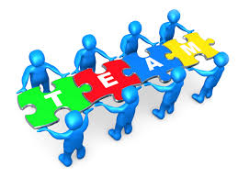
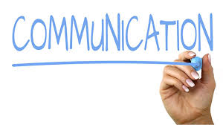

Executive Summary

The challenge
In today’s modern world, every product, big or small, faces stiff competition and having the well trained who can provide the best customer service and with the knowledge of their products gives a big advantage. Your brand is more than just a logo or corporate identity, and it starts from within. If your own people don’t know their own company’s story, customers almost certainly won’t either.
You need to motivate your people to get the best out of them, and in order to do this, you must cultivate a working environment whereby each employee feels valued and is immersed in the story and culture of the company.

The diagram below shows Sarah’s Business structure
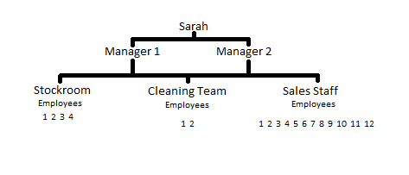
Source: Author
Recommendations
It is recommended Sarah should arrange monthly open team meeting giving the opportunity for the staff members to put forward ways they can improve the service and the way the company is run. Making them feel that they play a role in the success of the company. Encourage staff to leave feedback. Management need to make sure that all members of staff are kept up-to date with all changes where they are part-time full time or evening workers.
Make sure shift Rotas are easy accessible by all members of staff. Health and safe tips and techniques should be given to Staff through training or be easily accessible. Increase transparency to staff in regards to roll and responsibility they have.
It is recommended training of staff on a continuous basis will play a vital part in the improvement of communication within the company. Presentation, roll playing will help staff on the improvements and gain confidence.
It is recommended that Sarah to take on the diagonal approach of communication as her business has only three tiers herself 2 managers and the staff. She should be able to approach staff directly vice versa and discuss things without going through the managers in turn not undermining the managers.
It is recommended that Sarah try to make the atmosphere at work as warm and welcoming as possible but not be gullible. Motivate staff with incentives. Have a suggestion box for the staff giving them opportunities to express concerns anonymously.
Action Plan
It is recommended that Sarah does a 5 weeks action plan and review the progress.
 | Week 1 | Week 2 | Week 3 | Week 4 | Week 5
Staff | Communication between staff | Product know how | Customer relations | Employee awareness | Health and safety
Management | Managing staff motivation techniques | Health and safety | Customer relations | Product know now

Table of Contents
Executive Summary 2
The challenge 2
Recommendations 2
Action Plan 3
Introduction 5
Importance of Effective communication 5
Types of Communication 7
Two way communication 8
Communication within an organisation 12
References 14

Introduction

What is communication?
The definition of Communication is the act of transmitting information, for example you would exchange information by speaking, writing or by the use of other mediums emails, television, presentations etc.
In this assignment I will be writing a report to advise Sarah on ways she can improve team working and communication within her business. I will explain the advantages communications and how it will improve and maintain the smooth running of the business.

Importance of Effective communication

For any business or organisations to be successful the key is effective communication and the continuous interaction with management, employees and the clients. Having effective communication ensures that the information flows fluently between the parties involved reducing any chances of misunderstanding.
There are many forms of communication within an organisation that they communicate through Oral or Written forms of communication via email, intranet, internal telephone, networks and face to face.
Good communication needs to come top down. Management should have the right attitudes in the way they communication direct employees. A survey of 46 CEOs/ Senior Leaders in the UK Marketing Society (2013), shows essential leadership skills for senior management:
- A clear sense of direction: Making sure they know what the target is and how to get there and the effects it will have.
- Inviting customer into the boardroom: Inviting customers into the boardroom give the customer a sense of belonging and shows them that they are important to the business.
- Clear communication – both internally and externally: Make the instructions are given are clear and to the point so misunderstandings can be voided.
- Be flexible but not soft: be lenient but not careless with communication.
- Taking risks but do not ‘gambling’ the company: Take risk in decision making but don’t do anything that will have a negative impact on the business.
- Building the team: building a team requires trust, good leadership and good communication skills where you need to listen to staff.
- Listening with humility, acting with courage: Be companionate listen to needs and requirement.
- Trust building and Earning your reward: building trust between the work force is very important because it have direct links to productivity and
Communication is a key skill and a basic function required by management to be effective.
The diagram below shows the process that shanon and weaver (shanon and Weaver 1949) introduced their model of cammunication. Their model is consisting of five elements as shown of the diagram below.cited (Oxfordreferencing 2019)
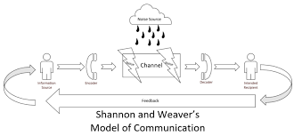
Sender
The source where the message is produced
Encoder/Transmitter
The sender’s messages converted into signals like waves or Binary data
Channel
The signal becomes compactable to transmit the messages through cables or satellites. For example: In telephone the voice is converted into wave signals and it transmits through cables

Decoder
This is where the message is received and reversed back from a signal to a message.

Destination
This is where the message arrives.
There is a sixth element which is Noise this a dysfunctional element its active when there is interference. During this process the messages may be distracted or affected by physical noise like horn sounds, thunder and crowd noise or encoded signals may distract in the channel during the transmission process which affect the communication flow or the receiver may not receive the correct message.

Types of Communication
There are many way to communicate the main 4 types are:
Verbal
Verbal communication is when you use language to speak or via sign language, this is the most common way of communication. Verbal communication is often used for meetings or during presentations or one-on-one conversation.
Nonverbal
Nonverbal communication is when you use body language, facial expressions and gestures to communicate with others. It can be used both intentionally and unintentionally. For example, you might smile unintentionally when you hear a pleasing or enjoyable idea or piece of information. Nonverbal communication is helpful when trying to understand others’ thoughts and feelings.
Written
Written communication is when writing, typing or printing symbols like letters and numbers to convey information. Writing is commonly used to share information through letters, memos, books, leaflets, blogs and more. Emails and chats are a common form of written communication in the workplace.
Visual
Visual communication are things like photographs, drawings, art, charts, graphs and sketches to relay information. They are often used during presentations to provide helpful context alongside written and/or verbal communication.

Two way communication

What is two way communication?
The definition of 2 way communication is information flow between sender and receiver and vice versa. In simple terms it means when you communicate with a customer via phone, text email etc.… the sender and receiver do not have to be present in one place when they send the messages so long as they are using the same platform while they are communicating.
Benefits of two-way communication

- It creates an environment which is more democratic (everyone treated equally).
- Everyone can share ideas and opinions and thoughts regardless of position within the company.
- Improves the staff relationship across the Hierarchy.

The two-way communication process will help solve problems better. It will give everyone a better understanding the business and create better working relations throughout the company by ensuring everyone is involved with the business updates, objectives, and progress.
There are many ways to effectively communicating in the workplace but not everything works or is variable to every organisation.
Open meetings
Allowing all members of staff to participate in meetings about the future of the organisation and make them feel that they have a belonging and have a say. For example staff could get recognition for their work achievements and complements received from customers.

Emails/ internal messaging systems
Communication via email or messaging system is potent as it allows you to pass messages to member of staff without taking them away from the work station. For example if someone in the business wanted to take a day off instead of going around asking everyone one by one he or she can email everyone at once. Example show errors that could be made on sending emails.
Email1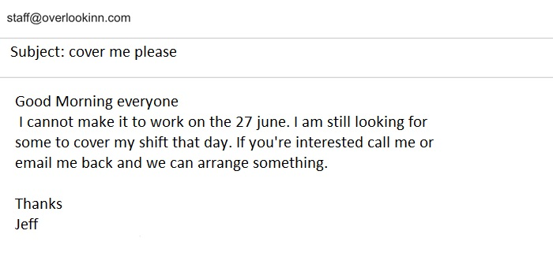
Email 2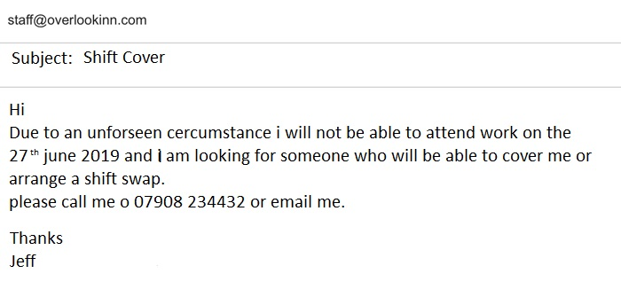
Source: Author
Email 1 is very unprofessional and has many grammatical errors no contact details
Email 2 much more professional and has contact details

Create a welcoming environment
To create an atmosphere where staff don’t feel uneasy to approach management level and discuss ideas and ways to improve growth for the organisation.

Simplicity in the way of communication
Everyone has a different level of understanding therefore to be effective in communication to staff use simple words and be precise to the point so they can understand, saving time and productivity is not affected.
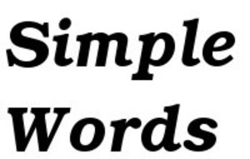
Confidence and seriousness
Making sure that confidence and seriousness in all communication is shown so that staff understand that they cannot take you for granted. If staff notice that you are communicating with uncertainty and lack of seriousness then they will most likely disregard the information.
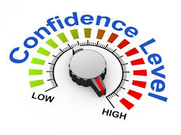
Listen to team members
Communicating with team members should be a two way conversation so listen to them and encourage them to give opinions and take part in the growth of the business.


Use visual and Presentations
Most people understand messages better if pictures and sounds are used. So using visuals and doing presentations give the staff the opportunity to refer back to things they didn’t understand or forgot.

Encourage Feedback
Don’t just talk away give the team members the chance to ask questions and give feedback on their understanding in ways improvements can be made.


Communication within an organisation

The communication within an organisation works in three different ways Vertical, Horizontal and Diagonal.
Vertical Communication
This type of communication is known as downwards and upwards communication meaning orders from heist level get sent down to lowest level and vice versa requests or feedback get sent upward. This type of communication is the oldest and still used widely.
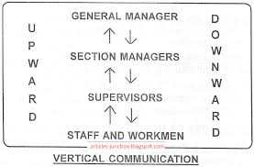

Source: Articles Junction

Horizontal Communication
This type of communications is when information is share between different departments of an organisation on the same level in the hierarchy.it has advantages and disadvantages such as the staff will feel comfortable to talk to other departments on the same level to gain from their learning.

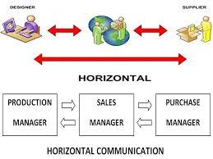 Source: Articles Junction

Diagonal Communication
This type of communication is between two people who work in the same organisation but from different departments and from different levels in the hierarchy. Example manager from the sales speaking to technician in IT to sort an issue with the system.
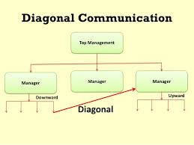 Source: Lumen Learning

References

Simpson, R.L., 1959. Vertical and horizontal communication in formal organizations. Administrative Science Quarterly, pp.188-196. Available at: https://www.jstor.org/stable/2390677?seq=1#page_scan_tab_contents (Accessed date 23nd July 2019)
Problem solving and decision available at:https://www.humorthatworks.com/learning/5-steps-of-problem-solving/ (Accessed date 23rd July 2019)
Importance of communication with an organisation. Available at: https://www.poppulo.com/blog/importance-of-communication-in-an-organization/ (Accessed on the 27th July 2019)
Survay on CEO Available at: https://www.researchgate.net/publication/304626602_The_Importance_of_Communication_for_Organisational_Effectiveness (Accessed date 22nd July 2019)
Types of communication available at:https://www.indeed.com/career-advice/career-development/types-of-communication (Accessed on the 28th July 2019)
Effective communication methods, Available at: https://www.educba.com/different-methods-of-communication/ (Accessed date 20th July 2019)
(Shannon and weaver 1949). Available at: https://www.oxfordreference.com/view/10.1093/oi/authority.20110803100459436 (Accessed date 4th August 2019)
(Shannon and weaver 1949). Available at: https://www.communicationtheory.org/shannon-and-weaver-model-of-communication/ (Accessed date 4th August 2019)

