Introducing the Modern Workplace: Case Study of Primark

(2,102 words)

Table of Contents

Executive Summary 3
Introduction 4
Organisational Structure, Culture and Performance 4
Factors influencing Individual Behaviour in the Workplace 8
Conclusion 9
References 11
Appendix 1: Primark’s Global Network 13
Appendix 2: Designing Organisational Structure 14
Appendix 3: Ideal Types of Organisational Culture 15
Appendix 4: The Managerial Grid 16

Executive Summary
In a rapidly changing business environment, it has become necessary to understand how management and leadership can be synchronised such that individual employees can be inspired to become more productive and diligent. However, from a behavioural perspective, it is necessary to understand the factors that play direct or indirect role in determining an employee’s individual preferences. The present report has been developed along two trajectories. Firstly, it explores how organisational structure and culture can influence organisational performances. Secondly, it scrutinises how different factors influence individual behaviour at the workplace. The report focuses on Primark, an Ireland-based fashion retailer.
The first part of the report covers the introduction and background to the research. In the second part, the impact of organisational structure and culture on organisational performance has been briefly discussed. Relevant analysis regarding the specifically chosen organisation, Primark, is also done. In the third part, the different factors that might influence individual behaviour at the workplace, including motivation and leadership, are explained and the situation of Primark is also discussed in this regard.

Introduction
In today’s rapidly changing workplace environments, it is impossible for an organisation to progress if it does not focus on its management principles and leadership style. This report aims to review modern workplace standards in the light of effective management and leadership with reference to the case study of Primark, which is a fashion retail chain headquartered in Dublin (where it is called Penneys) (Primark, 2021a). It is also a subsidiary of AFB which is a British food processing and retailing firm (Primark, 2021a; 2021b). Primark’s main operations are in Europe and the United States and the company offers a miscellaneous range of products like menswear, womenswear, accessories, clothing for children, and a lot more. Its main unique selling proposition (USP) is that it sells these products at relatively inexpensive rates (Primark, 2021a; 2021c). The vastness of Primark’s operations is shown in Appendix 1.
The rest of the report is divided into two main sections that address the following questions:
- How can organisational structure and culture influence organisational performance?
- Based on the behavioural approach, what are the most important factors that influence individual behaviour at the workplace?

Organisational Structure, Culture and Performance
To coherently analyse the relationship among organisational structure and culture on one hand and organisational performance on the other, it is necessary to first define these concepts before discussing how they relate to each other and how they work within the Primark context.
First, organisational structure refers to the pattern of relationships within the workplace and how people are arranged relative to each other in the organisation (Craig and Campbell, 2012). The organisational structure is important because it gives the framework for workplace control and order that affects how the organisation’s activities are planned, organised, directed, and monitored (Craig and Campbell, 2012). All aspects of organisational behaviour are influenced by the organisational structure (Appendix 2), which shows the link between structure and other organisational decisions (Mullins, 2010). In basic terms, Primark operates bureaucratic structure (Buchanan and Huczynski, 2019), which refers to “clearly delineated levels of management authority as a means of co-ordination and control” (Mullins, 2010, p. 404). Within this, Primark uses a matrix structure that has two flows of authority and responsibility, with both functional departments and geographical divisions to manage its business across the world (Primark, 2021a). This is necessary because of the global span of the company but it is complex and having two flows means that there can be co-ordination problems and role conflict if someone has two different managers they have to report to (Mullins, 2010).
Further, span of control is an important issue to address in terms of the organisation’s structure and refers to the number of subordinates that report to a single manager (Craig and Campbell, 2012). Another important issue is the level of centralisation or decentralisation of the company, which refers to the level of “specific delegation or empowerment to sub-units or groups within the organisation such that they enjoy a measure of autonomy or independence” (Mullins, 2010, p. 402). Multinational companies like Primark are examples of decentralised company, with parts located in different areas of the world (Craig and Campbell, 2012) and run by its international headquarters in Dublin and Reading (Primark, 2021b). There are advantages of having a decentralised structure since it means the company can engage in a wider range of activities and can operate in more than one location, as is the case with Primark (Craig and Campbell, 2012; Mullins, 2010). For example, the company has a varied production line with a lot of its manufacturing operations outsourced to and located in the low-income group countries like India and Bangladesh (Primark, 2021c). Another advantage of having a decentralised structure is that it allows for greater specialisation in various decentralised parts (Craig and Campbell, 2012). In line with this, Primark’s decentralised structure also supports its ability to outsource most of its manufacturing operations, allowing it to benefit from the specialisation of its manufacturers (Primark, 2021c).
This type of structure may positively affect performance because it can reduce decision-making time and can help to develop and improve the skills of many managers (which may also increase employee motivation) (Craig and Campbell, 2012; Mullins, 2010). However, the disadvantages also have to be considered because decentralisation might mean that synergies are not fully available, strategic business units might be competing with each other, and there might be inadequate support being provided from the centre of the business to the business units (Craig and Campbell, 2012). On the other hand, Primark has headquarters that focus on specialising in retailing and marketing, with core central functions being buying and merchandising, store development and facilities management, finance, human resource management, and information and communications technology (Primark, 2021b). Having some centralised functions also allows Primark to gain some of the benefits of centralisation, particularly easily implementing common policy in these areas, ensuring strategy is consistent across the company, and help to counteract the potential for slower decentralisation (Mullins, 2010). In sum, Primark has a vast network of offices, retail outlets, warehouses, and manufacturing centres across the world and must establish and maintain a multilevel administrative grip (Primark, 2021a; Primark 2021b).
Next, organisational performance refers to the actual results from the company and how it measures against its goals and objectives (Mullins, 2010). There are many things that can affect the organisation’s performance and among them is the organisational structure. As far as the model of organisational structure is concerned, it is a discernibly physical property of the organisation itself. If the structure of an organisation fits its purpose, expertise, vision, and mission, then it is less likely to become an impediment factor in the organisation’s performance optimisation. Maduenyi et al (2015, p. 356) state that that organisational structure has a proportional relationship with “specialisation of work process and labour productivity,” which suggests that organisational structure can affect the behaviour of the employees in an organisation. Research by Pleshko (2007) also supports this because it shows that organisational structure is important in determining the company’s level of profitability.
Finally, organisational culture has been defined as the underlying understanding about how work is performance (Mullins, 2010). In simple terms, organisational culture relates to how people act and think in the company they work in and refers to ‘how we do things around here’ (Armstrong and Taylor, 2017). Primark has established a common culture of its own (Hendriksz, 2017). In total effect, this cultural ambience also optimises the performance of the organisation. Due to a strong and “cohesive organisational culture” (Farnes, 2020, pp. 8, 11) at Primark, individual differences at work are rarely an obstacle.
To better understand organisational culture at Primark, different kindstypes of organisational cultures are examined. Four types of organisational cultures have been identified by Cameron and Quinn (2006) in their Competing Values Framework shown in Appendix 2: clan, adhocracy, hierarchy, and market. These organisational cultures differ based on the level of flexibility or stability and the amount of internal or external focus (Cameron and Quinn, 2006). The clan culture is one that is usually recommended because it has an internal focus based on flexibility, with the emphasis on morale, loyalty, commitment, and individual development (Cameron and Quinn, 2006). This is similar to what Craig and Campbell (2012, p. 495) call a person culture, which is “one which exists for the benefit of its members and this has a strong bearing on the ‘feel’ of the organisation.”
At Primark, it can be argued that they have a hierarchy culture, which is one that has formalised structures, clear procedures, and well-defined processes about how the organisation is run (Buchanan and Huczynski, 2019; Cameron and Quinn, 2006). It can also be classified as a role culture that focuses on legitimacy and bureaucracy to achieve the organisation’s goals (Armstrong and Taylor, 2017). Like the clan culture, the hierarchy culture has an internal focus and is based on stability, with an underlying concern of the company’s long-term efficiency based on stability and predictability (Cameron and Quinn, 2006). For example, Kraaijenbrink (2019) highlights the long-term excellent performance of Primark and its reliance on ensuring that its operations are very efficient. However, because of the hierarchy culture’s internal/stability focus, the emphasis is on tradition and consensus, and it is criticised for having less external focus on the market and it is less likely to support creativity, innovativeness and adaptability like the adhocracy culture (Cameron and Quinn, 2006). In Primark’s case, however, it can be seen that the company is very respondent to the external market and is very support creative, innovative and adaptable and this is what allows it to offer customers cutting edge, low price fashions quickly (Kraaijenbrink, 2019).
Research indicates that organisational structure and culture may not directly influence an organisation’s performance but they can, however, play a mediating role or can be viewed as a kind of catalyst in improving an organisation’s performance. For example, Krasnicka et al (2018, p. 757) examined factors affecting organisational performance and reported that organisational culture has the potential to catalyse “the relationship between management innovation and enterprise performance.” Similarly, Kalamaki, Mahmoudi and Yazdani Charati (2020) found that organisational culture has a significant impact on organisational health.

Factors influencing Individual Behaviour in the Workplace
In this section, a behavioural approach is used to identify some of the key factors that influence individual behaviour in the workplace. According to Northouse (2016), the behavioural approach looks at the leader’s task behaviours and relationship behaviours to influence how followers behave within the organisation. First, task behaviours refer to how the leader facilitates the accomplishment of tasks and help organisational members to achieve the company objectives (Northouse, 2016). Second, relationship behaviours refer to how the organisation’s leaders help employees to feel comfortable with themselves, co-workers, and the work situation (Northouse, 2016). Together, the behavioural approach looks at how leaders can use these two types of behaviours to influence employees to achieve the organisation’s goals and objectives.
The managerial grid (Appendix 4) has been presented as one way to understand how task and relationship behaviours can be combined to develop different management approaches to influence individual behaviour in the workplace (Northouse, 2016). Based on the discussion above, Primark uses authority-compliance management in which they are able to achieve efficiency in their operations by arranging work in a way that human elements are not emphasised and only interferes with the operations to a minimum (Northouse, 2016). However, team management is the approach that has been recommended because organisational performance is supported by employee’s commitment and the role of the leader is to get people to participate and overall enjoy working with the company (Northouse, 2016). From this approach, some of the key factors that influence individual behaviour in the workplace are motivation, commitment, and employee engagement as well as work design, leadership, and job satisfaction (Armstrong and Taylor, 2017; Buchanan and Huczynski, 2019; Mullins, 2010). For example, a manager should understand the importance of ethical leadership; without setting personal/organisational examples, neither an individual manager nor a management committee can expect to properly influence/control the behaviours of their employees thereby. Thus, from a behavioural approach, it can be identified that [1] psychosocial “collaborativeness” (Seo and Somaya, 2021) and [2] organisational behaviour (or more precisely, the policy-level behaviour of the organisation where the individual employee works) are two major factors that influence individual behaviour at the workplace. At Primark, collaborativeness is ensured by putting emphasis on conducting ethical business across all the branches and the departments of the company. As far as organisational behaviour is concerned, even top-level managers emphasise on occupational safety and employee welfare (Savage, 2021). There are some other important factors like attention, perception, memory, and logical reasoning (subject to environmental and job issues), which also play a considerable role in deciding the course of behaviour of an employee with respect to his/her employer organisation (Mullins, 2010).

Conclusion
This report has first discussed how organisational structure and culture can have a significant influence on the organisation and its performance. The results show that organisations should have an appropriate structure to ensure they can fulfil their functional and productivity needs. In the case of Primark, the company has set up a vast international structure of its retail stores, warehouses, and manufacturing subsidiaries worldwide. Additionally, the culture of the organisation will determine how well it functions but it also shows that the company can develop its own version of any ‘ideal’ culture to make it work for them. Finally, the report has discussed the behavioural approach and used it to identify some of the key factors that influence individual behaviour in the workplace, including leadership and work design.

References
Armstrong, M. and Taylor, S. (2017). Armstrong’s Handbook of Human Resource Management Practice. Kogan Page.
Buchanan, D. and Huczynski, A. (2019). Organisational Behaviour. Pearson Education.
Cameron, K. and Quinn, R. (2006). Diagnosing and Changing Organisational Culture: Based on the Competing Values Framework. John Wiley & Sons.
Craig, T., and Campbell, D. (2012). Organisations and the Business Environment. London: Routledge.
Hendriksz, V. (2017), Case study on Primark sustainability, ethics, supply chain. Available: https://fashionunited.uk/primark-sustainability. Last accessed on 11th August 2021
Kalamaki, F., Mahmoudi, G., and Yazdani Charati, J. (2020), Relationship between organisational culture and organisational health in employees of district 1 Iran teaching hospitals. Archives of Hygiene Sciences, 9(4), 256-264.
Kraaijenbrink, J. (2019). Why Is Primark so successful? The power of alignment. Forbes, 22 January. Available: https://www.forbes.com/sites/jeroenkraaijenbrink/2019/01/22/why-is-primark-so-successful-the-power-of-alignment/?sh=2724d526769d. Last accessed on 23rd August 2021
Maduenyi, S., Oke, A. O., Fadeyi, O. andAjagbe, A. (2015), Impact of organisational structure on organisational performance, In: Proceedings of International Conference on African Development Issues, Ota: Covenant University
Mullins, L. (2010). Management and Organisational Behaviour. Harlow, England: Pearson.
Northouse, P. (2016). Leadership: Theory and Practice. London: Sage.
Pleshko, L. (2007). Strategic orientation, organisational structure, and the associated effects on performance. Journal of Financial Services Marketing, 12(1), 53-64.
Primark (2021a), Primark Cares. Available: https://www.primark.com/en/primark-cares. Last accessed on 11th August 2021
Primark (2021b), About Us. Available: https://www.primark.com/en/aboutus. Last accessed on 11th August 2021
Primark (2021c), People and Production. Available: https://www.primark.com/en/primark-cares/people-and-production/a/0c2214ed-454f-4344-9b07-00f20678edab. Last accessed on 11th August 2021
Savage, S. (2021). Eight years on from factory collapse garment workers are again at risk, unions warn. Available: https://www.telegraph.co.uk/global-health/climate-and-people/eight-years-factory-collapse-garment-workers-risk-unions-warn/. Last accessed on 15th August 2021
Seo, E. and Somaya, D. (2021). Living it up at the Hotel California: Employee mobility barriers and collaborativeness in firms’ innovation. In: Organization Science, Urbana: Gies College of Business, University of California

Appendix 1: Primark’s Global Network
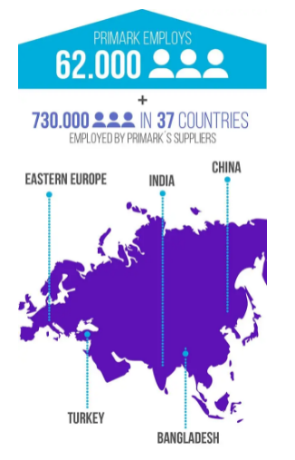
Primark has a vast corporate network across 37 countries (Hendriksz, 2017)

Appendix 2: Designing Organisational Structure

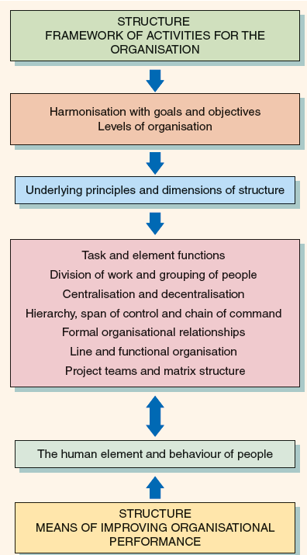
Source: Mullins (2010, p. 398)

Appendix 3: Ideal Types of Organisational Culture

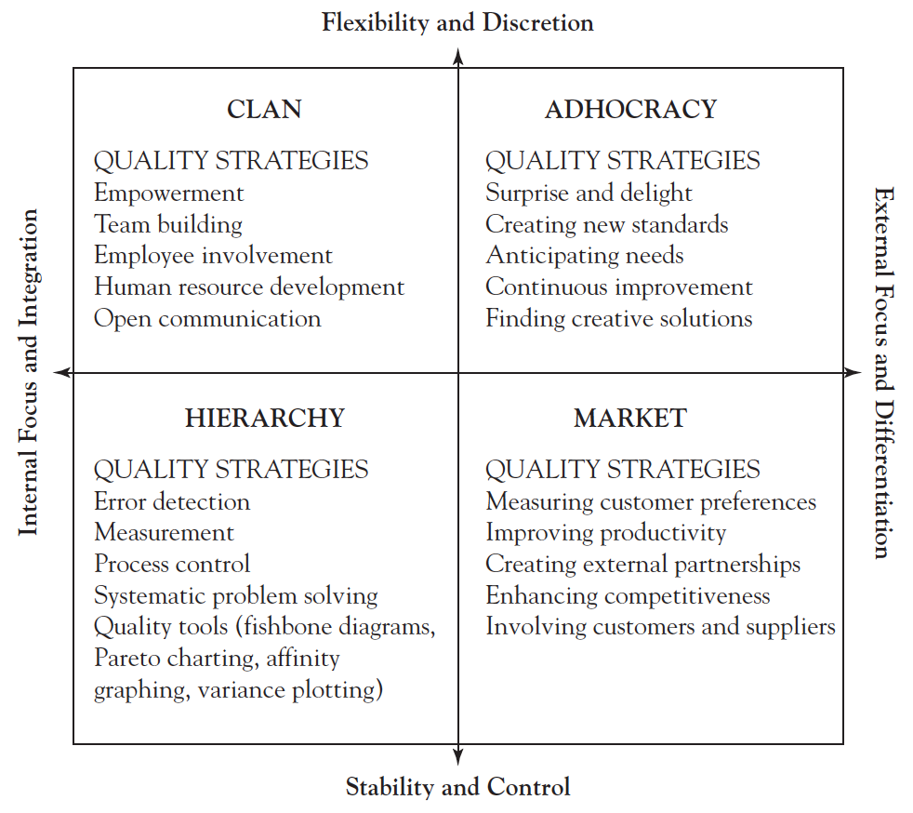
Source: Cameron and Quinn (2006, p. 50)

Appendix 4: The Managerial Grid
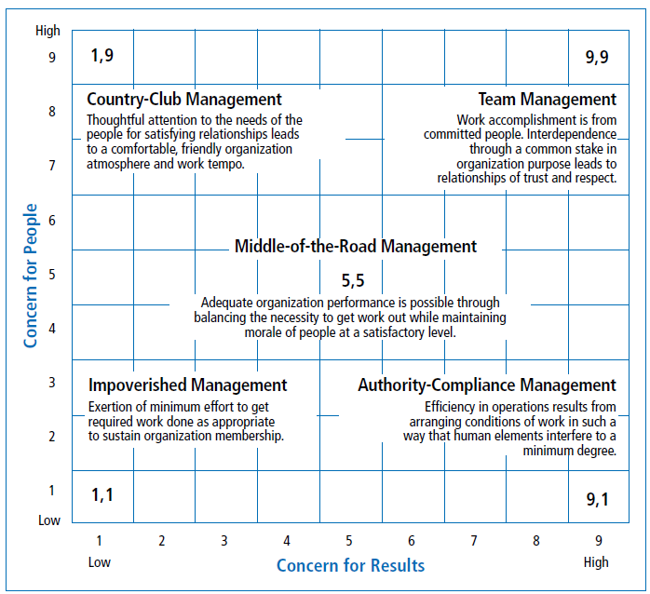
Source: Northouse (2016, p. 76)

