
Assignment 1

Course:BA Business Management

Module name:Introducing the Modern Workplace

Module code:LCBB4003

Lecture name:Dr Anupam Mazumdar

Student name:Tsveta Lyushtova

Student number:2124712

Table of Contents
Introduction……………………………………………………………………………..3
Discussion……………………………………………………………………………….3 Answer1…………………………………………………………………………………3
Answer2…………………………………………………………………………………7
Conclusion……………………………………………………………………………………………………………………9
References…………………………………………………………………………………………………………………10

Introduction
The achievement of the organization's objective is directly impacted by the fundamental relationship between structure, culture, personnel, and job performance. The impact of organizational structure, culture, and employee interactions will be examined in the current study's context of Sainsbury's, a well-known retailer in the UK. Employee performance in a company is not constant and is influenced by a number of elements related to the organization's structure, culture, and motivation levels. These elements frequently depend on the style and calibre of management and the governing board's business practices. Sainsbury's is the second-largest supermarket chain in retail sales and has a considerable market share in the UK. Argos, Habitat, Tu, Nectar, and Sainsbury's Bank, subsidiaries of the holding firm J Sainsbury plc, which has been providing services to the people of the UK since 1869, had a profit of £730 million in the fiscal year 2021–2022 with a 3.4% increase in retail sales(Sainsbury's, 2022). Based on the above factors, this research will discuss the longevity of the employees at Sainsbury's. The organizational structure of this corporation will be briefly reviewed, as well as how it affects the development and performance of the business. The same scenario will also emphasize culture management in addition to this. This study will critically discuss both leaders' and employees' behavioural approaches.

Discussion

Answer 1
The management of an organization's activities, such as work allocation, task coordination, and supervisory control, is referred to as its organizational structure or administration. Along with showing the basic standard operating plans and strategies, it may impact the operations of the relevant organizations.
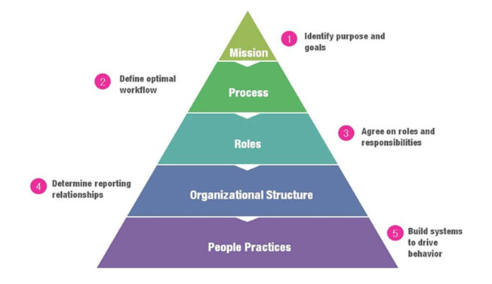
Figure 1 Organizational model of work (Source: Chión, Charles and Morales, 2019)
The full organizational model is shown in the above graphic as a pyramid, demonstrating how organizational structure determines how interactions within an organization are arranged. Many types of organizational structures might exist, including hierarchical, functional, divisional, team-based, network, etc. In the opinion of Chión, Charles and Morales (2019), organizational structure can influence process improvement and technological advancement by fostering strong interactions among stakeholders and knowledge sharing.
The organizational structure of the aforementioned retail corporation, Sainsbury's, in the UK is hierarchical; each level is overseen by a stage above, and there are several employees on a top-down level. Each level of personnel is accountable to its higher level. For instance, the line managers take on the responsibility of their sales assistants, while the senior managers take on the responsibility of the line managers.
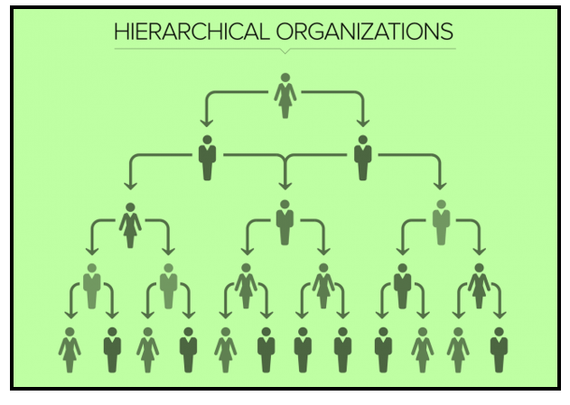
Figure 2 Hierarchical Organizational structure (Source: Created by Author)
A clear visual representation of it has been presented in the above image to understand the complete structure of the hierarchical organization model. It has been observed that all levels, except the highest level, are beneath the above level. This implies that the stage guides all employees above them regarding organizational activities at their respective levels. Regarding the hierarchical structure, Anning-Dorson (2018) asserts that the influence of leadership in various service organizations might affect their ability to innovate and generate competitive advantage from expanding markets.
Due to the employees and staff's well-instructed colleagues, the retail company's organizational structure gives its employees and staff a higher sense of assurance regarding the task at hand. This structure helps employees concentrate on their related jobs when the company is ready to launch items or enter a new market.
Sainsbury still uses their special opportunities to grow in its particular spaces. The company has expanded with many stores in various locations without losing its organizational business structure. With the aid of growing hierarchical procedures, the leader and board members are often in charge of the long-term plan(Colley and Spyridonidis ,2022). To ensure they can fulfil commitments, they operate in the best interest of their stakeholders, clients, employees, and shareholders. Additionally, an organization's hierarchical structure and leadership style provide a systemic and efficient workflow.
Organizational culture and its impact
The behavioural approach to society and the workforce might be called organizational culture. A company's vision for achieving its ultimate goals and economic objectives forms the foundation of its organizational culture. The nation where a company is located or intends to expand has a relationship with the organization's cultural management(Erthal and Marques, 2018).
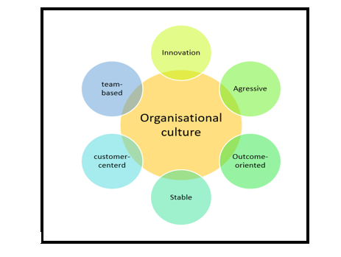
Figure 3 Organizational culture (Source: Created by Author)
To illustrate the key elements, different types of organizational cultures are shown in the above graphic. According to Obeidat (2018), an organization's organizational culture can significantly boost human capital, which can further foster good employee relationships. Various organizations embrace various cultural aspects based on their operational priorities and needs.
Sainsbury's uses power culture in its culture to help employees make decisions that are acceptable for achieving the organization's objective. The management of Sainsbury's culture is based on its vision, which is to develop into the most dependable direction where consumers and staff enjoy buying. To ensure that customers always receive excellent service, the company must leverage its workforce's innovation, talent, and diversity (Sainsbury's, 2022). The principles that Sainsbury upholds in terms of cultural performance are illustrated through a visual representation below:
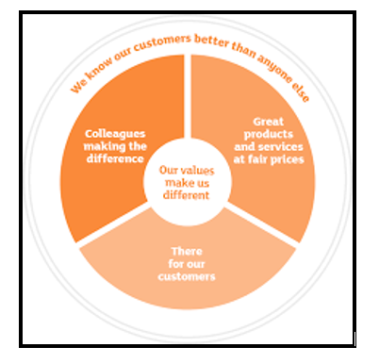
Figure 4 Values of Sainsbury's (Source: Sainsburys.co.uk, 2022)
Fairness, sourcing with integrity, respecting environmental health, differentiating for the community, and creating a great work environment are the five core values of the retail organization. These ideals form the foundation of the company's culture, and it has effectively given its employees a secure work environment. The management would like to embrace a support commitment when disability occurs at work to help establish a magnificent legacy, as mentioned on the official committee of this company(Sainsbury's, 2022). This shows the company's collaborative culture environment. This organization hopes to foster an environment where better ideas are used to inspire workers, increase staff retention, and strengthen the decision-making process. Performance improves when an employee is motivated.
Upadhyay, Kumar and Akter (2022) hold the opinion that UK merchants have begun to implement circular economy systems and to move in a policy-oriented orientation concerning clean technology and environmental policy. This company's top management has chosen a circular economy to maintain an organizational culture of corporate social response and ensure future sustainability.

Answer 2
From an organization's perspective, the employees' behavioural approach and attitude allude to how they might react to particular scenarios or conditions at work. Employees are structured by their personal and the cultures of the many companies they work for. Employees exhibit various behaviours, including leadership, innovation, customer-oriented, analytical, etc.
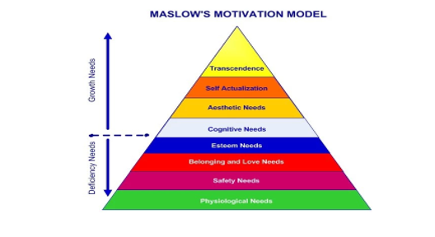
Figure 5 Motivation model of Maslow (Source: Created by Author)
The motivation model of Maslow is depicted in the image above as a pyramidal structure where each need is described and categorized from the employee's viewpoint. Deficit needs and growth requirements are two different types of wants that employees may have. Deficit needs include psychological needs, safety, belonging, and esteem, while growth requirements include everything else(Bhat, 2020). To meet the needs of its employees, Sainsbury's uses Maslow's theory of motivation; as a result, this business has highly motivated employees. This organization also satisfies the psychological condition by offering competitive compensation, attractive incentives, and adequate safety provisions. The following elements impact how this company's personnel behave and perform.
Leadership
Sainsbury considers the democratic leadership style since it thinks it can involve all personnel in operational and organizational decisions. Democratic leadership is characterized as a collaborative leadership style that accords equal value to personnel in high and low positions(Hilton, Arkorful and Martins, 2021). With this management approach, Sainsbury's has created a solid employee structure addressing the beneficial effects of employees' behaviour. However, depending on the nature and demands of their jobs, some of this company's managers embrace an autocratic management style.
Work culture
Since employees spend most of their waking hours at work, the workplace culture significantly impacts their behaviour and productivity. By involving them in all operational operations through appropriate training and development, Sainsbury's retail company, in this particular contract, has given its employees a positive work environment(Abdullah, 2020). Although the burden in this company is pretty significant, employees can cope with it because of the supportive and helpful leaders and supervisors. Employees at this company now feel valued because of the democratic workplace culture, which increases their likelihood of contributing to personal and organizational growth.
Motivation
Sainsbury's encourages its staff members by offering worthwhile rewards. Staff incentive programmes and recognition awards can raise output, inspire workers, and improve effectiveness and contribution. The business director of this corporation came up with a plan to provide current marketing assistance for discussing the amenities for the workforce. The gift cards, vouchers, and other gift-related items are an ideal incentive to show value to the workers because each employee receives items from the food, clothing, and health stores. This company offers additional services to help employees with security and mailing costs.
Job Responsibility
From the viewpoint of an organization, job responsibility relates to career opportunities and development. The in-store workforce at Sainsbury's consists of counter assistants, bakers, administrative staff, warehouse workers, etc. There are also numerous opportunities to advance the post level within the company by improving working efficiency(Jiandong, Qi and Haitian, 2022). With the aid of efficient training and improvement programmes and the opportunity to work on challenging tasks, employees are given the tools they need to enhance their skills in critical thinking and creativity.
Effective communication
Enhancing employee relations inside a company is more likely when communication skills are used. The effectiveness of work is increased from the standpoint of organizational performance when management leaders can inspire and direct people with great communication(Lasater, 2019). The organization's management has established strong and effective communication so employees can perform their duties efficiently without being redirected by misunderstandings. This company's communication strategy has been divided in response to the disparities in values, beliefs, languages, and customs among its personnel from various backgrounds and cultures(Olszowski, 2021). The employees' trust in one another and the development of positive behaviours are increased due to the communication policy.
Work-life balance
To improve employee cooperation and behaviour toward their respective organizations, work-life balance is crucial. The workers may be given more freedom to balance their personal and professional lives by using this organizational idea. The management of Sainsbury's has positioned the business as a fantastic place to work, offering the amenities necessary to maintain a healthy work-life balance. Employees are allowed to accept an additional hour of labour for additional compensation but are still given the option. Additionally, this business is accommodating regarding the days and hours that employees work, as well as being encouraging and just in how it handles any problems.
According to Tran (2020), organizational culture, work happiness, and leadership style are all interconnected and impact overall business performance. Contrarily, culture management refers to contributing to the advancement of environmental health; therefore, organizations also adopt the circular economy strategy concerning their cultural growth. For staff and members to thrive and achieve organizational objectives, it is the company's responsibility to provide them with the right support, cultural sensitivity, excellent communication, and other necessary factors.

Conclusion
The report's findings suggest that organizational values such as work culture, organizational structure, and the motivations offered by managers and leaders can significantly impact employees' performance. Despite the structure being relatively static, UK-based retail supermarket chain Sainsbury's has a dynamic sense of business strategies that are crucial for the organization's growth. Along with ensuring customer pleasure, the company's five core values are crucial for employee work satisfaction since they uphold employee and customer performance standards. The path to the group's objectives is sped up by this technique, which also improves staff performance. The discussion above was held to understand better an organization's important elements, such as its culture, structure, and employee relations. The organizational management environment of a UK retail corporation, Sainsbury's, has been used to support the analysis. The corporation has maintained a strong hierarchy in terms of its organizational structure, as seen from the demonstration. With this strategy, maintaining all the resources efficiently for growth goals has been made simple. Additionally, the power culture of this organization has flourished by valuing and respecting the workers' various customs, cultures, languages, and beliefs.

References
Abdullah, A., 2020. Relationship the Work Culture and Training Programs Within Performance. International Journal of Progressive Sciences and Technologies (IJPSAT), 20(1), pp.92-101.
Anning-Dorson, T., 2018. Innovation and competitive advantage creation: The role of organisational leadership in service firms from emerging markets. International Marketing Review.
Bhat, S., D'Souza, R., Bhat, S., Raju, R. and Kumara, B.P., 2020. Effective deployment of outcome based education: Strategies based on motivational models. Journal of Engineering Education Transformations, 33, pp.164-169.
Chión, S.J., Charles, V. and Morales, J., 2019. The impact of organisational culture, organisational structure and technological infrastructure on process improvement through knowledge sharing. Business Process Management Journal, 26(6), pp.1443-1472.
Colley, J. and Spyridonidis, D., 2022. Creating the Capacity for Strategic Leadership. In Unprecedented Leadership (pp. 119-138). Palgrave Macmillan, Cham.
Erthal, A. and Marques, L., 2018. National culture and organisational culture in lean organisations: a systematic review. Production Planning & Control, 29(8), pp.668-687.
Hilton, S.K., Arkorful, H. and Martins, A., 2021. Democratic leadership and organizational performance: the moderating effect of contingent reward. Management Research Review.
Jiandong, S., Qi, W. and Haitian, L., 2020, December. How do high-performance work systems affect work fatigue: mediate effect of between job responsibility and role overload. In Proceedings of the 2020 3rd International Conference on E-Business, Information Management and Computer Science (pp. 31-36).
Lasater, I., 2019. Words that work in business: A practical guide to effective communication in the workplace. PuddleDancer Press.
Obeidat, A.M., Abualoush, S.H., Irtaimeh, H.J., Khaddam, A.A. and Bataineh, K.A., 2018. The role of organisational culture in enhancing the human capital applied study on the social security corporation. International Journal of Learning and Intellectual Capital, 15(3), pp.258-276.
Olszowski, R., Pięta, P., Baran, S. and Chmielowski, M., 2021. Organisational Structure and Created Values. Review of Methods of Studying Collective Intelligence in Policymaking. Entropy, 23(11), p.1391.
Sainsbury's (2022) Welcome to Sainsburys Home, Sainsbury's. Sainsbury's. Available at: https://www.about.sainsburys.co.uk/ (Accessed: October 27, 2022).
Sainsburys, 2022 values-culture. available at https://sainsburys.jobs/working-for-us/values-culture/ (Accessed: October 27, 2022).
Sainsburys.co.uk, 2022 our-business-strategy, available at www.about.sainsburys.co.uk/about-us/our-business-strategy (Accessed: October 27, 2022)
Tran, Q.H., 2020. Organisational culture, leadership behaviour and job satisfaction in the Vietnam context. International Journal of Organizational Analysis.
Upadhyay, A., Kumar, A. and Akter, S., 2022. An analysis of UK retailers’ initiatives towards circular economy transition and policy-driven directions. Clean Technologies and Environmental Policy, 24(4), pp.1209-1217

