BMSW4002
Effective Team Working and Communication
Lecturer: Timothy Hopkins
Student name: Narcis Andrei Mindru
Student ID: 2021407

Table of Contents
Introduction 3
Section 2: Models of Communication 4
The Shannon and weaver communication model 4
The Schramm communication system 5
Berlo's SMCR model 5
Section 3: Communication Skills 6
Verbal Communication 6
Non-Verbal Communication 7
Listening in a Communication Process 8
Conclusion 10
References 11

Introduction
These are just some aspects that must be considered in the procedure of good communications in addition to making the communication more effective. Emotional responses and background noise serve as a deterrent to successful communication (McQuail, 2008). The communications models of Shanon and Weaver will be discussed in this paper. In this report the models of Shanon and Weaver, Schramm and Berlo’s, SMCR communication will be elaborately discussed to make the communication process of the workplace become more effective and prudent. Later on, verbal and nonverbal communication will be addressed properly to elaborately make the understanding of these methods proper, then the importance of active and empathetic listening will be addressed in the report.

Section 2: Models of Communication
A communication model provides a system that integrates the elements of communication with the process of communication. Shannon and Weaver communication model, Schramm communication model, and Berlo's SMCR model would be discussed in this section.

The Shannon and weaver communication model
The Shannon and weaver communication model is considered to be the primitive model of communication, and it is widely used in a variety of communication frameworks. The model deals with six components which was made seven with the addition of a new component feedback. In the process of this model firstly the message is sent by the sender and then the message is encoded and later on sent by a channel to the receiver. The message is decoded and then the receiver receives the message then provides feedback. But in the process the fact is that affects the communication is noise as this disrupts the communication (Al-Fedaghi, 2012).
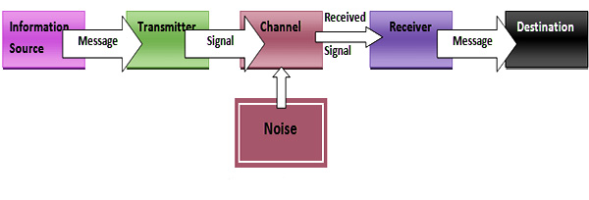
Figure 1: Shannon & Weaver's Communication Model (Al-Fedaghi, 2012)
In the example, the message was confused between Maria and Pedro owing to the noise the connection between Maria and Pedro was hampered by noise throughout the communication process because of the channel and here the noise is the reason for the problem created in the process.

The Schramm communication system
The Schramm communication system is a unique framework where in communication is considered as a cyclical process with no distinguishing sender and the receiver. This indicates to the possibility of a transformation in the circumstances. Also, because system is circular and works in a cycle, both the transmitter and the recipient must act as interpreters. The distinction between this model and the Shannon and weaver communication model is that the Shannon and weaver communication model is not circular, but model’s sender and receiver do not serve as interpreters (Schramm, 2014).
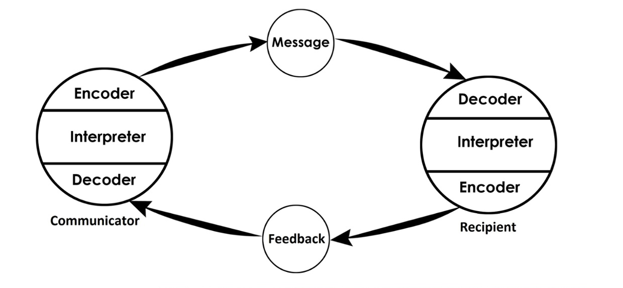
Figure 2: Schramms' Communication Model (Schramm, 2014)
This model simply says, in the case of Maria and Pedro, Pedro must have confirmed what Maria had suggested but Pedro did not. Their connection was finally broken and no two-way communication was done. Pedro could have avoided misunderstanding with feedback.

Berlo's SMCR model
Berlo's SMCR model is a linear model that requires the same level knowledge of all the participants and as the consequences are unclear, therefore communication barriers are overlooked in this model. Even while this model is linear like the Shannon and weaver communication model but it lacks feedback, and noise or interference can disrupt communication after the message has been sent. The sender's and receiver's vocabulary, understanding, but also their attitude all have an influence on the communication process (Sultanow, Vladova and Weber, 2009).
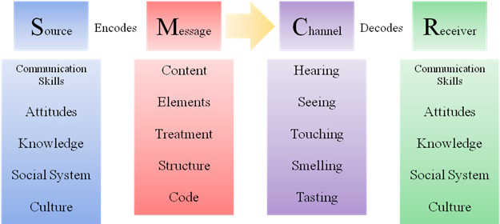
Figure 3: Berlo's SMCR Communication Model (Sultanow, Vladova and Weber, 2009)
In the example of the villagers and the professor, the professor stated that the edifice was devoured by great configuration, but that the villagers never could comprehend the content of the language owing to noise and also because they cannot understand the words. According to Berlo's SMCR model, the professor should have chosen terms that the people could comprehend.

Section 3: Communication Skills

Verbal Communication
KEYS model is used for conducting communication in the organisation and in this model or theory it is suggested that every employee have to follow 4 steps. At first, they have to know themselves as they are and then they have to evaluate the professional context of the communication that they are doing with another person (Broadbent, 2013). Furthermore the "your communication interaction occurs" is an individual monitor that occurred interactions that happened while communicating. And the final state that is taken is step back and reflect the evaluation that have been taken into conduct and then turned that evaluation into successful communication process. When it comes to verbal communication it can be both written or even it can be modelled as while communicating orally the reality and the choices of words is a major factor that must be brought into consideration. How the message is spoken and words are being used to make the communication more effective and fluent is an important factor that needs to be addressed. With the usage of KEYS model effective communication can be insured and this will make the communicator communicate with the person above properly using verbal communication. Usually, verbal communication have both positive and negative sides but when it comes to the negative side one of the most problematic factor is that while communicating verbally the most common mistake is ambiguity. The communicator may not be able to make the points their sharing clear to the receiver which results in ambiguity and not proper communication. On the other hand, there is written communication that is more like a formal form of communication. While conducting written communication the company is more formal and try to implied their rules regulations and other kind of aspects in their written communication. Written communication should be done very carefully as there is no tonality to provide the message properly and also the communicator cannot see the feedback of the receiver immediately which makes the written communication more complicated. The tonality in written communication is very important and the audience have to be determined and analyse properly before communicating through written communication (Kumar and Lata, 2011). Comparing oral and written communication oral communication is more important Mal as it is directly delivering to the receiver and the feedback is received directly from the receiver to the communicator at the very instant movement. But when it comes to written communication the receiver provides the feedback after the evaluation of the written document or communication that has been sent to them which with wires property anality and time to get the feedback.

Non-Verbal Communication
Sometimes communication is mainly done without speaking or writing any words and in here the body language of the communicator are the major factor that actually communicates with the receiver or the other party of the communication process. In discount of communication method kinesics is a very effective model that can be used because the meaning of this world is movement. The gesture or poster that the communicator holes is the major part of kinesics (Knapp, Hall and Horgan, 2013). Whenever operation is trying to move the body or provide the facial expression to make the message more powerful and understandable to the person in front of them which is the receiver of the communication process it can be known as the use of Kinesics. It helps a person to express themselves more accurately and provide the information more likely to the receivers. Also, this kind of gesture and posture does have a positive and negative impact on communication process as the way you move your body and the way you provide your expression to the people you are interacting with there will be integrated with you in here. Factor that plays a great role in non-verbal communication is proxemics. Where comes to the model of Edward Hall they have four spaces that needs to be maintained if the communicator is looking for an effective communication with the receiver (DeVito, 2016). The first is intimate space that is almost 18 feet distance from an individual and it is allowed for family members or the close friends that their communicating with but when it comes to personal space it expands to 18 inches to 4 feet and this is also required for the normal friends and the relatives that they have all the people that they are acquainted with. The factor that emphasizes is official communication which needs this kind of space but when it comes to social space the space must be from 4 to 12 feet and this will be appropriate when the communication is going on between a small group of people and the interpretation of this kind of communications social space can be said as a restaurant where the family dinner is being conducted (Windahl, Signitzer and Olson, 2008). Last but not least the public space is considered to go beyond 12 feet and it is when the communicator is communicating with more than a couple of people. In hair the communication can be done over radio or any public space where they are giving any speech to their peer in a webinar. In case of non-verbal communication, the factor of space must be considered and also the other factor that must be taken into account is how the body language and face expression of the communicator is conveying the message of the communicator.

Listening in a Communication Process
When it comes to listening as a part of a communication process, the individual who is the receiver must pay attention to the words of the communicator and listening is also a major fact that needs to be done by the listener or the receiver of the communication method. In a communication process the most important factor is listening as both of the parties have to listen to the other party carefully with enough attention and responsibility to ensure that the message their receiving is stored into their minds. Active listening is when a person is listening to the conversation or communication message properly with proper attention and they are taking notes throughout the communication process (Griffin, 2006). Also, when it comes to empathic listening it is more important when it comes to formal and informal communication as while listening to someone one fact that should be it showed into the expressions or by any kind of feelings is respect to the person who is delivering the message. If the listener is not a thick enough then the communicator may start to lose the interest of providing respect the other party and this will not lead to effective communication no matter what the communicator is trying to do. Listening is half the job of the communication process and the good communicator I will expect the respect and emotional feedback from the listener. That is why active listening and sympathetic listening is very important when it comes to any kind of formal or informal communication process. SOLER is a process that is used for nonverbal listening and in here S stands for sitting. the individual who is listening has to sit properly in front of all the clients and this is a must for the listener to do. The O stands for open posture which means the listener have to maintain open posture to ensure your effective communication (Broadbent, 2013). Also, in here, L stands for leaning slightly towards the communicator who is communicating to the listener as this will make the communicator understand that the listener is listening to their message carefully with more attention. E stands for eye contact with the communicators and last but not least R suggest to stay relaxed whenever the communication is done between the listener and the communicator.

Conclusion
Using the cases of the professor and the village people, as well as Maria and Pedro, the above study examined the communication models of Shanon and Weaver, as well as Schramm and Berlo's SMCR model. The study then goes on to explain several communication strategies. The report subsequently went on to examine several types of communication, such as verbal and non-verbal, and indeed the importance of listening in the process of communication in order to determine the influence on good communications including both the communicator and listener party.

References
Al-Fedaghi, S. (2012). A conceptual foundation for the Shannon-Weaver model of communication. International Journal of Soft Computing, 7(1), pp.12-19.
Broadbent, D.E. (2013). Perception and communication. Elsevier.
DeVito, J.A. (2016). The interpersonal communication book. Instructor, 1, p.18.
Griffin, E.M. (2006). A first look at communication theory. McGraw-hill.
Knapp, M.L., Hall, J.A. and Horgan, T.G. (2013). Nonverbal communication in human interaction. Cengage Learning.
Kumar, S. and Lata, P. (2011). Communication skills. New Delhi: Oxford University Press.
McQuail, D. (2008). Mass communication theory: An introduction. Sage Publications, Inc.
Schramm, W. (2014). How communication works. 1954, pp.3-26.
Sultanow, E., Vladova, G. and Weber, E. (2009). Overcoming Communication Barriers for CMC in Enterprises.
Windahl, S., Signitzer, B. and Olson, J.T. (2008). Using communication theory: An introduction to planned communication. Sage.

