Module Title: Developing Emotional Intelligence Skills for the Workplace
Module Code: BMSW6106
Student Name: Andreea Oana Vlasceanu
Student ID: 2108084

Table of Contents
Task 2: Individual Presentation 1
Task 3: Case Study on Emotional Intelligence and the Workplace 12
Introduction 12
Role of Emotional Intelligence in the Workplace 12
The Definition of EI and Why It Is Important in Organisations 12
Key Components of EI and Their Impact on Organisational Effectiveness 13
Relevance of EI in Fostering Innovation, Teamwork, and Adaptive Leadership 13
Three Emotional Intelligence Models for Enhancing Workplace Abilities 14
Daniel: Application of Daniel Goleman's Mixed Model of EI 14
Anita: Utilisation of Mayer and Salovey's Ability Model 15
Patrick: Application of the Emotional Competence Framework by Goleman and Boyatzis 15
Importance of Self-Awareness, Self-Management, Social Awareness, and Relationship Management in EI 16
Developing Emotional Intelligence Using Mindfulness and Relationship Management 18
Explanation of Mindfulness Techniques 18
Strategies for Improving Social Awareness and Relationship Management 19
Benefits of Integrating Mindfulness Practices in Corporate Culture 19
Recommendations Highlighting the Importance of Mindfulness in the Workplace 20
Conclusion 20
Reference 22

Task 2: Individual Presentation
Title Slide
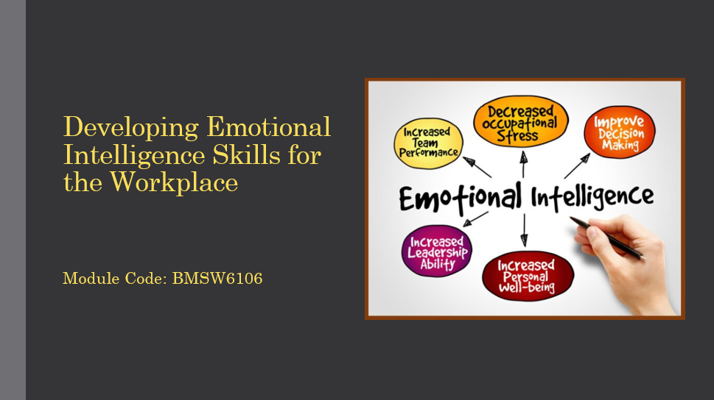
Introduction
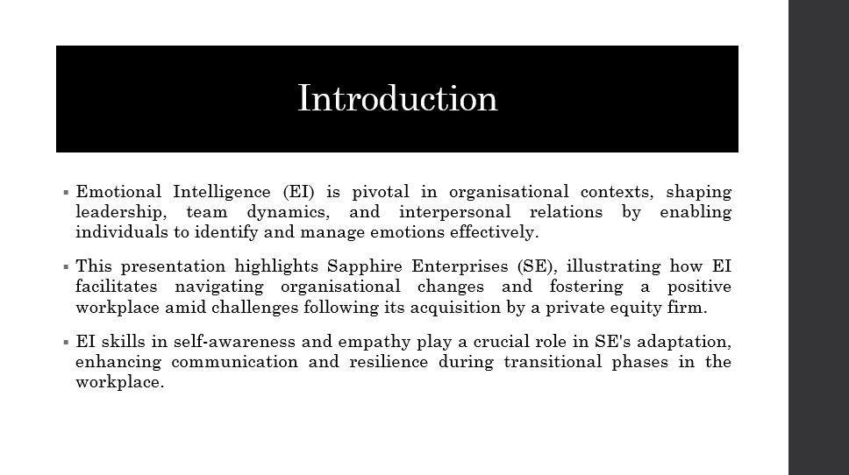

Definition of Emotional Intelligence (EI)
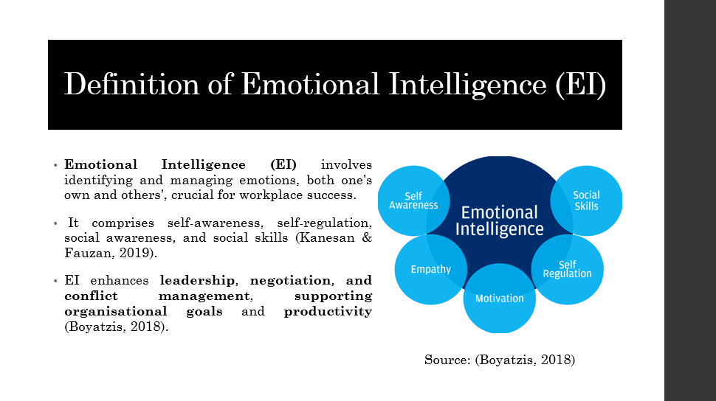
Importance of EI in the Workplace
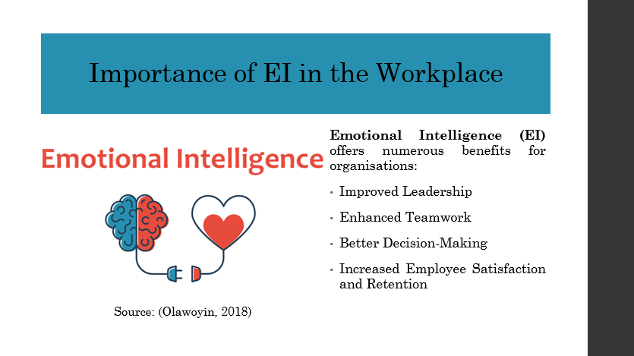

Case Study Example
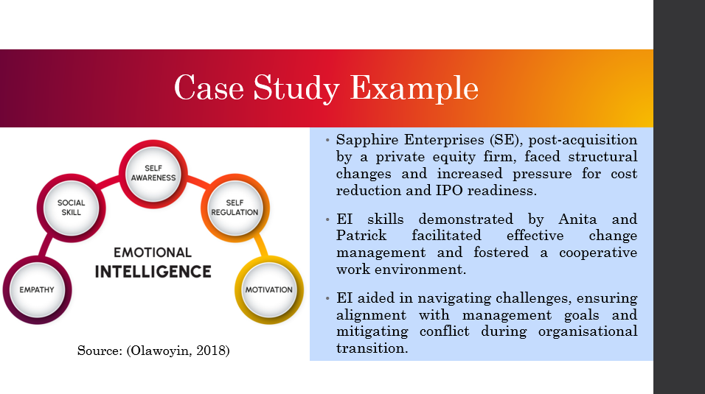

Application of Daniel Goleman's Mixed Model of EI
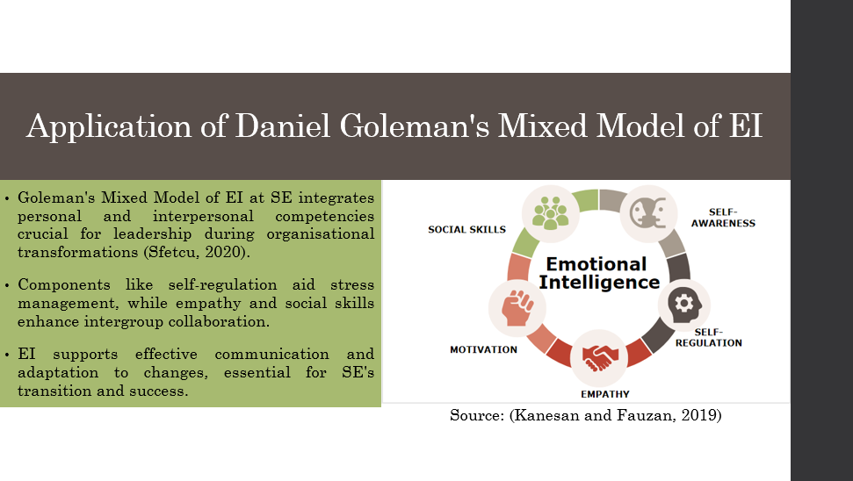

Critique of Daniel Goleman's Mixed Model
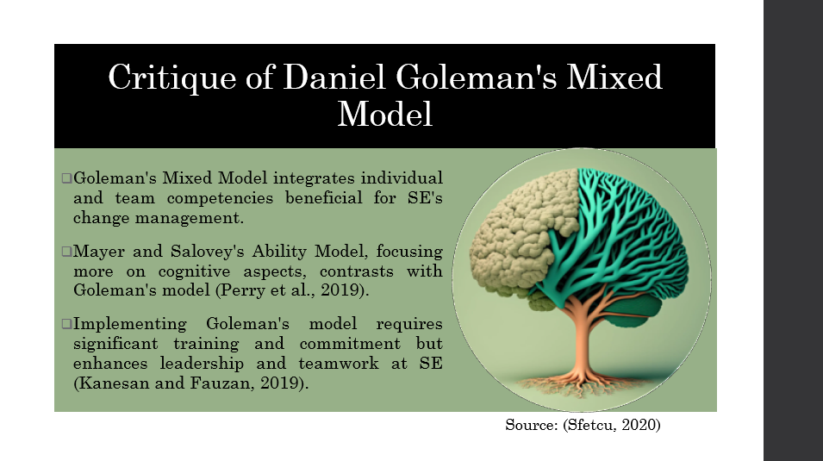

Implementation of EI Strategies
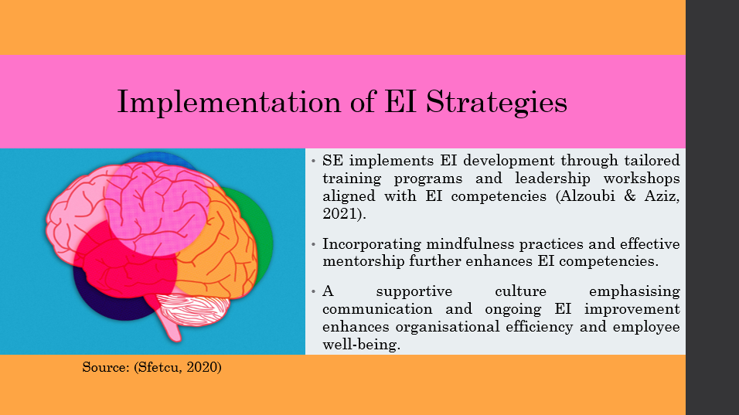

Benefits of Implementing EI Strategies
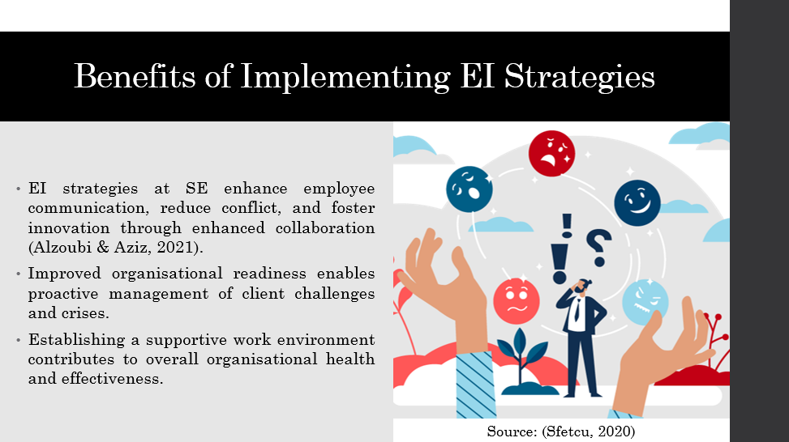

Conclusion
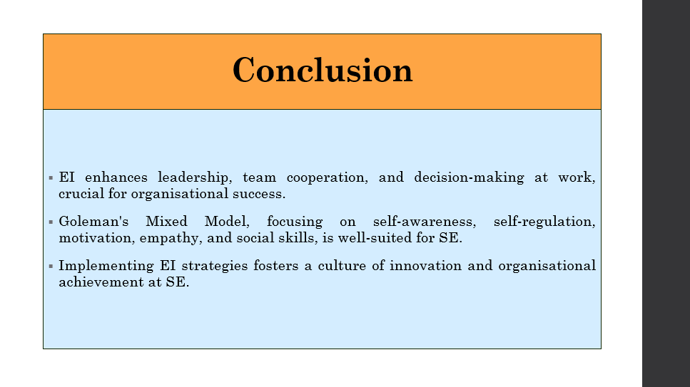

References
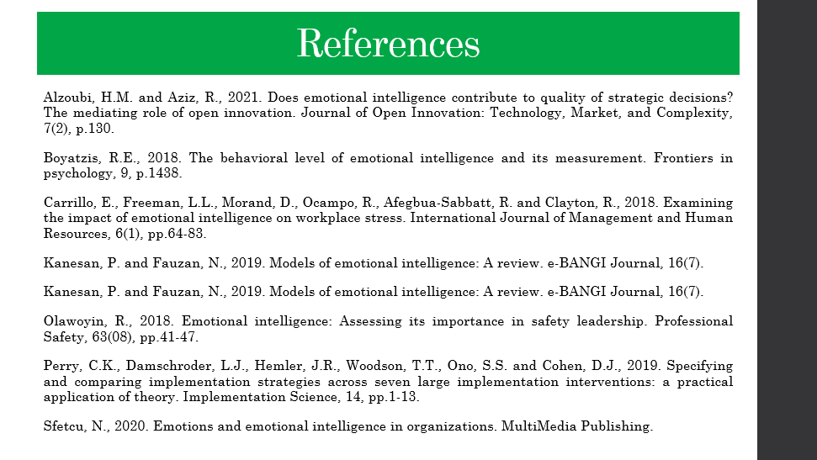
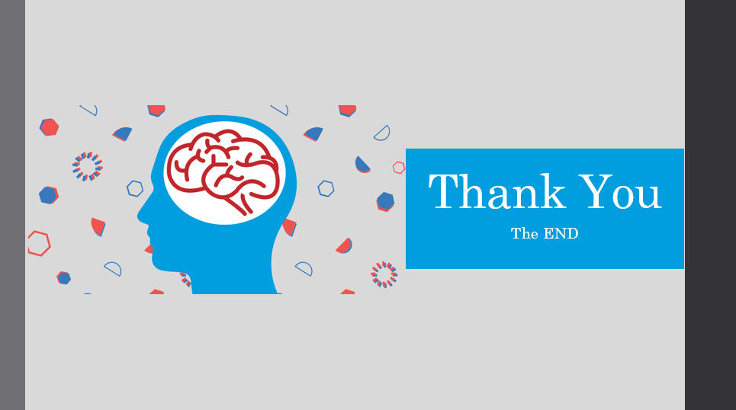

Task 3: Case Study on Emotional Intelligence and the Workplace

Introduction
The AIM of the case study is set at SE, which targets changes in organisational options following the acquisition via private equity, with an accentuation on the competency model of Emotional Intelligence. Emotional Intelligence therefore has a critical role in regulating new leadership dynamics and managing issues to do with strategic processes as well as upkeep of strong employees’ interaction. This report ACS considers how Emotional Intelligence plays a pivotal role when it comes to the pragmatic and enduring implementation of change initiatives within the ambit of SE’s programme of Respect and Excellence. Reflecting on the Organisational Changes & tactfully attempting to adhere to SE’s conceived Values of Respect and Excellence: Where Anita, Daniel and their co-workers are engaged in mostly dealing with transformational change and aspiring to conceptually and practically comprehend the studies’ highlights on EI and its immense significance.

Role of Emotional Intelligence in the Workplace
Emotional Intelligence (EI) is a crucial component in determining the organisational climate and improving employees’ performance. They include self-awareness, understanding, and regulating personal and other people’s emotions to build and maintain relationships that support the organisational objectives. In the context of organisational settings, EI comprises several key components: If developed are self-awareness, self-management, social awareness, and relationship management.

The Definition of EI and Why It Is Important in Organisations
EI as a concept encompasses understanding feelings that one has, as well as the impact that these feel accorded to thoughts and actions. For example, when it comes to self-awareness, managing directors know their advantages and disadvantages, which helps them make the right choice and control their actions when stressed (Krén and Séllei, 2021). Self-management helps people positively control their feelings and remain calm despite any hardship while emanating positivism from other people.

Key Components of EI and Their Impact on Organisational Effectiveness
- Self-awareness: Self-awareness plays an important role as it enables one to recognise the impact of one’s moods and actions on others. For instance, a manager who acknowledges that stress entered his/her decision-making process of work that needs discretion, then, he/she can work towards managing stress to ensure that it does not interfere with his/her pivotal choice.
- Social awareness: Social awareness refers to a person’s ability to accept others’ feelings and fluor, their perception of what is going on around them. Effective communication involves the ability of leaders to read and manage social situations that exist in a team and initiate the necessary changes (Nel, 2019). This skill is perhaps critical in BPO because it enhances organisation relations and the development of a positive work culture. For instance, a team leader who is sensitive towards showing concerns of the members can reduce conflicts among the team and hence improve cooperation.
- Relationship management: Relationship management therefore entails interaction management where one uses feelings to conduct the relationship. It is useful when it comes to attending to conflicts, encouraging workers and individuals, and developing interpersonal relationships. For example, a manager who can handle conflict in a non-violent way and who consequently supports team identity and cooperation increases opportunities for other team members to communicate and thus raises team performance.

Relevance of EI in Fostering Innovation, Teamwork, and Adaptive Leadership
It is worth underlining that EI is one of the foundational elements influencing organisational innovation since it contributes to building an organisational culture that supports the promotion of innovative ideas and the resolution of conflicts related to them. High EI leaders encourage individuals to come up with suggestions and try out new strategies and no one is going to scold them for doing so. This stimulates innovation and change within the organisation and ensures that it is forward-looking (Jena and Pradhan, 2018).
In addition, EI improves the ability to work as a team since trust and cooperation between the personnel is fostered; everyone has to respect each other. Supervisors who show concern and respect drive the workplace environment in such a way that people give their optimum to achieve organisational objectives. It fosters high levels of coordination and therefore improves the performance of the members of the group (Arar and Öneren, 2021).
Other scholars of leadership indicate that EI supports the concept of adaptive leadership, which entails the adaptation of the strategies and methods used given ever-shifting conditions. The text reveals that emotionally intelligent leaders can deal with uncertainties and change successfully, keeping their subordinates’ spirits up in times of crisis. Indeed, this dynamic capability to lead change is central to organisational adaptability and healthy, long-term development (Makkar and Basu, 2019).
Therefore, EI is one of the most significant components of leadership and organisational performance. Thus, training and promoting the use of EI skills avail the abilities to create and invoke positive organisational culture, improve team performance and attain organisational plans effectively and efficiently in the current complicated business world.

Three Emotional Intelligence Models for Enhancing Workplace Abilities
It is argued that EI frameworks are presented in models, which provide structures that people can employ in working situations. When considering three primary characters, Daniel, Anita, and Patrick working at Sapphire Enterprises (SE), three of the most important EI models can be applied on a strategic level to enhance leadership skills and improve the personnel’s role within SE.

Daniel: Application of Daniel Goleman's Mixed Model of EI
According to the Mixed Model of EI introduced by Daniel Goleman, which may help Daniel, a newly appointed COO to increase the value of SE and get it ready for an IPO, the following reserves of EI can be identified: This model emphasises five key components:
- Self-awareness: The awareness of one’s moods, abilities and, especially, limitations, of how one affects others, and how one rationally performs.
- Self-regulation: The ability to control one's feelings, especially in situations that would otherwise make a person lose his/her cool, hence being in a position to make sound decisions (Kanesan and Fauzan, 2019).
- Motivation: The use of emotions to get towards its goals and to remain motivated and persistent.
- Empathy: Empathy, refers to the ability to comprehend the feelings that other individuals are experiencing and the level of interest that the RPDA has for the subjects’ concerns.
- Social skills: Regulating relations to maintain and steer employee and other stakeholders’ behaviour in the contexts of influence, persuasion, and conflict (Singh et al., 2022).
Following Goleman’s framework, it refers to Daniel being conscious of the impact of his choices, as well as how he communicates, on the overall morale of the team, and the overall organisational culture. Through growing self-regulation and empathy, Daniel will be able to handle SE’s structural changes as a company along with cost reduction strategies without damaging team spirit and motivation among workers (Aamir, 2023).

Anita: Utilisation of Mayer and Salovey's Ability Model
Anita, as Corporate Counsel, can leverage Mayer and Salovey's Ability Model, which focuses on four key abilities:
- Perceiving emotions: Characterising feelings in oneself and others, basic feelings, moods, and nonverbal communication, vocal intonation, sign, and gesture (Odukoya and Olowookere, 2020).
- Using emotions to facilitate thinking: The use of emotions in reasoning and problem-solving processes to strengthen the decision-making aspect.
- Understanding emotions: Understanding strong feelings and occasions by which feelings may influence decisions and the relation aspect (Kanesan and Fauzan, 2019).
- Managing emotions: Managing individual and group affect for personal and team optimum functionality.
Regarding this model, for Anita, emotional perception implies the ability to assess stakeholders’ reactions throughout the bargaining process; emotional reason – to apply emotions as an addition to her strategic planning (Caruso et al., 2019). Appreciating emotions, and regulating them enable Anita to remain calm and focused during intense legal negotiations, thereby making sound decisions that would hold value to SE’s strategies.

Patrick: Application of the Emotional Competence Framework by Goleman and Boyatzis
Patrick, a member of Anita's legal team, can benefit from the Emotional Competence Framework, which focuses on specific emotional competencies essential for workplace success:
- Empathy: The ability to recognise other people’s moods and points of view, to build contacts, and to respond to other people’s feelings (Boyatzis, 2018).
- Collaboration and cooperation: Cooperating with other people for various tasks, collaboration, and managing diversity.
- Adaptability: It is the process of preparing people to manage their emotional, cognitive or psychological processes and responses in a dynamic context (Boyatzis et al, 2019).
- Conflict management: He returned with the positive part of negotiations, while we had to handle the conflicts with each other in a friendly manner.
These angles help apply the framework and allow Patrick to stand behind Anita’s drives suitably. Being sympathetic is useful to establish trust within the team and increase cooperation, whereas flexibility enables him to deal with the changes in the organisational structure of SE. From our analysis of Patrick’s behaviours, it can be deduced that he is proficient in managing conflicts in the workplace because he always professionally approaches them and teaches others to address them professionally (Truninger et al., 2018).

Importance of Self-Awareness, Self-Management, Social Awareness, and Relationship Management in EI
Emotional Intelligence (EI) includes various factors—self-awareness, self-control, awareness of people’s emotions, and interpersonal skills—that enhance leadership and organisational performance. All of them have a significant impact on EI because they develop the employees’ emotional competencies and serve as the framework for interactions in the workplace.
Critique of Every Aspect Related to the EI Improvement
- Self-Awareness: Emotional intelligence is comprised of three elements, namely self-regard which entails being aware of one’s feelings, towns which concerns personal skills and talents, and awareness of the self and others which focuses on the effects emotions may have on others. This is often considered the basis of EI since this way people can understand the relationships between emotions and thoughts or emotions and activities. Self-aware leaders develop effective insights about themselves, their strengths and weaknesses; learn from their successes and mistakes and be in a position to change their personalities to better suit the needs of the situation (Eurich, 2018).
- Self-Management: Self-management as a concept defines the capacity of an individual, particularly in the context of the present study, to control and manage their emotions, impulses and behaviours. It embraces ways of handling stress, aspects of self-control and ways of being optimistic. Self-managing leaders remain focused when facing problems, make people in their teams feel assured, and practice congruence in their behaviours and choices (Winkley et al., 2020).
- Social Awareness: Personal-related social skills termed as social awareness include comprehending the feelings, requirements, and views of other people. It helps leaders to get ready to deal with a response, learn more about social relations, and establish rapport. Assimilating CA social awareness is vital because leaders who possess it make sure that everyone in the team is valued and understood, therefore building trust (Chen et al., 2020).
- Relationship Management: Bones what is love, relationship management is always done using emotion. These are among the competencies of this nature, which entails; communication, conflict management, influence, and collaboration (Kumar & Reinartz, 2018). Managerial self-effectiveness in relationship management entails the formation of sound business relations, conflict resolution, and the ability to mobilise people to achieve shared objectives. Leadership practices enhance a good working environment in which employees feel free to give and receive information and respect their colleagues.
Examples from the Case Study Illustrating Their Impact on Interactions and Decision-Making
The attempt of SE’s case is presented through the meeting where Anita is interacting with Daniel and where the five components of EI could be observed. Hence, Anita showed self-awareness when she worked with Daniel and changed her expectations to reflect his insistence on measuring organisational performance in profits alone. This aspect of self-management also came out clearly when she was able to control her anger and present the argument of the case based on facts that convinced Daniel (Zhang et al., 2018). There was social awareness when Patrick agreed with Anita as well as argued with Daniel, grasping the dynamics of the team and providing important material that changed the latter’s mind. As for interpersonal and communication skills dealing with conflict, one should mention that due to the rather high level of conflict in the organisation, relationship management skills were critical for problem-solving; these individuals maintained cooperation and comprehensible conversations even if they shared opposite opinions (Pérez-Fuentes et al., 2018).
How These Components Contribute to Management and Positive Relations in Leadership
Leadership is also known to depend on elements of EI to steer people towards the achievement of common objectives. When a leader is self-aware of his/her strengths and limitations, he/she is better placed to manage or augment the strengths and limit the weaknesses, thus gaining people’s trust and respect. Self-management makes a leader calm and focused especially during crises; this helps sustain the team morale and productivity (Cole, 2024). Anxiety reductions improve communication and cooperation amongst the team members by drawing their attention to one another’s needs. Interpersonal interaction skills help leaders in the development of social capital where they can establish and maintain good working relations, manage conflicts and also motivate subordinates to work to the best of their abilities (Bion, 2018).

Developing Emotional Intelligence Using Mindfulness and Relationship Management
EI, which may be fostered by such methods as mindfulness and relationship management, plays the role of a framework for creating a cooperative and productive organisational context. They put into practice skills that increase understanding of oneself, regulation of oneself, understanding of others, and management of relationships, which are elements of EI.

Explanation of Mindfulness Techniques
Explanation of Mindfulness Techniques to Enhance Self-Awareness and Self-Management
Cognitive strategies like breathing exercises and full-body scans reduce self-attending hence enhancing self-awareness since one is trained to monitor oneself without evaluating the outcome. For example, mindfulness at SE could be carried out through a practice of meditation or having a mindfulness break during meetings (Kropp and Sedlmeier, 2019). This makes it possible for the employees, the leadership inclusive of Daniel, to understand the emotional states of their business and prevent/preempt stress-related issues. By increasing one’s understanding of the self, mindfulness can help leaders and their subordinates think before acting as opposed to acting based on an instinct or a knee-jerk reaction in adverse situations (Pratikta, 2020).

Strategies for Improving Social Awareness and Relationship Management
Strategies for Improving Social Awareness and Relationship Management through Active Listening and Empathetic Communication
Relationship building and estimation of self and others also derive significantly from things such as listening skills and assertiveness. Translating means paying close attention to what others are expressing, comprehending their views, and displaying attentiveness in reintroducing what has been said (Steinhoff et al., 2019). In SE company, leaders like Anita can enhance the legal team’s social awareness by listening to their concerns and feedback, hence ensuring good working relationships with their legal team members (Buttle and Maklan, 2019). Credibility results from favourable perceptions and favorability results from the acceptance of the message and the perceiver's Self-Other Agreement, hence emphatic communication is in part a recognition of the fact that a communicator has to show consideration to his/her audience because the audience does not only understand the feelings of the communicator but also is in a position to accept those feelings. For instance, when Patrick backs up Anita’s idea during meetings, he is empathetic to his coworkers’ interactions to conflict management to improve teamwork and productivity (Dhanesh and Duthler, 2019).

Benefits of Integrating Mindfulness Practices in Corporate Culture
Benefits of Integrating Mindfulness Practices in Corporate Culture to Foster Resilience and Reduce Stress
Mindfulness practice as an inherent aspect of business culture at SE also has certain advantages, such as creating resistance and a mild degree of stress among the workers. Scheduling mindfulness sessions or conducting mindfulness workshops for its employees can assist in dealing with pressure at the workplace, thus lowering the rates of burnout and increasing the staff's well-being (Bernal et al., 2018). For example, when the employees have undergone certain mindfulness workshops, they are likely to say that they are more focused, have enhanced decision-making capabilities, and have good interaction. This goes a long way in promoting organisational climate which has a characteristic of the employees bearing positive perceptions of their workplace with enthusiasm to add on their best and support the organisational objectives (Schuh et al., 2019).
Thus, one may state that the adaptation of mindfulness, and the focus on the relationship management strategies in the corporate culture contributes not only to the growth of the employees’ scores in EI but also to the organisational improvements of the staff’s interaction. These practices help to solve the problems with the higher emotional intelligence of leaders and employees and create a culture of cooperation for innovative and successful solutions at SE.

Recommendations Highlighting the Importance of Mindfulness in the Workplace
The inclusion of mindfulness training programs in SE’s organisational development interventions improves the well-being of employees and the performance of the organisation. Some recommendations include proposing daily mindfulness meetings, incorporating mindfulness practice into leadership training, and designating areas where people can find some peace.
Therefore, the case of mindfulness can help Daniel achieve his plan of improving value and stabilising for IPO by encouraging a clear, strong, and creative organisational culture. Thus, education on mindfulness skills may alleviate stress and can influence the choice and contribute to efficiency and unity within the employee-employer coordination in the organisation to align with the SE strategies (Arar and Öneren, 2021).
Mindfulness programmes in the workplace have been adopted by other organisations, including Google and General Mills, and it has worked for them; increased concentration among the employees, lower rates of absenteeism, and general satisfaction with the job among others. Such outcomes prove the effectiveness of mindfulness in developing a positive organisational culture and attaining stable business effectiveness.

Conclusion
Therefore, the discussion of the case study of Sapphire Enterprises (SE) demonstrates that EI plays a crucial role in organisational interactions and managers’ performance. Analysing Daniel, Anita, and Patrick’s communication patterns, one can conclude that EI components, including self-awareness, self-management, social awareness, and relationship management, are crucial when managing change, fostering innovation, and meeting business strategy objectives. Throughout the paper, the systematic enhancement of the EI competencies is identified as critical for SE’s organisational effectiveness. Managers and employees with higher levels of EI can face problems, motivate subordinates and adapt to changes in the market environment. This not only improves the person’s productivity and effectiveness but can also foster an acceptable organisational climate and embrace proactively. Thus, with a focus on EI under the leadership of Daniel, SE has much to gain in the future. Mindfulness practices and EI development can be used by SE as tools to improve its decision-making framework and create programs for employees The implementation of such programs can contribute to SE’s competitive advantage as it prepares for an IPO. If SE continually invests in the Improvement and building of these skills, then it will be capable of tackling future unforeseeable difficulties while achieving the enhancement of its performance. To sum up it is also revealed that SE prioritising EI within SE at the same time not only boosts personal and group efficiency but also strengthens SE’s focus on respect, integrity, and organisational excellence which are considered the company’s main values in the contexts of the changing business environments.

Reference
Aamir, A., (2023). Emotional Intelligence and Organizational Commitment-Application of the Goleman’s Model of Emotional Intelligence. International Journal of Intellectual Human Resource Management (IJIHRM), 4(01), pp.01-06.
Alzoubi, H.M. and Aziz, R., (2021). Does emotional intelligence contribute to quality of strategic decisions? The mediating role of open innovation. Journal of Open Innovation: Technology, Market, and Complexity, 7(2), p.130.
Arar, T. and Öneren, M., (2021). Role of emotional intelligence and work-life balance in relationship between workplace happiness and perceived performance in academic setting. Ege Academic Review, 21(4), pp.391-406.
Bernal, E., Edgar, D. and Burnes, B., (2018). Building sustainability on deep values through mindfulness nurturing. Ecological Economics, 146, pp.645-657.
Bion, W.R., (2018). Group dynamics: A re-view. New directions in psychoanalysis, pp.440-477.
Boyatzis, R.E., (2018). The behavioral level of emotional intelligence and its measurement. Frontiers in psychology, 9, p.385616.
Boyatzis, R.E., (2018). The behavioral level of emotional intelligence and its measurement. Frontiers in psychology, 9, p.1438.
Boyatzis, R.E., Goleman, D., Gerli, F. and Bonesso, S., (2019). Emotional and social intelligence competencies for project management. In Cognitive Readiness in Project Teams (pp. 171-195). Productivity Press.
Buttle, F. and Maklan, S., (2019). Customer relationship management: concepts and technologies. Routledge.
Carrillo, E., Freeman, L.L., Morand, D., Ocampo, R., Afegbua-Sabbatt, R. and Clayton, R., (2018). Examining the impact of emotional intelligence on workplace stress. International Journal of Management and Human Resources, 6(1), pp.64-83.
Caruso, D.R., Mayer, J.D., Bryan, V., Phillips, K.G. and Salovey, P., (2019). Measuring emotional and personal intelligence.
Chen, H., Xu, W., Paris, C., Reeson, A. and Li, X., (2020). Social distance and SARS memory: impact on the public awareness of 2019 novel coronavirus (COVID-19) outbreak. MedRxiv, pp.2020-03.
Cole, M.B., (2024). Group dynamics in occupational therapy: The theoretical basis and practice application of group intervention. Taylor & Francis.
Dhanesh, G.S. and Duthler, G., (2019). Relationship management through social media influencers: Effects of followers’ awareness of paid endorsement. Public relations review, 45(3), p.101765.
Eurich, T., (2018). What self-awareness really is (and how to cultivate it). Harvard Business Review, 4.
Jena, L.K. and Pradhan, S., (2018). Workplace spirituality and employee commitment: The role of emotional intelligence and organisational citizenship behaviour in Indian organisations. Journal of Enterprise Information Management, 31(3), pp.380-404.
Kanesan, P. and Fauzan, N., (2019). Models of emotional intelligence: A review. e-BANGI Journal, 16(7).
Krén, H. and Séllei, B., (2021). The role of emotional intelligence in organizational performance. Periodica Polytechnica Social and Management Sciences, 29(1), pp.1-9.
Kropp, A. and Sedlmeier, P., (2019). What makes mindfulness-based interventions effective? An examination of common components. Mindfulness, 10, pp.2060-2072.
Kumar, V. and Reinartz, W., (2018). Customer relationship management. Springer-Verlag GmbH Germany, part of Springer Nature 2006, 2012, 2018.
Makkar, S. and Basu, S., (2019). The impact of emotional intelligence on workplace behaviour: A study of bank employees. Global Business Review, 20(2), pp.458-478.
Nel, E.C., (2019). The impact of workplace bullying on flourishing: The moderating role of emotional intelligence. SA Journal of Industrial Psychology, 45(1), pp.1-9.
Odukoya, A.J. and Olowookere, E.I., (2020). Review of studies on the psychometric properties of Mayer–Salovey–Caruso emotional intelligence test. Journal of Advanced Research in Dynamical and Control Systems, 12(7), pp.1961-1968.
Olawoyin, R., (2018). Emotional intelligence: Assessing its importance in safety leadership. Professional Safety, 63(08), pp.41-47.
Pérez-Fuentes, M.D.C., Molero Jurado, M.D.M., Gázquez Linares, J.J. and Oropesa Ruiz, N.F., (2018). The role of emotional intelligence in engagement in nurses. International journal of environmental research and public health, 15(9), p.1915.
Perry, C.K., Damschroder, L.J., Hemler, J.R., Woodson, T.T., Ono, S.S. and Cohen, D.J., (2019). Specifying and comparing implementation strategies across seven large implementation interventions: a practical application of theory. Implementation Science, 14, pp.1-13.
Pratikta, A.C., (2020). Mindfulness: An effective technique for various psychological problems. ProGCouns: Journal of Professionals in Guidance and Counseling, 1(1), pp.1-13.
Schuh, S.C., Zheng, M.X., Xin, K.R. and Fernandez, J.A., (2019). The interpersonal benefits of leader mindfulness: A serial mediation model linking leader mindfulness, leader procedural justice enactment, and employee exhaustion and performance. Journal of Business Ethics, 156, pp.1007-1025.
Sfetcu, N., (2020). Emotions and emotional intelligence in organizations. MultiMedia Publishing.
Singh, A., Prabhakar, R. and Kiran, J.S., (2022). Emotional intelligence: A literature review of its Concept, models, and measures. Journal of Positive School Psychology, 6(10), pp.2254-2275.
Steinhoff, L., Arli, D., Weaven, S. and Kozlenkova, I.V., (2019). Online relationship marketing. Journal of the Academy of marketing science, 47, pp.369-393.
Truninger, M., Fernández-i-Marín, X., Batista-Foguet, J.M., Boyatzis, R.E. and Serlavós, R., (2018). The power of EI competencies over intelligence and individual performance: A task-dependent model. Frontiers in psychology, 9, p.353444.
Winkley, K., Upsher, R., Stahl, D., Pollard, D., Kasera, A., Brennan, A., Heller, S. and Ismail, K., (2020). Psychological interventions to improve self-management of type 1 and type 2 diabetes: a systematic review. Health technology assessment (Winchester, England), 24(28), p.1.
Zhang, L., Cao, T. and Wang, Y., (2018). The mediation role of leadership styles in integrated project collaboration: An emotional intelligence perspective. International journal of project management, 36(2), pp.317-330.

