DS 1 Template

My Screenshots/Photos
- Please add 4–6 screenshots or photos of your digital life.
- You can use your phone or laptop.
- For each screenshot, write one or two sentences explaining what it shows.

Screenshot/Photo 1
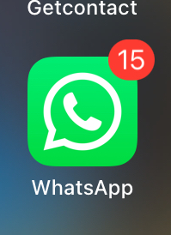
I use WhatsApp to communication with my friend and family. I can send messages, photos and make video calls. It helps me stay connected with people who live far away.

Screenshot/Photo 2
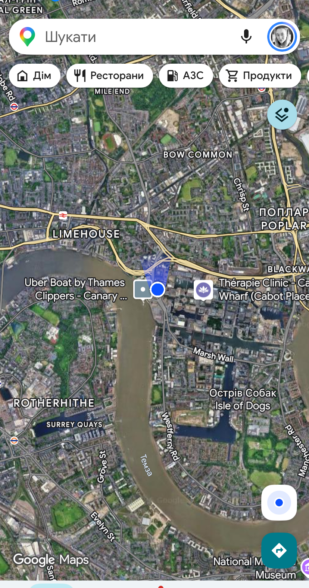
I use google maps to find places and plan my journeys.It helps me find the best routes and use public transport.

Screenshot/Photo 3
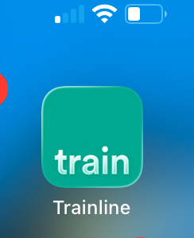
I use train line to plan my train journeys and buy tickets online. I can heck train time, ticket price.

Screenshot/Photo 4

I use SoundCloud to listen music and discover new artist.

Screenshot/Photo 5

I use online banking and card payments to pay for things. I can buy product online, check my balance and transfer money using my phone.

My Short Reflection
- Write 5–8 simple sentences about your digital life.
- You can use the sentence starters below if helpful.
1.I use my Google maps to find places and bus stop
2. I use train line to buy train tickets
3. I use SoundCloud to listen to music.
4.I use online banking to check my balance
5. I use the internet to study and learn English
Gigital technology makes my life easier.

Sentence starters
- I use digital tools to …
- I feel confident when I …
- I want to improve …
- I often use these tools: …
- I sometimes feel nervous about …
- I hope this module will help me …
- Digital skills are important for me because …
You can write more if you want.

Submission Checklist
Before you submit, please check:
​​​ ☒ I added 4–6 screenshots
☒ I wrote short sentences for each screenshot
☒ I wrote my short reflection
☒ My work is my own
☒ My file opens correctly
​​☒ My file opens correctly

