Introduction
It is an exciting time in Welsh education right now because of the new Welsh curriculum being written by Graham Donaldson focusing on new areas of learning which are, expressive arts, health and well-being, humanities, language, literacy and communication, mathematics and numeracy and science and technology that will be announced in 2019. The new curriculum will focus on the children as learners which will make the curriculum all about them instead of about the outcome, Graham Donaldson also has 4 new outcomes for learners which are shown in Figure 1 to provide better individuals.
During this essay, I will be discussing and linking different theories, theorists and current literature to a learning event that I witnessed and discuss how this will positively influence my future practice, while finally linking that to my ideal learning environment.
Observation
Jablon (2010) describes observation within education as a process where practitioners are required to watch and listen to children and record what is said or done. Observations are usually taken place in order to look and listen to children to discover how they are developing, what they are enjoying and how they are interacting within the learning environment (Anning et al, 2009).
The learning event took place in a large school in South Wales, the school was chosen by the university by distance. The school had over 410 pupils and 50 staff and on-site Flying Start. In the schools last ESTYN inspection in 2014 they scored ‘good’ for both their current performance and their prospects for improvement (reference has been removed for anonymity). All ethical guidelines were considered before any observations took place and I familiarised myself with the schools safeguarding policy on arrival. The schools, pupils and teachers’ names have been anonymised throughout the essay following the BERA (2018) guidelines in order to keep the information confidential the names that will be used for the children will be ‘child A’ and ‘child B’ to keep them anonymous. The class was chosen by the school at random, I had one day observing a key stage 2 classroom and one day observing in a foundation phase classroom within this school, but I decided to focus on my foundation phase observation which took place within a nursery class with 27 children aged three, within the class there were 3 LSA’s and 1 class teacher following the 1:8 ratio.
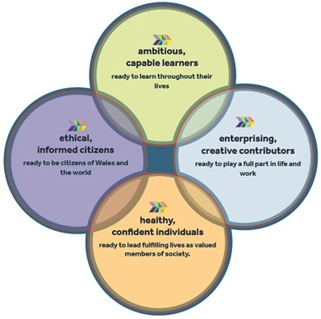
Figure 1: Donaldson (2015)

It became clear during the observations that there were many different learning events happening and I found it difficult to decide which ones to focus on. The learning event I chose took place in the nursery classroom on a Wednesday morning as the children were coming in to the class ready for the day.
8:50am : Nursery Class

Children entering class with parents bringing their coats and bags to their hooks

7 different areas of the classroom set up (usually the same set up)

Songs & Videos played on IWB – Familiarity

Child B watching the video and following directions from the song

Child A watching the Child B to see what they are doing

Child A copying and following instructions from the Child B as they as they repeated the instructions from the song and demonstrated the actions

Both doing the actions to the song

Child B more dominant
*The full written notes from this event will be on the appendix*.
The children spent the whole day together and child A continued to follow child B and follow directions throughout the day both in the classroom and outside.

Figure 2: Observation
The teacher had set up the different areas in the classroom for free play and put on a video on the interactive whiteboard (IWB) as they would any other day, the children were put into a routine when they started school to come in and have free choice when they arrive and for a following half an hour so that the practitioners can discuss the plan for the day and are able to do the register at the start of the day. Getting children into a routine is important within their first few weeks in the classroom and this way of allowing the children to choose their learning and become more ambitious, capable learners linking back to figure 1.
Vygotsky believed that learning takes place when children play which may be why the teacher set up the classroom in that way in the hope that children will learn and develop during the free play session. However, this set up of the classroom created limitations to the children's learning as they had the same activities day in day out and therefore may not be as engaged in the activities. The video may have been a new video which is why child B was engaged in the video although from reflection and analysing the event child B may have been following the song from memory as the child may already know the song instead of following instructions.
The children spent the whole day together and child A continued to follow child B and follow directions throughout the day including in the class and outside but I will only focus on one learning event that happened with these two children during this essay.
I used narrative way of observing for this observation as I was unsure on what I would see and it is such a broad observing technique. I used these techniques in order to get as much information and analyse the class’ daily routine to understand and get the best experience possible. (Tassoni, 2002) describes narrative free descriptions as a ‘snapshot of a child and is a little like filming’, this is exactly true as you can write as much as you like about that child to get as much information to analyse after the observation. I believed that this way of recording data would be easiest when observing different learning events so that I could look back at the notes in time and still understand what each one meant. The benefits to these techniques were viewing the whole class and analysing more than one child and recording as much information as possible in full details for accuracy, although these methods may not be as reliable, while writing about the event I may have missed something important and this can be supported by Szarkowics (2006) who argues that it may be difficult for researchers and observers to record all the data in a short amount of time and because of that something may have been missed, another disadvantage of this way of observing is that the children may be aware that I am sitting near them with a notebook and so they may alter their behaviour causing participant bias (Yardley, 2014) although The Department for Children, Education, Lifelong Learning and Skills (2008, p.11) at the Welsh Government state that ‘when engrossed in their work children are absorbed in the activity and may appear to be unaware of what is happening around them’.
There were other ways of observing that I would consider using next time, these are checklists, photographs and individual narrative way of observing. The checklist way of observing is often used to observe many different things although this is a ‘closed method’ and the data is determined by the observer's judgement (Nilsen, 2013). The checklist would have to be created before arriving and as I was unaware which classroom and year group I would be observing it would be difficult to know what to look for and check off, another downside of this technique is that the observer may just be looking for what is on the checklist and miss something important in front of them this is supported by (Tassoni, 2002) where they discuss that this method is ‘quite narrow’ and it focuses on the observer only looking for the skills on the tick chart. Another method that I considered was photographing although this method would require planning beforehand for consent. Papatheodorou et al (2013) discussed some concerns about this method as observers would need to get parental consent and follow BERA (2018) ethical guidelines not to show faces, this means that those observations couldn’t just be taken on the day and cannot be spontaneous. The last technique observation I considered is the narrative way of observing again but choosing an individual child as this could be interesting to follow one child throughout the day although Papatheodorou et al (2013) discussed that children who know they are being observed are more likely to act out and this may have an influence on the observation and you may not have an accurate representation of that child. This is similar to what I used for my observation as I had focused on one child in this event from afar and didn’t interrupt the learning but after I had viewed this I went back to viewing the classroom as a whole and observed other children so that the children were unaware that I had written anything about them or observed them. If I had to observe a learning event again I would consider other observation techniques but on reflection, the written method used was the correct method as it got as much information I would need to look back on and understand to analyse it further.
From this observation and research I have understood how important observations are and that it is important to know your learners, this is supported by Brodie (2013) who discussed that without knowing your children and understanding their interests and existing knowledge then you cannot plan meaningful, challenging and exciting activities, this is supported by Bilton (2010) who discussed the importance of observations to see what is encouraging quality play, this means that an environment that encourages observations is essential and will be considered in my ideal learning environment to provide engaged learners.
Connect
I decided to focus on this learning event as it has a good representation of scaffolding and Vygotsky’s zone of proximal development and can be linked to many different theories and theorists and these will be discussed, such as social constructivists theory and Vygotsky’s theories, constructivist theories linking to Piaget and Laevers, Bronfenbrenner’s ecological systems theory, Bandura and Montessori. The constructivist and social constructivist approach has been recommended in schools since the 1960s (Jordan et al, 2008).

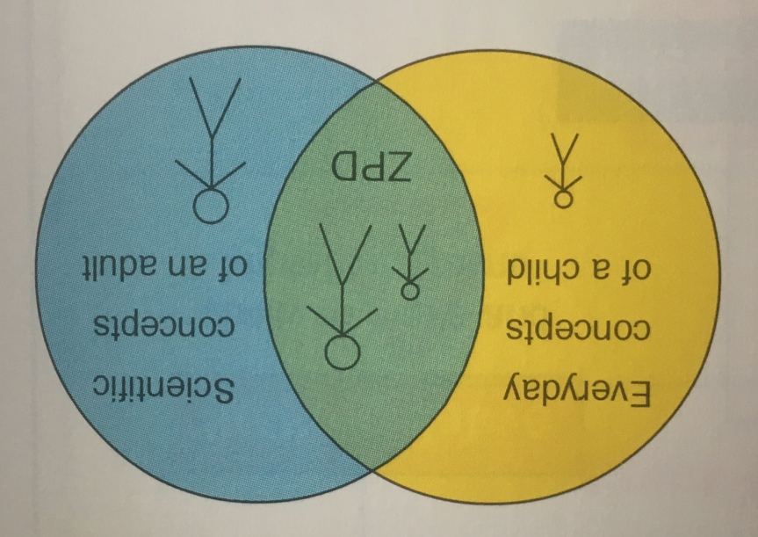
Figure 3: Zone of Proximal Development (Dolya, 2010)

Vygotsky follows the social constructivism theory which believes that learning is social and that children learn from interaction and dialogue with the world and others and make meaning with the social world (Vygotsky, 1978) and that language is a central component to their development and that learning becomes internalised.
This links to the learning event as child A learns from interacting with child B and child A is using their listening skills whereas child B is using their language skills to communicate with the other child. Vygotsky saw language as a tool for social interaction and this could be used to develop the child’s knowledge and through dialogue and communication new and existing understandings can be constructed (Pritchard, 2015) this links to Vygotsky’s Zone of Proximal Development (ZPD). This theory describes how children's development occurs, Figure 3 shows the ZPD connection between what a learner already knows and can do independently and what they can achieve with guidance, support and encouragement from a more knowledgeable person either a peer, teacher or another adult (Dolya, 2010), this links to the event as Child B gave child A the confidence and encouragement to follow the video and the song playing on the screen and they had someone to copy and follow. Vygotsky believes that it benefits both children, the one who is being helped as the interaction will help them develop what they’re learning and the more knowledgeable child benefits as the process of making their ideas more explicit renders the grasp of what they already know clearer and more objective (Pound, 2006). Guldberg (2009) argued that through play and formal education then the zone of proximal development can be reached, this means that it is important that children get the chance to develop through play and there isn’t just a focus on what they can do and that they get the chance to develop within many different areas.
Vygotsky believed that the learner does is more important than the outcome and this is supported by pound (2006) who explained that Vygotsky viewed at ‘how the child went about a task could reveal as much as the score of any test’ and this is supported by Mooney (2000) who discussed that the careful observations are just as valid as the test scores, from this understanding he highlighted that teachers must be keen observers to determine where the children’s learning process is and where it is heading.
Tharp and Gallimore (1988) discussed the four stages that show the learners progression through the zone of proximal development which were:
- Scaffolding is provided by others.
- Scaffolding is provided by learners themselves – for example, by self task.
- Scaffolding becomes redundant as learners act automatically
- Scaffolding is required again if there are changes in the task or context.
These are all elements that affect and support the zone of proximal development.
The constructivist theorists are Montessori, Piaget, Bruner and Laevers, their views are that learners are actively involved in their own learning, are lone scientists trying to make meaning and that they learn by doing and are not passive recipients. The constructivist view is that the teacher facilitates the learning, but use a child-centered approach and this theory is linked to the event as the teacher put on the video and music, but child B chose to teach and tell child A what to do during the video and created their own learning. Constructivists also believe that learning is a result of the child’s exploration and interaction with the environment.
Maria Montessori was influenced by similar ideas and creativity as Vygotsky and therefore her vision is similar to Vygotsky’s but the view is different. Montessori allows the children to have a free flow structure and believes in allowing the children to do things in their own pattern, by allowing them to do that practitioners can then observe to see where the child is at, rather than impose their own ideas on the child of what they should be doing and knowing. Montessori believed that ‘children learn language and other significant life skills, without conscious effort’ (Mooney, 2000. p.24). Montessori also believed that children learn through doing and experiencing life itself (Mooney, 2000).
Piaget was influenced by the work of Montessori who recognised and valued the importance of play as a vehicle by which children could construct knowledge (Halpenny and Pettersen, 2014). Piaget theory is that ‘knowledge comes from personal experience’ and that ‘learning is supported by action’ (Pound, 2006) and this means that they learn from real experiences rather than being told what things are and construct their own knowledge which means they have control over their own learning, Piaget (1972) also believed that teachers should not interfere and impose with the process of children's learning.
Bruner’s theory of cognitive development extends Vygotsky and Piaget’s beliefs that learning is initiated and enhanced by more knowledgeable people. Bruner believed that learning is goal-directed and driven by curiosity. He also believed that learning involved 3 processes which are knowledge acquisition, knowledge transformation and knowledge review (Jordan et al, 2008). Bruner created a ‘scaffolding’ theory from Vygotsky’s ZPD and this is where teachers may provide cognitive support to learners to help them solve problems that they may not be able to do independently (Bruner, 1978). Scaffolding is initiated by guiding, prompting, discussing, questioning and providing stimulus materials. Bruner (1986) used the metaphor of ‘scaffolding’ to explain how effective adult-child or peer interactions provide support and builds a child’s intellectual and social experience to perform at a level beyond their independent capability, within their ZPD (Rogers and Kutnick, 1992). Fernandez et al (2015) describe scaffolding as something that could involve providing feedback to pupils, promoting discussions, asking questions and explaining the structure of a task, this allows pupils to be able to understand where they are and where their development is going to be able to develop further.
Laevers also links to Bronfenbrenner who believes are that the environment influences children’s learning development. Laevers believes that there should be an enabling environment that helps children ‘make connections between previous experiences and between peers, adults and the recourses available to them’ (Pound, 2009) and they are essential to a child’s development.
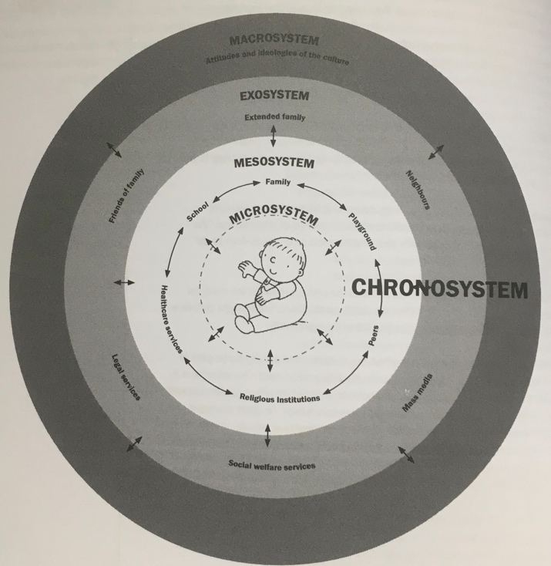
Figure 4: Bronfenbrenner’s Chronosystem (Pound, 2009)
Bronfenbrenner created the ecological systems theory which looks at 4 systems of human ecology, which are shown in Figure 4 which shows the link between the child and the objects around that they interact with. Bronfenbrenner supported Vygotsky’s view of the environmental influences on development although he placed little emphasis on biological and cognitive factors (Pound, 2009). Buckler and Castle (2014) describe Bronfenbrenner’s ecological systems theory as if something happens in one area it can cause a ripple and affect a completely different area. This view linked to the observation as the video was playing in the classroom environment and was just playing for the children to hear as they came in and to encourage the routine in the classroom as videos and songs are always played as they enter in the morning.
Bandura is a behaviourist who believed that external environmental reinforcement was not the only factor to influence learning a behaviour and that there is a reinforcement and reward in an internal form such as pride, satisfaction and sense of accomplishment. He also believed that learning can occur by observing the actions of others, this is called observational learning. Bandura’s theory of observational learning is where people and children learn from one another by observing, imitating and modelling what they are doing. Bandura (1977) explained that "most human behaviour is learned observationally through modelling: from observing others one forms an idea of how new behaviours are performed, and on later occasions, this coded information serves as a guide for action." Banduras theory added a social element arguing that people learn new information and behaviours by watching others. This links to the observation as at first Child A saw the Child B watching and imitating the video and therefore observed him and then joined in while imitating and following instructions. Although child A copied child B, not all imitation and learning through observing is the same and they differ if they take on an active or passive form.
John Dewey describes an important distinction between the two different forms of imitation which are imitation as an end which is when someone copies an act to just repeat the act and imitation with a purpose which is where someone copies an act which is more active and purposeful. Bandura identifies three basic models of observations learning which are a live model which involves an individual demonstrating or acting something out, a verbal instructional model which involves descriptions and explanations and a symbolic model which involves real or fictional characters displaying something in a book, film, television or online. This theory is usually worrying for parents but has a positive view from practitioners as they can provide the children with positive behaviours and they can imitate appropriate things to help them develop.
By carrying out the observations and understanding the theory behind the classroom layouts, reward systems and the structure of the day I have been able to reflect and create my own ideal learning environment and have been able to understand what teaching style I would use within my classroom and have been able to reflect on what kind of teacher I would like to be. I have also viewed the importance of observations within the classroom to view where the children development and interests are at and this will be a main focus within my ideal learning environment. Also considered in my learning environment will be specific areas for discovery so that they can facilitate their own learning with each peer and follow Vygotsky’s zone of proximal development by helping others understand and reach a new area of development.
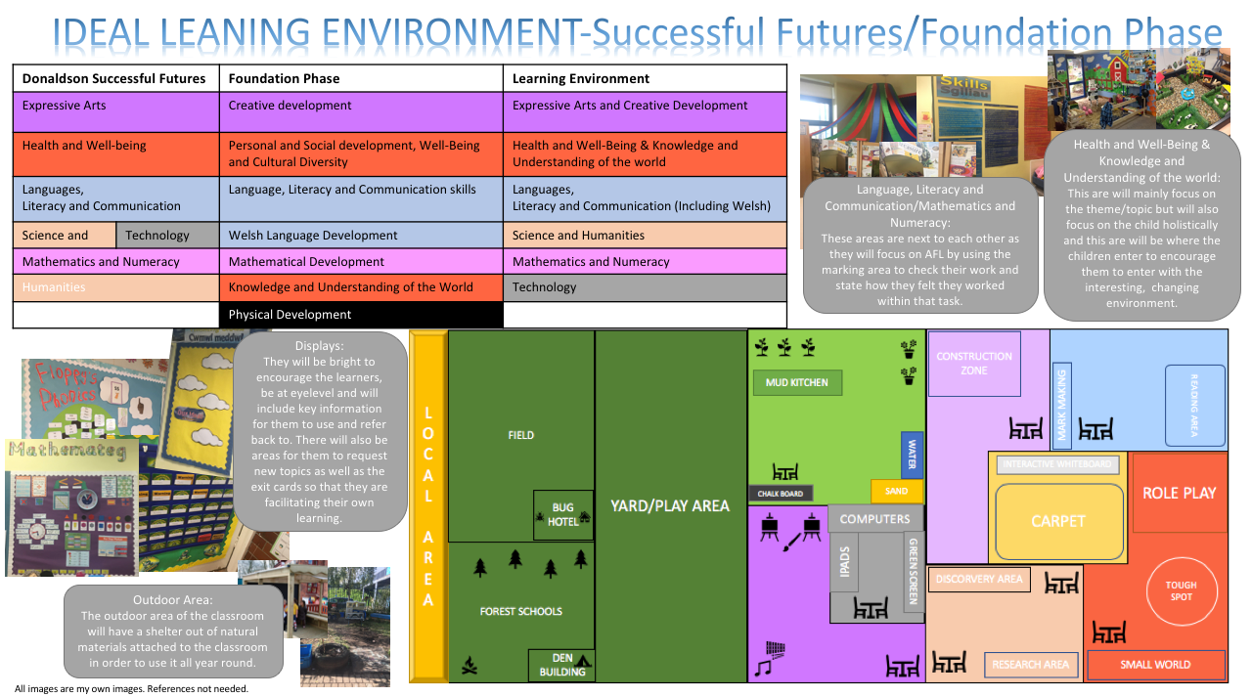
Ideal Learning Environment
Learning environments should engage children and they should provide a positive learning experience for pupils (Herrington, 2006), therefore this section will focus on the different aspects of my ideal learning environment and how they can provide the best holistic development and learning linking to both current foundation phase guidelines and also Donaldson’s successful futures (2015), by looking at these areas I was able to combine all areas of learning to create 6 new areas that I will focus on in my classroom shown figure 5.
Jackson (1998) discussed that the classrooms and schools should be a specialised place with a specialised purpose and “it must house children, staff and recourses in a way which allows them to live, learn and function together in the most effective way possible” these have been considered when creating my ideal learning environment and each area of learning has its own specialised area with relevant resources.
My belief is that children should be able to facilitate their own learning and use their voice and the learning environment should motivate them to do so, this is supported by Bilton (2010) who said “for play to be successful the environment has to be right. It needs to be well planned, involve adults when appropriate, involve plenty of open-ended recourses, have children in control, involve others, involve talking and listening and have lots of time available” this is also supported in Garrick (2004) where he ‘identifies three compelling arguments that underpin the recent emphasis on children’s rights. When adults listen to children's voices, we are respecting the child’s right to be heard; we enhance children’s lives; and we can improve the quality of policies and practice” these are all aspects that have been looked into when creating my ideal learning environment and from this I decided to focus on a child-led approach to my classroom with self-directed activities in different learning areas which follow the Montessori way of teaching to create independent learners and a positive learning environment, although I still believe that there should be some structure for the children, there will be one main work table used in total in that day in one area that a directed focus task will be completed on with a practitioner, Nuthall (2007) supports adapting methods to create a perfect environment for teachers by discussing that in the realities, methods do not exist and that every teacher adapts and modifies methods and theories for their own classrooms which is what I have done.
Bilton (2010) argues that “we have to be wary so we do not kid ourselves and assume that choosing time equals quality play” this is important to consider, relating to what was said earlier by Brodie (2013) that we must observe to see what is engaging the learners. By having self-directed activities I hope that it will promote Vygotsky’s theory of the zone of proximal development and learners will be encouraged by one another and will encourage Donaldson (2015) successful futures outcomes shown in figure 1.
Flow is described by (Pound, 2006) as ‘the deep personal satisfaction that we feel when engaged in something that challenges us, maintains our interest and rewards us in ways that are sometimes difficult to define’, by having an encouraging environment I hope that this will happen within my classroom as this is of high importance as without an encouraging environment they may become disruptive (Mooney, 2000) Bilton (2005) also supports this by discussing that the environment needs to encourage learning and stated that “for play to be successful the environment has to be right. It needs to be well planned, involve adults when appropriate, involve plenty of open-ended recourses, have children in control, involve others, involve talking and listening and have lots of time available” this is how I hope that my classroom is going to be and encourage learners by providing an encouraging, free open space with plenty of choice and recourses.
The classroom will be child centred and the theme/topic will be changed each term or half term depending on the class and learners engagement, the theme/topic will be chosen by the children by using exit cards and I as the class teacher will then choose out of those or use the one that will be the most engaging, this allows the children to become more engaged in their learning and plan their own topics and activities. The themes will allow me to change the different areas regularly especially the health and well-being & knowledge and understanding of the world area shown in figure 5. Although it is important when introduction a new topic that the correct wording and information is used so that they can use the correct vocabulary to promote their creativity and imagination in those different areas, Bilton (2005) also raised concerns that “sometimes practitioners change a play area overnight and children are expected to immediately fall into playing a new role” this will be acknowledged in my classroom as the children will get to choose their themes and topics and therefore they will know that the change in the classroom is coming and they can become prepared and will easily adjust to the change.
Classroom displays will be bright, colourful and clear to understand to encourage learners, they will have keywords on the displays for the children to use, some new words for each topic that they can use and some new words to develop their vocabulary so that they have a variety of words on the wall that they can refer to, these will also encourage their reading if the words are on the wall all around the class.
Welsh will be promoted in each different area with keywords relating to each area of learning on the wall displays so the children will become used to the language and be confident using it. Having a focused area of the classroom for Welsh may restrict the Welsh spoken in the classroom which means that there won’t be one main area for Welsh although Figure 5 shows it classed under the languages, literacy and communication area, but it will be just as important as English within my classroom and I would like to produce confident Welsh speakers within my learning environment following Welsh Government (2018) action plan to produce one million Welsh speakers by 2050.
The classroom will be bright and will encourage natural light in the classroom and would have large windows and patio doors that lead out to the shelter outdoor area of the classroom. Jackson (1998, p.15) discussed that it is important for children with learning difficulties to be surrounded by recourses which make the most of their sensory facilities this will be a focus in the learning environment, especially within my outdoor area. Garrick (2004) emphasises that “outdoor environments afford rich opportunities for physical learning. They also afford opportunities for other important experiences, not easily provided indoors”. Woods (1995) supports the importance of outdoor learning by saying ‘what we do outside at schools feels what happens inside and resources it, and vice versa. It has significance for every curriculum area (p.57). Everything outdoors such as the tables, chairs, water and sand areas will all be made out of natural materials so that the children are using the most out of nature, the area will also grow different fruit and vegetables in the outdoor area so that the children understand what it’s like to grow and care and have responsibility for something but this will also link into the leaning areas such as ‘Health and Well-Being & Knowledge and Understanding of the World ‘ as they will be learning where their food comes from compared to just buying it in a shop.
There will be a Forest School area which will be available to all ages from nursery all the way to the end of ks2 with a firepit and den building activities.
Grigg (2014, p.101) states that ‘the wider school grounds can also be used as a stimulus for children’s dispositions, particularly curiosity’ and this will be supported by the fact that there will not be a limit to just the classroom within my education and will try and provide my learners with as many real experiences as possible, and this means that the children’s learning won’t be limited to the school gates and I will utilise the local area for any topics and themes relating to it.
Livingstone (2012) and Siraj-Blatchford (2003) describe technology an ict as ‘more than just computers’ and is a ‘complex tool which can be used by teachers and by pupils in teaching and learning’ (Higgins, 2001, P.164). There will be a technology area in my learning environment as it is an ever growing, cross-curricular subject in the new curriculum that will be announced next year written by Graham Donaldson. Technology won’t be used individually and will work with the other areas of learning to develop their digital competency that Donaldson (2015) has discussed. The children should already be familiar with the technology in the classroom such as computers, laptops and iPads, Beauchamp (2012) supports this by describing early years children as ‘digital natives’ as they have been brought up around and using technology from birth. Although there will be one main technology area in the classroom the laptops and iPads can be moved to help the learning in the other areas too as technology is such a flexible teaching resource. Overton (2011) believes that by giving children access to technology helps make learning more exciting which is a focus within my classroom that children are excited and engaged in their own learning.

Conclusion
To conclude, the learning event I witnessed showed how simple scaffolding is created within the classroom by providing appropriate engaging activities. The event linked to many different theorists and theories such as constructivism and social constructivism which both believe that learning is encouraged by others and the environment. After witnessing this learning event and gaining a better understanding of constructivist and social constructivist theories, I will use this newly acquired knowledge to improve my future practice. Following on from this, the information I discovered was not only to focus on the children and their learning but there is also a focus on the learning environment and I will be supporting all areas of the foundation phase curriculum and successful futures (2015) within my classroom until the new curriculum is announced. I will support Vygotsky's zone of proximal development in my classroom by having learners as teachers and by having an AFL area in the classroom this will promote capable, informed learners.
Biesta (2013) argued that a busy classroom must not be mistaken for a good one which is important to consider when applying self-directed activities and creating child-led classrooms, the classroom will be child-led but it will be scaffolded so that the children are still learners and not getting distracted. The outdoors, Technology and themes can all have a positive impact on children’s learning and it is important to consider how you set up and use the areas, I have been able to view different views to gain a better understanding of good practice that will help improve my future teaching.

References
- Anning, A., Cullen, J. and Fleer, M. (2009). Early Childhood Education. London: SAGE.
- Bandura, A. (1977). Social Learning Theory. Englewood Cliffs, N.J: Pretice-Hall
- Beauchamp, G. (2012). Computing and ICT in the Primary School. Routledge.
- Biesta, G. (2013). Interrupting the Politics of Learning. Power and Education, 5(1), pp.4-15.

- Bilton, H. (2005) Playing Outside. London David Fulton
- Bilton, H. (2010). Outdoor learning in the early years. 3rd ed. London: Routledge.
- British Educational Research Association (BERA) (2018) Ethical guidelines for educational research. Available at: https://www.bera.ac.uk/researchers-resources/publications/ethical-guidelines-for-educational-research-2018 (Accessed: 8th October 2018).
- Brodie, K. (2013) Observation, Assessment and Planning in the Early Years. Berkshire: Open University Press.
- Bruner, J. (1978). The role of dialogue in language acquisition. In Sinclair, A., Jarvella, R. and Levellt. W. J. M (eds). The child’s conception of language.
- Buckler, S. and Castle, P. (2014). Psychology for teachers. London: SAGE.
- Department for Children, Education, Lifelong Learning and Skills (2008) Observing Children. Welsh Assembly Government AC/GM/0839. Available at: http://learning.gov.wales/docs/learningwales/publications/140828-observing-children-en.pdf (Accessed: 12 October 2018).
- Dolya, G. (2010). Vygotsky in action in the early years. Oxon: Routledge.
- Donaldson, G. (2015). Successful Futures: Independent Review of Curriculum and Assessment Arrangements in Wales.
- Fernandez, M., Wegerif, R., Mercer, N. and Rojas-Drummond, S. (2015) ‘Re-conceptualizing “Scaffolding” and the Zone of Proximal Development in the context of symmetrical collaborative learning’. Journal of Classroom Interaction, 50, 1, pp. 54-72.
- Garrick, R. (2004). Outdoor play in the early years. New York: Continuum.
- Grigg, R. (2016). Big ideas in education. Bancyfelin, Carmarthen, Wales: Crown House Publishing Limited.
- Guldberg, H. (2009) Reclaiming Childhood Freedom and Play in an Age of Fear. London: Routledge.
- Halpenny, A. and Pettersen, J. (2014). Introducing Piaget: A guide for practitioners and students in early years education. Hove: Routledge.
- Herrington, A., & Herrington, J. (Eds.) (2006). Authentic learning environments in higher education. Hershey, PA: Infosci.
- Higgins, S (2001) 'ICT and Teaching for Understanding', Evaluation & Research in Education, (15)3, 164 — 171
- Jablon, J. (2010) ‘Taking It All In: Observation in the Classroom’, Teaching Young Children, 4(2), pp.24-27.
- Jackson M. (1993) Creative Display & Environment. Sevenoaks : Hodder & Stoughton.
- Jordan, A., Carlile, O. and Stack, A. (2008). Approaches to learning. Maidenhead: Open University Press.
- Livingstone, S. (2012) 'Critical reflections on the benefits of ICT in Education', Oxford Review of Education
- Mooney, C. (2000). Theories of Childhood: An Introduction to Dewey, Montessori, Erickson, Piaget and Vygotsky. St Paul, MN: Redleaf Press.
- Nilsen, B. (2013) Week by Week: Plans for Documenting Children’s Development. 6th Edn. California: Wadsworth Publishing Company.
- Nuthall, G. (2007). The Hidden Lives of Learners. Wellington, New Zealand: NZCER Press.
- Overton, L. (2011) Benefits of technology in early childhood classrooms.
- Overton, L. (2011) Benefits of technology in early childhood classrooms.
- Papatheodorou, T., Luff, P. & Gill, J. (2013) Child Observation for Learning and Research. United States: Routledge.
- Piaget, J. (1972). To understand is to invent. New York: The Viking Press
- Pound, L. (2006). How Children Learn. London: Practical Pre-School Books.
- Pound, L. (2009). Contemporary thinking and theorists. London: Practical Pre-School Books.
- Pritchard, A. (2014). Ways of learning: Learning Theories and Learning Styles in the Classroom. London: Routledge.
- Rogers, C. and Kutnick, P. (1992). The Social Psychology of the Primary School. London: Routledge.
- Siraj-Blatchford, J. (2003) Developing new technologies for young children, Stoke on Trent: Trentham Books.
- Szarkowics, D. (2006) Observation and Reflection in Early Childhood Settings. South Melbourne: Thomson.
- Tassoni, P. (2002). Child care and education. Oxford: Heinemann Educational.
- Tharp, R. and Gallimore, R. (1998) Rousing Minds to Life: Teaching, Learning and Schooling in Social Context. New York: Cambridge University Press.
- Vygotsky, L. (1978). Mind in Society. Cambridge, MA: Harvard University Press.
- Vygotsky, L. (1978). Mind in Society. Ed Michael Cole et al. Cambridge, MA:Havard University Press
- Vygotsky, L. (1986) Thought and Language. Cambridge, MA: MIT Press.
- Welsh Government. (2018). 2050: Welsh language strategy action plan. [online] Available at: https://gov.wales/topics/welshlanguage/welsh-language-strategy-and-policies/welsh-language-policies-upto-2017/welsh-language-strategy-action-plan/?lang=en [Accessed 10 October 2018]
- Woods,P. (1995) Creative Teachers in Primary Schools. Open University Press: Buckingham.
- Yardley, A. (2014). Children describing the world: Mixed-method research by child practitioners developing an intergenerational dialogue. Educational & Child Psychology, 31(1). pp.48-62.

