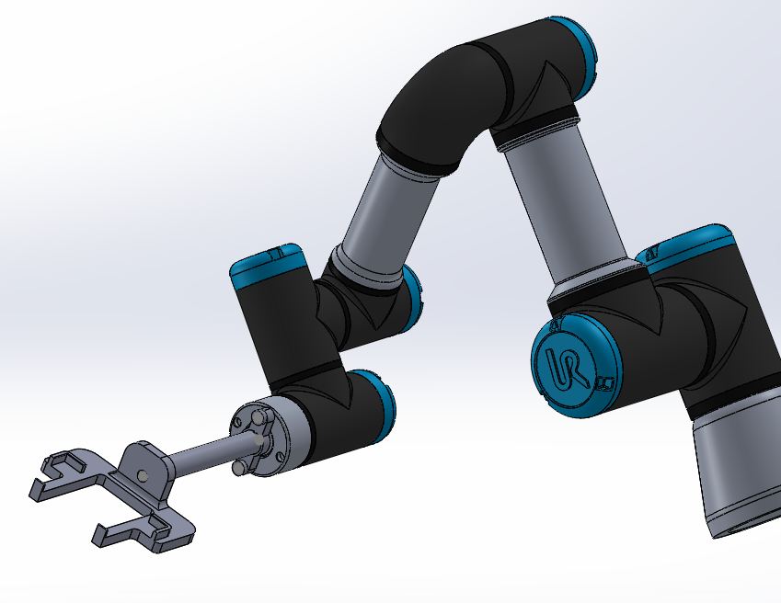
FESTO CYBER PHYSICAL PRODUCTION SYSTEM – GOODS DISPATCH PROCESS AUTOMATION DEVELOPMENT
AMCA5002
NAME: Ryan Harris
Student Number: 2115244
Lecturer: Richard Morgan
Date of Submission: 17/06/2022

Executive Summary
The following report documents the journey taken in the successful design of a robot gripper (end effector). The purpose of the end effector is to provide a solution to the unloading of finished goods from the output station onto an autonomous guided vehicle. The design is to collaborate with a UR3 Cobot manufactured by the company FESTO. To successfully design the end effector, the author utilised key design for assembly and design for manufacturing analysis techniques.
DFA and DFM play a major role in the decisions made by the designer to incorporate key modifications to improve the initial design into the final. The methodology and scoring system are all documented within the report and are effectively used to influence key decisions. In addition to this, Failure Mode Effect Analysis commonly known as FMEA and Quality Function Deployment (QFD) are used as tools to further justify design needs and improvements.
The end effectors final design is a simple, cheap but effective design solution for the intended purpose. With many design considerations undertaken, considering manufacturing processes that would be suitable to manufacture the parts. Computer Aided Design also played a major role in bringing to life the designs and illustrating the modification journey that was taken to reach the final version of the design.

Table of Contents
Executive Summary 2
Table of Figures 4
Introduction 5
Main Body 6
Design Brief 6
Relevant Research 7
Quality Function Deployment 9
The Initial Design 10
Design Evaluation 13
Failure Mode Effect Analysis 15
Modifications 16
Final Design 18
Final Design Evaluation 19
Manufacturing Processes 20
Conclusion 21
Reference List 22
List of Appendices 24
Appendix 1 – B&D Design Efficiency Appraisal Chart 24
Appendix 2 – Lucas DFA Manual Fitting Analysis 24
Appendix 3 – Lucas DFA Manual Handling Analysis 25
Appendix 4 – Modified Dispense Tray Drawing 26
Appendix 5 – Cradle Drawing 27
Appendix 6 – Mounting Plate Drawing 28
Appendix 7 – Extension Rod Drawing 29

Table of Figures
Figure 1 - House of Quality for Robot Gripper 9
Figure 2 - Modified Dispense Tray 10
Figure 3 - Cradle 10
Figure 4 - Mounting Plate 11
Figure 5 -Extension Rod 11
Figure 6 - Version 1 Design 12
Figure 7 - Boothroyd & Dewhurst Design Efficiency for First Design 13
Figure 8 - Lucas Method (Handling Index) for First Design 13
Figure 9 - Lucas Method (Fitting Index) for First Design 14
Figure 10 - FMEA for Robot Gripper 15
Figure 11 - Modified Cradle 16
Figure 12 - Modified Extension Rod 16
Figure 13 - Modified Mounting Plate 17
Figure 14 - Modified Final Design 18
Figure 15 - Final Design Exploded View 18
Figure 16 - Boothroyd & Dewhurst Design Efficiency for Final Design 19
Figure 17 - Lucas Method (Handling Index) for Final Design 19
Figure 18 - Lucas Method (Fitting Index) for Final Design 20

Introduction
The following report details the design process implemented in the creation of a Robot Gripper (end effector) for a collaborative robot (UR3 Cobot). The purpose of the end effector is to provide a solution to the unloading of finished goods from the output station onto an autonomous guided vehicle. To successfully design the end effector, the author utilised key design for assembly and design for manufacturing analysis techniques. Solid works was utilized as the main computer aided design tool.
Design for assembly (DFA) and design for manufacture (DFM) are both critical parts of the design process. It is imperative that a wide range of suitable design analysis techniques are applied to achieve a successful design. There are many benefits to implementing key DFA and DFM techniques, these include development of higher quality products, less time designing as well as lower production costs. This higher quality without increasing the cost is what leads companies to improved sales and an increased market reputation (Quality-One, 2022).
Design for assembly is the simplification of a products structure by reducing the overall components required in the assembly process. DFA aims to improve the overall speed and consistency of the manufacturing process which boosts productivity (Velling, 2021). Design for manufacture is a process that is employed by designers to consider the process, design, material, environment, and product compliance in a bid to ease the manufacture of products, leading to an effective low-cost product (East West Manufacturing, 2020).
In considering the products’ design for manufacture, the author also researched and considered a range of manufacturing processes to help justify the fabrication of the individual parts that make up the product. This was to ensure that parts were designed with material and manufacturing considerations fully examined.

Main Body

Design Brief
Problem Statement:
Industrial control and automation manufacturers Festo want to integrate a Co-bot within its cyber-physical production system. The intended function of the Co-bot is to transport finished goods (mobile phone) from the finished goods station and load onto the autonomous guided vehicle. Festo require a suitable robot gripper (end effector) for the application.
Target Audience:
The target audience is Festo control automation manufacturers as well as University of Wales Trinity Saint David’s engineering department in which the robot gripper will be utilized.
Goals:
The overall goal of the project is to convey the thinking and analysis behind the design process, as well as successfully model and offer a suitable final design that satisfies the target audience as described above.
Specification:
- The Final Design needs to be able to withstand high volume manufacture.
- The gripper must be mechanically actuated.
- The design should be sufficiently robust to withstand sustained use in production.
- The gripper must have the ability to reach the surface of the work part.
- The gripper must not create any sort of distort or scratch on the surface of the Phone.
- The gripper must keep the phone stable and in control during transfer.
- Must be able to hold the weight of the phone.
- Be able to pick up the phone considering top and bottom casing may not be fully fastened.

Deliverables:
- Successfully identify the problem.
- Identify and research relevant Design for Assembly and Design for Manufacture techniques and utilize in the analysis of the design to improve.
- Use Computer Aided Design to Draft version 1 of the Design.
- Evaluate using techniques successfully researched.
- Implement modifications and successfully define the final design.
- Identify the appropriate manufacturing processes for the design.

Relevant Research

Quality Function Deployment (QFD)
Quality function deployment is utilized in industry as a quality tool for new product development. The tool is a critical aspect for the translation of customer requirements (voice of the customer) into manufacturing standards (Stewart, 2017). QFD house of quality is a very powerful tool to use as it utilizes customer desires into design parameters, enabling the final product to effectively meet the customers’ expectations. Many large corporations use QFD as a tool to achieve voice of quality satisfaction. QFD is said to be used by Ford Motor company as one of seven key quality tool linkages, playing a key role in an initiative known as engineering quality improvements program (EQIP) (Al-Mashari, Zairi and Ginn, 2005).
Failure Mode Effect Analysis (FMEA)
FMEA is often used during the design of a new product to prevent possible product failures. FMEA is said to be most effective when implemented at the earliest stage of design conception, continuing throughout the products life cycle. FMEA allows the designer to identify some common failure modes, whether that be from an assembly or product use point of view. Those failure modes are then broken down to the effect and cause of the failure, assessing the severity, occurrence, and detection of the failure. A risk priority number (RPN) is then assigned, and relevant steps can be implemented to help lower the RPN number thus improving the overall design. After reviewing a study into the DFMEA of a centrifugal oil cleaner, it was stated that “FMEA is an effective tool popularly utilized by designers to average out the risks of failures in product development” (Shrotri, 2016), thus proving the effectiveness of FMEA as an analysis tool.
Design for Manufacture (DFM)
- Appropriate GD&T
Geometric Dimensioning and Tolerancing (GD&T) is an essential concept surrounding design for ease of manufacture. It is critical that the correct GD&T is applied to parts, this means using suitable tolerancing selection following standards. The correct tolerancing can be from either end of the scale, from using strict tolerancing to achieve interference fits to using larger tolerancing to ensure that a part can be machined easily. Appropriate GD&T is also a part of understanding the relationship between components during the products assembly.
- The role of CNC (Computer Numerical Control)
CNC is a form of automated machining as a manufacturing process. GD&T feeds into CNC machining when designing parts for manufacture. The symbolic language in GD&T shows the CNC engineer what the allowable variation / room for error is. It basically specifies the requirements and accuracy of the CNC required to machine the parts correctly (CNCLATHING, 2022).
- Material Selection
In the quest for a successful design, material selection is essential in minimising the cost of parts while maintaining the goals to satisfy product performance. Material selection should be at the forefront of design considerations during early conception. The design of a part should be modelled around the material and manufacturing process.

- Manufacturing Process Selection
Markforged (2022) state that “70% of the manufacturing costs of a product can be derived from design decisions like materials and manufacturing method”. Manufacturing process selection is a complex step in bringing the design to fruition. Careful consideration needs to be given to the way in which the part is modelled and the attended assembly process.
Design for Assembly (DFA)
- Boothroyd & Dewhurst Design Efficiency
The Boothroyd and Dewhurst method allows for a quantitative measure which is known as an assembly’s design efficiency. Each part of the intended assembly is analysed against the B&D Design efficiency chart that determines whether a part is “essential” or “non-essential”, this is illustrated in Appendix 1. The essential items are labelled as part A and the non-essential items are labelled as part B. The formula (A/(A+B)) x 100 is then utilised to determine the design efficiency as a percentage. The designer can then analyse the necessity of each part and decide whether it is needed or whether parts can be redesigned to lower the quantity. This perception of determining the necessity of a part allows the designer to increase the design efficiency allowing for an improved overall design.
- Lucas Method
The Lucas DFA method is a critical tool in the relative measure of assembly difficulty. The Lucas method analyses both the manual handling index and manual fitting index for a product. The manual handling index (Appendix 3) scores each component that makes up the assembly against several handling conditions, these include size and weight of the part, handling difficulty, orientation, and rotational orientation. This form of analysis allows the designer to really think of the importance of simplifying the handling process within the product assembly. When analysing the fitting method (Appendix 2), it is important that the designer lists the assembly process for the attended assembly step by step. These steps are reviewed against conditions such as part placing or fastening, Direction, Insertion, Vision, Alignment, and force of insertion required. The goal for the design is to have the lowest score possible for both indexes described, this tool can help identify the parts that require modification.
- Poka Yoke
Designing parts poka yoke is an important process in error proofing the assembly of parts that are deemed critical in orientation or position. An article written by Penton Media (1998) explains the importance of poka yoke designs, proving that products that only go together one way ensure reliable product performance and quicker repair. Additional research indicates that after the implementation of error proofing, a company called Dinaro explained that mistake proofing has led to the single best product the company has produced.

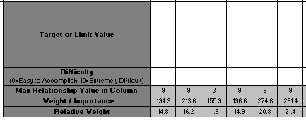
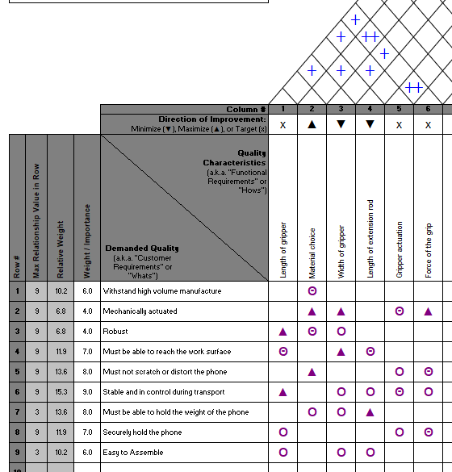
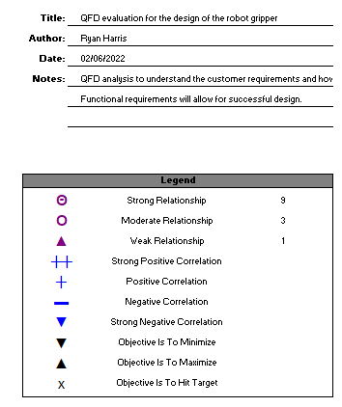
Quality Function Deployment
Figure 1 - House of Quality for Robot Gripper
QFD House of Quality tool was implemented as soon as the problem statement was drafted, highlighting the key customer desires for the robot gripper. It was key to understand how demanded quality could be successfully met. From the QFD the most important factor with the highest weight of importance (WOI) from the customer’s point of view was to ensure that the phone was stable and in control during transport (WOI = 15.3). The most critical functional requirement from the design point of view was perfecting the gripper actuation (WOI = 274.6). After completing the house of quality evaluation, it was clear that the gripper actuation had the highest impact on how successful the design would be, as it was crucial that as much of the customer demanded quality was met. The house of quality tool did not act so much as to focus complete attention on one subject, but it really illustrated key functionality points required to materialise a successful project.

The Initial Design
The initial design was highly influenced by the outcome of the house of quality analysis. The design features four main components that are assembled to create a cradle that essentially picks up the phone from the dispense station.

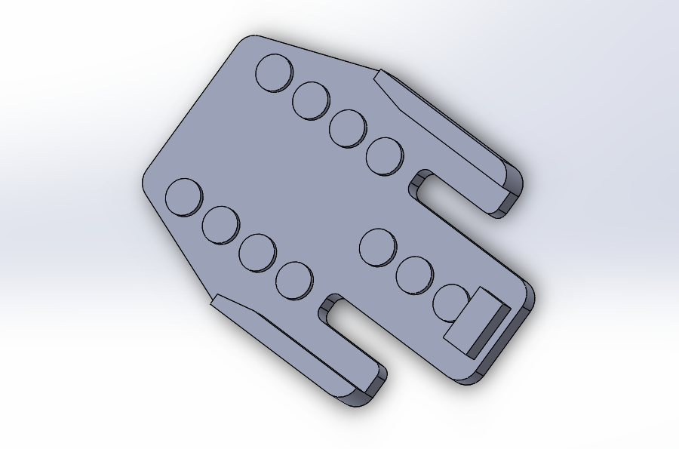

Figure 2 - Modified Dispense Tray

The original dispense tray required modification to suit the proposed gripper design. This included primarily adding 15mm slots for smooth phone pick up. Further dimensions are detailed in Appendix 4.
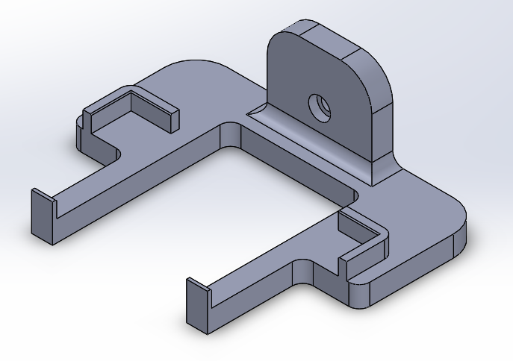

Figure 3 - Cradle

The cradle (Figure 3) was designed in unison with the modified dispense tray. The purpose of the cradle was to be lifted through the slots of the modified dispense tray and secure the phone. The extruded corners were designed to suit the size of the phone. These are 2mm wider than the phone body with chamfers to allow for ease of pick up. Further dimensions are detailed in Appendix 5.

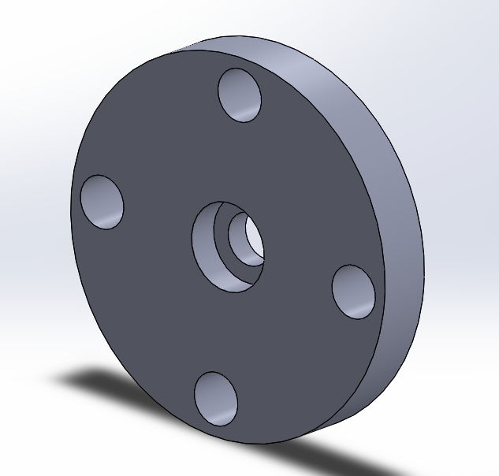
Figure 4 - Mounting Plate

The mounting plate (Figure 4) provides the grippers’ attachment to the Festo robot. This has been designed to mount the design to the robot arm to provide a strong anchor point for the gripper. The extension rod is also fixed to the mounting plate via an M8 screw secured within the counter-bored hole illustrated. Further dimensions are detailed in Appendix 6.
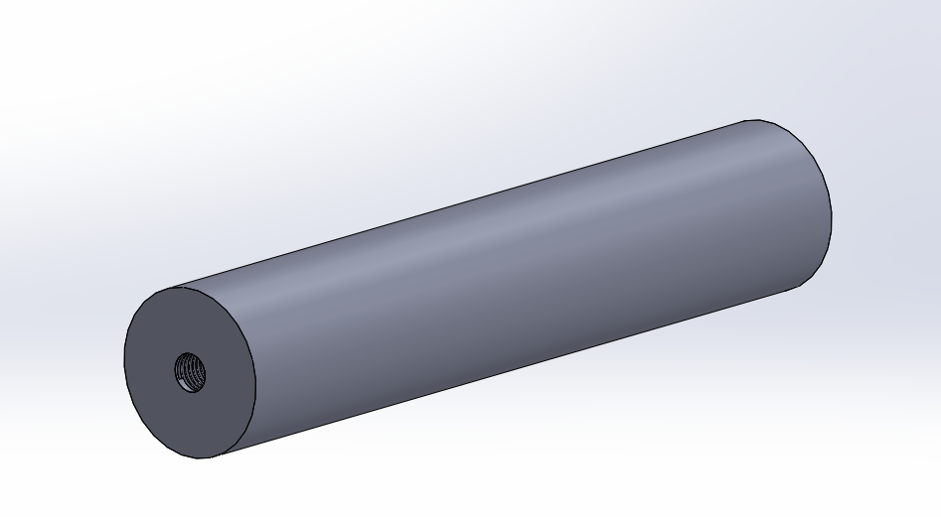
Figure 5 -Extension Rod

The Extension Rod (Figure 5) is attached to the mounting plate via the fastening of one M8 screw, the Cradle is also attached to the extension rod via one M6 screw. The extension rod provides the distance and stability necessary to allow the cradle to pick the phone from the dispense tray. Further dimensions are detailed in Appendix 7.
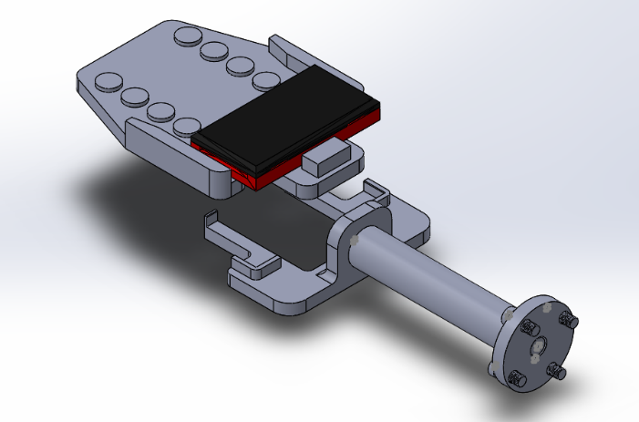
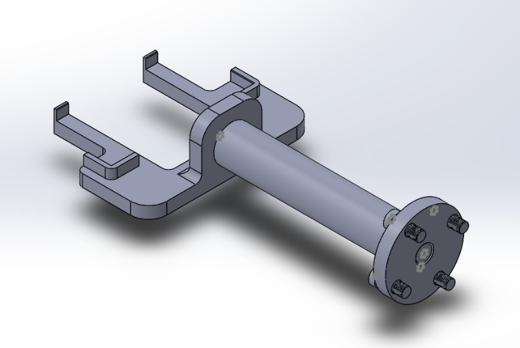
This was version 1 of the design prior to analysing against methods researched. The design itself was fit for function but the design evaluation page allowed the design to become more streamline and effective overall. As you can see from Figure 6, the cradle is designed to intercept the phone by lifting through the modified dispense tray.
Figure 6 - Version 1 Design

Design Evaluation
After the first design was modelled, it was essential that suitable evaluation techniques were utilised to justify and implement improvement modifications. Boothroyd and Dewhurst design efficiency technique was first used to evaluate the current efficiency of the design.
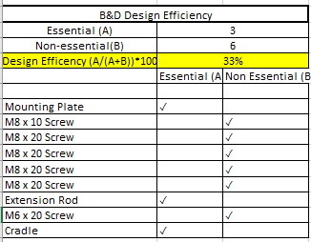

Figure 7 - Boothroyd & Dewhurst Design Efficiency for First Design

Figure 7 shows the results after using B&D design efficiency technique. Each of the parts that made up the assembly of the first design were analysed against the design efficiency chart (Appendix 1) to determine which parts were classed as essential (A) and which parts were deemed non-essential (B). Once this was determined, the design efficiency equation was used to reveal an overall design efficiency of 33%.
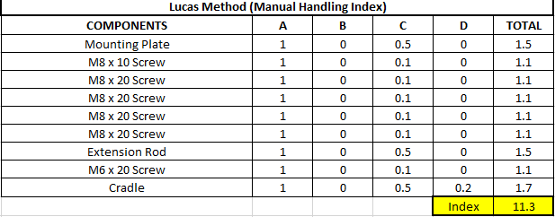
Figure 8 - Lucas Method (Handling Index) for First Design

Figure 8 shows the results of the manual handling index for the first version of the design. The Lucas method was used to highlight the overall manual handling index for the first design using the scoring system (Appendix 3). This illustrated that the cradle had the highest issues when it came to the handling of the component during the assembly. The overall handling index for the first design was 11.3.

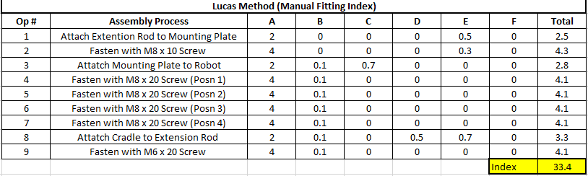
Figure 9 shows the results from the manual fitting index (Appendix 2) for the first version of the design. Similarly, to the manual handling evaluation, this method was utilised to show where the fitting challenges were during the assembly of the proposed design. This highlighted that each of the screws used for fastening the parts together scored very highly which displayed the potential need for modification. The author quickly realised that to reduce the fitting index, close attention needed to be paid to improving the fastening of parts in the assembly.
Figure 9 - Lucas Method (Fitting Index) for First Design

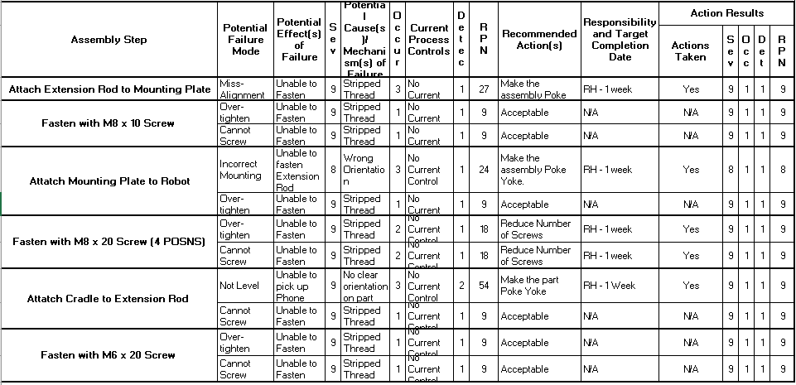
Failure Mode Effect Analysis
Figure 10 - FMEA for Robot Gripper
The FMEA was used to analyse the first design in a bid to identify potential problems with the assembly of parts for the proposed robot gripper. Identifying these issues as early as possible helped to further justify the need for modifications. The FMEA identified two main issues with the first design. The first issue highlighted with the highest RPN number at 54 was the process of attaching the cradle to the extension rod. With the current design, the Main concern was the difficulty in making sure that the cradle remained symmetrical and parallel to both the modified dispense tray and phone. The potential failure mode was the incorrect pick up of the phone which in turn could lead to the dropping of the product. The recommended actions for this were to make the design poka-yoke to ensure that the extension rod was level when fitting the cradle, thus avoiding any assembly difficulties. Attaching the extension rod to the mounting plate had the second highest RPN number at 27, the potential issue identified was miss-alignment causing incorrect fastening of the screw. Again, the recommended action was to make the design poka-yoke to ensure ease of fastening.

Modifications
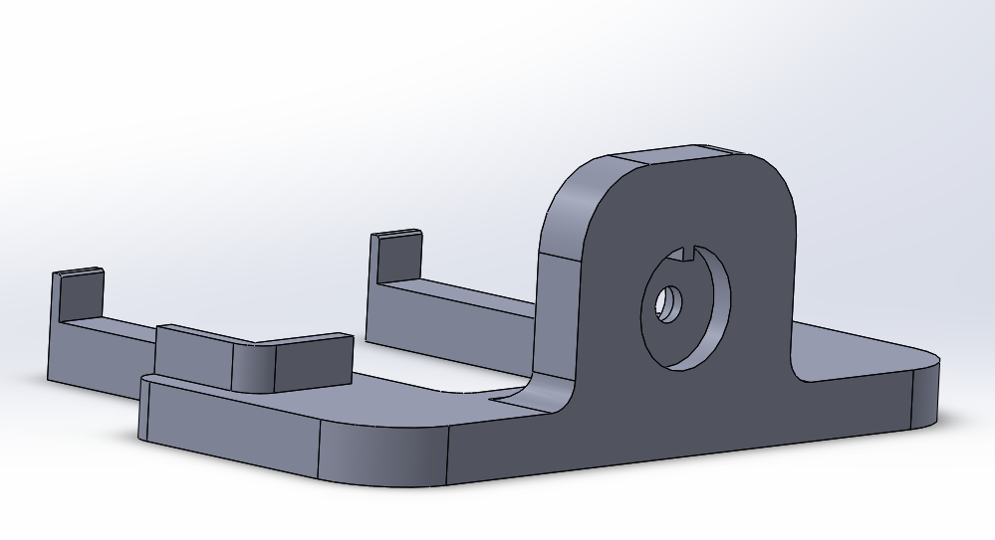
Through evaluating the proposed first design using Boothroyd & Dewhurst design efficiency, Lucas’s method for both fitting and handling index as well as failure mode effect analysis, it was clear that key modifications were required.
Figure 11 - Modified Cradle

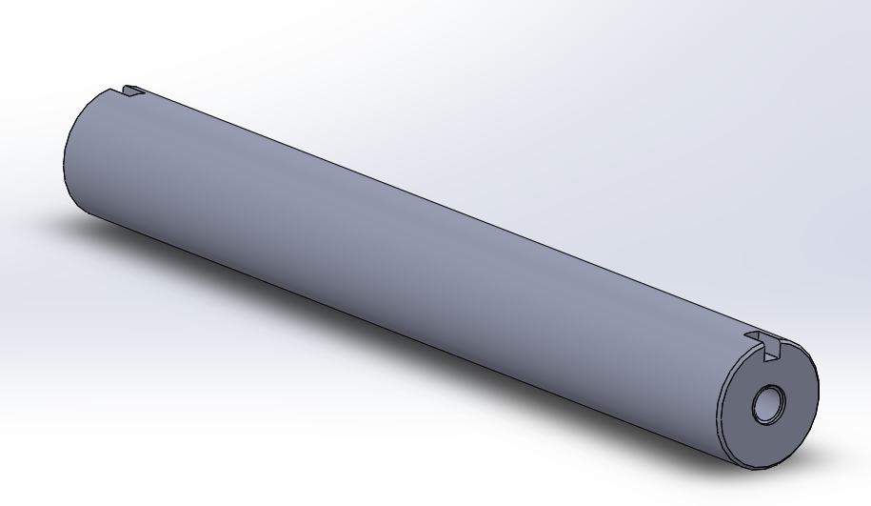
Highlighted by the FMEA, Assembling the cradle to ensure that it was symmetrical was a difficult challenge. The author modified the cradle to have a poka-yoke fitting on the back for ease of insertion of the extension rod further ensuring that the cradle remained parallel with the dispense tray.

Figure 12 - Modified Extension Rod

The extension rod was also highlighted as a potential method of failure. There was also no need for two separate sized screws for the mounting of the cradle and mounting plate. The first change in design was to make each end of the extension rod suit M6, chamfer for ease of insertion as well as poka-yoke slots that would orientate the cradle concentric with both the extension rod itself and the mounting plate.

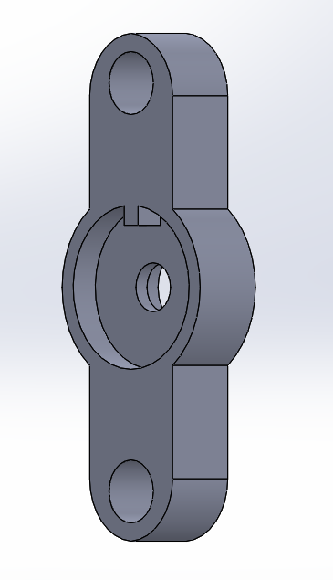
Figure 13 - Modified Mounting Plate

The mounting plate went through some dramatic changes, this included heavy material reduction to make a far more streamlined design with less material usage. Reduction of number of screws required to fit the mounting plate to the robot. As well as a poke yoke fitting to ensure complete concentricity between the extension rod, mounting plate and cradle for ease of assembly. The mounting hole for the extension rod was also changed from M8 to an M6 clearance hole to suit the changes made to the extension rod.

Final Design
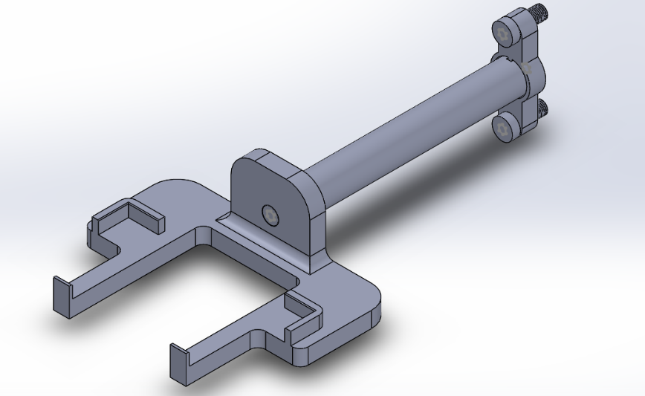

Figure 14 - Modified Final Design

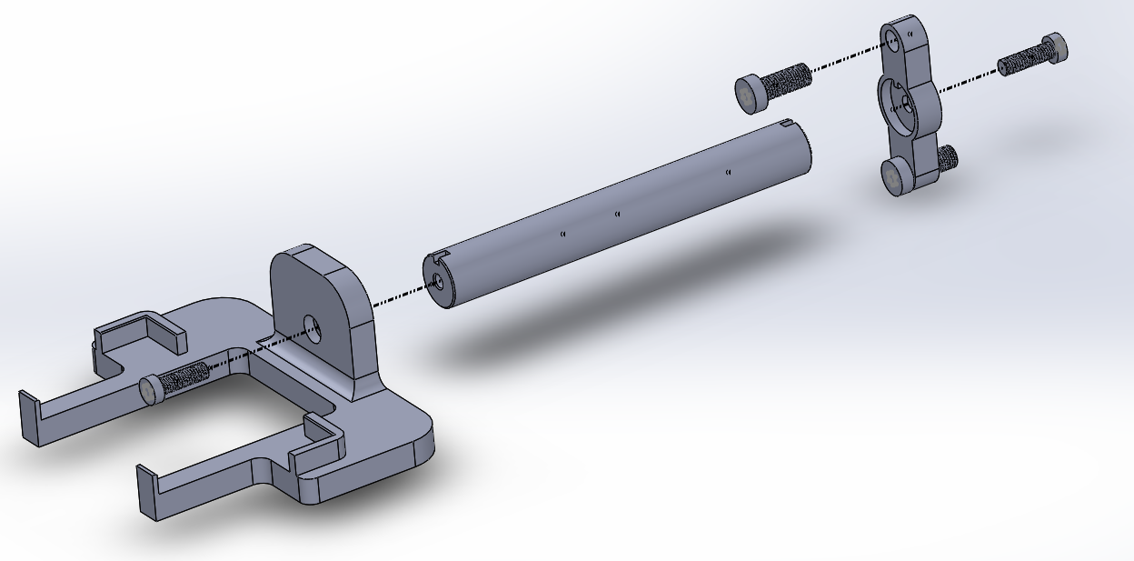
The final design features a thinner extension rod at 20mm diameter that has been modified to implement poka-yoke for both sides of fastening. The mounting plate that is now only fastened in two positions when fitted to the robot arm. This reduction in both common fasteners and material will help to further bolster both the designs capabilities and ease of manufacture
Figure 15 - Final Design Exploded View

Final Design Evaluation
After completing the modifications and finalising the design, it was important to gauge the level of improvements to draw comparison between the initial and final design. As well as possibly further highlighting improvements or opportunities to further increase the designs overall capability.
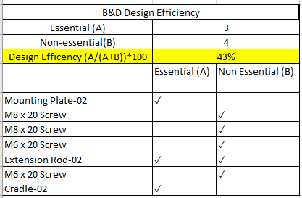

Figure 16 - Boothroyd & Dewhurst Design Efficiency for Final Design

The design efficiency increased by 10% from 33% to 43%. This was due to the removal of parts such as screws that were deemed not essential to the functionality of the design. This had a tremendous impact on improving the designs overall efficiency.
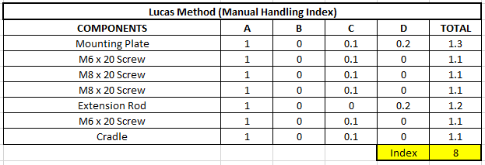

Figure 17 - Lucas Method (Handling Index) for Final Design

The manual handling index improved from 11.3 to 8, this was largely due to the poka-yoke and material reduction changes highlighted by carrying out the both the Failure Mode Effect Analysis and initial Lucas method evaluations. By reducing the diameter of the extension rod by 10mm down to 20mm this allowed for a far lighter and easier to handle part. The mounting plat was also much easier to handle and fit to the robot arm.

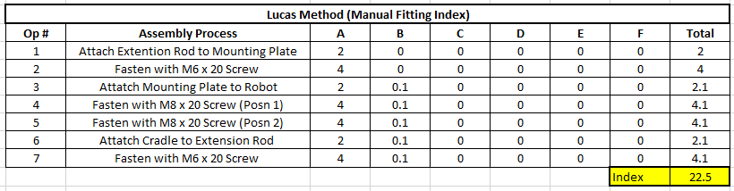
There was also positive movement on the fitting index that was reduced from 33.4 to 22.5. This was a very positive improvement on the designs ease for assembly. Some of the changes that led to this included the reduction of fasteners used, incorporating M6 fasteners to both ends of the extension rod, adding slots and guides on parts to ease symmetrical and concentric fastening as well as the recesses and chamfers added to help stabilise and guide parts for assembly.
Figure 18 - Lucas Method (Fitting Index) for Final Design

Manufacturing Processes
Design for manufacture played a key role in the considerations the author took from the initial design right up until the final. Design for manufacturing is a complex but necessary element in which all great designs are built. As sated by SVV (2022), “Design for manufacturing focuses on reducing the complexity of the manufacturing process”. To show the considerations taken, the designer highlighted the most appropriate technique for each part of the final design.
- Mounting Plate
This part would Ideally be CNC machined from a strong grade of aluminium. Computer Numerical Control (CNC) milling is a machining process that utilizes computer control teamed with high precision machine tools, to subtract material from the work piece creating custom product / parts (Zdraveski, 2022). This would give the part a great strength to weight ratio to function as the anchor point of the design. CNC milling is a fast and efficient method of machining parts, it is highly precise with the integration of CAD/CAM software. This would prove an affordable technique to the manufacture of the part.
- Extension Rod
Due to the long cylindrical design of the extension rod, the proposed manufacturing process for this part would be CNC Turning. CNC turning is again a subtractive machining process, where a cutter is placed against a spinning material to create accurate cylindrical objects. This again is an accurate manufacturing process with high precision. Aluminium Alloy 2024 would be a desirable material to make this part from with its high strength to weight resistance and fatigue strength ideal for the high production volume environment (MetalSupermarkets, 2015).
- Cradle
Due to the complex shape required to create the proposed cradle, the suggested manufacturing method to consider is 3D printing. Multi Jet Fusion printing would be an ideal manufacturing method to continue the prototyping period required to finalise the use of the cradle. This technique is both cheap and accurate, Pick3dPrinter (2022) explain that the technique helps to achieve a high quality of prototypes in no time. MJF has a finesse like no other 3D prototype printing technology.

Conclusion
The project was an overall success, with an effective final design modelled fit for the function intended. The problem was successfully identified when drafting the problem statement, this allowed for the project to not lose its end goal, making clear the deliverables required for success. Often projects can lose focus of the overall goal and overcomplicate matters. This project however had a clear goal from the start which carried right the way through.
DFA and DFM techniques were very well researched. This allowed for the appropriate techniques to be selected and utilised effectively by the designer. The QFD was used well to understand how the customer needs could be met by the appropriate use of design considerations. The Lucas’ Methods, B&D design efficiency and FMEA played a major role in evaluating the design to improve its overall effectiveness, this played a key role in comparing the initial and final designs to detail the journey taken to create a successful design.
Solidworks was used appropriately as a computer aided design tool to model both versions of the design. This allowed the designer to visualise key improvements made and how they would impact on other parts. The CAD models were also key in taking the measurements from the robot to suitably model parts to fit. The CAD software was also used to create drawings appropriate for part manufacture if this is required in the future. Appropriate manufacturing techniques were suggested because of this, with each part having a suggested fabrication method considered.
If there was more time available, it would be suitable to complete Finite Element Analysis (FEA) to further justify the use of appropriate materials and understand the effect they would have on the functionality of the gripper. Also, as cost was not stated, there is room for improvement of the design. The next step would be to possibly introduce pneumatics to grip the top side of the phone. Finally, the gripper offered is more than adequate to complete the job at hand and is a simple, cheap but effective design solution for the intended purpose.

Reference List

Quality-One. (2022) Design for Manufacturing / Assembly, [online] DFM/DFA | Design for Manufacturing / Assembly | Quality-One. (Accessed: 20th May 2022).

Velling, A. (2021) Design for Assembly, [online] Design for Assembly (DFA) Principles Explained | Fractory. (Accessed: 20th May 2022).

East West Manufacturing. (2020) What is Design for Manufacturing or DFM, [online] What is Design for Manufacturing or DFM? (ewmfg.com). (Accessed: 20th May 2022).

Stewart, D. (2017) The Advantages of Quality Function Deployment, [online] The Advantages of Quality Function Deployment (bizfluent.com) (Accessed 25th May 2022).

Al-Mashari, M., Zairi, M. and Ginn, D. (2005) Key enablers for the effective implementation of QFD: a critical analysis, [online] Key enablers for the effective implementation of QFD: a critical analysis | Emerald Insight (Accessed: 25th May 2022).

Shrotri, P, A. (2016) DFMEA of a Centrifugal Oil Cleaner and plan for validation, [online] *DESIGN-FAILURE-MODE-EFFECT-ANALYSIS-OF-A-CENTRIFUGAL-OIL-CLEANER-AND-PLAN-FOR-VALIDATION-OF-THE-DFMEA.pdf (researchgate.net) (Accessed: 25th May 2022).

CNCLATHING JUNYING. (2022) GD&T Basics, [online] GD&T Basics: GD&T Terms, Definitions and Symbols | What is GD&T | CNCLATHING (Accessed: 25th May 2022).

Markforged. (2022) The Importance of Design for Manufacturing, [online] The Importance of Design for Manufacturing (markforged.com) (Accessed:27th May 2022).

Penton Media. (1998) Poka-yoke designs make assemblies mistake proof, pp. 1-4. [online article] Harvard: how to cite an online journal article [Update 2020] - BibGuru (Accessed: 28th May 2022).

SVV. (2022) What is Design for Manufacturing DFM, [online] Why design for manufacturing is important? | SVV's Manufacturing Blog (Accessed: 1st June 2022).

Zdraveski, V. (2022) Understanding The CNC Milling Processs, [online] Understanding The CNC Milling Process | Bit Rebels (Accessed: 2nd June 2022).

MetalSupermarkets. (2015) What Aluminium Grade to Use?, [online] What Aluminum Grade Should I Use? | Metal Supermarkets (Accessed: 3rd June 2022).

Pick3dPrinter. (2022) Multi Jet Fusion Printing Explanied, [online] Multi Jet Fusion (MJF) 3D Printing - Simply Explained - Pick 3D Printer (Accessed: 4th June 2022).

List of Appendices

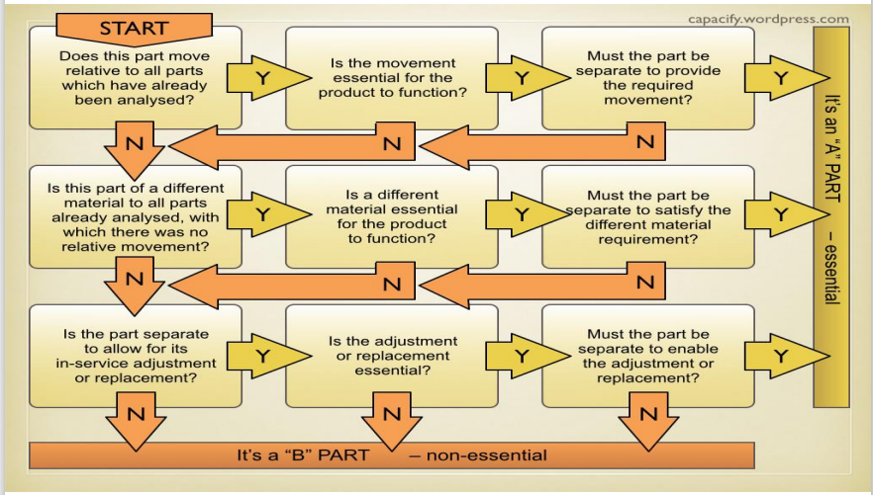
Appendix 1 – B&D Design Efficiency Appraisal Chart

Appendix 2 – Lucas DFA Manual Fitting Analysis
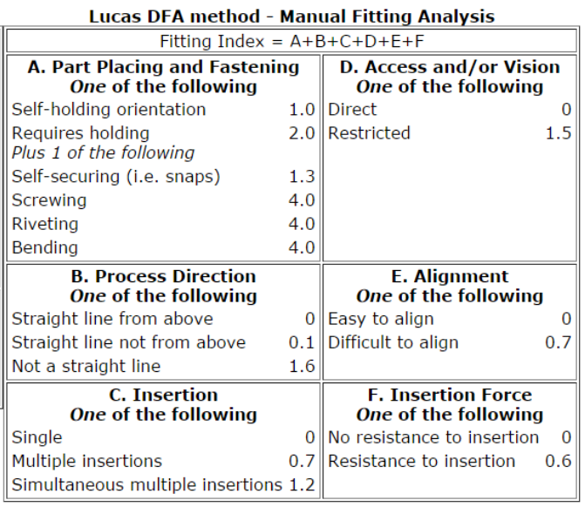

Appendix 3 – Lucas DFA Manual Handling Analysis
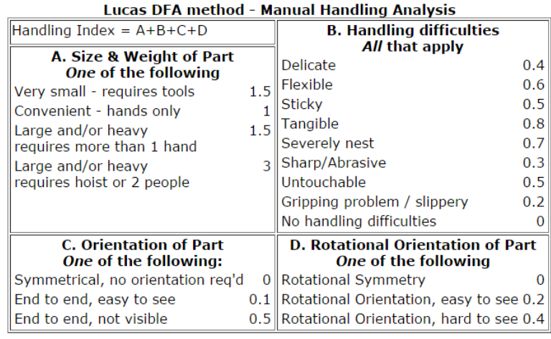

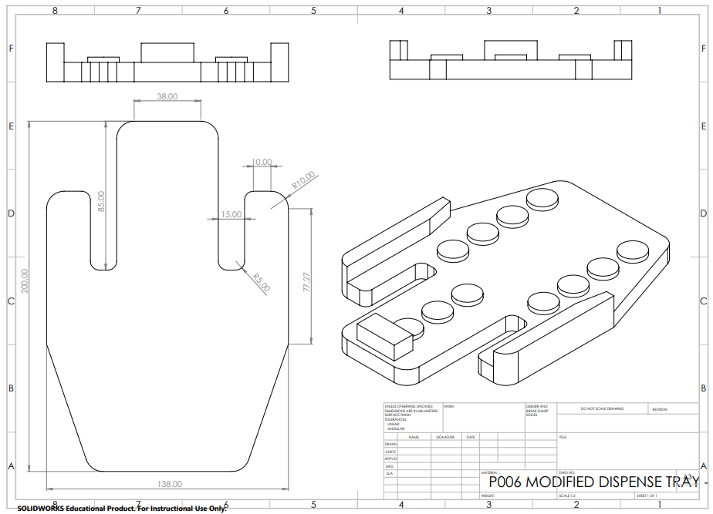
Appendix 4 – Modified Dispense Tray Drawing

Appendix 5 – Cradle Drawing
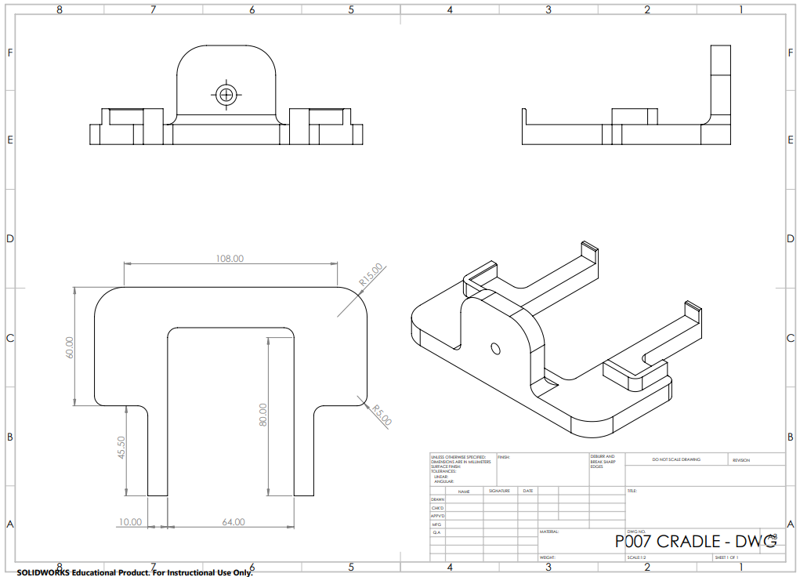

Appendix 6 – Mounting Plate Drawing
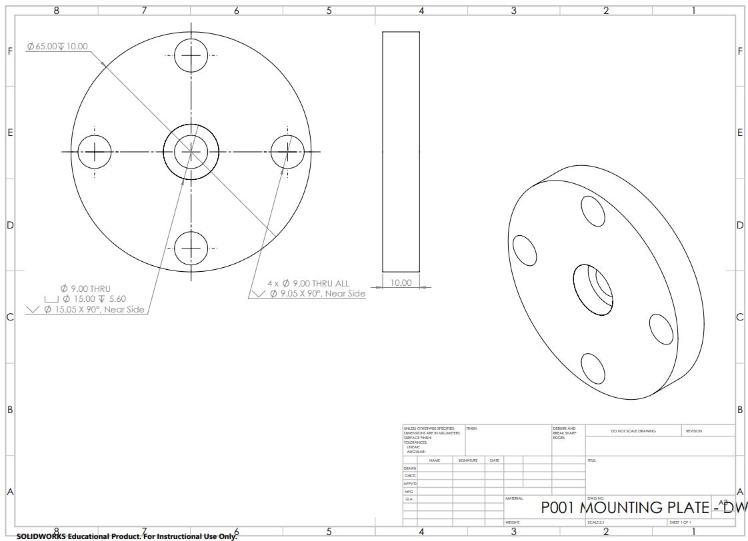

Appendix 7 – Extension Rod Drawing


