STUDENT NAME: Annette Smith

STUDENT NUMBER: 2512419

LECTURER: Christopher Wilkin

MODULE: BMSW4014

ASSESSMENT TITLE: Understanding the Business Environment of the Influencer industry

DATE: 17th July 2026 Time: 23.59
Word Count 1430

Contents Page

- AI Statement
- Introduction
- STEEPLE
- SWOT
- Future Lens DPSIR
- Conclusion
- References
- References
- References
- Appendix

1, AI Statement

I confirm that I have used, Microsoft COPILOT, Google, ChatGPT, Library Research Assistant within my work.

I can confirm that I have copies of my drafts, notes and other resources I used which I may be asked to provide in evidence.

2, Introduction
This report will be discussing what influencers are and how they have used social media platforms to create a significant following by content creating. According to (Jhawar, Kumar and Varshney, 2023) Influencers became popular as social media platforms expanded and marketers increasingly adopted influencer marketing to engage audiences. The popularity of financial influencers among social media consumers is increasing (Singh et al., 2025) According to (Joshi et al., 2023) Influencers first appeared in the early 2000s and have since progressed from a home-based hobby to a lucrative full-time career. Influencer marketing has become so attractive that with the growing industry, there is an ever-growing set of social media users that aim to become an influencer. During the Covid-19 pandemic, social media became the new way of communication as lockdown changed the entire world. Social media platforms such as Tik Tok became popular, especially with teenagers and young mums who felt isolated due to the restrictions that Covid-19 brought. This report will investigate the world of content creators and influencers and discuss how the industry works by performing a SWOT analysis, DPSIR and by using the steeple framework.

3, Steeple Framework
It examines the platform economy through a social, technological, economic, environmental, political, legal, and ethical analysis to offer a comprehensive understanding of its multifaceted effects on key external factors (Sivula et al., 2025) Please see attached appendix 1

4, Swot Analysis
For the swot analysis, this report will investigate the differences between two different levels of influencers. What are the Strengths, Weaknesses, Opportunities, and Threats (SWOT) (Dampson, Iwers and Hayford, 2026) In user-generated content platforms, influencers sort into multiple tiers, with bottomup one-way attention flows. (Chen, Li and Song, 2024) The top tier influencer investigated within this report is Ishowspeed and the up-and-coming influencer investigated is Ella Donnelly. See attached Appendix 2

Firstly, this report will investigate ishowspeed and how his strengths work for him. Ishowspeed has a global following which can in turn work well for him. He has followers on multiple platforms such as TikTok and YouTube. According to (Vaterlaus and Winter, 2021) In total, 52% of young adults reported using TikTok. He currently has 56.3 million followers on TikTok and has 57.5 million on YouTube. With a following of that magnitude, it puts him in a very strong place for having an influence on the followers’ opinions. People follow ishowspeed as he is highly entertaining although controversial at times. He has successfully collaborated with Cristiano Ronaldo. Cristiano Ronaldo has acknowledged him publicly a few times and this alone boosted his global profile. He also collaborated with Kai Cenat and he is a frequent guest appearance on his shows.
He also became a brand ambassador for Beats by Dre in December 2025. He promotes their products to his followers and in return receives free products. According to (Rolando, 2025) well-selected brand ambassadors significantly influence consumer behaviour by fostering trust and creating authentic connections.
Ishowspeeds biggest weakness is his controversial opinions. His behaviours and erratic outbursts can impact on his followers. He constantly pushes his limits with his content to ensure every performance is better than the last one. He is very chaotic and unpredictable which could affect the brands and people he collaborates with. This also limits the audience he appeals too as his behaviours are so unpredictable.
He has potential to grow with opportunities of collaborating with more brands and celebrities.
One of the biggest threats is his outrageous outbursts. This could potentially lead to legal action being taken. He has continuous competition from other live streamers.

Secondly this report will investigate up and coming influencer Ella Donnelly. She currently has 964.3k followers on TikTok. Her biggest strength is her persona as ‘Auntie Ella’. She appears to be very approachable, relatable and very likeable. She is family oriented and regularly has her niece feature in her content. Interactions are built through posted content, captions, comment sections, and the “Story” feature, which helps foster authentic and sustained relationships with followers. (Pangestu, Khumayah and Wihayati, 2026)
Her biggest weakness is the chance of repetitive content meaning followers can get bored of watching but she does her best to keep her content upbeat and interesting. She has faced criticism on her content as people make vile, crude comments about her weight and what she does. This negative attention has revealed her vulnerable side which trolls use to target her. According to (Seth, Ravikanti and Dave, 2026) As online social media usage continues to rise, with platforms such as Facebook, Instagram, and Twitter integrating deeply into daily life, the incidence and impact of cyberbullying have become critical areas of concern.
She has a good opportunity to expand onto other platforms as she already has an established following. This could give her the potential to become a top tier influencer.
She has successfully collaborated with Shein and supports their curve range. She has potential to collaborate with other curve clothing brands and promote a healthy body image. She always dresses well and showcases her Shein hauls to show her followers ideas for holiday clothing etc.
Her biggest threat is her vulnerability. She is an emotional person and documents all her life events putting her at risk of public scrutiny and bullying. She has intense competition from similar content creators so must push hard to keep content relatable, so she runs the risk of burnout.

5, DPSIR

Social media influencers are widely known, especially in the more recent years, for creating content videos to gain large online audiences. They use platforms such as YouTube, Instagram and TikTok to promote their profiles. The DPSIR framework will investigate the influencer culture. According to Gupta et al. (2019) The DPSIR framework stands for Driving Force–Pressure–State–Impact–Response

Drivers
Influencers use social media for multiple reasons but to gain fame and an income is a common reason. Almost everyone has access now to a smartphone or internet, so it is a quick way of becoming a recognised name. Influencers use AI technology to edit their content to get the views they need. Brands often reach out to influencers to promote their products in exchange for free products, payment and this generates a boost in their sales as consumers trust their favourite influencers. Over the next five years, influencers will grow their following quickly as social media platforms keep growing and revolving. AI technology is being used but it is rapidly developing and will continue to evolve. Social media influencers significantly impact both consumer engagement and purchase intention, and they are relatively more effective than brand posts, virtual influencers, and celebrities. (Barari, Eisend and Jain, 2025)

Pressures
Being an influencer needs constant content. They are under pressure to have the latest technology to ensure their content is high quality and relatable. They must have knowledge of AI technology and use it correctly to stay current. Over the next five years, trends will change massively and this increases the pressures for influencers to stay relevant. AI technology will rapidly develop as will the technology available to use it so they must keep their following high to ensure their income. According to Chin, Novacek and Burns Loeb (2026) Social media influencers face several stress factors related to the nature of their work. This includes stress, burnout, emotional exhaustion, depersonalization and reduce personal accomplishment.

State
The influencer industry is currently a very successful marketing industry that uses AI technology to its advantage. Influencers are using AI technology to improve the quality of their content and to keep followers engaged in their content. Almost every popular influencer has collaborated with some sort of brand in exchange for free items or payment and by doing this, it increases the brands sales, and the item starts trending across the platform. The influencer must build trust among their followers and create content that they resonate with and believe, this pulls them into buying the product they are promoting. According to (Ekinci, Dam and Buckle, 2025) Social media influencers are powerful agents as they broadcast information, steer consumer behavior and social norms.

Impacts
There are many positive impacts when it comes to influencers creating content on social media. Influencers are now a paid role so it has created jobs for people who would be unable to work due to childcare issues, disabilities and other personal circumstances. This allows them a sense of self-worth by being able to earn an income.
Popular influencers collaborate with brands, they promote a product and the product is suddenly trending in countries around the world. This allows them to build their businesses globally. The strategic social media partnerships enable increased brand visibility as well as higher credibility for both brands and influencers who draw consumers to their platforms. Khan (2025)
There is also a negative side to promoting online. AI technology can give very misleading information. Influencers promote products not because they are the best on the market, it is because they are paid to and they use the latest AI technology to edit their content to get the right following.

Responses
AI is used daily by millions of people globally and it can make it difficult to determine if content is authentic. There is a lot of misleading information, and it is easy for followers to be manipulated into purchasing. Influencers need to comply with government regulations and ensure that promoted products are clearly labelled as promoted or commission paid.
There needs to be more awareness for mental health challenges that come with being open for criticism and speculation on these platforms as suffering with your mental health is such a difficult challenge to overcome. Influencers could promote mental health campaigns and get the word out to audiences across the world. Adeane and Stasiak (2025)

6, Conclusion
By using SWOT and STEEPLE framework, the research shows that the world of social media is becoming increasingly popular to use to generate an income. There are many challenges that come with this type of profession such as the pressure to stay current and to have the latest digital equipment to make authentic, professional looking content.
Influencers are allowing businesses to trade around the world and reach audiences that potentially they would never have reached. By using the DPSIR framework, it is clear that there are potential solutions to combat some of the negative points which in turn increases marketing and opens communication for future business collaborations.

7, References
1, Adeane, E. and Stasiak, K. (2025). Relatability versus responsibility: Social media influencers on their roles in youth mental health. DIGITAL HEALTH, 11. doi:10.1177/20552076251382026.
2. Barari, M.M., Eisend, M. and Jain, S.P. (2025). A meta-analysis of the effectiveness of social media influencers: Mechanisms and moderation. Journal of the Academy of Marketing Science. doi:10.1007/s11747-025-01107-3.
3. Chen, Y., Li, X. and Song, T. (2024). Influencer Networks. SSRN Electronic Journal. doi:10.2139/ssrn.4744210.
4. Chin,D, Novacek,D.M. and Burns Loeb,T.(2026). The Impact of Non-Traditional Social Determinanets on Health and Mental Health Disparities.Frontiers media SA.
5. Dampson, D.G., Iwers, T. and Hayford, S.K. (2026). The Expansion of Students’ Field Excursions to Ghana into an Exchange Program: A SWOT Analysis of Universität Hamburg and University of Education, Winneba. Diversity, Internationalization and Self-reflection in Teacher Education, pp.71–88. doi:10.1007/978-3-658-49925-9_4.
6. Ekinci, Y., Dam, S. and Buckle, G. (2025). The Dark Side of Social Media Influencers: A Research Agenda for Analysing Deceptive Practices and Regulatory Challenges. Psychology and Marketing, [online] 42(4). doi:10.1002/mar.22173.
7. Gupta, J., Scholtens, J., Perch, L., Dankelman, I., Seager, J., Sánder, F., Stanley-Jones, M. and Kempf, I. (2019). Re-imagining the driver–pressure–state–impact–response framework from an equity and inclusive development perspective. Sustainability Science, 15(2), pp.503–520. doi:10.1007/s11625-019-00708-6.
8. Jhawar, A., Kumar, P. and Varshney, S. (2023). The emergence of virtual influencers: A shift in the influencer marketing paradigm. Young Consumers, 24(4), pp.468–484. doi:10.1108/yc-05-2022-1529.

8, References
9.Joshi, Y., Lim, W.M., Jagani, K. and Kumar, S. (2023). Social Media Influencer marketing: Foundations, trends, and Ways Forward. Electronic Commerce Research, [online] 15(1), pp.1–55. doi:10.1007/s10660-023-09719-z.
10. Khan, A. (2025). Influencers and Brands Successful Collaborations: A Mutual Reinforcement to Promote Products and Services on Social Media. Journal of Marketing & Social Research, [online] 2(4), pp.331–335. doi:https://doi.org/10.61336/jmsr/25-04-42.
11. Pangestu, L.I., Khumayah, S. and Wihayati, W. (2026). The Communication Style of Influencers in Building Interaction With Followers @Thifalislami. Jurnal Polisci, [online] 3(6), pp.800–818. doi:10.62885/polisci.v3i6.1210.
12. Rolando, B. (2025). THE ROLE OF BRAND AMBASSADORS IN SHAPING BRAND AWARENESS ON DIGITAL PLATFORMS. International Journal of Economics And Business Studies, [online] 2(2), pp.28–42. doi:10.1234/ijebs.v2i2.112.
13. Seth, U., Ravikanti, S. and Dave, J. (2026). A Review on Cyberbullying and Its Impact on Future Generations. New Generation Computing, 44(2). doi:10.1007/s00354-025-00313-5.
14. Singh, N., Albishri, N., Galgotia, A., Papa, A. and Del Giudice, M. (2025). Building trust and engagement: a comprehensive framework for analysing influencer credibility in social media. Journal of Enterprise Information Management, pp.1–26. doi:10.1108/jeim-03-2025-0187.
15. Sivula, A., Siakas, K., Naaranoja, M. and Lampropoulos, G. (2025). A STEEPLE Analysis and Information Technology Professionals” Interview Insights Regarding the Platform Economy. International Journal of Human Capital and Information Technology Professionals, 16(1), pp.1–28. doi:10.4018/ijhcitp.394507.
9, References
16. Vaterlaus, J.M. and Winter, M. (2021). TikTok: An exploratory study of young adults’ uses and gratifications. The Social Science Journal, [online] 62(3), pp.1–20. doi:10.1080/03623319.2021.1969882.

Appendix 1
STEEPLE | FACTOR | STAKEHOLDER
Social | 1, influencers use social media platforms to create a following by creating contents sponsored by brands. For example, make up brands, clothing and health gummies.  2, it is important they show they are a genuine, trustworthy influencer as people tend not to engage if the content seems unfriendly.  3, they must keep up to date with the latest trends to keep followers and to gain new ones. | Sponsored companies are high risk and high interest as it is their products being advertised.
Technological | 1, smart phones and camera technology need to be up to date to create quality content videos  2, cyber security to protect accounts from hacking.  3, hacking can threaten a content creators’ business | Branded companies and sponsors and the influencer themselves to ensure they have the right equipment and security. All high stakeholders
Economical | 1, consumer spending affects their success as more people have less disposable income.  2, inflation rates can reduce profit margins as prices increase for software subscriptions  3, exchange rates change quickly and can affect sponsors internationally | Sponsors, followers, brands and the influencers themselves are all high risk
Environmental | 1, climate change can disrupt travel so outdoor content creators may find this difficult  2, environmental regulations are in place to ensure packaging and shipping comply with the regulations set  3, carbon footprint, frequent travel for collaborations, events and photo shoots increases the influencers environmental impact. | Influencer themselves and brand sponsorships will be high risk
Political | 1, government regulations of social media have brought new laws that can affect how influencers create or share their content.  2, trade restrictions may impact partnership with international brands and audiences.  3, political stability, stable political environments generally support business growth while instability can disrupt campaigns and consumer confidence. | International brands and the influencer themselves are all high risk
Legal | 1, Influencers must disclose paid partnerships when they promote products  2, They must protect user data  3, Fines will be issued and accounts can be suspended if the rules are not adhered too. | Influencers are high risk as they can face the fines
Ethical | 1, Influencers must be honest when participating in sponsored content  2, They must consider the impact of their content when using AI technology as this could change content  3, Influencers must be genuine to gain and keep followers trust and business to continue to be a success. | Influencers are high risk as they have consequences to breaking the regulations set.

Appendix 2
 | Top Tier Influencer  IShowSpeed |  | Up and Coming Influencer  Ella Donnelly
Strength | Has a huge following globally across YouTube and other social media platforms  He has successfully collaborated with major creators and celebrities | Strength | She has a growing following of all ages on her tiktok account  She engages well to comments from her followers and is very relatable and honest
Weaknesses | His controversial behaviours and opinions could impact his followers  He would only appeal to a certain audience as his behaviours are so erratic | Weaknesses | Her content can be repetitive  Her following can easily be influenced by online criticism
Opportunities | He collaborates with celebrities  He has huge potential of securing sponsorships | Opportunities | She could expand onto other platforms such as YouTube now she has a big following.  There could be an opportunity to create her own brand of clothing, makeup etc or collaborate with companies to promote
Threats | He could end up in situations that would require legal repercussions.  He has competition from other livestreamers | Threats | She is at risk of burnout. She documents her health issues so has shown her vulnerable side.  She has competition from other lifestyle influencers that produce very similar content to her.

Appendix 3

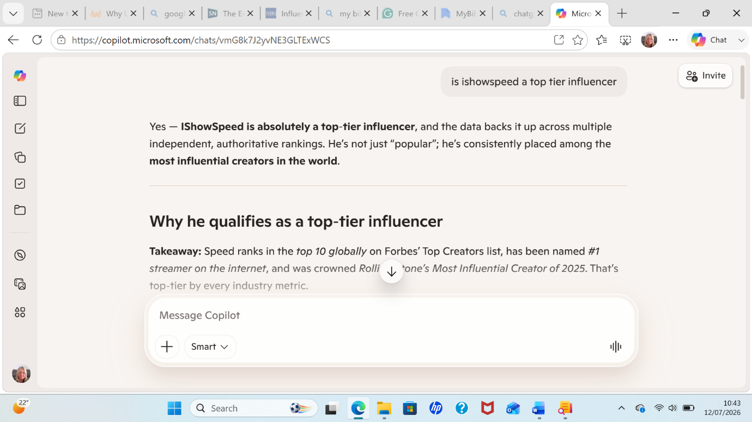

Appendix 4

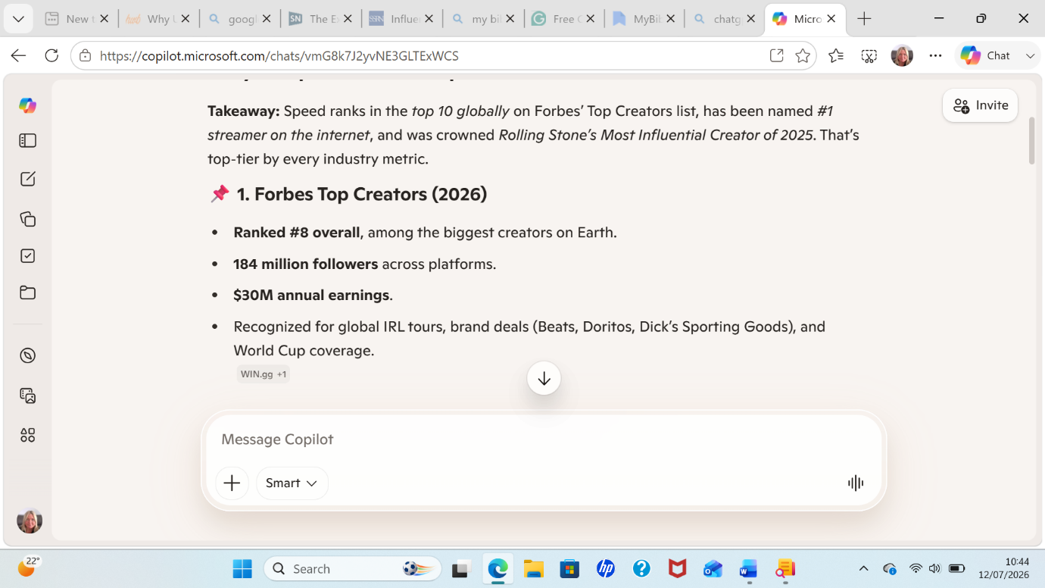

Appendix 5

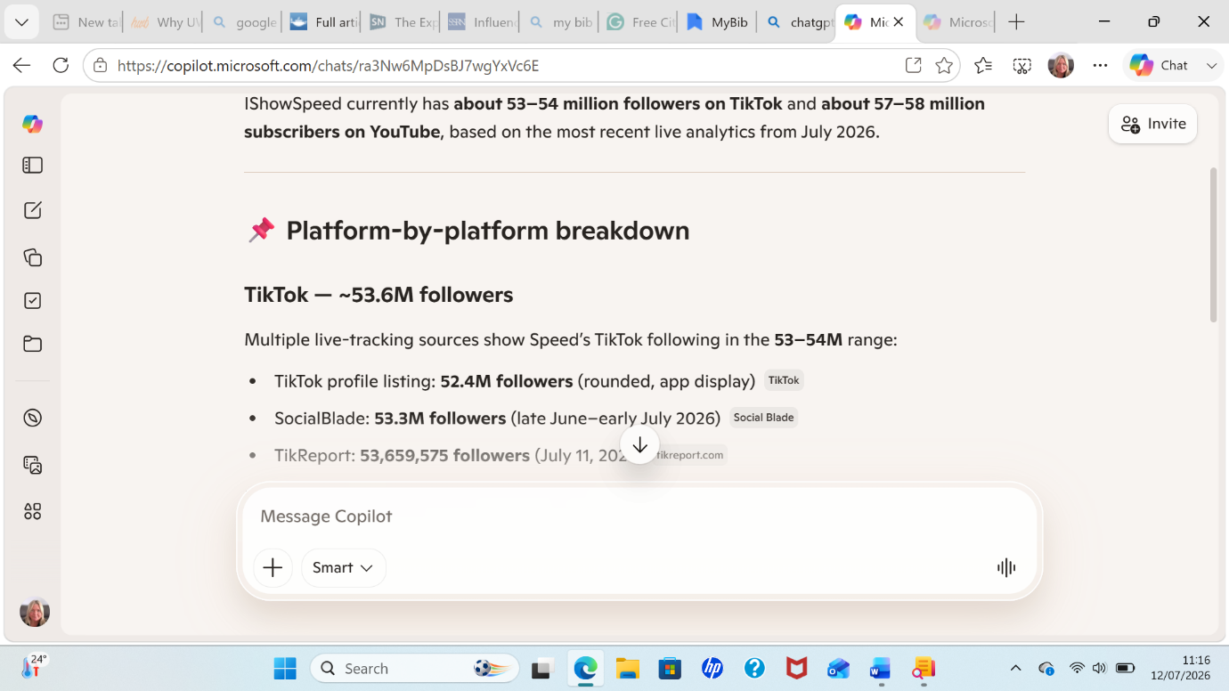

Appendix 6

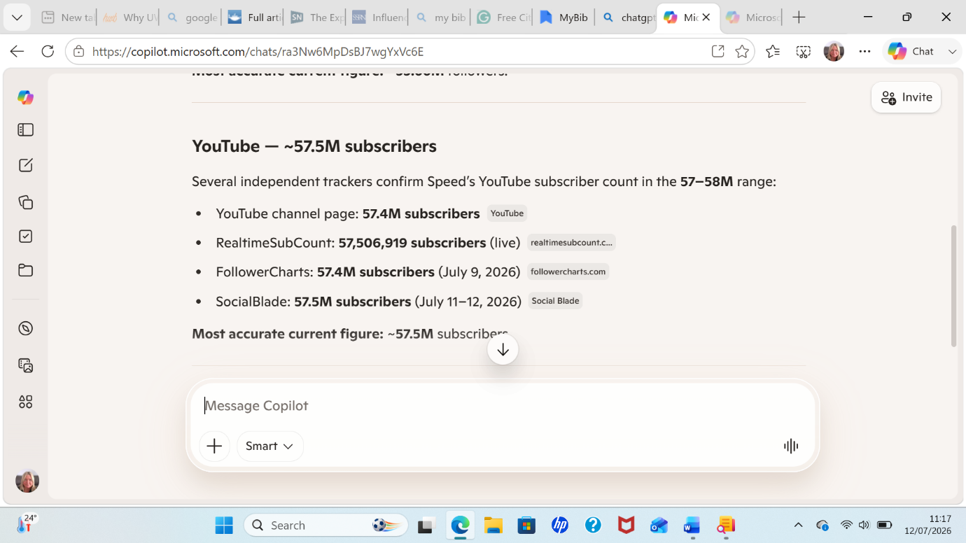

Appendix 7

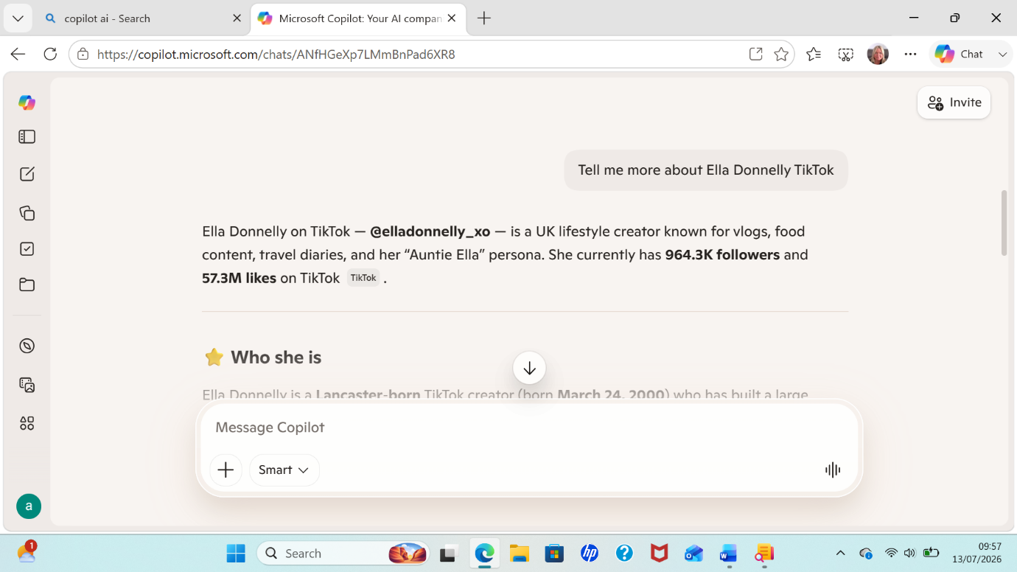

Appendix 8



