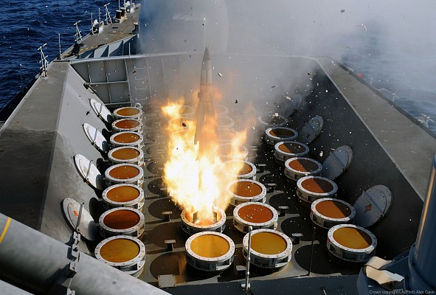
Cover Image 1: A GWS.26 Sea Wolf Missile launches from a Type 23 Frigate. [5] [7]© Crown Copyright Royal Navy

SEA WOLF GWS.25 AND GWS.26 PROPELLANT STABILITY
ALARP JUSTIFICATION

Silas Blevins | OME Degree Apprenticeship (BEng) | ACDB5013

Abstract
The Sea Wolf GWS.25 and GWS.26 are a family of Anti-Aircraft Missiles deployed with the Royal Navy from 1979 until 2020, and still in service in a number of nations around the world [1]. As with all energetic articles, there are a number of risks present throughout the life cycle from manufacture to firing or disposal. For this reason, a set of risk assessments [2] [3] were conducted to identify the risks and hazards associated with the long-term storage of Sea Wolf missiles in ashore depots. Amongst the risks identified was the risk of unintended initiation of the missile’s propellant due to aging and decomposition of the energetic material resulting in increased sensitivity. This report discusses how conducting regular monitoring of the rocket motor and carrying out analysis and testing can reduce the risk of motor failure to a point that it can be considered As Low as Reasonably Practicable (ALARP)

Table of Contents
Abstract 2
Table of Figures 4
1 Introduction 6
1.1 Sea Wolf Missile Overview 6
1.2 Cast Double-Base Propellants 7
2 Risks and Hazards 8
3 Mitigations 10
3.1 Aging Studies 10
3.2 Climate Control 10
3.3 Audits (Closed and Open Box) 10
3.4 Quantitative Chemical Analysis 10
3.4 Small Scale Hazard Testing (SSHT) 11
4 Conclusion 12
5 References 13

Table of Figures
Cover Image 1: A GWS.26 Sea Wolf Missile launches from a Type 23 Frigate. [2] [3]© Crown Copyright Royal Navy 1

Figure 1: A Sea Wolf GWS.25 launches from a Sextuple Launcher on board a Type 22 Frigate [5] [15] © Crown Copyright Royal Navy 6
Figure 2: A Sea Wolf GWS.26 Launches from a Vertical Launch System on board a Type 23 Frigate [5] [7] © Crown Copyright Royal Navy 6
Figure 3: The Chemical Formula of Nitroglycerin [11] 7
Figure 4: The Chemical Formula of Nitrocellulose [12] 7
Figure 5: RIsk Severity Definitions drawn from [13] 8
Figure 6: Risk Likelihood Definitions Drawn from [13] 8
Figure 7: Risk Rating Matrix Drawn from [13] 8
Figure 8: Risk Rating Definitions Drawn from [13] 9
Figure 9: The makeup of a typical CDB Propellant [9] 11

1 Introduction

Sea Wolf Missile Overview
The Sea Wolf GWS.25 and GWS.26 are a family of short-range Surface-Air Missiles in service with the Royal Navy from 1979 to 2020, and still in service elsewhere in the world [1]. The GWS.25 version of the missile is a single-stage vehicle, propelled by a Blackcap solid rocket motor and equipped with a 14kg HE-F warhead to destroy aircraft [4]. The GWS.26, or Vertical Launch Sea Wolf (VLSW) utilises the GWS.25 as an upper stage, and uses a booster stage to increase engagement range from 6 to 10km, and allow the missile to be launched from the Vertical Launch System (VLS) on board the Type 23 Frigates [5]. In both variants of the missile, a Cast Double-Base (CDB) Propellant is used in the motor [6]. The images below show the differences between the GWS.25 and GWS.26 variants.
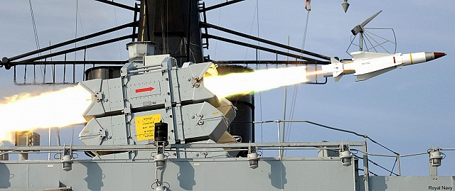
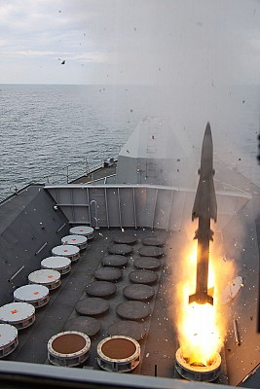
Figure 1: A Sea Wolf GWS.25 launches from a Sextuple Launcher on board a Type 22 Frigate [5] [15] © Crown Copyright Royal Navy
Figure 2: A Sea Wolf GWS.26 Launches from a Vertical Launch System on board a Type 23 Frigate [5] [7] © Crown Copyright Royal Navy

Cast Double-Base Propellants
The Propellant in the Sea Wolf’s Blackcap Motor is a Cast Double-Base propellant, common in UK and other European missile designs [6] [8] [9]. To define this propellant type, it is helpful to define both ‘Double-Base’ and ‘Cast’. The term ‘Double Base’ is used to describe energetic compositions which are made of a combination of Nitrocellulose (NC), and another explosive, often Nitroglycerin (NG) (although other explosives such as TNT and RDX have been used) along with inert components such as chemical stabilisers [10] [9].
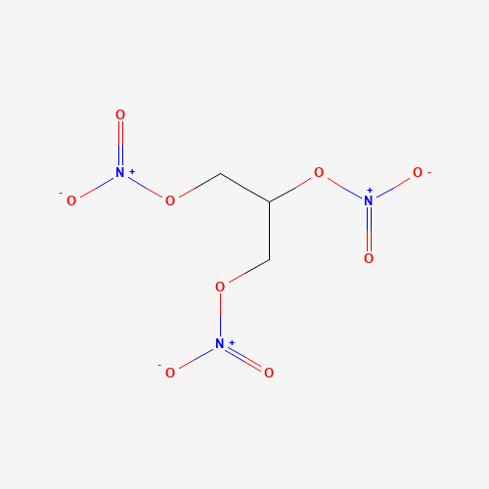
Figure 3: The Chemical Formula of Nitroglycerin [11]
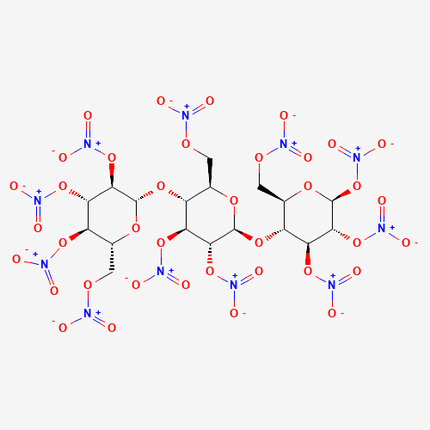
Figure 4: The Chemical Formula of Nitrocellulose [12]
The ‘Cast’ component of the Cast Double-Base name refers to the mechanism by which the propellant is formed and manufactured, in which the composition is cast into the desired shape to give the required cross section and surface area for the expected propellant burn [9]. This is as opposed to the more traditional extrusion method of manufacture, which is limited to an approximately 35cm diameter and cannot be case bonded. Whilst CDB propellants do include stabilising compounds, the nitrate esters are still prone to chemical decomposition over time, especially at high temperatures and this can have detrimental impacts on the sensitivity and performance of the propellant.

Risks and Hazards
The risk assessments [2] [3] carried out identified a critical risk posed by the inherent chemical instability of CDB propellants. The hazard was identified as blast, flame and projections caused by unintended initiation of the rocket booster, with increased sensitivity due to chemical aging being identified as the cause. It was identified that if this was to occur, the potential for harm would extend to Direct and Indirect personnel, personnel in training, 3rd Parties and Members of the public. Whilst existing mitigations such as only storing the missile inside of the official lifetime of the propellant (provided by the manufacturer), and the separate storage of warheads and motors were present, it was still assessed that an event of this kind was ‘Very Likely’ with ‘Critical’ Severity, resulting in a ‘Very High’ initial risk rating.
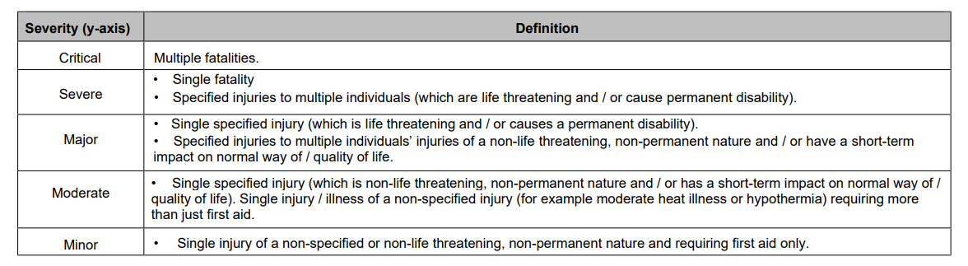
Figure 5: RIsk Severity Definitions drawn from [13]
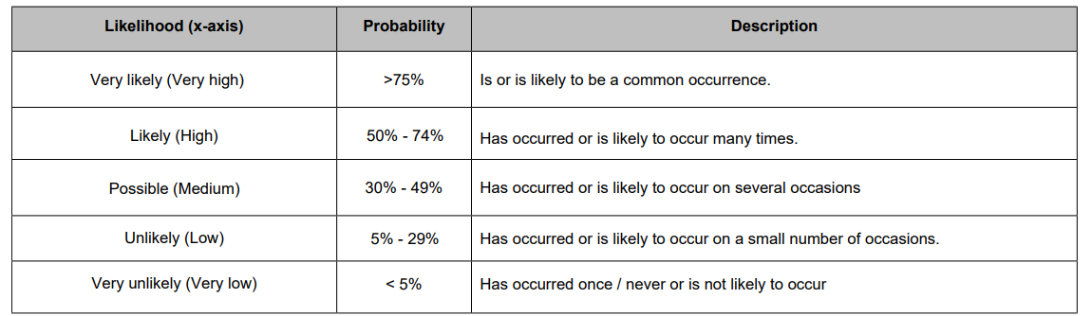
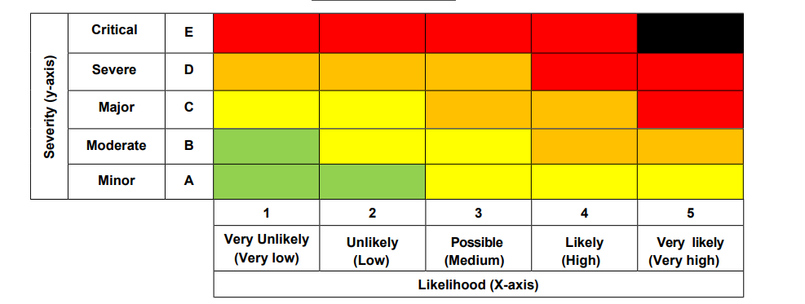
Figure 6: Risk Likelihood Definitions Drawn from [13]
Figure 7: Risk Rating Matrix Drawn from [13]
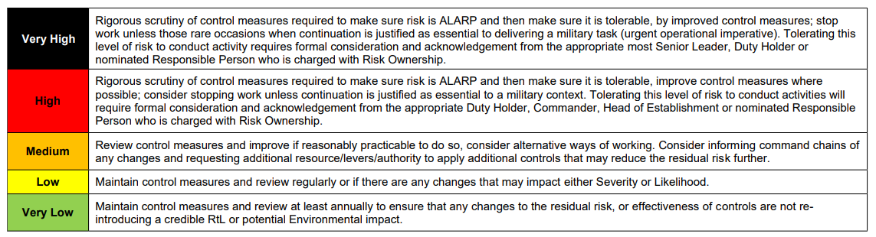
Figure 8: Risk Rating Definitions Drawn from [13]
As shown in Figure 8, a risk with an initial rating of ‘Very High’ requires intense scrutiny of control measures to demonstrate ALARP compliance. Section 3 proposes new controls to enable the risk rating to be reduced and made ALARP.

Mitigations

Aging Studies
The chemical aging of nitrate esters discussed in [9] can be accelerated by heating the propellant in an oven, resulting in years of aging being simulated in the space of hours or days. Using the analytical techniques laid out below in sections 3.4 and 3.5, the quantities of energetic and inert components in an artificially aged sample can be determined, along with its sensitivity to stimuli, in order to estimate a safe storage time before any munitions are placed in long term storage.

Climate Control
One of the main factors accelerating the decomposition of the nitrate esters in the propellant is temperature [9] and so ensuring that the munitions are stored in suitable conditions will reduce the rate of decomposition to a minimum. (Find sources and temperatures). Therefore, the facilities used to store and process the munitions should be fitted with temperature control which can operate within the required range. In addition, where climate control is not available, such as during transportation, the time spent outside of a climate controlled store should be kept to a minimum (transport vehicles should make stops only when absolutely necessary, journeys should take the shortest route between depots, and transport should only occur when operationally necessary)

Audits (Closed and Open Box)
Whilst the munitions are in storage, they should be regularly audited to check for obvious defects. Closed box audits involve inspecting the packaging of the munition to confirm that there are no obvious leaks, and that the box seals have not been broken. To confirm the condition of the munition, open box audits should be carried out at least once a year. This involves opening the storage container to physically inspect the munition, looking for any obvious damage or discoloration which may be indicative of a defect with the munition. Suspect munitions should be placed into segregated storage for further analysis and potential disposal. Since this activity constitutes energetic processing, it should be conducted in a licensed process building as opposed to the storage facility, and in line with an appropriate processing Risk Assessment and Method Statement.

Quantitative Chemical Analysis
The application of analytical chemistry to explosives is incredibly broad, and a full method description falls outside the scope of this report, however a quantitative technique such as Ultra High Pressure Liquid Chromatography (uHPLC) can be employed to determine the makeup of an energetic sample. By comparing the uHPLC results of a sample (taken from a munition in storage, broken down to extract the propellant) to those of a range of reference standards, the quantity of target components (NC, NG, Stabilisers) can be determined. This can then be compared to the baseline quantities in the propellant at the time of manufacture to determine how much (if at all) the propellant has degraded with time. The table below shows an example of the makeup of a CDB Propellant.
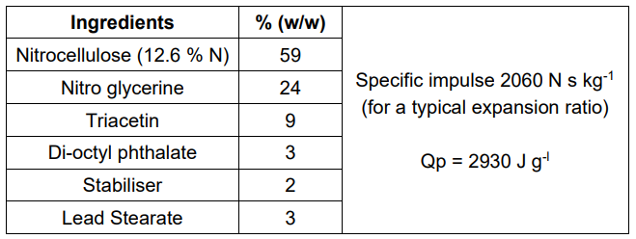
Figure 9: The makeup of a typical CDB Propellant [9]

3.4 Small Scale Hazard Testing (SSHT)
Small Scale Hazard Testing (SSHT) is used to determine the sensitivity of an explosive to common stimuli, such as shock, heat, static discharge, and friction [14]. This can be applied to samples of the Sea Wolf Propellant to determine the effects of aging on the sensitivity of the propellant. If a sample shows increased or decreased sensitivity to stimuli, it suggests that the composition has aged to the point that the risk of failure is more significant, and so the batch of munitions from which the sample was taken should be quarantined and marked for disposal.

Conclusion
Within the scope of the risk assessments [3] [2], the primary risk posed by degradation of the propellant was determined to be unintentional initiation of the propellant during movement or processing due to increased sensitivity, with an identified risk rating of ‘Very High’ With no mitigating factors in place, this risk was deemed to be unacceptable. However, if the mitigating factors identified in section 3 were to be implemented in the form of an initial aging study of the propellant to determine an initial storage lifetime, supported by regular in-service surveillance by means of audits, chemical analysis and SSHT, the chemical condition and sensitivity of the propellant will be known at all times, and the risk rating was reduced to ‘Medium’ and as such be deemed to be ALARP, and as such any residual risk can be accepted.

5 References

[1] | NavyLookout, “From Sea Wolf to Sea Ceptor the Royal Navy's Defensive Shield,” NavyLookout, 4 June 2019. [Online]. Available: https://www.navylookout.com/from-sea-wolf-to-sea-ceptor-the-royal-navys-defensive-shield/. [Accessed July 2024].
[2] | S. G. Blevins, Q. Dunbar, J. Eardley, B. Flannigan and L. Smith, “Sea Wolf Depot Storage Risk Assessment,” UWTSD, Swansea, 2024.
[3] | S. G. Blevins, “Sea Wolf GWS.25 and 26 Depot Storage Risk Asessment,” UWTSD, Swansea, 2024.
[4] | WeaponSystems.net, “GWS-25 Sea Wolf,” WeaponSystems.net, [Online]. Available: https://weaponsystems.net/system/1389-GWS-25%20Sea%20Wolf. [Accessed July 2024].
[5] | WeaponSystems.net, “Vertically Launched Sea Wolf,” WeaponSystems.net, [Online]. Available: https://weaponsystems.net/system/1390-GWS-26%20Sea%20Wolf. [Accessed July 2024].
[6] | M. Sloan, “Nitrocellulose: DOSG Propellant Qualification Requirements,” Cranfield University/DE&S, London, 2010.
[7] | Royal Navy, Vertically Launched Sea Wolf Missile seen upon Launch.
[8] | Roxel, “Market Segments - Propulsion Systems,” Roxel Propulsion Systems, 2024. [Online]. Available: https://www.roxelgroup.com/en/market-segments/. [Accessed July 2024].
[9] | D. Fossey and P. P. Gill, “13 Rocket Propellants,” in JSP333 Service Textbook of Explosives, London, Ministry of Defence, 2020, pp. 6-10.
[10] | P. P. Gill, “12 Gun Propellants,” in JSP333 Service Textbook of Explosives, London, Ministry of Defence, 2020, p. 10.
[11] | National Institute of Health, “Nitroglycerin,” PubChem, 6 July 2024. [Online]. Available: https://pubchem.ncbi.nlm.nih.gov/compound/4510. [Accessed 8 July 2024].
[12] | National Institute of Health, “Cellulose Nitrate,” PubChem, 6 July 2024. [Online]. Available: https://pubchem.ncbi.nlm.nih.gov/compound/44263835. [Accessed 8 July 2024].
[13] | Ministry of Defence, “MOD RISK ASSESSMENT - MOD FORM 5010 / 5010A - GUIDANCE NOTES RISK RATING MATRIX,” Nov 2023. [Online]. Available: https://assets.publishing.service.gov.uk/media/654b9206b9068c00130e7589/20231106_MOD_Risk_Assessment_MF5010_and_MF5010A_-_Guidance_Notes.pdf. [Accessed July 2024].
[14] | United Nations, Manual of Tests and Criteria, Seventh Revised Edition, New York and Geneva: United Nations, 2019.
[15] | Royal Navy, Sea Wolf missile being launched from its sextuple launcher..

A
Risk Assessor: |  |  | Silas Blevins
Task Description / Scope: |  |  | This risk assessment covers the storage and movement of the Sea Wolf GWS.25 and GWS.26 Surface to Air Missiles inside an MOD Storage Depot, and physical, non-destructive inspections of the munitions inside a licensed processing facility. Other processing tasks, including but not limited to Breakdown, X-Ray inspection, Modifications and Repairs are NOT covered by this document and require a separate Risk Assessment.
Supporting Documentation / Risk Assessment Framework |  |  | Sea Wolf Specs [1] [2]  Risk Classification Matrix and Acceptance Criteria [3]  DSA 03.OME - Compatibility Groups for Storage [4]  JSP333 Service Textbook of Explosives [5]  This document is derived from a Top-Level Risk Assessment carried out by S.Blevins, J.Eardley, B.Flannigan, L.Smith and Q.Dunbar [6], and the risks and hazards identified here are referenced appropriately
(a) | (b) | (c) |  | (d) | (e) | (f) | (g) | (h)
Ref | Hazard identification  (Something with potential to cause harm or damage) | Cause  (How the hazard is likely to arise) |  | Who might be harmed  (Specify all persons including contractors, visitors, members of public) | Existing  Controls and Mitigations  (Measures currently implemented to reduce the risk rating) | Initial Likelihood  (Prior to additional controls) | Initial Severity  (Prior to additional controls) | Initial Risk  rating  (Note 5)
1 [6] | Mass Explosion (inadvertent detonation of missiles) | Cause- Impact  Description- Dropping the munition during transportation between storage facilities leading to sympathetic detonation of missiles in immediate vicinity, with in the storage facility. |  | Direct Personnel, Indirect personnel, 3rd parties, Members of the public, Personnel in training | The missile has safety mechanism built into the design from factory. Therefore, there is an arming cycle and separation of explosive train. | Unlikely (Low) | Critical | High
2 [6] | Accidental initiation of the motor causing blast, flame, projection and fragmentation. | Cause- Aging and decomposition of the energetic and breakdown of the stabilisers.  Description- Time and heat due to poor storage conditions. |  | Direct Personnel, Indirect personnel, 3rd parties, Members of the public, Personnel in training | The missile has safety mechanism built into the design from factory. Therefore, there is an arming cycle and separation of explosive train.  Characteristic of the energetic material are known, explosive life cycle is calculated at X years under optimal storage conditions. | Very Likely (very High) | Critical | Very High
3 [6] | Mass Explosion | Cause- Lightning  Description- Mass explosion of warheads and/or propellant grain by natural ESD, lightning |  | Indirect personnel, 3rd parties, Members of the public, | No work to be carried out in the store house during a thunderstorm warning time.  Met Office thunderstorm warning system. | Possible (medium) | Severe | Medium
4 [6] | Mass Explosion of Stores | Cause – High velocity impact of Rocket Motor into Warheads  Description- due to accidental initiation of rocket motor |  | Direct Personnel, Indirect personnel, 3rd parties, Members of the public, Personnel in training | The missile has safety mechanism built into the design from factory. Therefore, there is an arming cycle and separation of explosive train.  Munition stored in separate boxes in correct United Nations packaging | Unlikely (Low) | Severe | Medium
5 [6] | Mass explosion of multiple munitions in store house | Cause- Fire  Description- Fire in the store house leading to slow/fast heating of energetic store leading to mass detonation. |  | Direct Personnel, Indirect personnel, 3rd parties, Members of the public, Personnel in training | The missile has safety mechanism built into the design from factory. Therefore, there is an arming cycle and separation of explosive train.  Munition stored in separate boxes in correct United Nations packaging | Very likely  (very high) | Severe | High
6 | Exposure to Nitroglycerine from the propellant | Cause: Poorly sealed boxes or Handling of the munition during open box audits/inspection  Description: Nitroglycerine is a vasodilator and as such lowers blood pressure and can cause severe headaches on skin contact or vapour inhalation [5] |  | Direct Personnel, Personnel in training | The condition of the packaging is regularly inspected to ensure it is correctly sealed. Open-box audits only take place in an appropriately equipped and licensed processing facility | Likely (High) | Major | Medium
7 | Musculoskeletal injury | Cause: Repeated manual handling of heavy munitions.  Description: Lifting and moving munitions within their boxes and when removed from their boxes for inspection can cause musculoskeletal injuries owing to the weight of the munitions and the repetitive nature of the movements |  | Direct Personnel, Personnel in Training | All personnel working in the explosives depot must have in-date manual handling training. The munition is stored in separate sections which reduces the weight. | Possible (Medium) | Major | Medium
8 | Electrocution (Missile Electronics) | Cause: Contact with the electronic components of the missile  Description: As a guided weapon, Sea Wolf is fitted with a range of electronic components to enable receiving of guidance commands and actuation of control surfaces/thust vectors. |  | Direct Personnel, Personnel in training | The electronics section of the missile (mounted forward of the warhead) is sealed and must not be opened during processing or handling | Unlikely (Low) | Moderate | Low
9 | Cuts, Abrasions and Splinters | Cause: Exposure to sharp or rough objects during handling and inspection of the missile.  Description: During handling of the munition and inspection, workers may suffer from cuts due to the sharp edges of the missile fins or the storage containers, and Splinters and Abrasions from any wooden storage boxes in use |  | Direct Personnel, Personnel in Training, | Any wooden boxes must be visually checked for splinters before lifting. | Possible (Medium) | Minor | Low
10 | Severe Bruising or Broken Bones | Cause: Dropping of the munition or it’s storage box during handling  Description: if the munition or it’s box is dropped during handling, workers may suffer broken bones or severe bruising |  | Direct personnel, Personnel in training, Indirect personnel | All personnel working in the explosives depot must have in-date manual handling training. The munition is stored in separate sections which reduces the weight. | Possible (Medium) | Moderate | Low

Ref | Additional Controls  (Measures implemented to mitigate the likelihood of an accident) | Additional Mitigations  (Measures implemented to mitigate the severity of an accident) |  | Residual Likelihood  (Post additional controls) |  | Residual Severity  (Post additional controls) | Residual Risk  rating  (Note 5) | Is residual  risk now  ALARP and tolerable Yes/No?  (Note 8)
1 [6] | Use correct lifting equipment rated for the task at  hand. Movement management plans to outline  methods of article transport. Minimise amount of  manual handling the munition. Limit stack height. Ensure correct packing of missile | Reduce amount of people in the storage areas when moving/processing munitions. Ensure correct storage regime, following hazards classification storage processes. |  | Very Unlikely (Very Low) |  | Severe | Medium | Yes
2 [6] | Continuous monitoring of the propellant by chemical  analysis every 5 years and regular annual visual audits  Disposal of the missile before the end of the missiles service life. | Minimum number of workers working in the facility during transport and processing.  Only working with a single munition at a time.  Perform all task with in a suitable storage/process facility to contain the effects of a functioning munition. |  | Very Unlikely (Very Low) |  | Severe | Medium | Yes
3 [6] | Lightning protection system regularly maintain. Store munitions 1 meter away from all walls. | Store munitions in a correctly licences ESH to contain the effects of the explosion. Reduce the number of munitions stored in the ESH. |  | Very Unlikely (Very Low) |  | Severe | Medium | Yes
4 [6] | Store the rocket motors and warheads in separate  ESH’s, or in segregated cells. Position the rocket motors in such a way the possible direction of travel  would be away from the warhead store and towards a reinforced wall. | Reduce the number of munitions present in the store house. Reduce amount of people in the storage areas when moving/processing munitions. Ensure correct storage regime, following hazards classification storage processes. |  | Very Unlikely (Very Low) |  | Major | Low | Yes
5 [6] | Maintaining site surrounding the ESH’s and in the  Potential Explosive Site. Fire suppression system. Good housekeeping within the ESH. Magazines of  sufficient size and with adequate ventilation to reduce the build-up of pressure and heat. | Reduce the number of munitions present in the store house. Reduce amount of people in the storage areas when moving/processing munitions. Ensure correct storage regime, following hazards classification storage processes. |  | Unlikely (Low) |  | Severe | Medium | Yes
6 | Chemical monitoring of the condition of the propellant  allows the amount of nitroglycerine vapours produced to be predicted and so munitions likely to produce  excessive vapour can be disposed of. | All staff carrying out audits of the motors should wear suitably certified respiratory protective equipment (RPE) to prevent inhalation of vapour and gloves and long sleeved clothing to prevent skin contact with any propellant. |  | Possible (Medium) |  | Moderate | Low | Yes
7 | Where possible, equipment such as forklifts and pallet trucks should be used to move munitions in order  To reduce human involvement.  When it is necessary for munitions to be manually  handled, any component weighing more than 5kg, or measuring more than 1m long should be lifted  only by a team of workers. | All staff carrying out manual handling should have regular occupational health surveillance to ensure musculoskeletal problems are not developing, and if they do, that those problems are treated. |  | Very Unlikely (Very Low) |  | Major | Low | Yes
8 | The electronic components should be removed from the missile and stored separately. If it is necessary  For them to be attached (e.g an audit on a missile  made ready for deployment) the munition should be  grounded and the electronics section should not be  opened | None |  | Unlikely (Low) |  | Moderate | Low | Yes
9 | Any sharp edges on the missile (nosecone, fins) should be covered with cardboard or foam to prevent  cuts. Wooden boxes should be kept in good condition  and replaced if obviously splintering. | All staff handling the munitions and/or their boxes must wear cut-resistant gloves |  | Unlikely (Low) |  | Minor | Very Low | Yes
10 | Where possible, equipment such as forklifts and pallet trucks should be used to move munitions in order  To reduce human involvement.  When it is necessary for munitions to be manually  handled, any component weighing more than 5kg, or measuring more than 1m long should be lifted  only by a team of workers. | All staff carrying out manual handling must wear gloves to ensure good grip, and boots with reinforced toecaps |  | Unlikely (Low) |  | Moderate | Low | Yes
Risk assessment review number (Note 13) |  |  |  |  | UWTSD_ACADEMIC_01
Timeframe (i.e. 6 month, annual) and / or reason for review |  |  | Reviewed annually, or in the event of significant changes to faclities,explosives, personnel, legislation or if the risk assessment is deemed insufficient following an incident or near miss

The following documents were used to inform the decisions made in this risk assessment:

[1] | WeaponSystems.net, “GWS-25 Sea Wolf,” WeaponSystems.net, [Online]. Available: https://weaponsystems.net/system/1389-GWS-25%20Sea%20Wolf. [Accessed July 2024].
[2] | WeaponSystems.net, “Vertically Launched Sea Wolf,” WeaponSystems.net, [Online]. Available: https://weaponsystems.net/system/1390-GWS-26%20Sea%20Wolf. [Accessed July 2024].
[3] | Ministry of Defence, “MOD RISK ASSESSMENT - MOD FORM 5010 / 5010A - GUIDANCE NOTES RISK RATING MATRIX,” Nov 2023. [Online]. Available: https://assets.publishing.service.gov.uk/media/654b9206b9068c00130e7589/20231106_MOD_Risk_Assessment_MF5010_and_MF5010A_-_Guidance_Notes.pdf. [Accessed July 2024].
[4] | Ministry of Defence, DSA03 OME Part 2, London: Minstry of Defence.
[5] | S. G. Murray, G. Hooper, I. G. Wallace, J. Akhavan, W. Proud, G. Manton, G. Appleby-Thomas, C. A. Couldrick, C. Knock, E. Dossi, P. P. Gill, D. Fossey, R. Vrcelj, A. Bentley, M. R. Williams, T. J. Temple, M. K. Ladyman and N. Rutter, JSP333 Service Textbook of Explosives, London: Ministry of Defence, 2020.
[6] | S. G. Blevins, Q. Dunbar, J. Eardley, B. Flannigan and L. Smith, “Sea Wolf Depot Storage Risk Assessment,” UWTSD, Swansea, 2024.

High Explosive Fragmentation

