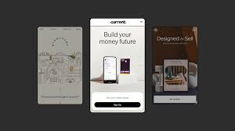

Mobile Enabled Website
  - Web and mobile technologies
Ethan Thomas | 08/06/2025
Table Of Contents

Introduction------------------------------------------------------------------------------------------2

Discussion------------------------------------------------------------------------------------------2/9

Conclusion------------------------------------------------------------------------------------------9

References -----------------------------------------------------------------------------------------10

Introduction
For this assignment I have been asked to develop a website with the purpose of it being suitable for mobile technology. The subject of the website was to be chosen by myself. I have chosen to create my website around a recipe finder that also shows images and has a description of ingredients. Within my website I have multiple pages that will have various mobile features enabling it to be suitable for mobile use. I also have an ajax call to a public weather API. Once I have created my website, I will test it with a mobile simulator from google store (1i). Throughout my discussion I’ll explain why I chose to implement certain features and areas I can improve on. At the end of the report, I’ll have a conclusion section where I summarize and go over the project as a hole.

Discussion

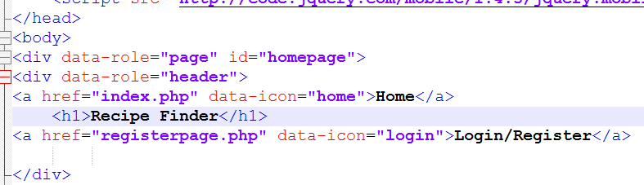

The Navigation around my website is simple and easy to use. It links to the most important pages of the website, being the home page itself and the login page for the user. My nav bar stays the same throughout the site even when going on to different pages that can’t be asked through it. As the nav bar only has two buttons it makes it very functional for a mobile device. When the user views this on a screen the navigation menu won’t feel crowded, and it will still be easy for users to use with it being so simple and clean looking. Below is how it would look like on a mobile screen.

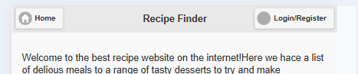

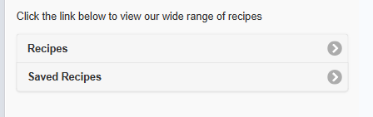
The other pages of my website are found linked on the home page of the website as buttons. I didn’t add these to the nav bar because I want that to be the only use of navigation on my site, it also makes the navbar look better in my opinion. This would affect the website’s image and not give it a good look.

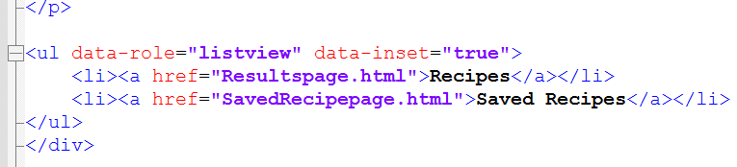

#

These two webpages are the content of the website. The recipe has an API connected to it to fetch data and display it on my own website. It’s also got a list of different recipes with photos of them, and the ingredients needed to make the recipe.

It also has a search feature so that users can search for the meals they want without scrolling on their phone for ages.
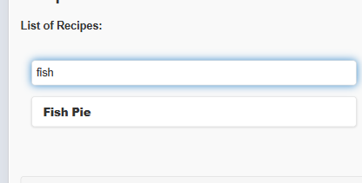

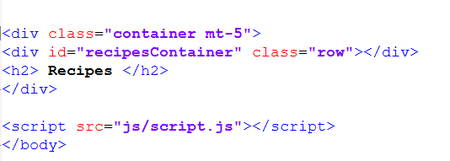

Once the user has searched for the recipe they want, they can then click on the tab and view the photo and ingredients.
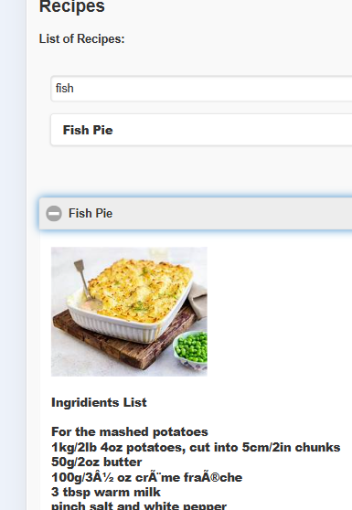

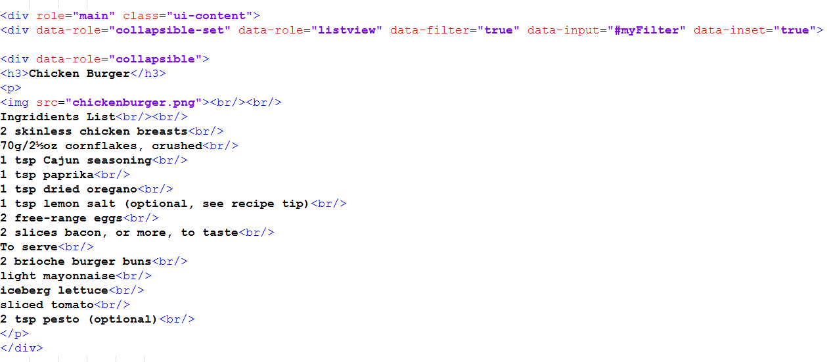

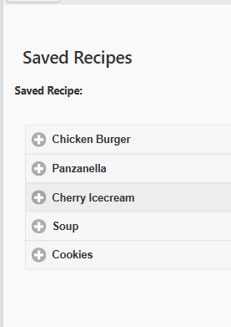
This can be done with multiple different recipes that are available on my site. The last page that is linked to my website is the saved recipe page. This is a feature to show some different recipes that users won’t find if they try to search for it in the search bar. The code for this is the same used in the recipe page.

When users want to log into an account or create one, they can do this by entering some information into the login page. If the user doesn’t need to create an account, they can use the link below the register page to login.
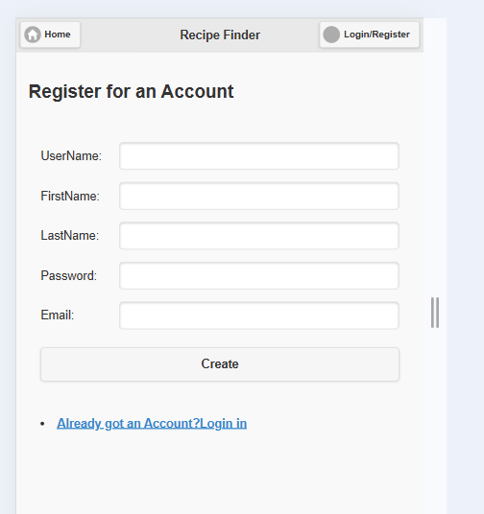
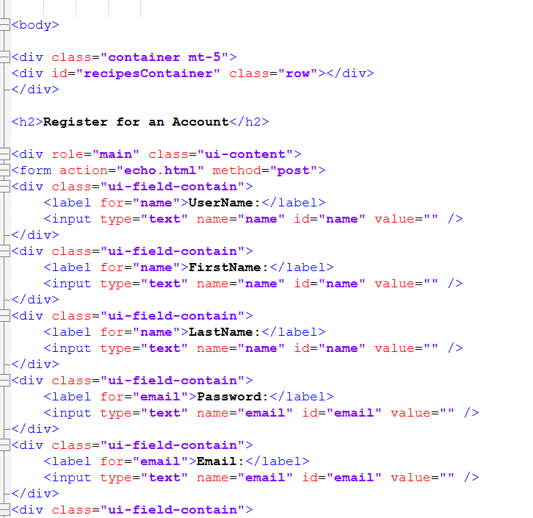

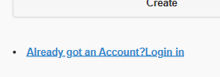

I also have a separate page that calls two different public APIs. One is about my topic food, and one is a weather API.
When the page is loaded the user wills ee this error message because my public API call does not work. When I check this in developer tools it gives me back the error message below. I can’t see where the error would be in my code, so I don’t understand why the API call doesn’t work.

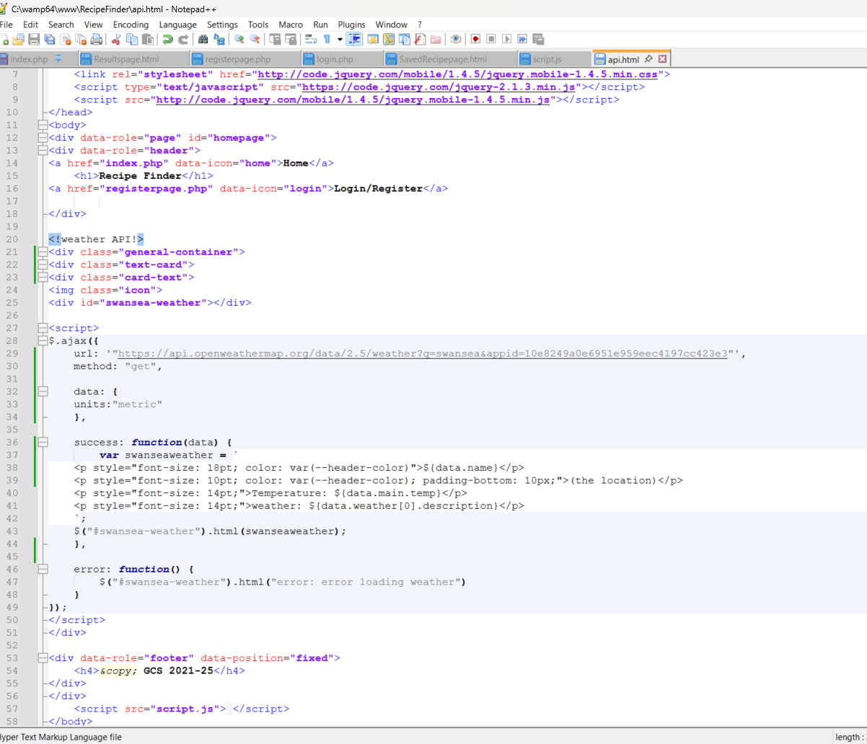

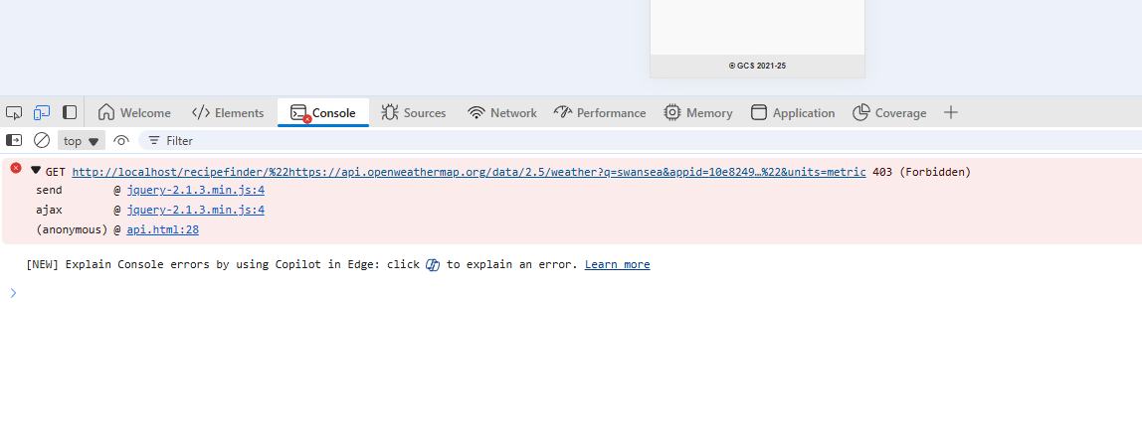
This error message means my API key isn’t activated or authorized but I have tested to see if this is true and it is not as when I search the URL in a web browser it loads the weather API information.
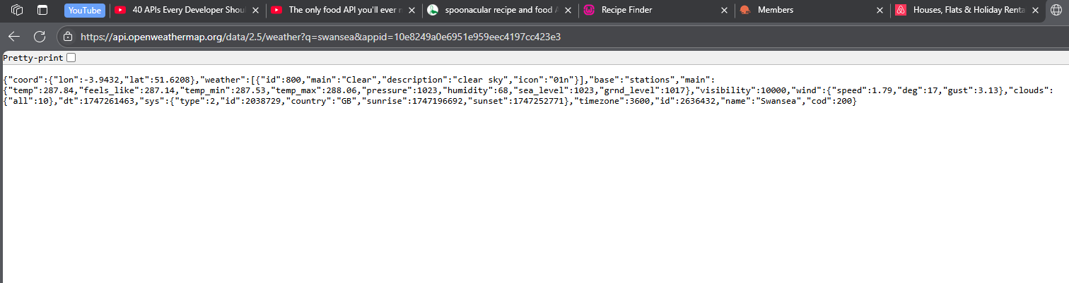

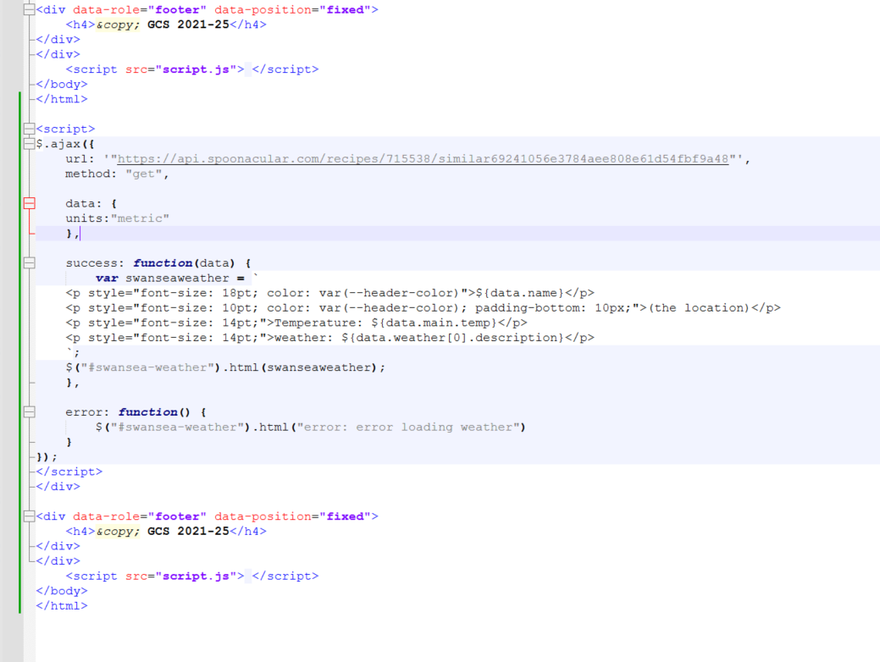
This is also the same case for the second public API I have.

In the head of my pages, I have the code “width=device-width”. This is a piece of code, which is great if you think your website will be opened on lots of different devices, especially iPhone. This code will allow my website to fit the width of the user’s device no matter what it is. Giving my website a clean look without having to change load of different texts and fonts codes to make sure they look good on mobile devices as this code does for you.

Conclusion
Overall, I think my website is mobile friendly, but could the presentation of the site be where the most improvement could be made. It’s got various mobile features that allow users to interact with the website. The website is easy to navigate around with the mobile features I have implemented, allowing people with disabilities to find it easy to use. The image of my site is very plain with only black and white colors on there, this makes it simple and easy for users to read, however this is one area I would improve in the future. I would add more colors making the website more attractive for users to view and be on whilst also keeping it easy to read and view. I think the features on my website make it easy for people to find what they are looking for which is the main purpose of the site.

References
Introduction – (1i)
https://chrome.google.com/webstore/detail/mobile-simulator-responsi/ckejmhbmlajgoklhgbapkiccekfoccmk
Websites that helped me with my code.
W3Schools Online Web Tutorials
YouTube

