Modern and Traditional Construction

Managing the Design and Construction Process

Steffan Dancey

2014079

- 1500 words +/- 10%

- 1000 words +/- 10%

Table of Contents
Introduction 3
1. 3
1.1 Select and briefly describe a system of primary structure that you consider appropriate for the building. 3
1.1.1 Foundations 3
1.1.2 Structural columns and beams 4
1.1.3 Roofing 5
1.1.4 Floors 6
1.1.5 Walls 7
1.1.6 Wind loads 8
1.2 9
1.2.1 identify and annotate the locations of all primary structural elements on ‘overlays’ of the plans and section drawings provided. 9
2. 11
2.1 Select and describe a system of enclosure that you consider appropriate for the building, conducive to the primary structural system than you have selected in Task 1 11
2.2 Identify and annotate the locations (and schematic architectural effect) of the elements of enclosure on ‘overlays’ of the elevation drawings provided. 13
References 15

Introduction

In this assignment I will present annotated drawings and a 2500-word essay researching the design elements that will arise in the design of the potential office building, for placement in SA1, including reference to images, regulations/standards and drawings. I will research the primary structures appropriate for the building such as the Foundations, Structure, Roof, Walls, and Floors. The research will also include considerations for wind loads and a system of enclosure that’s appropriate for the building.

Select and briefly describe a system of primary structure that you consider appropriate for the building.

Foundations

One primary structure that will be involved in the design of the office building would be the foundations. The foundations are fundamental in providing the required support for structures such as the office building in the case study provided. Foundations provide support through transferring a buildings load to the ground. There are many foundation types that are used, and each have their individual applications, suitable for each individual project. Foundations are divided into two different types, shallow and deep foundations. Typically, the base of a deep foundation is 3m or below ground level.

Due to the greater amount of soil excavation and technology Deep foundations tend to be more expensive to construct. However, shallow foundations are cheaper to construct, as they’re closer to ground level and require less design and construction contribution.

To create an efficient foundation design, there are factors and considerations that must be followed, such as the ground type the building constructed on, as this greatly affects the choice of foundation design. Different ground types range in strength, some soils are able to support large amounts of weight whereas some cannot. Considerations for soil erosion must also be made, the erosion of soil can cause a foundation to sink, and cause water seepage and other issues to the structure.

The bore hole log provided in the supporting documents below displays strata evidence that briefly consists of the following:

- Sandy, ashy made ground from the surface level down to 4.95 meters.
- Water that was met with very dense brown sandy gravel with traces of sandy clay at 6.00 meters.
- Stiff grey-brown gravelly boulder clay from 7.05 to 11.00 meters.
- Very stiff grey gravelly boulder clay from 11.00 to 18.60 meters.
- Grey mudstone from 18.60 to 22.00 meters, the bottom of the sample.

There was no evidence of man-made ground within the log, however there is a solid presence of clay which will provide a suitable load bearing layer for the office building after 7.00 meters.

In this sample, the clay continued down to 22.00 meters but no evidence of any bedrock geology. This is important in making a decision of foundation design. When carrying out further boreholes, the sandy ashy grounds are not self-supporting and will most likely need to be lined with temporary casings.
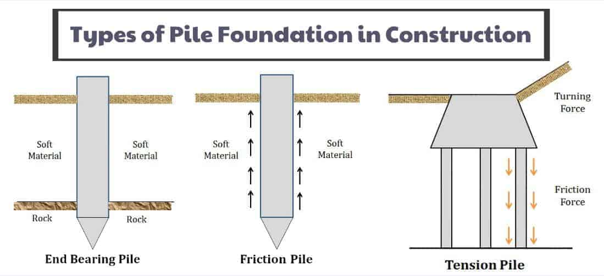

Information from Civil Concepts accessed 16/02/22.

The borehole encountered a particularly weak and compressible shallow sample continuing beyond the usual depth for traditional strip, raft or pad foundations to a structure. These grounds are considered not to be suitable for traditional strip, raft or pad foundations due to having a poor bearing capacity and poor quality of soils.

Using this information, the pile foundations tend to be better suited. This is due to transfer loads from buildings through weak and compressible strata down into a more compact, stiffer strata.

Structural columns and beams

Columns and beams are similarly primary areas of this structure, these are used for structural reinforcement and are mainly constructed from Concrete, Steel, and Timber. Columns are vertical members that span from the foundation to the top of the building transferring the load from the superstructure to the foundations, and beams are horizontal members that span over an opening to support a load or opening.
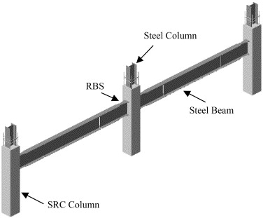

Information from Science Direct, accessed 18/02/22.

In the design of this office building the material best suited for structural columns and beams are steel. Although structural concrete is very effective, Steel columns and beams should be used in this build. This is mainly due to appropriateness due to the large spans in the building that concrete will not be suitable to support.

Structural steel is also usually more budget friendly compared to reinforced concrete, although steel can be a problem on tight programmes and schedules due to its lead times unlike concrete. Steel columns also prove to have good compressive strength but can buckle and bend when faced with extreme loading of weight.

Although steel frame construction does suffer from long lead times, the construction phase is significantly quicker. Steel frame construction is quicker as designs are prefabricated in a controlled manufacturing plant and then sent to site. This also eliminates the chances of human error and reduces the cost of labour on site.

Roofing

Another vital primary area of the structure is the roof, the roof is a covering on a top the building providing shelter and protection from the outside elements. Roofs will often include items such as windows, M&E Plant, and drainage systems, and can be built using a wide variety of materials, however this is determined by the requirements and local climate of the building.
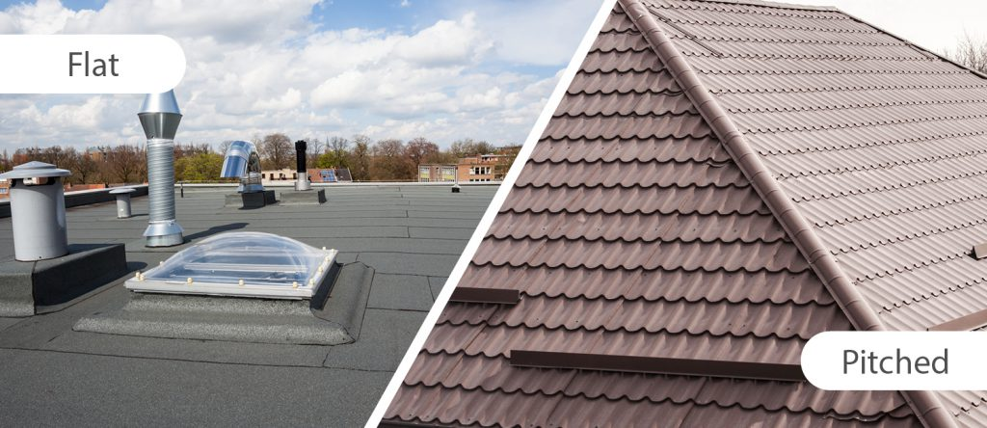

Information from JCT Roofing, accessed 18/02/22.

Modern day roofs primarily come in two types, pitched and flat. In this scenario, and by using the plans provided in the assignment brief we can determine that the roof appears to be flat in appearance also including the use of a green roof on the main roof area.

Due to the intended use of the building, a warm roof system must be specified. The application of a warm flat roof will ensure compliance with Building regulations and thermal comfort in buildings. Buildings regulations state all new build roofs other than dwellings must achieve a U Value of at least 0.18 W/m²K in order to comply with the regulations, however on new domestic dwellings the requirement is 0.13 W/m²K.

The high performance felt roofing system will include a Vapour Control Layer, 150mm insulation to meet building regulations, Underlay and Cap sheet. Roofs comprising of these components will typically provide a guarantee backed for 15-30 years subject to specification and manufacturer. Please refer to Approved Document L1A/ADL1A & L2A/ADL2A – Welsh Government regulations.

Factors of thermal comfort should be considered in the design, this includes concerns regarding Air temperature, Humidity, and Air Velocity. Specifying an effective warm flat roof in this build it will ensure thermal comfort is met. Information from HSE, accessed 19/02/22.

From January 2019, all new developments in Wales with a construction area of 100m2 or greater must include sustainable drainage systems. The method of SuDS must be designed and built in accordance to the requirements. Green roofs are proven to be effective methods of rooftop SuDS, by attenuating large amounts of water, delaying the water going into drainage systems, acting in the way that the SuDS policy requires.

Floors

The Ground floor construction of this building is to be solid, to reduce maintenance and possible movement. The Ground floor will include a well compacted sub-base with suitable hardcore to make up the required level. A damp proof membrane will then be installed using sheets of polythene, among a concrete bed to provide a solid level surface for the insulation and screed to be installed on. The ground conditions of the site will determine the required thicknesses of the layers and the order they’re installed.

The upper floors of this building will be constructed using concrete, precast concrete slabs are relatively light and easy to install. The precast concrete slabs also have excellent fire resistance and offer good thermal properties, improving the thermal efficiency of the building.

Image of precast concrete slabs in use below:
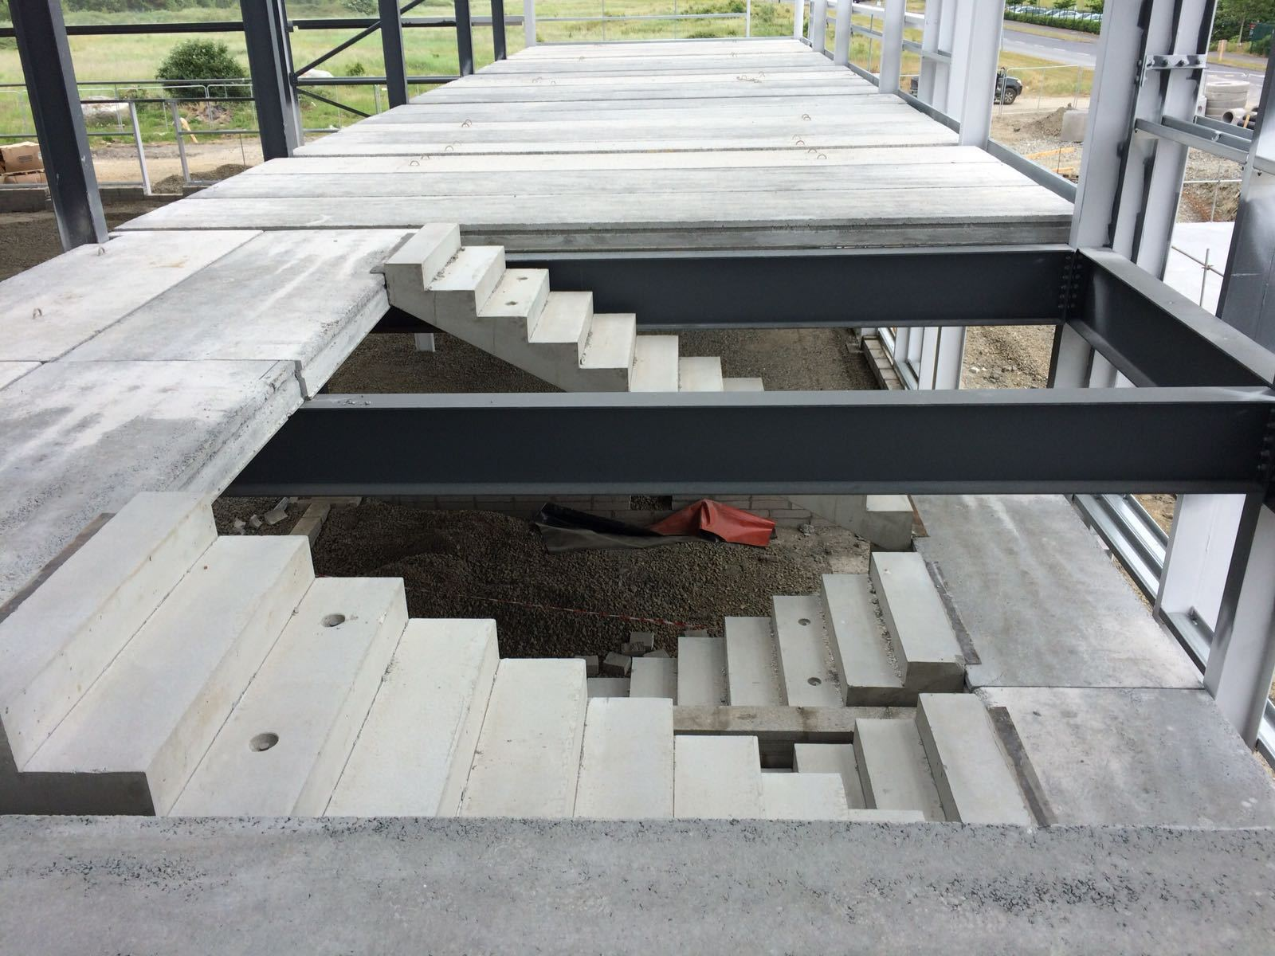

Information from Croom Concrete accessed 21/02/22.

The hollow design of concrete slabs allows services to run through channels and not be affected by the design. After all slabs and services are installed a layer of concrete is screed is poured, this creates a layer for the finished flooring to be installed.

Walls

External walls form a part of the building’s external envelope, separating the inside from the external elements. External walls often include openings for access, ventilation and glazing to allow sources of natural light. As this building will have a framed structure the external walls will not be load bearing, receiving no load from floor levels and the roof.

The external walls of this building should incorporate a rainscreen cladding system fixed to an engineering block, the rainscreen cladding consists of an outer weather-resistant decorative façade supported by means of a supporting grid, which maintains a ventilated and drained cavity between the façade and the structure. The supporting grid is an aluminium rail system that can be quickly fixed back to the building, which the tiles are then attached to.

The outer skin provides protection against wind and rain and thermal insulation can also be added to ensure the building’s heat losses are minimised. While the outer layer is semi permeable the structure of the building itself is kept perfectly dry as any water will travel down the back of the tile. Any moisture entering as a result of extreme weather conditions is carried off by drainage and evaporation, which occurs thanks to the increased ventilation rain screen offers.

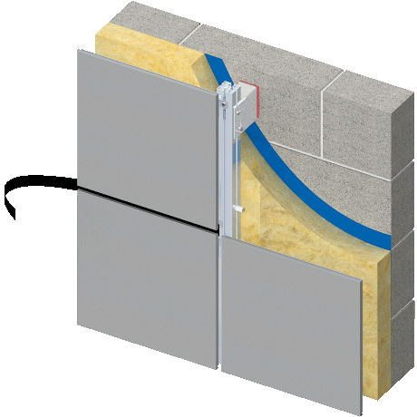
Drawing below indicates section of external rainscreen cladded wall fixed to a block wall:

Information from Proteus Facades accessed 21/02/22.

As the internal walls of this building are also non load bearing due to the steel frame, a partition wall should be used. The partition walls will be used to divide spaces in the building, whilst providing acoustic and fire separation qualities.

Solid partition walls are traditionally constructed using brick or blockwork, Partition walls can also be constructed using framed systems also known as stud walls. These are usually constructed using timber, steel or aluminium frames, and covered with plasterboard or timber. Some internal partition walls may also include glazing, as pictured below:

Image of internal glazed wall below:
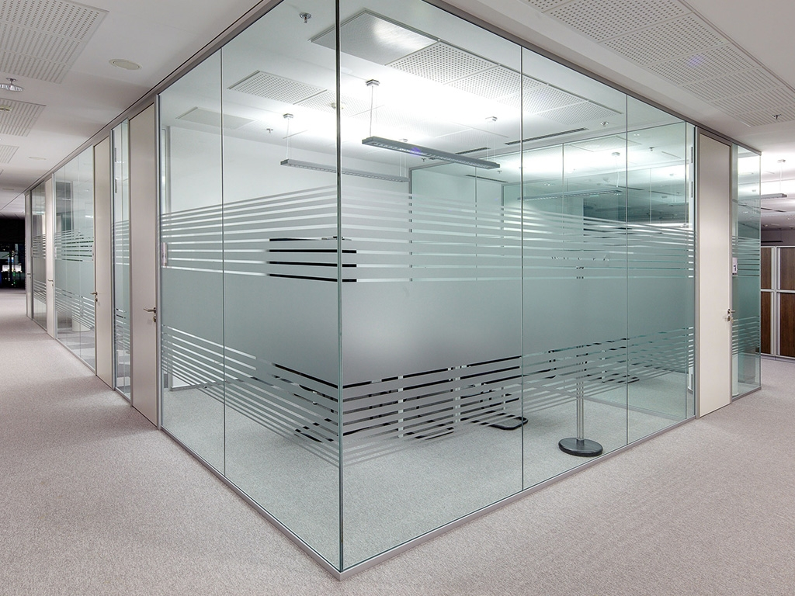

Information from SGG Glass Manufacturer, accessed 22/02/22.

Partition walls provide good flexibility, especially if lightweight framed systems, this means walls can be moved reasonably easily and economically without negatively impacting the structure of the building. Depending on the nature of the construction, it may be possible to re-use some, or all of the components of the wall in a different location.

The partition walls in this building will incorporate insulation to counteract sound or risk of fire spreading between rooms. The joints at ceiling and floor height must be properly finished and sealed, to prevent noise from passing through the voids and into rooms.

Wind loads

There should be great consideration for wind loads in the development of the new office building, as the buildings structural design must be able to absorb wind loads safely by transferring them to foundations, this avoids substantial problems such as reduction in structural integrity and possible collapse. Foundations may require modification to counteract the forces imposed by wind loads, such as deeper pile foundations.

The wind velocity and shape of the building will directly affect the wind loads that will be imposed. For example, if the building was facing wind head on (windward) the wind pressures could potentially blow windows through, whereas on the elevation that is sheltered the under pressure could potentially blow the windows out.

Wind uplift affects the roofing system in this build, although it can be affecting according to its finish, height, exposure and shape. Wind uplift arises where the air pressure below the roof is greater than the pressure above it. Wind uplift can cause significant damage to the windward corners and edges of the roof, damaging fascia’s trims and capping’s. Roofing manufacturers consider wind loads when composing specifications to ensure a suitable guarantee can be provided.

identify and annotate the locations of all primary structural elements on ‘overlays’ of the plans and section drawings provided.
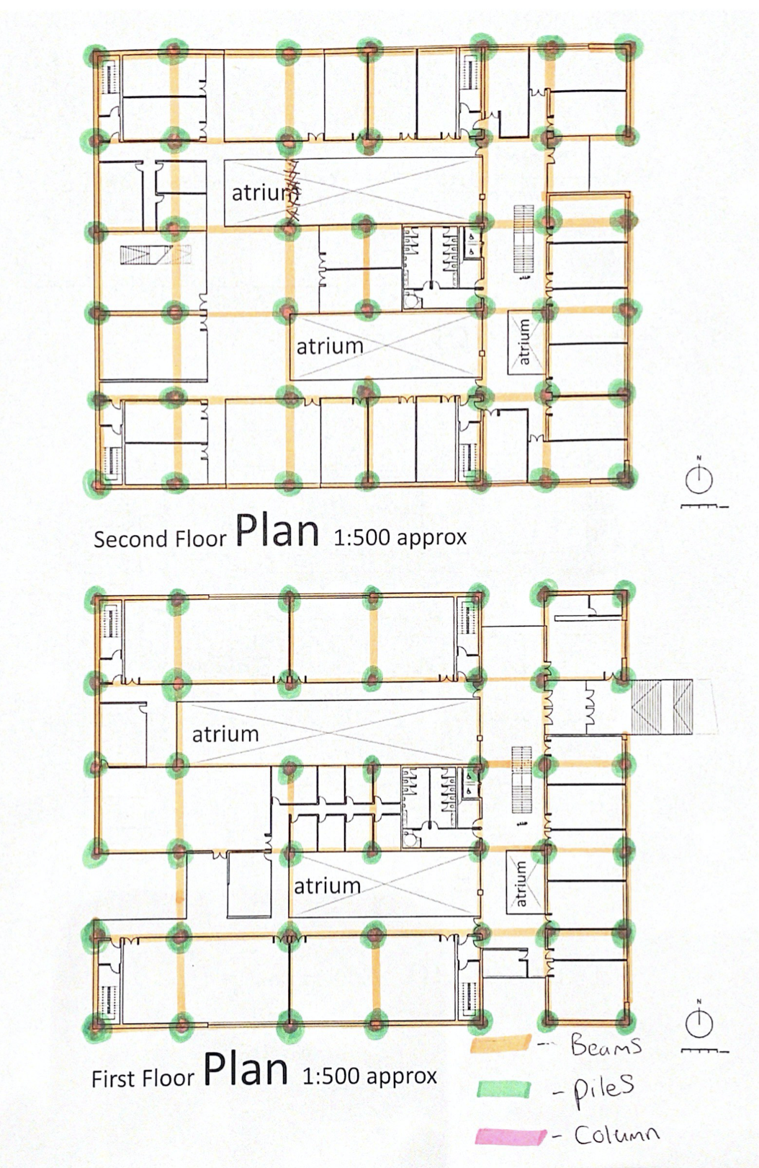

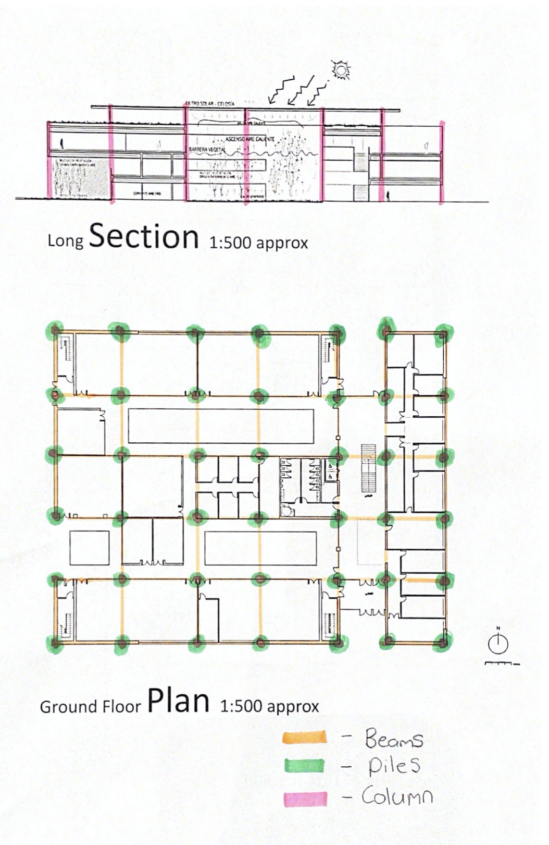

Select and describe a system of enclosure that you consider appropriate for the building, conducive to the primary structural system than you have selected in Task 1

A system of enclosure should be considered in the design of this building, an effective system of enclosure will ensure the building is weathertight, well ventilated and thermally efficient.

In this design of this building a rainscreen cladding system would be suitable, although the rainscreen cladding systems are considered primary structure, they provide a non-structural external finish. The cladding system is installed externally, by directly being fixed on the external face of a building, in this case the blockwork. This system generates a cavity between the structural frame of the building and the cladding.

Rainscreen cladding can be fabricated in a large range of materials and colours including sheet metals such as Steel, Zinc and Aluminium. These for the most part are cost effective, lightweight and easy to maintain. Aluminium Rainscreen cladding will be used in this build due to its ease of fabrication, malleability and light weight. Aluminium is resistant to corrosion as it has an oxide coating that provides protection, unlike other materials like copper. Materials such as steel will corrode over time if left unmaintained in weather unlike Aluminium.

Aluminium Rainscreen Cladding only requires maintenance to sustain its aesthetics. This material does burn and is classified as a non-combustible material. Although this does not make the material exempt from fire regulations but has much more resilience than a material like timber.

Aluminium Rainscreen cladding is also very environmentally friendly, due to its high recyclability and reducing amounts of material that goes to landfill. Once the cladding has reached the end of its usable life, the material can be easily recycled and reused to produce different products. As well as being highly recyclable, the cladding is also an incredibly sustainable building product. The majority of aluminium is smelted using hydroelectric power and is used in the production of off-site construction, this allows buildings to be partly prebuilt, this significantly reduces labour costs and waste on site.

Due to the fixing method of the ventilated cladding, the fixings must penetrate the insulation and fix into the block wall. In some instances, this has been known to cause an element of thermal bridging, potentially causing a negatively effecting the u value performance.

Unfortunately, the impact of the most recent revisions to Part L of the Building Regulations, which concern energy efficiency effect this system when specifying. The recent revisions place specific importance on the building details and the additional losses that can occur through linear thermal bridging. Building regulations in Wales state the minimum requirement for u value efficiency in external walls is 0.18 u value W/m2K. in this instance to achieve a 0.18 u value W/m2K a 130mm PIR Insulation Board should be installed as part of the rainscreen system. However, through specifying a 160mm PIR Insulation Board, it will improve the U Value performance to 0.13 W/m2K. Introducing thicker insulation will significantly improve the efficiency of the building and future proofing It’s life. Information accessed 22/02/22 from Welsh Government regulations.

There must be consideration for the height of this building as recent Building Regulations state only non-combustible or limited combustibility insulation can be used in external walls over 18 meters in height.

The BBA approval indicates compliance with Building Regulations and NHBC standards and determines the expected service life. For Rainscreen Cladding Systems, this is typically around 30 years. An example manufacturer Ash and Lacy would supply their “PVDF Coatings” systems with a guarantee of up to 40 years but reduced to 30 years when exposed to extreme conditions.

Rainscreen system fixed to block wall below:
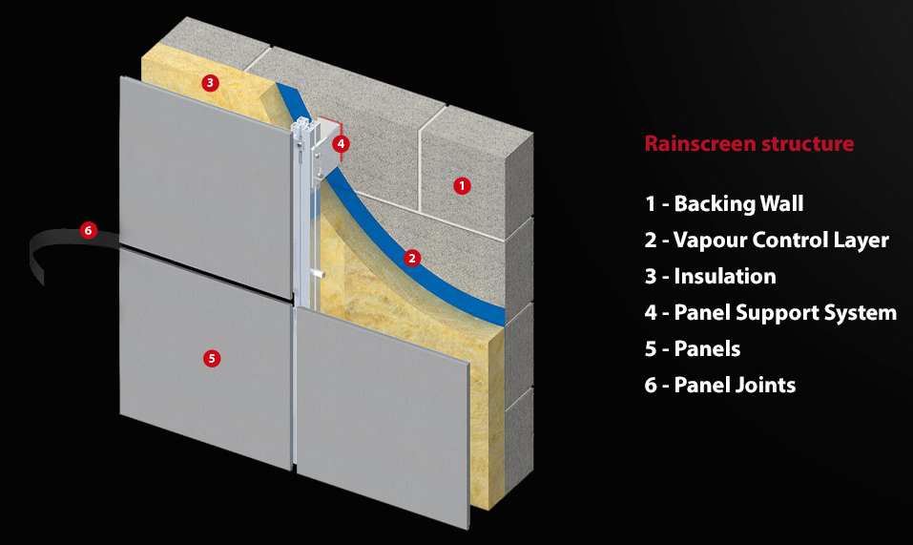

Information from Proteus Facades accessed 21/02/22 & 23/02/22. https

Design considerations must also be made for the location of this building, for example a building that is proposed to be situated in coastal area such as SA1 in Swansea will be exposed a lot more wind and salt water than a building situated in a built-up inland area such as Birmingham, as mentioned above this will reduce the guarantee provided for the Rainscreen system.

The system contains a ventilated cavity, this allows water penetrating the outer skin of the system to evaporate/drain away. Rainscreen cladding systems are also known as ventilated facades and are proven to be great systems of enclosure, since first being introduced in the 1950’s and still being used today.

The main purpose of rainscreen is to reduce moisture damage, this reducing the required maintenance and costs associated with it. Individual panels can be removed to allow easy access for future works and repairs.

While Rainscreen Cladding is a very sustainable and effective product, this is reflected in the overall costs. Rainscreen Cladding costs range from £220/m2 to £265/m2 installed, where a traditional Brick – Cavity – Insulation - Block wall will cost approximately £90 per m2. Information from RICS, accessed 28/02/22. This
comparison highlights the overall cost difference between the two systems, therefore the Rainscreen may not be as feasible with a tight budget. Rainscreen cladding also requires more intricate detailing on site, which will emphasise the Rainscreen systems additional cost.

Although there are disadvantages associated through specifying Rainscreen cladding as the external finish of the building, there are several advantages that outweigh them. Providing the client has the available budget to select Rainscreen Cladding as the external finish I believe the system of enclosure chosen is appropriate for the building.

Identify and annotate the locations (and schematic architectural effect) of the elements of enclosure on ‘overlays’ of the elevation drawings provided.
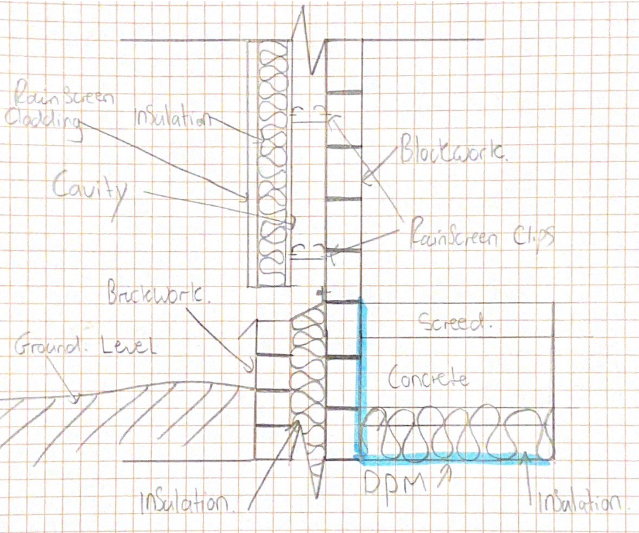

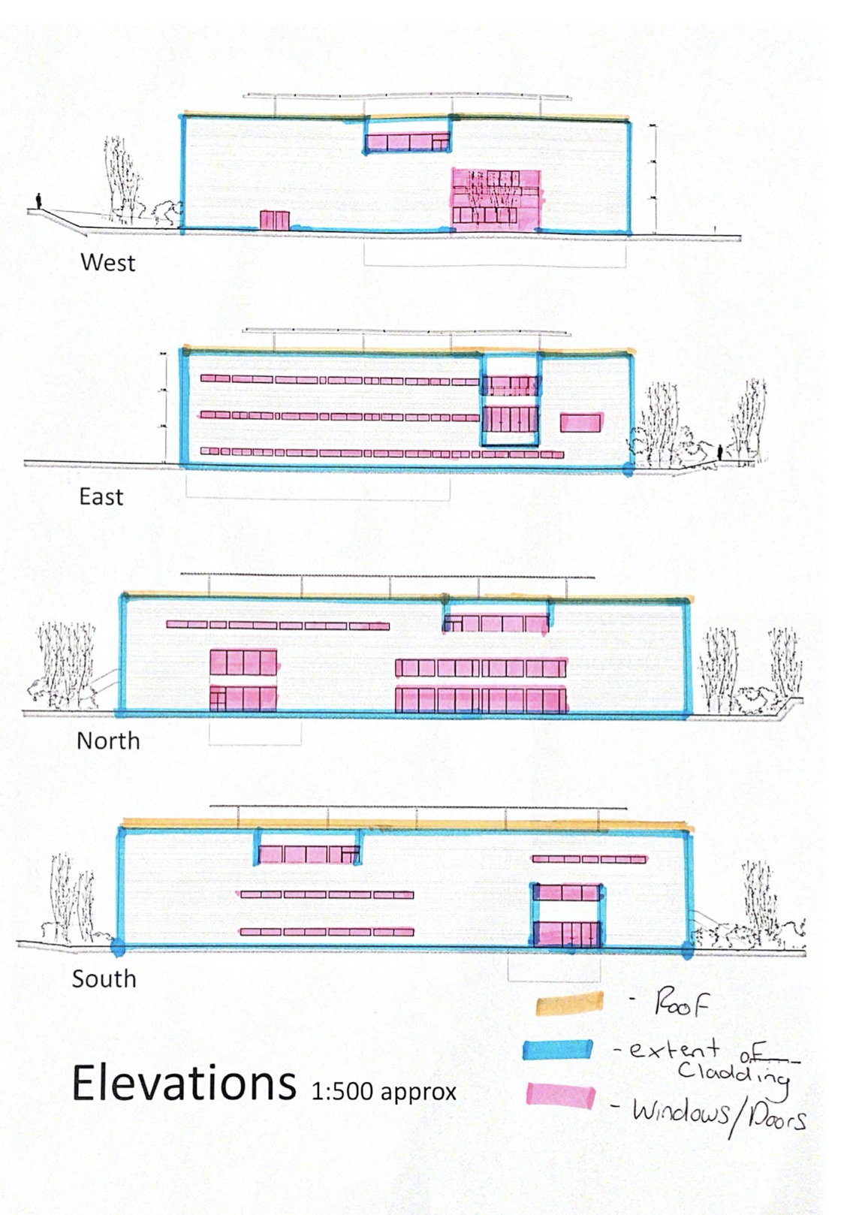

References

Information from Civil Concepts accessed 16/02/22. https://civiconcepts.com/blog/types-of-pile-foundations.

Information from Science Direct, accessed 18/02/22. https://www.sciencedirect.com/science/article/abs/pii/S0143974X0100089X

Information from JCT Roofing, accessed 18/02/22. https://jtcroofing.co.uk/news/pitched-roofing-flat-roofing/

Information from HSE, accessed 19/02/22. https://www.hse.gov.uk/temperature/thermal/factors.htm

Information from Croom Concrete accessed 21/02/22. frohttps://croomconcrete.co.uk/products/commercial/precast-concrete-hollowcore-concrete-flooring/

Information from Proteus Facades accessed 21/02/22 & 23/02/22. https://proteusfacades.com/benefits-of-rainscreen-cladding/

Information from SGG Glass Manufacturer, accessed 22/02/22. https://www.sggglassmanufacturer.com/products/17.52mm-tempered-laminated-glass-partition-walls-energy-saving-toughened-laminated-glass-partition-d.html

Information accessed 22/02/22 & 26/03/22 from Welsh Government regulations, published June 2016, last updated July 2018. https://gov.wales/building-regulations-guidance-part-l-conservation-fuel-and-power

Information from RICS, accessed 28/02/22. Published 25/01/21. https://www.rics.org/uk/products/data-products/insights/cladding-remediation-costs/

