UWTSD University Dissertation

Strategic Dynamics in the GPU Industry: Analysing the Competitive Approaches of NVIDIA and AMD

Shuo Wang
Student ID:2304699

27th September 2024

Submitted to the University of Wales in partial fulfillment for the degree of Master of Business Administration University of Wales Trinity Saint David
2024

Abstract
This dissertation explores the competitive dynamics of the global GPU market, focusing on the strategies of NVIDIA and AMD. Using Porter's Five Forces, the 4P Marketing Model, and the SERVQUAL survey, it examines how both companies leverage technological innovation and strategic management to strengthen their market positions. NVIDIA leads the high-end market with advanced AI and deep learning technologies, particularly through its CUDA platform and high-performance GPUs like the A100, while also expanding into data centres and cloud computing.
In contrast, AMD has established a strong presence in the gaming and mid-range sectors with cost-effective Radeon GPUs, and it is working to improve its competitiveness in professional computing and data centres.
Combining quantitative and qualitative methods, including a SERVQUAL-based survey, the study assesses consumer satisfaction and brand perception, revealing that NVIDIA excels in performance and innovation, while AMD attracts price-conscious consumers. Both companies face challenges from emerging competitors and shifting global trade policies.
The dissertation concludes with strategic recommendations for both companies, highlighting the importance of continuous innovation, market diversification, and adaptive strategies to maintain a competitive edge in the rapidly evolving GPU industry.

Table of Contents
UWTSD University Dissertation i
Abstract ii
Table of Contents iii
1. Introduction 1
1.1. Introduction and Study Framework 1
1.1.1. Research Background 1
1.1.2. Research Motivation 1
1.1.3. Research Questions 2
1.1.4. Research Objectives: 2
1.2. Company Introduction and History 2
1.2.1. NVIDIA 3
1.2.2. AMD 5
1.3. SWOT Analysis for NVIDIA and AMD 7
1.4. Terminology 12
2. Literary Review 14
2.1. Introduction to Technology-Driven Enterprises 14
2.2. Current Research 17
2.3. Theoretical Basis 20
2.3.1. Introduction to Porter's Five Forces Model 20
2.3.2. Introduction to the 4P Model 21
2.3.3. Introduction to the SERVQUAL Model 24
3. Methodology 27
3.1. Research Purpose and Objectives The research questions and objectives of this paper are: 27
3.2. Research Rationale 27
3.3. Research Design 27
3.3.1. Research Onion Framework 27
3.3.2. Research Philosophy 29
3.3.3. Research Methods 30
3.3.4. Research Strategies 31
3.3.5. Research Choices 32
3.3.6. Time Horizons 32
3.3.7. Data Collection 33
3.3.8. Reliability and Feasibility Analysis 35
3.3.8.1. Reliability Analysis 35
3.3.8.2. Feasibility Analysis 37
3.3.8.3. Research Limitations 37
3.3.9. Research Ethics 38
4. Analysis 41
4.1. Porter's Five Forces Analysis 41
4.1.1. Industry Rivalry 41
4.1.2. Threat of New Entrants 42
4.1.3. Threat of Substitutes 43
4.1.4. Bargaining Power of Suppliers 43
4.1.5. Bargaining Power of Buyers 45
4.2. 4P Model Analysis 45
4.2.1. Product 45
4.2.2. Price 49
4.2.3. Place 50
4.2.4. Promotion 53
4.3. SERVQUAL Model Survey Data Analysis 55
4.3.1. Survey Overview 55
4.3.2. Consistency Analysis 56
4.3.3. Data Description and Selection Distribution 56
4.3.4. Correlation Analysis 62
4.3.5. Survey Summary 63
5. Conclusion 65
5.1. NVIDIA's Current Status and Strategy 65
5.2. AMD's Current Status and Strategy 67
6. Conclusion and Recommendations 69
Bibliography 71
Appendix 84
I. Questionnaire 84

Introduction

Introduction and Study Framework

Research Background
This study aims to use NVIDIA and AMD as case studies to analyse the comparative importance of technological innovation and strategic management in enhancing the competitiveness of technology-driven companies. It will investigate how these companies leverage technological innovation and strategic management to carve out market niches, respond to market dynamics, and ensure sustained growth. This research will delve into market strategies, R&D investment, product positioning, and financial performance to fully understand how technology and strategy interact to drive business success.

Research Motivation
There are two main reasons why I am interested in this research topic. Firstly, the GPU market is undergoing rapid development, especially with its increasingly widespread applications in artificial intelligence (AI) and high-performance computing. Gaining an in-depth understanding of the latest developments in this area not only provides practical insights into broader technological trends but also aids my future research and practice in related fields. Secondly, as a graduate student in Electronic Information in China, the researcher is keenly interested in the operational mechanisms and strategic implementation processes of companies like NVIDIA and AMD. Considering the researcher’s likely future work in technology-driven enterprises, gaining a deep understanding of these companies' business strategies and market behaviours now will lay a solid foundation for my career.

Research Questions
• Analyse the market competition strategies of NVIDIA and AMD.
• Evaluate the effectiveness of these strategies in technological advancement and market competition.
• Explore how NVIDIA and AMD adapt to market changes to maintain competitiveness.

Research Objectives:
For technology-driven enterprises, technology is fundamental, but the impact of strategic management is also critical and often underestimated. In today's highly competitive environment, how enterprises should allocate resources between technological innovation and strategic management is a question that lacks in-depth discussion. Therefore, the purpose of this research is to explore in detail the specific roles and mutual impacts of technological innovation and strategic management in driving the success of technology-driven enterprises. Through this analysis, this study aims to help technology-driven enterprises develop more effective business strategies and decisions, enabling them to maintain a leading position in a competitive market environment.

Company Introduction and History
In this thesis, a timeline approach will be used to provide a detailed introduction to the development history of NVIDIA and AMD. Through this method, it is possible to clearly present the key technological innovations and strategic decisions made by these two companies at different stages of their development. This not only helps readers understand how they responded to industry challenges and market changes, but also shows how these decisions have impacted the companies' long-term growth and competitive positions. The following sections will present a detailed chronology, showcasing the major milestones and turning points in NVIDIA and AMD's history over the past decades, providing a solid background for an in-depth analysis of their business strategies and technological advancements.

NVIDIA
NVIDIA Corporation is a high-tech company focused on the research and manufacturing of Graphics Processing Units (GPUs). Established in California in 1993, NVIDIA has profoundly transformed the artificial intelligence market through innovative technologies and products. Today, over 4 million developers have created thousands of applications for accelerated computing. More than 40,000 companies use NVIDIA AI technology, including 15,000 global startups participating in NVIDIA Inception (NVIDIA Corporation: History, no date). NVIDIA's discrete graphics cards not only dominate the gaming market but have also become indispensable tools in scientific computing, professional visualization, and the emerging field of artificial intelligence.
Development History
1993: NVIDIA was founded in California with the vision of bringing 3D graphics to gaming and multimedia markets.
1999: Invented the Graphics Processing Unit (GPU), laying the foundation for reshaping the computing industry.
2006: Launched the CUDA architecture, which opened up the parallel processing capabilities of GPUs to science and research (NVIDIA Corporation: History, no date).
2011: AI researchers discovered NVIDIA GPUs. Subsequently, Google's Brain project achieved remarkable results by training an AI model to recognize cats and people from watching YouTube videos. Returning to NVIDIA and GPUs, Bryan Catanzaro from NVIDIA Research collaborated with Andrew Ng's team at Stanford University to apply GPUs to deep learning. Thanks to CUDA-compatible NVIDIA GPUs, which are better suited for computational acceleration, the processing power of 12 NVIDIA GPUs at that time was equivalent to 2,000 CPUs (Statista, 2024).
2010: Introduced the Fermi architecture, the first GPU architecture specifically designed for computing, further solidifying GPUs' position in high-performance computing.
2012: Launched the Kepler architecture, which brought significant performance improvements and energy efficiency, reinforcing GPUs' position in gaming and professional graphics markets. Additionally, at the ImageNet competition, a deep learning model powered by four GPUs outperformed Google's model, which used 2,000 CPUs, in both time and accuracy, sparking the AI era for GPUs.
2014: The release of the Maxwell architecture further improved energy efficiency, particularly for applications on mobile devices.
2016: Introduced the Pascal architecture, which for the first time included GPU-based deep learning acceleration capabilities, significantly impacting the fields of artificial intelligence and machine learning.
2018: Launched the Turing architecture, which for the first time integrated real-time ray tracing technology (RTX technology) into GPUs, pushing the boundaries of gaming graphics processing.
2020: The introduction of the Ampere architecture further enhanced GPUs' capabilities and efficiency in AI and machine learning, as well as high-performance computing.

AMD

AMD is the high performance and adaptive computing leader, powering the products and services that help solve the world’s most important challenges. (NVIDIA Corporation: History, no date) AMD is a globally renowned CPU manufacturer, whose main product lines include the Ryzen, Threadripper, and EPYC series processors. These processors are widely used in personal computers, workstations, and servers. Additionally, AMD's Radeon series of graphics processors are extensively utilized in personal computers, gaming consoles, and data centres. In the discrete GPU market, AMD is a major competitor to NVIDIA, gaining a significant market share with its cost-effective products and consumer-friendly pricing.
Development History
1969: Founded in 1969 as a Silicon Valley start-up, the AMD journey began with dozens of employees who were passionate about creating leading-edge semiconductor products. (About AMD, no date)
1991: AMD launched its first proprietary design x86 processor, the AM386, challenging Intel's dominance in the microprocessor market [18].
1999: AMD introduced the Athlon K75 processor, which was widely recognized for its superior performance and for the first time surpassed Intel in terms of performance (Computer Hope, 2023).
2003: AMD released the Opteron processor, entered the server market, and gained significant market share.
2006: AMD acquired graphics chip manufacturer ATI (Note: AMD initially planned to acquire NVIDIA, but due to unmet conditions, turned to acquire graphics chip manufacturer ATI (Shibu, 2024)), entering the graphics processor market and launching the Radeon series of graphics cards, further expanding its product line (Butler, 2020).
2011: AMD released the APU (Accelerated Processing Unit), integrating the CPU and GPU on a single chip, which enhanced computing efficiency.
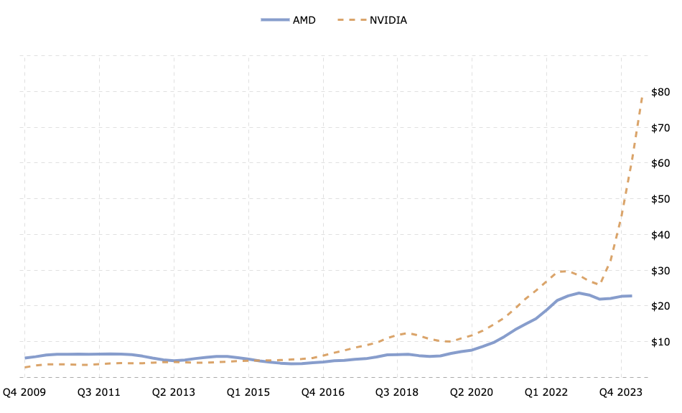
2015: AMD's revenue was surpassed by NVIDIA for the first time (macrotrends, no date), and although AMD performed well in both the CPU and GPU markets, its market value growth was not as rapid as NVIDIA's, and the gap between the companies gradually widened.
2016: The Radeon RX series of graphics cards, targeted at the gaming market, has been recognized for their excellent performance and price ratio, supporting high-resolution and high-frame-rate gaming (AMD, no date).AMD launched the ROCm platform, enabling the use of CUDA (NVIDIA’s artificial intelligence framework) for computations on AMD graphics cards (AMD ROCMTM Software, no date).
2017: AMD introduced the Radeon RX Vega series, specifically designed for data analytics and artificial intelligence applications (welcome AMD, no date).
AMD's development history is filled with stories of technological innovation and market competition. Through constant innovation and strategic acquisitions, AMD has achieved significant success in the CPU and GPU markets. Although AMD operates in multiple domains, its disruptive technologies are relatively few, which may place it at a disadvantage in future direct confrontations with NVIDIA.

SWOT Analysis for NVIDIA and AMD
To gain a comprehensive understanding of how technology-driven companies like NVIDIA and AMD maintain their competitive edge in a fiercely competitive market, a SWOT analysis will be conducted. SWOT analysis is a powerful tool that assists in evaluating a company's internal strengths and weaknesses, as well as external opportunities and threats. By thoroughly examining the strengths, weaknesses, opportunities, and threats of NVIDIA and AMD, we can better comprehend how these companies use their core capabilities and market strategies to stay ahead in the rapidly evolving GPU market. This analysis will uncover how these enterprises effectively address external environmental challenges through strategic actions and how these strategies contribute to their long-term business success and growth.

NVIDIA: Strengths: 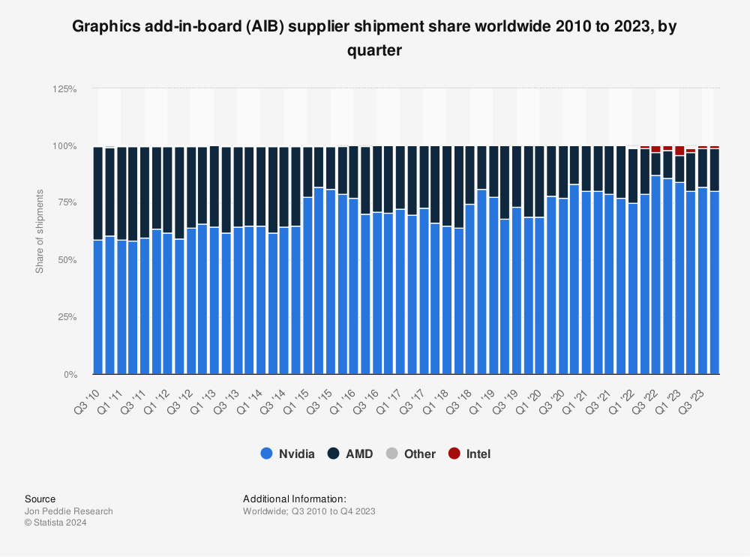
- Technological leadership: NVIDIA holds a dominant position in the GPU market (Leswing, 2024), with an 80% market share in 2023 as shown in the diagram [13], particularly excelling in the high-end market with its popular GeForce and Quadro series. Its GPU technology is extensively used in gaming, artificial intelligence, and data centres among other fields.
- Brand reputation: Known as a synonym for high-performance GPUs, NVIDIA has strong brand recognition and market trust (Castellano, 2024).
- Strong R&D capabilities: NVIDIA continuously invests in R&D to keep its technology at the forefront, especially in the fields of artificial intelligence and autonomous vehicles, where its innovations are leading (Castellano, 2024).
- Extensive partnership network: NVIDIA has established tight collaborations with many technology companies, automakers, and data centre providers, further strengthening its market position.
Weaknesses:
- Dependence on the GPU market: Despite NVIDIA's expansion into various fields, its revenue remains heavily dependent on the GPU market, with Compute and Networking contributing 78% (NVIDIA CORPORATION, 2024) and Graphics 28% (NVIDIA CORPORATION, 2024) to its total revenue in 2023, summing up to 96%.
- High product prices: NVIDIA's high-end products are relatively expensive, which may continue and potentially limit its penetration in the broader consumer market (Kan, 2022).
- Competitive pressure: Although NVIDIA leads the market, increasing pressure from competitors like AMD, particularly in the mid to low-end markets, is a challenge.
Opportunities:
- Rapid AI development: With AI technology increasingly being applied across various industries, NVIDIA's AI-specific chips, such as the Tesla and DGX series, have significant market potential [56].
- Autonomous vehicle sector: NVIDIA's investments in autonomous driving technology, known for fast and reliable GPU computing, are expected to yield substantial returns, especially as autonomous vehicles become a mainstream trend.
- Data centre expansion: The rapid growth of cloud computing and big data has increased the demand for high-performance computing in data centres, providing NVIDIA with significant market opportunities.
Threats:
- Intensifying market competition: The rise of AMD and other emerging companies in the GPU market could weaken NVIDIA's market share.
- Risks of technological change: Rapid changes in semiconductor technology and computing architecture might diminish NVIDIA’s current technological edge if not adapted swiftly, potentially leading to market setbacks.
- Government policy impact: U.S. government restrictions on NVIDIA's exports to China profoundly affect the global GPU market. As one of the largest GPU demand markets globally, this policy directly limits NVIDIA's sales capabilities in China [57]. Unable to rely on imports of high-performance GPUs from leading companies like NVIDIA, Chinese enterprises and the government will inevitably accelerate the development and production of local GPUs. This policy pressure will likely prompt the rapid rise of Chinese domestic GPU manufacturers, potentially with significant government support, to reduce reliance on foreign technology.
As China's technological strength and domestic market demand propel the rapid development of locally manufactured GPUs, they are poised to increasingly compete with international giants like NVIDIA on the global stage. Therefore, the U.S. export restriction policy not only affects NVIDIA's market share in China but also indirectly promotes the rapid development of China's GPU industry, potentially altering the competitive landscape of the global GPU market in the future.
AMD (Advanced Micro Devices): Strengths:
- Product diversification: AMD's product line spans both key areas of CPUs and GPUs, particularly strong in the CPU market with its robust Ryzen series, while its independent GPUs also hold a significant market share, being the second largest company with a 20% share [13].
- Price competitiveness: AMD has a notable advantage in offering cost-effective products, especially in the mid-range market, attracting many consumers.
- Technological innovation: In recent years, AMD has made significant progress in technological innovation, particularly with its Zen architecture for CPUs and RDNA architecture for GPUs, which have received broad market recognition.
Weaknesses:
- Relatively low brand recognition: Compared to NVIDIA, AMD's brand recognition and market trust are relatively lower, especially in the high-end market.
- Limited financial resources: Compared to NVIDIA, AMD has more limited financial resources, with a market value of $250.83 billion in August 2024, while NVIDIA's market value is $3.182 trillion (Shilov, 2023) (companiesmarketcap, no date), which may limit its investment capacity in R&D and market promotion.
Opportunities:
- Growth in the gaming market: With the continuous growth of the gaming market, especially in PC and console gaming, AMD's GPU and APU products are likely to benefit.
- Data centres and cloud computing: The growing demand for high-performance CPUs and GPUs in data centres provides AMD with opportunities to expand its market, especially in the server market.
Threats:
- Competition from Intel and NVIDIA: In both key markets of CPUs and GPUs, AMD faces strong competition from Intel and NVIDIA, competitors with stronger resources and brand influence.
- Technological risks: If AMD fails to continue its pace of technological innovation, it may lose its current market advantage in fierce market competition (Reuters, 2023).

Terminology
CPU and GPU:
CPU: Specializes in handling complex, sequential tasks such as managing operating systems, executing application logic, and controlling various input/output devices. CPUs excel at processing single-threaded tasks. The CPU industry has been around for a long time, and profits have gradually decreased, unlike the GPU series which enjoys excess profits.
GPU: Designed specifically for large-scale parallel computing tasks such as graphic rendering, matrix calculations, and scientific computations. It is important to note that GPUs are divided into integrated and discrete graphics cards. NVIDIA and AMD mainly focus on discrete graphics cards, which are the subject of this article, referred to as N cards and A cards. GPUs perform exceptionally well in tasks requiring massive parallel processing, particularly in AI model training. Recently, the popular Chat-GPT is trained and runs on NVIDIA’s A100 GPU (Shilov, 2023). The GPU industry is currently in a stage characterized by high technical barriers and market monopoly, which allows it to achieve excess profits.
CUDA:
NVIDIA's CUDA is a universal parallel computing platform and programming model that utilizes the parallel processing capabilities of GPUs to accelerate deep learning and other computation-intensive applications (Heller, 2022). To date, CUDA has been downloaded over 20 million times, utilizing the powerful capabilities of GPU accelerators to help developers speed up their applications (Oh, 2022). This increase in computational speed aids researchers in training AI models. In layman's terms, CUDA is software designed by NVIDIA, tailored for NVIDIA discrete graphics cards, which efficiently enables parallel computation to reduce AI model training time.
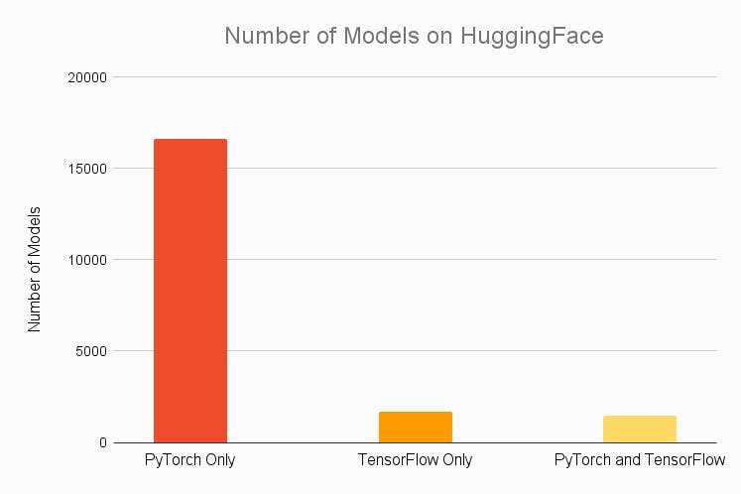[43]
PyTorch：
PyTorch is an open-source AI training framework widely used in computer vision, natural language processing, and other machine learning tasks. ChatGPT is trained using PyTorch as the core framework. As shown in the figure, PyTorch has a significant presence on Hugging Face, a community platform that hosts many cutting-edge models, like GitHub. The most mainstream GPU acceleration platform for PyTorch is NVIDIA's CUDA.

Literature Review

Introduction to Technology-Driven Enterprises
Technology-driven enterprises leverage technological innovation as their primary competitive advantage to propel business growth and expand their market presence. Such companies are deeply committed to research and development (R&D) efforts, focusing on crafting new technologies, enhancing existing products, and designing innovative services to address market needs and tackle intricate challenges. (Meier, 2022)
NVIDIA and AMD are exemplary technology-driven enterprises that utilize technological innovation as their core competitive advantage to drive business growth and market expansion. Both companies are renowned for their cutting-edge advancements in graphics processing units (GPUs) and other high-performance computing technologies. Here, we explore the significance of these companies as technology-driven enterprises and how they leverage technological innovation to propel their business forward.
Core Business Reliance on Innovation: NVIDIA and AMD's core businesses, including high-performance computing, graphics processing units (GPUs), and integrated circuits, require continual technological improvements and innovations to maintain competitiveness in the market.
For example, NVIDIA's technological breakthroughs in deep learning, artificial intelligence, and autonomous driving (Goel, 2024), as well as AMD's advancements in artificial intelligence, database analytics, and AI product design (Welcome to AMD, no date), underscore their pivotal roles in shaping the computer and graphics industry. These developments not only reflect their technological leadership but also their strategic responses to evolving market demands. The impact of such innovations on the broader technology landscape highlights the importance of continual investment in research and development (Kraus et al., 2021) ensuring that both companies remain at the forefront of technological advancements.
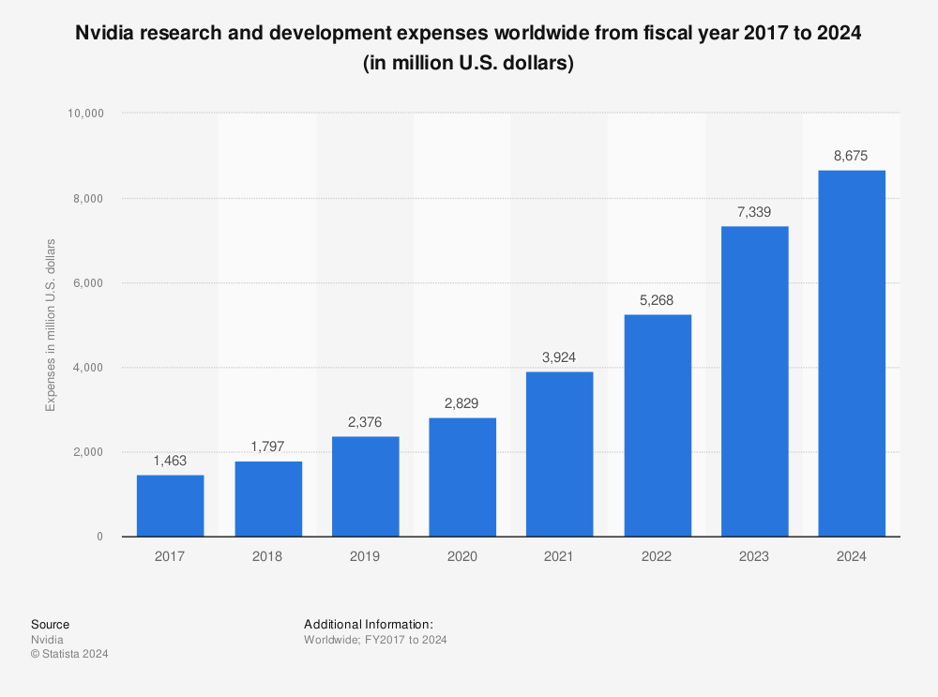
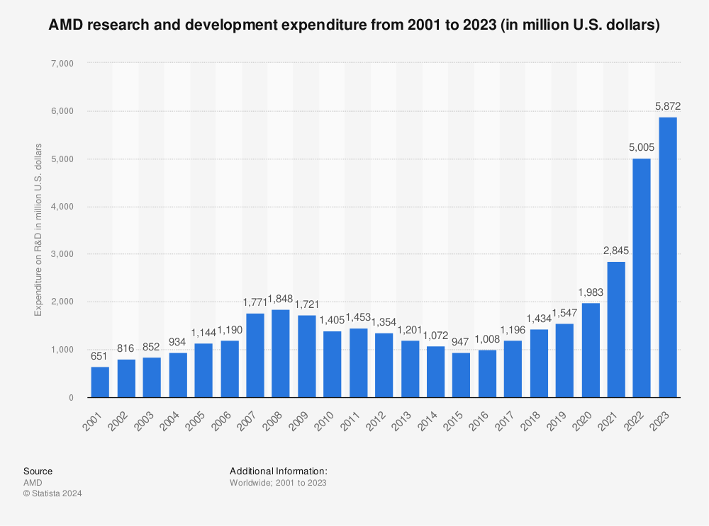
Significant R&D Investments: Technology-driven companies typically invest heavily in research and development (R&D). NVIDIA's R&D investments have continuously increased from 2017 to 2024 (as shown in Figure 1) (Statista, 2024), with the R&D expenditure as a percentage of revenue reaching 27% in 2023 (Zhu, 2023), which is significantly higher than other companies. Similarly, AMD has also been increasing its research spending since 2015 (as shown in Figure 2) (Statista, 2024), with its R&D spending as a percentage of revenue at 25.5% in 2023 (Amd, 2024). Data indicate that both NVIDIA and AMD have committed substantial resources to R&D to ensure technological leadership.
Rapid Response to Market Changes: The technology sector is characterized by rapid changes, requiring companies to swiftly adapt to new market demands and technological trends. NVIDIA and AMD have demonstrated their capability to quickly introduce products that address these changes through continual technological innovation. NVIDIA and AMD have adopted a strategic approach to updating their product lines on an annual basis, aligning with the fast-paced advancements in technology. This commitment to innovation is evident in NVIDIA's RTX series GPUs and AMD's Ryzen processors, which are designed to meet the dynamic demands of the market​.(Morgan, 2023) (AMD, 2024)Their consistent updates underscore a proactive stance in responding to technological trends and customer needs, ensuring they remain competitive in the ever-evolving landscape of computing and AI technologies. (semiconductors, 2024) (Tam, 2024)
Technology Leadership: Both NVIDIA and AMD strive to maintain a position of technological leadership. NVIDIA is recognized as a leader in the GPU and AI sectors, often referred to as the "engine of AI" (NVIDIA Corporation: about us, no date). AMD, on the other hand, is highly competitive in the processor and GPU markets (AMD, no date). Both companies achieve their leading status through continuous technological innovation and improvements. This commitment to advancing their technology ensures that they not only meet but often exceed the evolving demands of the market, solidifying their roles as leaders in their respective fields.
It is essential to highlight that for technology-driven enterprises, the ability to quickly respond to market changes is crucial (WalkMe, 2022). This requires not only a capability for technological innovation but also the right strategic decisions for implementation (Co-Authored, no date). This ensures that companies can maintain a sustained leadership position in their fields, further validating the significance of the research topic.

Current Research
Sousa et al. (2021) utilized qualitative research methods, primarily employing strategic management theory, organizational change theory, competitive strategy theory, technological innovation, and product lifecycle theory, to deeply analyse how AMD, under the leadership of Lisa Su, has responded to fierce technological market competition and challenges through strategic restructuring and management transformation. The study relied mainly on public data, company-released information, and CEO interviews to construct a comprehensive understanding of AMD’s strategic transformation.
Although Porter's Five Forces model or other specific competitive strategy frameworks were not directly mentioned in the paper, these theories were implicitly used to discuss how AMD has positioned itself in the market against competitors like Intel and Nvidia. This analysis highlights that, in addition to technological capability and product innovation, visionary leadership and strategic adaptability are key factors in a company's success. AMD's case demonstrates that even with relatively limited resources, a company can achieve success in a competitive market through wise strategic planning and accurate market positioning. This finding emphasizes the importance of sensitivity to market dynamics and the ability to seize strategic opportunities in technology-driven industries. The application of the case study method not only provided deep insights into AMD's transformation efforts but also revealed the role of management change and strategic innovation in driving long-term corporate success.
Chen (2024) combined qualitative and quantitative analysis methods to comprehensively assess Nvidia's market strategy and valuation. The quantitative analysis primarily used the Discounted Cash Flow (DCF) model to calculate Nvidia's intrinsic value based on predicted future cash flows, and conducted sensitivity analysis to evaluate the valuation's sensitivity to changes in key assumptions such as growth rates and discount rates.
These analyses help understand the risks and potential volatility of valuation outcomes. Qualitatively, the Porter Five Forces model was applied to analyse Nvidia's competitive environment in the semiconductor industry, including competition within the industry, threats of new entrants, the possibility of substitutes, buyer bargaining power, and supplier bargaining power. This analysis revealed the key factors affecting Nvidia’s competitive strategy and market position. Additionally, through competitive analysis with major rivals, combined with industry reports, market data, and strategic insights, Nvidia's market share and competitive advantages were assessed. These qualitative analyses provide a deep perspective on Nvidia's performance and competitive strategies in the global market.
Godinho (2022) [50] used both qualitative and quantitative analysis methods to comprehensively evaluate Nvidia's investment potential. Quantitatively, the paper explored Nvidia's revenue growth trends, profitability metrics, and cash flow situations through financial performance analysis.
This included a detailed examination of financial statements to track performance over specific financial periods and highlight annual trends in revenue and profitability. Additionally, it involved analysing the Price-to-Earnings (P/E) and Price-to-Sales (P/S) ratios to assess Nvidia's market valuation relative to its earnings and sales, gaining a deep understanding of how the market values the company based on its historical averages and industry standards.
Qualitatively, the paper used strategic analysis to evaluate the strength and scope of Nvidia's products, especially GPUs and their applications in AI and data centres, to understand how these technologies enhance Nvidia's competitive advantage and increase its investment appeal. The analysis also covered Nvidia's main competitors, such as AMD and Intel, by examining their market share and advantages to further understand Nvidia’s position in the competitive structure. Finally, the paper identified and mitigated potential investment risks associated with Nvidia through risk management strategies. This included using techniques like diversification, portfolio rebalancing, and hedging to manage market risk, credit risk, and liquidity risk. Through these comprehensive approaches, the paper not only provided an in-depth data-based financial assessment but also combined strategic insights to interpret the stories behind these data, offering a solid analytical basis for investment decisions.
These papers all exhibit a strong investment analysis orientation, using tools like Porter’s Five Forces model to deeply analyse industry competitiveness and company market strategies. These studies provide investors with decision-making bases based on data and strategic insights, emphasizing the crucial importance of sensitivity to market dynamics and the ability to grasp strategic opportunities in technology-driven industries.

Theoretical Basis

Introduction to Porter's Five Forces Model
Michael Porter introduced his Five Forces strategic analysis model in an article published in the Harvard Business Review in 1979, which remains a fundamental tool for strategy analysts to map out the competitive landscape of industries (Gratton, 2024). The model assesses the attractiveness and long-term profitability of an industry through five main forces: the intensity of competitive rivalry within the industry, the threat of new entrants, the threat of substitutes, the bargaining power of buyers, and the bargaining power of suppliers. These forces collectively define the extent to which a company can command pricing and profitability within a specific industry, making it an indispensable tool for strategic planning and market analysis.
- Industry Competitors: The degree of competition among existing companies within the industry influences the structure of prices, costs, and investments, thereby affecting the overall profit potential of the industry.
- Potential New Entrants: The ease with which new companies can enter the market affects the market share and pricing strategies of existing firms.
- Substitutes: The availability of alternative products or services limits price and profit margins.
- Buyer Bargaining Power: Strong buyers can compress profit margins by demanding lower prices or higher quality.
- Supplier Bargaining Power: The stronger the market control of suppliers, the more they can increase prices or control the quality and conditions of supply.
Using Porter's Five Forces model is particularly suitable for analysing the competitiveness of Nvidia and AMD:
- Industry Positioning: The model helps analysts deeply understand Nvidia and AMD's competitive positions in the semiconductor and GPU markets. By assessing these companies' strengths and weaknesses relative to competitors, their market strategies can be better positioned.
- Strategic Decision-Making: By analysing the threat of potential new entrants and the availability of substitutes, Nvidia and AMD can formulate more forward-looking strategies to protect their market share and optimize product launch timelines.
- Supply Chain Optimization: Understanding the bargaining power of supplier’s aids Nvidia and AMD in optimizing their supply chain management, reducing costs, and improving operational efficiency.
- Sensitivity to Market Dynamics: The model provides a mechanism to predict the impact of changes in consumer demand by analysing the bargaining power of buyers, thus helping Nvidia and AMD adjust their market approach strategies.
- Risk Management: The model emphasizes various threats in the external environment, assisting Nvidia and AMD in identifying and preparing against potential industry challenges, such as competition from new entrants or the emergence of substitute technologies.
By using Porter's Five Forces model, analysts and management can gain a comprehensive perspective on industry competitiveness and company strategic positioning, which is crucial for formulating effective strategies in a rapidly changing technology market. This approach not only helps enhance a company's market adaptability and competitiveness but also guides sustained growth and innovation in the global market.

Introduction to the 4P Model
This theory provides businesses with a comprehensive perspective to examine and optimize their marketing strategies, thereby gaining a competitive advantage. The 4P module is a classic model in marketing, introduced by E. Jerome McCarthy in 1960. The 4Ps represent Product, Price, Place, and Promotion (Twin, 2024). These four elements collectively determine a company's marketing strategy, explained as follows:

Product: Defined as the goods or services offered to the market by a company. This includes aspects such as product quality, design, features, brand, packaging, variety, uniqueness, service, and after-sales support. The core of product strategy is to meet consumer needs and desires, thereby enhancing the product's market competitiveness.

Price: Defined as the amount of money consumers must pay to acquire the product. This includes pricing strategies, discounts, payment terms, credit conditions, price adjustments, and pricing strategies such as skimming pricing, penetration pricing, and psychological pricing. Pricing strategy directly affects product sales volume and market share and is a crucial means for a company to achieve profitability.

Place: Defined as how the product reaches the consumer from the producer. This involves choices of distribution channels, market coverage strategies, logistics management, warehousing, transportation, and channel member management and coordination. An effective place strategy ensures that products are delivered to the target market in a timely and efficient manner, meeting consumer purchasing needs.

Promotion: Defined as the communication methods used by the company to promote the product. This includes advertising, sales promotions, public relations, direct selling, personal selling, publicity, social media marketing, and the execution of promotional activities. The goal of promotion is to increase product awareness, attract consumer purchases, and build and maintain the brand image.

Why Use 4P Instead of 7P for Analysing NVIDIA and AMD
When analysing NVIDIA and AMD, the choice to use the 4P module rather than the 7P module is based on the following reasons:
Industry Characteristics and Product Features: NVIDIA and AMD primarily produce and sell hardware products (e.g., GPUs, CPUs), which have distinct physical attributes. The 4P module focuses on the marketing strategies for tangible products, making it particularly suited for analysing the hardware industry. The 7P module includes additional elements such as People, Process, and Physical Evidence, which are more relevant to service industries or service-dominant market environments.
Analytical Simplicity and Focus: The 4P module offers a streamlined and focused structure, making it better suited for a direct and in-depth analysis of specific products and market behaviours. NVIDIA and AMD have unique characteristics in product design, pricing strategies, distribution channels, and promotional methods. Using the 4P module allows for a systematic analysis of their marketing strategies without extending into elements specific to the service industry.
General Applicability: The 4P module is more universally applicable to hardware product marketing and directly aligns with the market activities of NVIDIA and AMD. For instance, analysing NVIDIA's strategies in GPU technology promotion (such as the CUDA platform) and brand promotion (such as partnerships with PC manufacturers) or AMD's strategies in price promotions and digital advertising can be effectively conducted using the 4P module. This approach provides a comprehensive understanding of their market behaviour and competitive advantages.
Therefore, using the 4P module to analyse NVIDIA and AMD's marketing strategies not only captures the essence of their product features and market activities but also offers a clear and concise framework for understanding their strategic approaches.

Introduction to the SERVQUAL Model
The SERVQUAL (Service Quality) model was proposed by Parasuraman, Zeithaml, and Berry in 1988 to assess and manage service quality. This model is based on five dimensions of service quality: reliability, tangibles, responsiveness, assurance, and empathy (Masud, 2024). By measuring the gap between consumer expectations and actual experiences, the SERVQUAL model helps identify shortcomings and areas for improvement in service quality. These five dimensions are defined as follows:
- Tangibles: The physical evidence of the service, such as the appearance of facilities, employee dress, and the modernity of equipment.
- Reliability: The ability to provide service reliably, accurately, and promptly.
- Responsiveness: Quick reaction to customer requests, complaints, and problems.
- Assurance: The knowledge and courtesy of employees and their ability to convey trust and confidence.
- Empathy: The degree to which the business offers caring, individualized attention to customers.

Why Use the SERVQUAL Model to Assess Product and Service Quality: Although the SERVQUAL model was originally designed for the service industry, its principles and framework can effectively be extended to assessing the quality perception of products and services. In technology and consumer electronics sectors, such as Nvidia and AMD's GPU products, consumer satisfaction is influenced by both product performance and service quality, where service quality significantly determines customer loyalty and the willingness to repurchase.
Using the SERVQUAL Model to Assess the Strengths of Nvidia and AMD:
- Comprehensive Quality Perspective: By analysing multiple quality dimensions of products and services, the SERVQUAL model provides a comprehensive framework for quality assessment. This covers not only the performance and reliability of the product (tangibles and reliability) but also the efficiency of customer support and services (responsiveness and assurance), as well as the company’s understanding of and care for user needs (empathy).
- Identifying Gaps: Using the SERVQUAL model can help Nvidia and AMD identify gaps between consumer expectations and actual experiences. This analysis can reveal which aspects of the product and service exceed or fail to meet consumer expectations, guiding improvements.
- Improving Customer Satisfaction: By systematically assessing and enhancing the performance of each dimension, Nvidia and AMD can more effectively increase overall customer satisfaction and loyalty. Especially in competitive markets, exceptional customer service and support can become a significant competitive advantage.
- Strengthening Brand Image: Applying the SERVQUAL model helps strengthen Nvidia and AMD’s brand image by enhancing service quality, increasing consumer trust and loyalty to the brand.
- Strategic Positioning and Marketing Decisions: By thoroughly understanding consumer perceptions of product and service quality, Nvidia and AMD can more precisely formulate market strategies and marketing decisions, ensuring they better meet the needs of their target market.
In conclusion, although the SERVQUAL model originated in the service industry, its principles and methods are entirely applicable to evaluating and managing technology companies involved with complex products and services, like Nvidia and AMD. By employing SERVQUAL's rigorous approach to assess service quality and customer satisfaction, these companies can effectively enhance their market competitiveness and improve customer experiences, adapting the model to the nuances of the high-tech sector.
This chapter has reviewed some of the academic and technical literature on AMD and Nvidia, laying a foundational understanding of their strategic operations and market impacts. The next chapter will delve into the research methodology, exploring various approaches to further investigate these companies and their innovative ecosystems, aiming to provide a robust framework for analysing their continued evolution and influence in the technology landscape.

Methodology

Research Purpose and Objectives The research questions and objectives of this paper are:
- How do technology-driven enterprises gain and maintain competitive advantages in fierce market competition?
- How do NVIDIA and AMD utilize Porter's Five Forces model to analyse their market environments and develop strategies in a highly competitive technology market?
- What is the product, price, place, and promotion strategies (4P) of these companies, and how do they help the companies maintain their competitive advantages?
- According to the SERVQUAL model, how satisfied are consumers with the products of NVIDIA and AMD? What impact does this have on the companies' market strategies?

Research Rationale
The research aims to delve deeply into the specific roles and interplay of technological innovation and strategic management in the success of technology-driven enterprises. The study will assist these companies in developing more effective business strategies and decision-making, thus maintaining a leading position in a competitive market environment.

Research Design

Research Onion Framework
Whilst other models exist, the researcher has selected Saunders’s “research onion” as the most suitable methodology for delineating the stages involved in the development of research work. Developed by Saunders et al. (2007) (Thesismind, 2019), the research onion provides a detailed description of each stage of the research process, offering an effective progression for designing research methods. The layers of the onion help researchers structure their approach by defining elements such as philosophies, strategies, choices, time horizons, and techniques used for data collection and analysis, making it a comprehensive tool for planning and executing research.
Research Philosophies: This is the outermost layer, involving researchers' fundamental beliefs about the nature of knowledge. Common research philosophies include positivism, interpretivism, and pragmatism.
Approaches to Research: The next layer pertains to research methods, divided into deductive and inductive approaches. Deductive methods typically start from a theory and use logical reasoning to verify hypotheses; inductive methods begin with data or empirical observations and reason upwards to form theories.
Research Strategies: This layer includes various strategies such as surveys, experiments, case studies, action research, and longitudinal studies, depending on the research question and the choices made in the previous layers.
Research Choices: Research can be quantitative, qualitative, or a mixture of both.
Time Horizons: Research can be cross-sectional, conducted at a specific point in time; or longitudinal, extending over multiple time points.
Data Collection and Analysis Techniques: The innermost layer involves specific methods of data collection (such as questionnaires, interviews, observations) and data analysis techniques (such as statistical analysis, content analysis).

Research Philosophy
Research philosophies typically include positivism, interpretivism, and pragmatism. Positivism is cantered around obtaining objective, verifiable knowledge through observation and measurement. It emphasizes the application of scientific methods, asserting that only facts observed through sensory experience are reliable. In positivist research, the researcher plays the role of an objective analyst, aiming to ensure that personal values or biases do not affect the research outcomes (Dudovskiy, no date). Interpretivism advocates studying social science phenomena through understanding people's subjective experiences, meanings, and social behaviours. It criticizes the objectivity and quantifiability of positivism, emphasizing the subjectivity and depth of research.
Interpretivism suggests that reality is constructed by individuals within specific social and cultural contexts, hence research should focus on understanding these constructions. Interpretivist research might employ various methods such as in-depth interviews, case studies, and participant observation to capture the complexity and nuances of the subject under study (Dudovskiy, no date).
Pragmatism emphasizes that research should be action-oriented and aimed at solving practical problems. It holds that concepts are only relevant if they support action. Compared to paradigms like positivism and interpretivism, pragmatism is not confined to a single viewpoint or method but flexibly applies various research methods and strategies according to the nature of the research problem, offering a more comprehensive perspective and understanding (Dudovskiy, no date).
This paper adopts the pragmatic paradigm. The research objectives involve a comprehensive understanding and analysis of the behaviour and strategies of two technology-driven enterprises within a highly competitive market. This not only requires consideration of economic and technological factors but also consumer behaviour, market trends, and competitive strategies. The pragmatic paradigm allows for the use of multiple research methods to address this complexity, integrating both quantitative market data analysis and qualitative consumer and market insights within the same research framework. Therefore, the pragmatic paradigm is a suitable choice for this study.

Research Methods
Research methods generally include deductive and inductive reasoning, which are common logical reasoning approaches. Deductive reasoning is a method that proceeds from general to specific logic. It typically starts with one or more general premises and uses logical reasoning to arrive at specific conclusions. The core of deductive reasoning is that if all premises are true, then the conclusions drawn from them must be irrefutably true (Bhandari, 2023). Inductive reasoning is a method that moves from specific to general, commonly used to derive general laws or theories from specific cases or data. Inductive reasoning, in contrast to deductive reasoning, begins with specifics and works up to general conclusions (Bhandari, 2023).
Under a pragmatic paradigm, combining deductive and inductive reasoning provides a more comprehensive understanding. Deductive reasoning could be used to form specific hypotheses about NVIDIA's and AMD's market behaviours based on established theoretical frameworks of Porter's Five Forces and 4P marketing theories. Inductive reasoning would be applied to identify common themes and trends in consumer feedback data, forming general conclusions about consumer satisfaction and loyalty.

Research Strategies
Common research strategies include surveys, experiments, case studies, and action research. Survey research is a method of collecting information from a group of individuals through questionnaires or interviews and analysing the results. This method can be broadly applied across various fields such as sociology, market research, health studies, political science, and psychology. Surveys are used to understand the characteristics, preferences, opinions, or beliefs of specific groups of people (McCombes, 2023).
Experimental research is a systematic approach to studying cause-and-effect relationships by manipulating one or more independent variables and measuring their impact on one or more dependent variables (Bevans, 2023).
Case study is a research strategy that involves a detailed study of a specific subject, commonly used in fields like social science, education, clinical and business research. This method involves a deep, comprehensive analysis of a single case or multiple cases to gain specific, contextual knowledge about a particular real-world topic (McCombes, 2023).
Action research is a method aimed at investigating and solving problems simultaneously. This approach emphasizes participation and reflection in practice, commonly used in fields such as education, social sciences, and community development. Action research stresses bridging theory and practice by fostering the application and development of theories through actual actions (George, 2024).
The chosen research strategy for this paper combines case study and survey methods. Case studies provide deep insights into NVIDIA's and AMD's internal strategies and market behaviours, while surveys augment these insights with extensive consumer feedback, helping to assess the external effects of these strategies. This mixed method approach offers a comprehensive view, encompassing both internal strategy analysis and the perspectives and reactions of consumers, thus allowing for a thorough assessment of these technology companies' performance in the competitive market.

Research Choices
Research choices typically involve qualitative and quantitative analyses. Qualitative research is an exploratory research method used to obtain in-depth non-numerical data such as text, video, or audio. This method emphasizes a deep understanding of concepts, opinions, experiences, and perceptions. It is widely used in humanities and social sciences like anthropology, sociology, education, and history, helping researchers understand human behaviour and social phenomena from a more detailed perspective (Bhandari, 2024).
Quantitative research is a method that involves collecting and analysing numerical data to find patterns, averages, test cause-and-effect relationships, and generalize results to a broader population. This type of research is commonly employed in fields of natural science and social science, such as biology, chemistry, psychology, economics, and marketing (Bhandari, 2023). This study will employ a mixed methods research design, combining quantitative and qualitative analyses to assess Nvidia's and AMD's competitive strategies and the quality of their products and services. This approach allows for a comprehensive understanding of the issues from various angles, ensuring the depth and breadth of the research.

Time Horizons
Time Horizons can generally be divided into cross-sectional studies and longitudinal studies. Cross-sectional studies are observational research designs that involve collecting data from many different individuals at a single point in time to study the relationships and differences between variables. This method does not involve manipulating or affecting the variables, simply recording the state or performance at a specific point in time (Thomas, 2023).
Longitudinal studies are observational research methods that involve observing the same individuals or samples over a period to detect and analyse patterns and trends over time. This method allows researchers to track and record the long-term effects and changes of variables, thus better understanding causal relationships and development processes (Thomas, 2023). Given the focus of this paper on assessing market strategy effectiveness and response strategies, a cross-sectional research method is chosen to capture a snapshot of market and consumer behaviour.

Data Collection
Various research tools offer different insights and advantages depending on the nature and scope of the study. Methods like focus groups and interviews provide qualitative data that can give depth to understanding participant attitudes, behaviors, and experiences. Focus groups are particularly useful for exploring complex behaviors and motivations among groups, while interviews allow for a deeper, more personal exploration of individual perspectives. Observational studies and document reviews can also yield important contextual data that might not be captured through direct questioning.
Despite the rich insights these methods can provide, I have selected the questionnaire route as the most effective method for this research based on time constraints and the need for quantitative analysis. Questionnaires offer a practical means to collect large amounts of data relatively quickly and economically. They are particularly suited to studies requiring a broad geographic distribution or when dealing with a large sample size, making them ideal for this study's scope and objectives.
In alignment with the pragmatic paradigm, data collection methods should be flexible and diverse, capturing all factors influencing the research question:

Quantitative Data:
To deeply analyse consumer satisfaction and market performance of NVIDIA and AMD GPUs (Graphics Processing Units), this study has designed a detailed survey questionnaire. Based on the widely recognized service quality assessment tool, the SERVQUAL model, this questionnaire aims to capture consumer perceptions and expectations of the five dimensions of GPU products: tangibility, reliability, responsiveness, assurance, and empathy. The questionnaire includes multiple sections: initially, it collects basic information about the respondents, such as age, profession, and the primary purpose of GPU usage, which helps in understanding the basic attributes and needs of the audience. Subsequently, the questionnaire delves into the specific SERVQUAL dimensions, measuring each through multiple questions, including:
Tangibility: Assessing users' satisfaction with the design appearance of GPUs and their ideal design features.
Reliability: Inquiring about users' evaluations of the reliability of GPUs in daily use and any technical issues encountered.
Responsiveness: Exploring the speed and effectiveness of customer service when users face technical issues.
Assurance: Evaluating users' perceptions of the GPU brand's reputation and the quality control measures they wish to see improved.
Empathy: Investigating whether GPU designs consider users' specific needs and inviting them to share examples.
To ensure the validity and reliability of the survey, a pilot test was conducted with a select group of participants prior to the broader dissemination. This preliminary phase involved a mix of gamers, professional graphic designers, and data scientists who provided feedback on the clarity, relevance, and length of the questionnaire. Adjustments were made based on this feedback to refine the survey questions, enhancing the overall quality and effectiveness of the research tool.
The survey is distributed via the Questionnaire Star platform, targeting a broad range of GPU users, including gamers, professional graphic designers, and data scientists. The questionnaire is disseminated through social media platforms, forums, and emails to ensure a wide and representative sample.

Qualitative Analysis:
The study will utilize both Porter's Five Forces model and the 4P Marketing Model for a comprehensive analysis. The Porter’s Five Forces model will explore external market pressures and opportunities NVIDIA and AMD face, assessing industry rivalry, threat of new entrants, substitutes, and the bargaining power of both suppliers and buyers. Meanwhile, the 4P Marketing Model will delve into the internal market strategies of the companies, examining their product lines, pricing strategies, promotional activities, and distribution channels. This dual-framework approach will ensure a thorough understanding of the competitive environment and market dynamics influencing NVIDIA and AMD.

Reliability and Feasibility Analysis

Reliability Analysis
- Consistency in Questionnaire Design
To ensure the reliability of the questionnaire data, this study is based on the widely recognized SERVQUAL model. This model is specifically designed to measure service quality across five dimensions: tangibility, reliability, responsiveness, assurance, and empathy. The questionnaire design underwent multiple rounds of internal reviews and expert feedback to ensure that each question accurately measures the intended service quality dimensions.
Internal Consistency Test: The internal consistency of the questionnaire items is tested using Cronbach's Alpha coefficient. Cronbach's Alpha is a statistical tool used to measure the internal consistency or reliability of a set of questions in a questionnaire or test. It quantifies the degree of consistency between different questions on a standardized scale from 0 to 1. A higher alpha value indicates stronger consistency among the items, suggesting that these questions effectively measure the same trait or construct.
If participants tend to give high ratings to one item and give high ratings to other related items, it indicates consistency in responses, making the measurement results more reliable. Conversely, a low alpha coefficient means that there is poor consistency among different questions; high ratings on one item do not necessarily predict high ratings on other items, hence these questions are unlikely to effectively measure the same trait or construct. The expected Alpha value for each dimension should be higher than 0.7, indicating good consistency among questionnaire items. (Frost, 2024)
Cronbach’s Alpha Formula
The formula for Cronbach’s alpha is:
$α=\frac{N∙\overline{c}}{\overline{v}+\left(N-1\right)∙\overline{c}}$ (statisticshowto, 2024)
Where:
- N = the number of items.
- c̄ = average covariance between item-pairs.
- v̄ = average variance.
- Consistency in Data Processing and Analysis
Use of Statistical Software: Data analysis is performed using statistical software, such as SPSS, to ensure standardization in the data processing procedure and the repeatability of the results. Appropriate statistical methods, such as descriptive statistics, reliability analysis, analysis of variance, and regression analysis, are employed to systematically evaluate and interpret the data.

Feasibility Analysis
Technological Applicability
Data Collection and Analysis Tools: The data collection and analysis tools used in this study, such as online survey platforms and SPSS statistical software, are widely used and validated within the industry, ensuring efficient and accurate handling of large datasets.
Accessibility: The study targets a broad range of GPU users, utilizing social media and online platforms for questionnaire distribution, which effectively accesses this target group.
Ethics and Compliance
Data Protection: The study strictly adheres to data protection regulations, ensuring the security and privacy of all participants' data.

Research Limitations
This research provides valuable insights into NVIDIA and AMD's competitive strategies in a technology-driven market; however, several limitations could affect the interpretation and generalizability of the results：
- Time Scope Limitation The cross-sectional research design employed collects data at a single point in time. Although this design can provide a snapshot of the current situation, it does not capture dynamic changes or long-term trends over time. Hence, while the data interpretation at one point is achievable, we cannot ascertain the long-term effects or trends of market strategies (Wang & Cheng, 2020).
- Geographical and Cultural Scope Limitation The study sample is primarily focused on the Chinese market, implying that the results may not be applicable to consumers in other regions (Bharadwaj et al., 2024). Users in different regions might perceive GPU brands differently due to variations in culture, economy, and market access conditions. Thus, the conclusions of this study might not be directly generalizable to other global markets.
- Sample Selection and Representativeness Despite efforts to recruit a diverse sample through online platforms and social media, potential selection bias remains (Simkus, 2023). Relying on voluntary participation in online questionnaires might lead to overrepresentation or neglect of certain groups, such as tech-savvy young consumers being more likely than older consumers to complete surveys online.
- Methodological Limitations The study relies on the SERVQUAL model to assess service quality, which primarily evaluates consumer perceptions rather than objective performance indicators. Therefore, the data might be influenced by individual perception biases, such as personal emotions or specific experiences, which may not fully reflect the actual quality of the service.

Research Ethics
- Participant Consent
Informed Consent: Before collecting data, ensure all participants are fully aware of the research's purpose, methods, potential risks, and benefits, and that their participation is voluntary (Siegle, 2023). For this, a detailed informed consent form is provided, ensuring participants sign without any pressure.
Right to Withdraw: Clearly inform participants that they have the right to withdraw from the study at any stage without any negative consequences (Gordon & Prohaska, 2006).
- Data Confidentiality and Privacy Protection
Data Anonymization: When processing survey data, measures are taken to anonymize the data to ensure it cannot be directly linked to any personal identity (Robertson, 2023). For example, no personally identifiable information such as names, addresses, or IP addresses is recorded. The information provided in the questionnaires will strictly adhere to the ethical guidelines of the University of Wales Trinity Saint David (2024) . All surveys will be conducted anonymously. After the survey is completed, all copies of the survey data will be destroyed to prevent personal information leaks (General Data Protection Regulation (GDPR) – Legal Text, 2024)
Data Security: Appropriate technical and organizational measures are taken to protect data security and prevent unauthorized access, disclosure, or other forms of improper processing. For example, use password-protected computers and secure data storage servers.
- Transparency and Accountability
Handling of Research Outcomes: Ensure honesty and transparency in the data analysis and results reporting process. Any data interpretation or research conclusions should be based on actual observations and analyses, avoiding any form of bias or distortion.
Public Disclosure: In any published paper or report, fully disclose the research methods and findings, along with possible research limitations, to ensure the reproducibility of the research and external review.
- Respect for Participants
Respect for Differences: The research should respect cultural and individual differences, avoiding any form of discrimination or bias. Ensure the research design and implementation process considers the needs and feelings of participants from diverse backgrounds.
Feedback to Participants: Provide participants with a summary or full text of the research results, letting them know how their participation has contributed to scientific research (Hintz & Dean, 2019).
- Ethical Review
Ethical Review: The research design and implementation process should receive review and approval from an academic institution or relevant ethics committee, ensuring compliance with current ethical standards.

Conclusion
This chapter has detailed the research methodology employed to investigate NVIDIA’s and AMD’s competitive strategies in the technology-driven market. Using Saunders’ research onion framework, it illustrated the selection of a pragmatic paradigm and a mixed-methods approach, combining both qualitative and quantitative data collection techniques. The integration of case studies and surveys, guided by models such as SERVQUAL and Porter’s Five Forces, was shown to provide a well-rounded understanding of both consumer perceptions and strategic market forces. The chapter highlights the importance of this comprehensive research design in ensuring the reliability and depth of the findings.
In the next chapter, the analysis of the collected data will be presented, applying the methodologies discussed here. The chapter will evaluate the survey results, explore the strategic approaches of NVIDIA and AMD using Porter's Five Forces and the 4P Marketing Model, and assess customer satisfaction using the SERVQUAL model. This analysis will offer critical insights into how these companies maintain their competitive edge in a highly competitive market.

Analysis
This chapter will undertake an analysis of the results gained, organized into two sections. The first section utilizes industry analysis through academic models such as Porter's Five Forces and the 4P Marketing Model to understand the competitive landscape and market strategies of NVIDIA and AMD. The second section analyzes the results from the SERVQUAL model survey to assess customer perceptions and experiences with these companies' products. This dual approach will provide a comprehensive view of the industry dynamics and consumer feedback, highlighting areas of strength and opportunities for improvement.

Porter's Five Forces Analysis

Industry Rivalry
In the semiconductor industry, particularly in the GPU market, NVIDIA and AMD are direct competitors, vying for a broad customer base ranging from gamers to professional graphic designers and data centre operators. Despite intense market competition, as of July 31, 2024, the profitability of NVIDIA and AMD indicates high industry profitability and relatively low competitive pressure. NVIDIA's gross margin stands at 75.98% (macrotrends, no date), and AMD's at 47% (AMD, 2024), suggesting that despite fierce competition, the industry maintains a high profitability level. The technical barriers in the GPU industry are significant, maintained not only through patent protection but also through continuous technological innovation.
New entrants face high barriers due to the substantial initial investments and long-term technology accumulation required to reach this level of expertise. Moreover, NVIDIA and AMD rely on a few semiconductor manufacturing services capable of providing advanced process technology, like TSMC and Samsung. These suppliers lead globally with their advanced process technology capable of producing the most cutting-edge chips. Given the limited global foundry capacity, these suppliers have significant bargaining power in pricing and terms of delivery. Additionally, political and trade policies like the U.S. restrictions on chip exports to China have created additional supply chain barriers for GPU manufacturers. These policy restrictions have impacted the global supply chain layout, especially in the Chinese market, prompting China to accelerate the development of its local chip manufacturing capabilities with companies like Huawei and Jingjia Micro trying to fill the market void. These technical and supply chain barriers collectively protect the market positions of existing players like NVIDIA and AMD from intense market competition, maintaining their market advantages and ensuring continued profitability worldwide.

Threat of New Entrants
In the semiconductor industry, high R&D expenses, advanced technological requirements, and strong brand loyalty together create significant market entry barriers. NVIDIA and AMD's complex supply chains and production technologies, along with their extensive patent portfolios, make it difficult for new competitors to quickly replicate and enter the industry.
Despite this, the high profit potential has attracted the attention of many tech giants, leading companies like Microsoft, Meta, OpenAI, Amazon, and Google to invest resources in developing their AI processors (David, 2024), thereby increasing competitive pressure within the industry. Furthermore, U.S. restrictions on chip exports to China (He, 2024) have accelerated the development of China's local chip industry. These policies not only limit American companies from entering the world's second-largest high-end chip and the largest mid-low-end chip consumer market but also indirectly open massive market opportunities for Chinese enterprises like Huawei and Jingjia Micro. Such export bans effectively cede a vast market base to Chinese companies, allowing them to grow and strengthen in an environment free from international competition. These shifts in global trade policies not only affect market structures but also have profound impacts on the global semiconductor supply chain and technology trends.
While complying with government policies, American companies need to find new strategies to adapt to these changes to maintain their competitiveness in the global market. Meanwhile, Chinese chip companies can leverage this moment by accelerating technology research and market expansion to consolidate and expand their market position.

Threat of Substitutes
In the GPU market, the threat of substitutes primarily comes from other types of computing technologies, such as integrated graphics solutions and emerging AI accelerators. With the rise of cloud computing, some customers might opt for cloud infrastructure instead of traditional personal or enterprise hardware. Additionally, as technology evolves, specialized chips for AI and machine learning, like Google's TPU, could potentially replace traditional GPUs, but these dedicated chips are currently not mature enough to supplant existing GPUs.

Bargaining Power of Suppliers
NVIDIA and AMD, as leading global chip manufacturers, are highly dependent on a few high-tech semiconductor manufacturing service providers, like TSMC and Samsung. These suppliers naturally possess strong bargaining power due to their advanced manufacturing technologies and the limited global foundry capacity.
This bargaining power is particularly evident in pricing and delivery terms, which could impact the costs and supply chain stability of NVIDIA and AMD. To manage this supply risk, NVIDIA and AMD have adopted multi-sourcing strategies and long-term contracts. By establishing cooperative relationships with multiple suppliers, these companies can mitigate risks associated with single suppliers and enhance the resilience of their supply chains. Additionally, they continuously invest in R&D to reduce dependence on specific technologies or materials, thereby increasing their technological autonomy and market competitiveness.
However, geopolitical risks, tariffs, and other trade barriers could also significantly affect their supply chain strategies. For example, recent U.S.-China trade frictions have led to increased tariffs and supply chain restructuring, not only raising costs but also adding operational complexity. Such policy changes typically strengthen the bargaining power of suppliers, as manufacturers like NVIDIA and AMD may need to find alternative suppliers or pay higher costs to ensure supply chain stability in a shorter timeframe.
In this environment, NVIDIA and AMD must continuously evaluate their supply chain strategies, considering how to optimize their global production and distribution networks through diversifying supply sources, strengthening partnerships with suppliers, and enhancing internal technical capabilities.
This includes assessing the potential impacts of political risks and economic policy changes on their business and devising appropriate response measures, such as establishing more production bases and R&D centres in key markets to spread risks, ensuring sustained competitiveness and profitability in the global market.

Bargaining Power of Buyers
Large data centres and corporate clients, such as Amazon, Microsoft, and Google, theoretically could enhance their bargaining power through bulk purchasing due to their large procurement scale. However, the actual situation is different. As these tech companies engage in an arms race for resources and technology, their competition often makes it difficult to translate mere purchasing scale advantages into stronger bargaining power.
This competition not only drives rapid technological advancement but also leads to price wars and struggles for market share, forcing these large enterprises to invest more in procurement and supply chain management, unable to significantly enhance their bargaining power. Of course, this is based on the premise that the AI revolution is thriving, and the capital markets are very confident in it. If this premise changes, then the basic logic would also shift.

4P Model Analysis

Product
NVIDIA's Product Strategy：
- Discrete Graphics Cards:
NVIDIA's graphics card products include consumer-grade and professional-grade cards. For consumer-grade graphics cards, the GeForce series is aimed at gamers and general consumers. GeForce cards can be directly assembled into computers and are notable for their excellent ray tracing capabilities (NVIDIA DLSS 3), which greatly enhance the gaming experience by more accurately recreating realistic scenes (NVIDIA DLSS Technology, no date).
Additionally, their outstanding CUDA architecture also significantly aids researchers in computational modelling. On the professional side, the Quadro series focuses on graphics-intensive applications, while the Tesla series is specifically designed for high-performance computing and AI tasks. Thus, NVIDIA can meet the GPU needs of nearly all consumers. NVIDIA provides GPU chips to eight major graphics card manufacturers, who then produce their own branded NVIDIA series graphics cards.
For example, in the case of the GeForce RTX 3090 graphics card, MSI manufactures a version called "Suprim," while ASUS has released a series called "ROG Strix." This collaboration allows consumers to choose the product that best suits their needs, based on the unique designs and additional features offered by different manufacturers.
- Data Centre Products:
NVIDIA has indeed established itself as a dominant force in data center technology, particularly with the introduction of GPUs like the A100, which are tailored to meet the growing demands of artificial intelligence (AI), deep learning, and big data analytics. These GPUs are integral in accelerating computational workloads, which are vital for modern AI research and machine learning applications (NVIDIA, no date).
The A100, built on the Ampere architecture, delivers exceptional performance and scalability, enabling researchers and enterprises to train AI models faster, run inference workloads more efficiently, and tackle complex data analytics tasks. With support for multi-instance GPU (MIG) technology, the A100 allows for optimal utilization by enabling multiple networks or users to share a single GPU, which significantly enhances operational efficiency within a data center. This makes it particularly attractive for cloud service providers who need to allocate resources dynamically based on varying customer demands. Beyond GPUs, NVIDIA’s data center solutions encompass a broader ecosystem, including high-performance networking technologies like the Mellanox InfiniBand, which NVIDIA acquired to strengthen its infrastructure capabilities.
The combination of NVIDIA GPUs and networking solutions offers ultra-low latency, high throughput, and scalability, making them ideal for cloud computing platforms, AI-driven applications, and high-performance computing (HPC).
NVIDIA’s comprehensive data centre solutions provide it with significant competitive advantages in several key areas. Its cutting-edge GPUs, like the A100, offer unmatched performance for AI research, deep learning, and big data analytics.
The scalability and efficiency enabled by technologies such as multi-instance GPU (MIG) and high-performance networking solutions, including Mellanox InfiniBand, ensure optimal resource utilization and seamless integration within cloud computing environments. These technologies, combined with NVIDIA’s strong presence across major cloud platforms and its ability to support a wide range of industries, solidify its leadership in the rapidly evolving AI and data centre markets.
- Software Solutions:
NVIDIA offers a variety of software solutions, including CUDA for parallel computing, Game Works for game developers, and platforms like TensorRT and cuDNN for AI and deep learning. Through its CUDA technology platform, NVIDIA has established a leadership position in the fields of artificial intelligence and deep learning. The powerful parallel processing capabilities of its GPUs make them ideal for training complex machine learning models and performing inference tasks.
AMD's Product Strategy
- Discrete Graphics Cards:
AMD's GPU lineup includes the Radeon RX, Radeon Pro, Radeon Vega, and Radeon Instinct series. The Radeon RX series delivers high-performance graphic solutions for the gaming market; the Radeon Pro series is designed for professional graphics and workstation users; Radeon Vega caters to high-end gaming and professional graphics processing, while Radeon Instinct focuses on high-performance computing needs for data centres and machine learning. Currently, AMD primarily produces the Radeon RX series, which addresses both gaming and AI computing demands (AMD, no date).
Additionally, like NVIDIA, AMD also provides GPU chips to other companies. It is also worth noting that NVIDIA's latest top-end graphics card in 2022, the RTX 4090, is priced at $1599. Meanwhile, AMD's latest release in 2022, the RX 7900 XTX, is priced at $999 (AMD, no date) with performance differences that are difficult for the average user to discern. In the lower-end segment, NVIDIA launched the RTX 2060 in 2019 priced at $349, while AMD released a comparable product, the RX 5600 XT, in 2020 for just $279. Both cards have a performance index score of 28 points. (GPUcheck, 2021)
- Central Processing Unit (CPU)
AMD's CPU product line is known for its powerful multi-core performance and high energy efficiency, including the Ryzen, Threadripper, and Athlon series. The Ryzen series offers high performance for mainstream consumers and gamers, while Threadripper provides extreme multi-tasking capabilities for professional users such as video editors and content creators. It is also noteworthy that AMD's CPU chips are similarly priced lower compared to those produced by Intel. (Bendle, 2024)
- Semi-Custom Solutions
AMD's semi-custom solutions primarily serve the unique needs of major clients, such as designing customized processors for gaming consoles like PlayStation and Xbox. These solutions integrate AMD's CPU and GPU technologies to provide users with high-performance and highly integrated electronic products (Liu, 2020).
- Software and Technology Platforms
AMD enhances performance and functionality for developers and end-users through its software and technology platforms, such as Radeon Software and the ROCm platform. Radeon Software primarily boosts the performance of graphics cards, while the ROCm platform provides an open-source, high-performance computing environment for scientific computing and machine learning.

Price
NVIDIA's Pricing Strategy:

Premium for Cutting-edge Technology:
NVIDIA, leveraging its leadership in GPU performance and technological innovation, can command high prices for its products. Particularly, its RTX、DGX and A100 series graphics cards offer unique ray tracing and AI-enhanced capabilities that are unparalleled in the market, allowing NVIDIA to set higher prices for its products.
This pricing strategy not only highlights the high value of these technologies but also positions NVIDIA as a high-end technology brand. Although competitors like AMD also offer high-performance graphics cards, Nvidia can price its products high because it still is the biggest force in the discrete GPU sector by miles (White, 2023).
Competitive Pricing in the Mid-range and Entry-level Markets:
NVIDIA adopts a more competitive pricing strategy in the crowded mid-range and entry-level markets. The company balances significant performance improvements with affordability to attract a broader audience, including casual gamers and general users, ensuring it remains a strong competitor in these segments. NVIDIA's brand enjoys a high reputation for its stable performance in high-performance computing and gaming. The brand's strong influence makes consumers willing to pay a premium for the expected high quality and superior performance.

AMD's Pricing Strategy:
conservative pricing strategy： AMD's GPU strategy involves offering value-for-money products, targeting the mid to low-end market. Its Radeon series GPUs provide competitive performance at reasonable prices, attracting many gamers and budget-conscious users. AMD adopts a slightly conservative pricing strategy. It does not aim for the highest price and performance, but historically, it has maintained a strong lineup of mid-range GPUs to attract mainstream users.

Place
NVIDIA's Place strategy:

Cooperation with graphics card and PC manufacturers: NVIDIA's place strategy heavily relies on close collaboration with graphics card and PC manufacturers. The company provides advanced GPU chips to the top eight graphics card manufacturers, who produce a variety of graphics cards based on NVIDIA's chips, covering a wide range of market needs from high-end gaming to general consumer and business uses.
Additionally, NVIDIA partners with leading PC manufacturers to integrate its GPUs into various computer systems, such as desktops and laptops, ensuring that the technology reaches end-users directly through pre-installed systems.

Presence in Data Centres and Enterprises:

NVIDIA's marketing channel strategy in enterprise cooperation mainly focuses on strategic partnerships with data centres and large enterprises. This B2B (business-to-business) model allows NVIDIA to provide these partners with customized GPU and AI solutions to meet their high-performance computing needs and technical challenges. Through such collaborations, NVIDIA offers not only hardware but also related software and services, ensuring these solutions can seamlessly integrate into the clients' existing technology architectures.
For example, in April 2024, NVIDIA delivered the DGX H200 to OpenAI to support the training of ChatGPT-4 (Grimm, 2024). Elon Musk will use a massive computing cluster of over 100,000 GPUs to train the next version of xAI's (X Company's AI) quirky chatbot, Grok (Irwin, 2024). Additionally, Google, Amazon, Microsoft, and Meta have purchased around 50,000 chips from NVIDIA. According to Bloomberg, besides Microsoft and Meta, these four large tech companies account for nearly 40% of NVIDIA's revenue (King, 2024). The remaining 60% of the business flows to cloud service providers, including Oracle, CoreWeave, and Lambda, as well as Chinese tech giants Tencent, Baidu, Alibaba (BABA), and ByteDance (TikTok's parent company) (Tremayne-Pengelly, 2024).

It is evident that NVIDIA's business mainly operates on a B2B basis. Through this business-to-business (B2B) cooperation model, NVIDIA ensures the stable supply and continuous updating of its technology, enhancing the competitive strength of its partners.

AMD's Place strategy:

Collaboration with Graphics Card and PC Manufacturers:

AMD is committed to driving sustained growth in the high-end, gaming, and commercial markets by deepening its relationships with OEM partners. Additionally, NVIDIA collaborates with leading PC manufacturers to integrate its GPUs into various computer systems, such as desktops and laptops. For example, Lenovo's laptops include the Y9000 and R9000 series, where the Y series uses Intel CPUs and the R series uses AMD CPUs.
Notably, in 2021, the R9000P was priced at ¥7999, while the comparable Y9000P was priced at ¥8999 (Lenovo, no date). Interestingly, despite using different CPU chips, Lenovo chose to use NVIDIA's RTX 3060 GPU for both the Intel and AMD CPU series, rather than using AMD's matching GPU for the AMD CPU series.
Entry into the Gaming Market:

AMD collaborates with companies like Sony and Microsoft, providing crucial hardware support. For instance, AMD's hardware is integral to the PlayStation 5 (PS5), enabling top-tier gaming performance and image processing (Shilov, 2023). Similarly, AMD supplies hardware for Microsoft's Xbox series consoles, ensuring efficient performance and exceptional graphics (Tuttle, 2020).

Both AMD and NVIDIA primarily operate B2B businesses, but there are distinct differences. AMD mainly supplies hardware products, such as CPUs and GPUs, to other companies (e.g., computer and server manufacturers). These products are mostly finished goods that can be directly integrated into customers' product lines.
AMD's semi-custom solutions are also significant, particularly in providing custom processors for gaming consoles like PlayStation and Xbox. These can be considered "semi-finished" products for corporate clients, who then perform the final product integration based on their needs.
On the other hand, NVIDIA not only provides GPU hardware (e.g., GeForce and Quadro series) but also focuses heavily on parallel computing and deep learning technology solutions. NVIDIA's CUDA programming platform and various AI model frameworks offer robust technical support to enterprises, enabling them to develop and run complex computing tasks. NVIDIA actively promotes GPU and AI training solutions for data centres, supporting the development and deployment of machine learning and deep learning applications.

Promotion
NVIDIA's Promotional Strategy:

Technology Promotion:
NVIDIA places a strong emphasis on promoting its CUDA platform, which is integral to many AI frameworks. For example, the PyTorch framework, which is built on the CUDA platform, dominates the HuggingFace platform, accounting for 85% of all AI models hosted there (Foster, 2022). This prevalence means that for anyone looking to train an AI model, particularly large models like ChatGPT, the best choice is to use NVIDIA GPUs with the CUDA platform installed.
By ensuring that their hardware is the optimal choice for such widely-used software frameworks, NVIDIA creates a strong incentive for developers and researchers to choose their products.
Brand Promotion:
NVIDIA also engages in extensive brand promotion through strategic partnerships with leading PC manufacturers. A substantial number of these partnerships involve the integration of NVIDIA GPUs as the dedicated graphics cards in various computer systems. For instance, in 2019, NVIDIA GPUs were used in approximately 74% of all gaming PCs, according to data from Steam (Nelius, 2019). This high market penetration is further reinforced by NVIDIA's efforts to ensure their branding is prominently displayed in marketing materials and product specifications, which helps to strengthen brand recognition and consumer preference.

AMD's Promotional Strategy:
Price Promotions:
AMD employs aggressive price promotion strategies to attract consumers. One key approach is their collaboration with other hardware manufacturers to offer bundled product combinations, such as pairing processors with graphics cards. This not only boosts sales but also enhances the overall appeal and value proposition of their products. By offering these bundles at competitive prices, AMD makes its products more accessible and attractive to a broader range of consumers, from budget-conscious buyers to gaming enthusiasts looking for powerful yet affordable hardware.
Digital Advertising Promotions:
AMD allocates a significant portion of its advertising budget to digital advertising campaigns, understanding that their target consumers are primarily digital natives. These campaigns are designed to reach PC gamers, tech enthusiasts, and general PC consumers through various online channels. AMD's advertisements are strategically placed on popular websites, social media platforms, and other digital spaces frequented by their target audience. Additionally, AMD hosts and participates in offline events such as new product launch experiences and gaming expos, providing hands-on demonstrations and interactive experiences that resonate with their audience (Martinez, 2023). By combining digital and experiential marketing, AMD effectively engages with their target consumers and strengthens their market presence.

Analysis of SERVQUAL Model Questionnaire Data

Survey Overview
- A total of 110 questionnaires were distributed, and after removing some missing and outlier values, 94 responses were obtained.
- The respondents included students, engineers/technical experts, sales/marketing personnel, and freelancers.
- The survey covered various aspects such as GPU usage, brand choice, price range, user satisfaction, brand reputation, and recommendation willingness, aiming to comprehensively evaluate user experience through the SERVQUAL model.

Consistency Analysis
In the consistency analysis of the data, brand reputation, user satisfaction, product reliability assessment, and frequency of technical issues were chosen as the basis for consistency analysis because these indicators effectively reflect the internal logical relationships and consistency among the data. Since the results generally range from "very reliable" to "very unreliable," they were first encoded with LabelEncoder to represent them numerically. A consistency analysis was then performed, resulting in a Cronbach's Alpha of 0.593, indicating moderate consistency.

Data Description and Selection Distribution

Occupational Distribution:
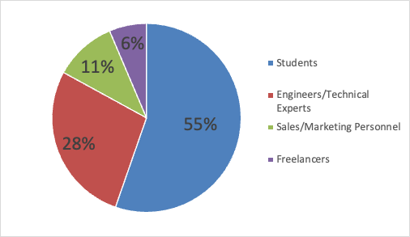
- Students: 55.3%
- Engineers/Technical Experts: 27.7%
- Sales/Marketing Personnel: 10.6%
- Freelancers: 6.4%

GPU Brand Preferences:
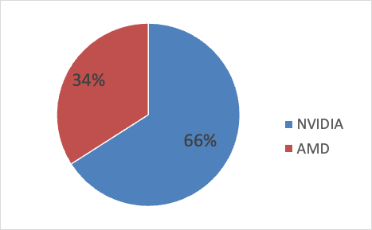
- NVIDIA: 65.96%
- AMD: 34.04%
GPU Usage Distribution: Count of GPU Brand by Usage:
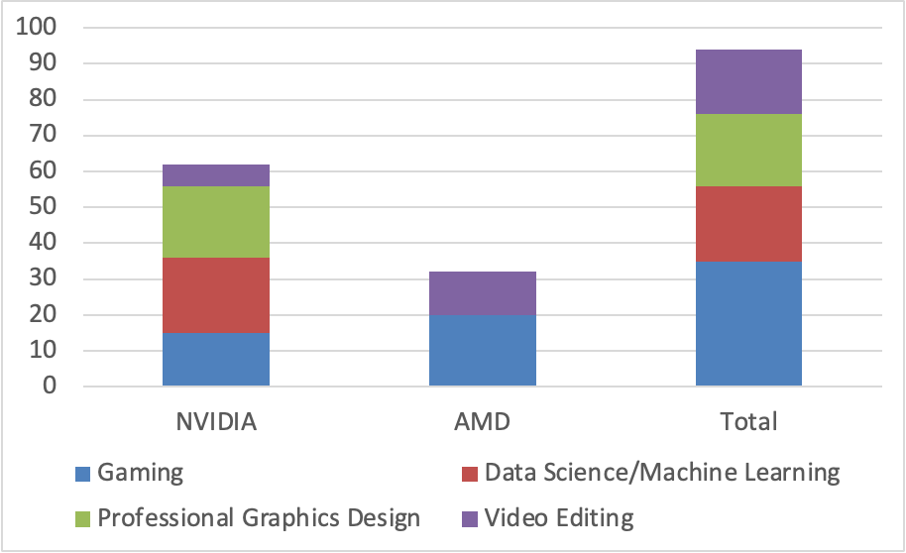
GPU Brand | Gaming | Data Science/Machine Learning | Professional Graphics Design | Video Editing | Total
NVIDIA | 15 | 21 | 20 | 6 | 62
AMD | 20 | - | - | 12 | 32
Total | 35 | 21 | 20 | 18 | 94
NVIDIA has a higher market share, being used in all areas, suggesting its dominance in machine learning and graphics design, whereas AMD is more competitive in consumer-oriented tasks like gaming and video editing.

GPU Price Range: Count of GPU Brand by Price Range: 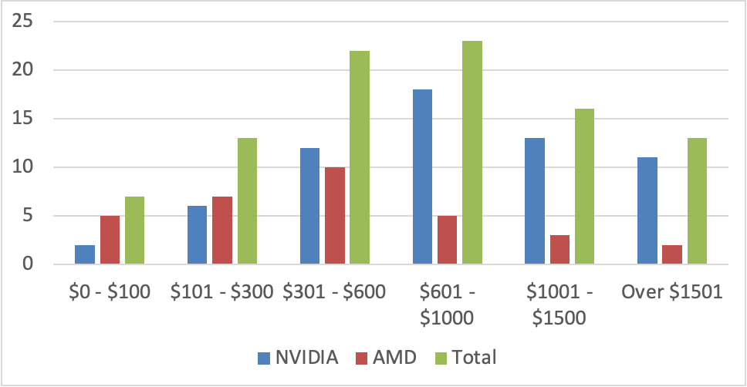
GPU Brand | $0 - $100 | $101 - $300 | $301 - $600 | $601 - $1000 | $1001 - $1500 | Over $1501 | Total
NVIDIA | 2 | 6 | 12 | 18 | 13 | 11 | 62
AMD | 5 | 7 | 10 | 5 | 3 | 2 | 32
Total | 7 | 13 | 22 | 23 | 16 | 13 | 94
Consumers tend to choose cost-effective AMD GPUs or higher-priced NVIDIA GPUs for higher performance. AMD is an ideal choice for price-sensitive users, while NVIDIA appeals to professional users or those seeking top-tier gaming experiences.
Brand Reputation: Count of GPU Brand by Trust Level:
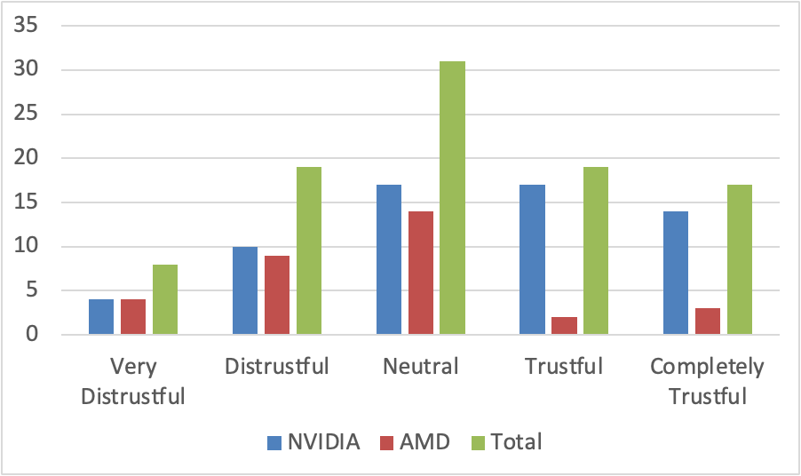
GPU Brand | Very Distrustful | Distrustful | Neutral | Trustful | Completely Trustful | Total
NVIDIA | 4 | 10 | 17 | 17 | 14 | 62
AMD | 4 | 9 | 14 | 2 | 3 | 32
Total | 8 | 19 | 31 | 19 | 17 | 94
Consumers purchasing NVIDIA products generally have a high trust in the brand, reflecting NVIDIA's long-established brand reputation and technological superiority in the market.

Open-Ended Responses:
23 respondents recommend NVIDIA due to its excellent performance meeting daily needs, while 21 do not recommend it primarily due to its poor cost-effectiveness. For AMD, nearly half of the respondents recommend their products mainly due to their high cost-effectiveness, offering better performance at the same price. However, the main reason for not recommending AMD is stability issues or technical problems.
Users provided various suggestions and comments regarding the improvement of graphics cards. Many highlighted the need for better cooling performance, as the current models tend to run hot during use. There is also a demand for more mid-range and low-end options to cater to budget-conscious consumers, as well as more frequent driver updates to address compatibility issues.
Users suggested optimizing energy efficiency, improving customer service response times, and enhancing product packaging to prevent damage during transport. Some requested more detailed user manuals for beginners, as well as quieter fan designs to reduce operational noise. Additionally, users expressed interest in more aesthetic options, such as different color choices to match their PC builds, and recommended collaborating with other hardware brands to improve compatibility.
While many were satisfied with the overall performance, especially under heavy loads, they also encouraged further optimization. Some users were dissatisfied with the driver management software interface and suggested improvements. There were also calls for extended warranty periods and more compact graphics cards that support a wider range of display interfaces and monitors.

Correlation Analysis
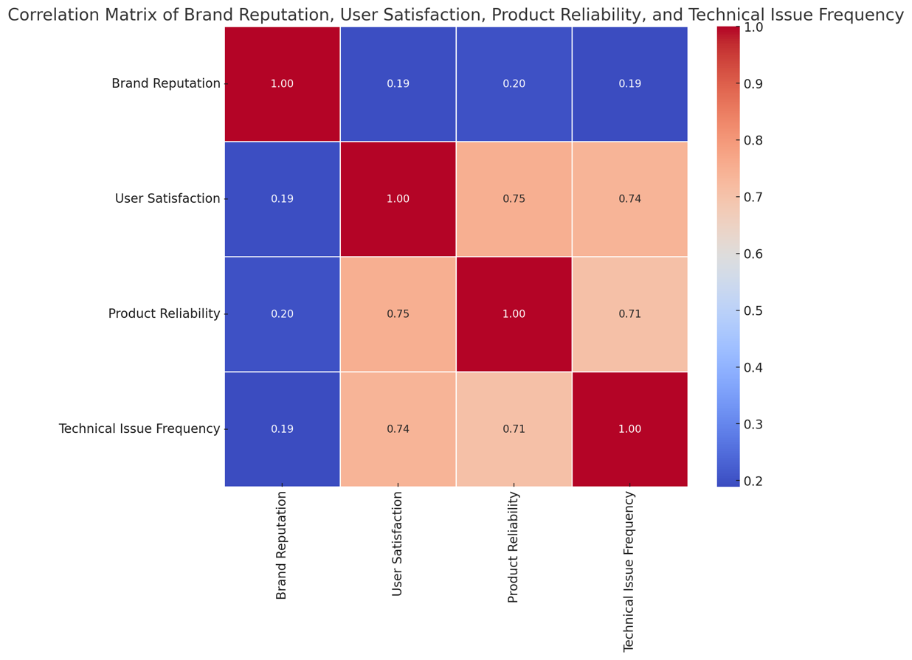
The heatmap from the correlation analysis shows low correlations between brand reputation and user satisfaction, product reliability, and frequency of technical issues. This indicates that while brand reputation is an important commercial asset, it does not directly determine actual user satisfaction, product reliability, or the frequency of technical issues. Brand reputation more likely affects user expectations rather than the actual experience.
Product reliability is influenced by manufacturing quality, design, and technological innovation, while the frequency of technical issues may be affected by product design, manufacturing defects, and user handling. Therefore, although brand reputation can attract consumers and influence purchasing decisions, brand managers should ensure that high reputation translates into high user satisfaction and low technical issue frequency through continuous improvement in product quality and customer service. This strategy will more effectively meet consumer expectations and needs, thereby maintaining a competitive advantage in a highly competitive market.
After analyzing the correlations between user satisfaction, product reliability, and frequency of technical issues, we can observe several key interactive effects.
First, there is a significant positive correlation between user satisfaction and product reliability, indicating that the stability and reliability of a product are key determinants of user satisfaction. A reliable product reduces failures and issues, significantly enhancing user satisfaction.
Secondly, the negative correlation between user satisfaction and the frequency of technical issues reveals that the occurrence of technical issues directly impacts user satisfaction; frequent technical issues lead to a decline in user experience, thereby reducing satisfaction.
Lastly, the negative correlation between product reliability and the frequency of technical issues further proves that high-quality and reliable products effectively reduce the occurrence of technical issues. These analysis results emphasize the importance of quality product design and strict quality control for enhancing user experience and satisfaction, suggesting that companies should continuously strive for optimization of product quality to meet user expectations and needs.

Survey Summary
The survey results show that NVIDIA maintains a strong brand image and user loyalty in the high-end market, especially in the fields of machine learning and professional graphic design. In contrast, AMD holds a larger market share in the gaming and low-price markets, indicating that AMD's products offer a high cost-performance ratio, meeting the needs of budget-conscious users. Brand reputation has a certain positive impact on users' willingness to recommend, with users tending to recommend brands they trust.
However, the relationship between user satisfaction and recommendation willingness is not very clear, suggesting that other factors such as price, product features, and performance may have a greater impact on users' willingness to recommend. User feedback highlights concerns about price, thermal performance, and customer service. These insights reveal potential improvement opportunities in the market.
For AMD, enhancing thermal performance and improving customer service response times may help improve user experience and satisfaction, thereby enhancing user loyalty and willingness to recommend.
For NVIDIA, while the brand image and technical superiority are prominent, it also needs to consider the cost-effectiveness of its products to address the needs of price-sensitive consumers. Companies should develop product and market strategies according to their brand positioning and target market segmentation.
For NVIDIA, maintaining its leadership in the high-end market is key, while it could also explore how to provide more cost-effective solutions while maintaining its technological edge. AMD should continue to strengthen its cost-performance advantage in the gaming and low-end markets, while expanding market share and enhancing user satisfaction by improving product reliability and customer service quality. Additionally, both brands need to pay attention to user feedback, continuously optimizing product performance and service to adapt to market changes and user needs.
This chapter has examined user choice from both an overall market view using academic models and focused on user preference results gained from the survey tool. It has provided a detailed look at how NVIDIA and AMD fare in terms of brand loyalty, market segmentation, and user satisfaction, reflecting different strengths and areas for improvement for each brand. By employing both industry analysis and consumer feedback, this chapter has highlighted key insights that can guide future strategies for both companies.
The next chapter will present the paper’s conclusion, summarizing the findings and offering strategic recommendations based on the comprehensive analysis conducted throughout the study.

Conclusion

NVIDIA's Current Status and Strategy
Current Status
NVIDIA maintains its leadership in the high-end GPU market, particularly noted for its brand image and technical prowess in machine learning and professional graphic design. The key strategy includes ongoing technological innovation, especially in AI and deep learning applications, leveraging its powerful CUDA platform and high-performance GPUs like the A100 to boost computing power.
Additionally, NVIDIA is focused on expanding its share in data centers and cloud computing markets, collaborating with major cloud service providers to offer computing solutions optimized for AI and machine learning. However, NVIDIA faces challenges from emerging chip manufacturers, especially under policy and trade restrictions, which may accelerate the development of autonomous technologies and threaten NVIDIA's position in the global market.
Strategic Recommendations
- Innovation and R&D Investment: NVIDIA is committed to maintaining its market leadership through continuous technological innovation. The company invests heavily in R&D for artificial intelligence, deep learning, and autonomous driving technologies. Additionally, NVIDIA continually pushes the boundaries in ray tracing and quantum computing technologies, which are crucial for maintaining technical superiority and attracting high-end customers.
- Product Diversification and High-End Product Development: To meet the broad demands from data centers to individual consumers, NVIDIA continuously expands its product line. The company particularly focuses on the development of high-performance chips like Blackwell, aimed at providing higher computing efficiency and processing speeds for complex AI applications and data-intensive tasks. NVIDIA also continuously develops specialized AI hardware, such as DGX, to strengthen its competitive edge in professional markets.
- Collaboration and Ecosystem Building: NVIDIA recognizes that collaboration with cloud service providers is vital for its business expansion. The company partners with platforms like Amazon Web Services and Microsoft Azure to integrate its GPU technology for advanced AI and computing services. Furthermore, NVIDIA is actively building an open developer ecosystem, offering tools like CUDA and TensorRT to support global developers and researchers on its platform.
- Market and Geopolitical Strategy: In a globalized market, policy and trade restrictions can impact business. NVIDIA adopts flexible market strategies and supply chain management to address these external challenges. The company also collaborates with governments and industry organizations in different countries to influence policy-making, ensuring compliance with technology and optimizing its global market strategy.

AMD's Current Status and Strategy
Current Status Unlike NVIDIA, AMD has garnered significant user support in the gaming and low-end markets with its cost-effective Radeon series GPUs, meeting the needs of a wide range of gamers and budget-conscious users. AMD also strengthens its position in the gaming field through collaborations with major gaming console manufacturers like Sony and Microsoft. Simultaneously, AMD is committed to enhancing its competitiveness in broader professional and data center markets, attempting to narrow the gap with NVIDIA in these high-end markets. The main challenge for AMD is how to balance its product line to maintain competitiveness in mainstream markets while innovating in high-end markets to address pressures from NVIDIA and other emerging competitors.
Strategic Recommendations
- Enhancing Consumer Chip R&D and Innovation: AMD should continue to increase R&D investments in consumer chips, particularly the Radeon series GPUs, to launch more innovative products that attract gamers and budget-sensitive consumers. By leveraging its advantages in price-performance ratio, AMD can better meet market demands, especially in price-sensitive segments.
- Expanding Collaboration with Console Manufacturers: AMD has established partnerships with major console manufacturers like Sony and Microsoft. By further deepening these relationships, AMD not only secures its chips' use in next-generation consoles but also enhances its market recognition through these partners' brand and market influence.
- Capitalizing on Global Trade Environment Changes: Given the uncertainties in global trade policies, AMD can mitigate potential trade barriers by optimizing its supply chain management and production layouts. With comparatively lesser export restrictions to China than NVIDIA, AMD is potentially better positioned to capture the Chinese market first.
- Enhancing Competitiveness in Data Centers and Professional Markets: Although AMD excels in consumer markets, there is significant room for growth in data centers and professional computing markets. AMD can enhance its product competitiveness by developing high-performance products targeted at these markets, like EPYC server processors, and attempt to narrow the gap with NVIDIA in these areas.
- Strengthening Open Source Software and Developer Support: AMD can enhance support for open-source software and the developer community by providing more development resources and tools. This not only increases the flexibility of AMD's product applications but also helps attract developers and enterprises seeking greater freedom and customized solutions.

Conclusion and Recommendations
As the global demand for high-performance computing, cloud computing, and artificial intelligence continues to grow, competition in the GPU market is expected to intensify further. Industry leaders NVIDIA and AMD are anticipated to continue driving technological innovation, particularly in the fields of AI and machine learning applications.
They will face diverse market demands ranging from cloud data centers to personal consumer electronics, prompting both companies to develop a broader product portfolio to cater to various needs from large-scale computation to edge computing. Amidst global trade policy uncertainties, adjusting globalization strategies, such as establishing partnerships in key markets or adjusting supply chains, will be key in responding to political and economic changes.
Moreover, NVIDIA and AMD might form strategic collaborations on certain projects and technologies while pursuing market leadership, jointly pushing the development of industry standards. Both companies are also expected to increase their investments in the developer community, providing advanced development tools and resources to spur innovation, and through these efforts, meet the global demand for high-performance computing solutions. In terms of sustainability, as global attention to environmental issues deepens, NVIDIA and AMD will need to integrate eco-friendliness into product design and corporate operations not just to respond to social responsibilities but also to meet increasingly stringent consumer and policy demands.
Overall, the future GPU market will witness not only technological competition but also a rapid response to shifting market demands. The strategic choices and market performances of NVIDIA and AMD will greatly influence the direction of global computing technology, propelling the entire industry towards a more efficient, eco-friendly, and intelligent future.

Future Research
In future research, several areas stand out as worthy of further investigation. One key area is the development of next-generation GPU architectures, particularly those optimized for quantum computing and neuromorphic computing applications. As AI and machine learning models continue to grow in complexity, exploring hardware architectures specifically designed for handling these workloads could reveal new performance efficiencies. Additionally, studying the integration of sustainability in GPU design and manufacturing is becoming increasingly critical. Investigating how companies like NVIDIA and AMD can reduce the environmental footprint of their supply chains and products would align with growing global eco-consciousness. Lastly, a deeper analysis of the geopolitical influences on the semiconductor supply chain, and how companies might adapt to navigate restrictions and maintain innovation, could provide insights into the industry's future resilience and strategic maneuvering.

Bibliography
About AMD (no date a). https://www.amd.com/en/corporate.html.
About AMD (no date b). https://www.amd.com/en/corporate.html.
Amd (2024a) &apos;AMD Accelerates Pace of Data Center AI Innovation and Leadership with Expanded AMD Instinct GPU Roadmap,&apos; AMD, 2 June. https://www.amd.com/en/newsroom/press-releases/2024-6-2-amd-accelerates-pace-of-data-center-ai-innovation-.html.
Amd (2024b) &apos;AMD Reports Fourth Quarter and Full Year 2023 Financial Results,&apos; AMD, 30 January. https://www.amd.com/en/newsroom/press-releases/2024-1-30-amd-reports-fourth-quarter-and-full-year-2023-fina.html.
AMD (2024) AMD Reports Fourth Quarter and Full Year 2023 Financial Results. https://ir.amd.com/news-events/press-releases/detail/1180/amd-reports-fourth-quarter-and-full-year-2023-financial.
AMD Radeon&lt;sup&gt;TM RX Graphics Cards (no date). &lt;span class=&qout;url&qout;&gt;https://www.amd.com/en/products/graphics/desktops/radeon.html.
AMD ROCm&lt;sup&gt;TM Software (no date). &lt;span class=&qout;url&qout;&gt;https://www.amd.com/en/products/software/rocm.html.
AMD Extends its Leadership with the Introduction of its Broadest Portfolio of High-Performance PC Products for Mobile and Desktop (no date). https://ir.amd.com/news-events/press-releases/detail/1111/amdextends-its-leadership-with-the-introduction-of-its.
Bendle, S. (2024) CPU Price Index 2024: The cheapest price on every PC processor today. https://www.tomshardware.com/news/lowest-cpu-prices.
Bevans, R. (2023) Guide to Experimental Design | Overview, Steps, &#038; Examples. https://www.scribbr.com/methodology/experimental-design/.
Bhandari, P. (2023a) Inductive Reasoning | Types, Examples, Explanation. https://www.scribbr.com/methodology/inductive-reasoning/.
Bhandari, P. (2023b) What Is Deductive Reasoning? | Explanation &#038; Examples. https://www.scribbr.com/methodology/deductive-reasoning/.
Bhandari, P. (2023c) What Is Quantitative Research? | Definition, Uses &#038; Methods. https://www.scribbr.com/methodology/quantitative-research/.
Bhandari, P. (2024) What Is Qualitative Research? | Methods &#038; Examples. https://www.scribbr.com/methodology/qualitative-research/.
Bharadwaj, A. et al. (2024) Navigating a Diverse World of Consumer Mindsets and Choice. https://www.bcg.com/publications/2021/understanding-consumer-mindset-and-choice-diversity.
Butler, D. (2020) &apos;History of AMD: Timeline and Facts,&apos; TheStreet, 16 March. https://www.thestreet.com/technology/history-of-amd.
Castellano, R. (2024) &apos;Nvidia: Why The Company And Its GPUs Will Dominate AI Processors,&apos; Seeking Alpha, 17 June. https://seekingalpha.com/article/4699675-nvidia-why-the-company-and-its-gpus-will-dominate-ai-processors.
Chen, S. (2024) &apos;Research on Nvidia Investment Strategies and analysis,&apos; Highlights in Business Economics and Management, 24, pp. 2234–2240. https://doi.org/10.54097/vzd0m812.
Co-Authored (no date) What is (and what is not) a technology-driven company | Making Sense Blog. https://blog.makingsense.com/2021/10/what-is-and-what-is-not-a-technology-driven-company/.
companiesmarketcap (no date) NVIDIA (NVDA) - Market capitalization. https://companiesmarketcap.com/nvidia/marketcap/.
Computer Hope (2023) Computer Processor History. https://www.computerhope.com/history/processor.htm.
David, E. (2024) &apos;Chip race: Microsoft, Meta, Google, and Nvidia battle it out for AI chip supremacy,&apos; The Verge, 9 September. https://www.theverge.com/2024/2/1/24058186/ai-chips-meta-microsoft-google-nvidia.
Dudovskiy (no date a) Interpretivism (interpretivist) Research Philosophy. https://research-methodology.net/research-philosophy/interpretivism/.
Dudovskiy (no date b) Interpretivism (interpretivist) Research Philosophy. https://research-methodology.net/research-philosophy/interpretivism/.
Dudovskiy (no date c) Pragmatism Research Philosophy. https://research-methodology.net/research-philosophy/pragmatism-research-philosophy/.
Frost, J. (2024) Cronbach’s Alpha: Definition, Calculations &#038; Example. https://statisticsbyjim.com/basics/cronbachs-alpha/.
General Data Protection Regulation (GDPR) – Legal Text (2024). https://gdpr-info.eu/.
George, T. (2024) What Is Action Research? | Definition &#038; Examples. https://www.scribbr.com/methodology/action-research/.
Godinho, J.P.D.R. (no date) Nvidia Corporation (NVDA) Nvidia: Reshaping the Foundations of Tomorrow - ProQuest. https://www.proquest.com/openview/2ae1390e8bf5d68f7d5bbe58cbfc9952/1?pq-origsite=gscholar&cbl=2026366&diss=y.
Goel, S. (2024) What does Nvidia do: Business model analysis. https://thestrategystory.com/2023/01/05/what-does-nvidia-do-business-model-analysis/.
Gordon, E.J. and Prohaska, T.R. (2006) &apos;The Ethics of Withdrawal from Study Participation,&apos; Accountability in Research, 13(4), pp. 285–309. https://doi.org/10.1080/08989620600848645.
GPUcheck (2021) 2024 GPU Benchmark and Graphics Card Comparison Chart. https://www.gpucheck.com/gpu-benchmark-graphics-card-comparison-chart.
Gratton, P. (2024) Porter&#39;s Five Forces Explained and How to Use the Model. https://www.investopedia.com/terms/p/porter.asp.
Grimm, D. (2024a) &apos;Nvidia CEO hand-delivers world’s fastest AI system to OpenAI, again &mdash; first DGX H200 given to Sam Altman and Greg&hellip;,&apos; Tom’s Hardware, 25 April. https://www.tomshardware.com/tech-industry/artificial-intelligence/nvidia-ceo-hand-delivers-worlds-fastest-ai-system-to-openai-again-first-dgx-h200-given-to-sam-altman-and-greg-brockman.
Grimm, D. (2024b) &apos;Nvidia CEO hand-delivers world’s fastest AI system to OpenAI, again &mdash; first DGX H200 given to Sam Altman and Greg&hellip;,&apos; Tom’s Hardware, 25 April. https://www.tomshardware.com/tech-industry/artificial-intelligence/nvidia-ceo-hand-delivers-worlds-fastest-ai-system-to-openai-again-first-dgx-h200-given-to-sam-altman-and-greg-brockman.
He, L. (2024) Nvidia names Huawei a top competitor in major areas including AI chips. https://edition.cnn.com/2024/02/23/business/china-nvidia-huawei-competitor-ai-chips-intl-hnk/index.html.
Heller, M. (2022) What is CUDA? Parallel programming for GPUs. https://www.infoworld.com/article/2256401/what-is-cuda-parallel-programming-for-gpus.html.
Hintz, E.A. and Dean, M. (2019) &apos;Best practices for returning research findings to participants: Methodological and ethical considerations for communication researchers,&apos; Communication Methods and Measures, 14(1), pp. 38–54. https://doi.org/10.1080/19312458.2019.1650165.
Intel (no date) CPU vs. GPU: What’s the difference? https://www.intel.com/content/www/us/en/products/docs/processors/cpu-vs-gpu.html.
Irwin, K. (2024) &apos;Elon Musk’s xAI Powers Up 100K Nvidia GPUs to Train Grok,&apos; PCMAG, 22 July. https://www.pcmag.com/news/elon-musk-xai-powers-up-100k-nvidia-gpus-to-train-grok.
Kan, M. (2022) &apos;Nvidia CEO: High Prices for GPUs Are Here to Stay,&apos; PCMAG, 21 September. https://www.pcmag.com/news/nvidia-ceo-high-prices-for-gpus-are-here-to-stay.
King, I. (2024a) &apos;Nvidia (NVDA) Shares Jump on Upbeat Forecast,&apos; Bloomberg.com, 22 February. https://www.bloomberg.com/news/articles/2024-02-21/nvidia-forecast-fails-to-impress-investors-after-dizzying-rally?sref=aPhxMSeh.
King, I. (2024b) &apos;Nvidia (NVDA) Shares Jump on Upbeat Forecast,&apos; Bloomberg.com, 22 February. https://www.bloomberg.com/news/articles/2024-02-21/nvidia-forecast-fails-to-impress-investors-after-dizzying-rally?sref=aPhxMSeh.
Kraus, S. et al. (2021) &apos;Digital Transformation: An overview of the current state of the art of research,&apos; SAGE Open, 11(3), p. 215824402110475. https://doi.org/10.1177/21582440211047576.
Leswing, K. (2024) Nvidia dominates the AI chip market, but there’s more competition than ever. https://www.cnbc.com/2024/06/02/nvidia-dominates-the-ai-chip-market-but-theres-rising-competition-.html.
Liu, Z. (2020) &apos;AMD Ramps Up CPU Production For PlayStation 5 and Xbox Series X,&apos; Tom’s Hardware, 3 May. https://www.tomshardware.com/news/amd-ramps-up-cpu-production-for-playstation-5-and-xbox-series-x.
Loeffler, J. and Thomas, J. (2023) &apos;AMD vs Nvidia in 2024: who is the graphics card champion?,&apos; TechRadar, 20 September. https://www.techradar.com/news/computing-components/graphics-cards/amd-vs-nvidia-who-makes-the-best-graphics-cards-699480&quot.
macrotrends (no date) NVIDIA Gross Margin 2010-2024 | NVDA. https://www.macrotrends.net/stocks/charts/NVDA/nvidia/gross-margin.
Martinez, I. (2023) Marketing Strategy of AMD: Marketing Mix. https://www.konsyse.com/articles/marketing-strategy-of-amd-marketing-mix/.
Masud, A.A. (2024) Servqual: What it Is + How To Understand the Model. https://www.questionpro.com/blog/servqual/.
McCombes, S. (2023a) Survey Research | Definition, Examples &#038; Methods. https://www.scribbr.com/methodology/survey-research/.
McCombes, S. (2023b) What Is a Case Study? | Definition, Examples &#038; Methods. https://www.scribbr.com/methodology/case-study/.
Meier (2022) How does technology drive business transformation? | IBM. https://www.ibm.com/blog/how-does-technology-drive-business-transformation/.
Morgan, T.P. (2023) Nvidia Picks Up The Pace For Datacenter Roadmaps. https://www.nextplatform.com/2023/10/12/nvidia-picks-up-the-pace-for-datacenter-roadmaps/.
Nelius, J. (2019) &apos;Steam hardware survey reveals how many people have RTX and Vega cards,&apos; Pcgamer, 12 February. https://www.pcgamer.com/steam-hardware-survey-reveals-how-many-people-have-rtx-and-vega-cards/.
NVIDIA (no date) NVIDIA HPC and accelerated computing platform for data centers. https://www.nvidia.com/en-us/data-center/products/.
Nvidia CEO Jensen Huang Turned Down a Merger Offer in the Company’s Early Days, According to Insiders. Here’s Why. (no date). https://www.msn.com/en-us/money/companies/nvidia-ceo-jensen-huang-turned-down-a-merger-offer-in-the-companys-early-days-according-to-insiders-heres-why/ar-BB1pCSYe.
NVIDIA CORPORATION (2024a) FORM 10-K, UNITED STATES SECURITIES AND EXCHANGE COMMISSION. https://d18rn0p25nwr6d.cloudfront.net/CIK-0001045810/1cbe8fe7-e08a-46e3-8dcc-b429fc06c1a4.pdf. Page 39.
NVIDIA CORPORATION (2024b) FORM 10-K, UNITED STATES SECURITIES AND EXCHANGE COMMISSION. https://d18rn0p25nwr6d.cloudfront.net/CIK-0001045810/1cbe8fe7-e08a-46e3-8dcc-b429fc06c1a4.pdf. Page 9.
NVIDIA Corporation: About Us (no date). https://www.nvidia.com/en-us/about-nvidia/#nvidia-is-the-engine-of-ai.
NVIDIA Corporation: History (no date a). https://www.nvidia.com/en-us/about-nvidia/corporate-timeline/.
NVIDIA Corporation: History (no date b). https://www.nvidia.com/en-us/about-nvidia/corporate-timeline/.
NVIDIA DLSS Technology (no date). https://www.nvidia.com/en-us/geforce/technologies/dlss/.
Oh, F. (2022) What Is CUDA | NVIDIA Official Blog. https://blogs.nvidia.com/blog/what-is-cuda-2/.
Porter, M.E. (2024) How Competitive Forces Shape Strategy. https://hbr.org/1979/03/how-competitive-forces-shape-strategy.
Research-methodology (no date) Positivism Research Philosophy. https://research-methodology.net/research-philosophy/positivism/.
Reuters (2023) &apos;US Curbs AI Chip Exports From Nvidia and AMD to Some Middle East Countries,&apos; US News & World Report, 30 August. https://money.usnews.com/investing/news/articles/2023-08-30/us-restricts-exports-of-some-nvidia-chips-to-middle-east-countries-filing.
Robertson, B. (2023) What is Data Anonymization | Pros, Cons & Common Techniques | Imperva. https://www.imperva.com/learn/data-security/anonymization/.
semiconductors (2024) [News] NVIDIA and AMD Clash in AI Chip Market, as TSMC Dominates Orders with Strong Momentum in Advanced Processes | TrendForce Insights. https://www.trendforce.com/news/2024/01/09/news-nvidia-and-amd-clash-in-ai-chip-market-as-tsmc-dominates-orders-with-strong-momentum-in-advanced-processes/.
Shibu (2024) Nvidia CEO Jensen Huang turned down a merger offer in the company’s early days, according to insiders. Here’s why. https://www.msn.com/en-us/money/companies/nvidia-ceo-jensen-huang-turned-down-a-merger-offer-in-the-companys-early-days-according-to-insiders-heres-why/ar-BB1pCSYe.
Shilov, A. (2023a) &apos;Elon Musk Buys Thousands of GPUs for Twitter’s Generative AI Project,&apos; Tom’s Hardware, 11 April. https://www.tomshardware.com/news/elon-musk-buys-tens-of-thousands-of-gpus-for-twitter-ai-project.
Shilov, A. (2023b) &apos;Sony Becomes AMD’s Largest Customer on Booming PS5 Sales,&apos; Tom’s Hardware, 1 March. https://www.tomshardware.com/news/sony-becomes-largest-customer-of-amd.
Siegle, D. (2023) Research Ethics and Informed Consent. https://researchbasics.education.uconn.edu/ethics-and-informed-consent/.
Simkus (2023) Sampling Bias: Types, Examples &amp; How to Avoid It. https://www.simplypsychology.org/sampling-bias-types-examples-how-to-avoid-it.html.
Sousa, B. et al. (2021) &apos;Competing with Intel and Nvidia: The Revival of Advanced Micro Devices (AMD),&apos; IEEE [Preprint]. https://doi.org/10.23919/cisti52073.2021.9476337.
Statista (2024a) AMD research and development expenditure 2001-2023. https://www.statista.com/statistics/267873/amds-expenditure-on-research-and-development-since-2001/.
Statista (2024b) Nvidia research and development expenses worldwide FY2017-2024. https://www.statista.com/statistics/988048/nvidia-research-and-development-expenses/.
statisticshowto (2024) Cronbach’s Alpha: Definition, Interpretation, SPSS - Statistics How To. https://www.statisticshowto.com/probability-and-statistics/statistics-definitions/cronbachs-alpha-spss/.
Stock Comparison Tool | MacroTrends (no date). https://www.macrotrends.net/stocks/stock-comparison?s=revenue&axis=single&comp=AMD:NVDA.
Tam (2024) AMD unveils new AI chips to challenge Nvidia. https://techxplore.com/news/2024-06-amd-unveils-ai-chips-nvidia.html.
Thesismind (2019) Analysis of Saunders Research Onion. https://thesismind.com/analysis-of-saunders-research-onion/.
Thomas, L. (2023a) Cross-Sectional Study | Definition, Uses &#038; Examples. https://www.scribbr.com/methodology/cross-sectional-study/.
Thomas, L. (2023b) Longitudinal Study | Definition, Approaches &#038; Examples. https://www.scribbr.com/methodology/longitudinal-study/.
Tuttle, W. (2020) A Closer Look at How Xbox Series X|S Integrates Full AMD RDNA 2 Architecture - Xbox Wire. https://news.xbox.com/en-us/2020/10/28/a-closer-look-at-how-xbox-series-xs-integrates-full-amd-rdna-2-architecture/.
Twin, A. (2024a) 4 Ps of Marketing: What They Are &amp; How to Use Them Successfully. https://www.investopedia.com/terms/f/four-ps.asp.
Twin, A. (2024b) 4 Ps of Marketing: What They Are &amp; How to Use Them Successfully. https://www.investopedia.com/terms/f/four-ps.asp.
University of Wales Trinity Saint David (2024) Research Integrity and Ethics. https://www.uwtsd.ac.uk/research/research-integrity-and-ethics.
WalkMeTM (2022) What Is a Technology-Driven Organization? https://www.walkme.com/glossary/technology-driven-organization/.
Wang, X. and Cheng, Z. (2020) &apos;Cross-Sectional Studies,&apos; CHEST Journal, 158(1), pp. S65–S71. https://doi.org/10.1016/j.chest.2020.03.012.
Welcome to AMD (no date). https://www.amd.com/en.html.
White, M.J. (2023) &apos;Nvidia&#8217;s outrageous pricing strategy is exactly why we need AMD and Intel,&apos; Digital Trends, 22 March. https://www.digitaltrends.com/computing/nvidias-pricing-strategy-is-why-we-need-amd-and-intel/.
Zhu, K. (2023) Visualizing the R&D Investment of the 10 Biggest Nasdaq Companies. https://www.visualcapitalist.com/cp/ranked-the-10-biggest-nasdaq-companies-by-rd-investment/.
欢迎来到 AMD (no date). https://www.amd.com/zh-cn.html.
Lenovo (no date) &apos;Y&apos; vs &apos;R&apos; 哪款才是高质量选手？. https://club.lenovo.com.cn/thread-7829493-1-1.html.

Appendix

Questionnaire
- General Information
- What is your age range?
  - 18-24
  - 25-34
  - 35-44
  - 45-54
  - 55 and above
- What is your occupation?
  - Student
  - Engineer/Technical expert
- What is your primary purpose for using a GPU? (You can choose more than one)
  - Gaming
  - Professional graphic design
  - Video editing
  - Data science/Machine learning
- Which brand of GPU are you currently using?
  - NVIDIA
  - AMD
- How familiar are you with the current GPU brands on the market?
  - Very little knowledge
  - Basic understanding
  - Quite familiar
  - Very familiar
- Did you purchase your GPU new?
  - Yes
  - No
- What was the price range of the GPU you purchased?
  - $0 - $100
  - $101 - $300
  - $301 - $600
  - $601 - $1000
  - $1001 - $1500
  - Over $1501

- Tangibility
- How would you rate the design of your GPU's appearance?
  - Very dissatisfied
  - Dissatisfied
  - Neutral
  - Satisfied
  - Very satisfied

- Reliability
- How reliable is your GPU in daily use?
  - Very unreliable
  - Unreliable
  - Average
  - Reliable
  - Very reliable
- Does your GPU frequently encounter technical problems?
  - Frequently
  - Occasionally
  - Rarely
  - Never

- Responsiveness
- How satisfied are you with the response time of customer service when dealing with GPU technical issues?
  - Very dissatisfied
  - Dissatisfied
  - Neutral
  - Satisfied
  - Very satisfied

- Assurance
- How do you perceive the brand reputation of your GPU?
  - Very untrustworthy
  - Untrustworthy
  - Neutral
  - Trustworthy
  - Completely trustworthy

- Empathy
- Do you feel the GPU design takes your specific needs as a user into consideration?
  - Not considered at all
  - Rarely considered
  - Average
  - Well considered
  - Very considerate

- Conclusion
- How satisfied are you overall with the NVIDIA or AMD GPU you are using?
  - Very dissatisfied
  - Dissatisfied
  - Neutral
  - Satisfied
  - Very satisfied
- Would you recommend the GPU you are using to your friends? If yes, why? If not, why not?
- Do you have any other suggestions or comments?

