UWTSD

AGILE approaches to software development


APPENDIX GA36d

LEVEL 7 ASSESSMENT SPECIFICATION

Student name: | James Morgan | Student ID number: | 1400817
Programme: | MSc (Hons)/PgDip/PgCert  Software Engineering (Itb Development)
Module: | Agile Software Engineering Principles
Module code: | ACCA7001 | Contribution to Overall Module Assessment (%): | 50%
Lecturer: | Jaymie L. Phillips | Internal Verifier: | Dr Kemi Ademoye/ Dr Tim Bashford
Assignment Title: | AGILE approaches to software development | Word count (or equivalent): | 2500
Submission deadline: | Jan 14th 2019 | Return date of provisional marks & written feedback:
Submission method: | All written assessments, where practical and possible, must be submitted via Turnitin unless otherwise instructed by the Lecturer. (Please DO NOT put this assessment specification into Turnitin or it will match many similarities with other students’ submissions.)  Alternative submission method (if applicable):  Late submission of the assessment will result in a late penalty mark. Penalties for late submission: Up to one itek late, maximum mark of 50%. Over one itek late, 0%. Only the Extenuating Circumstances Panel may approve a change to submission dates.
Academic honesty / referencing: | Academic honesty is required. In the main body of your submission you must give credit to authors on whose research and ideas your work is based. Append to your submission a reference list that indicates the books, articles, etc. that you have used, cited or quoted in order to complete this assessment.

Module Learning Outcomes
(from module syllabus)
Critically evaluate selected agile methods, tools and techniques and their deployment.

Contents
Table of Figures 3
Introduction 4
Main Body 4
Software Development Life cycle (SLDC) 4
AGILE and Traditional methods 6
Real world example 9
Conclusion 9
Potential Improvements 10
Reference List 11

Table of Figures
Figure 1: Software Development life cycle [1]. 4
Figure 2: The twelve agile principles [14]. 7
Figure 3: The scrum process obtained from [9]. 7
Figure 4: Waterfall method which can be found from [8]. 8
Figure 5:Software development methodology pro/con table. 8

Introduction

This report seeks to investigate ‘software development’. Specifically, it will be looking at how the process of planning and creating a finished software product is achieved. The report will reach our objectives by first obtaining an understanding of what the software development life cycle entails.

Furthermore, this report will discuss what Agile is and how its concepts affect software development, before continuing to investigate the traditional software development methodology called the ‘Waterfall model’, which will be compared to its Agile counterpart: the ‘Scrum model’.

Afterwards, the report will move from the theoretical side of the project to a practical example of an Agile approach to software development; in other words, it will demonstrate understanding of the methodology, by commenting on and relating our stated theory to a company that practises an Agile approach.

By definition, Agile software development is an “umbrella term for a set of methods and practices based on the values and principles expressed in the agile Manifesto.” [10]. Meanwhile, Scrum is an agile methodology which is a “framework for managing a process” [11], which relies on a “self-organizing, cross-functional team” [11].

Main Body

Software Development Life cycle (SLDC)

SLDC has open and continuous communication between the customer and the developers for requirements, adaptation, delivery and adjustment of a product. In other words, it allows a customer and delivery team options to decide on the best suitable product for the purpose, view the product as it is being built and can make necessary adjustments before, during and after deployment. In summary, a SDLC process will “focus on adding flexibility and supporting change in the development process” [4].
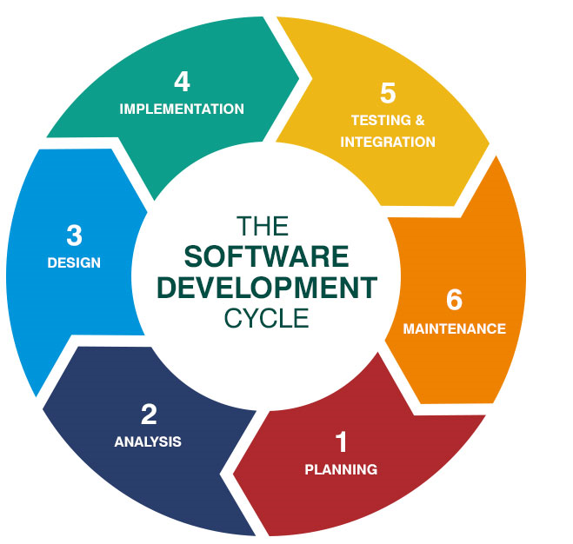
Figure 1: Software Development life cycle [1].
Using the above figure and from reading [1], the report understands SLDC can categorised by the following six stages shown above.

The planning and analysis stages

After examining the theory from [1], [6] and [12], the report states that the planning stage is a necessary part of the life cycle. Without it, there could be a large amount of issues later in the design stages. In addition, the finished product may not fit what the user desires. The report references a quote to support this statement as follows, “the purpose of this phase is to perform a preliminary investigation to evaluate an IT- relate business opportunity or problem” [12]. Initially, there is ‘requirement gathering’ and ‘requirements analysis’. In short, the process collects the client, development team and stakeholders to discuss what the product will be used for. The team asks what the user would want their product to perform. Once completed, the requirements are prioritized, delegated and value is assigned to the overall project.
Later, the development team can assess where problems exist in the current product, what issues can arise from the new product and how they can prepare preventative measures to future issues. This is then approved by managers before the project proceeds. The report knows this from the quote, “a key part of the preliminary investigation is a feasibility study” [12].

Design stage
The design stage can be split into three levels:
- Architectural Design.
- High-level Design
- Detailed design

From reading [6] and [12], it is clear that the Architectural design shows an overview with limited detail. Meanwhile, high-level sub-divides the entire design into smaller parts, allowing the distribution of user stories to become more easily allocated in the development teams. Finally, detailed design looks at the post-deployment stages and how the software will operate in ‘real-world settings’.
The report arrives at this conclusion from the quote “the system design phase is to create a physical model that will satisfy all documents requirements for the system” [12].
Each stage will tell the customer where their product can develop errors. Architectural can display upcoming errors as a result of poorly detailed user requirements from the planning and analysis stages. Detailed design will help identify errors for users who use the product after the deployment i.e. does it have glitches which prevent users from using the software? High-level design prevents integration problems from arising by highlighting how the sub-divided systems will essentially ‘communicate’. In other words, how will one aspect work with another area of the design.

By researching and reading the materials [1], [2] and [5], this report can see that the design stage involves multiple infrastructure constructions which are then assessed and reviewed with the customer and stakeholders. Stakeholders will decide if the design fits their product needs. This is supported by the quote, which states that the stakeholders review the “risk assessment, robustness, design modularity, time and cost” [5] and select the best design.

Implementation stage

By researching the elements from [1] and [5], the report may deduce that the implementation stage is where the development of the product moves from theory to practice. In other words, “actual development of the product starts according to the designed architecture” [5].

The development of a software can utilise many tools and packages e.g. Java. However; the approach and tools are decided by the development team, as the customer is unlikely to know which tool such as compilers, interpreters and debuggers would result in the optimal outcome. Hence, any input from the stakeholders at this point would mainly involve changes to the requirements. To re-emphasis this, the client would not be heavily involved at this stage. The choice of which tools will be used are normally decided in the earlier stages as this prevents delays in the implementation.

Testing and Integration stage

When code is written, there is a risk of ‘bugs’. The report knows that a ‘problem’ in the final product can be assigned to many different issues. For example, the code could have an error that causes complete software failure or poor performance. In addition to this, other issues can occur with the final product. An example of this could be a finished product which does not meet the user requirements. The testing stage is also a period of the life cycle where developers can assess if there are aspects that need to be added; in other words, requirements which were not in the original specifications set up. In short, the testing stage revolves around three areas validation, verification and error checking. We understand this by reading [1], [15] and [16].
Additionally, the report can confirm its understanding with the quote which says that the “major role of software testing involves that there should be no discrepancy in the software development process” [15].

We will discuss two testing processes. From [16] we understand that ‘test-first development’ is the process of creating tests on previously defined features. These tests will initially fail. The product can then be updated until the end product passes the set tests. The advantage is the overall time saved. Contrarily, there is a risk of feature creep (excessive expansion of features).
The second is ‘test driven development”. This is where “features may be adapted in a feedback loop” [16]. The advantage is the incremental and iterative software developments. Meanwhile, a drawback, is that the process requires continuous refactoring of the design and implementation.

In this stage, the developers play a large role in testing, while the customers are more active in the deployment stage. Therefore, it can summarise the testing and integration stage with the following quote, which states testing is where “the product is checked to ensure that defects are reported, tracked, fixed, and tested again until the product meets quality standards” [1].

Maintenance

Once finished, the product is deployed to the client, who uses the software and gives feedback on results. Also, by subjecting the software to a wider scale, it ensures any undetected flaws and unassigned (but necessary) user requirements can be identified and fixed. Similarly, if there are elements of missing requirements, the development team can evaluate the system for potential re -releases.

To summarise, the report highlights the following quote which says the “ultimate goal of the maintenance phase is to ensure that the product remains relevant and high quality” [1].

AGILE and Traditional methods

From reading [3] and [13] this report recognizes, that Agile methods are software development processes which matches the product to the client’s needs. The quote “bring development into alignment with business needs”[13] supports the reports statement. In addition to this statement, the approach is also designed to improve client-developer relationships and communication. The report understands this from the four values and twelve principles of agile.
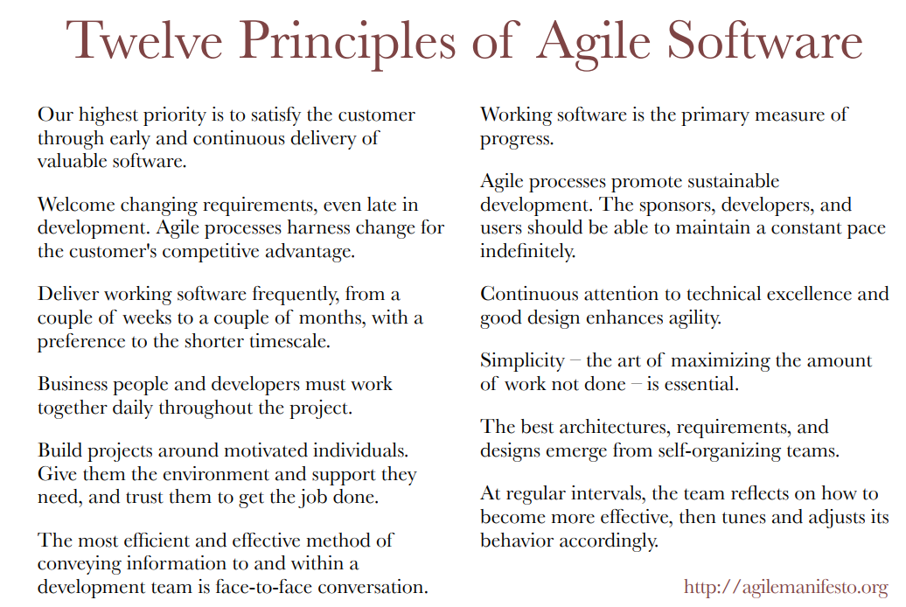
Figure 2: The twelve agile principles [14].
The main difference between agile and traditional developments is that traditional methods build and release a software without changes being made. Any improvements would then need a new process. Agile however, “continuously learn and improve to build a service that meets user needs” [17]. This is an advantage as agile methods “allow you to quickly make any changes while you’re building” [17].

Agile method - Scrum

Product Backlog
Figure 3: The scrum process obtained from [9].
An example of an Agile method is ‘Scrum’. From reading [9] and the figure shown above, the report understand that scrum uses the requirements from the analysis stage from SLDC. The requirements taken from the product (client) are then divided into tasks and placed in the product backlog as packages. The individual teams will then choose a set of tasks (sprint backlog) to complete in a sprint. It understands that a sprint is a “cyclical circles of work called sprints” [9] which typically lasts for up to four weeks. Providing no tasks are carried forward to the next sprint (backlog items), the sprint backlogs are completed and the product is shipped. A key advantage between scrum and other methodologies, is the scrum meetings. These are where “the team meets for short meetings (…) addressing three topics”. The topics covered usually consist of progress from the previous day, current targets for the working day and blockers which are essentially obstacles preventing task completion. The advantage of such a process is the communication between the team and the Scrum master who is the assigned overseer of the sprint. By having regular meetings, the entire team have an up-to-date understanding of how the product development is progressing.

Traditional method – Waterfall model
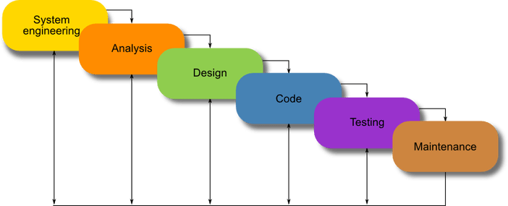
Figure 4: Waterfall method which can be found from [8].
.
The waterfall model is a traditional software development method. This development method follows a step-by-step process. This can be reiterated by the following quote, which states “waterfall model emphasizes that a logical progression of steps be taken throughout the software development life cycle (SDLC)” [8]. The method does not follow the exact same approach as agile. Instead, this method completes the product in segments without large quantities of client involvement, relying mainly on a product-in product out strategy, i.e. Method is inflexible to changes.

Advantages and disadvantages

From reading [7] and [9], the report will clarify the drawbacks and benefits of using Agile and traditional methods using a pro/con table (see below):

Software development methods | Pro | Con
Waterfall | Suitable for large scale design. | Difficult and expensive to make changes, once the project has started. (Incremental process)
Waterfall | Can provide a clearer prediction of what the end product will be. | Potential for scope creep.
Scrum | Team members are accountable and communication in scrum meetings allows team to keep track of their progress. | Needs experienced team members to prevent scope creep.
Scrum | Makes changes cheaper and easier (Incremental and iterative process). | Poor planning in the initial user requirements and design can cause inaccuracies.
Scrum | The sprint backlog is owned by the team, which usual consists of five to eleven members. | Inexperienced scrum masters can cause obstacles and slow development teams.
Figure 5:Software development methodology pro/con table.

Real world example

As mentioned in the introduction, the report will be referencing an example of a software that already exists and uses the agile approach to software development. The chosen product is tacho cards, which is a large project due to the number of users and processes to be considered.

Tacho cards are a tool which keeps track of hours worked by lorry drivers. The principle was to ensure that drivers did not exceed the legal set amount of driving time. By reading the evidence from a newspaper article (see [17]), the previous system was set so that drivers would fill in their hours completed into a paper form. This would then be recorded in a database for use in payslips.

To reduce the risk of duplication, suspected fraud and human error, it was decided that the process would become an online system. This is clear from the quote “we’ve moved from process to customer outcomes, so we no longer measure how quickly we move the piece of paper, but we measure what the impact is on the customer.” [19].

The information would be submitted via an on-board instrument or using a tacho card. Processed information would then be added to the driver’s online tachograph using an online service. The report understands this from the quote “digital tachograph stores data in two places: the instrument itself (the vehicle unit) and the driver's card” [17].

Researching the information from [18] and [19], we notice the civil service follows an Agile approach. Specifically, in several teams of 5-11 (which make up each department), the developers follow a scrum approach. The report understands this from the following quote that says, “two-weekly sprints and the continual iteration of what we’re doing has worked particularly well. That’s helped us to see a product emerging, and for us to be able to shape it with the developers” [19].

Conclusion

To conclude, this report sought to understand software development. To achieve this, there was first an insight into a software’s development life cycle. After investigating the six stages, the report then furthered its understanding of the traditional waterfall model and the more modern AGILE approach using the scrum model. Once both approaches had been formally understood, it was then appropriate to investigate the advantages and disadvantages of each model.

This report was able to conclude that both traditional and agile methodologies had drawbacks and advantages. Hence, neither can be ruled out in the development of software; rather, it is better that both approaches are considered within the initial planning stages of the product. By adopting this ‘best-fit’ attitude, developers will be able to return a product that has been processed using the ideal option.

Once the theory was completed, the report then investigated a real life setting of an agile developed piece of software. Specifically, this report investigated the software development of the online tachograph for lorry and bus drivers. This report discovered that the civil service developed an online service for recording hours by using the agile methodology and the scrum model.

The report concludes from this investigation that the process of software development using agile allows the end product to have a more tailored product, which is specific to the requirements of the client.

Potential Improvements
If the report was to be repeated, it would like to investigate an example of a software product where the waterfall model was used.

Furthermore, the report would benefit from the definition and examples of the ‘Kanban’ methodology.

Reference List
[1] Hussung, T. (2018). What is the Software Development Cycle?. [online] Husson University. Available at: https://online.husson.edu/software-development-cycle/ [Accessed 4 Dec. 2018].
[2] Bjøner, D. (n.d.). Software Engineering 3. 1st ed. Springer Science & Business Media, 2006, pp.24-30, 30-36, 40-42.
[3] Beedle, M., Bennekum, A., Cockburn, A., Cunningham, W., Fowler, M., Highsmith, J., Hunt, A., Jeffries, R., Kern, J., Marick, B., Martin, R., Schwaber, K., Sutherland, J. and Thomas, D. (2018). Manifesto for Agile Software Development. [online] Agilemanifesto.org. Available at: https://agilemanifesto.org/ [Accessed 5 Dec. 2018].
[4] Gruhn, V. and Striemer, R. (n.d.). The Essence of Software Engineering. 1st ed. Essen: Springer, 2018, p.26.
[5] Kazim. A, “A Study of Software Development Life Cycle Process Models”. International Journal of Advanced Research in Computer Science, vol. 8, no. 1, pp. 15-16, 2017, Accessed on: Jan. 6,2018. [Online]. Available at: https://search-proquest-com.ezproxy.uwtsd.ac.uk/docview/1901446145?accountid=130472&rfr_id=info%3Axri%2Fsid%3Aprimo.
[6] Zhu, H. (2004). Software design methodology. Oxford: Butterworth-Heinemann, pp.47-225.
[7] Lonergan, K. (2018). The Pros and Cons of Agile and Waterfall. [online] Pmis-consulting.com. Available at: https://www.pmis-consulting.com/agile-versus-waterfall/ [Accessed 6 Dec. 2018].
[8] Powell-Morse, A. (2018). Waterfall Model: What Is It and When Should You Use It?. [online] Airbrake Blog. Available at: https://airbrake.io/blog/sdlc/waterfall-model [Accessed 6 Dec. 2018].
[9] Kaleshovska, N., Josimovski, S., Pulevska-Ivanovska, L., Postolov, K. and Janevski, Z. (2018). THE CONTRIBUTION OF SCRUM IN MANAGING SUCCESSFUL SOFTWARE DEVELOPMENT PROJECTS. Skopje: Institute of Economics, pp.182-185.
[10] Unknown (2018). What is Agile Software Development?. [online] Agile Alliance. Available at: https://www.agilealliance.org/agile101/ [Accessed 7 Dec. 2018].
[11] Cohn, M. (2018). Scrum Methodology and Project Management. [online] Mountain Goat Software. Available at: https://www.mountaingoatsoftware.com/agile/scrum [Accessed 7 Dec. 2018].
[12] Shelly, G. and Rosenblatt, H. (2012). Analysis and design for systems. South Melbourne: Course Technology Cengage Learning, pp.23-25.
[13] Unknown (2018). Comprehensive Guide to the Agile Manifesto. [online] Smartsheet. Available at: https://www.smartsheet.com/comprehensive-guide-values-principles-agile-manifesto [Accessed 7 Dec. 2018].
[14] Ken, F. (2009). Agile manifesto. [online] Assets.uits.iu.edu. Available at: https://assets.uits.iu.edu/pdf/Agile-Manifesto.pdf [Accessed 7 Dec. 2018].
[15] M. E. Khan and F. Khan, "Importance of Software Testing in Software Development Life Cycle," International Journal of Computer Science Issues (IJCSI), vol. 11, (2), pp. 120-123, 2014. Available: https://search.proquest.com/docview/1535072439?accountid=130472.
[16] Phillips, J. (2018). TFDD. [online] Moodle.uwtsd.ac.uk. Available at: https://moodle.uwtsd.ac.uk/mod/resource/view.php?id=152093 [Accessed 7 Dec. 2018].
[17] Anonymous "...tachograph analysis," Commercial Motor, vol. 217, (5471), pp. 30-33, 2012. Available: https://search.proquest.com/docview/939519474?accountid=130472.

[18] GOV.UK. (2016). Agile and government services: an introduction. [online] Available at: https://www.gov.uk/service-manual/agile-delivery/agile-government-services-introduction [Accessed 7 Dec. 2018].

