Contents
Presentation / intro 1
Personal Skills 1
Higher educational and employability skills 1
Personal weaknesses 2
Self-evaluation 2
Skills needed for my dream job 3
Short term goals 4
Medium to long term goals 4
Long term goals 4
My time management plan 5
IT threats 5
IT Opportunities 6
Conclusion 7
References list: 7
Table of pictures 8
Appendix a 9
Appendix b 11
Appendix c 11
Appendix d 12
Appendix e 13

Presentation / intro
My name is Domenico Cardilli , I am Italian and I have been living in London for the last 5 years. I am passionate about computers and technologies and since I was very young, I have always been dreaming to become a video games designer. I joined University of Wales Trinity Saint David – BSc, Cloud Computing address in 2020 to learn more about computers and understand what I can achieve from this program.
The fundamental purpose of the first months was to reflect on some important characteristics regarding my self and my career path. This process was beneficial to understand:
- Personal strengths: Skills and knowledges that I have acquired during my life ;
- Personal weaknesses: What skills do I need to obtain to achieve my goals ;
- Opportunities: What I could aspire to, after graduating ;
- Threats: Obstacles that could hinder the achievement of my goals.
Moreover, I was able to create a Power Point presentation to provide a general description of myself, highlighting my personal skills / weaknesses and dream job with some first conclusions ( Appendix 1). During the process of creating those Power point slides I was able to learn new features of this software and I challenged my creativity skills in order to produce a discrete work. The purpose of this, however was to conduct a deeper reflection regarding some important point as above mention, related to personal strengths and weaknesses.
As part of the presentation process , I researched using online tools about job description or skills required for my dream job, there after I was able to understand that the goal of this work is to help students reflect on their own ambitions and to make realistic plans for the short and long term. Through this research process I have improved my research skills and I understand how useful this can be to explore different types of information.

Personal Skills
Through my previous experiences as supervisor in retail and hospitality, I was able to gain skills as empathy, communication, problem solving and team work and I become able to understand my strength as a person able to communicate in a clear way and manage the team correctly, smart in problem solving and time management.

Higher educational and employability skills
Brown (2019) , investigate 5 transferable skills in higher education. The author analyse how composition and documentation, are important to work in universities or administrative position. Problem solving and critical thinking is are important skills that through in-depth analysis and reflection on how to solve problems could help a lot in becoming a skilled developer. Although many of the programmers spend a lot of time on the PC, the importance of knowing how to communicate effectively leads to great results when it is required to present important projects or interact with colleagues and customers. A leader is a very skilled person to manage a team efficiently, but also to take personal improvement initiatives. Research skills are very important for any professional. through the use of research we have the possibility to deepen topics that interest us or we will be able to discover new opportunities.
According with Stemnet, employability skills are transferable skills that every professional should have to become employable. Those skills derive from our competences, our knowledges , and the way how we are able to introduce our self to the employers. This article derives from a research conducted by analysing several British companies and describes which are the top 10 skills that companies look for in the process of hiring their employees. Comparing this article with the previous one, it emerges that the required skills are the same, although this article is less specific in the IT context and provides a more general version of the employability skills. Some extra skills presented in this article to support the previous one, are numerical skills, negotiation skills and the ability to work under pressure.

Personal weaknesses
I am a person who does not particularly like being outside his comfort zone. This lack of confidence obstacles me when I am dealing with new assignments for the first time. My personal weaknesses regarding my professional and student career are lack of previous experience in IT, difficulty with advanced math subjects and engineering literacy. Studying in a foreign language makes my learning process even more difficult. These are some of the vulnerabilities that I managed to discover about myself through a deep reflection.

Self-evaluation
After becoming able to identify important characteristics of myself, I completed an online self-assessment test (appendix b) in order to access to a more complete picture of which are the professional skills I should obtain. This online exercise consists of 15 questions that help to reflect and identify how we deal with problems and how professional we are in the world of work. As a result of this test I was able to identify some areas where I should improve my skills such as leadership and management , problem solving and decision making. However, those skills can be learned. Communication skills and time management, instead, are areas where I had great results. Yet, I could keep working on those skills and achieve even better results for the future.
After completing this test and taking more time to reflect, I became able to understand my main strengths and weaknesses and consecutively the areas in which I should work more so as to benefit from it for my professional and student career. Regarding my initial presentation of power points, I am now very critical about this which at the beginning of my course of study seemed to me an excellent job. The language used in the slides is very basic and my strengths, weaknesses are not the result of adequate reflection, so if I had to develop a new presentation now, first of all I would try to use a more academic language, and in addition I would have better awareness about my skills and what could be the most suitable job for me after the achievement of my degree.
After these important self-analysis processes, I revised my personal development plan (appendix c). This document was also created at the beginning of my university career and the template was downloaded from the web (High Speed Training, 2020). However, the goals that I set myself to achieve a few months ago have not changed, unlike now I have more awareness about the time it will take to reach those goals and my short and long term projects could change accordingly.

Skills needed for my dream job
As I specified in the introductive paragraph of this work, I always thought I would like to become a videogames designer. Therefore, I thought was necessary to carry out research in order to find out what are the skills that a videogames designer should have. The easiest and fastest way to get this information, was to search for the keyword videogames designer in online job search engines. In this way it was possible for me to obtain a detailed description of the skills required to carry out this type of work. I extended my search to two different online sites:
- Indeed (2020) :Splash damage based in London is looking a videogames designer able to work with high quality videogames design for console like Play-station or Xbox.
- OPM jobs (2020) instead, is looking for a professional who is skilled in the production of video games for mobile devices.
After analysing and comparing these two job offers (appendix d) , I immediately managed to identify the main differences and similarity between them. The first discrepancy is about the skills required. Splash Damage requirements for his perfect candidate, are experience, platforms and game mechanic knowledges. Although for the second company involved, the skills required are similar of the first, a lower level of experience, platforms and prototyping knowledges are required. However, many of the requirements listed are even "incomprehensible" to me. Experience and skills researched from those companies, are still far away from my professional range as knowledge of software that I know nothing about. As I had already established on my development plan, between the second and third year of studies, I will start looking for work as a creator of videogames for mobile devices. This could be a good starting point to kickstart my career in videogames design.

Short term goals
The first objective that I decided to set myself is to become familiar with the university world. The second big challenge is to return to study after so many years. My PDP was created at the beginning of my course of study but has been updated several times and will probably continue to change as my goals and the way I reach them become more and more clear and defined. I am becoming increasingly able to understand what is really achievable, and in what amount of time.
During my studies I am also discovering new subjects that I really like and consequently I could expand my interest in new career paths that I had never thought of before. One of my most ambitious short to medium term plan is to learn the basics of computer engineering and acquire the skills that can be learnt and transmitted.

Medium to long term goals
My plan, for the medium to long term, it is to become able to create small apps and small videogames for mobile phones and have a look for an employment in some of those IT business while I am still studying. This could be a good opportunity to start my career in the IT world and If this were to succeed, I could quit my current job and earn money by selling these software. Another benefit would be to gain experience in my area of ​​interest.

Long term goals
According to Kennedy, (2013 page 13) a video games production studio could be the best place to start a career into the videogames industry whereas a lot of professionals in different areas are employed in this business and new personal perspectives of career unknown before, might become accessible; So, from this e-book I have understand why starting my career in a videogames studio could be an important choice for my career. As in the university path where I can discover new subjects, so in a videogames studio I could meet new people who deal with other characteristics related to videogames that could interest me and lead me to do a job that I really love.
Another important plan is to obtain a specialization course or a master's degree in videogames design after having obtained my university degree.

My time management plan
Stephens, (2018 pp 18-21 ) explains that time management is a big challenge for students. The following is and a collection of different sources that identify time management as a powerful skill for achieving goals. The most relevant considerations (Moses), identify some fundamental steps in achieving goals through time management skills: The first step is to break down personal goals into smaller goals and establish a period of time to achieve them. The second step is to make a selection of urgent and non-urgent activities and set priorities accordingly.
Girsch-Bock (2017) report about some systems that could be adopted by individuals or companies that provide time management support and explains how these systems can really help companies manage staff productivity and monitor job management and delivery times. An excellent time management system, will have features such as being compatible with mobile devices, presenting a support that keeps track of expenses based on time and a support for creating invoices. These systems therefore offer a great benefit especially to companies and there are some recommended ones on this article.
After reading these two articles I decided to create a calendar where I will report weekly and monthly study goals based on the time available. Subsequently, I was able to establish that I have twenty-four hours per week available to devote to the study but from my personal experience I know that the time is variable and could decrease consecutively to changes in personal circumstances. I therefore decided to dedicate two hours a day to study and two more hours to the research and learning of new skills within six days a week leaving Sunday free for rest. As a result of this action I increased my productivity in studying and I significantly lowered my stress levels.

IT threats
Through the “Network Principles” module, and Netacad (2020), I got valuable information about internet threats. Intrusions into a private network by malicious individuals can cause a lot of damage to a company such as theft of money, data, information or identity. The main causes of these attacks are due to malicious software (malware) such as viruses, worms or trojan horses. These software can enter our system and cause significant damage to us or our company. Other types of threats could instead derive from other causes such as hardware problems related to electricity, the environment, and other external factors. Later in this module are listed some protection systems that we can adopt to protect ourselves from these attacks. The recommended protection systems for the web are firewalls or antiviruses while backup operations are recommended for data protection.
After collecting this useful information, I was able to analyse several possible scenarios in which my data is put at risk:
In order to successfully complete my first semester of studies, the university asked me to develop jobs that will be submitted within a certain time limit. The correct performance of these tasks, in many cases takes time and if I accidentally lose my data or access to my computer, I could be in serious trouble. To prevent this from happening, I purchased an antivirus software that I already knew for its reliability (appendix e). This antivirus offers a threat scan function, web protection and a cloud backup function. In addition, I constantly save my most important data in my Microsoft cloud system. Assuming therefore that my computer may stop working or that my data is corrupted or made inaccessible I could access my files or backup data on my second laptop through a cloud and limit potential damage.

IT Opportunities
As threats on the Web increase, there is an increasing demand for cyber security staff. According with Reiners, ( 2020) cyber security is concerned with protecting millions of people and companies around the world. Consecutively more and more companies are starting to hire professionals who deal with online security and it is expected that by 2021 there will be 3.5 million open positions in this field.
“There has never been a better time to work in cyber security. A survey of more than 19,000 cyber security professionals has revealed that the world is expected to face a shortfall of 1.8 million cyber security workers by 2022. Not only are there plenty of jobs on offer but salaries are also on the rise” (networkers technologies, 2018). The author also describes that cyber security makes it possible to reach very high salaries that could reach up to two hundred thousand pounds a year. The career opportunities are vast and exciting and this job offers great satisfaction as well as being increasingly requested.
As a result of this research, I became able to identify threats on the web and the vast demand for cybersecurity personnel. This could however become a great opportunity for me and for every student studying computer science. Although I had never considered this idea before, working in cyber security could be an opportunity not to be underestimated as salaries and staff demand are increasing.

Conclusion
By completing this report, I became able to identify what my abilities and weaknesses are through deep reflection and a self-assessment test. Furthermore, I was able to identify the skills that I would like to develop in the coming years, and consequently I have planned short and long term goals. Creating a PDP was crucial as this document will help me stay focused on the objectives set. Moreover, I identified some of the major skills required for employability and learned to manage my time more effectively to increase my productivity. In the final part of my report I identified the primary threats that could hinder me from completing my first semester of studies successfully. At the same time I became able to discover other aspects that I had never considered before such as that of thinking about a possible future employment in IT security. However, achieving these results will not be easy and achieving these goals will require a lot of study, effort and determination.
Just believe.
“Stay hungry stay foolish”, (Jobs, 2014)

References list:
Brown S. (2019) 5 transferable higher education skills [Online]. Available at: https://opensource.com/article/19/6/5-transferable-higher-education-skills [Accessed: 21 April 2020].
Girsch-Bock (2017) “2017 review of time management systems” CPA Practice Advisor 21 November. Available at : https://www.cpapracticeadvisor.com/firm-management/article/12378244/2017-review-of-time-management-systems
Indeed (2020) Game designer for Splash Damage. URL:https://www.indeed.co.uk/Video-Game-Designer-jobs?vjk=200ccf47a66627d7 [Accessed: 16 April 2020]
High speed training “Free personal development plan example template” Available at https://www.highspeedtraining.co.uk/hub/wp-content/uploads/2016/08/personal_development_plan_template.pdf [accessed 13 March 2020]
Kennedy ,2013 How to become a Video Game artist: The insider’s Guide to Landing a Job in the Gaming World , 2013 page 13. [e-book].
Mindtools.com (2020) test your skills. Available at: https://www.mindtools.com/pages/article/get-started.htm [accessed 17 April 2020]
Netacad (2020) introduction to networks, network security fundamentals module 16, vol.7.0 . URL https://contenthub.netacad.com/itn [ accessed 20 April 2020]
Jobs (2014) Steve Jobs Stay Hungry Stay Foolish. BrickPress [video] Available at https://www.youtube.com/watch?v=_vdT7191l3E [accessed 12 April 2020]
Networkers technologies, 2018. 5 reasons why yo should choose a career in cyber security. URL: https://www.networkerstechnology.com/5-reasons-career-cyber-security. [accessed 22 april 2020]
OPM jobs (2020) Game designer for mobile games. URL: https://opmjobs.com/job/game-designer-mobile-games-london-permanent/ [ accessed 16 April 2020]
Reiners B., (2020) Cyber security Recruitment in 2020, what you need to know. URL: https://builtin.com/recruiting/cyber-security-recruitment [accesses 20 April 2020]
Stephens D. (2018) “Making more minutes, Time management for professionals”. Hispanic engineer and Information Technology Vol.33, No. 1 pp 18-21 Available at : https://www-jstor-org.ezproxy.uwtsd.ac.uk/stable/26448980?seq=1#metadata_info_tab_contents [Accessed 10 April 2020];
Stemnet (no date ) Employability Skills [online]. Available at : https://www.exeter.ac.uk/ambassadors/HESTEM/resources/General/STEMNET%20Employability%20skills%20guide.pdf [Accessed: 22 April 2020]

Table of pictures

Appendix a
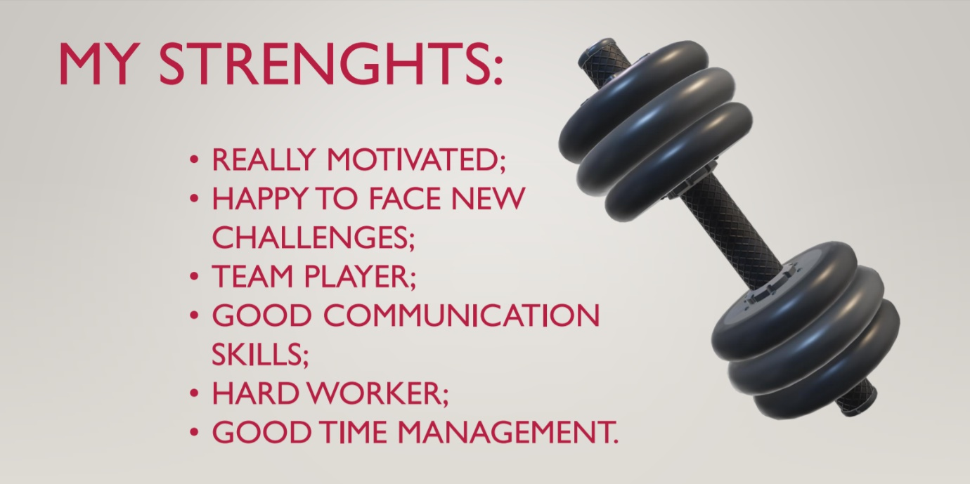
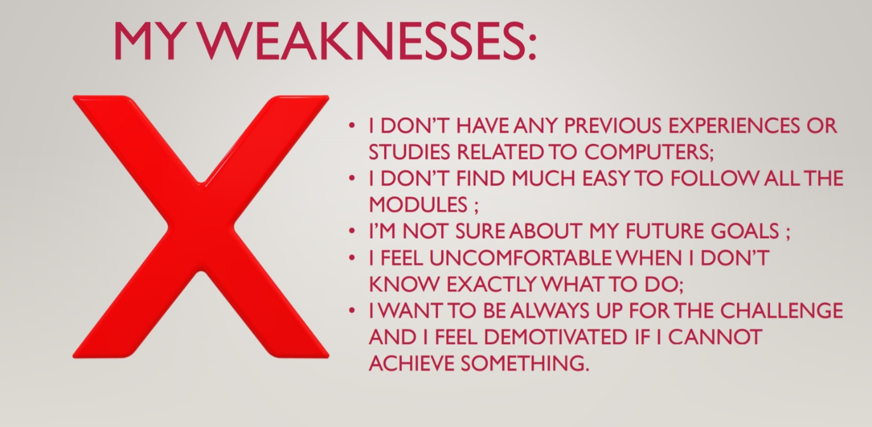
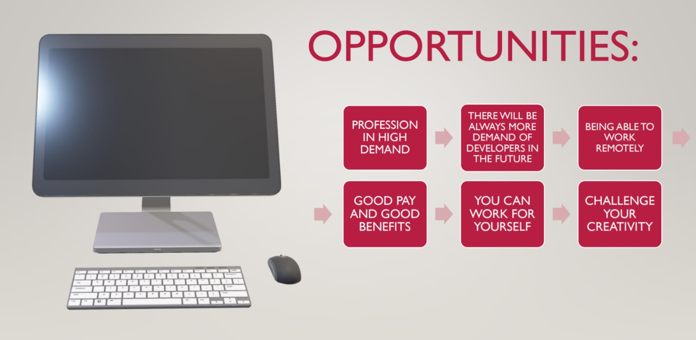
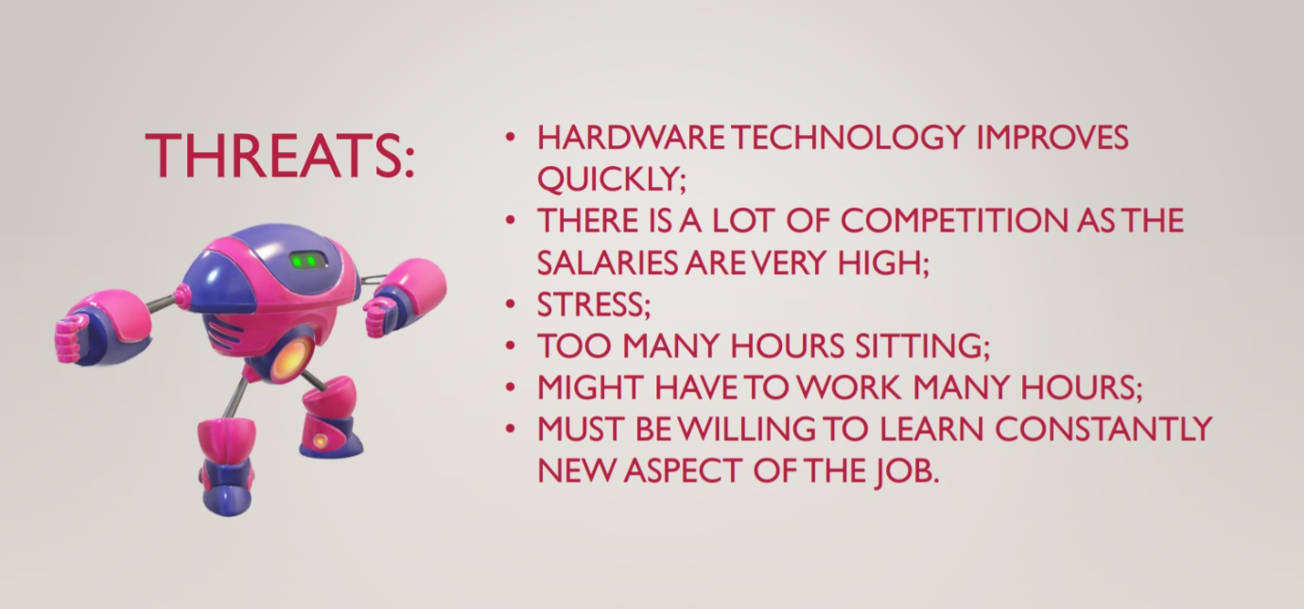

Appendix b
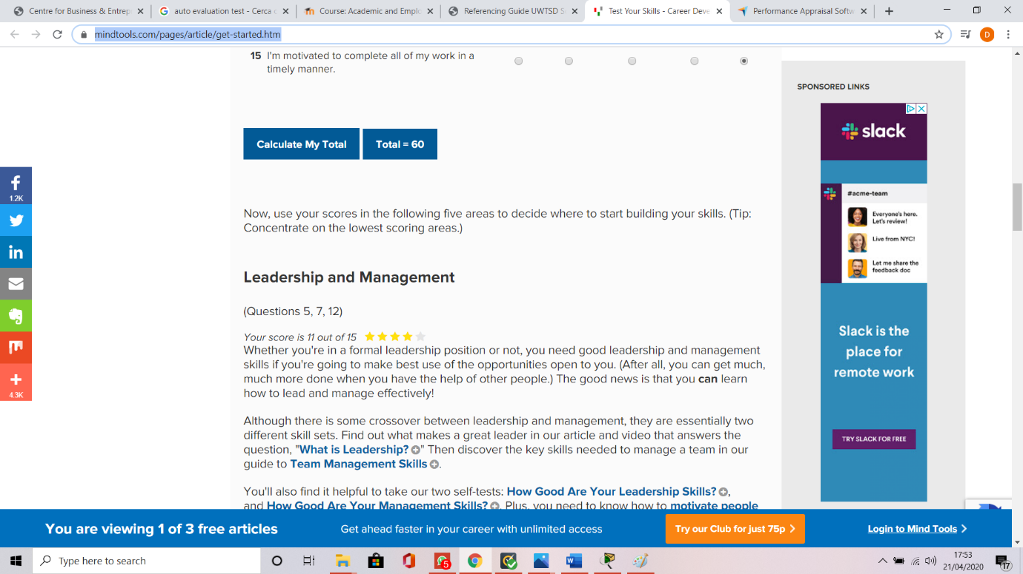

Appendix c

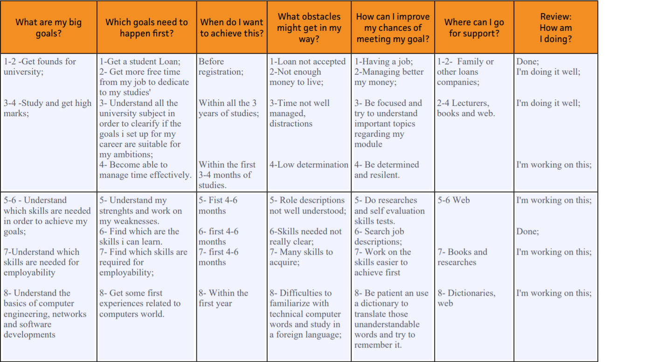
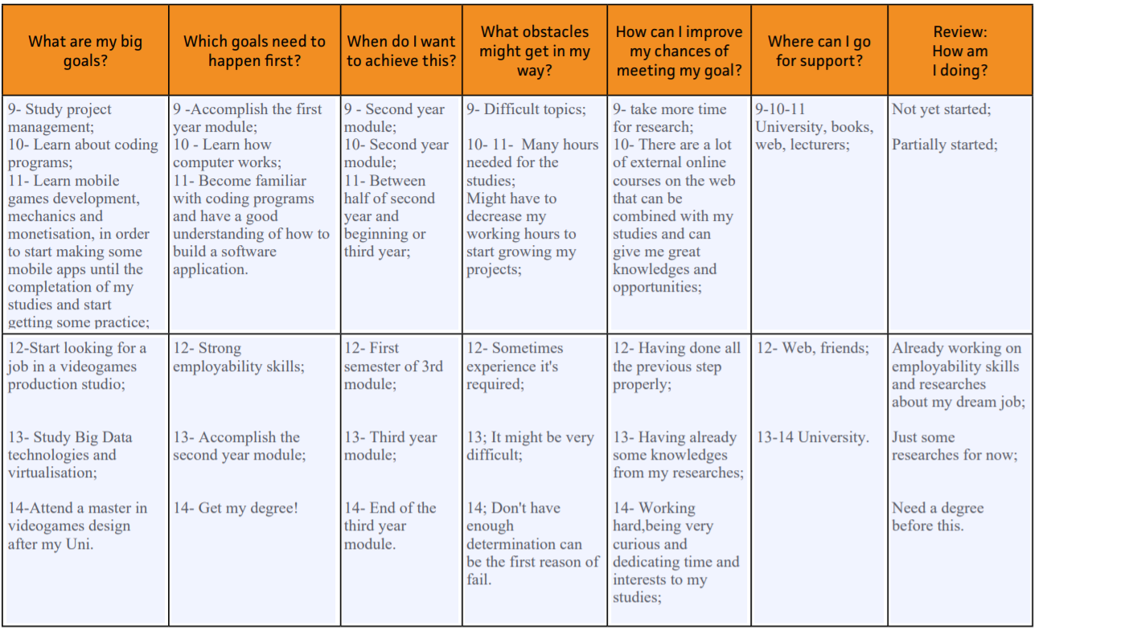
Appendix d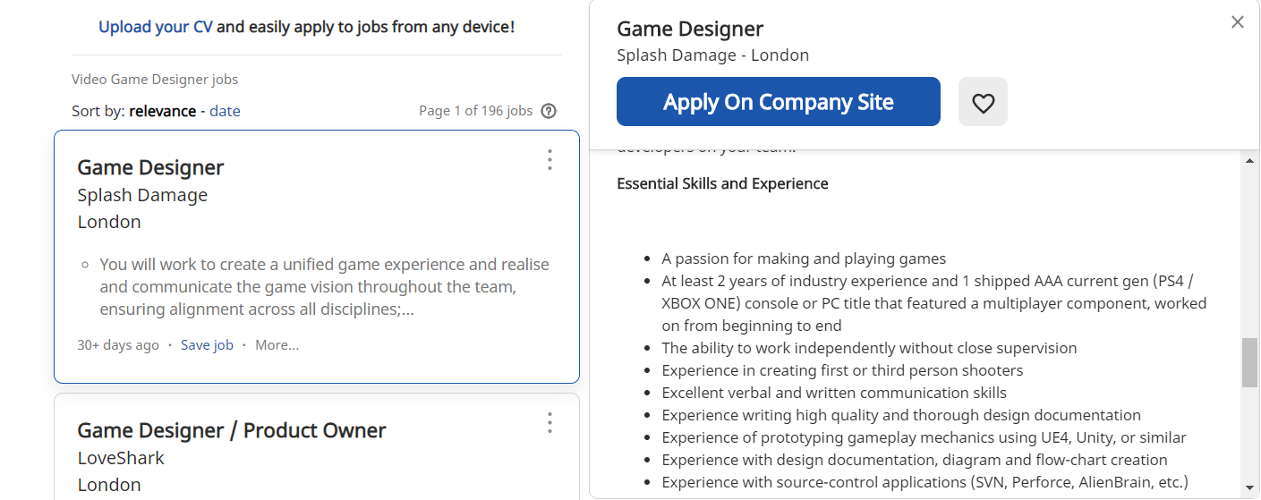
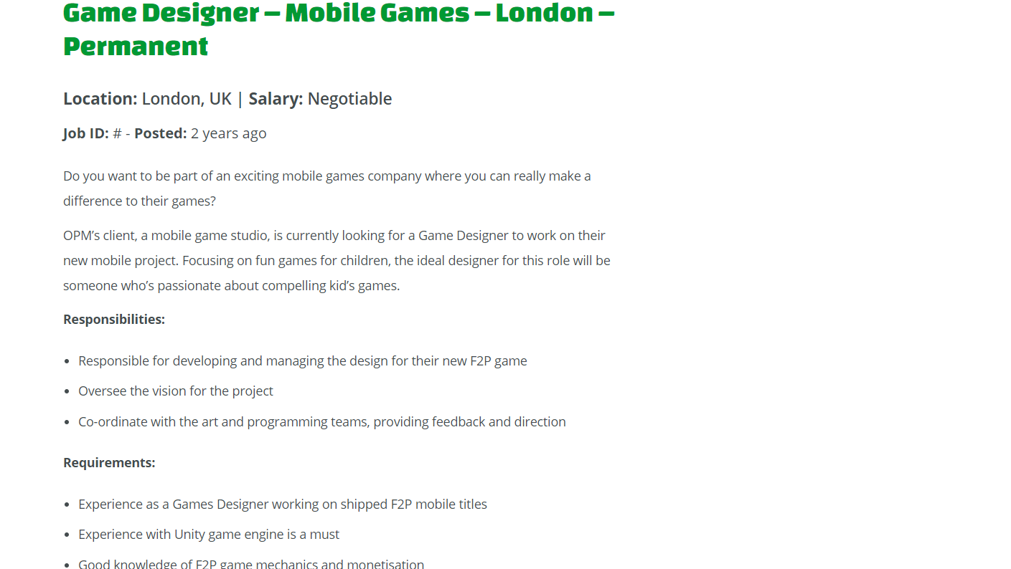

Appendix e


