

Module: Financial Management for the Hotel Industry
Module code: BMIH5007
Module Lecture: Jalya De Silva
Student ID: 2133014
Student Name: Anisoara Valentina Cucoranu

Contents
Introduction 3
Comparison of the total revenue between Mandarin Oriental Hotel Group and Premier Inn 4
Assessing the market position of two companies 6
The growth potential of Mandarin Oriental Hotel Group and Premier Inn 7
Financial Commitment to CSR (Corporate Social Responsibility) 9
Conclusion 11
Recommendations 12
References 13

Introduction
In today’s highly competitive world of business, determining the financial management strategies and practices in their organizations plays a vital for the long-term success and sustainability in the market. This report critically analyzes the two prominent players in the global hospitality industry named as Mandarin Oriental Hotel Group and Premier Inn. with a primary focus on some key areas such as Total Revenue, Market Position, Growth Potential, and Financial Commitment to Corporate Social Responsibility (CSR) of both companies. Through this comparative analysis, the report sheds light on how these two organizations differ in their financial approaches also it highlights their strengths and potential areas for improvement so that they can survive in their field of business as well as the hospitality industry.

Comparison of the total revenue between Mandarin Oriental Hotel Group and Premier Inn
Mandarin Oriental Hotel Group:
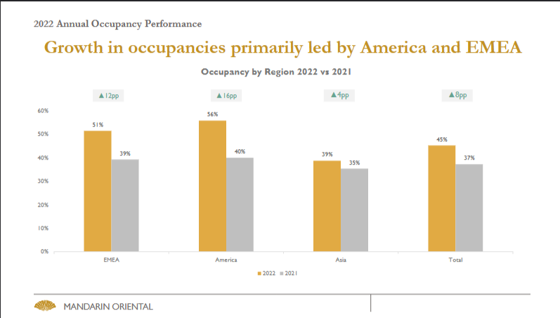
Figure1: Growth in Occupancies (source: www.mandarinoriental.com)
The collected data from the annual report did not reference a precise total revenue amount for the Mandarin Oriental Hotel Group. Nevertheless, there are connections to a variety of sources of revenue, such as rental income and contracts with consumers whose money is recognized in various situations in time (Wahlen, Baginski and Bradshaw, 2022). According to the report, the overall revenue for the year in question came in at £436.0 million from client contracts, while the revenue from rental income came in at £18.1 million. Moreover, 2022. The graph shows that the occupancies rate is growing in every region in 2022 than is in 2021 which is respectively in a total growth rate of 37% to 45%.

Premier Inn:
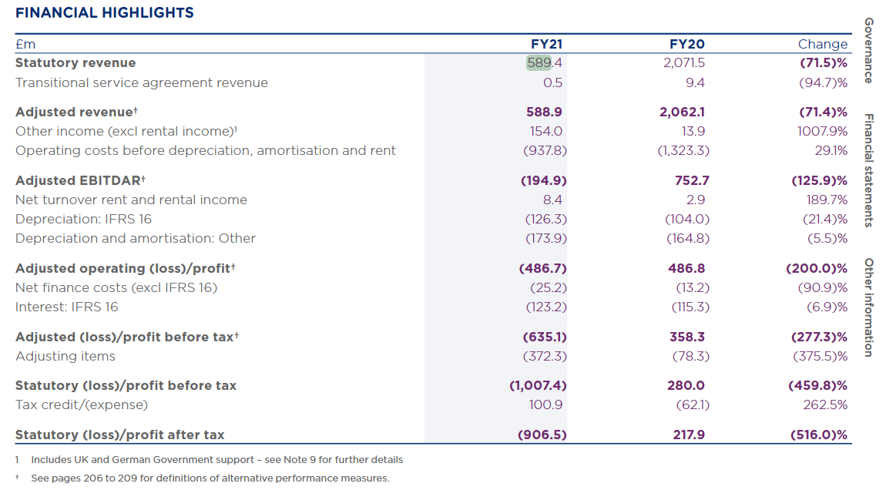
Figure 2: Financial Statement of Premier in 2021 (source: Whitbread.co.uk)
The amount of £589.4 million may be allocated to Premier Inn's overall income for the fiscal year that will finish on February 25th, 2021. When compared to the revenue of the previous year, which was £2,071.5 million, this is a considerable drop. The majority of the profits come from the rental of rooms as well as sales of food, drink, and other goods. To be more specific, the money generated from lodging amounts to £398.7 million, while the revenue generated from food, beverage, and other products amounts to £190.2 million.
Comparing the revenue from the previous year to the revenue from the year that will conclude in 2021, Premier Inn saw a considerable reduction. The decrease in revenue, which went from £2,071.5 million to £589.4 million, demonstrates that the company's activities were significantly impacted by external forces, most likely the COVID-19 pandemic. According to the study, Mandarin Oriental Hotel Group brought in a total income of around £454.1 million United States dollars for the year in question (Revsine, Collins and Johnson, 2021).

Assessing the market position of two companies
Mandarin Oriental Hotel Group: The Mandarin Oriental Hotel Group is a renowned luxury hotel group that has a worldwide existence with a strong market position. It creates its fame for its excellent services, luxurious accommodations they offer, and stunning location. MOHG placed their hotels in such places where they can easily reach their targeted customers for instance, these places include congested urban hubs like New York, Hong Kong, and London as well as far-off vacation areas like Bali and the Maldives that help the MOHG to meet their customer's need everywhere they are. It operates in about 34 places in the different countries. As MOHG is a luxurious brand the position of their hotel is in the prime area of the country so that it reaches the customers who need a luxurious hotel to accommodate (Li, 2022). Moreover, The Mandarin Oriental Hotel Group expects five new hotels and residence facilities in London, Zurich, Muscat and so on that will help to reach more wider range of market growth.
Premier Inn: Premier Inn established itself to provide quality accommodation at affordable prices. In addition to being well-known, it has a major presence in the UK. Premier Inn is also well-known for its extensive network of hotels many of which are found in urban areas, suburban areas, or adjacent to significant transportation hubs. Premier Inn offers budget-friendly accommodation services for travellers who are seeking affordable and comfortable accommodations.
Comparing the two companies according to market position, it is clear that Premier Inn's market position is better than MOHG's because MOHG targets only a certain elite class and the population of this class is relatively small whereas Premier Inn serves everything at an affordable price so that all classes of people can afford them (George, 2021).

Growth potential of Mandarin Oriental Hotel Group and Premier Inn
The potential growth rate is both Mandarin Oriental Hotel Group and Premier Inn are assessed based on the three dimensions such as:

Figure 3: Field of assessment (source: own)
Based on the research here’s an evaluation of the growth potential of Mandarin Oriental Hotel Group described below:
Market Opportunities: Mandarin Oriental Hotel Group has a strong potential for growth because of the increasing demand for luxury travel experiences. As the global economy is continuously growing, the earning capacity of the people is also growing so that they can afford more expensive travel costs and are looking for luxurious and unique experiences (Nakai, 2023).
Business Development Strategy: In the upcoming years, it intends to open several new hotels, including ones in important emerging markets like China and India ensuring high-quality services that have the potential to grow its market share and also help to increase brand awareness. In the upcoming 5 years, the company has a strong pipeline with over 26 projects expected to open (Huo et al., 2023).
Potential Barriers to Growth: Due to the lack of talented and skilled workers the industry faces a talent shortage to run their business which might affect the business development (Rajan et al., 2020).
Based on the research here’s an evaluation of the growth potential of Premier Inn companies described below:
Market Opportunities: Premier Inn is also well known for its high-quality budget accommodation and its focus on convenience. The growing demand for budget accommodations also has high growth potential. Because of the excessive cost of living that is increasing day by day, people are more interested in looking for affordable accommodation options (Kushniruk, 2023). Premier Inn is also trying to expand its business in many countries which will help to increase brand awareness. Besides, it continuously ensures quality and makes unique offerings for its clients that attract customer satisfaction level.
Potential Barriers to Growth: There is still uncertainty about COVID-19's long-term effects, and the pandemic's effects on trade conditions might last longer or be more severe than anticipated.
Business Development Strategy: The group is also restructuring its support centre and site operations mentioned as MOHG’s capital management strategy including keeping enough money on hand to cover working capital needs as well as planned investments needed to reach growth objectives. Moreover, to acquire more funds for expansion, the firm is exploring a sale and leaseback agreement (Kushniruk, 2023).
Overall, there is significant growth potential for both Premier Inn and Mandarin Oriental Hotel Group because of their market existence. While Premier Inn is well positioned to benefit from the rising need for affordable lodging, on the other hand, Mandarin Oriental is ideally placed its business to take advantage of the growing desire for premium travel experiences (Ali et al., 2020).

Financial Commitment to CSR (Corporate Social Responsibility)
Based on their company information the two companies are concerned about their corporate social responsibility because of that they are concerned with sustainability
practices, community engagement, and ethical business practices as well.

Figure 4: Areas of Development (source: own)
Mandarin Oriental Hotel Group: Mandarin Oriental Hotel Group is highly committed to performing their corporate social responsibility and taking numerous initiatives in place to support their communities such as Mandarin Oriental Hotel Group is committed to providing a safe and suitable work environment for their employees to ensure their health and wellbeing so that they can perform their task easily also it provide facilities that contributes to a wide variety of community activities, such as education and training initiatives and arrange programs that support the disadvantages communities (Su and Swanson, 2019). Moreover, Mandarin Oriental Group is committed to reducing its environmental impact on its business and operating sustainably. The company takes several initiatives to reduce energy and water consumption as well as to generate renewable energy that saves natural resources (Nakai, 2023). In addition, The Mandarin Oriental Hotel Group works to develop the communities where it conducts its business including the rural towns and villages where the Mandarin Oriental Hotel Group sources its labour as well as its raw materials and inputs needed to run its business. To improve the level of living and job prospects in these towns, the Mandarin Oriental Hotel Group has established several businesses (Jagels, 2007).
Premier Inn: Along with the Mandarin Oriental Hotel Group, Premier Inn is highly committed to its corporate social responsibility to the nation to improve its community’s standard of living. Since the inception of the company, Premier Inn has been organizing various programs for the development of their community, training, which motivates employees to do more, and Premier Inn has been donating to charities every year (Coleman, 2019). Since 2012, it has supported Great Ormond Street Hospital Children's Charity (GOSH Charity), staging events including bed-ins and fun races to raise money for very ill children across the UK. Over 5 years it has pledged £20m to GOSH charity Build It. Moreover, it is committed to improving the nutritional value of its menu due to high-quality service, great-tasting food, and drinks. It also donated over half a million meals to charity in 2020 and also works to reduce food waste (Guilding, 2014).
From the information of the above two companies, it can be seen that the two companies have been carrying out various activities for their community building. Both companies are fulfilling their Corporate Social Responsibility responsibly which helps them achieve brand value as well as create a positive image which plays a very helpful role in customer attraction (Atrill and McLaney,2021). However, with an emphasis on sustainability and community welfare, both corporations have made considerable CSR commitments but the size of their activities and the scope of their influence have led to increasingly elaborate CSR programs at Premier Inn (Drury, 2021).

Conclusion
The critical examination of Mandarin Oriental Hotel Group and Premier Inn in terms of their financial management strategies and practices, reveals that there is a distinction between their approaches in the hospitality industry which indicates that both companies have strengths and unique features within their respective market segments. The two companies work in different market segments where Mandarin Hotel Group attracts only elite class customers or customers who want luxurious accommodation service and on the other hand, provides Premier Inn affordable hotel accommodation services. This study shows that since Mandarin Oriental Hotel Group only provides luxurious hotel accommodation services, their profit margin is higher than Premier Inn. As they work with specific demographics, their client base is relatively small.

Recommendations
Certain tips will help Mandarin Oriental Hotel Group and Premier Inn expand their business to maximize value. For Mandarin Oriental Hotel Group can expand into emerging regions and join Asia and the Middle East's expanding riches (Kaliappen and Hassan, 2022). Diversity in business will assist in expanding the consumer base and generating new revenue streams, especially in branded accommodation. They should continue to emphasise sustainable and ecologically friendly service, making luxury hotel customers more environmentally conscious (Singh and Goel, 2021). Mandarin could also engage in more community initiatives as part of its corporate social responsibility to improve its image and business. Additionally, the Mandarin Oriental Hotel Group should focus more on its services to maintain its top rankings due to its distinct features. To enhance consumer satisfaction and diversify revenue streams, the organization should collaborate with stakeholders more creatively (Bas and Sivaprasad, 2022).
The Premier Inn should continue strategic expansion nationally and internationally, focusing on mid-range and economy hotels. For inexpensive hotels to satisfy modern travellers' expectations, they must include innovative technology. To stay competitive, Premier Inn should use its resources to provide high-quality services at low prices (Giousmpasoglou and Hua, 2020). Corporate social responsibility should also be emphasized. Maintaining the following recommendations can help the Mandarin Oriental Hotel Group and Premier Inn. succeed in the competitive market (Berry, 2022).

Rreferences
Ali, A., Egan, D., Haynes, N., Holland, C. and Martin, E., 2020. The Future of Hospitality Management Education.
Alvarez-Risco, A., Estrada-Merino, A. and Perez-Luyo, R., 2020. Sustainable development goals in hospitality management. In Sustainable Hospitality Management: Designing Meaningful Encounters With Talent and Technology (pp. 159-178). Emerald Publishing Limited.
Atrill P, McLaney E, 2021., Management Accounting for Decision Makers, FT Prentice Hall
Bas, T. and Sivaprasad, S., 2022. An Exploratory Insight into the Impact of COVID-19 on the Travel and Tourism Sector: UK Evidence. Bas, T. & Sivaprasad, S.(2022). An exploratory insight into the impact of COVID-19 on the travel and tourism sector: UK evidence. In S. Karabulut (Ed.), Economic and Financial Analysis of Global and National Developments, pp.355-369.
Berry, C.T.P., 2022. Equity research-Whitbread PLC (Doctoral dissertation, Instituto Superior de Economia e Gestão).
Coleman, D., 2019. Does brand purpose serve a brand purpose? WARC exclusive, srpanj, pp.1-2.
Drury C., 2021, (11th Ed) Management and Cost Accounting, London, Prentice Hall
George, R., 2021. Market Segmentation, Targeting, and Positioning. In Marketing Tourism and Hospitality: Concepts and Cases (pp. 221-246). Cham: Springer International Publishing.
George, R., 2021. Tourism and Hospitality Marketing Principles. In Marketing Tourism and Hospitality: Concepts and Cases (pp. 3-31). Cham: Springer International Publishing.
Giousmpasoglou, C. and Hua, T.T., 2020. The use of self-service technologies in budget hotels: the case of Bournemouth. European Journal of Tourism, Hospitality and Recreation, 10(3), pp.251-261.
Guilding, C. 2014., (3rd Edition) Accounting Essentials for Hospitality Managers, London, Routledge
Huo, X., Chang, J., Zhang, Q., Wang, W., Wang, P., Zhao, F., He, S., Yang, C., Liu, X., Liang, X. and Zhang, Y., 2023. Nanopeptide CI20 remarkably enhances growth performance and disease resistance by improving the mucosal structure, antioxidant capacity, and immunity in mandarin fish (Siniperca chuatsi). International Journal of Biological Macromolecules, p.126935.
Jagels, M. 2007., Hospitality Management Accounting, London, Wiley.
Kaliappen, N. and Hassan, A., 2022. Digital Trends in Asian Hotel Industry. In Technology Application in Tourism in Asia: Innovations, Theories and Practices (pp. 147-163). Singapore: Springer Nature Singapore.
Kushniruk, H., 2023. A STRONG BRAND IS A COMPETITIVE ADVANTAGE IN THE HOTEL BUSINESS. Publishing House “Baltija Publishing”.
Kushniruk, H., 2023. A STRONG BRAND IS A COMPETITIVE ADVANTAGE IN THE HOTEL BUSINESS. Publishing House “Baltija Publishing”.
Li, R., 2022. Hong Kong´s hospitality sector: the business case for quarantine hotels: the landmark mandarin oriental (Doctoral dissertation).
Liaud-Laval, R.L., 2021. Corporate social responsibility for sustainable goals achievement in the hotel industry: the case of Le Monumental Palace in Porto (Doctoral dissertation).
Nakai, A., 2023. Sustainable Initiatives of Forbes Five-star Hotels in Tokyo: Balancing Sustainability and Average Customer Spending under COVID-19.
Nakai, A., 2023. Sustainable Initiatives of Forbes Five-star Hotels in Tokyo: Balancing Sustainability and Average Customer Spending under COVID-19.
Rajan, H.C., Tan, G.G.M. and Tan, E.B.K., 2020. Unlocking Hidden Potential: Strategic Transformation and Value Creation at Mandarin Orchard Singapore and Mandarin Gallery.
Revsine, L., Collins, D.W. and Johnson, W.B., 2021. Financial reporting & analysis. McGraw-Hill.
Singh, V.B. and Goel, S.K., 2021. Growth of the Indian Tourism and Hospitality Industry. Turkish Online Journal of Qualitative Inquiry, 12(7).
Su, C.L., Lee, E.M. and Lee, Y.D., 2019. Empirical research of environment management strategy: Exploring The relationships among perceived corporate social responsibility, organizational trust, perceived external prestige and organizational identification. International Journal of Organizational Innovation (Online), 12(1), pp.245-260.
Su, L. and Swanson, S.R., 2019. Perceived corporate social responsibility's impact on the well-being and supportive green behaviours of hotel employees: The mediating role of the employee-corporate relationship. Tourism management, 72, pp.437-450.
Wahlen, J.M., Baginski, S.P. and Bradshaw, M., 2022. Financial reporting, financial statement analysis and valuation. Cengage learning.

