19th April 2022

BMPF7003: Module 1 Application of Learning in the Workplace.
Part 1.
Critically evaluate a range of theories and models that you have recently studied, explaining their relevance to your workplace practice and procedures and develop a strategy applying what you have learned to improve your practice.
Clare Ghigo
2115757

Analysing restorative methods and exploring the potential for better breath management for singers with Lordosis and/or Kyphosis.

My work as a professional classical singer has given me a thorough insight for the intense physical demands that preparation and performance put on the singers. This is even more challenging if they are dealing and performing with a hindering physical issue. I chose this topic due to a personal spinal issue that I encountered whilst preparing for a performance. I have been to several physiotherapists and medical professionals, to try and find help when dealing with vocal production issues that arise but there seems to be a missing link. They all deal with specific localized issues but none show a complete knowledge of cause and effect of the whole-body function and chain reaction that these issues together are causing. After having taken numerous Postural Restoration Institute courses and Anatomy Trains fascial release (myofascial) trainings, together with my experience in yoga and my 200- hour yoga teacher training, my aim and research is to find common ground and create a series of stretches and postures that can aid the singer to release the tension and to get through a phrase more efficiently.
Initially, I would like to dwell on the common issues such as neck, shoulder, and back pain, mostly classified as Lordosis and/or Kyphosis. My strategy will focus on these two main features, and on other issues such as arm pain, headaches or hip pain that might occur. Therefore, I will mention them without going into too much detail for the sake of the length of the essay.
The following voice-related concepts theories have been acquired from research websites such as: - PubMed, Postural Restoration Institute, ResearchGate, and Anatomy Trains.
These theories and models help me evaluate the importance of exercises in order to rehabilitate and re obtain postural stability in singing in order to achieve an efficient way to manage breath. In the popular singing technique literature such as Richard Miller (Miller, 1986), Janice Chapman’s (Chapman, 2017), Ruth Hennessey’s lectures (Hennessy, 2020) all emphasise that proper alignment is of utmost importance for singing due to its correlation with the breath.
However, what happens when spinal issues such as Kyphosis and Lordosis interfere with the mechanics of the low intercostal breath that is needed in the classical voice?
When dealing with both Kyphosis and Lordosis one needs to comprehend the crucial impact that these two physical adaptations leave on the whole body but most importantly for a singer, on the voice. This evaluation is helping me to prove the relevance of an alignment awareness and how to maintain optimal function in achieving a full spectrum of resonation. An optimal alignment is of utmost importance for the singer (classical singer) due to the influence it has on the torso and diaphragmatic region, and which impacts the flow of the breath (Acker, 1987; Nair, 2007). Owing to the flexibility and the everchanging body, awareness of maladaptive behaviour is first step to aid vocal freedom (Price et al., 2014). As from experience and practice, when the singer’s body is compromised due to a variety of factors, such as stress, sedentary lifestyle, virtual meetings, or an injury, the body contorts to lessen the impact on the affected area and therefore by time they form and become new habits.(Cardoso et al., 2019).
Therefore, Kyphosis and Lordosis are physical musculoskeletal adaptations that the body create to function more efficiently. Lumbar lordosis is when the lower part of the spire curves and arches the back thus restricting the diaphragm and this affects the inhalation muscles. Kyphosis is when the chest is sunken and the upper back curves, inhibiting chest muscles form breathing and functioning freely (Calais-Germain, 2016, p. 58). These concepts helped me become aware of what happens when there is lack of optimal output.
Other observations are that both of these inhibited postures create the inability to connect to the lower region (low abdomen and feet) efficiently and optimally. In (Chapman, 2017, p. 32), the author suggests that a singer needs to be balanced both in the upper and lower part of the body. By this she means that if the body is sloughing forward the hips are thrust in a position that inhibits the movement of the thorax. As a result, the low diaphragmatic breath locks and cannot function freely. Similarly, if the body is over upright and tight in the lower (back) lumbar region, the pelvis loses the girdle like position and the breath-thorax connection becomes compromised (Cardoso et al., 2019; Cardoso, Meneses, Lumini-Oliveira, & Pestana, 2021; Cuccia et al., 2008).
Both of these spinal imbalances put a strain on the pelvis inhibiting it from its main regulatory (Jordaan, 2007)function. The role of the pelvis is mainly to transfer the weight from the upper part of the body to the low part and vice versa (McCarther, 2014). The pelvis is stabilized by a number of muscles, which include the pelvic floor, which supports vital organs and is the base for the whole spine which is attached at the back part of the sacrum. Due to the interconnection with the spine, the pelvic floor as the foundational stabilizer of the laryngeal mechanism (Nair, 2007), is responsible for the breath. This is because the larynx and the surrounding cartilages are intrinsically attached and balanced on top of a whole mechanism that optimally functions if the pelvis, thorax, neck and head are in practical alignment (Malde, et al., 2020, p. 30).
Furthermore, Ron Hruska (2021, p. 26) in his Postural Restoration Institute, states that without a balanced pelvis, the voice will not function optimally due to the increase in pressure on the spinal column which restricts both the thorax and the diaphragm, resulting in a restricted and tense larynx.
Even more so, the spinal flexion and torsion may inhibit the singer from being able to fully open their mouth (Piekartz, 2007). This is a very important aspect of singing and this inability of aperture is usually compensated by putting pressure on the neck, neck accessory muscles and jaw joints (Calais-Germain, 2016, p. 612). This is because due to the inhibiting gravitational pull the spine Lordosis or Kyphosis create, the body feels the need to form a base and a ground for the neck to function (Cardoso, Meneses, Lumini-Oliveira, Pestana, et al., 2021).
One might argue how a teacher can understand the percentage of the compromised body. However, a teacher can easily understand that the voice production is constricted because all of these physical inhibitions that result in a distorted resonance. The main role of the singer is to project and create music through sound waves. Spinal issues such as cervical kyphosis create a negative impact on the back of the neck (thus making it shorter and protruding forward. This puts the back of the throat in flexion and therefore it shortens the oral resonating chamber (Johnson & Skinner, 2009). Having studied and finding their relevance into practice I agree that physical imbalances such as Kyphosis and Lordosis, inhibit the full production and the full range of resonation. Therefore, this can be a vital indication for a teacher to identify some of issues that hinder the full sound in singing. Ron Hruska’s lectures establish that in these circumstances, the full resonation spectrum suffers and disorders such as Hyper nasality or Hypo nasality occur (Hruska, 2021, p. 39).
Furthermore, through my observation and teaching experience, singers with Kyphosis or Lordosis tend to have the inability to fully breathe through the nose without tensing their sternocleidomastoid and jaw/ neck muscles. This results in a numerous number of issues with the management of breath flow and more often than not the inability to complete a full singing phrase.(Armstrong et al., 2008)
The traditional way of inhaling air is through the nose; however, this might not be the right solution for singers with neck impingements. Herbert Caesari (1968), clearly explains why solely nose breathing is inefficient for a singer. Although he mentions this in regard to singing fast passages, this also shows that the singer should breathe in a more efficient and convenient momentarily matter even if this means to mouth breathe. (Meyer, 2009) Even more so, traditional singing literature such as Richard Miller (1986) discusses the mechanics of the breath, abdominal wall, and the rib cage, yet it seems to leave the issue of nose/ mouth breathing, neck and the neck accessory muscles issues out of this flow system.
More recent literature such as Nair (Nair, 2007) and McKinney (McKinney, 1994) recognize the importance of a released neck to aid a proper laryngeal and breath function. From personal experience as a student, most singing teachers know that neck tension is not a good sign, however they tend to shy away from such anatomical issues due to their lack of medical expertise. This issue is usually a more complex matter and by indicating to release the jaw, or to let go of any neck tensions is therefore not an efficient correction for any singer. This usually leaves the student perplexed and the issue never gets fully addressed via vocal exercises. According to (Hruska, 2021; Piekartz, 2007) any neck tension and maladaptive and compensational use of the neck is the inability to rotate thoracically which results into a lack of abdominal breath support.
From my observation and practice, I found a lack of literature which suggests exercises and solutions for a singer with such issues, especially in how to bypass neck muscle tensions and how to build a stronger breath control.
After understanding the relevance of such theories another learning outcome is that of using Postural Restoration Institute methods and yoga poses to strengthen the singer’s muscles and re-establish an efficient alignment. These concepts have proven to be of genuine help in my work practice and they have given positive results. Therefore, I intend to develop complimenting exercises such as simple stretches that together with some singing exercises, can aid singers with both Lordosis and Kyphosis strains release musculoskeletal tensions and produce a better voice production.
Some common stretches that are usually suggested by physiotherapists and some knowledgeable singing teaches are side stretches and neck rolling from one side to the other (Amiri-Khorasani & Kellis, 2015). Garyth Nair (2007, p. 90) suggests side stretches to create awareness of neck and its influence on the laryngeal mechanisms. He continues that in some cases, whilst doing these mild stretches, some singers can truly feel the optimal breath connection and an awareness of an efficient voice production. These mild stretches can momentarily ease tension but they can be of detriment due to the complexity of the spinal issue (Amiri-Khorasani & Kellis, 2015; Wilson Arboleda & Frederick, 2008).
I noticed that the common medical treatments prescribed for the pain that accompany both Lordosis and Kyphosis, are the following: anti-inflammatory medication, physiotherapy, weight management programmes and vitamins to strengthen the body’s system (Physioplus, 2022).
Although I am not questioning these medical remedies because I am sure that they are somewhat effective yet they are very generic and clearly not specific to cater to singers’ needs. Being into this situation myself, these remedies are clearly not efficient for a working performer.
Having also researched alternative therapies, I found out that according to yoga traditional poses, each move needs to be counterbalanced by another asana (pose) and therefore, some of the stances that counterbalance the drooping neck syndrome (cervical kyphosis) are chest opener poses (Carman, 2004; Kuhn, 2006; Lloyd et al., 2017). These are poses that flex the back and open the rib cage to de activate the neck accessory muscles. Such heart opening poses are cobra [figure1 (Kaminoff, 2021, p. 176)], and camel [figure 2 (Kaminoff, 2021, p. 122)].
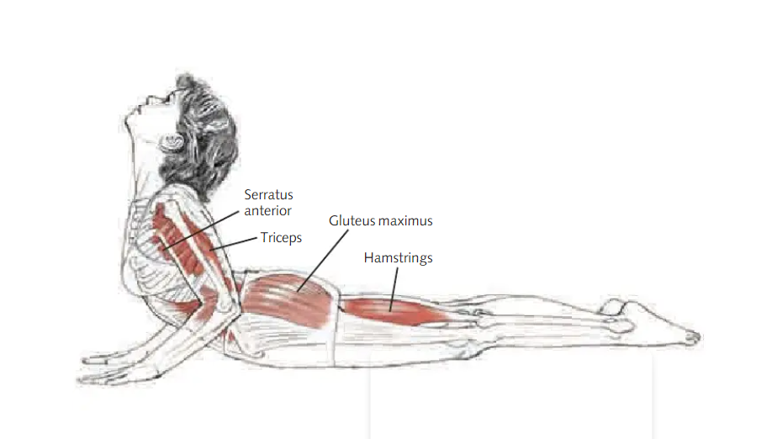
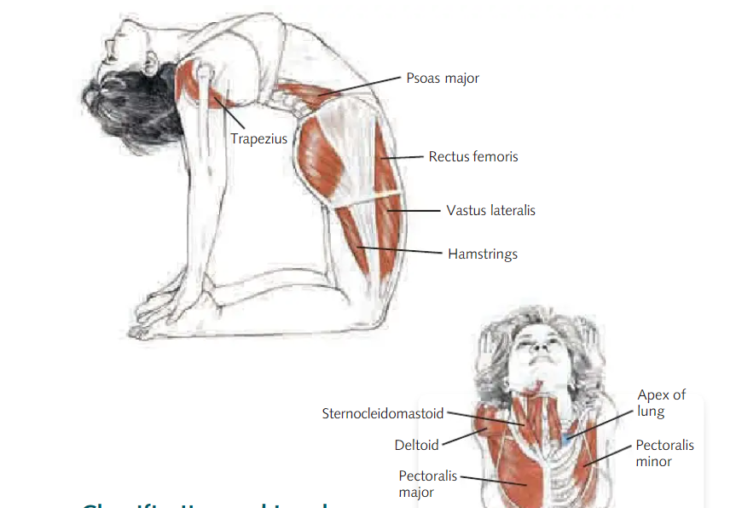

In his anatomy dictionary, Leslie Kaminoff (Kaminoff, 2021) suggests a variety of poses, however the chosen poses are amongst the well-known poses and easy execute. This is because they target more than just the crucial muscles but the whole foundational system. Singing in either the cobra or the camel pose, can be quite challenging and unproductive for anyone let alone someone with a neck issue. However, one can try to sing in a neutral standing position after trying these tension release exercises and notice if there was any difference in the sound/breath management.
Poses that counter balance the Lumbar Lordosis are movements that elongates and strengthen the lower back. Such moves are the child’s pose (Kaminoff, 2021, p. 122) [figure 3] and the downward facing dog (Kaminoff, 2021, p. 175) [ figure 4] variations.
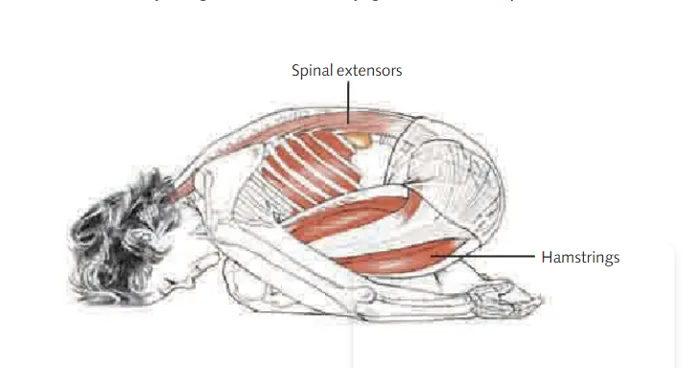
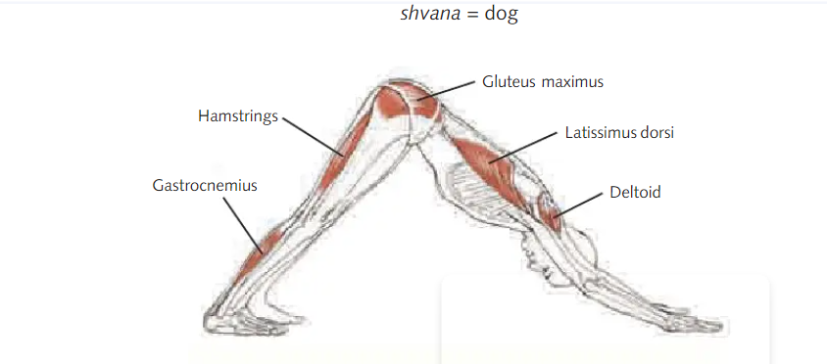
Similarly, like in the cervical Kyphosis exercises, these are uncomfortable postures to sing in and therefore one should try to sing after the execution of the postures. In my experience most students who can obtain a variation of any of these poses feel a sense of immediate freedom in their inhalation and in their singing.
Apart from these generalised yoga postures, the exercises taken from the Postural Restoration Institute are slightly more delicate than the once chosen from the yoga traditions. This is because these restorative postures deal with the instability or malfunction of the spinal rotation (Hruska, 2021). Therefore, these following exercises that aim in stabilising the abdominal wall need to be done with assistance. Such exercises need assistance due to the instability of the spine. The practitioner needs to guide the student towards the correct posture. Such postures are usually done seated or lying down. Some examples (Hruska, 2021, p. 93) are shown in the pictures below.
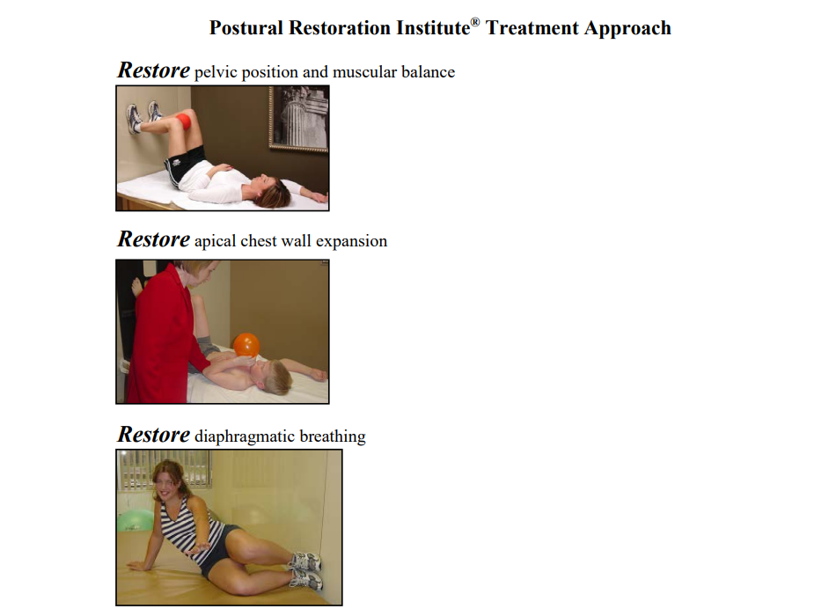
Additionally, I feel the need to connect both the yoga and the Postural Restoration Institute exercises together to be more directed towards the singer’s needs. Such exercises can be found in the appendix.
From my own teaching experience, most students feel more vocal freedom, after they execute the exercises that I have designed. In doing these postures plus the vocal exercises (Such as simple scales) they also felt more at ease in the pose than if they were solely executing the yoga postures. This is because the postures that I gathered and modified are specific for singing purposes and not only for a generalised release. Furthermore the student was aware of their own tension and the pose allowed them to fully connect with the breath without the need to tense extra muscles.
In conclusion I have understood the importance of the way forward that of including both the yoga postures, the Postural Restoration Institute exercises into the singing practice to aid and strengthen the breath flow and management. This method is efficient for any singer by aiding their musculoskeletal strength in a long-term period. Although the stamina for executing these exercises might take a while to establish, I believe that ultimately it is highly beneficial for one and most importantly for classical singers.

BMPF7003: Module 1 Application of Learning in the Workplace.
Part 2.
A Reflective Review Comprising of Two Parts.
a) Reflect on your recent learning experience, and the value of learning you acquired. Assess your current competencies and identify future development needs in the context of the work situation.
b) Devise a detailed personal development plan which incorporates development objectives, activities to be undertaken, methods, resources review periods and timescales

In the research that I have conducted regarding the importance of correcting the spinal alignment, I found a lack of literature in aiding singers dealing with Kyphosis and Lordosis. This because most literature regarding movement and spinal injuries is usually focused on in a generic way and towards a sports related injury. Most people dealing with these two (Kyphosis and Lordosis) spinal issues do not require the same efficiency in managing breath as singers do. Although singing related books like Janice Chapman’s (Chapman, 2017) and Claudia Friedlander’s (Freidlander, 2018) do mention the importance of correct alignment required in singing, they do not dwell on how singing with these spinal issues can be addressed and what specific methods can be used such as: spinal exercises done together with singing. Therefore, there seems to be a missing link between the methodology and literature on singing together with physical rehabilitation methods.
Moreover, due to the current events, which led to more hours being spent behind a computer screen I have experienced a growing number of students suffering with back pain, neck tension and jaw stiffness. Some of which also reported a decline in their singing confidence and an increase in anxiety. Although I will not mention the importance alignment has on the central nervous system, this is highly linked to a sedentary lifestyle and a long period spent in a compromised position that of working from a computer(Armstrong et al., 2008). Knowing that I have the yoga background together with my performance career most students ask me for help due to their decline in breath management or inability to sing with freedom. Even though they have gone to medical professionals for help, their treatment was never designed for singing purposes.
Therefore, I understand the pressing need for academic strategies and in finding a pedagogical solution in order to tackle such issues. Left untreated, these spinal conditions will get worse and they will lead to vocal complications such as Vocal dystonia and general pain (Piekartz, 2007, p. 625). From personal experience the instability in managing breath would consequently lead to a decline in the nervous system which will add on to the complications. As a teacher, I have understood the need to tackle these simple alignment issues before they start to affect the body and the voice negatively.
Having dealt with issues myself and after finding no specific therapy which aids directly to singing, I have taken a number of multi-disciplinary courses and attended a variety of medical lectures to find a specific solution for singers. Being both a yoga practitioner and a yoga student, I can help the students from a holistic body/ mind approach. I find the importance of creating these exercises for the students because it will be of great benefit for students and musicians in general.
As I have thoroughly studied and learnt from the Postural Restoration Institute courses which deal mainly on the importance in regaining physical stability so that the body can function optimally. Having been accepted and taken five different courses designed solely for medical professionals, which included, Pelvis Restoration, Voice Box Restoration and Cervical Restoration, I realised biomechanically the importance of breath and the effect it leaves on the movement of whole body. A simple muscular imbalance can throw the function out of its alignment and create a myriad of complications. (Hruska, 2021) as I have witness both in my signing colleagues and in my students, nowadays the ideal of an optimal alignment is not so well looked after due to the fast-paced lifestyles. I found that students who spend less time on their electronic devises and are more active have a better breath mobility and management. However, they immediately gain breath connection and the voice becomes stronger the minute they execute some of the devised exercises. Therefore, although these exercises are still in development, there seems to be a true linking with a vital rehabilitation.
Some of the issues that I deal with as a teacher and a holistic practitioner is overcoming prejudice in regarding this hand on method. Therefore, I am trying to create exercises which can be followed by simple unaided instruction and by limiting physical correction. Breath is the motor function for singing and therefore I am interested in furthering my interest in how can a practitioner understand the student’s way of managing breath.
I understand the importance of creating a variety of exercises that can be conducted by both practitioners and the students themselves whilst practising. However, this is not an easy task due to the chain muscle reaction that both Kyphosis and Lordosis create. Therefore, I have to be aware of the muscular tensions that accompany these issues.

Developing my future plan.
I am devising more specific exercises to cater to a variety of different needs such as exercises for tight or lack of shoulder mobility. Thoracic expansion and thoracic rotation stabilising postures. I am also making sure that each exercise will have three categories: lying down, seated and standing (both aided and unaided). This is because the exercises can be modified to any singer’s needs.
Practice Development Plan
Why am I doing this course and how it can be of benefit? | I am doing this course because I have understood the lack of literature and practice found in the area of spine and voice.  It is a personal benefit to me because I have dealt with these issues myself and I know how important it is for singers with spinal issues to feel that there is a method which includes the voice in their rehabilitation approach.
How can I improve on my strategy in applying my exercises? | Each exercise needs to have a variety of modifications in order to specifically cater to the singer’s need.
How can the result be measured and what is the long-term effect? | The difficulty in this task is making sure the students’ practice in the pose to monitor improvement, before singing in an upright position. Regarding the long-term effect, the practice is still in the making and therefore it is hard to foresee.
What other pedagogical skills that can be acquired? | I need to make sure that the therapy I am delivering is understood well by the students.
Planned time frame | The vocal/ breath management improvement should be felt immediately and if the commitment to the exercises is kept regularly, the vocal stamina should improve drastically within three months.

References
Acker, B. F., 1987. Vocal Tract Adjustments for the Projected Voice.. Journal of Voice, 1(1), pp. 77-82
Ahn, A. R., Rah, U. W., Woo, J. E., Park, S., Kim, S., & Yim, S. Y. (2018). Craniovertebral junction abnormalities in surgical patients with congenital muscular torticollis. Journal of Craniofacial Surgery, 29(3). https://doi.org/10.1097/SCS.0000000000004403
Alexander, M., Kopparthy, P., Grewal, S., & Frechette, V. (2016). Myasthenia Gravis: Don’t Let It Take Your Breath Away. Chest, 150(4). https://doi.org/10.1016/j.chest.2016.08.1211
Amiri-Khorasani, M., & Kellis, E. (2015). Acute effects of different agonist and antagonist stretching arrangements on static and dynamic range of motion. Asian Journal of Sports Medicine, 6(4). https://doi.org/10.5812/asjsm.26844
Armstrong, B., McNair, P., & Taylor, D. (2008). Head and neck position sense. In Sports Medicine (Vol. 38, Issue 2). https://doi.org/10.2165/00007256-200838020-00002
Binazzi, B., Lanini, B., Bianchi, R., Romagnoli, I., Nerini, M., Gigliotti, F., Duranti, R., Milic-Emili, J., & Scano, G. (2006). Breathing pattern and kinematics in normal subjects during speech, singing and loud whispering. Acta Physiologica, 186(3). https://doi.org/10.1111/j.1748-1716.2006.01529.x
Boyle, K. L. (2011). Managing a female patient with left low back pain and sacroiliac joint pain with therapeutic exercise: A case report. Physiotherapy Canada, 63(2). https://doi.org/10.3138/ptc.2009-37
Carman, J. (2004). Yoga and Singing: Natural Partners. Journal of Singing, 60(5).
Chapman, J., 2017. Singing and Teaching Singing: A Holistic Approach to Classical Voice. 3rd edition ed. San Diego California: Plural Publishing Inc.
Calais-Germain, B. F. G., 2016. Anatomy of Voice: How to Enhance and Project Your Best Voice. Toronto: Healing Arts Press.
Cardoso, R., Lumini-Oliveira, J., & Meneses, R. F. (2019). Associations between Posture, Voice, and Dysphonia: A Systematic Review. In Journal of Voice (Vol. 33, Issue 1, pp. 124.e1-124.e12). Mosby Inc. https://doi.org/10.1016/j.jvoice.2017.08.030
Cardoso, R., Meneses, R. F., Lumini-Oliveira, J., Pestana, P., & Guimarães, B. (2021). Associations between Teachers’ Posture, Muscle Tension and Voice Complaints. Journal of Voice, 35(6). https://doi.org/10.1016/j.jvoice.2020.02.011
Carneiro, P. R., & Teles, L. C. da S. (2012). Influence of postural alterations, followed by computadorized photogrammetry, in the voice production. Fisioterapia Em Movimento, 25(1).
Cattrysse, E., Buzzatti, L., Provyn, S., Barbero, M., & van Roy, P. (2016). Variability of upper cervical anatomy: A reflection on its clinical relevance. Journal of Functional Morphology and Kinesiology, 1(1). https://doi.org/10.3390/jfmk1010126
Chan, A., & CS, H. (1999). The effects of tilting the seating position of a wheelchair on respiration, posture, fatigue, voice volume, and exertion outcomes in individuals with advanced multiple sclerosis. In Journal of Rehabilitation Outcomes Measurement (Vol. 3, Issue 4).
Cuccia, A. M., Lotti, M., & Caradonna, D. (2008). Oral breathing and head posture. Angle Orthodontist, 78(1). https://doi.org/10.2319/011507-18.1
De Sá, R. B., Pessoa, M. F., Cavalcanti, A. G. L., Campos, S. L., Amorim, C., & Dornelas de Andrade, A. (2017). Immediate effects of respiratory muscle stretching on chest wall kinematics and electromyography in COPD patients. Respiratory Physiology and Neurobiology, 242. https://doi.org/10.1016/j.resp.2017.03.002
Di Carlo, N. S. (1998). Cervical spine abnormalities in professional singers. Folia Phoniatrica et Logopaedica, 50(4).
Friedlander, C., 2018. Complete Vocal Fitness: A Singer’s Guide to Physical Training, Anatomy, and Biomechanics. London: Rowman & Littlefield.
Gadia, A., Shah, K., & Nene, A. (2019). Cervical kyphosis. In Asian Spine Journal (Vol. 13, Issue 1). https://doi.org/10.31616/ASJ.2018.0086
Ghan, G. M., & Babu, V. S. (2021). Immediate Effect of Cervico-thoracic Mobilization on Deep Neck Flexors Strength in Individuals with Forward Head Posture: A Randomized Controlled Trial. Journal of Manual and Manipulative Therapy, 29(3). https://doi.org/10.1080/10669817.2020.1834321
G.N., F., T.C., C., A.B., R., D., B.-G., M.E., B., & F., D. E. (2014). Craniocervical posture changes in subjects with migraine. Headache, 54(SUPPL. 1).
Hennessy, R., 2020. www.hennessybb.com. [Online]
Available at: https://www.hennessybb.com/
[Accessed 09 February 2022].
Herbert-Caesari, E. F., 1968. Science and Sensations of vocal tone. London: Crescendo Publishers.
Honda, K., Hirai, H., Masaki, S., & Shimada, Y. (1999). Role of vertical larynx movement and cervical lordosis in F0 control. Language and Speech, 42(4). https://doi.org/10.1177/00238309990420040301
Hruska, R., 2021. Voice Box Resonation: An interdisciplinary approach in the management of hypopharyngeal dysfunction. Lincoln, Nebraska, Postural Restoration Institute.
Ito, Y., Yamada, T., & Takeda, M. (2007). Investigation of respiratory function and breathing pattern in elderly people with kyphosis posture. Rigakuryoho Kagaku, 22(3). https://doi.org/10.1589/rika.22.353
J.M., S., & A.K., S. (2002). Non-invasive ventilation for chest wall and neuromuscular disorders. European Respiratory Journal, 20(2).
Johnson, G., & Skinner, M. (2009). The demands of professional opera singing on cranio-cervical posture. European Spine Journal, 18(4). https://doi.org/10.1007/s00586-009-0884-1
Jordaan, R. (2007). Postural Changes in the Craniofacial and Craniocervical Regions as a Result of Changed Breathing Patterns. In Craniofacial Pain. https://doi.org/10.1016/B978-0-7506-8774-4.50027-7
Kaminoff, L., 2021. Yoga Anatomy. 3 ed. New York: Human Kinetics.
Knight, E. J., & Austin, S. F. (2020). The Effect of Head Flexion/Extension on Acoustic Measures of Singing Voice Quality. Journal of Voice, 34(6). https://doi.org/10.1016/j.jvoice.2019.06.019
Kuhn, I. P. (2006). Add Yoga to Your Singing Warm-Ups. Teaching Music, 13(4).
Leborgne, W. & Rosenberg, M. D., 2014. The Vocal Athlete. 1st ed. San Diego: Plural Publishing Inc.
Letícia Paiva Francoa, R. N. K. H. G. B., 2018. The effect of adenotonsillectomy on the position of head, cervical and thoracic spine and scapular girdle of mouth breathing children. International Journal of Paediatric Otorhinolaryngology, Issue https://doi.org/10.1016/j.ijporl.2018.01.033, pp. 10-106.
Lin, H. L., Kuo, L. C., Chen, C. W., Cheng, Y. C., & Lee, W. C. (2008). Neck hyperflexion causing isolated thyroid cartilage fracture-a case report. American Journal of Emergency Medicine, 26(9). https://doi.org/10.1016/j.ajem.2008.02.030
Liu, C., Song, K., Zhang, Y., Fu, J., Zheng, G., Tang, X., Zhao, L., Zhang, X., & Wang, Y. (2015). Changes of the abdomen in patients with ankylosing spondylitis kyphosis. Spine, 40(1). https://doi.org/10.1097/BRS.0000000000000662
Liu, C. Y., Jardim, J. R., Inoue, D. P., & Pignatari, S. S. N. (2008). The relationship between excursion of the diaphragm and curvatures of the spinal column in mouth breathing children. Jornal de Pediatria, 84(2). https://doi.org/10.2223/JPED.1771
Lloyd, A., Hoffman-Ruddy, B., Silverman, E., & Jeffrey, L. L. (2017). Vocal Yoga: Applying Yoga Principles in Voice Therapy. Journal of Singing.
Longo, L., di Stadio, A., Ralli, M., Marinucci, I., Ruoppolo, G., Dipietro, L., de Vincentiis, M., & Greco, A. (2019). Voice Parameter Changes in Professional Musician-Singers Singing with and without an Instrument: The Effect of Body Posture. Folia Phoniatrica et Logopaedica. https://doi.org/10.1159/000501202
Malde Melissa, Allen MaryJean, Zeller Kurt Alexander., 2020. What Every Singer Needs to Know About the Body. Fourth Edition ed. San Diego California: Plural Publishing.
McCarther, S., 2014. Being Careful with Cueing, Part 2: The Shoulder Girdle and Ribcage. Journal of Voice, 71(147),
McKinney, J. C., 1994. The Diagnosis and Correction of Vocal Faults: A Manual for Teachers of Singing and for Choir Directors. Illinois: Waveland Press.
Meyer, T. W., 2009. Anatomy Trains Myofascial Meridians For Manual And Movement Therapists .. 2nd Edition ed. Toronto: Churchill Livingstone. Elservier.
Mendes, A. P., Brown, W. S., Sapienza, C., & Rothman, H. B. (2006). Effects of vocal training on respiratory kinematics during singing tasks. Folia Phoniatrica et Logopaedica, 58(5). https://doi.org/10.1159/000094570

Miller. Richard. The Structure of Singing: System and Art in Vocal Technique.1986 Schirmer Books. New York.

Nair Garyth. The Craft of Singing. 2007. Plural Publishing. San Diego. California

Neiva, P. D., Franco, L. P., Kirkwood, R. N., & Becker, H. G. (2018). The effect of adenotonsillectomy on the position of head, cervical and thoracic spine and scapular girdle of mouth breathing children. International Journal of Paediatric Otorhinolaryngology, 107. https://doi.org/10.1016/j.ijporl.2018.01.033
Park, S., Woo, J. E., Kim, S., & Yim, S. Y. (2018). Torticollis Caused by Nontraumatic Craniovertebral Junction Abnormalities. Journal of Craniofacial Surgery, 29(5). https://doi.org/10.1097/SCS.0000000000004441
Pedro Melo Pestana, 2017. Prevalence of Voice Disorders in Singers: Systematic Review and Meta-Analysis. Journal of Voice, 31(6).
Physioplus, 2022. www.physio-pedia.com. [Online]
Available at: https://www.physiopedia.com/Postural_Principles_Useful_to_Consider_in_Voice_Production
[Accessed 7 February 2022].
Pettersen, V., & Westgaard, R. H. (2005). The activity patterns of neck muscles in professional classical singing. Journal of Voice, 19(2). https://doi.org/10.1016/j.jvoice.2004.02.006
Piekartz, H. J. M. v., 2007. Craniofacial Pain: Neuromusculoskeletal Assessment, Treatment and Management. s.l.: Elsevier Limited.
Razfar, A., Sadr-Hosseini, S. M., Rosen, C. A., Snyderman, C. H., Gooding, W., Abla, A. A., & Ferris, R. L. (2012). Prevention and management of dysphonia during anterior cervical spine surgery. The Laryngoscope, 122(10). https://doi.org/10.1002/lary.23284
Rollings, A. A. (2018). The Effects of Heel Height on Head Position, Long-Term Average Spectra, and Perceptions of Female Singers. Journal of Voice, 32(1), 127.e15-127.e23. https://doi.org/10.1016/j.jvoice.2017.03.005
Romagnoli, I., Gigliotti, F., Galarducci, A., Lanini, B., Bianchi, R., Cammelli, D., & Scano, G. (2004). Chest wall kinematics and respiratory muscle action in ankylosing spondylitis patients. European Respiratory Journal, 24(3). https://doi.org/10.1183/09031936.04.00123903
Ross, R. G. (2003). Orthopaedic physical assessment. Journal of Hand Therapy, 16(3). https://doi.org/10.1016/s0894-1130(03)00047-4
Sabatucci, A., Raffaeli, F., Mastrovincenzo, M., Luchetta, A., Giannone, A., & Ciavarella, D. (2015). Breathing pattern and head posture: Changes in craniocervical angles. Minerva Stomatologica, 64(2).
Schneider, C. M., Dennehy, C. A., & Saxon, K. G. (1997). Exercise physiology principles applied to vocal performance: The improvement of postural alignment. Journal of Voice, 11(3). https://doi.org/10.1016/S0892-1997(97)80012-4
Scotto Di Carlo, N. (1998). Cervical spine abnormalities in professional singers. Folia Phoniatrica et Logopaedica, 50(4). https://doi.org/10.1159/000021463
Silveira, W. da, Mello, F. C. de Q., Guimarães, F. S., & Menezes, S. L. S. de. (2010). Postural alterations and pulmonary function of mouth-breathing children. Brazilian Journal of Otorhinolaryngology, 76(6).
Singla, D., & Veqar, Z. (2017). Association Between Forward Head, Rounded Shoulders, and Increased Thoracic Kyphosis: A Review of the Literature. Journal of Chiropractic Medicine, 16(3). https://doi.org/10.1016/j.jcm.2017.03.004
Tong, B. K., Tran, C., Ricciardiello, A., Chiang, A., Donegan, M., Murray, N., Szollosi, I., Amatoury, J., Carberry, J. C., & Eckert, D. J. (2020). Efficacy of a novel oral appliance and the role of posture on nasal resistance in obstructive sleep apnea. Journal of Clinical Sleep Medicine, 16(4). https://doi.org/10.5664/jcsm.8244
Watson, P. (2002). What Have Chest Wall Kinematics Informed Us about Breathing for Singing? In The First International Conference on Physiology and Acoustics of Singing (PAS).
Wilson Arboleda, B. M., & Frederick, A. L. (2008). Considerations for Maintenance of Postural Alignment for Voice Production. Journal of Voice, 22(1). https://doi.org/10.1016/j.jvoice.2006.08.001
Yoon, T. L., Cynn, H. S., Choi, S. A., Lee, J. H., & Chio, B. S. (2016). Effect of the craniocervical brace on craniocervical angle, thoracic kyphosis angle, and trunk extensor muscle activity during typing in subjects with forward head posture. Work, 55(1). https://doi.org/10.3233/WOR-162378
Appendix:
Breath efficiency for singers with Cervical Kyphosis.
Singers with the hanging neck issue tend to feel that they never have enough breath to sustain a phrase. This means that the air is getting stuck either in their neck muscles or in the diaphragm area.
- Lie on a mat with the knees bent, shoulder width apart, whilst putting a medium inflated Pilates ball between both knees. It is important to use a soft ball that serves as a gentle aid not resistance.
- Make sure the singer is fully on the mat with no neck or abdomen clenching.
- Tilt the hip slightly as if to aid the bum a few centimetres off the ground without arching the back. It is important to inhale and exhale without tensing the abdomen.
- Angle the neck slightly to one side and breathe in, then whilst staying in this position, activate the pelvic tilt and centre the neck at the end of each inhale.
- The singer will be able to check if the air is easier on one side more than the other.
Whilst applying this exercise on my students I was able to understand if it is the singer’s Occipital Joint disfunction which is hindering their breath and thus resulting in cervical Kyphosis.
By doing the exercise with just breathing, then incorporating a sound, the singer will start to feel the breath connection, the back muscles working without the standing gravitational challenge.

Exercise to aid thoracic movement for students suffering with Lumbar Lordosis.
Singers with Thoracic Lordosis have the inability to feel the expansion in the back due to constricted muscles.
- Ask the singer to face a wall or a surface with their legs open, shoulder width apart.
- Make sure they bend their knees and to constantly feel the ground with both their toes and heels.
- Have them place their palms on the wall with the elbows bent and relaxed. With an inhalation ask them to tuck in their tail bone and round their back whilst not losing connection to the ground and without tensing their neck and shoulders muscles.
- After completing this exercise, ask them to tuck their tailbone on either side of the body as if they are wagging their tailbone. In my experience this exercise makes the singer aware of their back muscles and aid them in achieving a freer sound.
---------------------------------------------------------------------------------------------------------------------------

