An exploration of the effectiveness of the use of science-based pedagogy, imagery and learning styles in the teaching of voice

Module 1 - Application of Learning in the Workplace
BMPF7047D

Julie Turner
Student Number - 2320177

Date: 28th April 2024
Word count: 3919

An exploration of the effectiveness of the use of science-based pedagogy, imagery and learning styles in the teaching of voice.

INTRODUCTION

Further education (FE) and higher education (HE) students are under increasing pressure to perform well and achieve good results (Rogers, Feb 2009). Today’s classrooms are becoming increasingly diverse, and teachers are expected to develop strategies that reach every student (Beidenbender, 2012). My belief is that teaching the physiology of voice production is essential for the students to be prepared and able to sing contrasting songs as part of their audition process at stage schools. For example, classical legit genres are becoming more essential as a pre-requisite alongside a contemporary musical theatre song in musical theatre training, due to many newly written musicals having stories based in the olden times. Physiologically the voice qualities are very different based on the Estill Method, resulting in potentially being required to learn a new voice quality as will be explained further in the module (Estill, 2021). I find when teaching group sessions, it can be more difficult to gauge the students’ level of understanding and individual learning style, this becomes easier during a one-to-one session and more beneficial if the student learns in the style that I teach, however if this is not the case, the timeline in learning will be delayed plus the method of teaching can be ineffective.

In this module, it is important to research and analyse different methods of good practices including the introduction of physiology, but also to extend outside of this method in search of other successful methods with the aim of producing effective teaching.

Whilst scrutinising and documenting my research in draft form, it came to my attention that the CRAAP model mainly aligns with that of my own personal approach to writing, the checklist is straight to the point and follows an order in which my writing flows (Library, 2010). Therefore, in this module, I have based most of my evaluating using this model.

Further scientific research into how the voice works has shed light on why problems arise, as well as potential treatments (Miller, 2004) with lots of questioning of the power and precision of oral tradition of teaching and its reliance on imagery (Ware, 2013).

IMAGERY AND THE VOICE

“When individuals imagine they first retrieve information from memory to create or recreate an experience in their mind” (Morris, et al., 2005)

Visual learning is not new, Martin Luther King is remembered for his famous speech “I have a dream” (Rev. Dr. Martin Luther King, 1963). His speech symbolised hope and a better future for the African American people and by using imagery, his hope was for the audience to visualise in depth what the future could look like. William Shakespeare often used imagery as a tool to add emphasis to a particular idea eg blood, darkness and clothing are significant images in Macbeth. This represents guilt, violence, and the consequences of ambition (Tandon, 2019). The imagery of blood helps convey the guilt and retribution felt by Macbeth and Lady Macbeth, as they struggle with their choice to murder King Duncan. In Romeo and Juliet Romeo compares Juliet to the sun and Juliet compares Romeo to the moon, implying that both belong together despite being different. In the Shakseapearan times many people were illiterate and relied on visual and auditory cues. (Cartwright, 2020) mentions “around 30% of men and 10% of women were able to read and write in late-Elizabethan England although figures varied wildly in regard to urban and rural populations, class, wealth, and amongst certain trades”.

Most people report of picture like images as part of their day to day lives, (Libby, 2011, pp. 185 - 245) said “people tend to “see” events in their mind's eye when they think about them.” (Rooney, 2016) cites “Historically, due to a lack of scientific understanding, singing pedagogies have relied on the use of imagery and on the sensations felt by singers and teachers”(Chapman, 2023) .

Imagery can be an aid supplied by the voice teacher, but it can also be so much more for the singer. “While the basis for exploring imagery use in the performing arts is evident, little research has been conducted to investigate imagery’s utility in singers or other musicians” (E.Seashore, 2024, pp. 311-688), however “it has been evidenced that musicians and vocalists reported using imagery to prevent distractions, recover from error, maintain mental toughness, demonstrate confidence, and overcome mental and physical fatigue” (Gregg, July 2008, pp. 23-247).

“If explained correctly, the use of images in singing training shows quite positive results. Its positive effects are saving time, facilitating the process, being catchy and concrete when the students are in the process of gaining technical skills” (Yiğit2 & Doğanyiğit1, 2023, p. 179). In other words, the writer is portraying the idea of retaining the interest and concentration of the singer.

“Since singing training passes through a completely inward-oriented system, I think it is inevitable for imagination. We, as singers, train our voices without seeing but feeling the muscle groups. We don’t have so many physical data even in front of the mirror; that’s why, it is quite important to improve the subject using imagination” (participant in Case study research and applications: Design and methods, (Yigit2, 2023, p.179). This quote has caught my attention to the concept that maybe I do use imagery in conjunction with the science method unknowingly; recording of my lessons would be interesting as a follow up to this.

A qualitative research study was carried out using opera singers who were also teachers to form their opinions about the practice of using imagery (Yin, 2018). Even though the study produces outcomes around the area I am researching, the data collated will not be used in this module due to its detailed methods, however I will be using it as a tool to support my development as part of my PDP. Examples of practised methods are shown below using categories and codes: -

Figure 1 – Practised Methods
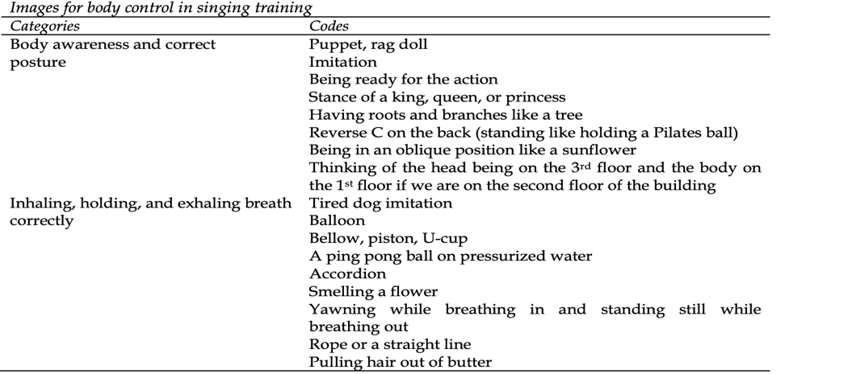

Figure 2 – Practised Methods
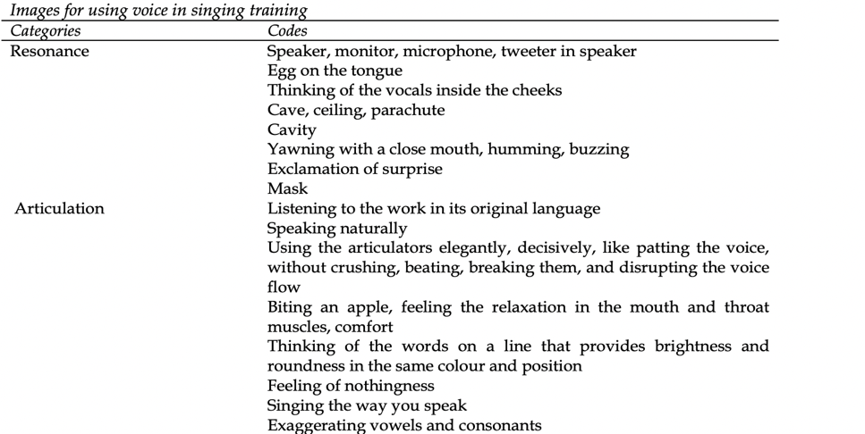

Although imagery and metaphors are widely used as teaching tools, there are many practitioners who are quick to critique, as it has been suggested that exaggerated interpretations and images could cause malfunction and trauma.

(Wis, 1999) argues that verbal metaphor has limitations and can lead to misunderstanding of the intent of the statement. She gives the following example: “The director might ask singers to imagine a light weight hanging from their jaw to acquire a long ah vowel. For the singer who already demonstrates the desired position, the verbal metaphor alone can encourage over-extending the jaw and create tension, the opposite result from what was originally intended (p. 25).” Similarly, (Williams, 2012) is critical of visualisations and metaphorical language in teaching children how to sing. She argues that statements such as “singing with a yawning sensation to open the throat” or “sing as if you have a hot potato on your tongue” (pp.174-175) are shortcuts which may have unintentional, but negative impacts on the vocal technique.

In 20 years of teaching, I have heard many a metaphoric phrase being used as part of the teaching process in which is so far removed from the required outcomes, but to my astonishment, it has had the desired effect. This part of teaching is when I become hesitant, there are no specific instructions to follow, how do I know if I am causing voice trauma when my mind is trying to create images to achieve the same outcomes as a physiological instruction. (Brand, 2016) cites “Regardless of situation, there is one ethical obligation that should rise above all else: do no harm” (Miller, 1986). Hence why I am inclined to agree with Williams, (2012) and Wis (1999).

SCIENCE AND THE VOICE

Voice pedagogy has moved on significantly over the last decades by use of laryngoscopies, voiceprint, x rays, MRI scans and so on. Fascination with the voice has prompted studies for centuries. Historically the study of vocal pedagogy began in Ancient Greece with some scholars making observations on the art of singing (searching beyond speech). In the 18th Century, an Italian named Francesco Antonio Pistocchi founded a Bolognese singing school. He was the teacher of Antonio Bernacchi, who was well known for teaching Handel’s castrati singers (Dwight, 2022), castrati meaning singers being castrated when younger for the purpose of retaining their treble voice. Other famous singers became curious and interested in the technical aspect of the voice, i.e., breath management, the resonating system and natural posture etc. Moving into the 20th century, The Deva Method was established in 1978 working with many famous artists’ backing singers including Led Zepplin, Amy Winehouse, Pink, Elton John, and Celine Dion to name but a few (Deva, 2019). Deva’s method was “focused on working with the natural body and building up muscle memory and the attitude to the body like an athlete would”. Jeannie died in 1916 but her method is still widely relatable to many.

The Estill Method was founded in 1988 and concentrated on vocal manoeuvres to develop specific control over muscle groups and in turn producing sounds of many genres of music.

Figure 3 – Vocal Tract/Larynx Structures
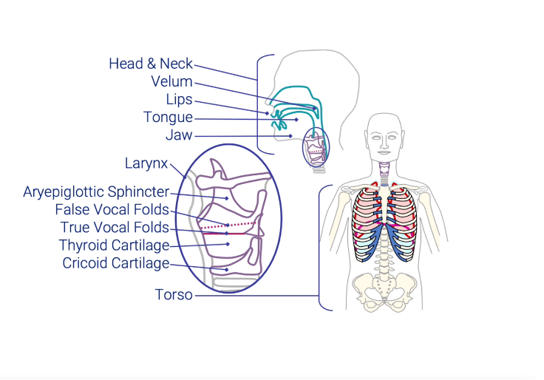
“By focusing on one structure at a time, the learning process is simplified, and enables speakers and singers to differentiate and voluntarily control each structure. Combinations of structural conditions are called Voice qualities which are the characteristics of an individual voice or style of voicing, independent of speech sounds, pitch, and loudness” (Estill, 2010).
(Salisbury, 2014) writes in her thesis a breakdown of each voice quality; how it sounds, the benefits and limitations. Whilst it seems like a good read and the ingredients of each voice quality follow that of the official Estill training, I am assuming that the benefits and limitations are of the writer’s opinion and/or experiences. I studied and trained on a one-to-one basis with an Estill Master of Voice from 2017 – 2023 and in that time, slowly integrated this method into my teaching, and from reading the thesis, it is evident that the writer is coming from the angle of having a different natural attractor state to me (natural singing voice). She goes on to discuss how speech quality should be the easiest voice quality in terms of no trauma and pain to achieve, knowing that we all naturally talk. However, speech quality ingredients rely on the true vocal folds to be at a good thickness, but we can’t assume that everyone speaks using thick folds, a lot of people are quietly spoken or speak using a higher pitch, therefore some may find “speech” voice quality difficult. Salisbury does confirm at a later stage that she is an opera/classically trained singer in contrast to my own attractor state being speech. Whilst I’m sure the writer is trying to remain impartial; the benefits and limitations seem to become more of an opinion based on her own experiences. Below is a typical table which is used for testing purposes. The options to the left would be the list of voice qualities produced by Jo Estill being Falsetto, Speech, Sob/Cry, Nasal Twang, Oral Twang, Belt and Opera. The sections to the right of the options are where the vocal structures change accordingly to produce the differing voice qualities.

Figure 4 – Estill Voice Worksheet
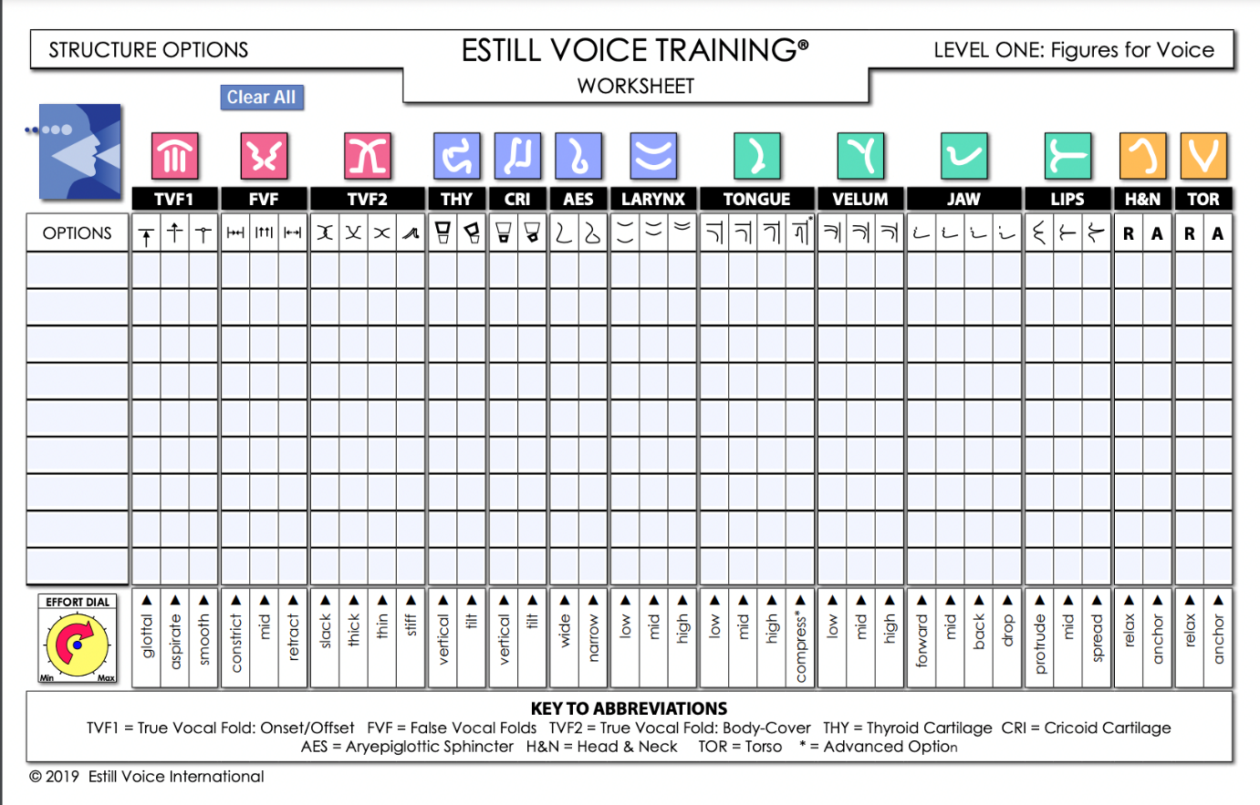

Estill is known for working well and complementing other voice pedagogies, in other words blending and mixing with other methodologies.

A study was carried out by (Bennett, 2017) who states “Knowing the science of the voice is important for vocalists because it changes the way that they view their voice. It is very difficult to study vocal anatomy and understand how it effects voice production and phonation, but it is very important that one does thorough research to better understand it”. Bennett cites that “Thanks to the medical advances in vocal study, a whole science has developed in researching the voice and how it operates, all we knew about how the voice exerted itself in singing was mostly speculation based on sound and feeling” (Fields, 2020).

LEARNING STYLES AND THE VOICE

The VARK model (Fleming, 2001), a New Zealand educationalist. It consists of 16 multiple choice questions which ask about an individual’s preferred learning method. It takes 5 – 10 minutes to complete and provides a score for each of the four learning styles and a summary of the person’s overall preference.

Figure 5 - VARK MODEL
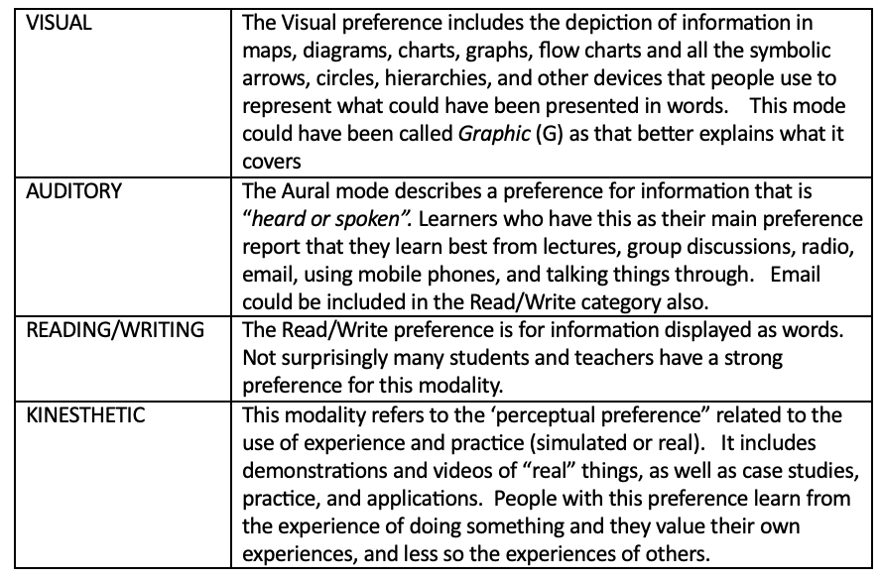

It was suggested that four modalities seemed to reflect the experiences of students and teachers when internalizing information; Visual, Aural, Read/Write and Kinesthetic. There is evidence to show that some teaching styles relate to the teacher’s own learning style. Fleming indicates that higher student achievement is attained when instructors match their teaching strategies with the learning styles of the students in their classrooms.

However, a new review by Swansea University (Newton, 2020) cites that there is insufficient evidence to that of the modalities in that they are ineffective and could be harmful to learners. Professor Phil Newton goes on to say that his study points out that a learner could be at risk of being pigeonholed and consequently lose their motivation as a result. He said: “For example, a student categorised as an auditory learner may end up thinking there is no point in pursuing studies in visual subjects such as art, or written subjects like journalism and then be demotivated during those classes.” (Newton, 2021, p. 2). In other words, learning styles are also known to have a fixed outlook on learning.

In terms of my own learning style, I sway to the kinaesthetic and reading/writing modalities, as I like to work with facts, and also evidence what I am learning through instruction and technique, therefore the scientific approach would win every time. However, when learning to sing, I was taught one way, and that was what came naturally to my singing teacher. Looking back, maybe this is why it took me longer than I would have wished to develop through the grades. Reflecting on the above statement and in hindsight, my initial teaching skills fell in line with using my natural learning style. From this, I wonder if observing how young people teach or learn from each other might offer an insight into their preferred learning style? This is an area for development as part of one-to-one lessons and will form part of my Personal Development Plan.

STRATEGY – TO IDENTIFY LEARNING STYLES

Moving forward I will utilise the VARK questionnaire as part of an initial lesson, which is designed to produce results on learning styles based on peoples’ learning experiences. I have decided not to label or categorise the students’ learning style as I think it’s important to be open minded about other modalities and not pigeonhole onself. For any teacher, the ideal would be to offer all methods of teaching, which in turn will speed up the initial teaching process once a modality has been decided. Based on the results of the questionnaire, it will become much clearer in which learning style to utilise, and from this I can introduce the specific tools including imagery and science-based learning to match that of the learning style. Hopefully this will speed up the teaching and learning.

Imagery is not natural to me. and so is not used within lessons as often as could be. However, I have learnt that the power of the imagination if used correctly speaks for itself in terms of evidence, therefore it is a tool that I will work on becoming more confident in using.

Science based pedagogy is special to me as I have produced some great results after lots of learning and research over the years, therefore will be continuing this method albeit with applicable students.

In summary there is an abundance of research available to teach the three methods as discussed above, evidence and experience has shown me that the more practiced and well-informed I am of a topic, it can be delivered with confidence. More importantly the learning and teaching styles of the student, need to be considered prior to delivering lessons.

As briefly discussed earlier, based on my own experiences with my singing teacher, I will commence research on the effectiveness of student lead teaching/learning, and it may be that those students who work together currently, may have learning styles in common and in turn produce effective results, I am interested and curious in the outcomes.

My aim is to help adapt a student with a good singing voice to that of using their voice as an instrument by utilising the relevant teaching methods.

CONCLUSION

Researching and evaluating this topic has evidenced by practitioners and authors that there are benefits to utilising all methods discussed, however more importantly the information needs to be directed to the correct learning path of the student. Based on the level of my confidence in teaching science-based pedagogy, it seems there is a pattern to my learning in that I refrain from further development if the relatability factor is not as strong. If all teaching methods are to be used, then further research is essential to develop the weaker areas of my teaching. This will be added to my Personal Development Plan.

There were arguments for and against each teaching method, this was a great tool for myself to consider what works best in my teaching environment considering all students’ learning styles.

There were many ideas and patented models to research, and it seemed that imagery was far more prevalent historically due to lack of scientific research, however evidence shows that using imagery as a teaching style is extremely popular even though science has moved on enormously. Both can be used to produce the same result if they are determined by the correct learning styles. The idea is to make it easier for the student to develop ideas and skills using what they know as a base. To this current day, the VARK model is being utilised by many, however there are arguments against pigeonholing a character or personality trait to that of one category.

Overall, I conclude there was sufficient data to confirm both benefits and limitations to all three methods, however it seems inevitable to introduce the VARK questionnaire initially to obtain the results of the four modalities. It is now my role to use this information both effectively and efficiently to produce more speedy and qualitative results.

CRITICAL REFLECTION

The aim of the module was to research and analyse effective methods of teaching to enable me to gain confidence in moving outside of the boundaries that I am currently comfortable with. Reflecting on my teaching experience, I have gained awareness and used loosely, elements of the three forms of teaching as discussed above. The science-based method of teaching is what I am most comfortable with since there has been a lot of financial investment and many intense learning years specifically focusing on this topic. In this module it was important for me to delve further into imagery and learning styles and science furthermore, to develop as a learner as well as a teacher, with the aim of thinking in two different forms. It was important for me to learn about the benefits and limitations to all of the methods from differing practitioners, then once my knowledge had increased, I could form my own opinions, also taking into consideration that of the students.

The Era Cycle (Jasper, 2003), one of the reflective models interested me as it is what I would naturally veer towards albeit in a very disorganised manner. If I had kept in mind this process throughout, there would have been a high possibility of not deviating into different parts of the module. In essence I believe this to be down to lack of confidence and panic. When researching, if I encountered some analysis relevant to another part of the module, I would copy and paste into the document which then changed my focus. “Building understanding from experience” (VSC, Feb 24) resonated with me as I am beginning to consider if I teach mainly in a scientific way due to consistently being taught the same method over an extended time period. This is why it is important to acquire additional knowledge and experience in other methods of teaching from differing practitioners.

Learning styles is a tool in which I have never offered the time to research further, and being truly honest, lesson times are so busy and very much driven like a conveyor belt at colleges, the emphasis has always been on outcomes, which in turn I have learnt that if the teaching isn’t relevant, then a positive outcome would be delayed. So, moving forward it is important that I spend the time initially investing in the students, asking questions, and becoming acquainted with their learning style, and hopefully in turn will instil trust and confidence in the student from the early stages of teaching. It maybe that I don’t stick to one specific method as I would prefer not to label the student with a specific learning style just so they can keep an open mind in building on more than one or two styles.

Imagery has always been contentious in that a) I believed I wasn’t naturally creative, b) I am fearful of causing physical voice trauma due to creating wrong imagery, c) my preferred method seems to be conditioned to that of science. However, there are lots of imagery ideas produced from other practitioners and teachers in which I related to which have produced positive outcomes. I am aware that some of my students are visual, therefore I will use other’s ideas until I become more confident.

Science based learning holds a big place in my heart and from research I am aware there is still a lot to learn. Using the Estill Method, I have become very comfortable in the fact that I do produce results and are inspired with those students who have become increasingly versatile in terms of producing differing voice qualities. I am still mesmerised to this day when listening to, but not watching a student, I wouldn’t recognise who was singing if it is outside of their natural singing voice, however, I have come to realise that the success rate is mainly with those students whose style likens to that of mine.

I believe that I have experienced and reflected upon those learnings in this module and the next step is to take action and confirm this in writing in the form of a PDP. The three topics discussed; Imagery, Science and Learning Styles all have benefits and limitations, moving forward I will be utilising all three once I gain further knowledge about the students’ learning style and I will continue to learn about the weaker areas in my teaching. After research and analysis, I am now convinced the three methods all connect as mentioned above, and in the future, I am confident of using them all together to achieve the best results.

Finally, academic writing has been somewhat difficult for me to produce, I am a hedger; more of a descriptive writer and the concern with this is that I need to be mindful not to create an essay piece. This is the hardest part of the journey so far for me, and it becomes frustrating as I try to explain with a little refinement, resulting in the writing not making sense. However, I now understand what academia means, it’s purpose and what the requirements are, and I am sure this will improve throughout the modules.

References
Anon., n.d.
Anon., n.d. PSYCHOLOGY.
Beidenbender, A. J., 2012. An Exploratory Study of Learning Styles in the Elementary Music Classroom, Michigan: University of Michigan.
Bennett, G., 2017. The Science of Singing: A Voice Lesson from Anatomy and Physiology, Cedarville: Cedarville University.
Brand, E. K., 2016. Humanistic Vocal Pedagogy: Exploring a Voice Teacher’s Scope of Practice through a Perspective of Wellness, Ohio: The Ohio State University .
Cartwright, 2020. Education in the Elizabethan Era. World History Encycopedia, Volume 1.
Chapman, J. L., 2023. Singing and Teaching Singing - A Holistic Approach to Classical Voice.. San Diego: Plural Publishing.
Deva, J., 2019. The Deva Method. [Online]
Available at: https://jeanniedeva.com/vocal-technique/deva-method-what-is-it/?v=79cba1185463
Deva, J., 2019. The Deva Method. [Online]
Available at: https://jeanniedeva.com/vocal-technique/deva-method-what-is-it/?v=79cba1185463
[Accessed 26th April 2024].
Dwight, J. S., 2022. Dwight's Journal of Music. In: Dwight's Journal of Music. s.l.:Outlook Verlag, p. 403.
E.Seashore, C., 2024. Psychology of Music. Sage Journals, 49(3), pp. 311-688.
Estill, J., 2010. Estill Voice Training Level Two Workbook. [Online]
Available at: https://estillvoice.com/2021/12/learn-the-language-of-estill-voice-training/
[Accessed Friday 26th April 2024].
Estill, J., 2021. The Estill Method. 2 ed. Pittsburg: s.n.
Fields, V. A., 2020. Training the Singing Voice: An Analysis of the Working Concepts Contained in Recent Contributions to Vocal Pedagogy. 1 ed. New York: Columbia University Press.
Fleming, N., 2001. Teaching and Learning Styles: Vark Strategies. Kindle edition ed. s.l.:N Fleming.
Gregg, C. a. H., July 2008. Seeing the Sound: An Exploration of the Use of Mental Imagery by Classical Musicians. ResearchGate, 12(2), pp. 23-247.
Jasper, M., 2003. Beginning Reflective Practice, Foundations in Nursing and Health Care. Cheltenham: Nelson Thornes.
Libby, P. E., 2011. Chapter four - Visual Perspective in Mental Imagery: A Representational Tool that Functions in Judgment, Emotion, and Self-Insight. Advances in Experimental Social Psychology, Volume 44, pp. 185 - 245.
Library, M., 2010. The CRAAP Test, California: Californian State University.
Miller, R., 1986. The Structure of Singing: System and Art of Vocal Technique. First ed. Belmont CA: Wadsworth Publishing Ltd.
Miller, R., 1986. The Structure of Singing; System and art in vocal technique. First ed. New york: Schirmer.
Miller, R., 2004. olutions for Singers: Tools for Every Performer and Teacher. New York: Oxford University Press.
Miller, R., 2004. Solutions for Singers: Tools for Every Performer and Teacher. 2 ed. New york: Oxford University Press.
Morris, T., Spittle, M. & Watt, S., 2005. Imagery in Sport and Performance. 1st Edition ed. Victoria: Human Kinetics.
Munroe, K. J. e. a., 2024. The Sport Psychologist. Human Kinetics Journal, 38(1).
Newton, P., 2020. How Common Is Belief in the Learning Styles Neuromyth, and Does It Matter? A Pragmatic Systematic Review. Systematic Review Article, Swansea University Medical School, December, Volume 5, p. 2.
Newton, P. P., 2021. How Common Is Belief in the Learning Styles Neuromyth, and Does It Matter? A Pragmatic Systematic Review. Systematic Review Article, Swansea University Medical School, December, p. 2.
Rev. Dr. Martin Luther King, J., 1963. I have a dream. Washington: The Washington Post.
Rogers, K. M. A., Feb 2009. A preliminary investigation and analysis of student learning style preferences in further and higher education.. Journal of Higher and Further Education, 33(1 ), pp. 13-21.
Rooney, T. J., 2016. The Understanding of Contemporary Vocal Pedagogy and the Teaching Methods of Internationally Acclaimed Vocal Coaches. International Journal of Learning, Teaching and Educational Research, 15(10).
Salisbury, K. E., 2014. ESTILL VOICE TRAINING: THE KEY TO HOLISTIC VOICE AND SPEECH TRAINING FOR THE ACTOR, Virginia: Virginia Commonwealth University Richmond, Virginia.
Tandon, N., 2019. SYMBOLISM IN SHAKESPEARE'S PLAYS. International Journal of Development in Social Sciences and Humanities, Volume 7.
VSC, Feb 24. Critical Reflection, Colchester: Voice Study Centrre.
Ware, R., 2013. The Use of Science and Imagery in the Voice Studio—A Survey of Voice Teachers in the United States and Canada.”. Journal of singing, 69(4), pp. 413-417.
Williams, J., 2012. Teaching Singing to Children and Young Adults.. 2 ed. London: Compton Publishing Ltd.
Wis, R. M., 1999. Physical metaphor in the choral rehearsal: A gesture-based approach to developing vocal skill and musical understanding.. 40(3), pp. 25-33.
Yiğit2, N. & Doğanyiğit1, S., 2023. The perspective of trainers on the use of imagination in singing training. Journal of Pedagogical Research, 7(1), p. 179.
Yin, R. K., 2018. Case study research and applications: Design and methods, Satya Wacana Christian University: Sage Publications Inc.

APPENDIX 1

MODULE 1 – PERSONAL DEVELOPMENT PLAN

“An exploration of the effectiveness of the use of science-based pedagogy, imagery and learning styles in the teaching of voice”.

OVERALL GOAL | DEVELOPMENT OPPORTUNITY TO MEET OVERALL GOAL | WHAT I WILL DO TO ACHIEVE THIS | RESOURCES AND SUPPORT NEEDED | WHAT SUCCESS LOOKS LIKE | TARGET DATE FOR COMPLETION
Develop a faster and more efficient approach to teaching using three teaching methods.  Explore and research into student lead teaching/learning.  To become more aware of my own teaching methods.  To follow up on Yin 2018 case study research and applications: Design and methods as discussed in this module. | To develop further and improve on teaching methods:- learning styles, imagery and science based learning and know which method to use when.  Research further and carry out trials.  To bring together students with the same learning methods to teach/learn together with the aim of producing effective results.  To assess my own teaching methods.  To assess practiced methods of imagery based on the case study. | Use the VARK questionnaire as a tool to learn about the student as part of their initial one to one lesson.  Develop further learning on imagery to build confidence in teaching with that specific method.  Hold group classes and pair up students to work together.  Record lessons to show evidence of teaching methods.  Research further. | VARK questionnaire and students over 18 years of age  Utilising Voice Study Centres resources, journals and the UWTDS library to develop further knowledge.  Extra class time in college  Voice recordings via  mobile phone  Case Study | Once completed, the speed of understanding will allow the correct learning style/s to be used more effectively.  Teaching a balance of the three methods including imagery taking into consideration the student’s learning style.  The production of effective practices within speedier timelines.  Confirmation of lesson outcomes.  Confirmation of assessment with the aim of improving my own teaching methods. | December 2024 starting in new academic year allowing for 3 months of assessing and planning.  December 2024  December 2024  December 2024  December 2024

