

Master of Business Administration
Module Code and Title: LCMB7034 International Business Concepts

Assignment Title: Individual Report

Lecturer: Jean Wang

Student Name: Md Forhad Hossen Rony
Student ID: 2433472

Words: 5512

Date of Submission: 27th April 2026

AI Use Acknowledgement

I confirm that I have not presented any AI generated text as my own work. I confirm I have copies of my drafts, notes, and other resources I used before, and after the use of AI tools which I may be asked to provide in evidence.

Table of Contents
List of Figures 5
Section 1: International Business Report 6
1. Introduction 6
2. Industry and Country Overview 7
2.1 FMCG Industry (India) 7
2.2 Economic Importance 8
2.3 Competition and Market participants 8
2.4 Competitive Strategy (Critical Analysis) 9
3. Analysis using Porter's Diamond Model 10
3.1 Factor Conditions 10
3.2 Demand Conditions 11
3.3 Supporting and Related Industries 11
3.4 Strategy, Structure and Competition 12
3.5 Government Role 12
3.6 Chance Factors 13
3.7 Critical Synthesis 13
3.8 Final Judgement 13
4. Nestlé in India 14
4.1 Company Overview 14
4.2 Strategy of entry - OLI Paradigm 15
4.3 Market attractiveness (PESTLE and CAGE) 16
4.4 Integration–Responsiveness Framework 17
4.5 Critical Evaluation 18
4.6 Value Chain Analysis 19
5. Conclusion 20
Section 2: Reflective Account (Gibbs Reflective Cycle) 21
1. Description 21
2. Feelings 22
3. Evaluation 22
4. Analysis 23
5. Conclusion 23
6. Action Plan 24
References 25

List of Figures
Figure 1: Diamond Model by Porter 10
Figure 2: Nestlé 14
Figure 3: Gibbs Reflective Cycle 21

Section 1

1. Introduction
Fast-Moving Consumer Goods (FMCG) industries play a critical role in the global economy due to their high turnover, high consumption and direct impact on the lifestyles of consumers. Multinational FMCG companies are a crucial subject of research in international business because they contribute significantly to economic growth and development worldwide, the creation of employment and trade, and form a crucial part of international trade (Sałek, 2024). The developing countries, particularly India have become prominent due to their population size, rising middle class and rise in consumption. One of the fastest-growing FMCG markets is India, which offers great opportunities to multinationals. Nestle, especially, has taken advantage of this opportunity through its global brands such as Maggi, KitKat and Nescafé and the characteristics of localisation of products to conditions in the Indian market. The scope of this report is to evaluate competitiveness of the Indian FMCG industry and critique the Nestle strategy in that regard, based on major global business models.

2. Industry and Country Overview

2.1 FMCG Industry (India)
The Fast-Moving Consumer Goods (FMCG) industry in India consists of goods sold quickly and having low prices and used frequently. They are staple products like food and drinks, personal care and home care. The sector is largely categorized into three groups, namely food and beverages, personal care, and home care (or household) products (Pangarkar and Prabhudesai, 2024). Among these, the food and beverage segment is the largest and this is mainly due to the increased consumption of packaged food. This has been particularly true in urban India where there has been an increasing pressure on time and a shifting eating pattern towards increasing consumption of processed food.
The growth of FMCG is a sector in India that can be ascribed to certain interconnected reasons. First, consumption patterns have changed due to urbanisation. As more people migrate to urban areas, their lifestyle is becoming more hectic, and that is why processed and packaged food is being consumed (Turner, 2024). Secondly, the rise of middle-class has raised the purchasing power and has allowed consumers to shift off the low-priced no-named goods to high-quality, branded products. This change has encouraged companies to concentrate on branding, product development and marketing in order to capture a market share.
Thirdly, the FMCG industry has also experienced growth due to digitalisation. Digital connectivity and payments have been boosted by the government initiative known as Digital India and the advent of the Unified Payments Interface (UPI) (Turner, 2024). As a result, e-commerce sites, whereby FMCG products are purchased on the internet, have had a boom. This digital revolution makes the process more convenient besides allowing businesses to gather and process customer information to market and target products. However, in spite of the growth drivers, the industry has continued to have issues such as fragmented distribution systems, infrastructural shortfalls and digital divide. Therefore, Indian FMCG industry is a promising one in the context of growth but it remains to have its challenges and opportunities.

2.2 Economic Importance
FMCG is a significant contributor to the GDP and job creation in India, as it is an economic growth sector. As one of the largest industries in India, it supports other industries, such as manufacturing, distribution, retail and marketing (Benito and Meyer, 2024). The high demand and high frequency of consumption of the sector offer stable growth impetus to the economy. The other important feature in the FMCG industry is the rural connection. It will be a large buyer of farm products, including food and personal-care ingredient products, and therefore will contribute to the support of small farmers and producers. Moreover, the sector also provides job opportunities in other activities of the value chain like manufacturing, distribution and retail and thus it is a significant source of inclusive growth. India also exports a variety of products in its FMCG sector such as processed food, beverages and personal care products (Dalirazar and Sabzi, 2023). This enhances the trade balance and foreign exchange reserves of India. This industry is a market seeking FDI in terms of international business. The size of Indian market, the growing amounts of personal income and future market development attract multinational corporations.

2.3 Competition and Market participants
The Indian FMCG market is highly competitive, and both multinational and domestic firms play in the market. Nestle, Unilever and Procter & Gamble are multinational companies. These companies rely on their network of branches around the world, technology and brand awareness to maintain their market share. They have the ability to invest in R&D, marketing and innovation thus able to introduce better and differentiated products to the market (Benito and Meyer, 2024). But on the other hand, local corporations like ITC Limited, Dabur India and Patanjali Ayurved are well known and knowledgeable about their markets. They also tend to have a strong distribution network particularly in the rural markets, which provides them with a competitive advantage in rural market penetration. Furthermore, local companies focus on price and compatibility to the local culture and offer highly accepted products. This leads to innovation, quality enhancement and enhanced efficiency in the market (Budiharso, 2022). However, it also leads to price competition, which may reduce profits. Critically, the Indian market of FMCGs is also quite a dynamic and competitive market and so companies must continuously transform their competitive strategy so as to remain relevant and competitive there.

2.4 Competitive Strategy (Critical Analysis)
The competitive strategies that are followed by the Indian FMCG firms are primarily the cost leadership and differentiation. The local firms normally follow cost leadership, which focuses on low prices and cheap products that are oriented to cost-sensitive consumers. This is effective in the rural setting, where customers do not possess such high amounts of disposable income and are more concerned with need than brand. These businesses are oriented at serving urban and middle-income markets that are inclined to use well-recognized brands, high quality, and other product characteristics (Aneeis Hashim et al., 2023). The lines between cost and differentiation strategies are however becoming blurred as companies endeavor to cater to various segments of the market. One of the major factors in the evolution of the competitive strategy in India is the rural-urban divide. In cities there is a large disposable income, exposure to international brands and a desire to have quality. This poses a challenge to businesses and they must offer both high and low-end products in order to serve various segments of the market. More importantly, firms that can strike a balance between cost leadership strategies and product differentiation strategies are more prone to attain a competitive advantage. This requires flexibility and understanding of the local market forces.
2.4 Competitive Strategy (Critical Analysis)iIndian FMCG companies follow various competitive strategies, mainly cost leadership and differentiation.oLocal firms typically adopt cost leadership strategies, emphasising low prices and affordable products targeted at cost-conscious consumers.rThis strategy works well in rural areas, where consumers have lower levels of disposable income and are more focused on necessity than brand.cIn contrast, global firms pursue differentiation strategies, focusing on product attributes, branding, innovation, and service.cThese companies focus on serving urban and middle-class markets who prefer well-known brands, superior quality and other product features.eBut the boundaries between cost and differentiation strategies are becoming blurred as firms strive to serve different market segments.lA key element in the development of competitive strategy in India is the rural-urban divide.dCities have high disposable incomes, exposure to international brands and a demand for quality.tBy contrast, rural markets value cost, availability and practicality.tThis creates a dilemma for companies, which need to provide both high-end and low-end products to cater to different market segments.dCritically, companies that are able to balance cost leadership and product differentiation strategies are more likely to gain a competitive edge.gThis calls for both adaptability and insights into local market dynamics.nOverall, the Indian FMCG market is a dynamic marketplace, requiring a balance of innovation, cost efficiency, and localisation.es.2.4 Competitive Strategy (Critical Analysis)iIndian FMCG companies follow various competitive strategies, mainly cost leadership and differentiation.oLocal firms typically adopt cost leadership strategies, emphasising low prices and affordable products targeted at cost-conscious consumers.rThis strategy works well in rural areas, where consumers have lower levels of disposable income and are more focused on necessity than brand.cIn contrast, global firms pursue differentiation strategies, focusing on product attributes, branding, innovation, and service.cThese companies focus on serving urban and middle-class markets who prefer well-known brands, superior quality and other product features.eBut the boundaries between cost and differentiation strategies are becoming blurred as firms strive to serve different market segments.lA key element in the development of competitive strategy in India is the rural-urban divide.dCities have high disposable incomes, exposure to international brands and a demand for quality.tBy contrast, rural markets value cost, availability and practicality.tThis creates a dilemma for companies, which need to provide both high-end and low-end products to cater to different market segments.dCritically, companies that are able to balance cost leadership and product differentiation strategies are more likely to gain a competitive edge.gThis calls for both adaptability and insights into local market dynamics.nOverall, the Indian FMCG market is a dynamic marketplace, requiring a balance of innovation, cost efficiency, and localisation.es.🔹 2.4 Competitive Strategy (Critical Analysis)iIndian FMCG companies follow various competitive strategies, mainly cost leadership and differentiation.oLocal firms typically adopt cost leadership strategies, emphasising low prices and affordable products targeted at cost-conscious consumers.rThis strategy works well in rural areas, where consumers have lower levels of disposable income and are more focused on necessity than brand.cIn contrast, global firms pursue differentiation strategies, focusing on product attributes, branding, innovation, and service.cThese companies focus on serving urban and middle-class markets who prefer well-known brands, superior quality and other product features.eBut the boundaries between cost and differentiation strategies are becoming blurred as firms strive to serve different market segments.lA key element in the development of competitive strategy in India is the rural-urban divide.dCities have high disposable incomes, exposure to international brands and a demand for quality.tBy contrast, rural markets value cost, availability and practicality.tThis creates a dilemma for companies, which need to provide both high-end and low-end products to cater to different market segments.dCritically, companies that are able to balance cost leadership and product differentiation strategies are more likely to gain a competitive edge.gThis calls for both adaptability and insights into local market dynamics.nOverall, the Indian FMCG market is a dynamic marketplace, requiring a balance of innovation, cost efficiency, and localisation.es.🔹 2.3 Market Participants & CompetitionoThe FMCG market in India is highly competitive, with both multinational and local players.sMultinational giants include Nestlé, Unilever and Procter & Gamble.eThese firms draw upon their global resources, technological know-how and brand strength.eThey are able to invest substantial resources in R&D, marketing and innovation to produce superior and unique products.sOn the other hand, domestic companies like ITC Limited, Dabur India and Patanjali Ayurved have a strong understanding of the local market.rThey often have strong distribution channels, especially in rural markets, offering them an edge in penetrating the market.sMoreover, local firms often prioritise cost and cultural fit, catering to local tastes.sCompetition between multinational and domestic companies leads to intense competition.eThis fosters innovation, quality improvement and efficiency in the market.yBut it also results in price wars, negatively impacting profits.sCritically, the Indian FMCG market is competitive, but also ever changing, and companies need to keep evolving their strategies in order to remain competitive.s🔹 2.4 Strategy (Critical Analysis)iThe Indian FMCG market sees companies employ various competitive strategies, mostly pursued through cost leadership and differentiation.oIndigenous firms tend to follow cost leadership strategies, emphasising low prices to target cost-conscious consumers.rThis strategy works well in rural areas, where consumers have lower incomes and purchase is based on affordability.cIn contrast, transnational firms tend to pursue differentiation strategies, focusing on quality, innovation, branding and service.cSuch companies cater to urban and middle-class markets that demand quality brands and product features.eBut the boundaries between cost and differentiation strategies are becoming increasingly blurred, as firms seek to target different market segments.lA key consideration in developing competitive strategies in India is the rural-urban divide.dThe urban market has a higher disposable income, is exposed to global brands and values quality.tRural markets, on the other hand, value affordability, convenience and functionality.tThis necessitates a two-pronged approach by firms, with both high-end and low-price products to cater for market segmentation.dCritically speaking, companies that effectively combine cost leadership with product differentiation are likely to gain competitive advantage.gThis means not only being adaptive but also attuned to market realities.nIn summary, the Indian FMCG market is a challenging space, where success is achieved through a balance of innovation, cost efficiency and localisation.es.Top of Form
Bottom of Form

3. Analysis using Porter's Diamond Model
Porter’s Diamond Model offers a holistic approach to understanding the competitive advantage of countries by considering the interaction of various factors affecting industry competitiveness. And when applied to the FMCG industry in India, it shows both positive and negative structural determinants. These determinants contribute to India being a lucrative but challenging market for multinational FMCG companies like Nestlé.
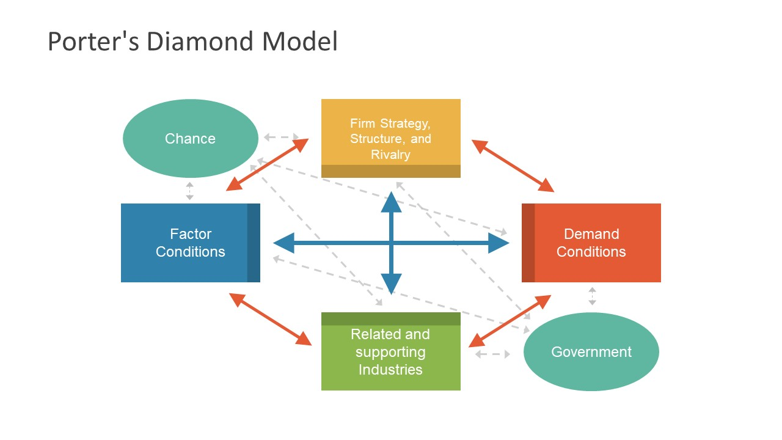
Figure 1: Diamond Model by Porter
Source: (Pangarkar and Prabhudesai, 2024)

3.1 Factor Conditions
TheThere are both opportunities and challenges associated with the factor conditions in India for FMCG. Perhaps the most important opportunity is the plentiful and low-cost labour supply. This allows companies to set up cost-effective manufacturing facilities, which is crucial in a price-sensitive environment (Pangarkar and Prabhudesai, 2024). However, this is partially compensated by low productivity levels, as compared to developed markets, which may lower overall efficiency. Infrastructure is a mixed bag. Major cities have seen infrastructure improvements in transportation, logistics and warehousing, but rural areas suffer from infrastructure problems. This poses difficulties for transportation and supply chain management, especially of fresh produce.
India’s flourishing digital economy is a strength. The country’s high mobile phone and growing internet penetration have supported the expansion of e-commerce and online transactions. This presents a paradoxical opportunity of low cost and digital efficiency. But regional inequality of digital access reveals structural inequalities (Fernandes and Shailashree, 2022). Thus, while factor conditions increase competitiveness, they also force firms to adopt flexible strategies to deal with the inefficiencies.

3.2 Demand Conditions
One of the most important factors that can be used to improve competitive aspects within the FMCG industry is the demand conditions in India. The large and young population of India presents a large domestic market giving the companies opportunity to enjoy economies of scale. Additionally, the rise in the income level and urbanisation is pushing consumers towards the consumption of more quality branded products. One of these changes is an increasing interest in health and wellness which is influencing consumer spending. This is fueling a need to have more quality and healthy products with a focus on nutrition, hygiene and quality. It aligns with Nestle strategy which focuses on Nutrition, Health and Wellness (NHW) (Ghial et al., 2025). However, the consumer demand in India is varied and urban and rural consumers are different in their preferences. The urban consumers might be quality and brand conscious but the rural consumers are still quite price conscious. This necessitates the use of different market strategies thereby complicating the operations. One of the critical opinions is that the favourable conditions of market demand stimulate the process of innovation and contributes to the necessity of market segmentation and flexibility.

3.3 Supporting and Related Industries
Proximity of the related and supporting industries enhances competitiveness of the Indian FMCG industry. The agricultural industry plays a significant role in provision of raw materials to food items and the packaging industry also helps to differentiate the product and raise the shelf life of the product. In addition, distribution has been improved with the creation of logistics and supply chain management (Hassani et al., 2026). The retail environment in India is an amalgamation of both old and new. Traditional kirana stores are still common and particularly found in rural and semi-urban areas and offer convenience. Nonetheless, modern retailing and internet shopping (Amazon and Flipkart) is also on the rise and is altering the pattern of retailing. This multi-channel retailing policy enhances the market penetration, but makes distribution complex. Importantly, even though the advantages of supporting industries are numerous, costs and inefficiencies can be caused by the lack of integration of supply chains and small retailers. Therefore, businesses should ensure they come up with supply chain strategies that take advantage of such industries.

3.4 Strategy, Structure and Competition
The Indian FMCG is very competitive and this has led to innovation and efficiency. Having strong domestic firms and multinationals results in cut-throat competition, which motivates companies to constantly innovate and improve their product lines, pricing and distribution network (Turner, 2024). Firms employ several competitive strategies, including cost leadership/differentiation, to gain competitive advantage. The local companies are more likely to focus on cost and rural market coverage as compared to the multinationals which are more likely to focus on branding, product quality and innovation. This competition encourages efficiency and responsiveness, but also leads to price based competition which may lead to loss of profitability. The competitive analysis of the FMCG industry in India is critical which implies that it is a two sided sword. Companies should therefore strike an optimal balance between competition and value creation to be sustainable.

3.5 Government Role
The Indian government is actively involved in the establishment of favourable environment of the FMCG industry. The way the government has promoted the creation and expansion of multinational companies is through government efforts such as liberalisation of foreign direct investment (FDI). The tax structure has also been streamlined with the introduction of the Goods and Services Tax (GST) which has increased the efficiency of the supply chain and broken the barriers of the supply chain (Sałek, 2024). Government agencies: Government agencies play a key role in ensuring standards of quality and safety, e.g. the Food Safety and Standards Authority of India (FSSAI). These enhance the market confidence and stability, but increase the compliance and transaction costs of the companies. Critically, government support is facilitative and restrictive. Despite the fact that the business-friendly measures enhance competitiveness, regulatory and bureaucratic processes are unpredictable. This means that firms have to be wary of the regulatory environment to avoid risks and utilize opportunities.

3.6 Chance Factors
And there are external and unpredictable factors influencing the competitiveness of the FMCG sector in India that are chance factors. COVID-19 pandemic, in particular, has altered the preferences of the consumers and industry trends. The COVID-19 increased the application of digital technologies and hygiene products market, which has benefited FMCG companies (Sałek, 2024). Other causes are inflation and changes in climate. Climate change can affect agricultural supply chains and inflation can affect consumer spending and increase the costs of production. These underline the necessity of flexibility of strategy.

3.7 Critical Synthesis
Critical evaluation of the Diamond Model of Porter, indicates that the competitiveness of the Indian FMCG industry is not a direct outcome of one factor but a combination of different factors. The demands are the drivers of innovation and product development as well as efficiency and improvement induced by competition. Likewise, supportive and related industries and digital infrastructure enhance access and efficiency in the market (Budiharso, 2022). Poor infrastructure, particularly in the rural areas limits distribution channels and regulatory provisions contribute to the operation cost.

3.8 Final Judgement
The FMCG sector in India has a conditional competitive advantage and high demand, labour and competition, which presents opportunities, but the infrastructural and institutional limitations limit the growth of the sector (Benito and Meyer, 2024). To multinational companies such as Nestle, the distinctive approach to succeeding in this market will be to exploit these opportunities and effectively deal with these challenges.

4. Nestlé in India

4.1 Company Overview
Nestlé is a multinational company, operating in over 180 countries, with a strong presence in the global food and beverage market. With its headquarters in Switzerland, the company has developed a solid global reputation for its vast product range, technological expertise and its focus on nutrition, health and wellness (Yu et al., 2022). Nestlé's success at a global level is a result of its ability to capitalise on economies of scale while investing in research and development, which supports a culture of innovation and product development.
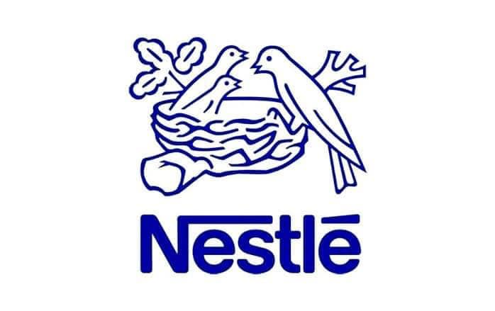
Figure 2: Nestlé
Source: (Turner, 2024)
Nestle initially established itself in India in the early 20 th century, and it has since taken a leading role in the FMCG industry in India. The company has over the years developed a rich brand portfolio with some of the most popular brands in India such as Maggi, KitKat and Nescafé. Such brands have become part of Indian culture, which highlights the ability of Nestle to localise its international brands to suit Indian consumers (Williams et al., 2024). Over the years, Nestle has succeeded in India because of its focus on localisation, which is supported by an effective distribution system and supply chain management. Additionally, the strategy Nestle uses in India is both a global integration and localisation strategy. It also utilizes its international brand and technology, yet local market knowledge. It has enabled Nestle to maintain the competitive advantage in a rapidly developing, competitive market. This has assisted in making the company a role model to successful multinational companies in the emerging markets.

4.2 Strategy of entry - OLI Paradigm
The OLI (Eclectic) Paradigm of foreign direct investment (FDI) in India is applicable to the Nestle strategy based on the OLI location benefits, Ownership and Internalisation benefits of the Nestle venture. The paradigm explains the theoretical reason why Nestle invested the extensive presence in the Indian market through direct presence as opposed to other types of entry such as licensing and franchising. To begin with, Nestle enjoys various ownership benefits, including international brand recognition, better research and development facilities and technology. These enable it to have a distinctive positioning ability of its products and offer uniform levels of quality (Saha et al., 2024). These ownership benefits are vital to Nestle in India because they will allow it to compete with local and other multinationals in the world. In addition, its international expertise in nutrition and food science enables it to create and customize products to address the Indian market.
Secondly, India has good location benefits which offer an ideal investment opportunity. Its size and growth in population offers it a large market potential and the rise in income and urbanisation further promotes the demand of the FMCG commodities. In addition, cheap labour costs allow production and distribution to be cheap. The increasing retail and digital infrastructure in India also contributes to accessing the market, which makes it an ideal place to introduce a foreign company. Third, the internalisation benefits include the fact that Nestle prefers to manage its operations instead of outsourcing or licensing (Budiharso, 2022). With fully owned subsidiaries, Nestle is able to closely monitor the quality of its products, protect its proprietary knowledge, and manage its brand image. This is needed in the food industry where safety and quality plays a critical role in success. This has led Nestle to select FDI in the shape of wholly owned subsidiaries so that it can enjoy the benefits of ownership and the benefits of location which India possesses. This approach is also less risky when it comes to dealing with third parties and makes the process more efficient. The OLI paradigm, critically, explains the reason why Nestle was chosen to be controlled and integrated in order to succeed in the long-term when in foreign markets.

4.3 Market attractiveness (PESTLE and CAGE)
Political and Legal
The political and legal environment in India presents both opportunities and threats to Nestle in a mixed bag. On the one hand, the political stability and business-friendly policies of India, including liberalisation of FDI, give a good environment to multinationals. Investment is also supported by regulatory policies to develop industries and digitise them (Eierle et al., 2022). But there are regulatory uncertainties. The case of Maggi, during which the international corporation Nestle was temporarily prohibited from selling one of its famous brands due to allegations of their inferior quality and safety concerns, highlights the necessity of compliance with national legislation. This underscored how the government and the legal liability of MNCs enforce strict food safety laws.
Economic
Strong growth, increased disposable incomes and the middle-income earners leading to the demand of FMCG products characterize the economic environment in India. This gives Nestle an excellent chance to gain market share and sell luxurious products (Eierle et al., 2022). Yet, there are economic realities that must be considered like inflation and income inequality. In rural markets consumers are extremely price sensitive, which implies that Nestle needs to be adaptable with prices. Therefore, although the economic environment is favourable it must be handled to maximise the growth and cost variables.
Cultural (CAGE Framework)
The cultural dimension, which was tested according to the CAGE framework, reiterates the necessity to take into consideration the consumer behaviour. The cultural differences in India, regarding eating habits and religion are a cultural barrier to foreign firms. An example of this is that a large number of Indians are vegetarians, which influences their food habits (Fernandes and Shailashree, 2022). This challenge has been overcome in Nestle where the company has localised its products to suit the preferences of the Indian consumers. The ability of the company to adjust to cultural diversity is manifested in the localised flavours and variants of products. This does not only increase customer satisfaction but also brand loyalty.
Technological
Technological innovations in India helped the company a lot. Online payment and e-commerce technologies have transformed the retail industry enabling the company to attract more people. Furthermore, data analytics can help Nestle understand consumer preferences that can be utilized to guide marketing (Hanifayev, 2023). However, with the constantly evolving technological environment, competition increases as well, requiring businesses to invest in innovation in order to be on top. More importantly, technology is a threat and opportunity and needs to be continuously invested in and planned.
Environmental
One of the important issues in the FMCG sector is sustainability. Increasing consumer interest and adherence to regulations have caused a turn to sustainability. Nestle has considered this by focusing on sustainable packaging, reducing plastic waste, and sustainable sourcing of ingredients (Fernandes and Shailashree, 2022). Such initiatives enhance the image of the company, but also increase the cost and complications. The supply chain requires continuous innovation and integration to meet the sustainability targets. Environmental sustainability is important to the success of the future, despite the complexities.

4.4 Integration–Responsiveness Framework
The Integration-Responsiveness framework provide an insight about the global approach of Nestle. Regarding the Indian market, Nestle is highly globalized and localized, which also belongs to the strategy of transnational. This enables it to enjoy economies of scale as a result of global integration, and address local demands (Sałek, 2024). An example is Nestle maintains brand uniformity across the world with products such as KitKat which share a uniform branding across the world. It also adapts its products to the local markets e.g. by developing Masala Maggi which is designed to suit the Indian markets. This strategy will help Nestle to obtain cost efficiency and market fit, which enhances its competitiveness.
Most importantly, the transnational strategy fits well in markets such as India that are complicated and heterogeneous. It enables Nestle to use its global capabilities and address local demands thereby defeating the foreignness liability. However, it involves a high level of organisational skills and coordination, thus is a difficult strategy (Turner, 2024). To sum up, the existence of Nestle in India demonstrates that multinational companies can successfully operate in difficult markets with a combination of a global and local approach. The fact that the firm has been using international business models highlights the importance of adaptability, innovation, and cultural sensitivity in the attainment of sustainable competitive advantage.

4.5 Critical Evaluation
An in-depth analysis of the Nestle business in India points to a set of strong and influential weaknesses that constitute its competitive environment in the FMCG industry. A well-established brand equity is one of the main strengths of the company that has been achieved over decades of international activity and a steady product quality (Budiharso, 2022). Brands like Maggi, KitKat and Nescafé have high consumer recognition and trust that give Nestle a significant competitive edge within the saturated market. Besides brand equity, Nestle has a large and well established distribution network that enables it to access both the urban and rural markets. Penetration capabilities into the rural regions are especially vital in India, where a noticeable fraction of the population is not in the large cities (Binti Tsuraya et al., 2023). Moreover, the successful localisation strategy is another important strength of Nestle.
Nonetheless, in spite of these advantages, Nestle has some significant weaknesses and threats. The The fact that operations were disrupted by the temporary ban on Maggi noodles based on food safety reasons and that consumer trust was harmed, underlines the significance of rigorous adherence to local regulations (Dalirazar and Sabzi, 2023). Moreover, the notion of the liability of foreignness is not completely outdated as Nestle has to constantly cope with cultural variations, regulations, and local rivalry on the Indian market. Domestic competition with domestic firms like ITC and Dabur adds to the pressure especially in price sensitive segments where the local firms have a cost advantage. In general, these risks demand flexibility and strategy management in the short term because Nestle has strong aspects that can make the company very successful in the long term.

4.6 Value Chain Analysis
The Nestle value chain analysis of Nestle in India illustrates how the company has been able to combine global strategic capabilities with operational efficiency at the local level to attain a competitive advantage. On inbound logistics, Nestle gives a lot of focus to sourcing of raw materials locally including milk, wheat, and other agricultural inputs. This will not only decrease transportation expenses but also encourage local suppliers and improve on the sustainability of the supply chain. Nestle establishes a good relationship with local producers and guarantees the stable supply of inputs and adjusts to the local conditions of the market (Nurlatifah et al., 2023). At the operations level, Nestle uses operations in manufacturing plants in India to manufacture their products. Local manufacturing helps the company to react fast to any alteration in consumer demand, lessen lead times and meet regulatory demands. It is also cost effective in that it is able to take advantage of comparatively low labour costs which are found in the developed markets. In addition, localisation of production enables adaptation of products that enables Nestle to offer its products according to the tastes and preferences of the regions.
Regarding the outbound logistics, Nestle utilizes multi-channel distribution model which encompasses both conventional stores, including kirana stores, and contemporary stores and e-commerce. This two-pronged strategy guarantees that it can cover a vast market and be accessible to a wide range of consumers both in cities and in rural regions (Yu et al., 2022). The customer engagement and distribution efficiency are further improved by the integration of digital platform. On the whole, the value chain at Nestle in India is indicative of a well-coordinated system, which integrates global competence and local implementation. This integration helps the company to be efficient, responsive and competitive in a dynamic and complex market environment.

5. Conclusion
The Fast-Moving Consumer Goods (FMCG) sector is a significant industry not only to the global economy but also to India because it is a high consumption, high turnover and high life impact industry. The industry in India is highly growth potential, with a high and young population, a rising middle income and a high degree of urbanisation and digitalisation. This mix offers an extremely attractive market to foreign entrants. However, the paper also indicates that India has the potential to be very attractive in terms of the FMCG industry, provided that infrastructural, regulatory and market issues are addressed. The case of Nestle indicates that a flexible approach is required to compete in such a market. Nestle has been in a position to establish a strong position through the introduction of its ownership advantages (high brand value and technology) and location advantages (market size and cost efficiency) of India. Moreover, by using a transnational strategy, which combines a global economy of scale with a local responsiveness, the company has had the opportunity to meet various needs of consumers and realize economies of scale. Overall, this report shows that in the Indian FMCG market, companies cannot just enter the market but they have to change, innovate and learn the local environment. Therefore, despite the promising market opportunity presented by India, businesses need to be able to manage the complexities to guarantee success in the long-term.

Section 2: Reflective Account (Gibbs Reflective Cycle)
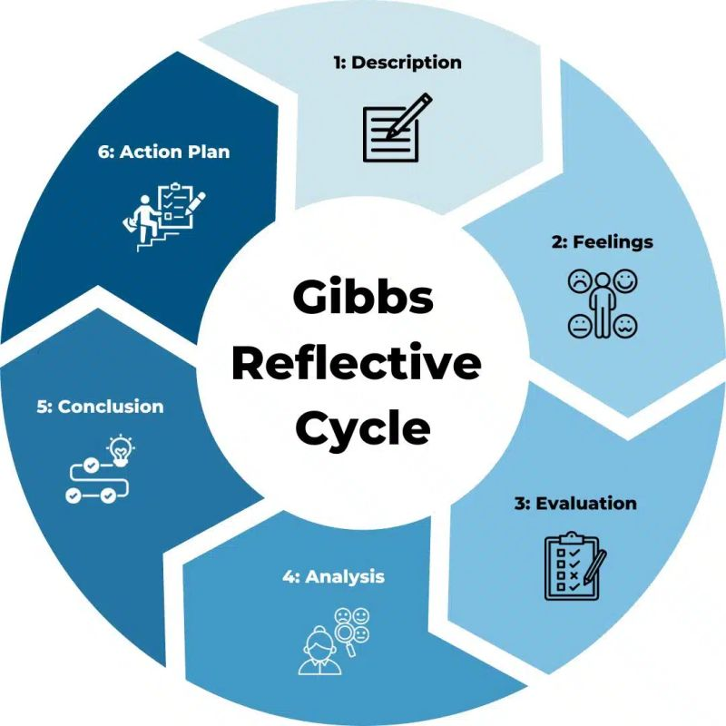
Figure 3: Gibbs Reflective Cycle
Source: (Ahmadpour et al., 2025)

1. Description
It is a reflective report of my experience in conducting research, analysing and writing of the international business report on the FMCG sector in India and Nestle in particular. Various international business models were used in the task including Porters Diamond Model, PESTLE model, CAGE model, OLI paradigm and the Integration-Responsiveness framework. This was done to assess the competitiveness of the Indian FMCG industry and critically examine the competitive position adopted by Nestle in this industry.
The report was done by conducting a thorough secondary research using journals, reports and trusted online sources. This included looking at the big picture (industry factors) and how this can be translated into corporate strategy. The report was structured in terms of industry, competitive forces and the company. I tried to demonstrate critical thinking in the assignment of connecting theory and practice (such as analyzing the localisation strategy of Nestle and its reaction to the regulatory concerns in the Indian market).

2. Feelings
At the onset, I would have to admit that my decision to select the FMCG industry and India to do my assignment was based on the fact that both are vital in the global business environment. However, when I started doing it, I was a bit lost and nervous in an attempt to include the various models and theories in the analysis. Whereas I had been exposed to such models as PESTLE and Porters Diamond, it proved harder than I expected to be critical and not descriptive in how I used the models.
On the same note, data collection was somewhat daunting at some point since it consumed quite some time to find pertinent and up-to-date information. I also discovered that sometimes it was difficult to connect the theories with real life examples. However, I also developed confidence when I developed a more accurate understanding of the relationship between the frameworks. I was pleased to have the opportunity to do a more structured and analytical nature assignment and one that satisfies the requirements of a postgraduate-level assignment.

3. Evaluation
Generally, this assignment was a good experience because it helped me to sharpen my academic and analytical skills. One of the most powerful aspects of my work was the manner in which it was done and that enabled the examination of a clear and coherent structure. Application of a variety of frameworks enabled me to examine the FMCG industry and the approach of Nestle in detail. Besides this, the application of case studies, including the Maggi case, led to the enhancement of the applicability of the report.
Nevertheless, there were certain aspects to be improved. My analysis was not critical at all, which was sometimes descriptive and constrained the scope of the analysis. I also had trouble combining information of different sources and summarizing it. There was also inadequate time management on my part as I had underestimated the amount of time necessary to spend on research and analysis. Despite having done the assignment, there are aspects that can be enhanced.

4. Analysis
The assignment has enhanced my understanding of the dynamics of international business and the application of theories to practice. One of the lessons learnt was through the use of Porters Diamond Model. This model helped me understand that the national competitiveness will be influenced by a number of interacting factors which include factor conditions, demand conditions and rivalry. This has taught me to view the interplay of these factors in determining competitiveness in the industry not individually. As an example, the demand conditions in India are favorable to innovation and competition is favorable to efficiency.
My awareness of the business environment was also increased with the help of the PESTLE model. It stressed the interaction of politics, economics, society, technology, law, and the environment and their impact on business. In particular, the analysis of the Maggi scandal provided the clues on the significance of legal and regulatory risks. It demonstrated that neglecting regulations of the region can negatively affect the reputation, even in relation to a global brand. This indicated the dangers and regulatory challenges of international business. To sum up, this was done to highlight the fact that the global business world is more complicated. It highlighted the importance of taking multiple points of view to have a better view of different market and strategic choices. Such analysis is essential in making a decision in a global business setting.

5. Conclusion
In conclusion, I have found this assignment enriching and I have learned more about the concepts of international business and enhanced my analytical skills. I have learned to apply theoretical knowledge to real-life scenarios and evaluate business strategies. It also gave an understanding of the necessity to take into consideration different perspectives in analyzing the business environments. I will also work on improving my writing ability in various academic assignments by making my assignments clear, coherent and consistent. I will also ask lecturers and classmates to provide feedback on my writing to further enhance my writing. Finally, I will also work to improve my understanding of concepts about international business and its application as it will be relevant in my academic and professional development. However, it also brought to light the necessity of working on it in terms of a consistent critical analysis and time management. Despite being able to do a good analysis, I know I still have more to practice to ensure that I do a high-quality critical analysis regularly.

6. Action Plan
When carrying out future tasks, I will consider several actions to improve my work. To begin with, I will commence my research earlier in order to have more time analysing and critically assessing them. This will provide me with extra time to study and analyse my topic in detail. Secondly, I will further develop my critical thinking abilities by reading more widely in the academic literature and understanding how to critically evaluate the arguments, as opposed to merely paraphrasing them. The assignment has enhanced my professionalism in analysing international markets and business decision making. Critical thinking, research and analysis in learning can be used in multinational companies. This will assist me in future to make wise decisions in international business in a demanding environment.

References
Aguinis, H., Bergh, D. and Molina-Azorin, J.F., 2023. Methodological challenges and insights for future international business research. Journal of International Business Studies, 54(2), pp.219-232.
Ahmadpour, N., Shariati, A. and Moghadam, M.P., 2025. Effect of narrative writing based on Gibbs’ reflective model on the empathy and communication skills of nursing students. BMC Medical Education, 25(1), p.10.
Aneeis Hashim, S.N., Yaacob, A., Suryani, I., Mohd Asraf, R., Bahador, Z. and Supian, N., 2023. Exploring the Use of Gibbs’ Reflective Model in enhancing in-Service ESL teachers’ reflective writing. Arab World English Journal (AWEJ) Volume 14.
Benito, G.R. and Meyer, K.E., 2024. Industrial policy, green challenges, and international business. Journal of International Business Studies, 55(9), pp.1093-1107.
Binti Tsuraya, H., Endayani, L., Zahda, F.M., Utami, I.S. and Jayadi, U., 2023. Unilever Company Work Model. International Journal of Economics, Management and Accounting (IJEMA), 1(1), pp.7-14.
Budiharso, T., 2022. Porter’s Five Forces: Evaluating education management practices in the postgraduate program of UIN RM Said Surakarta, Indonesia. Journal of Social Studies Education Research, 13(1), pp.164-192.
Dalirazar, S. and Sabzi, Z., 2023. Strategic analysis of barriers and solutions to the development of sustainable buildings using the PESTLE technique. International Journal of Construction Management, 23(1), pp.167-181.
Dias, S., Espadinha-Cruz, P. and Matos, F., 2023. A Porter's five forces model proposal for additive manufacturing technology: A case study in Portuguese industry. Procedia Computer Science, 217, pp.165-176.
Eierle, B., Hartlieb, S., Hay, D.C., Niemi, L. and Ojala, H., 2022. External factors and the pricing of audit services: A systematic review of the archival literature using a PESTLE analysis. Auditing: A Journal of Practice & Theory, 41(3), pp.95-119.
Fernandes, D.L. and Shailashree, V., 2022. Rural Marketing and Product Promotion: An Analysis of the Project Shakthi by Hindustan Unilever Limited. International Journal of Case Studies in Business, IT, and Education (IJCSBE), ISSN, pp.2581-6942.
Ghial, R., Pundir, D., Kaur, R. and Jawanda, K., 2025. An Analytical Overview of Sustainable Strategies of Hindustan Unilever. ICT Systems and Sustainability: Proceedings of ICT4SD 2024, Volume 1, 1159, p.187.
Hanifayev, F., 2023. Strategic analysis of an industry's macroenvironment based on the Spanish Tourism industry in the years 2020-2022.
Hassani Nia, N., Karami, S., Shahraki, F. and Kohan, M., 2026. Structured reflective sessions enhance knowledge and clinical skills in operating room technology students: a Solomon four-group study. BMC Medical Education, 26(1), p.121.
Meyer, K.E., Fang, T., Panibratov, A.Y., Peng, M.W. and Gaur, A., 2023. International business under sanctions. Journal of World Business, 58(2), p.101426.
Meyer, K.E., Li, J. and Brouthers, K.D., 2023. International business in the digital age: Global strategies in a world of national institutions. Journal of International Business Studies, 54(4), p.577.
Ndzabukelwako, Z., Mereko, O., Sambo, T. and Thango, B., 2024. The impact of Porter's five forces model on SMEs ' performance: A systematic review. Available at SSRN 4999059.
Nurlatifah, L., Purnawarman, P. and Sukyadi, D., 2023, December. The implementation of reflective assessment using Gibbs’ reflective cycle in assessing students’ writing skills. In AIP Conference Proceedings (Vol. 2621, No. 1, p. 070006). AIP Publishing LLC.
Pangarkar, N. and Prabhudesai, R., 2024. Using Porter's Five Forces analysis to drive strategy. Global Business and Organisational Excellence, 43(5), pp.24-34.
Saha, K.B., Ahmed, I., Rabbi, A.M.F. and Hasan, M., 2024. Evaluation of Business Models of the East India Company and Unilever Bangladesh Limited: A Comparative Study.
Sałek, R., 2024. PEST macro-environment impact analysis as a strategic management tool for a weigh-in-motion system implementation. Polish Journal of Management Studies, 30(2), p.244.
Turner, C., 2024. International business: Themes and issues in the modern global economy. Routledge.
Williams, T., Kallas, E., Garcia, E., Fitzroy, A. and Sithole, P., 2024. International business expansion strategies: A data-driven approach with IBM SPSS. APTISI Transactions on Management, 8(2), pp.131-138.
Yu, H., Bansal, P. and Arjalies, D.L., 2022. International business is contributing to environmental crises. Forthcoming in the Journal of International Business Studies.

