ACDB6020 – Materials Chemistry & Ageing of Polymer Bonded Explosives Presentation and Reflection

Samuel Hawkins¹

¹ UWTSD IQ Campus, Waterfront, IQ Campus University of Wales Trinity, Swansea SA1 8EW, UK; 2216506@student.uwtsd.ac.uk

Contents
1. Abstract 1
2. Introduction 2
3. Supporting Technical Explanation and Relevance to OME 2
4. Conclusion 8
References 9
Annex A - Presentation 10
Annex B – Presentation Highlights 10

Table of Figures
Figure 1 - Amorphous and Crystalline Morphology [1] 3
Figure 2 - Thermoplastic Elastomers [2] 3
Figure 3 - Glass Transition [3] 4
Figure 4 - Modified Glass Transition Temperature [4] 5
Figure 5 - PGN [8] 6
Figure 6 - Aza-Michael Reaction [9] 6
Figure 7 - Degradation Pathways [12] 7

Abstract

This reflection captures the individual’s contribution to a presentation delivering a comprehensive run through of key topics that are fundamental to Polymer Bonded Explosives (PBX). Focusing on polymers and how they are designed to create binders which are incorporated into energetic fills whilst resisting degradation through life is critical to ensuring safety, reliability and performance.

Introduction

  - The purpose of this reflection is to capture the individual’s contribution to a presentation on the “Materials Chemistry and Ageing of Polymer Bonded Explosives.”

  - This covered the background chemistry of the formation and utilisation of polymers and how they can be used to create useful binders and additives that contribute to the safety, stability and performance of Polymer Bonded Explosives (PBX). The importance of demonstrating these attributes have been woven throughout the presentation delving into the physical and chemical properties as well as degradation mechanisms that impact how they function. This has then related to crystallography of the energetic fill painting a holistic view of PBX.

  - The main tasks are:

    - Work with fellow presenters to understand the overarching topics of PBX and determine who will be responsible for which area.
    - Research and understand materials chemistry that make up polymers in PBXs.
    - Use experience from professional career to relate the chemistry and its importance to safety, stability and performance. Highlighting factors that can be affected and its result.
    - Summarise and present this information in enough depth relevant to the audience being presented to within the timeframe allotted.
    - Reflect on the presentation, capturing key concepts, technical explanation, references and relevance to OME.

  - For this presenter’s presentation the focus is on polymers, the key topics covered by this presenter are delivered slides 1 – 20 and slides 36 – 45. Key concepts from the presentation will be expanded upon below. Instead of reiterating all information please see the presentation, Annex A. For a complete list with brief explanations of each slide, see Annex B.

Supporting Technical Explanation and Relevance to OME

  - PBXs are a composite material composed primarily of a crystalline energetic providing the explosive energy that is embedded within a polymer matrix generally around 5-20% weight improving safety and reliability.

  - A polymer is a chain of repeating monomers used to create larger molecules that can be organic or synthetic. To create polymers, the two fundamental methods are step growth (condensation) and chain growth (addition) polymerisation. See Annex A.

  - These polymers go on to form linear, branched, networked and cross-linked structures, and the morphology are fundamental in determining polymer properties. Linear chains can pack tightly thus having lower enthalpy, promoting crystallinity. Whereas branched hinders close packing leading to more free volume and higher enthalpy, creating amorphous regions. As such, crystalline polymers have a structured order giving it high mechanical strength and thermal stability creating thermosetting plastics. Amorphous has no regular structure making it less rigid and flexible creating thermoplastics. However, semi-crystalline is the best of both. See figure 1.

  - In addition, cross-linked polymers are chemically bonded together, forming a strong, three-dimensional network that also resist oxidative chain scission. This stores more internal elastic energy and restricts motion having higher enthalpy compared to linear. Crosslinking even raises glass transition temperature as the system requires more enthalpy to mobilise segments.

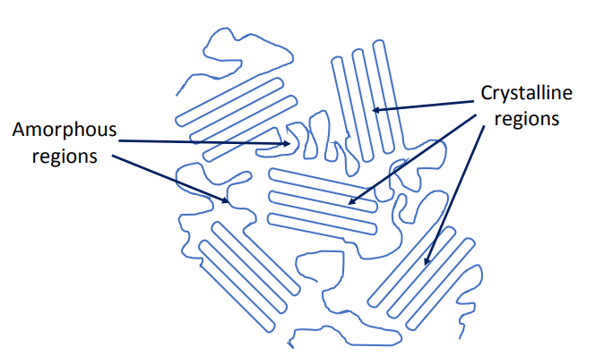
Figure 1 - Amorphous and Crystalline Morphology [1]
  - Now if these amorphous and crystalline regions were to be used together, this creates thermoplastic elastomers that incorporates dual-phase morphologies. These are polymers that are elastic at room temperature. Have two regions, soft block (elastomeric portion) and the hard block (thermoplastic portion). Utilise physical crosslinks and not covalent bonds which allows to be remoulded, reshaped and reused. See figure 2.

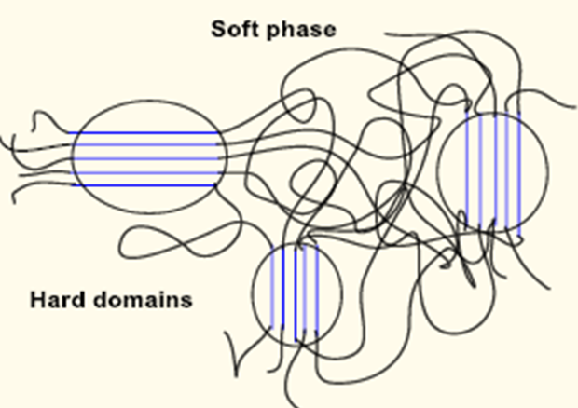
Figure 2 - Thermoplastic Elastomers [2]
  - As per the presentation, temperature and its effect on the glass transition temperature has a profound effect on the state of the polymer and subsequently its properties. The rubbery state is ideal as the polymer binder still retains it structural rigidity and mechanical strengths whilst being flexible to resist shocks and impacts. See figure 3.

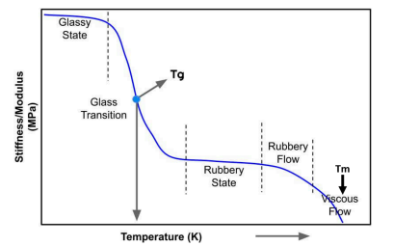
Figure 3 - Glass Transition [3]
  - Polymer binders exhibit phase transition as part of glass transition temperature (T_{g}). T_{g} is extremely relevant to OME as it directly determines the PBXs sensitivity to shock, vibration or impact from external stimuli. It can be seen that if a polymer binder is operating below its T_{g} then it can become glassy making more sensitive to stimuli requiring less activation energy as the polymer chains have limited molecular mobility and so cannot disperse the energy that can lead to friction and or hot spot generation leading to unintended initiation. This poses as significant safety risk.

  - If the binder is above its T_{g} at the ideal rubbery state it becomes soft but maintains structural integrity making it less sensitive to stimuli requiring more activation energy allowing molecular mobility to absorb energy.

  - However, binders need to be designed in such a way that it remains in its rubbery state for the intended service environment and typical temperatures it will be subjected to so that the right balance of safety and sensitivity thus performance is achieved to as if temperatures were to reach extremes the binder could too viscous leading to exudation (binder migration) posing other safety related issues.

  - A study on curing kinetics found that the T_{g} of polyurethane elastomers reflect its thermal stability and degradation properties. The T_{g} is related to the cross-linking density and structure of the elastomer. This shows that with the right modifications by introducing an epoxy group the T_{g} was increased by 5 °C, and the thermal stability also improved. See figure 4. [4]

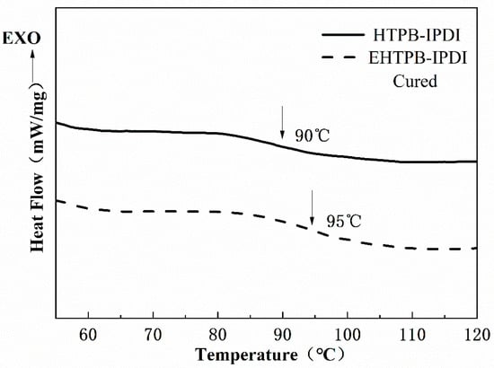
Figure 4 - Modified Glass Transition Temperature [4]
  - To provide greater capabilities and characteristics to the binder, certain additives can be combined. [5] For example:

    - Plasticizer – small chain polymers used to improve flexibility and reduce brittleness. For example, thermoplastic polyurethane (TPU) [6]
    - Bonding Agents - chemically link the binder to the energetic so that micro-voids or gaps are less likely to form.
    - Stabilizers – Extends shelf life by inhibiting decomposition and slows down autocatalytic breakdown of nitro compounds.
    - Curing Agents – Hardens the polymer binder into a durable cross-linked network. Giving greater dimensional stability and resist deformation under stress.
    - Antioxidants – Further extends life by protecting the binder from oxygen attack, UV exposure, or thermal stress.

  - These are extremely useful in OME as it modifies the binder into the most desirable product to optimise safety, reliability and performance throughout its lifecycle.

  - One of the drawbacks from using inert binders like HTPB [7] is that they improve safety with the trade-off for reduced overall performance. However, this can be mitigated by introducing energetic binders. One example is Poly Glycidyl Nitrate (PGN) which contains a nitrate group. This provides a higher density and oxygen balance providing higher heats of formation when they decompose increasing performance. Nitrate ester highlighted red in figure 5. [8]

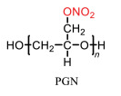
Figure 5 - PGN [8]
  - To take this a step further, nontoxic method for creating energetic binders can be done through Aza-Michael reactions. This is done by using PGN as a Michael acceptor where the (-OH) are esterified, making acryloyoxy-terminated PGN (ATPGN). This is then mixed with an Aza-Michael donor – multifunctional amine where nucleophilic attack occurs as the amine attacks the 𝛽-carbon of the acrylate group on the polymer chain. This creates a 𝛽-amino carbonyl linkage creating a 3d crosslinked network as well as a performing energetic binder that mitigates the drawbacks from using inert binders. [9]

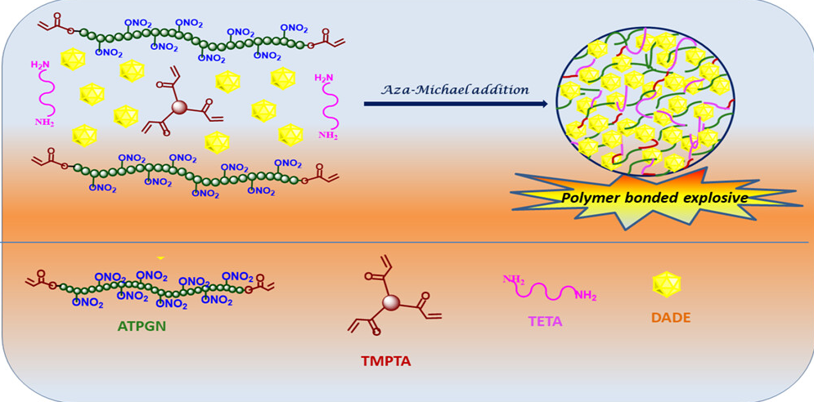
Figure 6 - Aza-Michael Reaction [9]
  - To support aspects of what has been covered, heats of detonation can be used to calculate energy available to do mechanical work. This can be determined by knowing the enthalpies of formation of the reactants used to make up the PBX. [10]

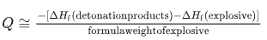

  - Further to this, oxygen balance refers to the oxygen required for the complete combustion of all products involved in the detonation. Sometimes there is a need for the use of the modified KW rules instead of the regular. If there is a negative balance, poor products like CO and NO are produced. If there is a positive balance, then complete combustion occurs and less harmful products are created like CO₂ and NO₂. [11]

$$Ω=\frac{d-2a-\frac{b}{2}}{MW}×1600$$

  - Munitions will spend the majority of its lifecycle in storage whilst being subjected to various conditions and environments. As such it is important to understand what degradation mechanisms exist and how that can alter PBXs properties in relation to safety, performance and reliability.

  - A study of Irganox 1010 used in PBX 9501 found that hydrolysis, scission and oxidation led to decomposition products resulting in cleavage of ester groups while oxidation occurred in multiple locations. This results in less antioxidants, so oxidation occurs faster accelerating the formation of acids that produces reactive species that attacks the binder leading to more degradation. This causes the binder to lose it critical properties increasing brittleness and cracking, change in density and porosity and potential exudation of plasticiser. [12] [13]

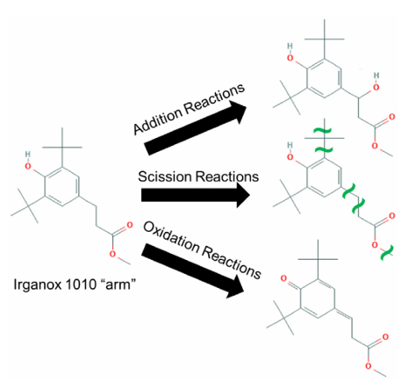
Figure 7 - Degradation Pathways [12]

  - However, experience has shown that through effective design of munition whilst under ideal storage conditions through climatic control, certain munitions will remain safe and serviceable. Suitable inspection processes and testing have enabled nations to extend shelf life of munitions far beyond their intended service life but with the risk of failure to function when required. There is also great importance to ensure chemical compatibility to ensure that there are no adverse reactions that could lead to poor outcomes.

  - A useful formula to understand the rate of degradation (chemical reaction) in relation to temperature is the Arrhenius equation. As such it can be used to determine how the rate of degradation increases as temperature increases. This is the basis for artificial ageing to allow us to know what the condition of an explosive will be like in 25 years after being heated at 60 °C for periods up to 25 weeks. [14]
$$k=Aⅇ^{-\frac{E_{A}}{RT}}$$
k = rate constant
A = pre-exponential factor
Ea = activation energy
R = universal gas constant
T = absolute temperature (in Kelvin)

Conclusion

  - In conclusion, the presentation and subsequent reflection have highlighted the critical role of polymer chemistry in the design and ageing of Polymer Bonded Explosives (PBXs) through life.

  - Through understanding polymer structure, morphology and glass transition temperatures. The design of these binders through suitable selection and modification is essential to underpinning safety, reliability and performance.

  - Also, rate of degradation and possible mechanisms have been looked at to understand how PBX breakdown but under ideal storage conditions and correct processes, the effects of ageing can be mitigated.

  - In addition, it is crucial to strike the right balance of additives and use of energetic binders to ensure compliance with insensitive munition requirements whilst maintaining operational effectiveness. Doing this meets OME regulations.

References

[1] | A. M. Booth, S. Kubowicz, C. Beegle-Krause, J. Skancke, T. Nordam, E. Landsem, M. Throne-Holst and S. Jahren, “Microplastic in global and Norwegian marine environments: Distributions, degradation mechanisms and transport,” Sintef, Trondhiem, 2017.
[2] | D. L. Dossi, “Manufacture and Material Properties of Explosives (MMPE),” Centre for Defence Engineering and Physical Science, 2025.
[3] | H. M. Yehia, A. Hamada, T. A. Sabaey and W. Abd-Elaziem, “Selective Laser Sintering of polymers: Process parameters, machine learning approaches, and Future Directions,” Journal of Manufacturing and Materials Processing, vol. 8, no. 5, p. 197, 2024.
[4] | X. Zhang, Y. Liu, T. Chai, Z. Ma and K. Jia, “Curing reaction kinetics of the EHTPB-based PBX binder system and its mechanical properties,” Coatings, vol. 10, no. 12, p. 1266, 2020.
[5] | D. Merran A., “Polyurethane Binder Systems for Polymer Bonded Explosives,” Defence Science and Technology Organisation, Edinburgh South Australia, 2006.
[6] | C. C. K. L. X. W. Z. C. J. W. K. L. X. C. Y. B. Y. L. Y. N. H. N. Guancheng Shen, “The polyurethane elastomer-based PBX with excellent cyclic manufacturing performance,” FirePhysChem, 2025.
[7] | A. Provatas, “Formulation and Performance Studies of Polymer Bonded Explosives (PBX) Containing Energetic Binder Systems,” DSTO Systems Sciences Laboratory, Edinburgh, 2003.
[8] | J. Dou, M. Xu, B. Tan, X. Lu, M. Hongchang, B. Wang and N. Liu, “Research progress of nitrate ester binders,” FirePhysChem, vol. 3, no. 1, pp. 54-77, 2023.
[9] | G. Sheela, V. K. Periya, S. Gopalakrishnan and R. Sasidharakurup, “Energetic nitrate-based polymer-bonded explosives derived from sustainable aza-Michael reactions,” ACS Omega, vol. 9, no. 20, pp. 22065-22073, 2024.
[10] | M. H. Keshavarz, “Simple procedure for determining heats of detonation,” Thermochimica Acta, vol. 428, no. 1-2, pp. 95-99, 2005.
[11] | I. Sochet, D. Gardebas, S. Calderara, Y. Marchal and B. Longuet, “Blast wave parameters for spherical explosives detonation in Free Air,” Open Journal of Safety Science and Technology, vol. 1, no. 2, pp. 31-42, 2011.
[12] | C. E. Freye, “Decomposition of irganox 1010 in plastic bonded explosives,” Journal of Applied Polymer Science, vol. 139, no. 30, 2022.
[13] | chemicalbook, “What is the degradation of antioxidant 1010?,” chemicalbook, [Online]. Available: https://www.chemicalbook.com/article/what-is-the-degradation-of-antioxidant-1010.html. [Accessed 12 January 2026].
[14] | E. Kirchhof, R. J. Rocha, N. M. Nakamura, C. M. Lapa, G. F. Pinheiro, R. F. Gonçalves, J. A. Rocco and K. Iha, “Estimate of PBX (plastic-bonded explosive) shelf life with accelerated aging,” Química Nova, vol. 39, pp. 661-668, 2016.
[15] | C. Decker, “Photoinitiated crosslinking polymerisation,” Progress in Polymer Science, vol. 21, no. 4, pp. 593-650, 1996.
[16] | B. Tan, J. Dou, Y. Wen, B. Duan, H. Mo, Z. Wei, J. Zhang, Y. Pan, X. Ding and N. Liu, “3D printing for Explosives and propellants applications,” Additive Manufacturing Frontiers, vol. 3, no. 3, p. 200151, 2024.
[17] | M. Hoffman, T. W. Hawkins, G. A. Lindsay, R. B. Wardle and G. E. Manser, “Clean, Agile Alternative Binders, Additives and Plasticizers for Propellant and Explosive Formulations,” in Life Cycles of Energetic Materials Meeting, Del Mar, CA, 1994.
[18] | J. Bogdanov, R. Jeremić, Z. Bajić, R. Dimitrijević and Z. Veličković, “Calculations of detonation parameters for high explosives using different methods,” The International Conference on Chemical and Environmental Engineering, vol. 6, no. 6, pp. 1-7, 2012.
[19] | W. A. TRZCIŃSKI and S. Grys, “Calculation of Combustion, Explosion and Detonation Characteristics of Energetic Materials,” Central European Journal of Energetic Materials, vol. 7, no. 2, pp. 97-113, 2010.
[20] | R. Zito, “Accelerated Age Testing of Explosives and Propellants,” Mathematical Foundations of System Safety Engineering, pp. 237-255, 2020.

Annex A - Presentation

Annex B – Presentation Highlights

- What is a PBX? – Provided the history, JSP 333 definition, typical formualtion.
- Why are they important? – Establishing relevance to OME by identfiying key UK standards and policies specified by the Ministry of Defence (MoD) and enforced by the Defence Ordnance Safety Regulator (DOSR) like DSA 03 OME DCOP 112 and STANAG 4439 which ensures that munitions are designed to ensure risks are As Low As Reasonably Practicable (ALARP) which is achieved through PBXs.
- What are polymeric binders? – Overview of binder purpose and utility.
- How are polymers formed? – Explained the mechanisms and used animations to show step and chain growth.
- Polymer structures – Specified linear and branched structures and how these form thermoplastic as they are flexible and able to be reshaped when heated due to weak bonds. Specified cross-linked and networked used in thermosetting and cant be reshaped due to strong covalent bonds.
- Polymer morphology – Crystalline, Amorphous and Semi-Crystalline polymers
- Thermoplastic Elastomers – Duel phase morphology incorperating soft and hard regions seen in thermoplastic and thermosetting.
- Glass Transition Temperature – Specified region where material changes from glass and rubber state. Related to thermoplastic elastomers and its properties.
- Types of additives – Specified a range of useful additives that augments polymer binders to provide greater capability and longevity. Showed off energetic plasticiser.
- Examples of polymeric binders – Showed chemical reaction forming polyurethane and Poly Glycidyl Nitrate as an energetic binders and how it gains additional energy from its nitrate group leading to higher energy density and oxygen balance leading to higher heats of detonation when decomposing increasing performance.
- Interplay between binder and energetic – Forms a continuous matrix surrounding the binder and provides additional properties improving resistance to mechanical and physical degradation.
- Using binders in munitions – Summerising topics covered and how the formulation of PBX provides MoD with ability to demonstrate compliance against IM policy.
- Polymer effect on safety – Explained how Thermoplastic elastomers provide best properties to energetic and how it related to glass transition temperature.
- Polymer effect on stabiltity – Explained benefits of polymers in protecting energetic throughlife and how additives provide further capability and longevity.
- Polymer effect on performance – How energetic binders improved performance to see higher velcity of detonation and pressure whilst maintaining IM status.
- Balancing act – Importance of formulating the munition correctly, can be too sensitive or insensitive and need to ensure chemical compatability.
- Ageing mechanisms – covering mechanisms from manufacture through its service life.
- Lifecycle implications – How environmental factors lead to chemical and physical degradation that leads to munitinon no longer being safe or reliable.
- Miniming the effect of ageing – Correct storage environment (climate control) deisgn the munitions for its intended service eviornment and use suitable monitoring.
- Monitoring – Live firings, Breakdown Test and Criticality Analysis. Artificial Ageing.
- Ageing example – Used an example from industry, Rowanex 1400.

Photoinitiated Crosslinking Polymerisation is another method that uses UV rays to turn multifunctional monomers into crosslinked polymer by chain reaction by radical or ions. This can be seen in a wide range of application, for example resin 3D printing. [15] 3D printing via vat polymerisation is being investigated for making explosives. [16]
However, it has been seen that the degree of crystallinity in the binder can change due to aging as well as thermal cycling and degradation. An increase in crystallinity will lead to the PBX becoming harder and more brittle, degrading its mechanical properties and increase sensitivity.
Unfortunately, PBXs suffer from similar issues common with other explosives that they produce waste and pollution as part of their lifecycle from manufacture, to use and disposal. However, there have been studies that suggest cleaner alternative components and formulations that come from using thermoplastic elastomers that have been discussed above. [17]
There are a number of computer programs like Delphy 6.0 and EXPLO5 that require the correct selection of equations of state that have been developed with the sole purpose to calculate detonation parameters. This reduces the burden of having to use heats of detonation. [18] [19]
Further studies do support the Arrhenius equation for short term accelerated ageing, however it has its limitations as modern energetics are complex formulation each with their own pre-exponential factor and activation energy that the equation does not compute. [20]

