Student Name: Lowri Bowen
P Number: 2401013
Programme of Study: Graphic Design
Module: ADDA4022 Ways of Thinking

Tasks in the order I received them:
Task One: Semiotic Analysis = 565
Task Two: Manifesto = 565
Task Three: Practice-based writing = 561

For this assessment, I confirm that I have not used Generative AI to support me in structuring my submission, including creating a draft argument structure, identifying parts and headings. I confirm that I have not used Generative AI to create text for my submission. I confirm that I have not used Generative AI for creative materials, such as images.

Task One: Semiotic Analysis
Semiotics can be described as ‘a way of looking at the production of meaning from a particular critical perspective.’ (Chandler, 2022, pg. 17) but also, as Paddy Whannel joked, “semiotics tells us things we already know in a language we will never understand” (Allen and Seiter, 1992, pg. 31). Semiotics takes something we believe we understand and deconstructs it leaving us wiser but more inquisitive. Using some theories I’ve researched, ranging from Roland Barthes, Ferdinand de Saussure and Charles Sanders Pierce I will de-code this poster.
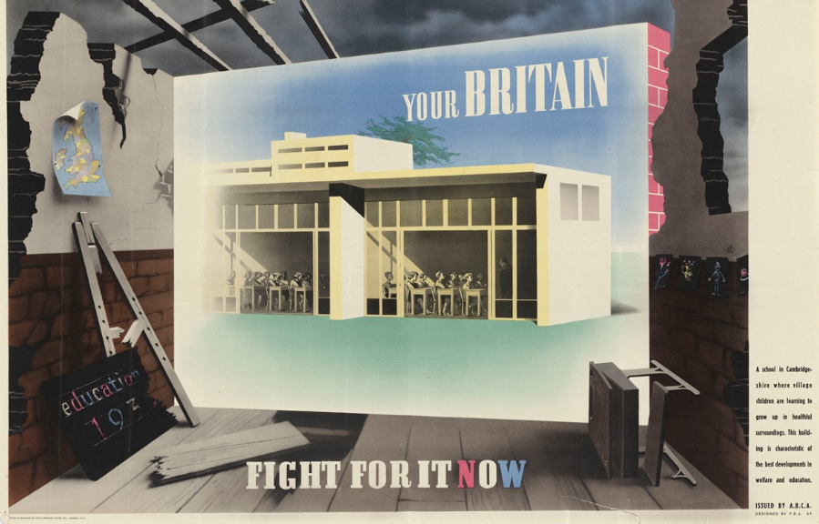
Fig 1, (Abram Games, 1942, ‘Your Britain Fight For it Now’ Poster)
This Abram Games poster is from his 1942 series ‘Your Britain Fight for it Now’ presenting buildings ‘based on structures that epitomised the emergence of modern architecture in Britain’ (Games, Moriarty and Rose, 2003, pg. 65). The poster depicts the ruins of an old school surrounding an advertisement of a modern one. The old decrepit remains represent the ruin after WWII and are presented as a symbol of ‘a fresh start made towards a bright optimistic future’ (Games, Moriarty and Rose, 2003, pg. 67) rather than a symbol of what’s lost. The advertisement serves as a blueprint and icon depicting what good could follow the devastation based on ‘the modern Impington Village College,’ ‘1939’ (National Army Museum Website, nd). By surrounding it with the indexical sign of the debris, signifying it’s an old school, it highlights the damage of war and contrasts with the hope of the advertisement. The new school is light, breathes, and seems a healthier place to develop education and promote growth. It’s almost glowing, conveying heavenly, desirable connotations and presents a hopeful image for the soldiers giving them a reason to fight and the civilians a reason to hope.
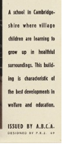
Anchorage text is utilized here to guide our understanding and persuade us. Jakobson believes language is ‘most important among all human semiotic systems’ (Chandler, 2022, pg. 18) which suggests the use of language and written word is an essential way of manipulating the viewer’s interpretation. In the corner of the poster there’s an explanation that guides our own beliefs, telling us that the image connotes health, ‘welfare’ and positive education whereas the image itself shows children seated at tables in a building. The icon shown depends on the myth and paradigm that schools should be a healthy environment centring its development around ensuring the welfare and proper education of students.
The title also serves as anchorage text. The use of ‘Your Britain’ is powerful as it signifies it’s ‘Your Britain’ and therefore ‘Your’ responsibility to fight for it, hope for it and make the change. The following impact of ‘Fight for it now’ says it’s something worth fighting for in the first place and has an air of command and necessity. This impact is elevated by the urgency of ‘now’. The soldiers need to ‘fight for it now’ to ensure hope for ‘your britain’ to be as great as shown in the advertisement.
Before deconstructing even these minor elements of a larger image I hadn’t considered its depth, viewing it simply as a form of propaganda or an advertisement, which is true to an extent. After deconstructing parts of the poster, I’m now aware that it is designed to inspire hope and also remind people not of the war but of the things worth fighting for and the good that may come from it.
Bibliography:
Allen, R. (1992) Channels of discourse, reassembled: television and contemporary criticism. 2nd edn. North Carolina: The University of North Carolina Press.
Barthes, R. (2009) Mythologies. Revised edn. New York: Vintage.
Berger, J. (1990) Ways of seeing. London: Penguin.
Chandler, D. (2022) Semiotics : the basics. 4th edn. London: Routledge
Games, N. Moriarty, C. and Rose, J. (2003) Abram Games: graphic designer: maximum meaning, minimum means. Hampshire: Lund Humphries.
Mullen, M. (1994) ‘Velvet light trap’, Review of Channels of discourse, reassembled, by Robert C. Allen, Available at: https://link.gale.com/apps/doc/A90190418/AONE?u=anon~5559d8e6&sid=googleScholar&xid=9e4376cd (Accessed: 18 November 2024).
National Army Museum. nd. Abram Games, ABCA and the fight for post-war change. Available at: Abram Games, ABCA and the fight for post-war change | National Army Museum (Accessed: 18 November 2024)

List of Figures:
Figure 1 : Games, A. (1942) Your Britain, fight for it now poster. Available at: https://artvee.com/dl/your-britain-fight-for-it-now-2/ (Accessed: 5 December

Task Two: Manifesto
- Always persevere and follow the career of your dreams.
- Design with empathy.
- Try everything at least once.
- Don’t fear adventure.
- Challenge yourself, go outside of your comfort zone.
- Treat others with kindness.
- Be authentic.
- Work hard and you will achieve your goals.
1. Always persevere and follow the career of your dreams.
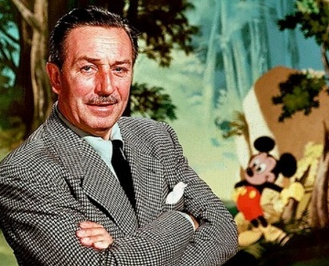
Fig 1, (Albelda, J. 2012, Photo of Walt Disney)
Creative careers are taken less seriously, ‘compared to other professionals’ ‘the professional status of graphic designers is relatively lower’ (Chiang, Idris and Chuen, 2019, pg.1). Many are dissuaded from creative careers due to the myth it’s unstable and results in unemployment. The stigma around creative fields should be abolished. People should be encouraged to believe in themselves and work hard to bring their dreams to life. Through hard work you can build your career and the happier you are the more likely you will create better work, ‘employees are far more likely to have new ideas on days when they feel happier’ (Amabile and Kramer, 2011, pg.1). I included Walt Disney as proof that hard work and perseverance leads to the career of your dreams. He ‘launched several unsuccessful animation companies’ before Mickey Mouse In 1928 (Inc., 2015). People should be encouraged to persevere and follow their dreams, creative or otherwise as It’s easier to improve and have a fulfilling life when we’re happy and engaging in things that bring us joy. ‘The notion of the starving artist needs amending’ (Cherbo et al., 2008) and the idea that artistic careers are dead-end or unrealistic should be left in the past.
2. Design with empathy.
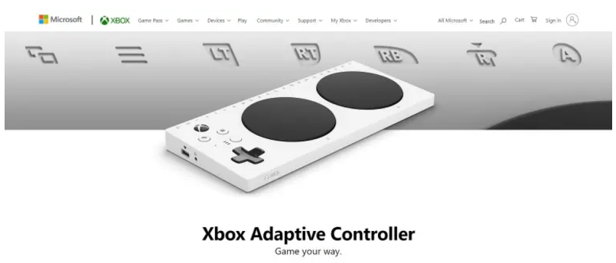
Fig 2, (Xbox, 2018, Xbox Adaptive Controller)
Good Design connects with people. To connect to your audience or client you have to put yourself into their shoes and be open and able to design with empathy. As Anthony Burrill states in ‘Work Hard & Be Nice to People’ (2020), you need to ‘Understand Yourself’ but also ‘Understand Everyone’. When designing you should ‘understand yourself’ to understand your style, who you design for and why you design. However, it is even more crucial as a designer to ‘understand everyone’ else as they are the people you design for, and if your designs don’t resonate or connect with them, then they won’t stand out or make as much of a difference. This controller makes gaming accessible for those with mobility issues and Xbox wouldn’t have thought to design it without a little empathy. Empathy changes lives.
5. Challenge yourself, go outside of your comfort zone
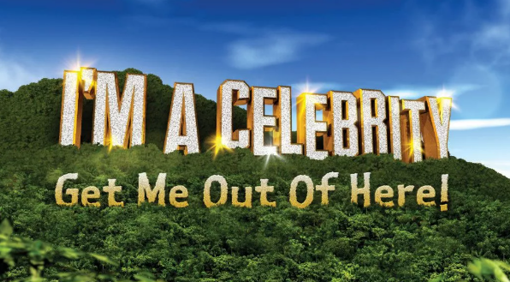
Fig 3, (Mirror, 2023, I’m a celebrity, get me out of here!)
“We must do everything to see what others are blind to” (Dru, 2010, pg.79). For designs to connect to people, designers must challenge themselves to experience things so that it’s possible to truly understand the design’s topic. I picked an image of the ITV ‘I’m a celebrity’ show (2023) because watching it, I believe the ones who put their all into it, get the most rewarding outcome. This manifesto statement also applies to the designing process itself, ‘originality comes out of combining influences and experiences in a new and interesting way’ (Burrill, 2020, pg.20). This statement highlights that, challenging and exposing ourselves to different ways of designing makes us original. Failure is irrelevant, ‘getting things wrong is key to the creative process’ (Burrill, 2020, pg.16) and we never know what we’ll find on the way. While an idea may fall through, it’s possible that there’ll be aspects that we love and can use as we begin a new idea and continue the process. Only then are we left with a design that is creative, unique and original.

Bibliography:
Amabile, T. Kramar, S. (2011) ‘Do happier people work harder’. 3 September. Available at: http://www.brjonesphd.com/uploads/1/6/9/4/16946150/the_science_of_what_motivates_people.pdf (Accessed: 2 December 2024)
Burrill, A. (2020) Work hard & be nice to people. UK: Virgin Books
Cherbo, J. Stewart, R. and Wyszomirski, M (2008) ‘5. About Artists’ Understanding the Arts and Creative Sector in the United States. Ithaca, NY: Rutgers University Press, Available at: https://doi.org/10.36019/9780813545059-007 (Accessed 2 December 2024)
Dru, J. M. (1996) Disruption: Overturning Conventions and Shaking Up the Marketplace. California: Wiley.
Filer, R. K. (1986) ‘The "Starving Artist"--Myth or Reality? Earnings of Artists in the United States’ Journal of Political Economy, 94 (Issue 1) pp. 56-75. Available at: https://www.jstor.org/stable/1831960?seq=3 (Accessed: 2 December 2024)
Inc. (2015) 11 Inspiring People Who Followed Their Passions and Found Amazing Success. Available at: https://www.inc.com/bill-murphy-jr/here-s-how-to-turn-your-passion-into-a-fortune.html (Accessed: 4 December 2024)
Wong, S. C., Idris, M. Z. (2019) ‘Is graphic design being taken seriously as a profession?’, ResearchGate, January. Available at: https://www.researchgate.net/publication/346399180_Is_Graphic_Design_Being_Taken_Seriously_as_a_Profession (Accessed: 2 December 2024)

List of Figures:
Figure 1: Albelda, J. (2012) The man, the myth, the cartoonist/ Walt Disney. Available at: https://www.theworldorbust.com/the-man-the-myth-the-cartoonist/ (Accessed: 5 December 2024)
Figure 2: Xbox (2018) Xbox Adaptive Controller. Available at: https://blog.uxtweak.com/empathic-design/ (Accessed: 5 December 2024)
Figure 3: Mirror (2023) I’m a celebrity, get me out of here! Title Sequence. Available at: https://www.mirror.co.uk/tv/tv-news/itv-im-celebrity-2023-winner-31408497 (Accessed: 5 December 2024)
Task Three: Practice-based Writing
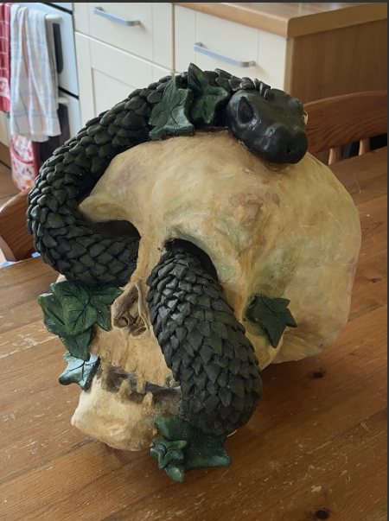
Figure 1: Skull Sculpture (Lowri Bowen, 2022)
Never let the doubts of others supress your creativity. For, GCSE Art, we had to create a pot or sculpture in three months in our two one-hour lessons a week. I asked if I could do a skull with a snake flowing through it and my teacher said no. I thought perhaps it didn’t fit the brief but she said it was because she didn’t believe I could. It was my first time working with clay, but I was determined to create the skull, challenge myself and show the teacher my abilities.
I’m proud of this work having achieved each goal but I’m aware there’s room for improvement. ‘The creative process requires conscious reflective practice as well as the ‘intuitive’ processes of creativity…’ (Candy, 2019, pg.49). Because of this, whilst looking back with pride, I simultaneously critique it, reflecting on ways I’d improve. When finished, I wasn’t impressed. On reflection, considering it was my first time using clay, I believe I did a good job and exceeded others’ expectations. Nevertheless, I’m more aware now of what could be improved. My intention was to bond life and death, showing the world continues to move after we’ve passed. I attempted this with the snake’s movement. I believe it adds a sense of life. Before starting, I had to decide how to best present my idea. The ivy, while seemingly unimportant, conveys time passing and neglect. I decided not to include all the skull’s teeth to add personality and further the idea of time. I also made the decision to have the snake travel through three of the skull’s holes to appear invasive and indifferent to privacy, conveying that after death we’re left to the elements.
New to 3D work, I designed in 2D, distorting the skull depending on the angle. From some the skull looked great, however, some angles are too flat and aren’t cohesive. To keep the top half of the skull from collapsing, I filled the base with newspaper and sculpted the top half separately. I wish I’d had more time to refine the snake’s body, as some areas are thicker than others. It also may have elevated the piece If the scales were more alike, but due to lack of time they were shaped haphazardly.
I’m proud of the colour as originally the skull was a sickly grey green. ‘Colour is considered to have three key attributes: hue, value and saturation.’ (O’Connor, 2021) but what I hadn’t considered is, nothing natural has a singular colour, it’s all a mixture of blended hues. When resolving the problem, I decided to use fingerpainting to add texture and a human quality, pushing a variety of hues together to create a realistic surface. Mixing on the skull allowed for a more realistic colour. I also believe the pale colour of the skull contrasts well with the snake’s dark green.
This project taught me to push myself, never relenting to the misconceptions others have of my ability. The quote, ‘inspiration for creative works are often unspoken and not necessarily obvious at the time but emerge on reﬂection’ (Candy, 2019, pg.48) proves the importance of reflection as it reveals the original intent and helps us critique and understand how it could be altered to better present it. If I had understood my intent better initially, my presentation would’ve improved.
Bibliography:
Candy, L. (2019) The creative reflective practitioner research through making and practice. London: Routledge
Kruk, K. A. Aravich, P. F. Deaver S. P. and DeBeus R. (2014) ‘Comparison of Brain Activity During Drawing and Clay Sculpting: A Preliminary qEEG Study’. Art Therapy, 31 (Issue 2) pp. 52–60. Available at: https://www.tandfonline.com/doi/full/10.1080/07421656.2014.903826?scroll=top&needAccess=true#d1e120 (Accessed: 2 December 2024)
Liu, S. Xu, D. Zhou, S. K. Pauly, O. Grbic, S. Mertelmeier, T. Wicklein, J. Jerebko, A. Cai, W. and Comaniciu, D. (2018) ‘3D Anisotropic Hybrid Network: Transferring Convolutional Features from 2D Images to 3D Anisotropic Volumes’ Medical Image Computing and Computer Assisted Intervention – MICCAI. Online, 26 September. Available at: https://link.springer.com/chapter/10.1007/978-3-030-00934-2_94 (Accessed: 2 December 2024)
O’Connor, Z. (2021) ‘Traditional colour theory: A review’. Colour Research & Application, 46 (Issue 4) article 838-847. Available at: https://onlinelibrary.wiley.com/doi/full/10.1002/col.22609 (Accessed: 2 December 2024)
Stankiewicz, M. A. (2015) ‘Self-expression or Teacher Influence: The Shaw System of Finger-Painting’. Art Education, 37 (Issue 2) pp. 20–26. Available at: https://www.tandfonline.com/doi/pdf/10.1080/00043125.1984.11654154 (Accessed: 2 December 2024)

List of Figures:
Figure one: Skull Sculpture (Lowri Bowen, 2022)

