

Programme: MSc Public Health and Social Care in
Practice

Module: Quality Assurance and Service Improvements

Module Code: LCHS7006

TOPIC: MID STAFFORDSHIRE NHS FOUNDATION TRUST UNITED KINGDOM
Student Name: Keyur Ashvinbhai Patel

Student ID: 2434370

Lecture Name: Dr Fahad Khan

Table of Contents
Introduction 2
Discussion 3
Overview of the systematic failure 3
Analysis using Donabedian Model 3
Applying fishbone diagram 4
SWOT analysis of Mid Staffordshire NHS Foundation Trust 5
Synthesis of the findings 5
Application of PDSA Cycle 5
Kotter’s 8 step change model 6
Recommendations 8
Evaluation of the benchmarking against the standards 8
Conclusion 9
References 11

Introduction
The case of Mid Staffordshire NHS Foundation Trust case is representing one of highly extensive failures in history of the healthcare system of United Kingdom. Between the years of 2005 and 2008, the Mid Staffordshire NHS Foundation Trust recorded the mortality rate significantly huge than national average, comprising of hundreds of preventable deaths being attributed to the systematic neglect, poor leadership as well as the understaffing. The entire crisis exposed the deep-rooted weaknesses in the accountability, governance and the organizational culture in the National Health Service. It has effectively highlighted the consequences of prioritizing the institutional and financial objectives over the proper safety of patients and the quality of care. The entire inquiry been done in the failures of the Mid Staffordshire NHS Foundation Trust became rather catalyst for the extensive reforms in the quality assurance as well as the health governance across entire NHS. The incident not solely revealed the organizational breakdown at local level but also efficiently underscored inadequacy of the national systems of oversight dedicated towards the safeguarding of standards of care.
The overall background to the issue mainly lies in drive of the leadership of achieving the status of foundation trust, that emphasized the financial efficiency instead of welfare of the patients. As per Francis Inquiry (2013), the focus of the management on meeting the bureaucratic targets and the financial aspects led to chronic understaffing as well as employment of the unqualified staff. It led to extensive lapses in fundamental patient care like hygiene, hydration as well as medical response in timely manner. The regulatory bodies involving the healthcare commission as well as Department of Health extensively failed in responding efficiently to the initial warning signs, permitting for the systematic failure to exist. It has been argued by Ilie and Ciocoiu (2010) that culture of Mid Staffordshire NHS Foundation Trust discouraged the staff from reporting the concerns, directing to the loss of complete moral responsibility as well as professional responsibility. As the result, the patients suffered in surrounding where the compassion has been replaced by the institutional indifference.
The focus of the report is towards critically evaluating all root causes behind failures of Mid Staffordshire NHS Foundation Trust utilising proper evidence backed models of quality improvement. The frameworks like Donabedian Model, Fishbone Diagram as well as the SWOT analysis would be employed for analysing the systematic weaknesses which contributed towards poor outcomes. The report would properly explore how the models could be applied for strengthening the quality assurance and governance within the healthcare organizations. Drawing from various peer reviewed literature as well as the policy analysis, the report is aiming to provide the evidence backed suggestions for gaining the sustainable improvement in the quality of healthcare. Finally, the Mid Staffordshire NHS Foundation Trust case is serving as powerful less of various dangers of completely neglecting the ethical and human dimensions of the healthcare delivery in the pursuit of financial or administrative goals.

Discussion

Overview of the systematic failure
The entire failure of Mid Staffordshire NHS Foundation Trust case is representing the thoughtful case of systematic collapse in the public organization of healthcare. The inability of the Mid Staffordshire NHS Foundation Trust of providing compassionate and safe care between the years of 2005 and 2008 mainly stemmed from complex interplay of the managerial, structural as well as the cultural weaknesses. With proper application of the evidence backed analytical frameworks permits for the deeper exploration of how the factors interacted for producing the devastating the outcomes for the patients. This particular section is employing three primary models, which are Donabedian Model, Fishbone Diagram and the SWOT analysis for determining the catastrophe comprehensively. It is also evaluating the associated leadership, ethical theories and the policy for understanding how the poor governance, weak accountability methods and misaligned priorities contributes to deterioration of the care quality.

Analysis using Donabedian Model
Donabedian model that is dividing the healthcare quality in the process, structure as well as outcome is providing the strong framework for evaluation of how the organizational deficiencies led to the harm of patients. In the domain of structure, Mid Staffordshire NHS Foundation Trust suffered from insufficient staffing, inadequate training investment and the poor leadership. The financial pressures as well as fixation on gaining foundation trust status overshadowed requirement for the competent oversight of the clinical processes. The leadership failures in prioritising the well-being and the safety of the patients, with eroding the professional morale as well as the accountability (Tossaint-Schoenmakers et al. 2021). In the process dimensions, uncertain clinical protocols, communication breakdowns as well as lack of the interdepartmental coordination extensively compromised the care delivery. The necessary patient needs, pain management, hydration, hygiene had been often neglected. The reporting systems which must have recognized the lapses were basically ignored or even dysfunctional (Ibn El Haj, Lamrini and Rais 2013). The outcome dimensions, ultimate measure of the quality, manifested in traffic escalation of the patient mortality as well as erosion of the public confidence. Outcomes at the Mid Staffordshire NHS Foundation Trust were extensive predictable provided the procedural and the structural failures (McCullough et al. 2023).
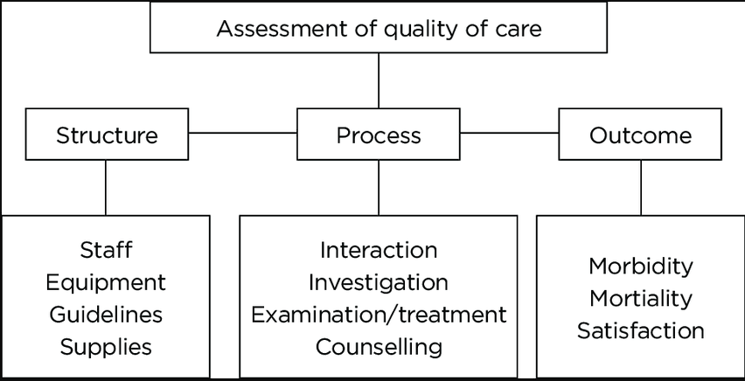

Applying fishbone diagram
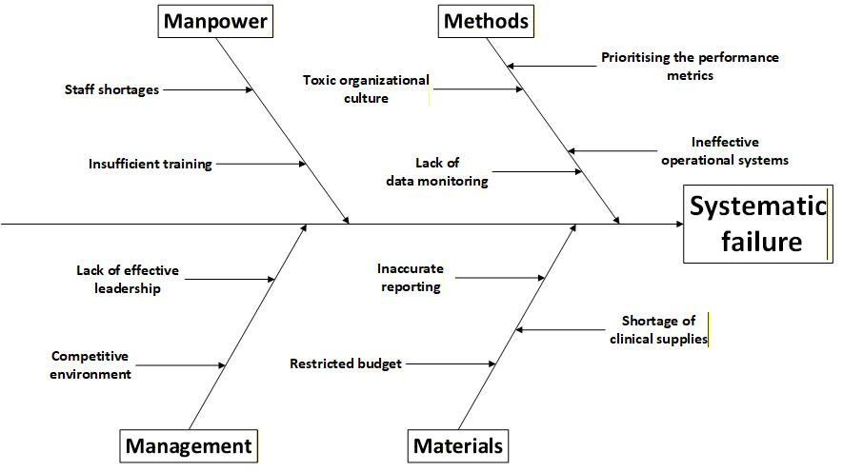
Applying the fishbone diagram on the Mid Staffordshire NHS Foundation Trust case, the framework has revealed major six dimensions of failure; management, manpower, environment, methods, materials and the measurement. The manpower domain is reflecting on the chronic understaffing as well as employment of the insufficiently trained staff of the organization. The management domain is highlighting the inefficient practices of leadership being characterized by the authoritarian decision making as well as the culture of the fear. The methods domain is relating to the ineffective operational systems as well as the performance metrics which prioritized the bureaucracy over the proper patient cantered care (Coccia 2020). The environmental causes involved the toxic culture of the organization where the compassion has been eroded as well as the professional accountability replaced by the indifference. The materials and measurement factor have revealed absence of the dependable data monitoring as well as the shortages of the necessary clinical supplies. When observed collectively, Fishbone Diagram exposes interdependence of the factors as well as aligns with Swiss Cheese Model of the systematic failures (Coccia 2018).

SWOT analysis of Mid Staffordshire NHS Foundation Trust
Strengths | Weaknesses
Integration in the NHS  Access to national resources | Staff shortages  Low morale  Poor communication systems  Absence of the learning culture
Opportunities | Threats
National Initiatives to quality improvement  Potential collaboration with the exterior audit agencies | Public scrutiny  Media coverage exposing the patient neglect  Increase in political pressures

Synthesis of the findings
When analysed collaboratively, the Donabedian Model, Fishbone Diagram as well as the SWOT analysis offers the multidimensional viewpoint on failure of Mid Staffordshire NHS Foundation Trust. Collectively, the models are illustrating that systematic failure was the reason for the crisis of Mid Staffordshire NHS Foundation Trust. It has emerged from culture which has valued the performance indicators over the patient experience as well as treated the quality assurance as the bureaucratic need instead of the professional and moral commitment.

Application of PDSA Cycle
PDSA cycle is offering the structured method to test and then implement the change using iterative experimentation. In planning phase, the Mid Staffordshire eNHS Foundation Trust must initiate recognizing the key quality as well as the safety priorities on the basis of the mortality data, staff surveys, and the patient feedback (Christoff 2018).
During planning phase, Mid Staffordshire eNHS Foundation Trust must conduct proper comprehensive diagnostic assessment utilising the baseline data like the patient complaints, mortality rates, staff feedback and the sepsis response times. It would include identification of particular gaps within care like the inconstant monitoring of the deteriorating patients, delay in the clinical escalation, as well as the lack of the adherence towards the care protocols. Through setting proper precise and measurable objectives, Mid Staffordshire eNHS Foundation Trust could easily structure their overall improvement goals around the priorities which are patient centered instead of focussing on the organizational targets.
The doing stage would involve implementation of the targeted interventions like the improved staffing frameworks, establishing the safety champions and the team backed communication huddles. In study stage, data must be systematically gathered as well as evaluated for analysing the impact of implemented changes (Taylor et al. 2014). It would include the comparison baseline as well as the post implementation outcomes using the quantitative metrics. The data like the initial escalation rates, time of treatment metrics, and the patient feedback could be easily compared against the baseline benchmarks. Reviewing this type of data within the multidisciplinary meetings of quality would ensure the transparency as well as the total ownership of the outcomes. The act phase would entail proper expansion or refining all the interventions on the basis of the insights collected. For example, if enhanced handover procedures lead to lower incidents of patient safety, then this approach must be standardized across all the clinical sectors. At this particular stage, the Trust could easily embed the new protocols into the policy documents, combining them with the induction programmes for the staff, and the proper automated monitoring systems using the digital dashboards. This iterative nature of the PDSA denotes that respective cycle would build on last, developing the culture of proper constant improvement. It properly applied, PDSA framework could enable Mid Staffordshire eNHS Foundation Trust into recognizing the initial warning signs, responding to the operational weaknesses, and maintain the ongoing commitment to the safe, high-quality care of the patients.

Kotter’s 8 step change model
Given scale of the entire operation, along with the systematic nature of failure at Mid Staffordshire eNHS Foundation Trust, the Kotter’s 8 step change model could be considered as the highly suitable framework for guiding the meaningful transformation in the organization (Harrison et al. 2021). The overall phased and structured approach would provide highly clear direction to address the complicated behavioural, cultural as well as the governance issues along with backing the sustainability in long term. Kotter’s 8 step change model is specifically relevant within the healthcare environments because the changes should be implemented rather ethically, and collaboratively along with the consideration for the patient safety and the clinical risks. Creating effective sense of urgency could be considered necessary for starting the change and then decreasing the complacency. It could easily be achieved through presenting the stakeholders like managers, regulators, clinical staff and the patients with the clear proof of any harm, involving the mortality statistics, benchmarking data and the patient testimonials, which would highlight the deviations from the national standards. The transparent acknowledgement of deficits could assist in generating proper readiness to introduce changes and foster the shared accountability. Focus on the moral as well as the professional duty for protecting the patients would strengthen the overall legitimacy of proposed enhancements.
Guiding coalition could comprise of the nursing leaders, senior clinicians, patient advocates, quality enhancement specialists, as well as the executive managers. This particular diverse group would help in ensuring that the entire decision making would include both the patient viewpoints and the clinical expertise. The collaboration should effectively demonstrate the trustworthiness, credibility as well as the ability of influencing the organizational culture. Their entire leadership plays central role towards maintaining the momentum as well as aligning the staff behind change agenda. Efficient communication through regular updates regarding the intranet dashboards, staff forums, visible leadership briefings and the safety briefings could help in keeping the entire vision in forefront. Messaging should completely remain transparent, consistent as well as associated with the updated data. For sustaining changes, the successful practices should be properly formalized within policies, the standard operating procedures as well as the training programmes. Finally, eighth stage would institutionalize the new practices and values into culture of Mid Staffordshire NHS Foundation Trust for sustaining the changes in long term (Patel et al. 2025).
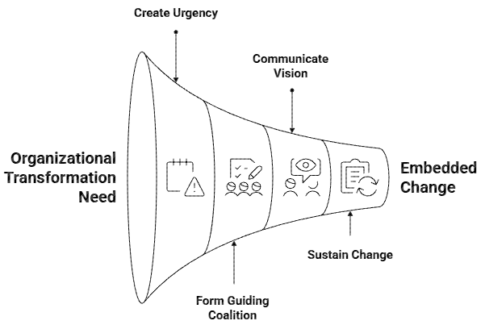

Recommendations
The recommendation is being provided that the approach of Lean management would initiate with the identification of value from the perspective of the patients. Mapping this value stream will include examination of the complete journey of the patient, from the admission to the discharge, for identifying the points where the duplication, delays or even the neglecting happens. Next principle of Lean is flow which would ensure that the processes would progress rather smoothly without any unnecessary interruptions. The poor communication among the departments at Mid Staffordshire NHS Foundation Trust frequently led the fragmented care and Lean principles would advocate for the standardised protocols of communication, visual tools of management and the everyday multidisciplinary issues. Through implementation of the pull systems, the care delivery would become completely demand backed, ensuring all the resources like equipment and the staff are being allocated as per the needs of the patient instead of the strict schedules (Marsilio and Pisarra 2021). Finally, principle of the constant improvement would empower all the staff members, regardless of their rank into identifying the inefficiencies as well as propose various solutions. This type of participatory models would assist with restoring the professional morale as well as the cultivate shared sense of the responsibility for the quality (Mahmoud et al. 2021).

Evaluation of the benchmarking against the standards
Metric | Before | Target | After
% of the patients gaining antibiotics in 1 hour | Prior the initiative of improvement, only 62% of the patients gained antibiotics in 1 hour, showing delays in identifying and responding properly to sepsis (Willmington et al. 2022). | The national target implemented for the timely antibiotic administration has been set to 90% which is reflecting the clinical need for swift treatment for preventing any deterioration in the sepsis patients (Borisova and Manoilova 2023). | After the targeted interventions, involving quicker escalation and the streamlined pathways, the performance increased to more than 88% (Reponen et a. 2021).
Compliance with the sepsis screening tool | Early compliance was only 70%, indicating the unreliable use of screening tools as well as the unbalanced documentation done of the symptoms (Willmington et al. 2022). | National standard is set for 95% compliance for ensuring that the initial signs of the sepsis would be recognized promptly (Borisova and Manoilova 2023). | Following the strengthened protocols as well as the training, the compliance enhanced to more than 93% (Reponen et a. 2021).
Average time take from the triage to senior review | Average time taken was 120 minutes which is exceeding the suggested restrictions and showing delays (Willmington et al. 2022). | National benchmark needs the review in 60 minutes for ensuring the early diagnosis, intervention and the escalation (Borisova and Manoilova 2023). | After the redesign of the workflow as well as the improved escalation methods, time has decreased to less than 55 minutes (Reponen et a. 2021).

Benchmarking has been used for measuring the performance of the hospital against the national standards as well as the peer organizations, specifically in the relation to the sepsis management. Main three indicators have been assessed, which are the patient’s percentage gaining antibiotics in one hour, the compliance with the screening tools of sepsis, and average time from the triage to the senior review. Prior the initiative of improvement, the performance levels could be observed to be increasingly low, with 62% of the patients acquiring antibiotics in suggested time, 70% compliance with the sepsis screening as well as average triage to review being 120 minutes. The administration of antibiotic rose to more than 88%, compliance of sepsis screening reaching 93% as well as time for triage to review declining to 55 minutes, that is surpassing national benchmark of below 60 minutes. These particular results are demonstrating that the systematic benchmarking, when integrated with the evidence backed models of quality improvement, would efficiently identify the gaps, drive the performance improvement and foster necessary accountability.

Conclusion
Therefore, the conclusion is being derived from the above discussion that the implementation of the suggested improvements in Mid Staffordshire NHS Foundation Trust would assist with ensuring proper healthcare is being provided to the patients and focus on patients is increased and administrative gains are not prioritized significantly. The entire failure of Mid Staffordshire NHS Foundation Trust case is representing the thoughtful case of systematic collapse in the public organization of healthcare. The organizational culture changed from patient centered care to focusing on administrative and financial gains led to the disaster at Mid Staffordshire NHS Foundation Trust. The accountability and the governance methods at the Mid Staffordshire NHS Foundation Trust were extensively weak. The regulatory bodies like the Department of Health and Healthcare Commission had the absence of the efficient coordination as well as the data integration.

