

PROGRAMME: MBA – International Business
Term 2

STUDENT NAME: YASHKUMAR DHOLAKIYA
STUDENT ID: 2505243

MODULE: International Marketing: Principles and Practices
MODULE CODE: LCMB7026

Lecturer’s Name: Tushara Balendran

THE INTERNATIONAL MARKETING MIX
COMPANY = MERCEDES BENZ
COUNTRY = CHINA AND GERMANY
Executive summary

This report has shed light on a comparative macro-environment analysis of Mercedes-Benz in two countries, namely Germany and China. The use of PESTLE analysis, along with a particular focus on social and cultural factors influencing consumer behaviour have showcased some essential information. The Segmentation, Targeting, Positioning strategy of Mercedes-Benz with a focus on the 7Ps framework has also been highlighted through a comparison among Germany and China.
The report identified how Germany is a stable and mature market with influence of engineering quality and functional luxury, while China offers greater growth potential with rising status-based consumption and disposable income. The STP of the company is adapted based on local market needs, showing localising product, pricing and promotional approaches. The analysis also showed how China is a key focus for the company’s future growth through product development and localisation. While ethical concerns were identified in China, the company needs to adapt various recommendations identified in the report to maintain its global competitiveness. The reflective account also supported understanding the learning journey and what approaches will be considered in future similar report developments for enhanced quality.

Table of Contents

Section 1: Company analysis in two chosen countries 4
1. Introduction and background of the company 4
1.1 Company background 4
2. Macro environmental analysis (PESTLE) 6
2.1 Use of PESTEL analysis for comparing and contrasting the micro-environment 6
2.2 Comparison of social factors using Hofstede’s Cultural Dimension model 8
3. STP Analysis (Segmentation, Targeting, Positioning) 9
3.1 Segmentation 10
3.2 Targeting 12
3.3 Positioning 13
4. Marketing Mix Analysis (7Ps) 13
4.1 Product 14
4.2 Price 15
4.3 Place (Distribution) 15
4.4 Promotion 16
4.5 People 16
4.6 Process 17
4.7 Physical evidence 17
5. Directional Development Strategy 18
6. Ethical marketing issues 19
7. Recommendations for international marketing strategies 20
Section 2: Reflection 22
8. Conclusion of the report 24
References 26

Section 1: Company analysis in two chosen countries

Introduction and background of the company
In this report, the key focus is given to the marketing mix strategies adapted via Mercedes-Benz in the markets of China and Germany. Being a global automotive brand, the company has to operate in 255 locations across the globe economies and cultures while managing its diverse regulatory aspects (groupmercedes-benz, 2026). This is crucial to consider as in these diverse regions, it is crucial to adapt in a strategic manner like their approach for reducing luxury branding messaging to ensure its global brand image (Boston, 2025). The report will analyse STP strategies while considering the International Marketing Mix factors to showcase the diversities for price, product, and other approaches. A particular analysis of Mercedes’ directional development strategy in one selected country will be done while considering ethical issues in the marketing mix. The report will provide strategic recommendations based on the analysis for future international growth in order to sustain competitive advantage in global markets.

1.1 Company background
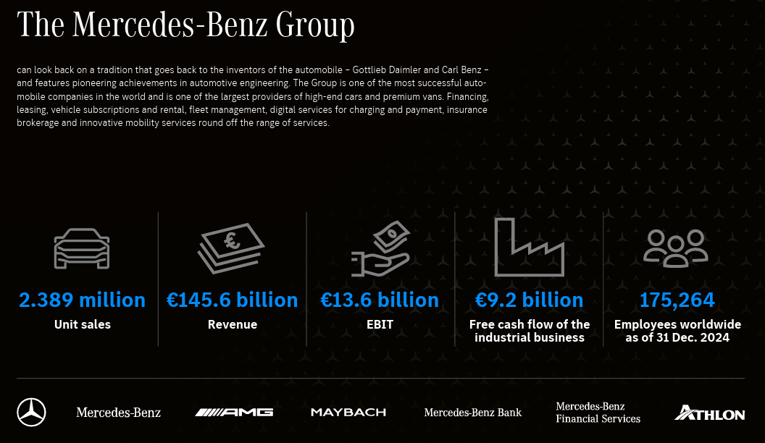

Figure 1: Financial overview of Mercedes-Benz
(Source: Mercedes-Benz Group, 2025)
Mercedes-Benz is one of the largest luxury car manufacturers in the world, created in 1926 when Karl Benz and Gottlieb Daimler combined their two companies (Mercedes-Benz Group, 2025). It is a division of its parent company Mercedes-Benz Group AG which operates its business in 93 locations from its headquarters in Stuttgart, Germany. Through the development of high innovation, engineering perfection, and high brand placement the company is visioning about being the pioneer in the field of electric mobility and digital transformation in order to provide premium automobile products. On the other hand, the ‘One employee, one customer, one vehicle’ mission of the brand influences it to travel the world with high-quality, sustainable, and premium auto inventory to foster luxury shopping experiences (Mercedes-Benz of Charleston, 2026). Figure 1 revealed revenue of €145.6 billion in 2024 when it sold 2.389 million units.
Germany is the domestic market of Mercedes-Benz in which the brand leverages high heritage, technological superiority, and a developed luxury car market through the integration of its ‘Ambition 2039’ strategy which is guided by sustainability, integrity and diversity (Mercedes-Benz Group AG, 2025). Conversely, China is recognised as the largest host market of the company due to its providing a huge part of the global sales in Mercedes-Benz. In 1986, Mercedes-Benz officially joined the Chinese market with partnerships and reinforced its presence in the country with joint ventures like Beijing Benz Automotive Co., Ltd. (BBAC). This aspect allowed the brand to foster its local production approach and expand its market (Mercedes-Benz Group AG, 2025). Through localisation of Mercedes-Benz in China, the company has maintained its top market share in 2025 for vehicles costing one million RMB or more (Mercedes-Benz Group AG, 2026).

Macro environmental analysis (PESTLE)

2.1 Use of PESTEL analysis for comparing and contrasting the micro-environment
As recognised by Qadri and Tariq (2025), PESTLE analysis is a core business instrument, which helps in analyzing macro-environmental forces that affect business performance from different forces like political, economic, social, technological, legal and environmental forces. Thus, the integration of this framework in the case of a global brand such as Mercedes-Benz, a comparison between Germany (domestic country) and China (largest host country) plays an important role in terms of understanding the dynamics in the international market.
Political: The macro-environment is associated with global sourcing and shows strong alignment with global and regional laws in its international operation. In this context, Germany is found to be a very stable democratic country with strong institutionalization and clear EU regulations (Freedom House. 2026). Its Federal Constitutional court plays an important role in political terms, in which the ‘traffic light’ aspect of the government subsidy programme encourages long-term investment and innovation of Mercedes-Benz’s sustainability goals as well as sales rates of Mercedes EQ line (Mercedes-Benz Group AG, 2022). Conversely, China has a centralized political system whereby the government plays a big role through large intervention in different industries in accordance with the ‘Made in China’ and ‘Industrial policy’ (Chen et al., 2024). Although this adds complexity to regulation, it also gives a solid industrial backing, especially in the form of subsidies and policies favoring electric vehicles (EVs). Nevertheless, there is a threat of German automakers in China due to the geopolitical tensions as well as complex trade tariffs between China and the European Union. Thus, Germany offers a favourable and stable political environment for the company rather than China in the global environment.
Economical: Germany is the mature and highest-income economy of Europe, with leading exporters of machinery, vehicles with strong demand for high quality automotive industry (Eissel et al., 2021). In this nation, the growth in car sales grew from 3.4% to 2.9 million units. This, in turn, indicates a stable market situation for Mercedes-Benz Group (Karanth, 2026). However, market saturation and financial volatility in global platforms also affect the growth opportunity of the brand. On the contrary, China is the largest automotive market globally and also recognised as the largest market of Mercedes-Benz. The company has sold more 34% vehicles in China in 2024 despite the high competition of the local brands (Mercedes-Benz Group AG, 2025).
Technological: Germany is the domestic market of the company, which is recognised as the global leader in automotive engineering and innovation. This supports the ‘Digital First’ approach of Benz by focusing on the in-house MB.OS operating system in further advancement (Mercedes-Benz Group AG, 2025). However, with over 50% of new car sales being, China is making remarkable progress in EV technology and digital ecosystems, indicating a significant move toward sustainable mobility (EV Expert, 2026). This influences Mercedes-Benz under pressure from the competition as well as opportunities.
Legal: the legal system of Germany is transparent, where there are 3 levels of law enforcement system and predictable rules like the EU emission standards (Euro 6/Euro 7) (State Gov, 2023). It specifies compliance criteria for automakers like Mercedes-Benz and guarantee consistency in manufacturing and market access. In comparison to Germany, China has a more complex legal framework due to the high issues with intellectual property protection. This country has mandated that international manufacturers like Mercedes-Benz have to operate through joint ventures which adds to the legal and operational challenges (Mercedes-Benz Group AG, 2025).
Environmental: High-end policies like the EU's 2035 ban on the sale of new petrol and diesel vehicles in the automotive industry pushes automakers like Mercedes-Benz toward complete electrification, demonstrating Germany's commitment to sustainability (European Parliament, 2023). This not only creates opportunities for Benz, but also fosters financial stress to cope with green mobility pricing. On the other hand, as stated by Zhao et al. (2024), subsidies and incentives that have enabled China to account for more than 50% of worldwide electric vehicle sales in recent years highlight China's leadership in EV adoption.

2.2 Comparison of social factors using Hofstede’s Cultural Dimension model
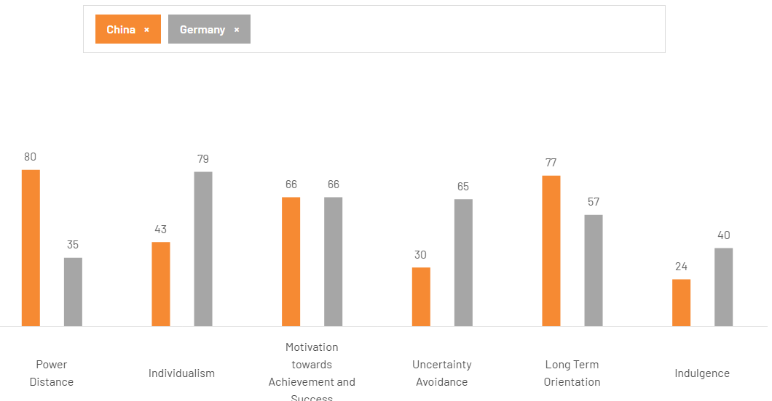

Figure 2: Cultural dimensions of China and Germany
(Source: The Culture Factor, 2026)
A vast range of comparison is followed in the social factor between two nations, in which the differences in the social and cultural aspect are analysed by Hofstede’s Cultural Dimension model. The high individualism (79) and low power index (35) of Germany influences the ageing and sustainable concerned population (The Culture Factor, 2026). This fosters consumer preferences towards the quality and safety aspects in automotive purchase. This is aligned with the premium pricing and positioning of Mercedes-Benz in Germany. In contrast, the high-power distance (80) and collectivism approach in China influenced its fast urbanisation and middle-class growth that continued to fuel luxury vehicle demand. This is perceived as status symbols (Zhao et al., 2024). Whereas the domestic competition in the Chinese market is recognised as the lower uncertainty avoidance which is an increasing challenge for the Benz about the sensitivity to technological innovation and digital features. However, Germany strikes a balance between history and innovation, whereas China's strong long-term perspective encourages investment in long-lasting luxury items (Fang et al., 2024; Gerlich, 2023).

STP Analysis (Segmentation, Targeting, Positioning)
The strategic use of Segmentation, targeting and positioning of Mercedes-Benz is highly diverse in China and Germany due to the verities of economic aspects, consumer culture, and competitiveness. Regardless of similar brand image across the globe, there are slight differences in terms of targeting, positioning, and segmentations (Nilplengsang and Pankham, 2024). Considering this, a STP analysis for both countries is done below:
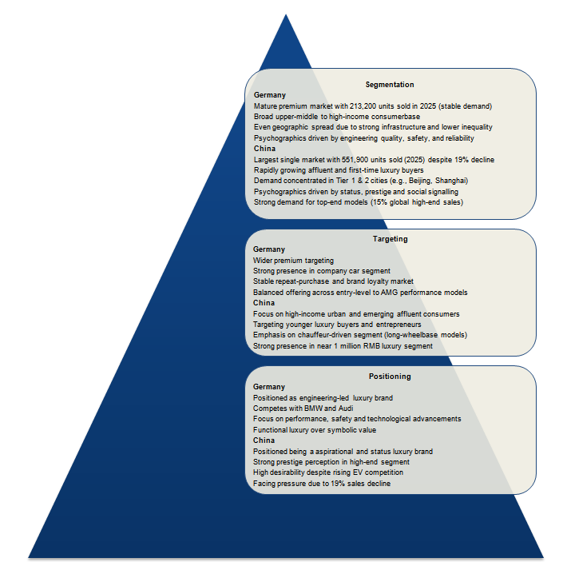

Figure 3: STP analysis of Mercedes-Benz
(Source: self-made)

3.1 Segmentation
Mercedes-Benz segments the market through demographic, geographic, and psychographic aspects.
- Demographic: For Germany, a mature premium automotive market with a stable income base can be identified for the company. For example, based on company disclosures, the car sales of Mercedes-Benz of Germany, in FY2025, are 213,200, showing a stable demand in the region, as showcased in the below figure (mercedes-benz, 2026). This also showcases how the luxury car ownership is extended to various classes. On the contrary, China is developing a more dynamic and expanding demographic structure. Disclosures also highlighted how the sales in China has reached 551,900 in FY2025 (Mercedes-Benz, 2026). It became one of the largest single national markets, regardless of decline by 19% due to competition. The sale of demand is highlighting the trends for the rapid expansion of affluent consumers. One of the reports revealed that the region’s luxury car market has constantly performed well, especially due to the rising disposable incomes (daxueconsulting, 2025).
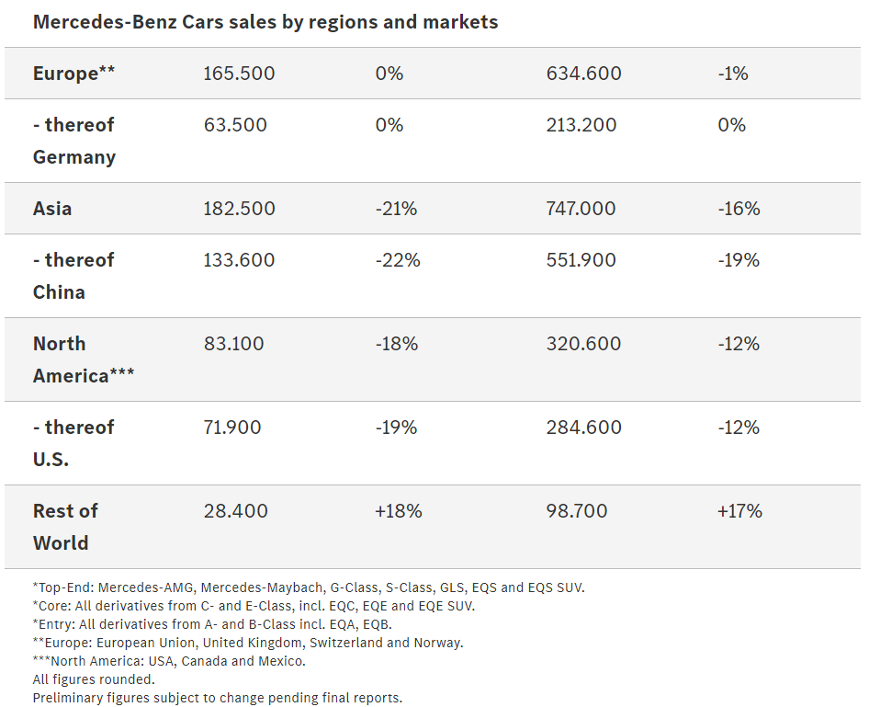

Figure 4: Car sales of Mercedes-Benz by regions
(Source: mercedes-benz, 2026)
- Geographic: Germany has shown higher dispersed patterns for purchase with strong infrastructure and income equality. This can be supported through Germany’s focus on Less Inequality, supporting the nation’s income stability (oecd, 2024). Mercedes-Benz is thus operating in various regions without a proper basis on metropolitan regions only. On the other hand, China is showing demand in Tier 1 and Tier 2 cities, especially in Beijing and Shanghai, where the income levels are much greater (renub, 2024). Yet, Mercedes is focused on expanding to the lower-tier cities also/.
- Psychographic: In terms of the psychographics of Germany, consumer behaviour is more focused on rational and based on products. Industry reports showcase that consumer behaviours are majorly focused on safety, engineering quality, and long-term reliability (odgers, 2026). This is aligned well with the heritage of the company, with its focus on reputation for technical excellence (Andreeva and Petikhin, 2022). The psychographic influencing factors in China are more symbolic based with luxury vehicles being aligned with social status and success. China is identified to be a key market for top-end vehicles, with a representation of nearly 15% share of total sales, at 268,000 units (Mercedes-Benz, 2026). These are closely related to status consumptions in China, compared to Germany.

3.2 Targeting
Mercedes-Benz has adapted a more differentiated targeting approach based on each market’s maturity level and consumer expectations. The Germany-focus is a wider premium segment with individuals and even corporate buyers. The cruciality of fleet sales is showcased in the company’s performance, which contributes majorly to the German automotive landscape. The balanced approaches allowed the company to maintain a good result in Germany, in which sales remained same levels of 2024 with 213,200 units (Magureanu, 2026). While for China, the targeting is more selective and growth-focused. The company is focusing on higher-income urban consumers with emerging affluent segments in the region. The company is also focusing on personalised experiences of consumers of China. Troska (2022) identified how the company has developed long-wheelbase models customised for the Chinese market only. This strategic foucs is supported by the mostly dominating price segment of approximately 1 million RMB (approximately $145K) (Bloomberg, 2022).

3.3 Positioning
Mercedes-Benz is managing a consistent global positioning based on luxury, innovation, and engineering quality. Although the perceived value is quite different in Germany and China, as in Germany, the brand is positioned as a symbol of engineering heritage and technological giant. The competition is majorly based on domestic rivals like Audi and BMW with a focus on performance, safety, and rapid innovations (Ergocun, 2025). This developed the need for shifting focus from only brand heritage to the functional need of luxury factors. While in China, the positioning is highlighting aspirational luxury and social status of individuals, which can be supported through Mercedes being considered among the prestigious automotive companies in high-end sector (Troska, 2022). Regardless of the rising competition from domestic electric manufacturers, the company is maintaining its strong brand desirability among the consumers. Although, the car sales in China are expected to fall more in 2026, followed by the 19% decline already in 2025, showing how local competitors are offering more competition to them (More, 2026).

Marketing Mix Analysis (7Ps)
As inspired by the ideas of Jain et al. (2022), the marketing mix is one of the most commonly used and effective frameworks that help in planning marketing strategy and effectively market products to the targeted audiences. The following discussions show the 7Ps of Product, Price, Promotion, Place, People, Packaging, and Process of Mercedes-Benz.
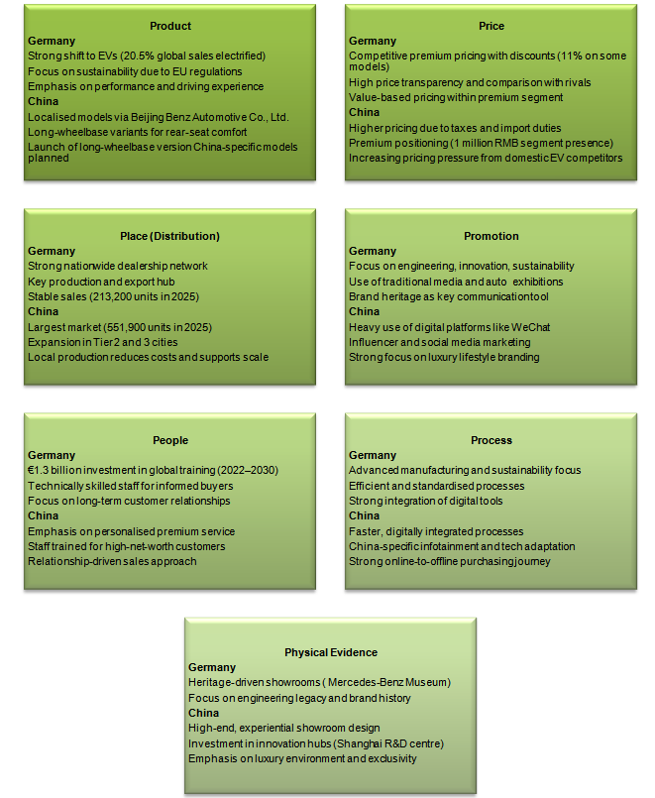

Figure 5: 7Ps of Mercedes-Benz
(Source: Self-made)

4.1 Product
The product strategy of Mercedes-Benz is based on global standardisation and local adaptations. For example, global trends of the company are based on electrification needs with sales of 1.801 million Mercedes-Benz cars across the globe (mercedes-benz, 2025). Out of these, 20.5% are electric vehicles, which shows a clear shift towards sustainable mobility, especially for Germany due to regulatory pressures. In the region, the transition is especially due to EU emissions regulations and higher awareness of climate impacts (europarl.europaeu, 2024).
In case of China, product adaptation is more visible among consumers. The company through a joint venture of Beijing Benz Automotive Co, developed products specified for the market, like a long-wheelbase version of the C-Class and other (mercedes-benz, 2026). These adaptations focus on Chinese preferences for rear-seat comforts. The localisation of products also sheds light on the scale of demand and regulatory needs.

4.2 Price
Pricing strategy is based on the market structure and consumer perceptions. As per reports by Acharya (2026), Mercedes-Benz is considered to be operating through a competitive pricing approach in Germany, aligned with BMW and Audi. Consumers became price-conscious with premium aspects and often can compare values with other competitors. The company aimed to provide discounts of up to 11% for selected variants, like for EQA and EQB 250 base models. It further qualifies for 11% discounts of 6,945 Euros (Approximately $8000) (Randall, 2024). Thus, pricing is a key approach for the company to maintain competitiveness and brand heritages.
In China, the pricing strategy is influenced by factors like taxes, import duties, and brand perceptions. The increased pressure through competition has developed concerns for pricing. The increase in competition from domestic brands and even electric approach has declined margins in China. This presents a challenge for managing premium positioning in pricing, yet the pricing often ranges near 1 million RMB (approximately $145K) (Bloomberg, 2022). Yet the rising EV competition in China is also developing potential issues for ensuring premium pricing in the market.

4.3 Place (Distribution)
Distribution is also crucial for the company by diversifying it in various markets. Germany, among these two companies, showed more stability with 213,200 unit selling in 2025, especially due to the mature and consistent market (mercedes-benz, 2026). Germany is gaining advantages from the effectively established dealership networks and has become a key production hub. Stronger infrastructure allows efficient distribution and their after-sales services while increasing the loyalty base and reliability of brands.
While for the Chinese market, the unit sales of 551,900 in FY2025 is showcases the continued investment in localisation and dealership expansions. In the region, Mercedes-Benz is operating through the joint venture of Beijing Benz and expanded dealership networks. From the findings of Zhang (2024), this allows for reducing any type of excess production costs while aligning well with local regulatory environments. Furthermore, the complete scale of the Chinese market is also developing, with a need for continuous expansion in new areas.

4.4 Promotion
The cultural and regional differences can be identified through the promotional strategies. For example, the company’s approach through Tomorrow XX technology program as a key support for innovation in relation to sustainability and quality (mediambusa, 2025). Traditional media, exhibitions and brand heritage also play a major role in enhancing these approaches’ reach to the complete region.
In case of China, digital marketing is a key factor for any company, where platforms like WeChat has become a major player in digital communication in recent years (Giudice, 2020). The company utilises platforms like WeChat to connect to the consumers and lead the market share pricing through high-quality communications. Social media campaigns, influencer partnerships, and others also play a crucial role in developing strong engagement in the digital exosystem.

4.5 People
The context of human resource and consumer interaction strategies are based on local expectations. Mercedes-Benz is analysed to be focused on investing in training approaches of employees through initiatives like turn2lear. In this, it aims to invest more than €1.3 billion ($1.5 billion) for Germany only from 2022 to 2030 (mercedesbenz, 2026). The key focus is on providing detailed product services and developing strong relations with consumers.
In China, the focus is, however, mainly on personalised services and relationship development. The staffs are potentially trained properly to provide premium experiences, often for higher Worthing individuals. Its “customer-oriented services, continuous investments, and long-lasting alliances with strong local partners” have altogether assisted it to prove its commitment to Chinese customers (Mercedes-Benz China, 2026). This has, therefore, shown a cruciality for service quality to ensure luxury positioning in China.

4.6 Process
The operational processes are globally integrated regardless of minor local adaptations. In Germany, Mercedes-Benz is utilising advanced manufacturing and digital sales, which is adapted on a global basis. In this country, key focuses are often sustainability, efficiency, and quality for the automotive sector (Isopp et al., 2024). In China, processes are adapted for rapid decision-making and digital integrations. For example, Mercedes-Benz is focused on developing a China-specific infotainment strategy for better understanding of industry trends and serving to consumer expectations (mercedesbenz, 2026). This, therefore, aligns with the rising use of online platforms and purchases of vehicles, highlighting advancements in the digital infrastructure of China.

4.7 Physical evidence
The luxury image of the brand is stabilised through its physical evidence. Germany's showrooms shed light on engineering heritage and sophisticated approaches with linking to brand history. For example, the Mercedes Museum Germany is a key example of showing heritage and brand value for the consumers (Johnson, 2025).
In China, the physical presence is shown through their showrooms, which are designed for developing higher quality experiences. Furthermore, the R&D Centre in Shanghai is another key example of their innovation network through a solid base as physical evidence (mercedesbenz, 2024). The crucial focus on visual appeal and exclusivity is aligned with consumer status and behaviour in the region.

Directional Development Strategy
The directional developmental strategy of Mercedes-Benz in China can be considered through the Ansoff matrix perspective, especially the product development segments in the matrix, as identified in the figure below.
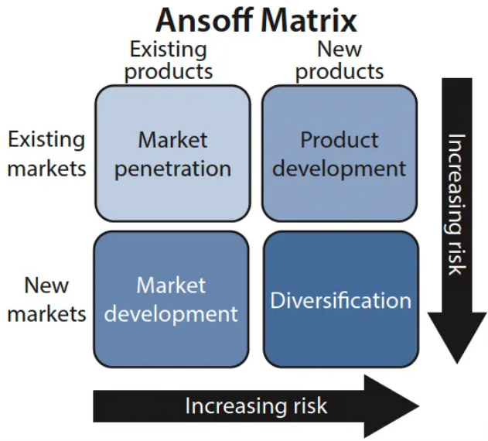

Figure 6: Ansoff Matrix
(Source: Inspired by the ideas of Ganguli, 2024)
As per analysis, China is among the largest and a key growth market, regardless of various issues, making it a supportive segment in the company’s future expansion plans. The company has focused on a product development strategy in the region. This can be shown through their market-specific innovations, as their approach for launching over 15 new models customised for the Chinese consumers (Chinadaily, 2024). Furthermore, this can be considered as a response to the rise of domestic key players in the EV segment, like BYD. According to Liu (2025), this has gained major shares in the market through its advanced technologies and competitive pricing. The need for localisations was also influenced through the sales in this region, which, although reduced by 19% from 2024, still holds a major sales portion for the company (Bekker, 2026).
Additionally, the company has also potentially revealed implementation of a market penetration strategy through expansion in low-tier cities. While the Tier 1 cities like Beijing are dominant sources, Mercedes-Benz can gain future growth through emerging urban cities in which middle class is expanding rapidly. This can be supported by the research of Zipser (2023) who identified rising urbanisation and disposable income levels of Chinese consumers. In this, another key strategic direction can be localisation of production and R&D. For an example, the joint venture Beijing Benz allows Mercedes to enhance their local manufacturing capabilities while reducing costs and improving legal alignments (Yao, 2022). Furthermore, the expansion of R&D in China is found to be considered a key approach for shifting to more developed technologies, specifically customised for Chinese consumers (mercedesbenz, 2024).

Ethical marketing issues
Ethical concerns in relation to the marketing mix of Mercedes-Benz in China are also developing, especially for promotions and product communications. This develops the understanding of how culturally sensitive the Chinese market is for the company. In China, cultural sensitivity for the company has been a major ethical issue for a long time, like in 2018 the company got highly criticised for using a quote related to the Dalai Lama in their Instagram campaign (Aljazeera, 2021). This quote, focusing on self-reflection, was considered to be politically insensitive, due to the stance of the Chinese government on Tibet/. This led to public concerns and an official apology from the company. It also highlighted how global promotional approaches can be conflicting with local values for political and cultural aspects. This also develops the need for better cultural awareness and respect for communities in advertising.
Another key concern for ethical issues developed in relation to cultural insensitivity in promotional approaches. In the year 2021, the company faced major backlash in China as they posted a video advertising on their official Weibo account, which was criticised for solidifying stereotypical Asian facial features (Globaltimes, 2021). The model in the advertisement included a makeup. This, according to the Chinese consumers, was depicting the slanted eyes, developing wider controversies and discussions on social media. The post got over 170 million views, reaching wider audiences in China and across the globe before the company removed it from their platform (Globaltimes, 2021). This develops major concerns for ethical alignment through cultural sensitivity and respect. Findings of Berezina (2024) have revealed that the company has contributed through some positive ethical approaches like Ambition 2039, which focuses on gaining carbon neutrality in the supply chain. However, maintaining potential transparency and sustainability focus has always been a concern for the company. Furthermore, the previously identified localisation and production efforts by Mercedes also support economic development and job creation.

Recommendations for international marketing strategies
In relation to the enhancement of marketing effectiveness, it is indispensable for automobile giants like Mercedes-Benz to consider various approaches in both China and Germany.
- In China, the company needs to focus on increasing its electric vehicle strategy. Considering the rising prevalence of major domestic players like BYD, Mercedes-Benz needs to expand its EQ line and enhance pricing (Liu, 2025). With a focus on investing in local supplier partnership and or in battery technology can support enhancing their positioning for the EV sector (George, 2024).
- The China-specific infotainment by the company is also crucial approach for gaining a better understanding of the market and expectations of consumers to be met (mercedesbenz, 2026). However, Mercedes-Benz can focus on expanding in tier 2 and 3 cities for better market penetration in wider demographics of the regions, especially in China.
- In Germany, Mercedes-Benz can focus on sustainability leadership and an innovative approach. Due to rising scrutiny of the German government for environmental alignment of major automotive companies, the company’s commitment to carbon neutrality and sustainability needs to be improved (Muller, 2026).
- The company should also increase its digital marketing capabilities through the use of popular platforms like WeChat (Giudice, 2020). This will ensure the company messaging is better personalised to the consumer they primarily target.
The company should also focus on investing in managing consistent ethical marketing approaches, especially in communication and sustainability claims in both regions. Better transparency and alignment among marketing messages and actual approaches can support in improving brand trust at larger scale (Cambier and Poncin, 2020).

Section 2: Reflection
The process for analysing, researching, and preparation of this report for Mercedes-Benz in China and Germany has been a highly academically challenging and informative course for me. To better understand this approach, the Kolb’s reflective cycle can be utilised which focuses on 4 segments of concrete experiences, reflective observation, abstract conceptualisation and active experimentation.
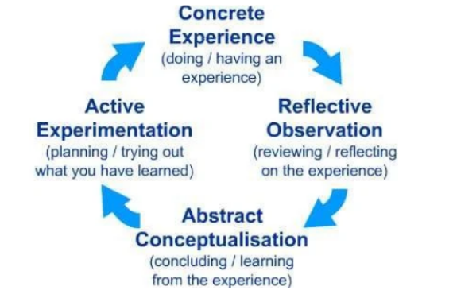

Figure 7: Kolb’s reflective cycle
(Source: Kumar, 2019)
Concrete Experience
The very first beginning of this report included selecting a most suitable brand and two contrasting markets in which the brand operates in. In this case, I chose Mercedes-Benz and its comparison in Germany and China to develop a strong basis of my research, as China is a rapidly expanding market while Germany shows to be a more mature domestic market. I found that it is very simple for gaining general information from various official reports and automotive industry reports for the company. Although I started to align the information with academic frameworks like 7Ps, I started to face barriers. For example, while utilising the STP strategies, I realised that only describing the segmentation or targeting is not efficient enough. There was a need to support the claims with real-world data, which allowed me to shift from just textbooks and include a wider analysis of market reports and company disclosure materials. This also supported me understand the basis of theoretical frameworks with business performances.
Reflective observation
From the completion of the report, I can say that one of the key issues I faced was balancing theory with evidence. First, my writing always was descriptive and mostly generic, which hindered criticalness and only explained concepts. Based on the ideas of Levin (2025), feedback and self-reviewing allowed me to clear the research approach and understand how the lack of depth is negatively impacting academic expectations. Furthermore, I also found it to be challenging to identify the best possible credible sources. I had to be careful for gaining support from authentic data, like the ones from company reports and research platforms. This also developed the need for me to take more time and verify each statistic and ensure all the sections in the report are consistent.
For example, while considering the analysis of Chinese market, I needed to check many times the sources to ensure trends like the growth of domestic EV manufacturing and the decline of Mercedes-Benz sales in 2025 in the region. I also noticed that my understanding of cultural differences was greatly improved in the process. I first did not properly connect the fact that consumer behaviour can be diverse in China and Germany. Through gaining a better understanding via detailed research, I realised that while the consumers in Germany are prioritising quality and reliability, Chinese consumers often associate luxury cars with social status factors.
Abstract conceptualisation
Through the complete process, I was able to develop a more detailed understanding of how marketing theories are operating in real-world contexts. The STP analysis, was crucial to use, as I started to apply it to actual market data. I also found that segmenting cannot be just for categorisation of consumers, as it can focus on identification of measurable differences that influence the strategies of companies. Furthermore, targeting is found to be closely related to economic conditions and cultural expectations, which can be different in various regions (Nilplengsang and Pankham, 2024). Furthermore, the analysis of the PESTLE framework also was simple for me before considering a more in-depth analysis of it. It was just a task for me, at first, yet as I continued the research, I understood that all the elements are interconnected, and thus it became challenging for me. I also developed a key learning for how localisation can be considered in international marketing. The company’s strategy in China like local production through a joint venture, highlighted how global companies need to adapt to the needs for ensuring competitiveness.
Active experimentations
In a situation of a future similar assignment for me, I would adopt a more structured approach for the research. This will allow me to not get lost in a collection of wider information from various sources, and allow me to focus on gathering data for a particular segment or framework. This will make the analysis more in-depth, logical, and efficient for future purposes. I will also focus on integration of data in analysis. During this report, I faced a situation in which I inserted statistics after writing the key contents, which resulted in a hindered flow. So, in future cases, I will focus on developing arguments based on the data to ensure a more evidence-based approach. I will also aim to enhance my skills in academic referencing through managing the records of sources more strategically and in an organised manner. Furthermore, I will focus on developing a more critical perspective through considering all the data and comparing it with existing sources and information to develop a deeper and more critical analysis of the research topic. This will support enhancing the analytical depth and critical nature of the report.

Conclusion of the report
This complete report analysed the international marketing strategies of Mercedes-Benz in China and Germany through the integration of frameworks like PESTLE, 7Ps, and STP analysis. The findings from the report identified how the company is managing a global, consistent brand identified for luxury and innovation aspects, while adapting to local market demands. Germany was identified to be a mature and stable market with a rising preference for sustainability and engineering excellence.
While China offered higher growth potential, aspects like competition and ethical issues in marketing developed barriers for the chosen brand. The recommendations provided a clear path for the company to gain success in diverse economies, while the reflection allowed to understand the areas of personal development done and the need for future, through the report. The analysis showed that the long-term success of the company is based on its capability to balance consistency and local responsiveness in the rapidly changing market places across the globe.

References
Acharya, S., (2026). BMW, Mercedes-Benz and Audi to Raise Prices by up to 2% from April 1—Here's Why. Available at: https://www.outlookbusiness.com/corporate/bmw-mercedes-benz-and-audi-to-raise-prices-by-up-to-2-from-april-1heres-why [Accessed on 20.03.2026].
Aljazeera, (2021). Mercedes axes ad after Chinese backlash over model’s eyes. Available at: https://www.aljazeera.com/economy/2021/12/30/bbmercedes-axes-slanted-eyes-ad-after-chinese-netizen-backlash [Accessed on 18.03.2026].
Andreeva, S. and Petikhin, D., (2022). Research on the marketing of technological innovations for car safety: case company: Mercedes-benz. https://www.theseus.fi/bitstream/handle/10024/787064/Thesis_Petikhin_Andreeva.pdf?sequence=2 [Accessed on 20.03.2026].
Bekker, H., (2026). 2025 (Full Year) Global: Mercedes-Benz Worldwide Car Sales by Country and Model. Available at: https://www.best-selling-cars.com/brands/2025-full-year-global-mercedes-benz-worldwide-car-sales-by-country-and-model/ [Accessed on 11.03.2026].
Berezina, P., (2024). The Electric Revolution from China: Impact of Chinese Electric vehicles on Logistics and Market in Europe. https://www.theseus.fi/bitstream/handle/10024/876983/Berezina_Polina.pdf?sequence=2 [Accessed on 18.03.2026].
Bloomberg, (2022). Mercedes Slashes China EV Prices By Up to $33,000 as Sales Lag. Available at: https://www.bloomberg.com/news/articles/2022-11-16/mercedes-slashes-china-ev-prices-by-up-to-33-000-as-sales-lag [Accessed on 20.03.2026].
Cambier, F. and Poncin, I., (2020). Inferring brand integrity from marketing communications: The effects of brand transparency signals in a consumer empowerment context. Journal of Business Research, 109, pp.260-270. https://nscpolteksby.ac.id/ebook/files/Ebook/Journal%20International/Marketing/Journal%20of%20Business%20Research/Volume%20109%2C%20March%202020%2C%20Pages%20260-270.pdf
Chen, Y., Dai, X., Fu, P., Luo, G. and Shi, P., (2024). A review of China's automotive industry policy: Recent developments and future trends. Journal of Traffic and Transportation Engineering (English Edition), 11(5), pp.867-895.https://www.sciencedirect.com/science/article/pii/S2095756424000989
Chinadaily, (2024). Mercedes to introduce 15 models into China in 2024. Available at: https://www.chinadaily.com.cn/a/202401/24/WS65b0d14ba3105f21a507e1b9.html [Accessed on 11.03.2026].
daxueconsulting, (2025). Innovating for the Chinese luxury car market’s electronic vehicle era. Available at: https://daxueconsulting.com/chinese-luxury-car-market/ [Accessed on 20.03.2026].
Eissel, D., Park, S.C., Ogawa, N., Kim, C.J., Sirivunnabood, P. and Le, T.H., (2021). Economic impacts of demographic transition: The case of Germany. Demographic transition and its impacts in Asia and Europe, pp.335-364.https://www.researchgate.net/profile/Kazi-Zaman-3/publication/355144260_First_Demographic_Dividend_Digitalization_and_Economic_Growth_Bangladesh's_Experience/links/615ff2171eb5da761e5e3d34/First-Demographic-Dividend-Digitalization-and-Economic-Growth-Bangladeshs-Experience.pdf#page=352
Ergocun, G., (2025). Profits fall, rivals rise: German auto sector faces tough road. Available at: https://www.aa.com.tr/en/europe/profits-fall-rivals-rise-german-auto-sector-faces-tough-road/3746146 [Accessed on 21.03.2026].
europarl.europaeu, (2024). Germany's climate action strategy. Available at: https://www.europarl.europa.eu/RegData/etudes/BRIE/2024/767182/EPRS_BRI(2024)767182_EN.pdf [Accessed on 20.03.2026].
European Parliament, (2023) EU ban on sale of new petrol and diesel cars from 2035 explained. Available at: https://www.europarl.europa.eu/topics/en/article/20221019STO44572/eu-ban-on-sale-of-new-petrol-and-diesel-cars-from-2035-explained [Accessed on 24.03.2026].
EV Expert, (2026) Mercedes-Benz and BMW forecast under 500,000 China sales each in 2026 amid local EV surge. Available at: https://www.bike-ev.com/news/cars/mercedes-benz-and-bmw-forecast-under-500000-china-sales-each-in-2026-amid-local-ev-surge [Accessed on 24.03.2026].
Fang, Q., Wen, C. and Xu, H., (2024). Long-term oriented culture, performance pressure and corporate innovation: evidence from China. Plos one, 19(5), p.e0302148.https://journals.plos.org/plosone/article/file?id=10.1371/journal.pone.0302148&type=printable
Freedom House. (2026). Germany. Available at: https://freedomhouse.org/country/germany/freedom-world/2024 [Accessed on 11.03.2026].
Ganguli, M., (2024). Ansoff Matrix 101: The 4 Strategies for Growth and Expansion. Available at: https://meghaganguli23.medium.com/ansoff-matrix-101-the-4-strategies-for-growth-and-expansion-2149da4b5a76 [Accessed on 20.03.2026].
George, A.S., (2024). Strategic battery autarky: Reducing foreign dependence in the electric vehicle supply chain. Partners Universal International Research Journal, 3(1), pp.168-182. https://www.puirj.com/index.php/research/article/download/177/139
Gerlich, M., (2023). How short-term orientation dominates Western businesses and the challenges they face—an example using Germany, the UK, and the USA. Administrative Sciences, 13(1), p.25.https://www.mdpi.com/2076-3387/13/1/25
Giudice, F., (2020). WeChat: the impact of the super app on Chinese society. https://unitesi.unive.it/bitstream/20.500.14247/4664/1/851164-1232436.pdf [Accessed on 21.03.2026].
Globaltimes, (2021). Mercedes-Benz removes controversial ad amid Chinese netizens' uproar. Available at: https://www.globaltimes.cn/page/202112/1243631.shtml [Accessed on 17.03.2026].
Isopp, A., Philipp, M., Weyer, J. and Zilt, A., (2024). Exploring differing perspectives on sustainability and corresponding strategies in German automotive companies. International Journal of Automation Technology, 18(6), pp.737-746. https://www.jstage.jst.go.jp/article/ijat/18/6/18_737/_pdf
Jain, R., Jain, S. and Jain, S., 2022. Analyzing and exploring the effectiveness of each element of 7Ps of marketing mix. International Journal of All Research Education and Scientific Methods (IJARESM), 10(1), pp.2455-6211. https://www.researchgate.net/profile/Riddhisha-Jain/publication/357657009_Analyzing_and_Exploring_the_Effectiveness_of_Each_Element_of_7Ps_of_Marketing_Mix/links/61d84cdfb6b5667157d148c7/Analyzing-and-Exploring-the-Effectiveness-of-Each-Element-of-7Ps-of-Marketing-Mix.pdf
Johnson, F., (2025). mercedes museum germany: An Unforgettable Journey Through Automotive History and Engineering Excellence in Stuttgart. Available at: https://www.wonderfulmuseums.com/museum/mercedes-museum-germany-92/ [Accessed on 20.03.2026].
Karanth, (2026) EV sales rebound in Germany as Chinese brands make inroads: Detailed 2025 market analysis. Available at: https://evdrive.in/ev-sales-rebound-in-germany-as-chinese-brands/ [Accessed on 23.03.2026].
Kumar, A., (2019). Lights! Camera!! Action!!! Views on Experiential Learning in Higher Education in India. Available at: https://www.researchgate.net/publication/332527249_Lights_Camera_Action_Views_on_Experiential_Learning_in_Higher_Education_in_India [Accessed on 20.03.2026].
Levin, O., 2025. ‘Reflecting on every move’: the role of video in simulation-based learning for teacher Education. European Journal of Teacher Education, pp.1-20. https://www.tandfonline.com/doi/abs/10.1080/02619768.2025.2519774
Liu, Y., (2025). BYD’s Pricing Strategy in the EV Market: Comparative Analysis with Tesla and Strategic Recommendations for Sustainable Development. Finance & Economics, 1(6). https://lseee.net/index.php/fe/article/download/1522/FE007832.pdf
Magureanu, R., (2026). Mercedes sales fell by 9% in 2025, but Mercedes-AMG and G-Class Sales Increased. Available at: https://mercedesblog.com/mercedes-sales-fell-by-9-in-2025-but-mercedes-amg-and-g-class-sales-increased/ [Accessed on 18.03.2026].
mediambusa, (2025). Tomorrow XX: Mercedes-Benz unveils a new dimension of sustainability. Available at: https://media.mbusa.com/releases/release-38c9543bcb6142f7d20a68c4cc0b6460-tomorrow-xx-mercedes-benz-unveils-a-new-dimension-of-sustainability [Accessed on 20.03.2026].
Mercedes-Benz China. (2026). Mercedes-Benz Group China Ltd., Beijing. Available at: https://group.mercedes-benz.com/careers/about-us/locations/location-detail-page-5184.html [Accessed on 20.03.2026].
Mercedes-Benz Group AG, (2022) Sustainability report 2021. Available at: https://group.mercedes-benz.com/documents/sustainability/reports/mercedes-benz-sustainability-report-2021.pdf [Accessed on 20.03.2026].
Mercedes-Benz Group AG, (2025) Ambition 2039: Our path to CO₂ neutrality. Available at: https://group.mercedes-benz.com/sustainability/environment-climate/decarbonisation/ambition-2039-our-path-to-co2-neutrality.html [Accessed on 14.03.2026].
Mercedes-Benz Group AG, (2025) Annual report 2024 including combined management report. Available at: https://group.mercedes-benz.com/documents/investors/reports/annual-report/mercedes-benz/mercedes-benz-annual-report-2024-incl-combined-management-report-mbg-ag.pdf [Accessed on 14.03.2026].
Mercedes-Benz Group AG, (2026) Mercedes-Benz sold 2.2 million cars and vans in 2025. Available at: https://group.mercedes-benz.com/company/news/sales-2025.html [Accessed on 18.03.2026].
Mercedes-Benz of Charleston, (2026) Mission & vision. Available at: https://www.mercedesbenzofcharleston.com/about-us/mission-vision/ [Accessed on 20.03.2026].
mercedesbenz, (2024). New products and country-specific developments strengthen strategy. Available at: https://group.mercedes-benz.com/technology/specials/auto-china-2024.html [Accessed on 11.03.2026].
mercedes-benz, (2025). Annual Report 2025. Available at: https://group.mercedes-benz.com/documents/investors/reports/annual-report/mercedes-benz/mercedes-benz-annual-report-2025-incl-combined-management-report-mbg-ag.pdf [Accessed on 15.03.2026].
mercedes-benz, (2026). Beijing Benz Automotive Co., Ltd.. Available at: https://group.mercedes-benz.com/careers/about-us/locations/location-detail-page-5268.html [Accessed on 16.03.2026].
mercedesbenz, (2026). Digital luxury: Developing a China-specific infotainment strategy. Available at: https://management-consulting.mercedes-benz.com/projects/china-infotainment-strategy [Accessed on 20.03.2026].
mercedesbenz, (2026). Learning. Available at: https://group.mercedes-benz.com/sustainability/people/learning/ [Accessed on 18.03.2026].
mercedes-benz, (2026). Mercedes-Benz sold 2.2 million cars and vans in 2025. Available at: https://group.mercedes-benz.com/company/news/sales-2025.html [Accessed on 24.03.2026].
More, R., (2026). Mercedes flags more margin pressure ahead, tough road in China. Available at: https://www.reuters.com/world/china/mercedes-reports-2025-earnings-plunge-year-rocked-by-tariffs-china-woes-2026-02-12/ [Accessed on 20.03.2026].
Muller, N., (2026). German court rejects climate case against BMW, Mercedes. Available at: https://www.dw.com/en/german-court-rejects-climate-case-against-bmw-mercedes/a-76485571 [Accessed on 14.03.2026].
odgers, (2026). How Consumer Expectations are Transforming Automotive Globally. Available at: https://www.odgers.com/en-in/insights/how-consumer-expectations-are-transforming-automotive-globally/ [Accessed on 15.03.2026].
oecd, (2024). Reducing inequality: Germany’s approach to integrating a distributional perspective in international co-operation. Available at: https://www.oecd.org/en/publications/development-co-operation-tips-tools-insights-practices_be69e0cf-en/reducing-inequality-germany-s-approach-to-integrating-a-distributional-perspective-in-international-co-operation_40bf9fcc-en.html [Accessed on 19.03.2026].
Qadri, A.U. and Tariq, M., 2025. SWOT and PESTLE Analyses in Strategic Business Planning. International Journal of Modern Research in Management, 2(01), pp.34-44. https://www.ijournalmrm.com/index.php/IJMRM/article/download/15/15
Randall, C., (2024). Mercedes drops prices in Germany. Available at: https://www.electrive.com/2024/08/20/mercedes-drops-prices-in-germany/ [Accessed on 19.03.2026].
renub, (2024). China Luxury Car Market Size and Forecast 2025-2033. Available at: https://www.renub.com/china-luxury-car-market-p.php [Accessed on 20.03.2026].
State Gov. (2023). 2023 Investment Climate Statements: Germany. Available at: https://www.state.gov/reports/2023-investment-climate-statements/germany [Accessed on 18.03.2026].
The Culture Factor. (2026). Country Comparison tool. Available at: https://www.theculturefactor.com/country-comparison-tool?countries=china%2Cgermany [Accessed on 15.03.2026].
Troska, H., (2022). The Remarkable Rise of Premium Automobiles in China. In Transition and Opportunity: Strategies from Business Leaders on Making the Most of China’s Future (pp. 169-174). Singapore: Springer Nature Singapore. https://link.springer.com/content/pdf/10.1007/978-981-16-8603-0_16.pdf
Troska, H., (2022). The Remarkable Rise of Premium Automobiles in China. In Transition and Opportunity: Strategies from Business Leaders on Making the Most of China’s Future (pp. 169-174). Singapore: Springer Nature Singapore. https://link.springer.com/content/pdf/10.1007/978-981-16-8603-0_16.pdf
Yao, J., (2022, December). The Future Development Trend of Mercedes-Benz in China. In 2022 4th International Conference on Economic Management and Cultural Industry (ICEMCI 2022) (pp. 1668-1677). Atlantis Press. https://www.atlantis-press.com/article/125981378.pdf
Zhang, P., (2024). Mercedes-Benz ups investment in China to expand local product lineup. Available at: https://cnevpost.com/2024/09/04/mercedes-ups-investment-in-china/ [Accessed on 20.03.2026].
Zhao, X., Li, X., Jiao, D., Mao, Y., Sun, J. and Liu, G., (2024). Policy incentives and electric vehicle adoption in China: From a perspective of policy mixes. Transportation Research part A: policy and practice, 190, p.104235.https://www.sciencedirect.com/science/article/pii/S0965856424002830
Zipser, D., (2023). China consumption: Start of a new era. Available at: https://www.mckinsey.com/cn/our-insights/our-insights/china-consumption-start-of-a-new-era [Accessed on 20.03.2026].

