Hotel Handbook
  - Romana afrin
Student Number: 2021258

Module number: BMIH5003

Lecturer: Mike Davies

Word count: 1004

Introduction

Cultural awareness and sensitivity are extremely important in the hotel industry, from both a guest and staff perspective (Set Minder, 2021). Where the hotel is located, the staff must consider that the culture may be diverse than the guests in the hotel due to the location. not only that, but the staff may also have a diverse background than the current staff in the hotel, even though there may be a language barrier between the other staff members, it is crucially important to show respect towards other staff. Furthermore, it is extremely crucial to also understand the guests. although they want to experience something new by coming to a hotel that is different, they may also want to see some features from where they are originally from, for example, food. The guest should feel welcomed by seeing things that are from their culture (Bethesda, 2018), this may lead to the guests feeling more at home than feeling uncomfortable. This report will be focusing on how hotels manage diverse cultures, and they could provide to make the guests from diverse countries feel more welcomed in the hotel.
Cultural Dimensions
Cultural dimensions sum up the degree to which social gatherings are found experimentally to contrast from each other as far as mental characteristics like qualities, convictions, self-understandings, character, and ways of behaving. There are 6 dimensions in the Cultural dimensions, they are:

- Individualism- this relates to the characteristics and identifies the extend of which people in society are integrated into groups.

- Power Distance- refers to the members who are in less power accepting and expecting unequal power distributions.

- Masculinity-femininity- addressed as a societal and refers to the distribution of values between the genders.
- Uncertainty Avoidance- indicates the level of comfort with unstructured situations where the situations are unknown.

- Long- and short-term Orientation- Refers to whether society exhibits a pragmatic future-oriented perspective or a historic point of view.

- Indulgence Versus Restraint- identifies the extent to which a society allows free gratification of basic and natural human desires.
Hofstede fostered this social model fundamentally founded on contrasts in values and convictions regarding specific objectives. Hofstede's framework is particularly valuable since it gives fundamental data about contrasts among nation (Hofstede Center, 2015).
The Hotel
An example of a hotel where cultural awareness is managed is Marriott in New York, US. New York is referred to as an assorted city. Because of such a blended populace, New York City celebrates celebrations from various nations and societies. The way of life in New York City is energetic, invigorating and consistently evolving. There is a plenty of restaurants, shopping locations and occasions to appreciate, also an overflow of theatre, expressions, and culture scenes, etc. This suggests how Many guests from diverse countries visit Marriott in the US due to how well known it is, especially from Spain (eDiplomat, 2010).
To ensure Marriott meets the specific cultural norms and requirements to make the guests happy and comfortable in the hotel, the hotel will need to know the culture from the help of the Hofstede model. An example of a culture where some guests come from is Spain. The culture of Spain is based on a variety of historical influences, primarily based on the culture of ancient Rome. There are varieties of traditional of in Spain such as, Paella Valenciano, Patatas bravas.
How the hotel could adapt the culture
Due to the dissimilarities in culture between Spain and US, it makes it harder for staff in Marriott to greet customer however there are some similarities regarding greeting. One of the similarities is that in both cultures a handshake is the preferred method of business greeting meaning the staff may greet the guest by a handshake or by saying ‘bienvenidas’ meaning welcome, this can lead to the guests feeling more welcomed as the staff are greeting them by using their language (Bosrock, 2006). Another way staff can greet the guests is by being extremely polite, although their language is different the guests, the staff can greet them by saying good afternoon/evening making them feel welcomed either way. Marriott adapts the Spanish culture by also adding some cultural food in the menu, this prompts the visitors having something to eat that they are acquainted with than having something to eat that is unfamiliar to the guests.
Comparison
A high score (Masculine) on this aspect demonstrates that the public will be driven by contest, accomplishment, and achievement, with progress being characterized by the victor/best in field. A low score (Feminine) on the aspect implies that the predominant qualities in the public eye are really focusing on others and personal satisfaction.
This shows the 6 dimensions for Spain and USA:
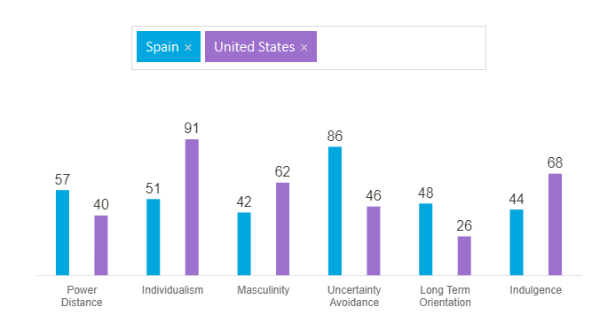
Looking at the graph, it shows how in some areas united states are higher than Spain however there are also some areas where Spain is higher than united states. Starting with power distance, Spain's score on this aspect 57 is a high score (Hofstede Insights, 2011), and that implies that Spain has a various levelled society. In the other hand United States scores 40 in this dimension which implies how there is not a levelled society. In the second dimension it is shown that the United States is much higher than Spain this is due to the how formal the Americans are when it involves working. Overall looking at the graph, most of the higher scores in dimensions are from United states. This suggests how well United States manages to keep the place balanced leading to less individuals from the country and guests from hotels from leaving due to how stable the country is.

Conclusion
Overall, Social contrasts really do affect organizations happening in diverse settings. A ton of issues emerge in issues of support, correspondence, and other social regions. In any case, if hotel Marriott encounters any problem due to culture, the hotel as for Hofstede's six social aspects, these issues can be investigated through an alternate point of view, and essential strides to resolve these issues can be taken.

Reference:
- Agar, M., Language Shock: Understanding the Culture of Conversation,” New York: Quill 1994.

Bethesda,. 2018. Marriott International Expands “Culture Day” Program Worldwide In 2018. Available at: https://news.marriott.com/ (Accessed at: 8, November 2018).

- Brendan McSweeney, “Hofstede’s Model of National Cultural Differences and Their Consequences: A Triumph of Faith– A Failure of Analysis,” Human Relations, Volume 55, No. 1, 2002, pp. 89-118.

- Bosrock, M. M. (2006). European business customs & manners. Minnetonka, Minn: New York: Meadowbrook Press; Distributed by Simon & Schuster.

- eDiplomat. (2010). Cultural Etiquette: United States. In eDiplomat. Retrieved March 14, 2015.

- 43 Gert-Jan M Linders, et al., “Cultural and Institutional Determinants of Bilateral Trade Flows,” Timbergen Institute Discussion Paper, TI 2005-074/3

- Hofstede Center. (n.d.a). Country Comparison: Spain. In Cultural Tools. Retrieved April 2, 2015.

- Hofstede Insights,. 2011. The Comparison Between Two Countries Using the 6 Dimensions. Available at: https://www.hofstede-insights.com/ (Accessed at: 13, June 2011).

- Site Minder,. 2021. Cultural Sensitivity: Does your hotel cater for all guests? Available at: https://www.siteminder.com/ (Accessed at: 23, August 2021).

- Trompenaars and Charles Hampden-Turner, Riding the Waves of Culture: Understanding Cultural Diversity in Business (2nd ed.), 1997, London: Nicholas Brealey.

