Difficult Heritage: Chernobyl – Matthew Morris – 1908777

Chernobyl, Ukraine – On the 26th of April 1986, during the maintenance restart of reactor four within the nuclear power plant, a surge of energy and subsequent accident resulted in the ‘world’s worst nuclear accident’ (Stone, 2013, pp. 1). Furthermore, this accident took place at a time of political notoriety, in which Ukraine at the time, was the Ukrainian Soviet Socialist Republic. This was the time of communist rule in which the Ukrainian SSR acted as a ‘pseudo-state’ (Wolczuk, 2013, pp. 29-58) to its Soviet overlords, mirroring their Soviet architecture, design, and political sentiments. The accident at the plant, caused the nearby city of Pripyat and surrounding areas to be evacuated, with two radiation exclusion zones set up at 10km and 30km rings around the power plant. Today, the city is frozen in time covered with Soviet architectural installations, houses, and motifs. Former citizens belongings lay abandoned with nature reclaiming much of the Exclusion zone and urban areas. While tourists (legal and illegal) visit to see a site of such tragedy and media attention. Which has led to many debates over the future heritage and how to address and present the tragic former heritage of such a locale. Within this essay, the aim will be to give insight into the difficult history and heritage of Chernobyl (Banaszkeiwicz et al, 2017), in addition to how this can be developed, re-negotiated, and perhaps re-considered.
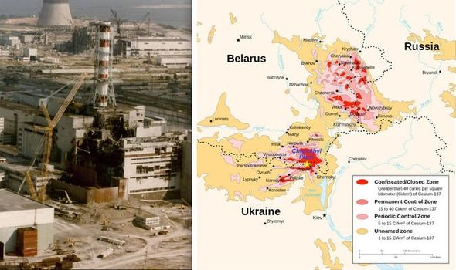
Fig 1. (Kettley, 2020) Displays the Zones of the Chernobyl accident, including how far spread the radiation travelled, affecting not just Ukrainians, but Belarusians, as well as Russians. Indicating perhaps a shared (radioactive) heritage in the wake of Chernobyl.
It is important to note that even before the construction of the reactor the Chernobyl region had gone through turbulent political and cultural events. Ranging from the Soviet purges in the 1930’s ‘radically resettled the region- deporting nearly half the regions Poles and Germans’ (Hryhorczuk, 2013, pp.6). During WW2, a place once known as the borderland had become the ‘Bloodlands’ (Snyder, 2010). The region of Chernobyl had been subject to war, deportations, re-population, de-population, and then radiation. Much of this pre-Chernobyl cultural history has been replaced by the ‘shadow of the Chernobyl reactor accident’ (Hryhorczuk, 2013, pp.7), as this is the primary heritage addressed when people think of Chernobyl in cultural memory. Despite this rich past cultural history much of the contemporary difficulty with Chernobyl’s heritage lies in its Soviet and nuclear past and its future.
The Exclusion Zone contains many buildings bearing heraldry of Ukraine’s Soviet past. A clear reminder the of Soviet’s Unions control, which the Soviets may have installed as an ‘impression of a homogenous country’ (Rudnytsky, 1972, pp. 235). Yet wisely as Rudnytsky (1972) ascribes; ‘The nations which compose the Soviet Union are ethnic and cultural entities with long past’s’. After the collapse of the Soviet Union in 1991 (Schmemann, 1991) many satellite States, gained their independence, including Ukraine. Ukrainians had a long a difficult history with their Soviet Union, with many still possessing strong anti-Soviet mentalities after Stalin’s 1932-33 ‘Holodomor’ (Ukrainian word for ‘starvation’ and ‘inflicting death’) claimed the lives on ‘3.9 million’ people, approximately thirteen percent of the Ukrainian population (Kiger, 2019). In place like Chernobyl, certainly there is too a degree a push to ‘disengage Ukraine from its soviet past’ (Kravchenko, pp. 447), which many Ukrainians echo in ideologies of de-communization, which many views as ‘Justice to the victims of Communist totalitarian regime’ (Hrynykha, 2019).
Yet in a place like Chernobyl these counter-monuments (Stevens et al, 2012) of abandoned and decayed buildings in memory of a Communist past, offer something more historic, and informative as it has been describing as ‘a communist paradise’ (Williams, 2017), in which time Froze. Offering the unique opportunity to explore the past, through an inhabited city, full of symbols, emblems of a Soviet past. w
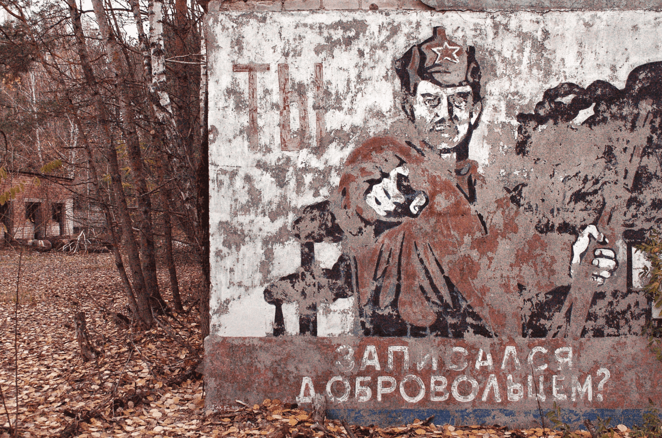
Fig 2. (Kahveci, 2019) Pripyat was a city founded for the power plant workers, offering ‘a higher standard of living than was available across most of the union’ (Kahveci, 2019). The faded message notes Soviet pride and says: “Have you Volunteered?”, displaying the reality of Soviet life, and one of the many deteriorating urban areas in the zone. Also noting the how Pripyat different from other ‘atomgrads’ (atomic cities), while other ‘atomgrads’ changed and evolved, becoming ‘adapted for new industries, with a different style of living, Pripyat was frozen in time’ (Richter, 2021). As aforementioned socialist lore is steadily becoming extinct in Ukraine, in 2013 legislation had all ‘communist symbols outlawed’ (Panagopoulos, 2019), Chernobyl and its Exclusion Zone is fast becoming the last memorial or commiseration to its communist past. Memory of the past is important, despite Ukraine’s decommunizing beliefs, factual representation, and documentation should be applied to Chernobyl, treating it as a place to explore Soviet society, but also the rapidly re-wilding of the Zone, and how this could contribute to future Ukrainian and world heritage.
For many visitors to Chernobyl’s EZ, it is a place of mystery, exploration, and the distant past, considerably more so among younger individuals ’inspired by memories of Chernobyl’ (Khan, 2017), and born after the Chernobyl disaster. This younger generation interact with Chernobyl’s heritage in a different way, by exploring, scavenging, and re-discovering through dangerous irradiated areas, in some respects it is almost a post-apocalyptic rite of passage. These intrepid explorers identify themselves as ‘Stalkers’ based upon Soviet Media; Roadside Picnic by the Strugatsky Brother (1971), and Stalker by Andrei Tarkovsky (1979), both made pre-Chernobyl, but both capture the essence of post-industrial and post-apocalyptic romantics. Developed by Stone (2013), Chernobyl represents ‘an-Other place’, a ‘heterotopia’ (Stone, 2013 pp. 15) in which one can gaze upon the familiar and the unfamiliar, in a surreal locale.
To the Stalker subculture it explores for many the direct issues of heritage and remembrance as one stalker interviewed by Morris (2014) of Scale said: ‘my grandfather worked in the zone against his will; I go because I want to’, as Morris continues; ‘(Chernobyl remains) an open wound for their parents and grandparents’ (Morris, 2014). Offering perhaps the different ways generations deal with their shared heritage, with some viewing it as a tragic place of misery and death, while some others view it as a land of mystery and an opportunity, and fantasy to explore and define parts of their heritage. Stalkers experience a different more unregulated Exclusion zone, creating a unique memory in their own terms, seeing themselves as ‘students of history and documentarians-preventing the memory of Chernobyl from falling into oblivion’ (Khan, 2017). Stalkers do offer unique but often problematically individual reasons for visiting the zone, being personal, media based or thrill seeking. The stalkers’ themselves have become part of history of the Exclusion Zone, in which radiation and illegality are thrown away, and they choose to escape and visit this abandoned city of their forefathers, taking in the sights and sounds of the EZ. Stalkers will remain a prominent, albeit illegal part of Chernobyl’s heritage. Representing Chernobyl’s dark allure to the young, in which they can explore the Urban remains of their countries political and culture invoking ‘generational difference’ (McDonald, 2009, pp. 175)
To stalkers and many other visitors to Chernobyl the meanings and memories of past human experiences are remembered via interactions with material places and environments, through performance enacted upon and with, meanings and memory may differ between individuals, or otherwise be remade or rewritten (Smith, 2006). Chernobyl attracts people to create these interactions, forming new memories and meaning amongst environment of the EZ. Contributing to its growing heritage, by being a spot of dark and tragic history.
The Nuclear remnants of Chernobyl remains another difficult aspect of its heritage, due to the range and spread of damage the reactor did. Depositing radioactive matter in many parts of Europe, killing two workers on the night of the accident, and twenty-eight died within weeks due to radiation syndrome (World Nuclear Association, 2020). Furthermore, the USNEAR (United Nations Scientific Committee on the Effect of Atomic Radiation), has reported that 6500 thyroid cancers resulting in 15 deaths as a result of the Chernobyl disaster. Although they further concluded the now lower radiation levels posed as ‘non-significant to public health’ (Canadian Nuclear Safety Commission, 2018). Meaning perhaps re-negotiation of the heritage as more than just site of the worst nuclear disaster, but something that can benefit Ukraine, the world, and future generations, as a place of learning and beauty.
For many people, especially older generations the Chernobyl Exclusion zone remains a place of tragic events, being surmised as a ‘cemetery’ (French, 2016, pp. 2). This perception of Chernobyl as a cemetery is particularly poignant, as this can be attributed to the deaths, long term health-issues and illnesses amongst the workers, liquidators, former civilians, and children affected by radioactive materials (CNSM, 2018). has left Chernobyl with a heritage of sickness, death, and perhaps an air of mystery at the empty city scape. Despite these notions, Chernobyl’s flora and fauna have flourished, contributing to a more accessible and positive heritage
The Ukrainian Government has been proactive in preparation for future development of the site, with the Implementation of a sarcophagi (Pictured below in fig 3), acting to prevent the release of radioactive and contaminated material. Arguably paving the way for new developments and re-consideration of the area in and around Chernobyl, providing a further reduction to radiation levels and much needed stability for the environment for up to 100 years (Borys, 2017).
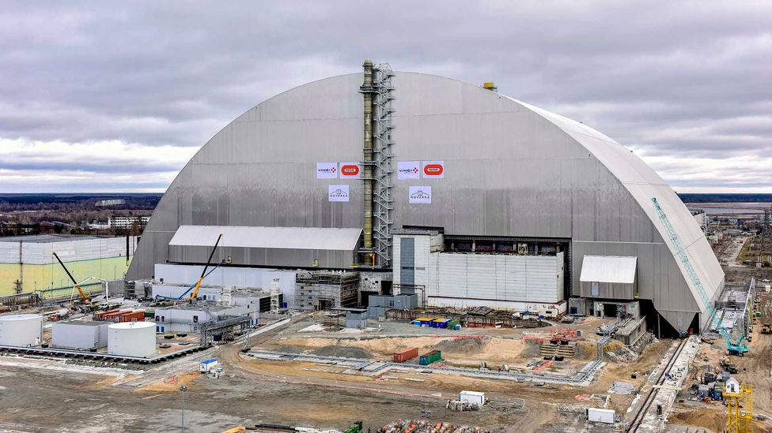
Fig. 3 (Novarka, 2017)
The issue remains on the future of Chernobyl, how to re-consider, and expand interpretations of the site. Currently, the Ukrainian government ensuring a future for the site in which Ukrainian President Volodymyr Zelenskyy, signed a Decree to forward the development of the Exclusion zone into a ‘green corridor’ (Zelensky, 2019) for tourists. More-over a greater development of the zone, ‘waterways, checkpoints, and prohibitions of filming on site will be abolished’ (Zelensky, 2019). Not that illegal filming has stopped people, but these reconsiderations are correct direction for the rehabilitation of Chernobyl, the conversion of the macabre and dark into something with ‘New life- Until now, Chernobyl was a negative part of Ukraine’s brand, it’s time to change it’ (Zelenskyy, 2019). Zelenskyy understands that development is key to the future of the Chernobyl region, and while it is increasing popular with dark tourists. The government wish rightly, to move beyond just the dark tourism, and offer it as a spot of outstanding beauty, capable of once again contributing to the economy, and being not a place of fear but new opportunities.
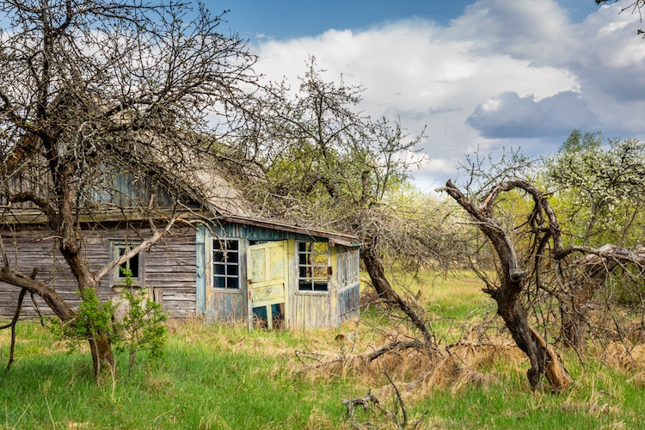
Fig 4. (Weges, 2019).
Depicting the reclamation by nature, a slow and continuous process of re-birth in Chernobyl and the Exclusion zone. Despite the loss off life, fallout and soviet industrialism in the area ‘Chernobyl has become a haven for all types of wildlife’ (Stewart, 2019). Ukraine further seeks to obtain planning for the conversion of parts of the zone into a potential UNESCO World Heritage Site, which could be hugely beneficial to restoring and cultivating the area of Chernobyl into a safe refuge for plants and animals. In addition, it would ‘help regulate traffic’ (McGreevy, 2020) to the area, acting to reduce the trafficking of contaminated objects from the zone, which by being taken are reducing the integrity and quality of heritage in the zone.
Ultimately the development of a UNESCO Heritage is a difficult task due to the political and sensitive nature of Chernobyl. Its Soviet past must be considered and not erased in the construction of ‘Green zones’. As it does represent a part of collective cultural memories of ex-Eastern block states. Following Assmann’s (1995) Ideology we can analyse these cultural memories constructed within Chernobyl, in which ‘cultural memory is a form of collective memory’ (Assmann, 1995), which is shared amongst others and adds to ‘cultural identity’ (Assmann, 1995 pp.110).
Undoubtedly, Chernobyl remains part of a cultural identity of Ukrainians, forming associations and relationships with Chernobyl based upon ‘Communicative Memory’, of soviet political legacies, radiation, and the suffering and death it caused. Instead, these could be re-developed once again, into a ‘New Chernobyl’, addressing what Chernobyl will become, it will not have to lose its past heritage. As precedented with Auschwitz and the Hiroshima Atomic bomb dome, both becoming UNESCO World heritage sites in 1997. Which both represent areas of former tragedy, while keeping their respective dark heritage in intact . Chernobyl could become ‘one of Europe’s largest nature preserves’ (Thompson 2019) with ‘Wolves, boars, bears returning to the forest’ (Thompson 2019). Moreover, some 100 species on International Union for Conservation of natures Red List can now be found in the exclusion zone (Hryhorczuk, 2013). These newly resettled species gives a unique and special hope of regeneration with Chernobyl. The Nature reserve not only offers a chance at natures regeneration, but also the influx of tourists to sustain the development of the ‘Exclusion zone’’
Despite the hope re-wilding and re-confronting the past has for Chernobyl the EZ does still face issues. The growth of larger wild and re-claimed areas has left the Zone at greater risk of Forest fires, which in April 2020 was the ‘biggest fires ever recorded in the Chernobyl exclusion zone’ (Alimov 2020). These fires possess a huge problem to the UNESCO proposal for Chernobyl, as they threaten the security of the newly build sarcophagus, more problematic still is the release of ‘radionuclides’ (Alimov, 2020) from the fire, which has been releasing heavily contaminated and less deadly particles of ‘caesium-137 to deadly plutonium-239’ (Alimov, 2020). These fires release these particles over long distances, expanding the reach of radioactive fallout, with these fires occurring on an almost annual basis, it does question the integrity and risk to building an UNESCO heritage site, in a place that is still environmentally stabilising.
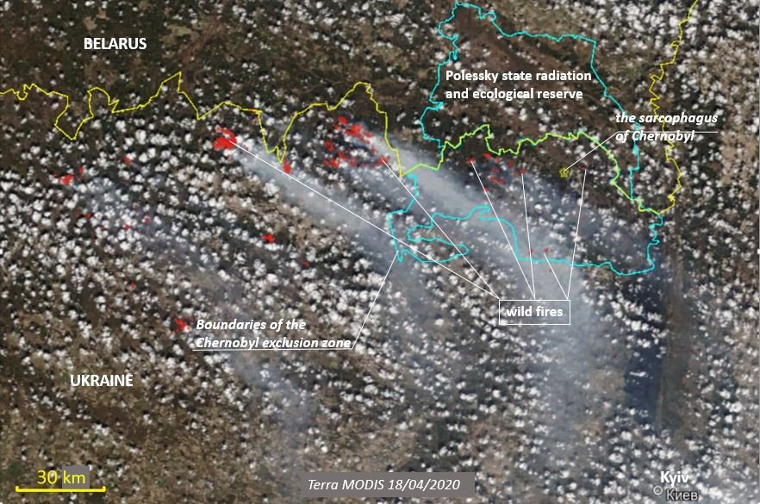
Fig.5 (Alimov, 2020) Displaying the fires that re-disturb the radioactivity of Chernobyl and represent a very real, and dangerous threat of radiation, to the surrounding region. Suggestions to avoid these plumes of radioactive debris could Involve the re-sitting/re-consideration of part of Chernobyl. In which the City of Slavutych (established 1986) which ‘owes its existence to the Chernobyl explosion, and it is (one of the last) major feats of social and physical soviet engineering’ (Fedykovych, 2019). Created for the plant workers who were never to return to Chernobyl, it perpetuates a similar message, of Soviet power, strength and engineering ability. Yet perhaps this town of Slavutych, offers an escape from dangerous radioactivity unearthed by wildfires in Chernobyl, perhaps the addition of Heritage green zones in the Slavutych area, could act as an experiment for the larger number of people who may visit to a formerly abandoned zone turned heritage site. The clean-up for an area like Chernobyl is expected to continue to ‘at-least 2065’ (Blakemore, 2019) so it is important to consider other prospects when facing the prospect of radiation.
Chernobyl represents a diverse but also an extraordinary opportunity to re-constitute its heritage. The debate largely remains over the impact to the ecosystem being minimal or noticeable, it largely varies, depending on individual organisms’ ability to survive in radioactive environments. The future for Chernobyl, lies in the development of its ecotourism (Hryhorczuk, 2013 pp. 80), in which Ukraine stands a chance for economic recovery and can display both it is Soviet past and newly created national park and ideally UNESCO Heritage site. In which unique features of the natural environment are developed and extensively managed.
We live in age where heritage is ever-present (Harrison, 2012), The EZ of Chernobyl represents difficult heritage and dark tourism simultaneously. The dilapidated building’s attract Stalkers in search of the unknown, and mysterious-fictitious nature of the zone. The abandoned and overgrowing cities begin to restore the city to a natural heritage aided by the return of animal species. The radiation has allowed Chernobyl to stay as a monument to the past, and ultimately become something more than a nuclear disaster. Configuring itself into a nature sanctuary, capable of educating younger generations. Ukraine’s hope of re-considering this site, involves UNESCO. In which it must past at least one of the ten criteria, of which it meets multiple including ‘biological and ecological processes’, ‘reference to history or living traditions’ (cultural) and the current on-site preservation of biodiversity (natural) (McKendrick, 2020). This would provide the funding, through promoted eco-tourism and loans, to develop Green areas, which could then be used to support wildlife, or reinvested to help combat latent radiation and forest fires. Furthermore, the structural reinforcement of important buildings within the zone, such as the sarcophagi and soviet buildings, would allow further future generations to experience nature and explore ex-urban areas, in a safer environment, that would teach them of the multifaceted heritage of Chernobyl.
Chernobyl has already begun its process of transforming into a heritage site not only through growing tourism but also the synthesis between lowering nuclear levels, resurgence of nature and identification and education on Soviet political heritage. Remembering that these places of difficult (MacDonald 2009), heritage are far less numerous than their counterparts and their importance to ‘preserve them in order to remind humanity about catastrophes, that could be avoided in the future’ (Storm, 2020). Heritage conservation is a part of cultural politics, it’s about links between ideology, public policy, as well national and community identity formation.

References:
Alimov, R. (2020) Chernobyl Still Burns, Article, Published by: Greenpeace, Url: https://www.greenpeace.org/international/story/30198/chernobyl-still-burns-forest-fires-ukraine-nuclear-radiation/, Accessed online: 07/02/21
Assman, J. Czaplicka, J. (1995), Collective Memory and Cultural Identity, New German Critique, Cultural History/Cultural Studies, No. 65, pp.125-133, published by: Duke University Press, Url: https://www.jstor.org/stable/488538?seq=1, accessed online: 07/02/21
Banaszkiewicz, M. Kruczek, Z. Duda, A. (2017), The Chernobyl Exclusion Zone as A Tourist Attraction. Reflections on the Turistification of the Zone, No. 44, pp. 145-169, Published by: Folia Turistica, Url: https://www.researchgate.net/publication/323591865_THE_CHERNOBYL_EXCLUSION_ZONE_AS_A_TOURIST_ATTRACTION_REFLECTIONS_ON_THE_TURISTIFICATION_OF_THE_ZONE, Accessed online: 06/02/21
Blakemore, E. (2019), The Chernobyl disaster: what happened, and the long-term impact, Published by: National Geographic, url: https://www.nationalgeographic.co.uk/environment/2019/05/chernobyl-disaster-what-happened-and-long-term-impact, Accessed online: 07/02/21
Borys. C. Novarka, (2017), A vast Tomb for the most dangerous waste in the world, Article, Published online: BBC Future, Url: https://www.bbc.com/future/article/20170101-a-new-tomb-for-the-most-dangerous-disaster-site-in-the-world, Accessed online: 07/02/21
Canadian Nuclear Safety Commission, (2018), Health Effects of the Chernobyl Accident, published online: nuclearsafety.gc.ca, Url: https://nuclearsafety.gc.ca/eng/resources/health/health-effects-chernobyl-accident.cfm, accessed online: 07/02/21
Fedykovych, P. (2019) Inside Slavutych, the city created by the Chernobyl explosion, published by: CNN Travel, url: https://edition.cnn.com/travel/article/chernobyl-slavutych-ukraine/index.html, Accessed online: 07/02/21
French, N. (2016), Gazing at Pripyat from East and West: a ruin of contemplation, published by: University of Birmingham, url: https://www.york.ac.uk/media/history/russianenvironment/chernobyl/Nadia%20Pripyat.pdf, accessed online: 06/02/21
Harrison, R. (2012), Heritage, Critical Approaches, No. 1 pp. 1 -288, Published by: Routledge, Url: https://www.routledge.com/Heritage-Critical-Approaches/Harrison/p/book/9780415591973, accessed online: 07/02/21
Hryhorczuk, N. (2013), Radioactive Heritage: An autoethnographic investigation of Chernobyl as Dark Heritage Site, Vol. 1, pp. 1-97, Published by: University of Illinois, Url: https://www.ideals.illinois.edu/bitstream/handle/2142/46781/Nicholas_Hryhorczuk.pdf?sequence=1&isAllowed=y, Accessed online: 06/02/21
Hrynykha, A. (2019), Ukraine’s De-Communization: Pros and Cons, Article, Published by: Ukraine world, Url: https://ukraineworld.org/articles/ukraine-explained/ukraines-de-communization-pros-and-cons, Accessed online: 06/02/21
Kahveci, E. (2019), Frozen in Time, Chasing Demons, Article, Published by: Hidden Compass, Url: https://hiddencompass.net/story/frozen-in-time/, Accessed online: 06/02/21
Khan, G. (2017), Chernobyl’s Dead Zone: See Photos Taken on Illegal Visits, Article, Published by: National Geographic, Url: https://www.nationalgeographic.co.uk/adventure/2017/12/chernobyls-dead-zone-see-photos-taken-illegal-visits, accessed online: 07/02/21
Kravchenko, V. (2015), Fighting Soviet Myths: The Ukrainian Experience, Harvard Ukrainian Studies, The future of the past: New perspectives of Ukrainian History Vol. 34, No. 1/4, pp. 447-484, Published by: Harvard Ukrainian Research Institute, Url: https://www-jstor-org.ezproxy.uwtsd.ac.uk/stable/44364503?seq=4#metadata_info_tab_contents, Accessed online: 06/02/21
Logan, W. Reeves, K. (2008) Places of Pain and Shame, Dealing with ‘Difficult Heritage’, Vol 1, pp. 1-308, Published by: Routledge, Url: http://routledge.com/Places-of-Pain-and-Shame-Dealing-with-Difficult-Heritage/Logan-Reeves/p/book/9780415454506#:~:text=Places%20of%20Pain%20and%20Shame%20is%20a%20cross-cultural%20study,these%20cases%20%E2%80%93%20or%2C%20conversely%2C, accessed online: 07/02/21
Macdonald, S. (2009) Difficult Heritage, Negotiating the Nazi Past in Nuremberg and Beyond, Vol.1 pp. 1-240. Published by: Routledge, Url: https://www.routledge.com/Difficult-Heritage-Negotiating-the-Nazi-Past-in-Nuremberg-and-Beyond/Macdonald/p/book/9780415419925, accessed online: 07/02/21
McGreecy, N. (2020), Ukraine Seeks to Designate Chernobyl as a UNESCO World Heritage Site, Published online: Smithsonian Magazine, url: https://www.smithsonianmag.com/smart-news/ukraine-proposes-chernobyl-unesco-world-heritage-site-180976567/, accessed online: 07/02/21
McKendrick, F. (2020), What is a World Heritage Site, Published by: National Trust, Url: https://www.nationaltrust.org.uk/features/what-is-a-world-heritage-site#:~:text=A%20World%20Heritage%20Site%20is,present%20and%20for%20future%20generations., Accessed online: 07/02/21
Morris, H. (2014), The Stalkers, Inside the Bizarre subculture that lives to explore Chernobyl’s Dead Zone. Published online: Slate, Url: https://slate.com/news-and-politics/2014/09/the-stalkers-inside-the-youth-subculture-that-explores-chernobyls-dead-zone.html, accessed online: 07/02/21
Panagopoulos, E. (2019), The Pantheon of Energy: mythology and symbolism in Chernobyl, Published online: Explorabilla, Url: https://explorabilia.co.uk/2019/06/12/the-pantheon-of-energy/, accessed online: 07/02/21
Ritcter, D. (2021), Chernobyl: The Stalkers’ Guide, A step inside the irradiated heart of the nuclear power plant, Article, Published by: GreyScape, url: https://www.greyscape.com/chernobyl-a-stalkers-guide/, Accessed online: 06/02/21
Rudnytsky, I.L. (1972), The Soviet Ukraine In Historical Perspective, Canadian Slavonic Papers / Revue Danadien ne des Slavistes, Vol. 14, No. 2, pp. 235-250, Published by: Taylor & Francis, Ltd, Url: https://www-jstor-org.ezproxy.uwtsd.ac.uk/stable/40866431?seq=1#metadata_info_tab_contents, Accessed online: 06/02/21
Schmemann, S. (1991), End of the Soviet Union; The Soviet State, Born of a Dream, Dies, Article, Published by: New York Times, Url: https://www.nytimes.com/1991/12/26/world/end-of-the-soviet-union-the-soviet-state-born-of-a-dream-dies.html, Accessed online: 06/02/21
Snyder, T. (2010), Bloodlands, Europe Between Hitler and Stalin, pp. 316-338, Published by: Basic Books, Url: https://www.bisla.sk/english/wp-content/uploads/2014/03/Timothy-Snyder-Bloodlands-ethnic-cleansing.pdf, Accessed online: 06/02/21
Stevens, Q. Franck, K.A. Fazakerley, B. (2012), The Journal of Architecture, Counter-monuments: the anti-monumental and the dialogic, Vol 16, No, 6, pp. 951-972, Published by: Taylor and Francis, Url: https://www.researchgate.net/publication/260991298_Counter-monuments_the_Anti-monumental_and_the_Dialogic, Accessed online: 07/02/21
Stewart, J. (2019), Chernobyl Has Transformed into an Incredible Nature Reserve Now Open to the Public, published: My Modern Met, Url: https://mymodernmet.com/chernobyl-wildlife-tours/, accessed online: 07/02/21
Stone, P.R. (2013), Dark Tourism, Heterotopias and Post-Apocalyptic Places: The Case of Chernobyl, Edited by: L. White, & E. Frew Dark Tourism and place identity, pp. 1-20, Published by: Routledge, Url: http://clok.uclan.ac.uk/27724/1/27724%20fulltext_stamped-3.pdf, accessed online: 06/02/21
Storm, A. (2020), Will Chernobyl become a World Heritage Site? Published online: Atomic heritage, Url: https://atomicheritage.wordpress.com/2021/01/04/20th-anniversary-of-the-chernobyl-npp-closure-will-it-become-a-unesco-world-heritage-site/, accessed online: 07/02/21
Williams, S. (2017), The town Chernobyl built: how former Soviet paradise Slavutych could save the nuclear industry, Article, Published online: Wired, Url: https://www.wired.co.uk/article/slavutych-chernobyl-nuclear, Accessed online: 07/02/21
Wolczuk, K. (2001), Moulding of Ukraine, The constitutional politics of State Formation, Chapter two: In search of a tradition: discontinuities of statehood in Ukraine’s history, pp. 29-58, Published by: Central European University Press, Published online by: OpenEdition Books (2013), url: https://books.openedition.org/ceup/1739?lang=en, Accessed online: 06/02/21
World Nuclear Association, (2020), Chernobyl Accident 1986, Safety and Security, Safety of Plants, Chernobyl Accident, Published: world-nuclear.org, Url: https://www.world-nuclear.org/information-library/safety-and-security/safety-of-plants/chernobyl-accident.aspx, accessed online: 07/02/21
Zelenskyy, V. (2019), Head of State signed a decree on the Development of the Chernobyl Exclusion Zone, Published by: President of Ukraine, Url: https://www.president.gov.ua/en/news/glava-derzhavi-pidpisav-ukaz-shodo-rozvitku-chornobilskoyi-z-56321, Accessed online: 07/02/21
Smith, L. (2006), Uses of Heritage, No. 1, pp. 1-368(77), Published by: Routledge, Url: https://www.taylorfrancis.com/books/uses-heritage-laurajane-smith/10.4324/9780203602263, Accessed online: 07/02/21

Picture References:
Fig 1 – Kettley, S. (2020), Chernobyl MAPPED: Countries that were affected by Chernobyl - radiation map revealed, Published online: Express, Url: https://www.express.co.uk/news/science/1141514/Chernobyl-map-radiation-fallout-what-countries-affected-chernobyl-radiation, accessed online: 06/02/21
Fig 2 - Kahveci, E. (2019), Frozen in Time, Chasing Demons, Article, Published by: Hidden Compass, Url: https://hiddencompass.net/story/frozen-in-time/, Accessed online: 06/02/21
Fig 3. Novarka, (2017), A vast Tomb for the most dangerous waste in the world, Article, Published online: BBC Future, Url: https://www.bbc.com/future/article/20170101-a-new-tomb-for-the-most-dangerous-disaster-site-in-the-world, Accessed online: 07/02/21
Fig 4. Weges, H. (2019), Chernobyl Has Transformed into an Incredible Nature Reserve Now Open to the Public, Published: My Modern Met, Url: https://mymodernmet.com/chernobyl-wildlife-tours/, accessed online: 07/02/21
Fig 5. Alimov, R. Greenpeace Global Mapping Hub Source, (2020), Chernobyl Still Burns, Article, Published by: Green Peace, Url: https://www.greenpeace.org/international/story/30198/chernobyl-still-burns-forest-fires-ukraine-nuclear-radiation/, Accessed online: 07/02/21

