ECIE4012
The Principles of Learning and Teaching

Portfolio

Student Number:
2307774

Blog 1
Demonstrate your understanding of a theory of learning from the following list: Bruner, Skinner, Piaget, Vygotsky, Froebel

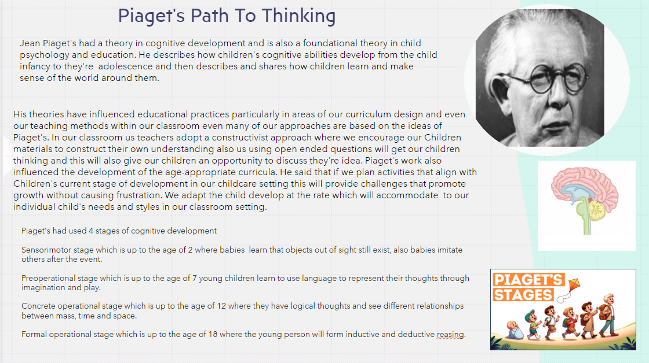

Blog 1: Reference list
Jean Piaget’s theory of cognitive development https://www.earlyyears.tv/piagets-theory-of-cognitive-development/ (accessed:04.01.25)

Piaget’s theory (psychology AQA) at: https://www.tes.com/teaching-resource/piaget-s-theory-gcse-psychology-aqa-12880717 (accessed:04.01.25)

Piaget’s theory of cognitive development at: https://www.youtube.com/watch?v=2spOA-H6JEY (accessed:04.01.25)

Simply psychology (2024) Piaget’s theory and stages of cognitive development- website (accessed:04.01.25)

Blog 2
Demonstrate your understanding of a theory of learning from the following list:
Bruner, Skinner, Piaget, Vygotsky, Froebel. The theory must be different to Blog 1.

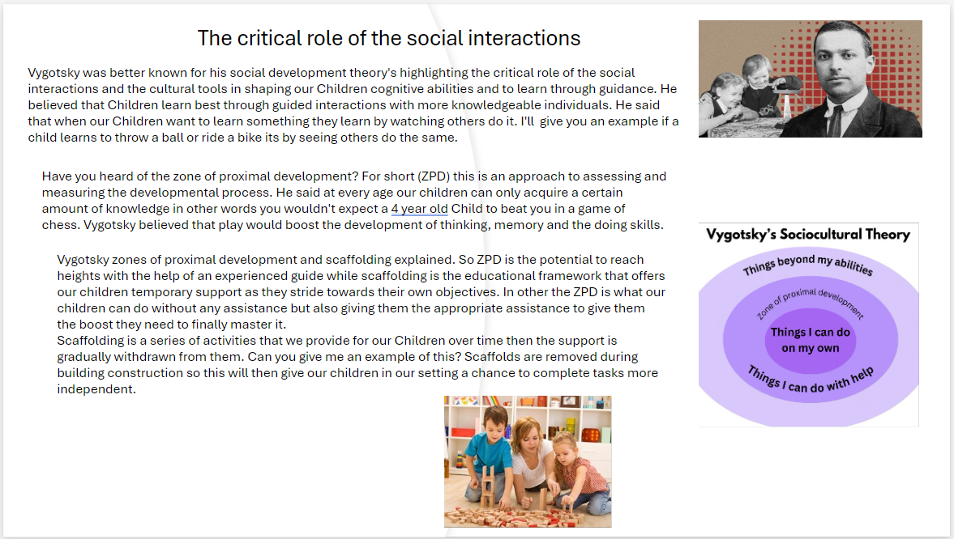

Blog 2: Reference

Center for Children and youth https://ccy.jfcs.org/scaffolding-your-childs-whole-development/ (accessed:04.01.25)

Explore psychology (2024) Vygotsky’s social development theoryhttps://www.explorepsychology.com/vygotsky-social-development-theory/ (accessed:04.01.25)
Mozart of psychology: how lev Vygotsky helped shape modern thinking (2020) https://www.rbth.com/education/332871-vygotsky-soviet-psychology (accessed: 04.01.25)

Vygotsky’s zone of proximal development and scaffolding https://www.skillshub.com/blog/vgotskys-zone-proximal-development-scaffolding/ (accessed:04.01.25)

Blog 3
Identify, discuss, and evaluate the theoretical approaches to learning linked to your theories from Blogs 1 and 2.
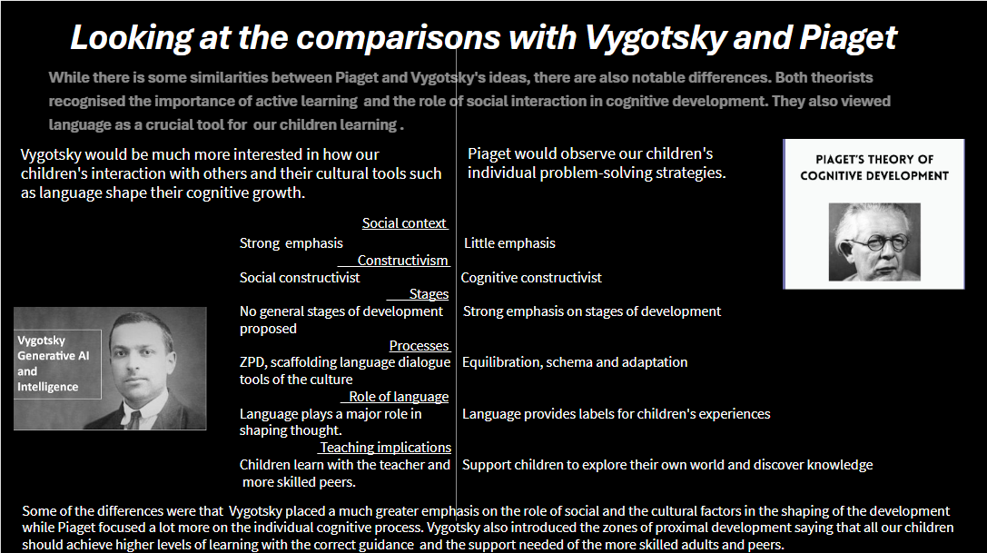

Blog 3: Reference
Early years tv comparison with lev Vygotsky -theory https://www.earlyyears.tv/piagets -of-cognitive-development/ (accessed: 05.01.25)

Simply Psychology (2024) https://www.simplypsychology.org/piaget.html (accessed:05.01.25)

Simply Psychology (2024) Vygotsky vs. Piaget: A paradigm shift https://www.simplypsychology.org/piaget-vs-vygotsky.html (accessed:05.01.25)

Vygotsky, language, intelligence and AI (2023) https://donaldclarkplanb.blogspot.com/2023/06/vygotsky-language-intelligence-and-ai.html (accessed: 05.01.25)

Blog 4
Draw on experiences from your own setting to identify resources and strategies used to support effective teaching and learning, linking back to your chosen theories in Blogs 1 & 2

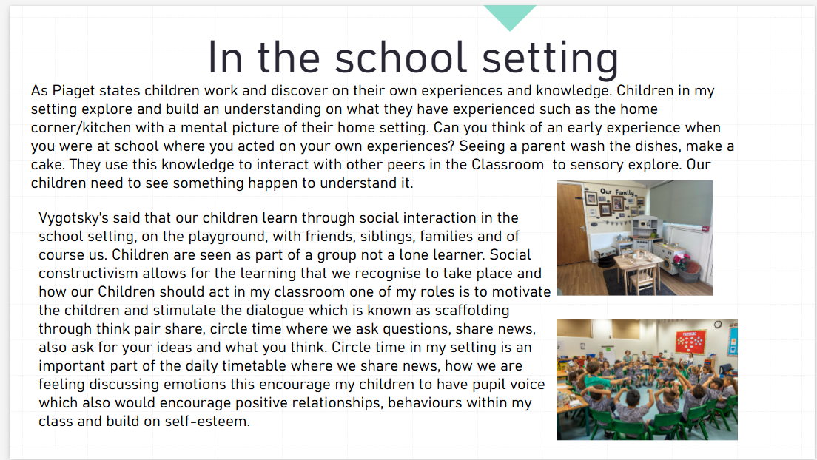

Blog 4
Reference list

Hope is all you need https://blog.hope-education.co.uk/home-corner-makeover-with-early-years-outdoor/ (accessed:05.01.25)

How circle time supports positive playtimes and mental health and wellbeing https://theresehoyle.com/wp-content/uploads/2022/01/Therese-15-1-1-scaled.jpg (accessed:05.01.25)

Simply Psychology (2024) Piaget’s Theory and stages of cognitive development https://www.simplypsychology.org/piaget.html (accessed:05.01.25)

