Professional career development
BMSW4005
Module Leader: Malani Gunaratnam
Submitted by: Neli Todorova
Student ID: 1909068

Table of Contents
Introduction 2
Reflection 2
Career plans 3
What employers want 3
Self-motivation 3
Learning Styles 4
Personal Development 4
Employment Goals 6
Conclusion 6
Bibliography 7

Introduction
I am Neli Todorova and originally, I am from Bulgaria. In this report, I will aim to reflect on my learning and career development, especially considering what I have learned in the Professional Career Development module of my university course. To start off, I am using a lifeline exercise to reflect on my career journey up to now. This includes a person picking a few turning points in their life, ‘indicating critical events or relationships along the way that shaped them’ (Thomas, 2008, p.111). Thinking of this model, I would pick the first lower point of my life when I was working as a waitress for minimum wage. My highest point would be developing my career and working as a Head Chef in Bulgaria. My next lower point would be having to move to the UK and work here as a cleaner because of financial difficulties which I experienced in my country. Seven years later, or in the present day, I am taking a course in Skills for the Workplace in order to improve my knowledge and be able to progress in my career in the UK. This is a higher point in my life as it consists of the opportunity to learn and grow academically and professionally. This report is an important part of the process as it focuses on reflections on my development, skills and future plans, which will help me construct what I have learned and the further steps I need to take in order to achieve my goals.

Reflection
An important part of the learning process is reflecting on different experiences in order to understand them and improve in the future. A model which is commonly used for reflection is Kolb’s Experiential Learning Cycle. Kolb claims that ‘learning is the process whereby knowledge is created through the transformation of experience’ (Kolb, 2015, p.49). In other words, by thinking of a certain experience and observing what it consisted of, one can draw conclusions from it and apply them in the future. Below is a diagram of the four stages of Kolb’s Experiential Learning Cycle.

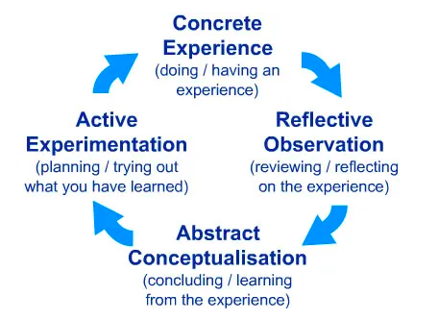
Source: McLeod, S. (2017) Kolb’s Learning Styles and Experiential Learning Cycle. Available at: https://www.simplypsychology.org/learning-kolb.html (Accessed: 1st August 2020).
In other words, this reflective model contains four steps which a person has to take in relation to an experience – do it, reflect on it, draw conclusions and construct or try to practice what they have learned. For example, I could use this cycle to reflect on the first assignment in Professional Career Development, an interview role play which we did on Microsoft Teams. Firstly, in class, I was interviewed by my partner for the position of Restaurant Manager. I had prepared some talking points in order to do well in the assignment. Later on, we had a chance to look at the marking scheme for the interview. Reflecting on this experience now, it was a good idea that I was prepared to answer the questions well, but I was still very nervous as I was being assessed. I now realise that this is one of the reasons for which I could receive a lower grade, or in real life, not get the job. What I learned from the experience is that I need to work on my anxiety in order to get better results in interviews. My plan for the future is to do more practice interviews, in order to get used to the dynamic and decrease the impact that my anxiety has on my performance.

Career plans
The skills I am building and reflecting on at this moment are a part of my bigger career plans. For example, the course for Skills for the Workplace which I am doing now has helped me learn about and practice some of the most important skills which employers look for. My future career goal is to have my own restaurant in the UK. Starting now, from working as a cleaner, I need to gather the necessary qualifications and experience in order to climb up the ladder, starting from the position of a Chef, building on to become a Head Chef, and finally establishing my own restaurant.

What employers want
An important thing for every person’s career journey is meeting employer expectations and requirements. According to Prospects, an organisation specialising in graduate careers advice, the top skills employers look for are resilience, good communication and effective leadership (Prospects, 2019). Reflecting on my experience and knowledge, I believe that I can demonstrate that I have these skills. Firstly, I have dealt with a number of setbacks in my life and career. I have faced financial difficulty and been forced to take on sudden change, such as moving to another country. Throughout all this time, I have remained resilient and I am still trying my best to grow professionally, by acquiring both new qualifications and experience. Secondly, I am a great communicator, as I have worked in both customer- and employee-facing jobs. Through this, I have managed to learn how to behave and talk to different types of people while striving for good business outcomes. Thirdly, I have the skill of effective leadership, as I have five years of experience in working as Head Chef in Bulgaria. During my time in this job, the restaurant received only one complaint which was related to the cooks’ work. After I worked with the team to ensure synchronicity, there were no further problems. This demonstrates that I can manage a number of people and ensure that everything is done efficiently.

Self-motivation
Another important trait or skill for professional career development is self-motivation. Self-motivation is defined as ‘encouraging yourself to continue making progress toward a goal even when it feels challenging’ (Robbins Research International, 2020). In other words, it consists of one’s ability to motivate themselves to keep going, despite the challenges they are facing. Reflecting on what allows me to motivate myself, there are many things I could give as an example. Firstly, I always think of my career development as a big journey. It is important to realise that the work towards any goal is not always easy. In every endeavour, there are many difficulties to overcome before getting to the finish line. I keep myself motivated by thinking of the lessons and new knowledge I gain from each difficult step and failed attempt. Secondly, I track my progress. I keep a diary of the important things I have achieved and the key skills I have gained from those achievements. By continuing to reflect and write about those developments, I have a visual representation that I have gotten closer to achieving my career goals. As a consequence, seeing the progress makes me motivated to keep going. Finally, I set small goals and accomplish them along the way. For example, I research things related to my goals, such as different types of cuisine, cooking techniques and the business models which top restaurants use. The more I enrich my knowledge, the more excited and motivated I am to work towards a goal that I am passionate about.

Learning Styles
Something I have found to be useful in acquiring new knowledge is being familiar with my personal learning style. An important tool for this is the VAK learning styles theory. The ‘VAK learning model’ claims that there are three different types of learners – visual, auditory and kinaesthetic (Macmillan, 2018). In other words, the first category learns best by visual information, the second – by sound, and the third – by movement. Reflecting on my learning style, I am mostly a visual learner. For example, I learn best by looking at diagrams, PowerPoint slides, or picturing things in my head when I am given instructions. Discovering this has been very helpful so far, as I realised how I absorb information best, and focused on taking notes and visualising things, which helped me remember things better in my university course. In the future, this can also help me in my career development. For example, when I take my course in culinary arts, I can use the same technique in order to maximise my learning and achieve good results. I can also use my ability to visualise things in my job, in order to follow instructions and develop new dishes as a chef.

Personal Development
In order to aid my personal development, I use some theories and models to increase my self-awareness. The first theory is Kolb’s Learning Styles Theory which is related to his Experiential Learning Model. It is concerned with the ways in which different people approach a task, and their emotional response to it. The different learning styles can be shown in the form of a matrix, pictured below:
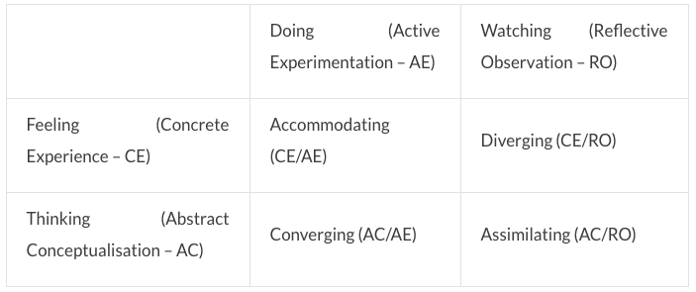
Source: Rumson, R. (2018) David Kolb’s Learning Styles. Available at: https://www.eln.io/blog/david-kolb-learning-styles (Accessed: 10th August 2020).
Reflecting on my experiences, I usually observe and reflect on things, and then think about what can be done better in theory. I am not emotional in my responses and not a very practical person. This means that according to Kolb’s theory, by learning style is Assimilating. In other words, I am more interested in the logic and theoretical aspects of experiences, rather than their practical and emotional aspects.

Another useful theory for discovering learning styles is Honey and Mumford’s Learning Styles Questionnaire. According to them, there are four different types of learners: activists, reflectors, theorists and pragmatists (Rosewell, 2005). In other words, the first type of people learns by acting on new experiences, the second – by reflecting on them, the third – by looking at the theory behind them, and the last – by trying out various things. Honey and Mumford’s theory is visualised below:

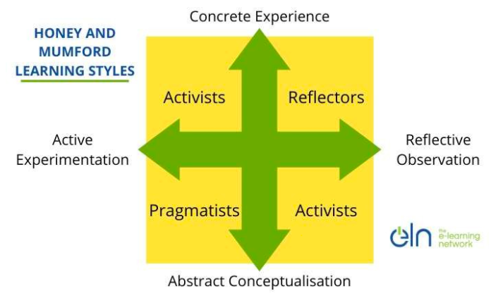
Source: Rumson, R. (2017) Honey and Mumford Learning Styles. Available at: https://www.eln.io/blog/honey-and-mumford-learning-styles (Accessed: 16th August 2020).

Reflecting on my own experience, similarly to Kolb’s theory, I consider myself to be a reflector as I learn best by observing and thinking about the tasks I am faced with.

Based on the reflection I have done in this report, I have constructed a SWOT analysis of my skills below:

- Current economic crisis
- Lack of employment opportunities

- Visual learning
- Reflecting on and gaining new knowledge from past experiences
- Different pathways towards becoming a chef
- Anxiety in interviews
- No academic qualification to be a chef
- Communication skills
- Experience in leadership
- Resilience
- Ability to self-motivate

Employment Goals
All the skills I have acquired and reflected on, are to be used towards my employment goals. My first career goal is to work as a Chef in London. In order to achieve this, I will need to acquire extra qualifications. According to the National Careers Service website, there are different pathways to becoming a chef. For example, one could choose between doing a university course in culinary arts or starting as a kitchen assistant and working their way up (National Careers Service, 2020). As I already have some experience as a chef in my country of origin, I am planning to do a university course in culinary arts. This would provide me with the necessary knowledge of cooking in this country and the qualifications in health and safety which are necessary for the job. In my second year of the course, I plan to start working as a chef so that when I graduate, I have everything necessary to be promoted to be a Sous Chef. Later on, I plan to work hard in order to become a Head Chef, and one day, open my own restaurant in the UK.

Conclusion
To conclude, in this report, I have reflected on my learning experience and skills in a variety of ways. For the future, I can use these different techniques to reflect and learn along my career journey. Below is a Personal Development Plan which I have constructed to outline the further steps I will take in my professional career development:

Current role: cleaner
- Cleaning houses
- Communicating with clients
- Writing invoices
Future goals:
- Become Head Chef
- Establish a restaurant
Next Steps | Development Needs | Steps to fulfil development needs
Develop the necessary knowledge and skills to be a chef in the UK | - Learn about health and safety  - Learn about new techniques  - Create new dishes | - Take the BSc (Hons) course in Culinary Arts Management in University of West London  - Research new cooking techniques and ideas online  - Practice the new knowledge by cooking at home
Gather knowledge on the restaurant industry in the UK | - Learn about market gaps in the hospitality/ restaurant market  - Research the essential resources to run a restaurant  - Improve leadership skills | - Do online research to determine the type of restaurant I will establish  - Create a business plan  - Take an online course in leadership skills

Bibliography

Kolb, D. A. (2015) Experiential Learning: Experience as the Source of Learning and Development (2nd edition). New Jersey: Pearson Education.

Macmillan, F. (2018) VAK learning styles: what are they and what do they mean?. Available at: https://engage-education.com/aus/blog/vak-learning-styles-what-are-they-and-what-do-they-mean/#! (Accessed: 8th August 2020).

McLeod, S. (2017) Kolb’s Learning Styles and Experiential Learning Cycle. Available at: https://www.simplypsychology.org/learning-kolb.html (Accessed: 1st August 2020).

National Careers Service (2020) How to become a chef. Available at: https://nationalcareers.service.gov.uk/job-profiles/chef (Accessed: 2nd August 2020).

Prospects (2019) What skills do employers want?. Available at: https://www.prospects.ac.uk/careers-advice/applying-for-jobs/what-skills-do-employers-want (Accessed: 3rd August 2020).

Robbins Research International (2020) What is self-motivation?. Available at: https://www.tonyrobbins.com/personal-growth/what-is-self-motivation/ (Accessed: 6th August 2020).

Rosewell, J. (2005) Learning styles. Available at: https://www.open.edu/openlearn/ocw/pluginfile.php/629607/mod_resource/content/1/t175_4_3.pdf (Accessed: 15th August 2020).

Rumson, R. (2017) Honey and Mumford Learning Styles. Available at: https://www.eln.io/blog/honey-and-mumford-learning-styles (Accessed: 16th August 2020).

Rumson, R. (2018) David Kolb’s Learning Styles. Available at: https://www.eln.io/blog/david-kolb-learning-styles (Accessed: 10th August 2020).

Thomas, R. J. (2008) Crucibles of Leadership: How to Learn from Experience to Become a Great Leader. Boston: Harvard Business School Publishing Corporation.

