THE DECLINING PROFITABILITY AT TM LEWIN, UK



Student Name: Denise Chambers 2020342
Module Name: Problem Solving and Decision Making
Module Code: BMSW 4004
Lecturer Name: Chijioke D Uba

UNIVERSITY OF WALES TRINITY SAINT DAVID
TABLE OF CONTENTS

INTRODUCTION 2
THE NATURE OF THE COMPLEX PROBLEM 3
THE IMPACT OF THE COMPLEX PROBLEM 3
IDENTIFY THE CAUSES OF THE PROBLEM USING PESTEL AND FISHBONE DIAGRAM 4
PESTLE ANALYSIS 4
FISHBONE ANALYSIS 4
POSSIBLE SOLUTIONS TO ADDRESS PROFIT DECLINE AT T M LEWIN 5
Store Closures 5
Invest in Online Retail 5
Product redesign/rebrand 6
EVALUATION OF POSSIBLE SOLUTIONS USING PMI ANALYISIS 6
Most Appropriate Solution 7
ACTION PLAN TO IMPLEMENT ONLINE INVESTMENT 8
Action Plan (before implementation) 8
Monitoring Plan of Online Investment 8
Evaluation Plan 9
CONCLUSION 9
REFERENCES 9

INTRODUCTION

In most recent years the retail sector has gone through some very difficult times with regards to profitability with some retailers going into administration due to the impact of the problem. In this report we will look at the problem TM Lewin UK have had with declining profitability to understand the causes and impact of TM Lewin profit decline has had on the business and its employees.

We will start by looking at the nature of problem analysing the internal and external factors using Pestel and Fishbone frameworks. Perfectly rational decision makers would identify all the relevant criteria that might influence the decision process (Williams, 2002).

We will then discuss the possible solutions identified to solve the problem TM Lewin UK are experiencing with declining profitability and evaluate them using PMI analysis. The most appropriate solution will be selected following the evaluation. The report will end with a plan for implementation of the chosen solution then monitor and evaluate with a Key Performance Indicator will be done.

THE NATURE OF THE COMPLEX PROBLEM

Thomas Mayes Lewin and Geoffrey James first opened their London store in 1898 and have been operating for over 120 years, they developed a reputation for design and quality among London’s gentleman, creating the first button up shirt. It was a supplier to the RAF and British Army during World War I and supplied ties for the London 2012 Olympic bid (Banham, 2022).

The work-from-home shift due to the Covid-19 pandemic has claimed men’s suits from the basket of goods used to calculate inflation, the Office for National Statistics (ONS) has said (Neville, 2022).
Recently, they have seen a decline in profitability; exacerbated by numerous factors (pandemics lockdowns, social distancing and working from home policies). The causes of the profit decline led to a low demand for men's formal wear (tmlewinuk, n.d.)

THE IMPACT OF THE COMPLEX PROBLEM

According to Menswear Shop 2020 the declining profit at TM Lewin UK has resulted in the following impacts on the business and its employees:

- Store Closure – in 2020 66 stores were closed
- Staff Redundancy – 600 redundancies were made
- Insolvency / Administration – the online business was sold to Torque Brads
- Low Staff Moral – staff having to manage a company with this huge problem will feel unsure about their future and may be considering leaving the sinking ship
- Poor Reputation – the TM Lewin declining profitability problem has been highlighted by news and press
- Business Collapse - The shirtmaker TM Lewin has called in administrators for the second time in less than two years (Butler, 2022).

TM Lewin last collapsed in June 2020, resulting in 600 redundancies and the closure of 66 of stores (Banham, 2022). The impact of the of declining profitability problem weighs heavy on the business and its employees it is imperative for TM Lewin to solve this complex problem, to do this the causes must be identified.

IDENTIFY THE CAUSES OF THE PROBLEM USING PESTEL AND FISHBONE DIAGRAM

PESTLE ANALYSIS

PESTEL is an analysis of the external factors causing the problem. Political, Economic, Social, Technological, Environmental and Legal framework to analyse the macro-environment of the problem (Song, 2017).
- POLITICAL – the lockdown legislation meant that everyone stayed at home most of us didn’t even get dressed for weeks and only left home to buy groceries, sales for formal suits and shirts declined as they were not needed
- SOCIAL – People’s buying behaviour changing due to COVID lockdown more consumers were buying online due to the restriction on movement
- TECHNOLOGICAL – More and more consumers are largely online shopping using trusted online retail giants who use social media more effectively and are utilising mobile apps (. T M Lewin over relied on physical stores, they are still very important, as some consumers do prefer to feel the quality by touch and try on the products before purchasing.
- ECONOMIC – Inflation rises put more pressure on consumers who have recently seen a cost increase in nearly every aspect of living putting formal wear for most the least necessary purchases. TM Lewin UK also suffered with supply chain issues which heavily impacted on costing for the company
- LEGAL – Work from home legislation heavily reduced need for formal workwear, with this legislation also came the ban on social gatherings like weddings and funerals heavily impacting on the sales margins for TM Lewin UK.

FISHBONE ANALYSIS

A fishbone analysis diagnostic tool was used to analysis the root cause of the problems contributing to the profit decline of TM Lewin.

In the 1950s, Japanese Professor Kaurou Ishikawa was the first person to describe the cause of a problem using a visual diagram, commonly known as the fishbone analysis diagram, named for its resemblance to a fish backbone and ribs.
(Phillips and Simmonds, 2013)

The fishbone analysis below has been created to demonstrate the causes and effect of the declining profitability TM Lewin UK is having.

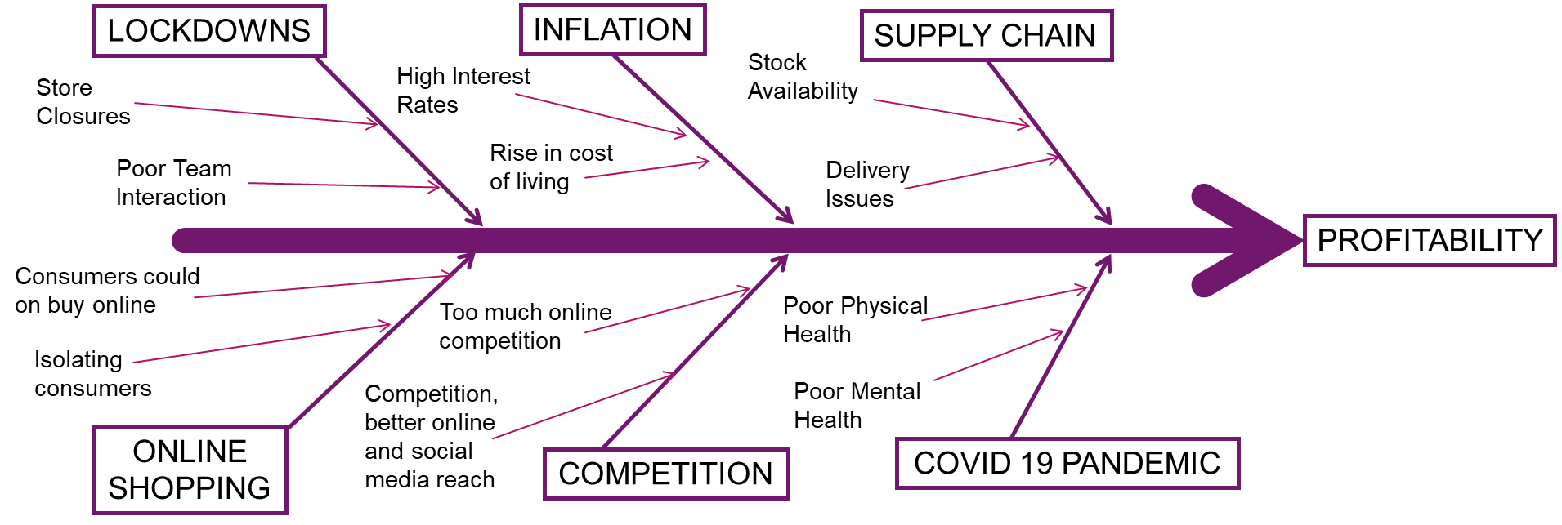

Organisations in which staff are encouraged to evaluate practice, risk and mistakes when they occur tend to have a culture where root cause analysis or fishbone analysis is used (Phillips, Simmonds, 2013).

POSSIBLE SOLUTIONS TO ADDRESS PROFIT DECLINE AT T M LEWIN

To address the profitability problem TM Lewin UK will need to evaluate possible solutions that address all the root causes identified in the PESTEL and Fishbone analysis tools. The following solutions were put forward:

Store Closures
Some stores will be doing better that others, and some may be costing more to run than they make in profit, the closing of some stores would make a huge saving for TM Lewin, a lot of high streets have been abandoned reducing footfall, stores in these areas are bleeding money with business rates, furnishing cost, staff salary, fuel costs, renting/leasing costs and maintenance costs.

Invest in Online Retail
In recent years online retail has become more dominant many stores now are only available online. This solution will allow TM Lewin UK, to compete with other online retailers dominating the market who use social media more proficiently and have apps available to the consumer. This solution will help TM Lewin UK to reduce outgoing of furnishing costs, renting/leasing and maintenance costs.

Product redesign/rebrand
In cases were interest in the products on offer has fallen a rebrand or redesign can help to give new life and energy to the company. This solution will have a heavy financial impact for TM Lewin UK, they would have to invest in new materials and designers, they would also have to invest in a rebranding launch which could

EVALUATION OF POSSIBLE SOLUTIONS USING PMI ANALYISIS

According to Ahmed and Omotunde in Theories and strategies of good decision making. International journal of scientific & technology research 2012 PMI Analysis is used to evaluate the advantage and disadvantage of possible solutions and options. This is achieved by identifying values, uncertainties and other things that might influence the decision (Ahmed, Omotunde, 2012).

Store Closures
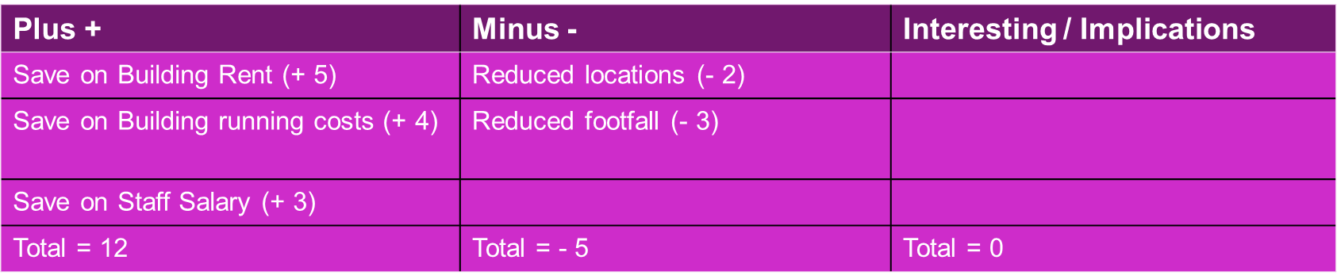
I have scored the table:
Plus = 12
Minus = -5
Interesting / implications = 0
Total = 7

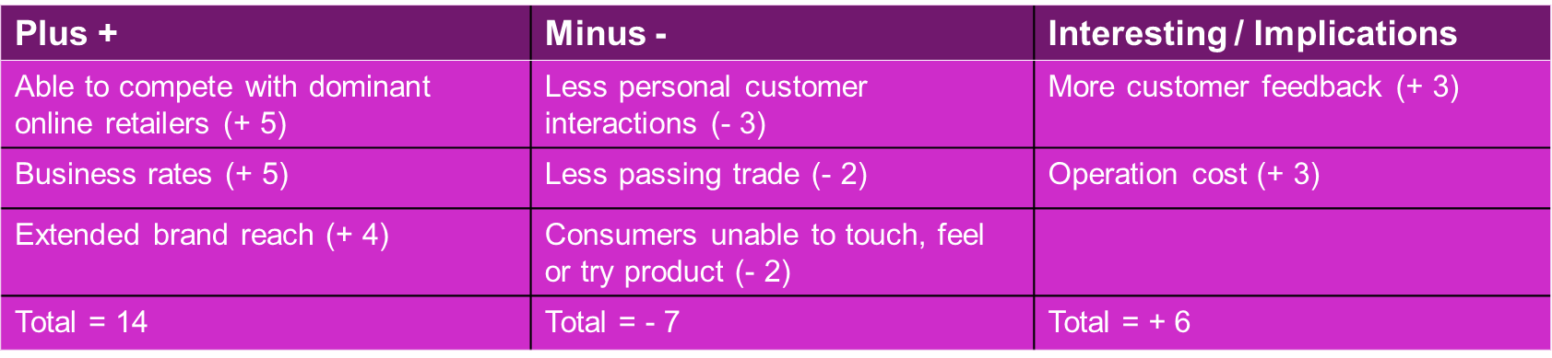
Invest in Online Retail
I have scored the table:
Plus = 14
Minus = 7
Interesting / Implications = + 6
Total = 13

Redesign or Rebrand:
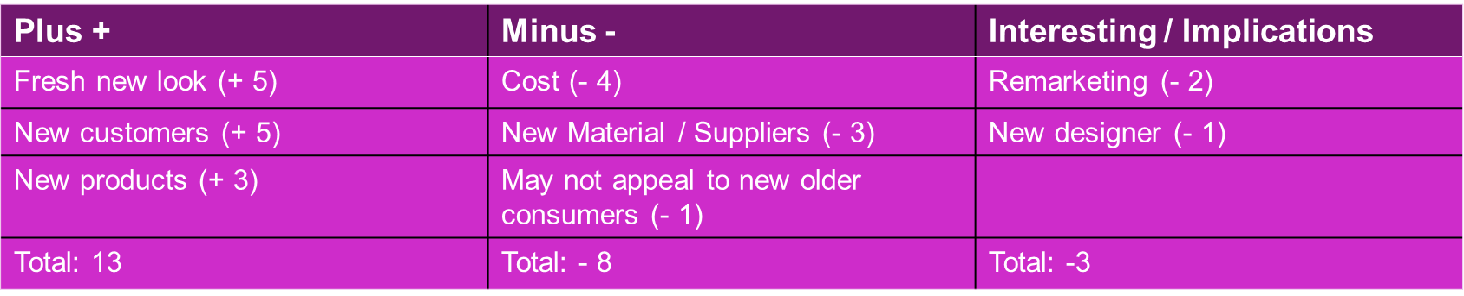
I have scored the table:
Plus = 13
Minus = - 8
Interesting/ Implications = - 3
Total = 2

Most Appropriate Solution

To select the most appropriate solution I have used the PMI analysis framework, which has shown the most appropriate solution for TM Lewin UK declining profitability is to Invest in Online Retail Market.

According to Jones and Livingston 2018 in The “online high street” or the high street online? The implications for the urban retail hierarchy study The UK has the greatest proportion of online sales in Europe.

Online retail markets continue to grow, the value of internet sales as a proportion of total retail sales rose from 2.7% in January 2007 to 11.1% in January 2013. In December 2013, average weekly internet sales peaked at 8.1 billion (Rhodes, 2014)

Recent figures indicate that online retailing in the UK accounted for 15.8% of
all retailing in late 2016 (ONS, 2016a). With TM Lewin extending the brands reach geographically, they will have an automatic worldwide market online expansion, allowing the company to reach new areas of the world. Smaller financial commitment, with no rents, building maintenance costs, staff salaries, business rates TM Lewin will be able to invest in the online market and begin to see an increased profit.

ACTION PLAN TO IMPLEMENT ONLINE INVESTMENT

This section discusses the action plan before implementation of Online Investment solution by identifying what the action point is, a description of how the action point will be managed, a timeline/deadline for the action point and who will be responsible for the action point.

Action Plan (before implementation)
Action Point | Description of The Action Point | Timeframe | Staff Responsible
Identify online investment requirements | Managers/Department heads team meeting to discuss possible new location (Office Space), staff, costs and equipment | 20/05/22 | Chief Executive Officer
Identify website designer | New web designer Manager required job advertisement needed | 27/05/22 | HR Manager
Create a website | Meeting with web Designing team | 04/06/22 | Web Design Manager
Location | Availability of new space for the project and possible new equipment and staff | 27/05/22 | Building and Estates Manager
Equipment | What equipment will be required to facilitate the new project | 27/05/22 | IT Manager and Building and Estates Manager

Monitoring Plan of Online Investment
A plan for the monitoring of the now implemented solution is necessary to get a clear idea of how many sales have been completed, show many view the on website and the number of apps that have been downloaded.

Monitoring Aspect | Description | Timeline | Staff Responsible
Sales | Speak to the accountant | 27/07/22 | Accounts Manager
Views | Use website network traffic | 27/07/22 | Website Manager
Apps downloaded | Use website network traffic | 27/07/22 | Website Manager

Evaluation Plan
A plan for evaluation is also necessary, the key performance indicator will allow TM Lewin to calculate the total profit from launch of the new website.

KPI | Description of KPI | Timeline | Staff Responsible
Sales | Speak to Accounts regarding completed order quantity | 28/07/22 | Sales Manager
Costs | Speak to the Accounts manager regarding cost | 28/07/22 | Accounts Manager

An increase in sale will indicate that the Investment in Online Retail market was the right solution for TM Lewin and its problem with declining profitability, but we must also take a good look as costings to calculate an accurate profit line.

CONCLUSION

This report began with TM Lewin and the declining profitability problem caused by many factors over the years exacerbated by the covid 19 pandemic and discussed the nature and of the problem impacting on the business and its employees. The retail sector has undergone and will continue to undergo transformation in the coming years, especially as multichannel retailing has become the dominant operating business model for most retailers (Doherty, Ellis-Chadwick, 2010).

Three possible solutions were identified Store Closures, Redesign/Rebrand and Invest in Online Retail. A PMI analysis was used to identify the most appropriate solution for TM Lewin’s declining profit. Thus, retailers that want to keep their current customers and attract future ones are therefore challenged to explore the potentials of the virtual storefront (Tiago et al., 2015). This report concludes with an action plan for before implanting the identified solution, a plan for monitoring the solution when implemented and a plan for the KPI evaluation.

REFERENCES

Ahmed, M.T. and Omotunde, H., 2012. Theories and strategies of good decision making. International journal of scientific & technology research, 1(10), pp.51-54. Accessed 27/11/22)

Banham, M. (2022). TM Lewin heads for second administration in two years as suits fall out of style. [online] Evening Standard. Available at: https://www.standard.co.uk/business/tm-lewin-administration-interpath-advisory-torque-brands-shirts-ons-inflation-b988859.html [Accessed 20 Nov. 2022].

Butler, S. (2022). TM Lewin calls in administrators for second time in two years. [online] the Guardian. Available at: https://www.theguardian.com/business/2022/mar/17/tm-lewin-calls-in-administrators-for-second-time-in-two-years. (Accessed 26/10/22)

Doherty, N.F. and Ellis-Chadwick, F. (2010). Evaluating the role of electronic commerce in transforming the retail sector. The International Review of Retail, Distribution and Consumer Research, 20(4), pp.375–378. doi:10.1080/09593969.2010.504001. (Accessed 27/11/22)

Izogo, E.E. and Jayawardhena, C. (2018) ‘Online shopping experience in an emerging e-retailing market’, Journal of research in interactive marketing., 12(2), pp. 193–214. Available at: https://doi.org/10.1108/JRIM-02-2017-0015. (Accessed 27/11/22)

Jones, C. and Livingstone, N. (2018) ‘The “online high street” or the high street online? The implications for the urban retail hierarchy’, The International review of retail, distribution and consumer research., 28(1), pp. 47–63. Available at: https://doi.org/10.1080/09593969.2017.1393441. (Accessed 27/11/22)

Menswear shop T.M. Lewin to close all UK stores, go online only. (2020). Reuters. [online] 30 Jun. Available at: https://www.reuters.com/article/us-health-coronavirus-britain-tmlewin-idUSKBN2412X4 [Accessed 27 Nov. 2022].

Neville, S. (2022). Pet collars and meat-free sausages added to inflation basket but suits out. [online] Evening Standard. Available at: https://www.standard.co.uk/news/uk/ons-bank-of-england-yorkshire-b987939.html [Accessed 20 Nov. 2022].

ONS. 2016a. “Retail Sales in Great Britain: Nov 2016”, ONS Statistical Bulletin, November 2016. (Accessed 27/11/22)

Phillips, J. and Simmonds, L., 2013. Using fishbone analysis to investigate problems: NT. Nursing times, 109(15), pp. 18-20. (Accessed 20/11/2022)

Rhodes, C. (2014). The retail industry: statistics and policy. [online] Available at: https://moderngov.middlesbrough.gov.uk/Data/Executive/201503171300/Agenda/att1005416.pdf. (Accessed 30/10/22)

Song, J., Sun, Y. and Jin, L. (2017) ‘PESTEL analysis of the development of the waste-to-energy incineration industry in China’, Renewable & sustainable energy reviews, 80, pp. 276–289. [Accessed 26 Oct. 2022]

Williams, S.W. (2002) Making better business decisions [electronic resource] : understanding and improving critical thinking and problem-solving skills . London; Thousand Oaks, Calif. ;, SAGE. (Accessed 27/11/22)

