

HUMAN RESOURCE MANAGEMENT
Student Name: Mnadeep Kaur
Student Id: 2224381
Lecturer’s Name: Mushfiqur Kulothungan

Table of Contents
1. Introduction 3
1.1 Background of Nike 3
1.2 Purpose of the report 4
2. Current state on labour market in UK 4
2.1 Labour market in UK 4
2.2 Labour management in Nike 7
3. Emerging changes in human resource strategy 8
3.1 Changes of human resource strategy in post COVID condition 8
3.2 Changes of human resource strategy post Brexit external environment 9
3.3 Impact of emerging changes of HR strategy on Nike after Brexit and COVID-19 9
4. Recommendation 10
5. Conclusion 11
Reference list 12

1. Introduction

1.1 Background of Nike
Nike is an American multinational corporation, which designs and manufactures food and apparel equipment and services. Headquarter of this brand is in Oregon, United states. This brand has provided a wide range of apparel and footwear products to the target customers since 1964. The company believes that “Bring is inspiration and innovation to every athlete in this world” as their key message to engage customers with the key product of the brand (Nike.com, 20223).
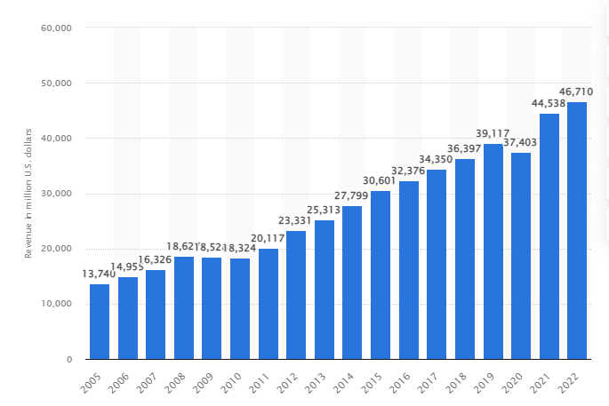Figure 1: Worldwide revenue of Nike
(Source: Statista.com, 2022)
In 2019, this company was developed around 39.11 billion in US dollar, which was increased in 2021 to around 44.53 billion (Statista.com, 2022). The revenue of this company was developed in 2021 from 2020. In addition, by the end of 2022, the revenue of this footwear company was 46.71 billion in US dollars. The revenue of the footwear company was projected to increase from 2019 to 2022.

1.2 Purpose of the report
Human Resource Management (HRM) is a strategic approach that provides support to employees, which ensure a positive workplace environment. This report is focused on Nike to determine the HRM strategy of the company to manage employees. In addition, this report will discuss the current state of the labour market in the UK. Further, the changes of the HRM strategies of COVID-19 and Brexit will elaborate in this report. This report will identify the effect of the changing HRM strategies on the growth of Nike. Moreover, suggestions will be developed for Nike for its betterment in future.

2. Current state on labour market in UK

2.1 Labour market in UK
Employment rate in the UK was around 75.6% by the end of the year 32022. It was identified that the employment rate in this country was increased from October to December 2022 by 0.2% (Gov.uk, 2023). It has evaluated that the increasing part of the labour market was identified with the part time workers. The rate of the labour market is associated with economic inactivity. In this perspective, the rate of economic inactivity declined in the UK by 0.3% from October 2022 to December 2022 (Gov.uk, 2023). The statistics of economic inactivity was driven between the 16 to 24 year age group in the UK based on the student, retired or long-term health issue burden.
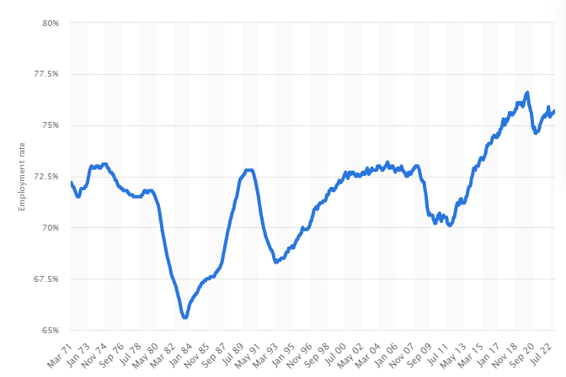
Figure 2: Employment rate in UK
(Source: Statista.com, 2023)
On the other hand, the earlier figure depicts the employment rate in the UK. The earlier geographical presentation is indicates that by the end of 2020, employment rate in the UK was around 74.8% by the end of the 2020 (Statista.com, 2023). Further, in November of 2021, the employment rate in this country was approximately 75.6%. Further, in January of 2023, the employment rate in the UK was around 75.7% (Statista.com, 2023). The above statistical information indicates that the employment rate in the UK is increase from 2020 to 2022.
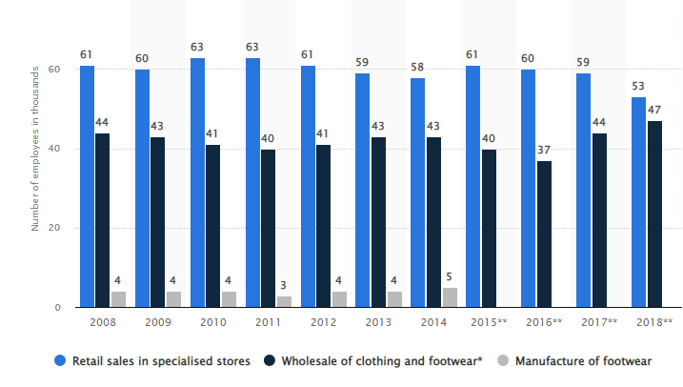
Figure 3: Employment rate in UK under footwear industry
(Source: Statista.com, 2019)
Now this part will evaluate the total number of employees in the UK under the footwear industry. It indicated that in 2017, around 59 employees were associated with the footwear industry under retail sales in specialist shoes (Statista.com, 2019). The above graphical figure highlights that in 2018; around 53 employees were associated with the footwear industry under the retail of specialist shoes. In this aspect, the number of employees in the footwear industry declined in the UK. On the other hand, in 2017, around 44 employees were associated with the wholesale of footwear, which was inclined to 47 in 2018 (Statista.com, 2019). In this regard, it can be highlighted that the rate of the labour market was increased in the footwear industry under the wholesale of footwear segment.
In 2020, during the initiation of COVID-19 pandemic situation, the unemployment rate rose throughout the globe. In the context of the UK, the labour market was stable in this country compared to the other countries. However, at the middle of the pandemic or the lockdown situation drastic changes were observed in the UK based on the labour market. During the pandemic situation, the unemployment rate in the UK was around 4.47%, which was projected to increase in 2020 compared to 2019 (Parliament.uk, 2022). At the beginning of the COVID-19, around 825,000 employees lost their employment from January to March of 2020. In this regard, economic inactivity also increased in the UK by 327,000 at the beginning of the pandemic situation (Parliament.uk, 2022). Simultaneously, during the pandemic situation, the working hours also declined. It was found that total working hours was reduced in UK after the COVID-19 pandemic situation. However, it could be stated that by the initial state of 2023, the level of employment will increase in the UK.

2.2 Labour management in Nike
Nike believes that the engagement and the satisfaction of the employees is a core factor that would ensure the success of the brand. The company strongly agrees that the skilled, engaged and supportive employees are the key aspects that could ensure the success and the sustainability of the brand (Nike.com, 2023). In this aspect, Nike is focused on the value that will improve the engagement and the dedication of the employees; as a result, the company could improve the need and the satisfaction of the employees in an effective style. In 2019, the company is focused on the strategic management and style, which enable the company to improve the innovation, motivation in the engagement of the employees towards the common organizational aims and objectives. It has evaluated that the strategic management team of Nike is believed to provide significant support to the employees, which will help the company to improve their operation. This company promoted a common attempt including “if you want to do something there, we’re going to support you” to the employees which would allow this company to increase the engagement of the consumers as well as employees (Forbes.com, 2019). In this aspect, it could be stated that Nike has improved the management of employees in an effective style.
However, at the beginning of 2223, the company was announced to cut off the employees to maintain the effective workflow. It was found that the company unexpectedly announced that they will cut off around 6000 jobs from Nike based on the poor performances (Indiatimes.com, 2023). It is found that when an organization is focused on the sudden employee cut off, it creates a negative effect towards the motivation and dedication of the employees. In this situation, employees in Nike have faced a significant level of poor motivation in the workplace based on the unexpected announcement from the management department of Nike.

3. Emerging changes in human resource strategy

3.1 Changes of human resource strategy in post COVID condition
Nike faced a wide range of challenges and burdens during the pandemic situation that affected the profit and growth of the organization. It has evaluated that during the pandemic situation the global GDP declined, which had an effect on this footwear brand. The employee management challenges were also identified during the pandemic situation. It was found that in 2019, the company was around 76,700 employees while in 2020 this company was associated with 75,400 employees (Statista.com, 2020). It has evaluated that the employee retention burden was identified in Nike that affects the progress of the business. Besides Nike, human resource management of an organization faced the almost same challenges during the pandemic situation. In this aspect, to manage the workplace conditions. HRM developed new strategies and methods that could help the organization to improve their operation. In this regard, this section will elaborate the strategies of HRM after the pandemic situation.
According to Schneider et al. (2021), after the pandemic situation, HRM enables multiple legal compliances and policies in the workplace that could help an organization focus on the need and satisfaction of the employees in an efficacious manner. It was found that HRM increased the number of sick leave, family leave and time off aspects in the workplace after the pandemic situation to provide the possible facilities to the employees that will maintain the satisfaction of the employees. In addition, the trend of the remote working culture was also identified in the workplace after the pandemic situation to maintain the workforce followed by improving the organizational aims and objectives. The trend of remote working is considered the key process that ensures the success of the organization in an efficacious and crucial style.
The implementation of the digitalisation technology is one of common technology based changes identified in the workplace after the pandemic situation. It has evaluated that HRM has been changing the communication and the coordination process after the pandemic situation. In addition, the trends of automation, robotics increased in the workplace after the pandemic situation (Prasad et al. 2021). In this regard, it could be evaluated that in the post COVID situation HRM has developed a wide range of strategies and approaches that ensure the success of the brand.

3.2 Changes of human resource strategy post Brexit external environment
UK government has been announced the separation of the UK from the EU through article 50 which is recognised as the Brexit that affect the wide areas in UK., It is found that organizations or businesses face wide range of challenges due to the implementation of Brexit in UK. According to Ridgway, (2019), employee resourcing could be one of the common burdens in the workplace in UK after the Brexit incident. In this aspect, the article has evaluated that HR of an organization could focus on the “flexible working culture”, which will create a positive effect towards the success of the brand. Through flexible working culture HRM of an organization depends on the diverse work culture, which could help an organization to improve their position followed by it, will enhance the collaboration and relationship with the co-workers. In addition, the implementation of the talent hub in business is to make sure an organization improves the organizational process. In this regard, the implementation of flexible working culture is considered the one of common processes that identified among HRM after the Brexit external environment.
On the other hand, Crasii and Nawar, (2022) reported that besides the flexible working culture; an organization needs to focus on the psychological need and requirement of an organization after the execution of the Brexit. HRM was focused on the effective psychological need by which an organization could develop the salary scale of employees which will allow an organization to grab the attention from the wide range of employees followed by it will improve the direction of the employees. As per the view of Maslow hierarchical theory of motivation, when an organization should focus on the psychological need, it creates a significant negative effect towards the success of the brand. Therefore, the HRM was focused on the effective psychological need and flexible working culture process in the workplace to maintain the positive work culture after Brexit.

3.3 Impact of emerging changes of HR strategy on Nike after Brexit and COVID-19
Nike was focused on the employee need and engagement to improve the dedication and the contribution of the employees in a crucial manner. Before the pandemic situation, the HRM of Nike was focused on the “purpose of work” as one of common slogans that allow this brand to build the motivation and dedication of the employees (Forbes.com, 2019). However, after the pandemic situation, Nike has changed their strategy and they focus on the diversity aspect, which improves the organizational process in an efficacious style. Nike has implemented a diversity aspect while it continues the operation and it provides significant services to the customers. Execution of the diversity allows Nike to bring transparency followed by it improving the collaboration among employees. After the pandemic and the Brexit situation, Nike implemented a “wellbeing and engagement survey” among employees that played an efficacious and positive role towards the progress of the business (Nike.com, 2023). It was found that the company is targeted that they will have the motivation of the employees by implementing the well-being and engagements survey in workplace, which will improve the progress of the operation.
In addition, HRM of Nike was focused on the talent management approach, which played an efficacious role to improve the collaboration and coordination among employees. It has evaluated that talent management is recognised as the one of common processes, which makes sure the success of the brand. Thite et al. (2023) reported that effective talent management is a crucial process that allows an organization to improve their operation in an insignificant style. Further, the HRM of Nike was focused on the compensation, success planning and engagement of the employees to ensure the success of the organization. In this situation, it could be stated that the HRM of Nike implemented the talent management and diversity aspect to manage the risk of the COVID-19 and Brexit.

4. Recommendation
- Recommendation 1: To implement diverse work culture
Diverse work culture is one of key approaches that make sure the success of the brand followed by it enhances the progress of the operation. It was found that diverse work culture is consider as common workplace where an organization could recruit employees from multiple regions regardless of their background and cultural information (Gould et al. 2022). The development of a diverse work culture allows an organization to improve the talent hub in the organization. The implementation of the diverse work culture and talent hub in business will allow an organization to make a talent pool in the workplace. In the context of Nike, the execution of the diverse work culture is considered one of key processes that ensure the success of the brand. The implementation of the diverse work culture will help Nike to reduce the negative effect of Brexit and COVID-19 in appropriate style.
- Recommendation 2: To bring transparency in workplace
Transparency is an essential factor that helps an organization to improve education and coordination among team members. The implementation of transparency is considered the key aspect that ensures the success of the brand (Weber-Lewerenz and Vasiliu-Feltes, 2022). In the context of bringing transparency, Nike could implement the ethical leadership style in the workplace, which will help the company to improve the dedication and contribution of employees. Therefore, the focus on the ethical leadership style will create positive effects on the progress of the business.

5. Conclusion
This study can be concluded that employee satisfaction management is one of the common strategies of HRM to ensure the success of the organization. This study was focused on the Nike to evaluate the effect of Brexit and COVID-19 on the progress of business. This paper has analyzed the labour market in the UK followed by the labour management strategy in Nike. Further, the strategy of HRM in Nike to manage Brexit and COVID-19 has been elaborated in this paper. This paper was developed suggestion for Nike to manage the negative effect of Brexit and COVID-19. It was identified that Nike could implement ethical leadership style which ill help this brand to improve their business strategy.

Reference list
Journals
Crasii, O. and Nawar, Y.S., 2022. Exploring the Effect of Business Strategy on Employees’ Retention During Pandemic and After Brexit: The case Home Care Sector in UK. The Business & Management Review, 13(2), pp.134-144.
Gould, R., Mullin, C., Parker Harris, S. and Jones, R., 2022. Building, sustaining and growing: disability inclusion in business. Equality, Diversity and Inclusion: An International Journal, 41(3), pp.418-434.
Prasad, D.K., Mangipudi, D.M.R., Vaidya, D.R. and Muralidhar, B., 2020. Organizational climate, opportunities, challenges and psychological wellbeing of the remote working employees during COVID-19 pandemic: A general linear model approach with reference to information technology industry in Hyderabad. International Journal of Advanced Research in Engineering and Technology (IJARET), 11(4).
Ridgway, M., 2019. Brexit: human resourcing implications. Employee Relations: The International Journal.
Schneider, D., Harknett, K. and Vivas-Portillo, E., 2021. Olive Garden’s Expansion Of Paid Sick Leave During COVID-19 Reduced The Share Of Employees Working While Sick: Study examines Olive Garden’s expansion of paid sick leave and the impact on incidence of employees working sick during COVID-19. Health Affairs, 40(8), pp.1328-1336.
Thite, M., Rammal, H.G. and Ferreira, J.J., 2023. Talent management in the “new normal”—Case study of Indian IT services multinationals in China. Thunderbird International Business Review, 65(1), pp.131-141.
Weber-Lewerenz, B. and Vasiliu-Feltes, I., 2022. Empowering Digital Innovation by Diverse Leadership in ICT–A Roadmap to a Better Value System in Computer Algorithms. Humanistic Management Journal, 7(1), pp.117-134.
Websites
Forbes.com, 2019. Purpose At Work: How Nike Inspires And Innovates With Employees And Consumers. Available at: https://www.forbes.com/sites/simonmainwaring/2019/07/23/purpose-at-work-how-nike-inspires-and-innovates-with-employees-and-consumers/?sh=7119a2777a85 [Accessed on: 05/04/2023]
Gov.uk, 2023. Labour market overview, UK: February 2023. Available at: https://www.ons.gov.uk/employmentandlabourmarket/peopleinwork/employmentandemployeetypes/bulletins/uklabourmarket/february2023#:~:text=The%20UK%20employment%20rate%20was,driven%20by%20part%2Dtime%20workers. [Accessed on: 05/04/2023]
Indiatimes.com, 2023. layoffs-hit-nike-impacted-workers-write-about-unexpected-life-event-on-linkedin. Available at: https://hr.economictimes.indiatimes.com/news/industry/layoffs-hit-nike-impacted-workers-write-about-unexpected-life-event-on-linkedin/98349422 [Accessed on: 05/04/2023]
Nike.com, 20223. Home. Available at: https://about.nike.com/en [Accessed on: 05/04/2023]
Nike.com, 2023. prioritizing-worker-engagement-and-wellbeing. Available at: https://about.nike.com/en/impact/initiatives/prioritizing-worker-engagement-and-wellbeing [Accessed on: 05/04/2023]
Parliament.uk, 2022. Coronavirus: Impact on the labour market. Available at: https://commonslibrary.parliament.uk/research-briefings/cbp-8898/ [Accessed on: 05/04/2023]
Statista.com, 2019. apparel-clothing-industry-employment-in-the-united-kingdom-uk-by-sector. Available at: https://www.statista.com/statistics/387701/apparel-clothing-industry-employment-in-the-united-kingdom-uk-by-sector/ [Accessed on: 05/04/2023]
Statista.com, 2022. nikes-sales-worldwide-since-2004. Available at: https://www.statista.com/statistics/241683/nikes-sales-worldwide-since-2004/ [Accessed on: 05/04/2023]
Statista.com, 2023. Employment rate in the United Kingdom from March 1971 to January 2023. Available at: https://www.statista.com/statistics/281992/employment-rate-in-the-united-kingdom/#:~:text=In%20the%20three%20months%20to,the%20same%20period%20in%202022. [Accessed on: 05/04/2023]

