International Hotel Management
Module Name: Marketing Essentials
Module code: BMIH4005
Marketing Plan
Company: Ritz Carlton Hotel
Lecturer Name: Chris Wilkin
Student Name: Khalilur Rahman
Student ID number: 2211971

Contents
Introduction 3
Situation Analysis 4
Company: SWOT analysis 4
Customers 4
Competitors 6
Collaborators 7
Climate: PESTLE 8
Marketing mix 8
Objectives 9
Strategy 9
Tactics 9
Action 11
Control 11
Conclusion 12
References 13
Appendix 15

Introduction
This marketing plan welcomes a new era of luxury hospitality and positions Ritz-Carlton as a leading sustainable luxury brand that matches the growing demand for eco-friendly holidays. The strategy highlights significant possibilities and challenges through a comprehensive evaluation of the current environment to help take a focused and strategic approach to the market. The system uses RACE and Ansoff's matrix to reach the target audience, increase brand awareness, and promote positive brand emotion. This marketing approach emphasizes quantitative KPIs and exceptional experiences to increase Ritz-Carlton's growth, profitability, and reputation as a leader in sustainable premium hospitality.

Situation Analysis
A thorough understanding of the present business climate may be attained via a situational analysis by taking stock of the company's internal and external resources and its possibilities and risks (Niemitz, 2018). The current condition at Ritz-Carlton is summarised below.

Company: SWOT analysis
Strengths | Weaknesses
1. Strong brand reputation and legacy | 1. High price point may limit accessibility for some customers
2. Exceptional customer service | 2. Limited presence in some geographic regions
3. Luxury accommodations and amenities (Yeung, 2022) | 3. Dependence on affluent and discretionary consumer spending

Opportunities | Threats
1. Growing luxury travel market | 1. Intense competition from other luxury hotel brands
Expanding into emerging markets | 2. Economic downturns and global crises affecting the travel industry
Increasing demand for unique experiences | Evolving consumer preferences and trends

Customers
Segmentation and Targeting:
Demographic Segmentation:
- Individuals with substantial financial means and an interest in indulgent activities are the intended target audience for this strategy.
- People with more disposable money value convenience and privacy when traveling.
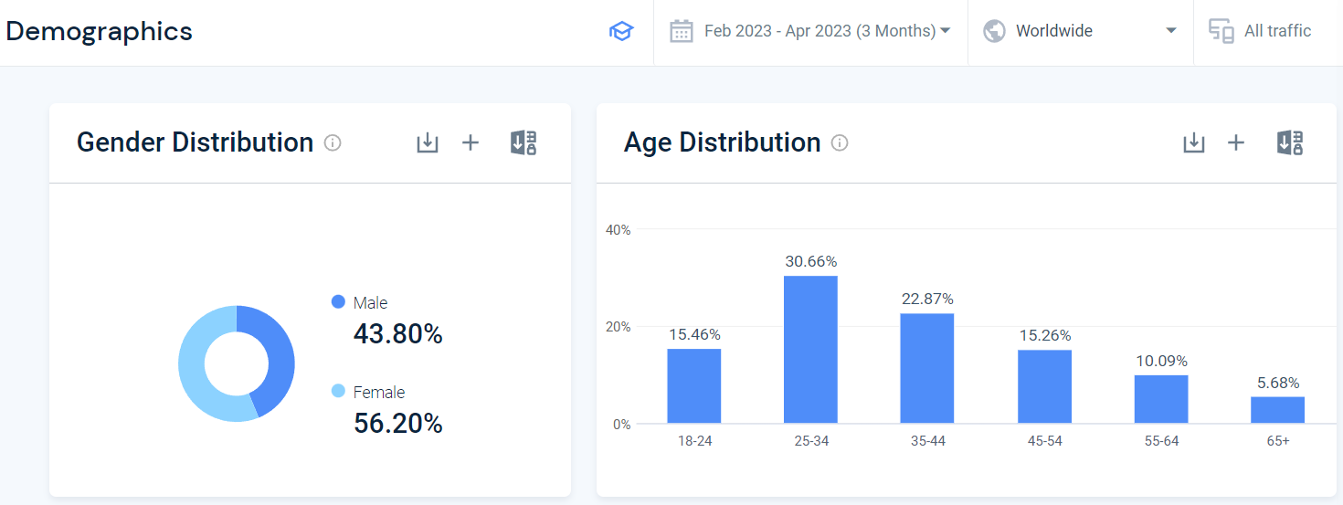
Figure 1: DemographicsSource: (SimilarWeb, 2023)
Psychographic Segmentation:
- Tourists with a refined sense of taste; those looking for special treatment and unforgettable adventures.
- People that are avidly on the lookout for luxurious experiences are your target audience (Hernández-Mariné, Clavero and Roldán, 2020).
Geographical Segmentation:
- Concentrated urban areas Emphasis is placed on urban areas with dense populations of affluent consumers and businesses.
- Vacation hotspots: resort areas where tourists go for relaxation and fine dining.
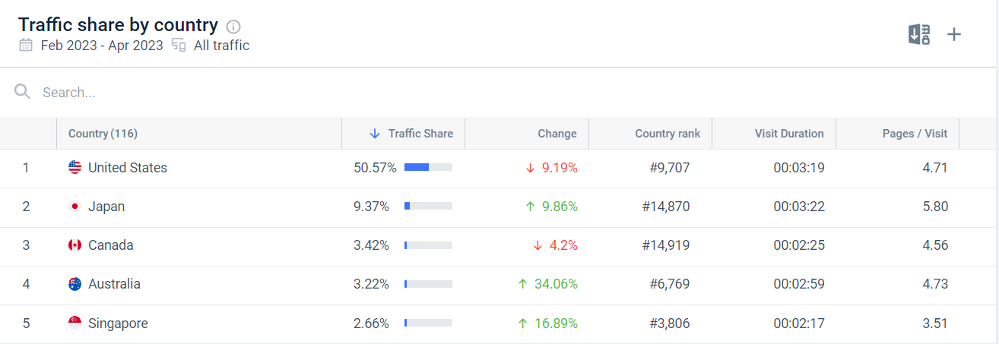
Figure 2: Geography Source: (SimilarWeb, 2021)

Competitors
Perceptual Positioning Map:
To better understand where various companies stand in the eyes of consumers, consider a perceptual positioning map (Chipoco, 2018). The Ritz-Carlton and its main rivals in the high-end hotel market are shown on the following simplified perceptual positioning map:
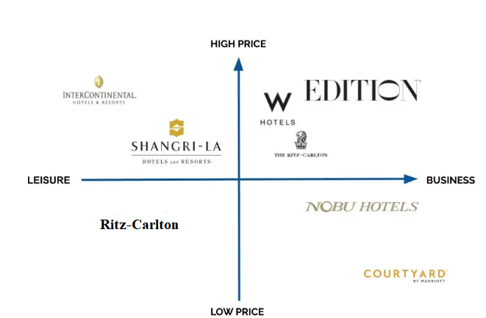
Figure 3: Perceptual Positioning Map of Ritz-Carlton.

Bowman’s clock
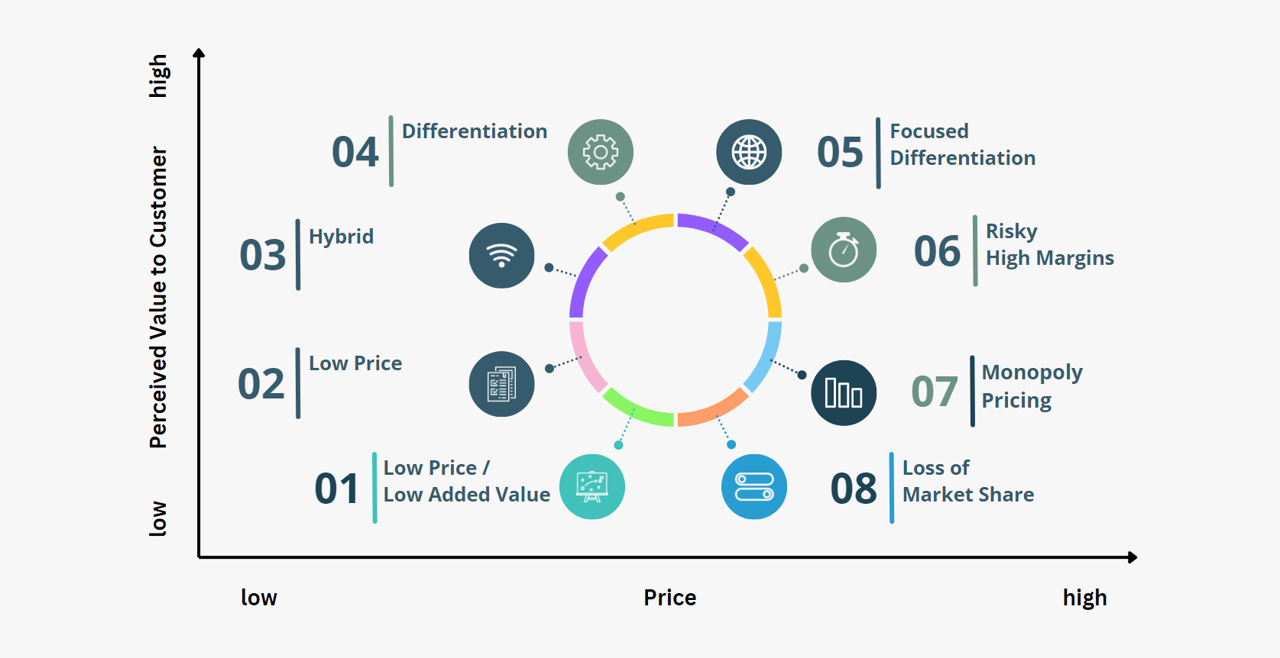
Figure 4: Bowman’s clock. Source: (StrategyPunk, 2023)
Collaborators
- Marriott International: One of the biggest hotel chains in the world, Marriott International, owns Ritz-Carlton as a wholly owned subsidiary (Hormby et al., 2019). As a result of this collaboration, Ritz-Carlton has access to a wealth of tools, marketing assistance, and operational know-how.
- Travel Agencies and Tour Operators: Ritz-Carlton partners with travel agents and tour operators to advertise its hotels and vacation packages to reach a larger audience. Bookings are generated, and brand awareness is raised thanks to these collaborations.
- Corporate Clients and Event Planners: Ritz-Carlton builds partnerships with companies and event planners that host frequent business conferences and other gatherings. Ritz-Carlton provides specialized event services and customized packages to improve its business-to-business partnerships.

Climate: PESTLE
Economic Factors:
Customers' increased awareness and demand for "green initiatives" may allow Ritz-Carlton to differentiate itself and attract eco-conscious guests. Green initiatives may need extra funding (Courtemanche et al., 2020).
Social Factors:
Global warming and sustainable living have changed consumer preferences. Demand for eco-friendly lodgings has increased. Ritz-Carlton might capitalize on this trend by promoting its eco-friendly initiatives.
Technological Factors:
Ritz-Carlton's technological advances in energy management systems, intelligent controls, and building automation allow energy optimization, waste reduction, and operational efficiency improvement (Nixon and Rieple, 2021).

Marketing mix
Product Value Proposition:
The Ritz-Carlton's luxury facilities, dedicated personnel, and attention to detail make it stand out. It offers exquisite rooms and top-notch services for a memorable visit.
Pricing:
Ritz-Carlton's high pricing reflects its luxury brand status. The premium prices make guests feel unique and reflect the high level of service and facilities.
Distribution:
Ritz-Carlton advertises directly and indirectly. Direct channels include its website, app, and reservation offices. Businesses may partner with travel agents, tour operators, and online travel platforms to boost awareness and bookings.
Promotions and Communications:
Ritz-Carlton utilizes several marketing and outreach tactics. Strategic advertising, PR, social media, and influencer partnerships promote its brand, assets, and unique offerings. The phrase emphasizes the brand's commitment to luxury and individualized service (Partlow, 2022).

Objectives
- Boost website visits by 10% in the following six months.
- Six months from now, you should be able to increase your social media following by 15%.
- Monitor website traffic, bounce rate, and sales metrics to evaluate your marketing efforts.
- To evaluate the efficacy of your social media activities, you should monitor KPIs like your follower count, engagement rate, and audience reach.
- Find out how your marketing efforts influenced confirmed reservations by looking at the statistics.

Strategy
Ritz-Carlton would use the Product Development approach in Ansoff's matrix to develop a new value proposition, such as catering to environmentally aware tourists via sustainable operations. This tactic targets already established markets with fresh or revised product offerings.
The new value proposition for Ritz-Carlton would center on the hotel chain's commitment to green practices such as renewable energy, recycling programs, and eco-friendly materials procurement at all locations (Michelli, 2019). The target market would be eco-conscious vacationers, and the goal would be to appeal to them.
By adopting this method, Ritz-Carlton may differentiate itself from rivals while maintaining its current client base. The company might capitalize on shifting customer tastes by positioning itself as environmentally responsible.

Tactics
Ritz-Carlton will use the RACE (Research, Action, Communication, and Evaluation) framework inside the Communications Mix to solve the challenges discovered in the scenario analysis and align with the new strategy. Here's how each part is going to be put to use:
- Research: To better understand the preferences, interests, and values of the intended audience regarding sustainability, extensive market research will be done. This will make the strategy and message more suited to the target audience (Hillewaert, 2021).
- Action: Ritz-Carlton will act on the study’s conclusions by introducing sustainable practices across all properties. Sustainable energy and waste management programs, eco-friendly facilities, and collaborative relationships with regional manufacturers are all in the picture.
- Communication: The company's new public relations strategy will highlight its eco-friendly practices and unique selling point. The campaign will highlight the company's dedication to sustainability, high-end experiences, and individualized care. Important strategies include:
- Content Marketing: Produce exciting and informative material, including blog entries, social media updates, and videos to spread the word about the company's commitment to environmental responsibility, green business practices, and community service.
- Influencer Partnerships: Ritz-Carlton collaborates with prominent environmentalists and travel bloggers to promote its green policies and activities (Rowley, 2018). As a result, the intended demographic will have a better impression of the legitimacy and quality of the brand.
- Online Advertising: Advertisements will appear on websites frequented by eco-tourists as part of a digital marketing strategy. Inviting prospective visitors to experience luxury with a conscience, advertisements will focus on Ritz-Carlton's eco-friendly policies.
- Evaluation: To evaluate the efficacy of the new communication strategies, key performance indicators (KPIs) will be developed. Website visits, shares, likes, comments, and mentions in the media are all examples of such indicators. The effectiveness of the communications activities may be gauged and fine-tuned via the regular review of key performance indicators.
Actions:
Gannt Chart:
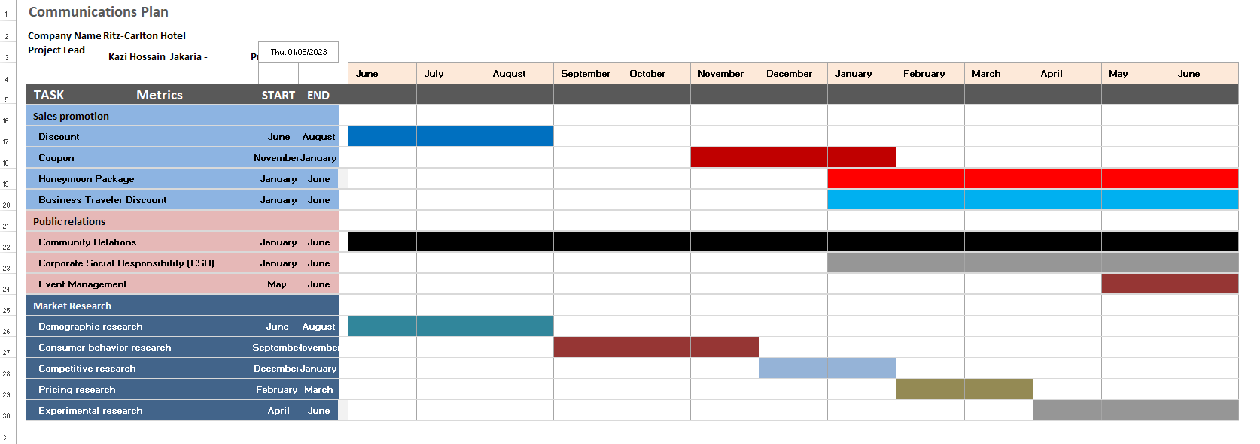

Control
Several metrics and key performance indicators will be used to evaluate the effectiveness of the marketing strategy. New customers, a better reputation for the company, and more profits are all benefits.
Metrics tailored to each marketing channel are used to evaluate success. Examples include assessing the reach and engagement of influencer-produced content and keeping tabs on the number of new followers and level of interaction created by social media ads. These indicators were selected because they enable direct alignment with channel goals and quantitative outcomes (Slater and Hult, 2020). They make it possible to assess the efficacy of each marketing strategy, allowing for fine-tuning and improvement as needed.

Conclusion
This marketing strategy for Ritz-Carlton is meant to make the hotel chain stand out as an example of an eco-friendly premium service provider. The design features a new value proposition focused on sustainability and emphasizes targeted communications methods to address identified challenges using the RACE framework and Ansoff's matrix. The chosen marketing channels and KPIs provide a holistic approach to measuring performance since they align with the goals and target audience. The strategy aims to grow the company's bottom line while staying true to the brand's original promise of providing ethically-minded premium experiences.

References
Chipoco, M. (2018). PERCEPTUAL MAP TEACHING STRATEGY. Revista Digital de Investigación en Docencia Universitaria, pp.83–91. doi:https://doi.org/10.19083/ridu.10.447.
Courtemanche, C.J., Pinkston, J.C., Ruhm, C.J. and Wehby, G.L. (2020). Can Changing Economic Factors Explain the Rise in Obesity? Southern Economic Journal, 82(4), pp.1266–1310. doi:https://doi.org/10.1002/soej.12130.
Hernández-Mariné, M., Clavero, E. and Roldán, M. (2020). Why there is such luxurious growth in the hypogean environments. Algological Studies/Archiv für Hydrobiologie, Supplement Volumes, 109, pp.229–239. doi:https://doi.org/10.1127/1864-1318/2003/0109-0229.
Hillewaert, S. (2021). Tactics and Tactility: A Sensory Semiotics of Handshakes in Coastal Kenya. American Anthropologist, 118(1), pp.49–66. doi:https://doi.org/10.1111/aman.12517.
Hormby, S., Morrison, J., Dave, P., Meyers, M. and Tenca, T. (2019). Marriott International Increases Revenue by Implementing a Group Pricing Optimizer. Interfaces, 40(1), pp.47–57. doi:https://doi.org/10.1287/inte.1090.0482.
Michelli, J.A. (2019). The New Gold Standard: 5 Leadership Principles for Creating a Legendary Customer Experience Courtesy of the Ritz-Carlton Hotel Company.
Niemitz, C. (2018). The present ecological situation of mankind – analysis and consequences. Anthropologischer Anzeiger. doi:https://doi.org/10.1127/anthranz/2018/0901.
Nixon, N.W. and Rieple, A. (2021). Luxury Redesigned: How The Ritz-Carlton Uses Experiential Service Design to Position Abundance in Times of Scarcity. Design Management Journal, 5(1), pp.40–49. doi:https://doi.org/10.1111/j.1948-7177.2010.00015.x.
Partlow, C.G. (2022). How Ritz-Carlton Applies ‘TQM’. Cornell Hotel and Restaurant Administration Quarterly, 34(4), pp.16–24. doi:https://doi.org/10.1177/001088049303400406.
Rowley, J. (2018). Understanding Digital Content Marketing. Journal of Marketing Management, 24(5-6), pp.517–540. doi:https://doi.org/10.1362/026725708x325977.
SimilarWeb (2021). SimilarWeb Identity. [online] secure.similarweb.com. Available at: https://pro.similarweb.com/#/digitalsuite/websiteanalysis/audience-geography/ [Accessed 26 May 2023].
SimilarWeb (2023). SimilarWeb Identity. [online] secure.similarweb.com. Available at: https://pro.similarweb.com/#/digitalsuite/websiteanalysis/audience-demographics/ [Accessed 26 May 2023].
Slater, S.F. and Hult, G.T.M. (2020). Factors influencing the relative importance of marketing strategy creativity and marketing strategy implementation effectiveness. Industrial Marketing Management, 39(4), pp.551–559.
StrategyPunk (2023). Maximizing Competitive Advantage: An Overview of Bowman’s Strategy Clock (plus PPT). [online] StrategyPunk. Available at: https://www.strategypunk.com/bowmans-strategy-clock-powerpoint-template/ [Accessed 7 May 2023].
Yeung, A. (2022). Setting people up for success: How the Portman Ritz-Carlton hotel gets the best from its people. Human Resource Management, 45(2), pp.267–275. doi:https://doi.org/10.1002/hrm.20108.

Appendix

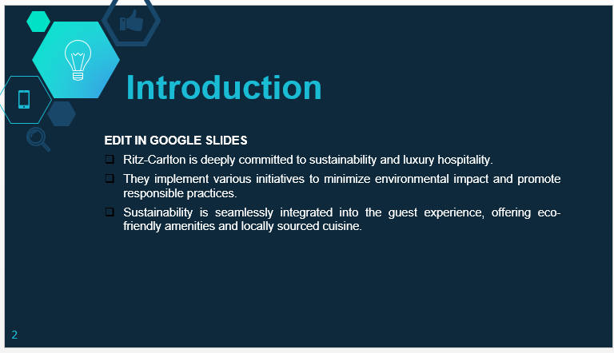
Introduction
Good morning/afternoon/evening, everyone. Welcome to the presentation on the Ritz-Carlton Marketing Plan. Today, we will explore how Ritz-Carlton aims to lead the way in sustainable luxury hospitality. We will delve into the strategies, tactics, and channels that will enable us to engage our target audience, drive brand awareness, and foster positive brand sentiment. Let's begin.
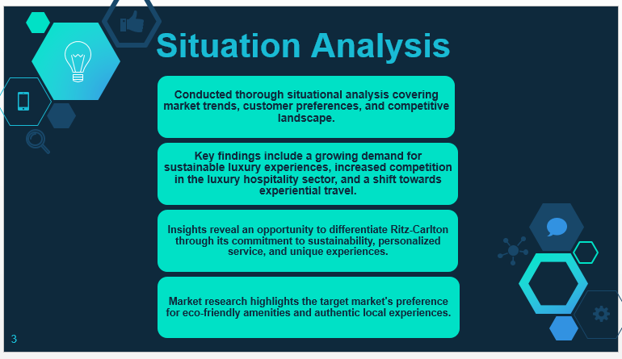
Situational Analysis
Before diving into our marketing plan, let's first understand the current landscape. Our situational analysis revealed valuable insights into the market, including customer preferences, competitive landscape, and environmental factors that influence our business. These insights have guided our strategic decisions.
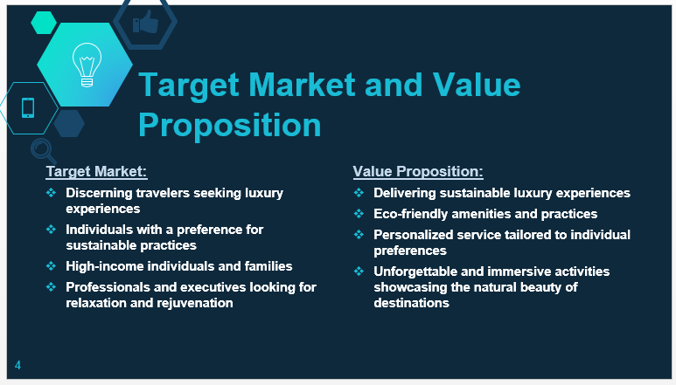
Target Market and Value Proposition
Our target market consists of discerning travelers who prioritize sustainable practices and seek exceptional luxury experiences. To cater to their needs, our value proposition focuses on delivering sustainable luxury, offering eco-friendly amenities, personalized service, and unforgettable experiences that align with their values.

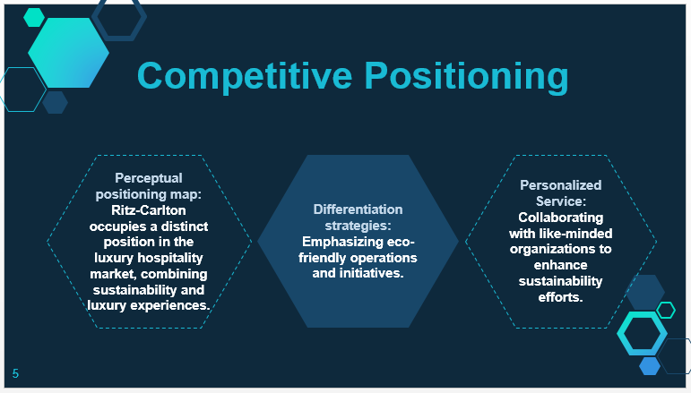
Competitive Positioning
To differentiate ourselves from competitors, we have positioned Ritz-Carlton as the leader in sustainable luxury hospitality. Our perceptual positioning map illustrates our unique position, showcasing our commitment to sustainability and luxury experiences. Through our eco-friendly practices, partnerships, and superior service, we stand out and offer something truly distinctive to our target market.
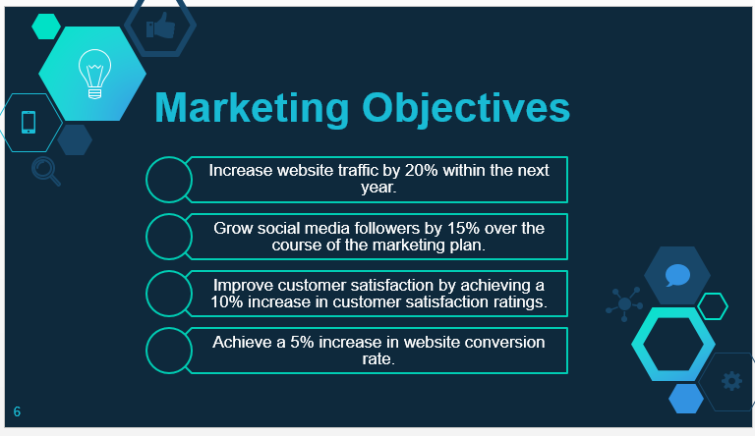
Marketing Objectives
Our marketing objectives are SMART (Specific, Measurable, Achievable, Relevant, Time-bound). We aim to increase website traffic by 20%, social media followers by 15%, and customer satisfaction by 10% within the next year. These targets will serve as key performance indicators (KPIs) to measure the success of our marketing efforts.

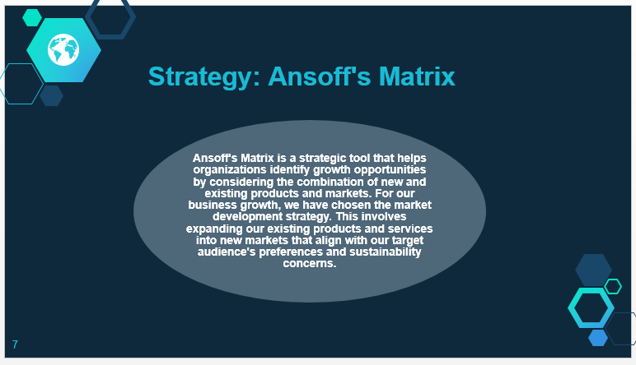
Strategy: Ansoff's Matrix
Ansoff's Matrix helps us determine the best strategy for business growth. After careful consideration, we have chosen the market development strategy. This strategy involves leveraging our existing products and services to enter new markets that align with our target audience's preferences and sustainability concerns.

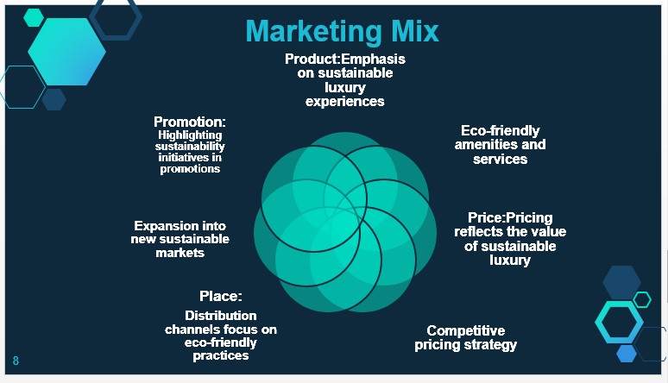
Marketing Mix
To align with our new strategy, we have made adjustments in the marketing mix elements. Our product now emphasizes sustainable luxury experiences, pricing reflects the value we offer, distribution channels focus on eco-friendly practices, and promotions highlight our sustainability initiatives.

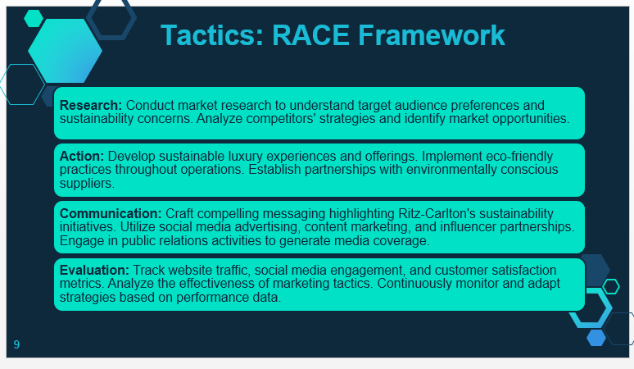
- Research: Conduct market research to understand target audience preferences and sustainability concerns. Analyze competitors' strategies and identify market opportunities.
- Action: Develop sustainable luxury experiences and offerings. Implement eco-friendly practices throughout operations. Establish partnerships with environmentally conscious suppliers.
- Communication: Craft compelling messaging highlighting Ritz-Carlton's sustainability initiatives. Utilize social media advertising, content marketing, and influencer partnerships. Engage in public relations activities to generate media coverage.
- Evaluation: Track website traffic, social media engagement, and customer satisfaction metrics. Analyze the effectiveness of marketing tactics. Continuously monitor and adapt strategies based on performance data.

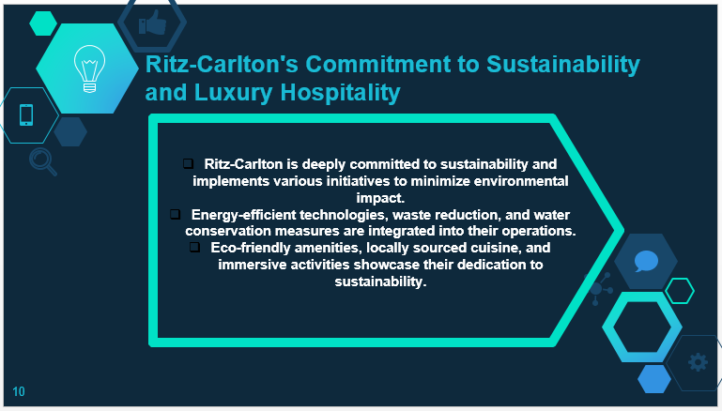
- Ritz-Carlton is deeply committed to sustainability and implements various initiatives to minimize environmental impact.
- Energy-efficient technologies, waste reduction, and water conservation measures are integrated into their operations.
- Eco-friendly amenities, locally sourced cuisine, and immersive activities showcase their dedication to sustainability.

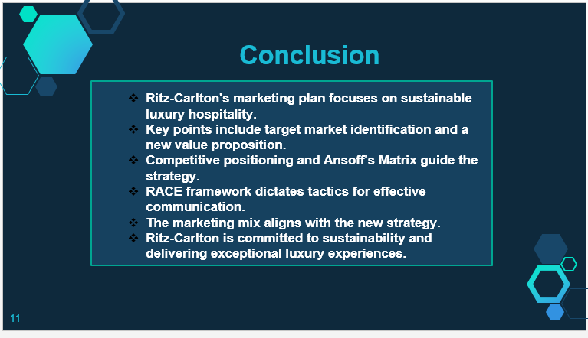

Conclusion
Finally, the marketing plan positions Ritz-Carlton as a sustainable premium hotel leader. We seek to increase brand recognition, audience engagement, and guest experiences by knowing our target market, executing strategic initiatives, and using efficient marketing strategies. Our dedication to sustainability allows us to rethink luxury hospitality and create unforgettable experiences that match today's discriminating travellers. We appreciate your time and look forward to a successful marketing campaign.
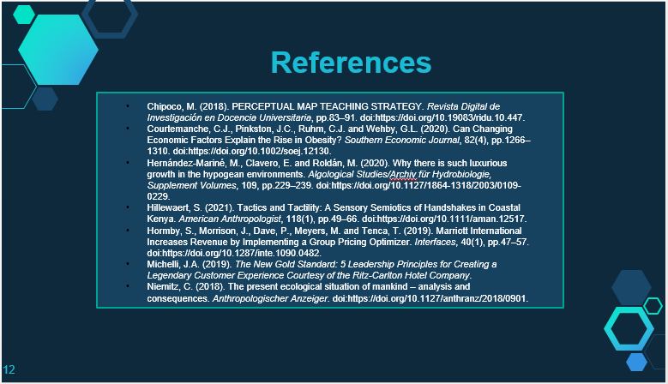
References
- Chipoco, M. (2018). PERCEPTUAL MAP TEACHING STRATEGY. Revista Digital de Investigación en Docencia Universitaria, pp.83–91. doi:https://doi.org/10.19083/ridu.10.447.
- Courtemanche, C.J., Pinkston, J.C., Ruhm, C.J. and Wehby, G.L. (2020). Can Changing Economic Factors Explain the Rise in Obesity? Southern Economic Journal, 82(4), pp.1266–1310. doi:https://doi.org/10.1002/soej.12130.
- Hernández-Mariné, M., Clavero, E. and Roldán, M. (2020). Why there is such luxurious growth in the hypogean environments. Algological Studies/Archiv für Hydrobiologie, Supplement Volumes, 109, pp.229–239. doi:https://doi.org/10.1127/1864-1318/2003/0109-0229.
- Hillewaert, S. (2021). Tactics and Tactility: A Sensory Semiotics of Handshakes in Coastal Kenya. American Anthropologist, 118(1), pp.49–66. doi:https://doi.org/10.1111/aman.12517.
- Hormby, S., Morrison, J., Dave, P., Meyers, M. and Tenca, T. (2019). Marriott International Increases Revenue by Implementing a Group Pricing Optimizer. Interfaces, 40(1), pp.47–57. doi:https://doi.org/10.1287/inte.1090.0482.
- Michelli, J.A. (2019). The New Gold Standard: 5 Leadership Principles for Creating a Legendary Customer Experience Courtesy of the Ritz-Carlton Hotel Company.
- Niemitz, C. (2018). The present ecological situation of mankind – analysis and consequences. Anthropologischer Anzeiger. doi:https://doi.org/10.1127/anthranz/2018/0901.

