

Programme: CertHE Skills for the Workplace
Module: Digital Skills and Research Methods
Module code: BMSW4003
Assignment Title: DSR Assessment 2
Individual Report

Table of Contents
Introduction 3
Virtual Learning Environment 4
Impacts of Virtual Learning Environment 4
Benefits of Virtual Learning Environment 4
Research Methodology 5
Selected Method 6
Data Collection 6
Data Analysis 7
Ethical Research 7
Result 7
Conclusion 10
References 11

Introduction
Digital skills are the talents of a person to utilise the internet to its utmost extent. It has become highly crucial for everyone to succeed in this since today everything is digital and has become a need (Jackson and Fearon, 2014). The next report will analyse the influence of virtual learning on learners from the same institution. This research will utilise both primary and secondary sources to get the necessary data since this will provide for the most comprehensive comprehension of the subject at hand. The project is being completed at the request of the University of Wales Trinity Saint David London Campus.

Virtual Learning Environment
When computers and the Internet are incorporated into the classroom, it creates what is known as a virtual learning environment (VLE), which is a combination of learning and teaching technologies meant to improve the educational experiences for students (Barker and Gossman, 2013).

Impacts of Virtual Learning Environment
Several studies have shown that Virtual Learning Environments have an impact in a variety of settings. They can do things like getting students thinking critically, meet their individual needs, boost their motivation, make them more confident in their abilities, and better prepare them for class, all of which should translate into better results on standardised tests (Torres Martín and El Homrani, 2021).

Benefits of Virtual Learning Environment
Every new technological advancement is pursued to make life easier and more efficient. There are no exceptions made for the VLE. Let's start with the reasons why online education is superior (Shandilay, 2018).
Flexibility: Virtual learning environments (VLEs) provide for more time and location independence in the classroom. Having unrestricted and constant access to all course materials makes it much simpler for students to balance their academic obligations with their other commitments (KRUK, 2022). Therefore, it becomes less difficult to continue their education despite other commitments, such as a full-time job or a young child that requires a lot of care and focus. Furthermore, students may go at their speed in class. There is no need for slow learners to wait for the class to continue to the next subject, and everyone may take as much time as they need to study the texts and view the videos (Logie and Donaldson, 2021).
Availability: Another major benefit of using a virtual learning environment is that it makes higher education more affordable, even at the most prestigious institutions. If anything, the situation improves for non-native speakers since they need not spend a fortune relocating (Soria, and Campo, 2016).
Ease of access: There is no longer a need to attend classes, since education may be obtained remotely. This means that those in rural regions or on other continents, as well as those who are handicapped, now have access to a high-quality education. Because of the flexibility of the virtual learning system, students can keep up with their coursework even if they are away on holiday, away on business, or home sick with the flu (Dalgarno and Lee, 2012).
Participation: In a digital classroom, it is easy to try out various methods and material forms. Online assessments, quizzes, movies, and podcasts all contribute to a more robust curriculum map. Blending in a little gaming to the learning process and increasing student engagement is a perk of a diverse array of activities (Gillett-Swan, 2017).
Easy administration: Teachers benefit from VLEs because they can use them to better organise their time, keep tabs on their students' progress, activities, and engagement, and provide those who need it access to supplementary resources and aid. VLE also makes it simpler to assess how well a programme is working and make necessary adjustments (Soria and Campo, 2016).

Research Methodology
The goal of any research methodology is to improve the knowledge of a topic by developing a plan, implementing a set of procedures, and amassing a body of evidence that can be examined and analysed. Experiments, surveys, questionnaires, and other similar research tools are all commonplace (Snyder, 2019). In addition, the research methodology is really useful for such a job. In this report, the questionnaire has been utilised primarily to collect up-to-the-minute data.
Primary Research
The investigator must actively participate in the data collection process in a primary study design. In other words, rather than relying on data that has already been gathered related to the research topic, the researcher gathers relevant data examples themselves (Ross and Schoonen, 2015). Primary research is generally intended to gather knowledge that is context-specific and can address a particular issue. Furthermore, it allows the researcher to gather first-hand information, which is considered to be more accurate and reliable in a study context.
Secondary Research
When conducting a systematic study, it is usual practice to rely only on previously collected data, a method known as secondary research. To draw reliable findings from this study, we will need to collect, sort, and analyse representative samples of the data (Largan and Morris, 2019).

Selected Method
Non-numerical data, such as language, is the focus of qualitative research, which entails its collection, analysis, and interpretation. Twenty students were interviewed for quantitative research, white papers on the topic of online education were read for qualitative research. Statistics were gathered and analysed (Feature selection method for High Dimensional Data, 2016). As a general rule, quantitative research is conducted to verify or test hypotheses, whereas qualitative research seeks to elucidate issues. It was possible to finish the questionnaire thanks to both pieces of study. 40 students were polled using a Likert scale question on their opinion of online education, and the mean score was 7 out of 10. When asked whether they thought any changes were necessary, another set of students shared their concerns. This study would not have been possible without the combined efforts of both qualitative and quantitative research (Torres Martín and El Homrani, 2021).
Since primary research is based on first-hand investigation rather than relying on facts currently on the market, it can be more effective in this type of research. It takes a lot of time and money to do primary research. Researchers often omit primary data collection in favour of secondary sources because of the time and money savings. To finish the virtual learning environment (VLE) project, primary research was far more useful than secondary research. Information and statistics were gathered from the students themselves.

Data Collection
The process of gathering relevant data is important to any research strategy. It is not simple to gather appropriate data and use it following the study's recommendations. First, one should establish what data needed to be gathered, then establish a timeline, then they have collected the data, and last, analyse the data (Sivakumar, 2018). The students who were requested to contribute to this study on online education provided a wealth of material that was crucial to the outcome of the study (Willson and Miller, 2014).
In statistics, the term population refers to the larger group of people from whom a study's sample is collected, while sample refers to that smaller subset. The London-based Trinity Saint David University of Wales students were taken into account as the demographic from which the 40 students who contributed to the project's success were drawn.

Data Analysis
When a researcher does secondary data analysis, they use information that was originally collected for another reason (e.g., articles and journals, etc.) The information presented here is considered secondary source material (Johnston, 2017).

Ethical Research
The project was finished in a morally sound manner. The researcher obtained approval from the school and polled all of the students to collect primary data, while all of the secondary data came from peer-reviewed academic publications or reputable online resources. This is a completely ethical and honest report (Yip and Sng, 2016).

Result
The use of virtual reality in education seems to greatly enhance both student happiness and retention. 40 people were present for each class. Even though the Virtual Learning Environment group's mean recall ratings were greater than the instructional group's, the differences were not statistically significant. A higher degree of contentment or involvement was seen among students who used virtual learning environments as opposed to receiving just expository content. There was no correlation between students' preferred learning strategies and how well they performed in school.
The qualitative data revealed three major themes:
- The images were useful and excellent.
- It was a enlightening discussion
- It would have been helpful to have some kind of images or additional information.
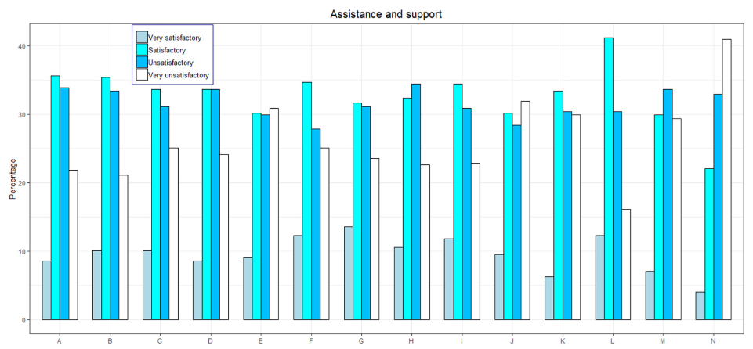
Figure:1 (Torres Martín and El Homrani, 2021)
To what extent do students feel they are being helped and supported by instructors in the following ways throughout their online courses? What they do is help students understand the material and direct their education. They are used as a roadmap for learning and accomplishing goals. (C) They come along for the ride and boost morale. They encourage pupils to look for a commitment (D) They provide a more in-depth exploration (E). They pay close attention to the team and provide helpful suggestions. That's because (G) they provide each customer personalised service and guidance. (H) They assist and fix any problems that may arise with the technology. (I) They show up and offer their help at the most opportune moments. (J) The pupils benefit from their guidance and encouragement. (K) The pupils are actively engaged. (L) They reaffirm and clear up any uncertainties. They decide to keep up with the rest of the party. To answer the question (N) They do individualised follow-up.
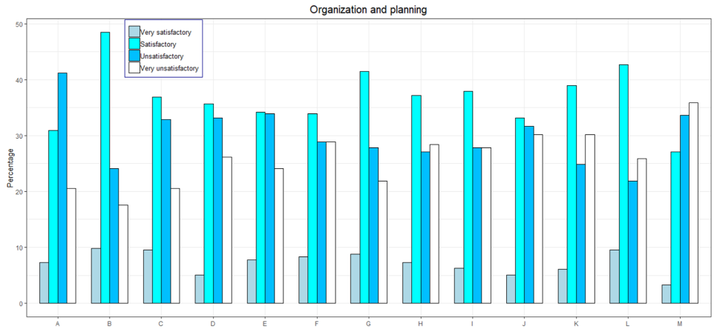
Figure:2 (Torres Martín and El Homrani, 2021)
Student evaluation of faculty performance in the following instructional roles and responsibilities as they relate to the administration and preparation of online learning: The inherited skills and knowledge are appropriate and sufficient. The information presented here (B) is competence-based. The text is well-structured and logically presented, thus (C) it's easy to follow. The information presented is, in a nutshell, quite useful, thus (D) the emphasis is on that. The challenges increase in the level of difficulty as you move through them. (F) Task durations and due dates are realistically accommodated. The work is completed by various means of verbal and nonverbal communication (G). All of the supplementary data is well-organised (H). The criteria for assessment centre on specific skills and knowledge. Assessment methods (J) are consistent with the skill sets. There is a qualitative component to the assessment of tasks, as indicated by clause (K). Evaluation of performance is a measurable (L) process. (M) The timing is appropriate and takes into account the confined student's semester.

Conclusion
In conclusion, to help students go from being observers to participants in their education, virtual learning environments (VLEs) were developed. Students who engage in active learning are more likely to develop the critical thinking abilities necessary to apply what they have learned in the classroom in real-world situations (Jackson and Fearon, 2014). The study's main results indicate that VLEs may be useful in the classroom. Virtual reality has been demonstrated to boost students' pleasure, participation, and memory; as a result, there is a need to include sophisticated technology in public healthcare teaching. These preliminary findings are intriguing, but further research is needed to evaluate whether or not VLEs qualify learners more effectively than traditional didactic education.

References
Barker, J. and Gossman, P., 2013. The learning impact of a virtual learning environment: students’ views. Teacher education advancement network journal (TEAN), 5(2), pp.19-38.
Dalgarno, B. and Lee, M.J., 2012, November. Exploring the relationship between afforded learning tasks and learning benefits in 3D virtual learning environments. In Proceedings of the 29th ASCILITE Conference, Wellington, New Zealand (Vol. 2528, pp. 236-245).
Gillett-Swan, J., 2017. The challenges of online learning: Supporting and engaging the isolated learner. Journal of Learning Design, 10(1), pp.20-30.
International Journal of Modern Trends in Engineering &amp; Research, 2016. Feature selection method for High Dimensional Data. 3(10), pp.190-203.
Jackson, S. and Fearon, C., 2014. Exploring the role and influence of expectations in achieving VLE benefit success. British Journal of Educational Technology, 45(2), pp.245-259.
Johnston, M.P., 2017. Secondary data analysis: A method of which the time has come. Qualitative and quantitative methods in libraries, 3(3), pp.619-626.
KRUK, A., 2022. THE BENEFITS OF VIRTUAL LEARNING ENVIRONMENT (VLE) IN TEACHING ESP. Humanities science current issues, 2(52), pp.171-175.
Largan, C. and Morris, T., 2019. Qualitative secondary research: A step-by-step guide. Sage.
Logie, M.R. and Donaldson, D.I., 2021. Do doorways really matter: Investigating memory benefits of event segmentation in a virtual learning environment. Cognition, 209, p.104578.
Ross, S.J. and Schoonen, R., 2015. Guidelines for reporting quantitative methods and results in primary research. Language Learning, 65(2), pp.470-476.
Shandilay, D., 2018. Virtual Learning Environment Scenario in Higher Education (Web-based Learning). International Journal Of Management And Economics Invention, 04(05).
Sivakumar, V., 2018. Prison Research: Challenges in Securing Permission and Data Collection. Sociological Methods &amp; Research, 50(1), pp.348-364.
Snyder, H., 2019. Literature review as a research methodology: An overview and guidelines. Journal of business research, 104, pp.333-339.
Soria, A. and Campo, M., 2016. Adaptive 3D virtual learning environments—A review of the literature. IEEE Transactions on Learning technologies, 10(3), pp.262-276.
Torres Martín, C. and El Homrani, M., 2021. Impact on the virtual learning environment due to COVID-19. Sustainability, 13(2), p.582. (Torres Martín and El Homrani, 2021)
Willson, S. and Miller, K., 2014. Data collection. Cognitive interviewing methodology, pp.15-33.
Yip, C. and Sng, B.L., 2016. Legal and ethical issues in research. Indian journal of anaesthesia, 60(9), p.684. (Yip and Sng, 2016)

