

Assessment 1 – Reading Task Template
PART 1: Upload your photo of your A3 in-class notes here:
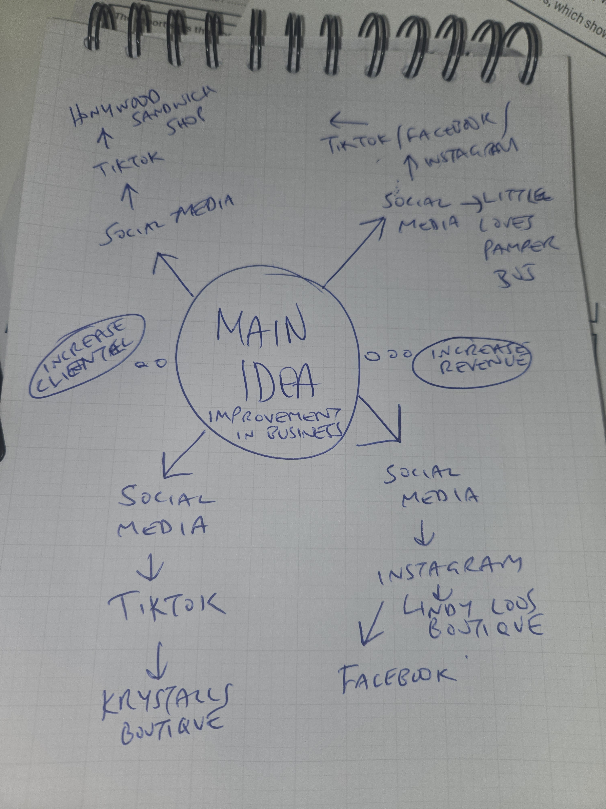

Zoe Riggs AS1

PART 2:
- Answer every question below in 1-3 full sentences.
- Use your own words. Do not use generative AI to answer these questions.
- Include a specific detail from the text when asked.
REMINDER
- The main idea is the overall message of the whole text.
- A key point helps to explain the main idea.
- A specific detail or example from the text shows that the key point is true.

- What is the main idea of the whole text?
The main idea of the text is explaining how online presence and social media can turn small businesses into booming enterprises.

- What is one key point that supports the main idea, and which specific example from the text shows this?
One example in the article is Kirsty Chamberlain’s business Krystalls Boutique. The business has boomed since using TikTok to promote her business in prom dresses. The business owner has received millions of views and has clients from all over the world now.

- What is a different key point that supports the main idea, and which specific example from the text shows this?
One other example in the text is Linda Loo’s Boutique owned by Linda Hunter. The business owner started using Instagram during the pandemic and found that the business increases rapidly. Linda explains that she is now fully online selling clothes and no longer needs to rely on stall or industrial trade.
Instagram has been integral to her business growth.

- Which part of the text do you think is most important, and why?
The most important part of the text is the statistics from the government’s Business Academy that quotes more than 200 million businesses worldwide use Instagram to reach customers.
This is important as it provides clear indications of just how powerful Instagram and social media has become.

Reflection:
- What did you find difficult in this task (including in-class components), and why was it difficult?
I did not find anything difficult per say however I am astounded by just how powerful social media is for businesses big and small.

- What helped you with this difficulty, and how did it help you?
I found listening to the tutor on how businesses operate is giving me a better scope on how they succeed.

