

Power Electronics & Drives M6X00375

Joseph Landeg – 1708387

BEng (Hons) Electrical & Electronic Engineering (Part Time)

Lab Report 1 – Power Factor Correction

Module Lecturer – Gary Jones

The Faculty of Engineering, Computing & Science

08/03/2017
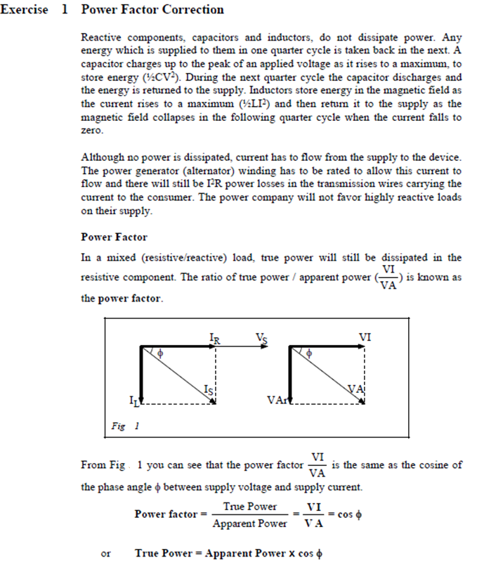

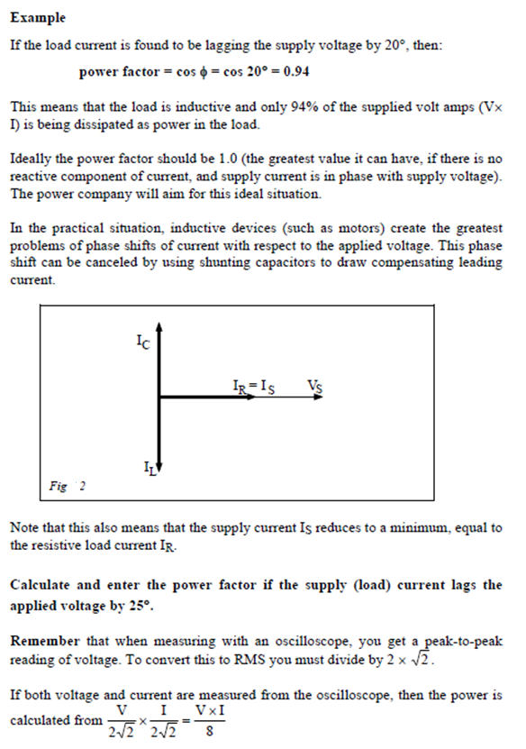

1.a.
Power Factor = Cosϑ = Cos(25°) = 0.91
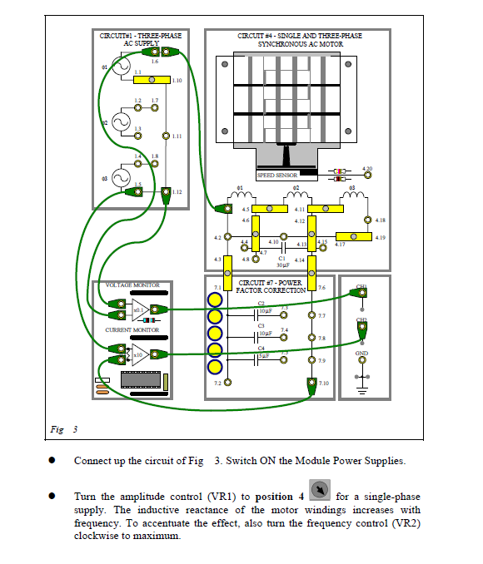

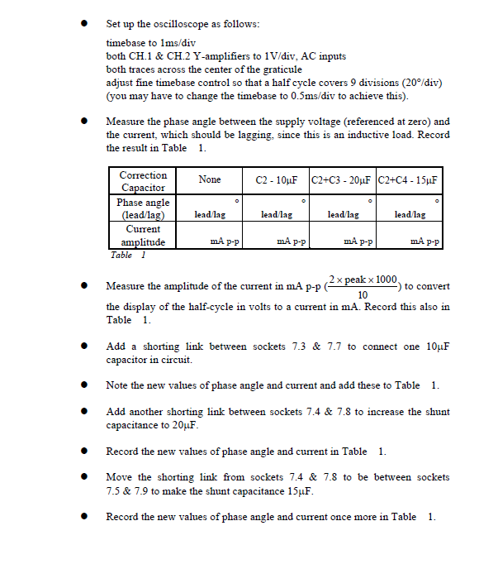
485.8mA p-p
22° LAG
2° LAG
520mA p-p
2° LEADING
467.2mA p-p
8° LEADING
508.6mA p-p

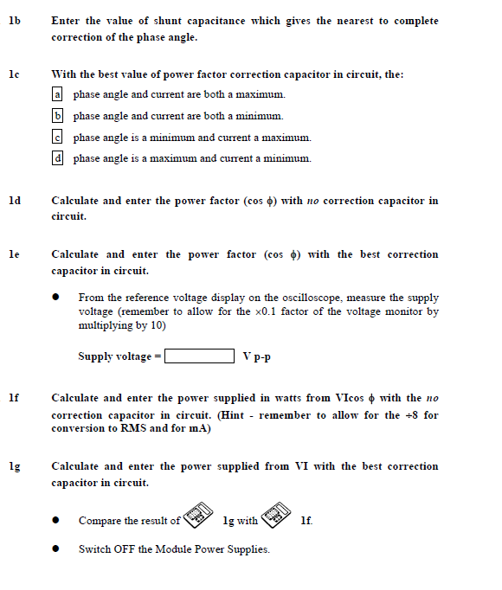
Cos(2°) = 0.999 (with 10µF capacitor in circuit).
Cos(22°) = 0.927 (with no correction capacitor in circuit).
The nearest to complete correction was C2 - 10µF.
Supply Voltage = 2.4 x 10 = 24V peak.

So, p-p supply voltage = 2 x 24V = 48V.
2.429 x 485.8 x 10⁻³ / 8 x Cos(2°) = 0.1479W
After analysing the results from the power supplied with no correction capacitor and the power supplied with the best correction capacitor in circuit, it is clear to see that by adding the 10µF capacitor, the circuit will use less power than if no correction capacitor is connected into the circuit as the power supplied to the circuit with no correction capacitor is 0.1499W meaning that the circuit will require that power to run. Whereas, the circuit with the best correction capacitor only requires 0.1479W to operate, making it more efficient.
2.543 x 508.6 x 10⁻³ / 8 x Cos(22°) = 0.1499W
48

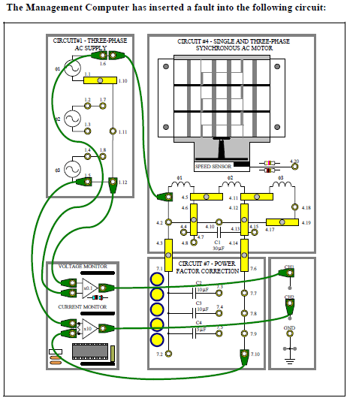

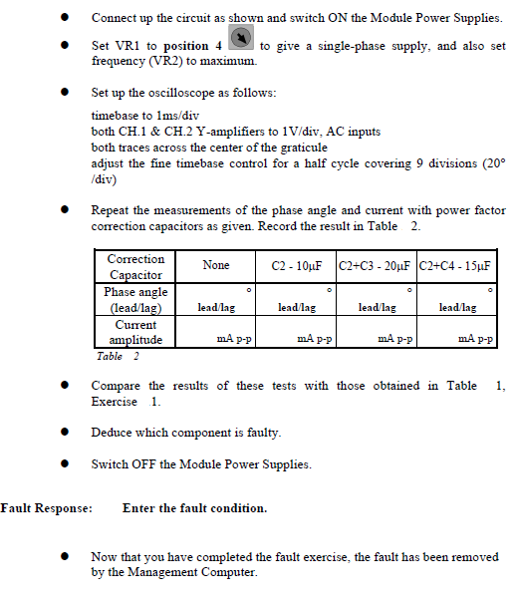
26° LEAD

4° LEAD

34° LEAD
L
40° LAG

Fault condition – When adding C2 to the circuit, phase angle differs from previous test. C2 giving too high capacitance.
From analysing the data which was produced in both table 1 and table 2, in table 2 when adding the 10µF capacitor into the circuit, the phase angle given was now 4° leading the supply. This piece of data shows the inconsistency with that of table 1 where the 10µF capacitor gave a phase angle of 2° lagging which gave the best power factor correction result. The faulty component was located then as C2. The fault condition was that C2 was giving too high of a capacitance as the phase angle changed when re-doing the tests. The fault could be that the C2 capacitor is breaking down, which is having an effect when put into the circuit.
617.2mA p-p
645.8mA p-p
588.6mA p-p
577.2mA p-p

