7/21/2026
University of Wales Trinity Saint David
London campus
Module Name: Learning In the Digital Era
Module Code: ACCA 4025

Student Name: Roberto Carlos Vidal Cabrera
Student ID: 2539028
Group: 1

Lecturer’s Name: Koushik Modak

E-Portfolio Link: Home | Roberto Vidal Lear
LDE Assignment 1
E-Portfolio

Table of Contents
Introduction 2
Main Body 2
Task 1: Essential Academic and Employment Skills for the future career Path 2
Task 1 (a): Report on Essential Academic and Employment Skills 2
Task 1 (b): Evaluation of Task 1 (a) based on Similarity Report 5
Task 2: Collaborative Mind Map and Individual Poster 6
Mind Map (Collaborative): https://mm.tt/map/4030976520?t=W733O9Thx6 6
Poster (Individual) Link: https://canva.link/6y3v78t6ye53m0i 7
Task 3 (a): Virtual Collaboration and RefWorks 8
Report on Virtual Collaboration 8
Task 4: E-Portfolio Creation and Evaluation 12
Task 4 (a): E-Portfolio Creation 12
Task 4 (b): Illustrative Review of E-Portfolio tool Selection 26
Conclusion 26
References 27
Task 1 Sources 27
Task 3 Sources: 28

Introduction
As a student at the University of Wales Trinity Saint David, the integration of academic capabilities with employability skills in higher education is vital for preparing students for the workforce. If we learn all the possible skills required for employers while we are studying, we can succeed in our future career.

Main Body

Task 1: Essential Academic and Employment Skills for the future career Path

Task 1 (a): Report on Essential Academic and Employment Skills
Academic skills
Academic skills in higher education are going to help me in my future career in cyber security, to have the abilities and strategies students use to learn effectively, complete coursework, and succeed at university. Help me develop critical thinking, research, academic writing, and analytical abilities. These skills enable me to evaluate information, make informed decisions, and communicate ideas clearly [1].
key academic skills include:
- We must learn practical skills in email security.
- We must know how to avoid phishing.
- We should know how to manage the web cookie storage policy in the browser.
- We must have the skills to manage sensitive information.
- Research skills: Finding reliable sources, using my university library databases or google scholar for evaluating the credibility of information [2].

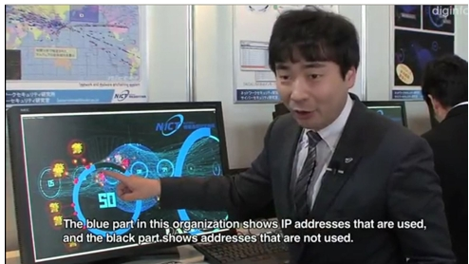
Fig. 1: A 3D Visualization of Cyberevent [3].

Employability skills
Are the knowledge, abilities, and personal qualities that help people gain employment, perform effectively in the workplace, and progress in their careers. These skills are transferable, meaning they can be applied across different jobs and industries like the one I intend to do soon, which is cybersecurity.
Employability skills help individuals to work effectively with colleagues and clients and improve productivity and job performance and adapt to changing workplace demands and technologies [4].
Key skills needed for cybersecurity employment are the following:
These skills that you see below are very important and necessary for now and in the future.
- Strong analytical skills with the capacity to identify trends, abnormalities and dangers.
- Creative thinking and problem-solving, especially in relation to new risks.
- Good awareness of data protection, privacy and regulatory requirements.
- Excellent communication skills, especially in explaining risk.
- Ability to prioritise and respond promptly to incidents and timelines [5].
In summary, academic skills prepare students to succeed in higher education, while employability skills prepare them to succeed in the workplace. By developing both academic and employability skills, I will become a more confident, capable, and professional employee. These skills will improve my chances of securing employment, performing well in my role in cyber security, and progressing into positions with greater responsibility. They will also support my personal and professional growth by helping me adapt to new opportunities and continue developing throughout my career [6].

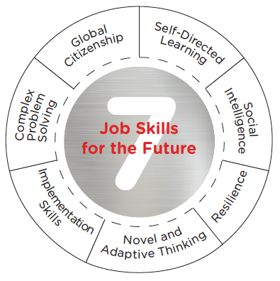
Fig. 2. 7 jobs Skills for the future [7].

Task 1 (b): Evaluation of Task 1 (a) based on Similarity Report
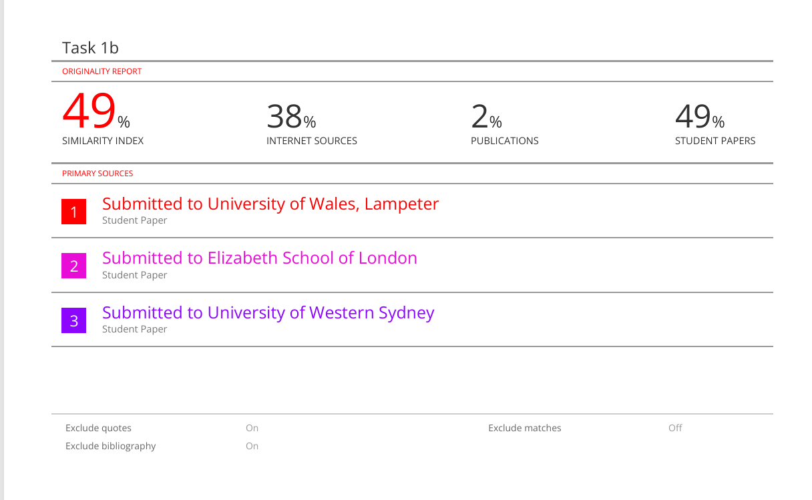

The table above from my similarity report shows that I got a score of 49%, which is in the middle range. This means I need to get better at using sources and make sure that the information I use from books, articles or journal is balanced with my own writing.
Figure out the best times for me to paraphrase, summarise, or explain an idea in my own words.
Since I do my own research and use different Google Schoolar sources, I think I deserved a score of 70%. I also show that I know how to properly cite and reference sources and that I can understand and summarise what I read.

Task 2: Collaborative Mind Map and Individual Poster

Mind Map (Collaborative): https://mm.tt/map/4030976520?t=W733O9Thx6
Mind Map Screenshot:
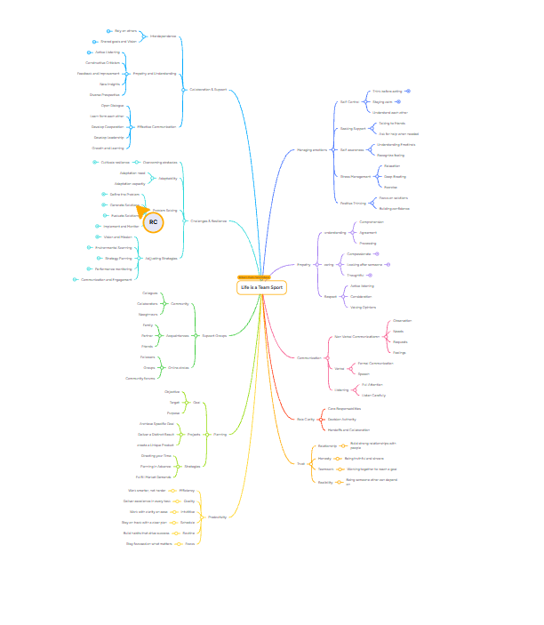

Poster (Individual) Link: https://canva.link/6y3v78t6ye53m0i
Poster Image:

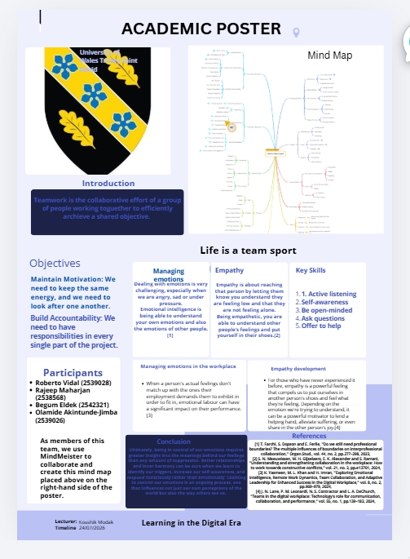

Task 3 (a): Virtual Collaboration and RefWorks

Report on Virtual Collaboration
Topic 3: Riding The Storm
People may start to question the team's goal as their true selves and preferred ways of working come to light and cause problems with other team members.
challenging that come with the "storming" moments of a team's growth. People were seen to be more irritated. One or two people are trying to take control.
It is more likely that misunderstandings will happen. Without direct interaction, members may find it hard to keep themselves going. The risk of avoiding conflicts and the luck of trust make people avoid them, which hurts team commitment and decision-making.
There is a difference between handling a conflict in person and handling it in a virtual space[1].
When we disagree, it forces us to come up with better ideas.
Teams that work best trust each other and place their faith in each other before they have earned it. Other people on the team need to be asked questions and given facts along with your interpretation of them so that they can correct your point of view or add anything else that is important or missing from the conversation.
Leaders shouldn't try to get rid of conflict; instead, they should help it grow, spark new ideas, and make teams work better together. It's better to set up a call or video call when there is a disagreement. Instead of keeping quiet, try to voice your anger.
People on the team shouldn't depend on one person to solve problems for the whole group. Instead, everyone should work together.
If members don't know what their roles and responsibilities are, they might feel like they have too much to do or that progress isn't being made. Some people are better at leading a team, while others are better at coming up with great ideas. Each job has its own pros and cons.[2]
We need to make a list of our strengths, flaws, chances, and threats.
This topic taught me how to show that I understand how to handle disagreements in virtual teams, the parts we play in our personal and professional lives. We need to think about and use the SWOT analysis, which stands for strengths, weaknesses, opportunities, and threats[3].

Task 3 (b) Step-by-step process of using RefWorks with visuals
Step 1: go to Google search and write RefWorks.
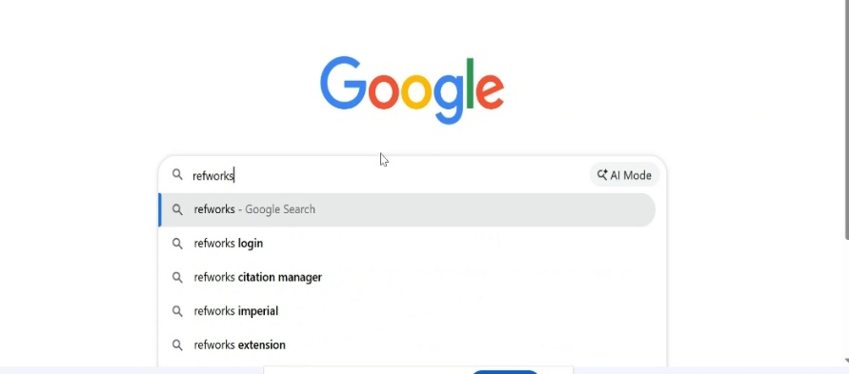
Step 2: click in RefWorks website.
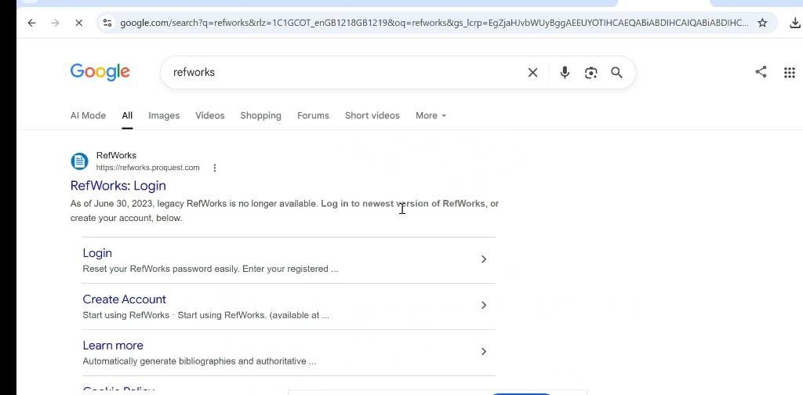
Step 3: sigh into RefWorks.
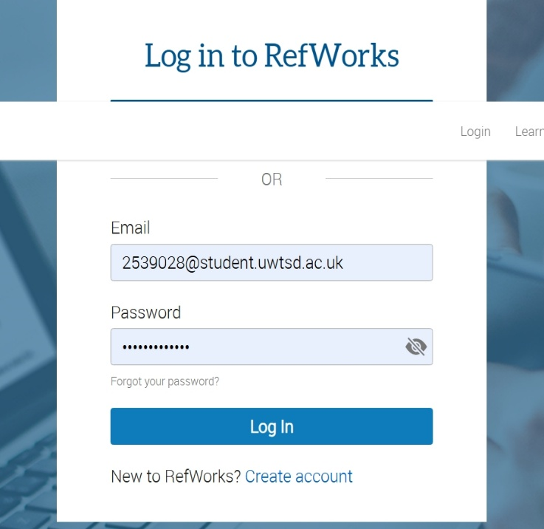
Step 4: find an article or more sources to complete my paragraph which is shown above to use automatic referencing tool such as RefWorks.
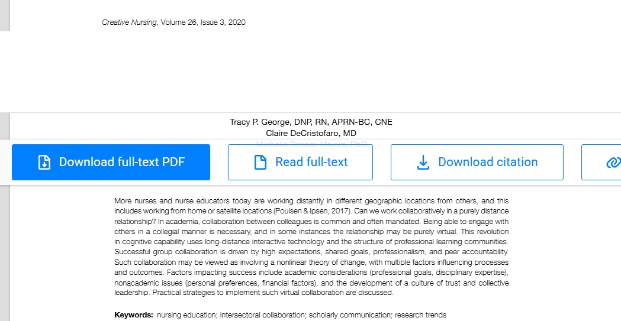
Step 5: add referencing to RefWorks.
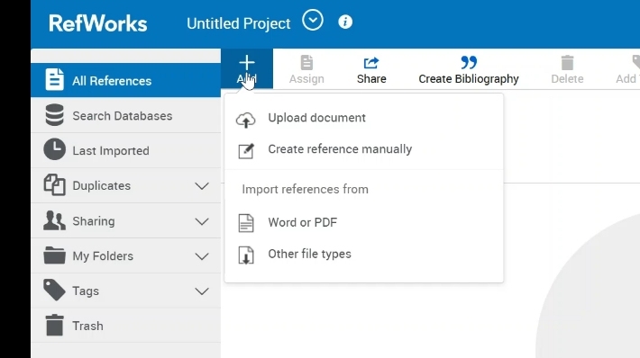
Step 6: If it is a document I can uploaded to RefWorks, otherwise I need to enter reference details manually.
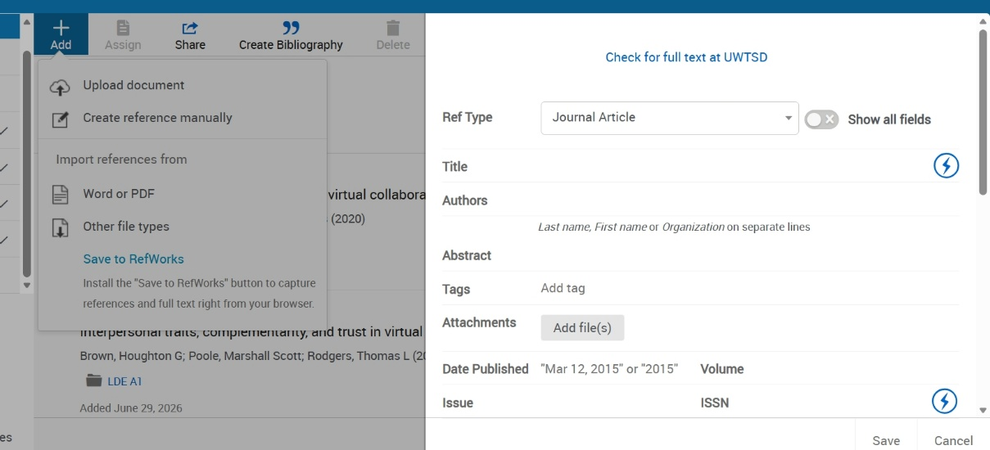
Step 7: go to create Bibliography and select the option citation style editor.

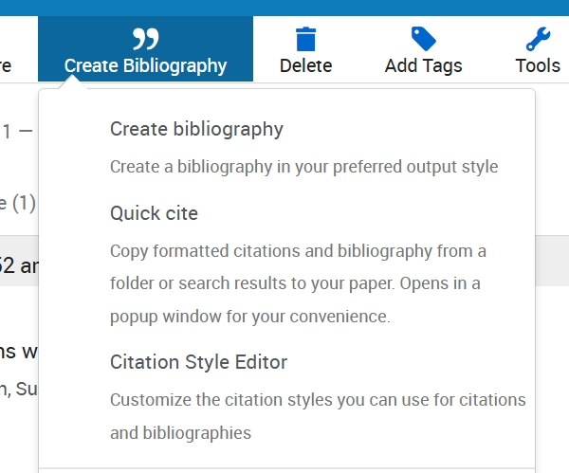
Task 8: Here I am highlighting with the arrow how to do citation in the paragraph from the reference that we saved in our RefWorks Citation Manager.
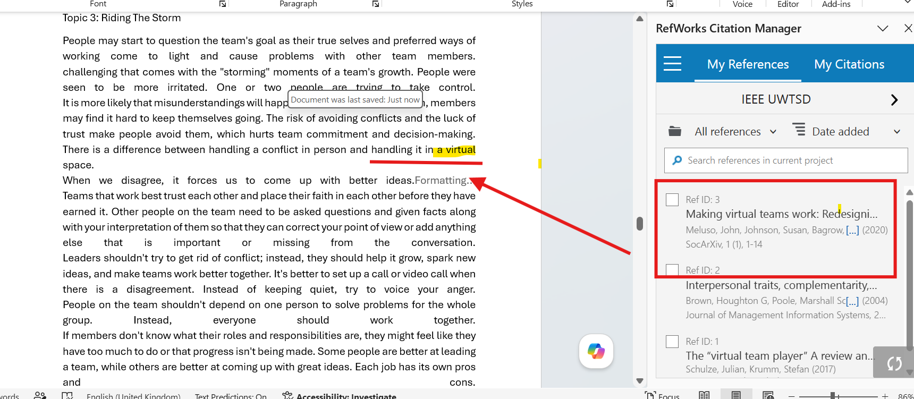
Step 9: select the option IEEE UWTSD.
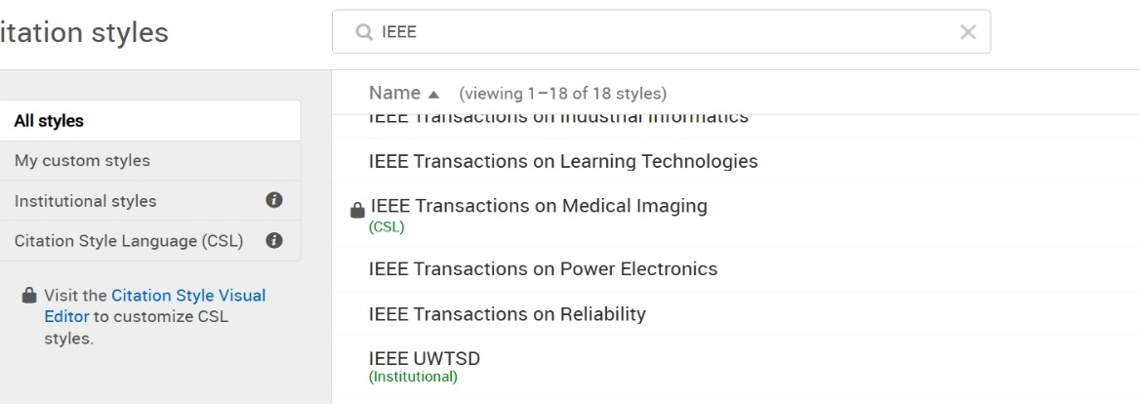
Step 10: select the option save and copy at the top right of the screen.

Task 4: E-Portfolio Creation and Evaluation

Task 4 (a): E-Portfolio Creation
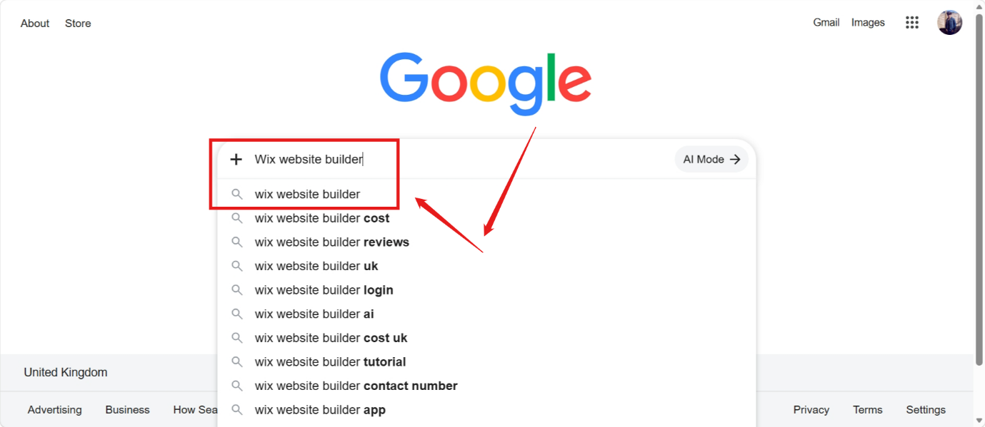
Figure 1. I went to Google search and wrote Wix website builder.
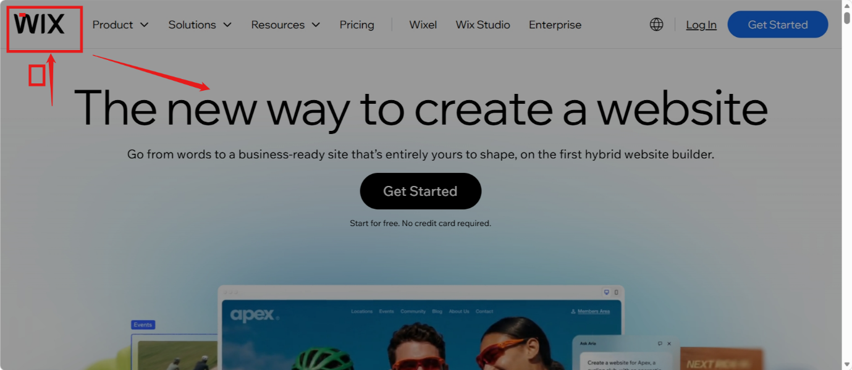
Figure 2. After we clip in google search, we can find the actual Wix website builder.

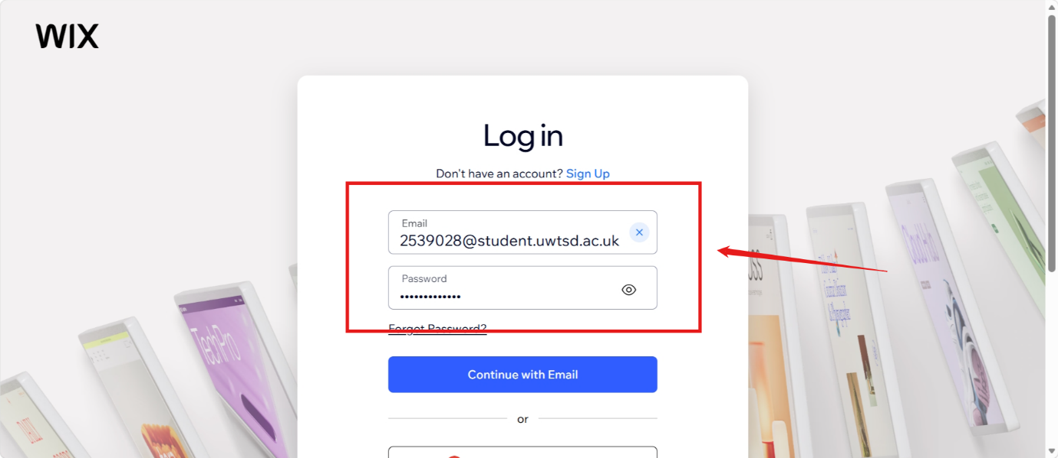
Figure 3. I already sign up and I am now needed to log in with my university email as you see in this figure.

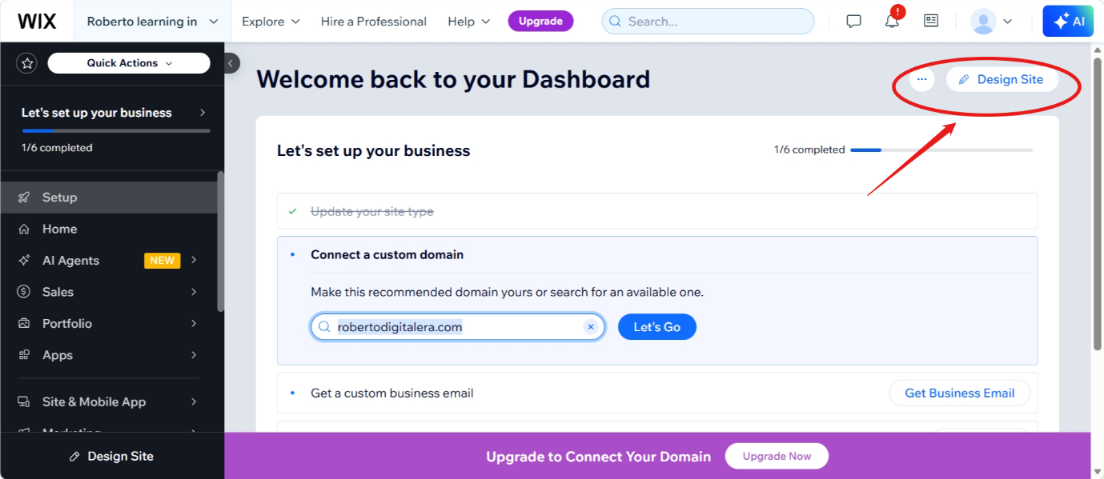
Figure 4. this is my personal website created in Wix, and now I selected design site in the top right of the screen.

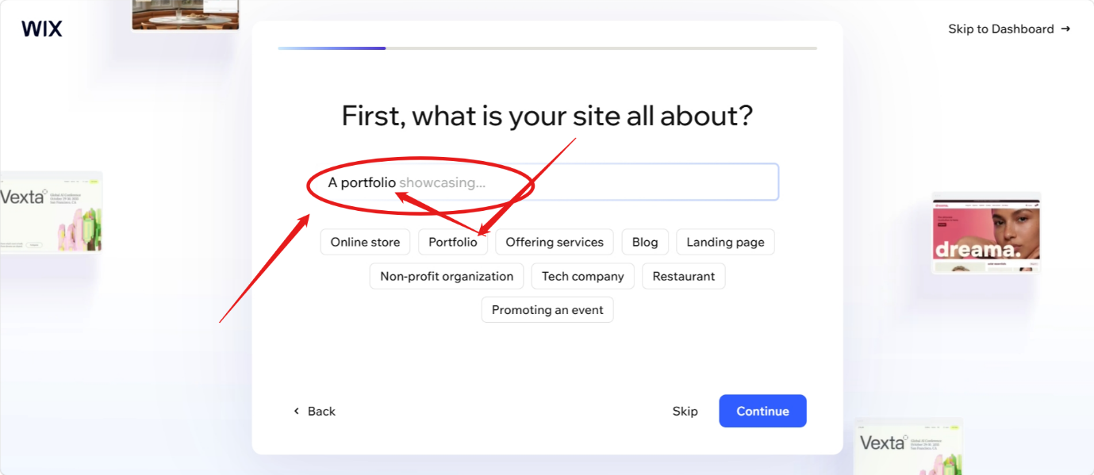
Figure 5. In this step we need to personalise our website choosing what kind of site you want to create. As you see in this figure I selected a portfolio.
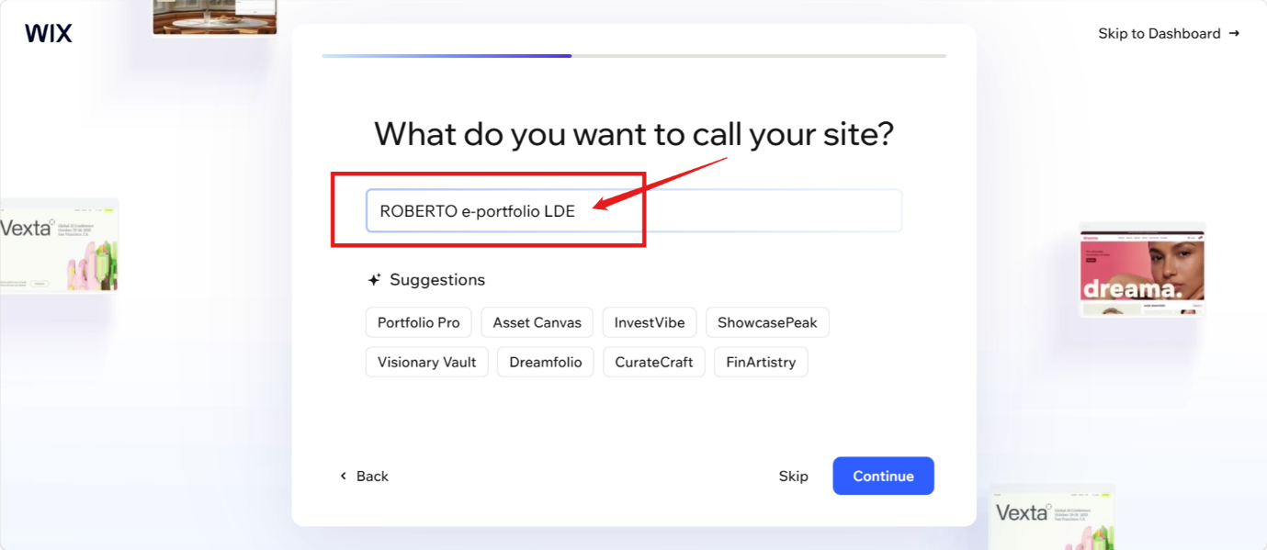
Figure 6. in this figure we have an option to put a name in your portfolio. My choice was my own name to make it more personal and specific with the module LDE.

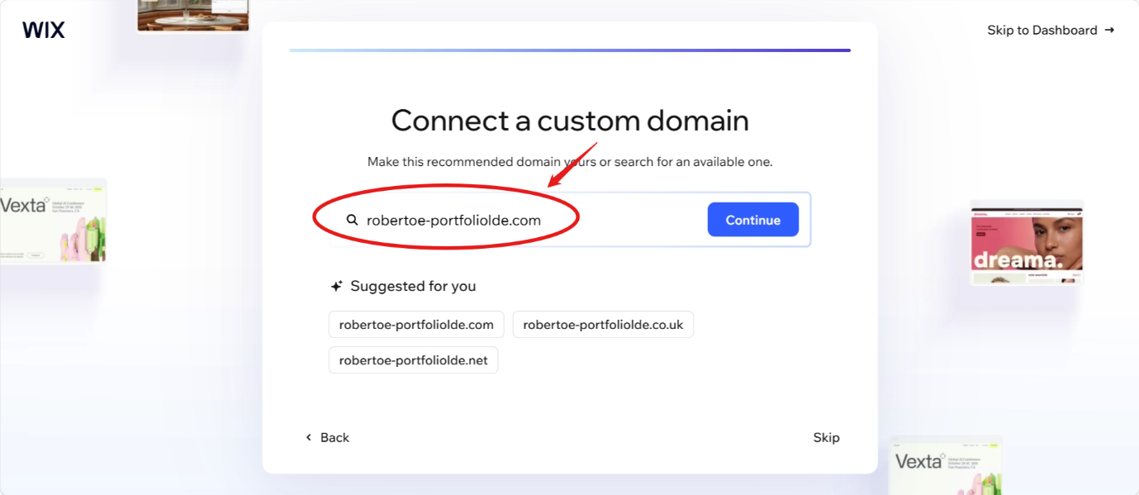
Figure 7. You have options to choose Suggested domain to use, or you can personalise your domain to make it more attractive to the public when you decided to publish it.
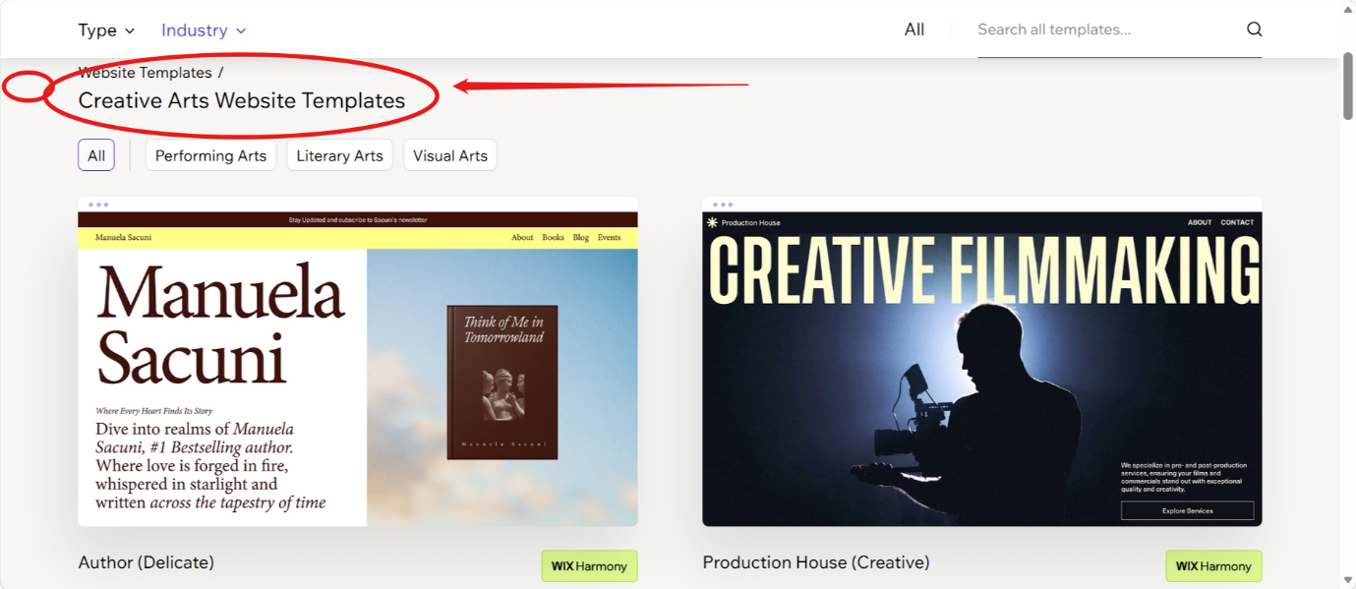
Figure 8. you must choose your template of your preference according to your work that you want to create.

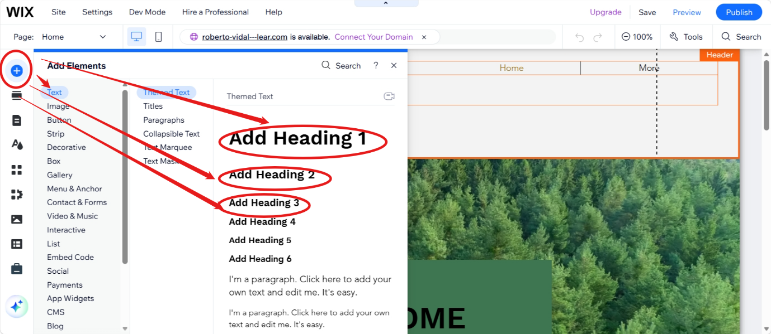
Figure 9. In this step I went to add elements to add heading 1, 2 or 3 to write you titles and paragraphs in case you need it.
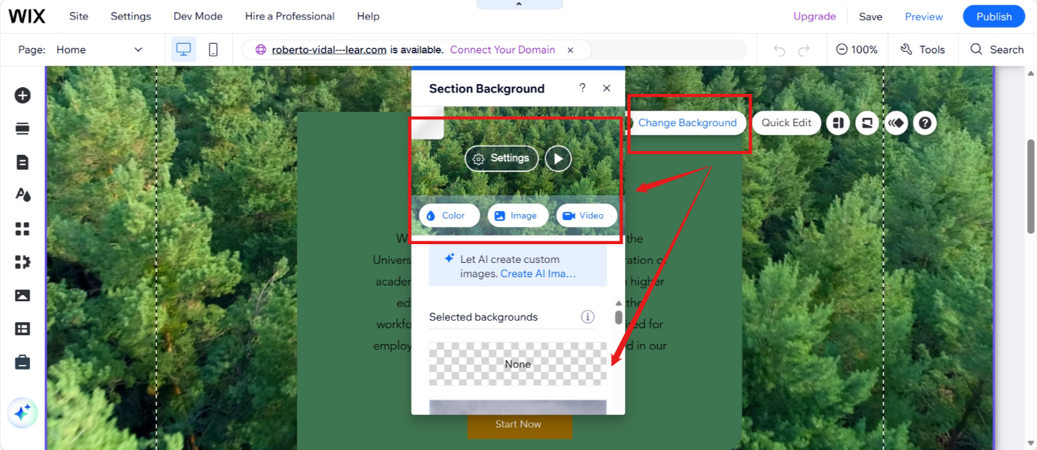
Figure 10. To change your background, you must place your mouse in the place you want to change it and then clip and select the option change background. You will have to choose one option from many that you have.

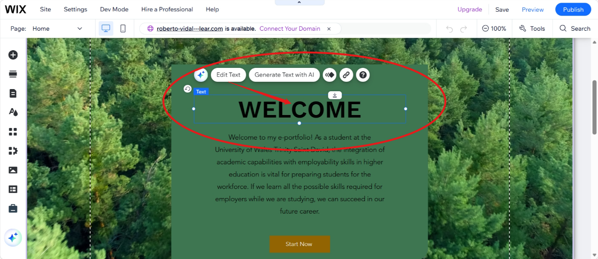
Figure 11. Here you can edit the text in your title selecting the option edit text after placing your mouse in the section you want to change.
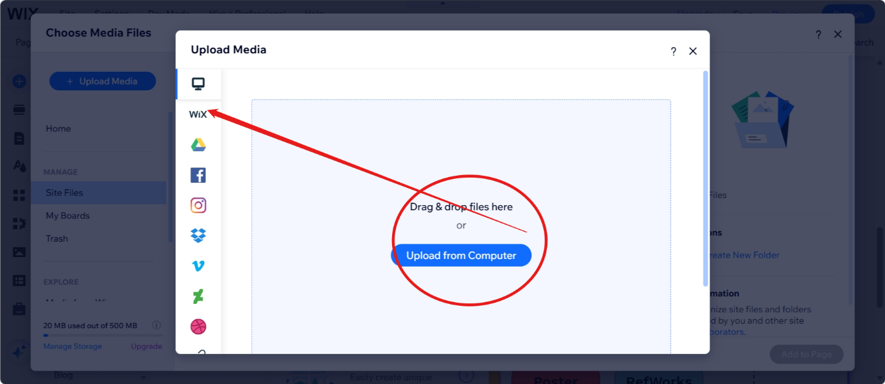
Figure 12. choose media files and select the option upload from computer and it will take to your saved pictures in your OneDrive to select the one you want to put in your portfolio.

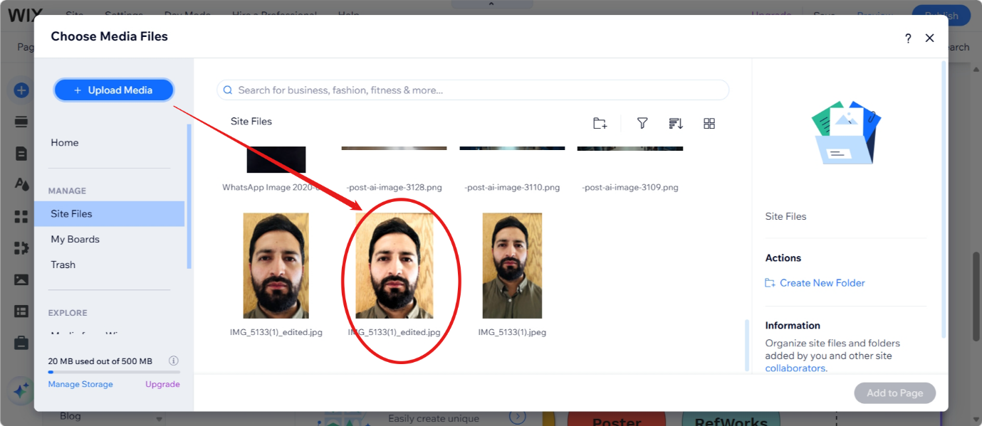
Figure 13. Here you can see that I choose my own image to put in my portfolio home page.

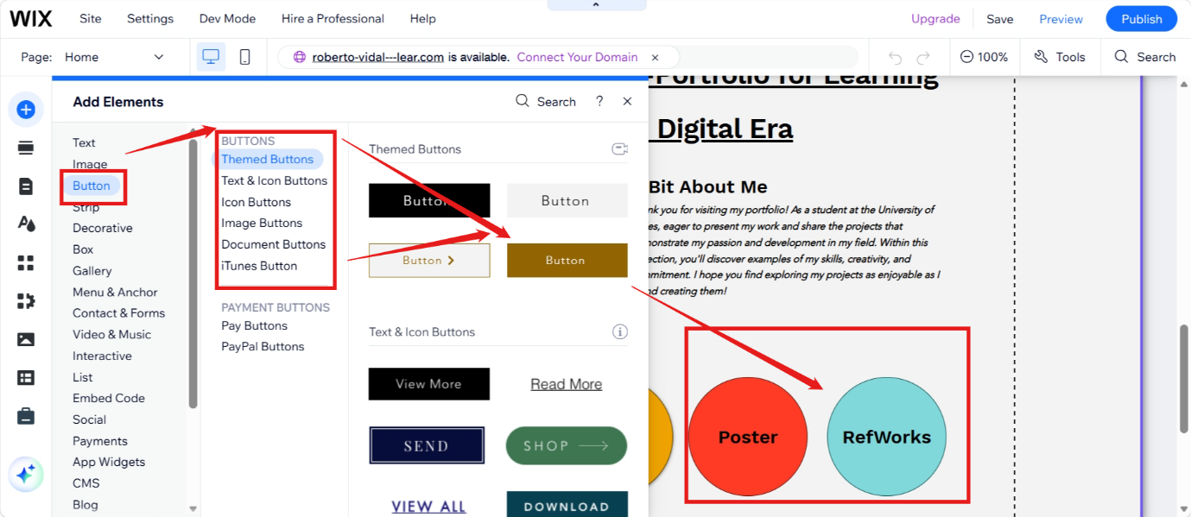
Figure 14. here you need to go to add elements, then select the option to add a different kind of buttons with texts, iTunes or image.

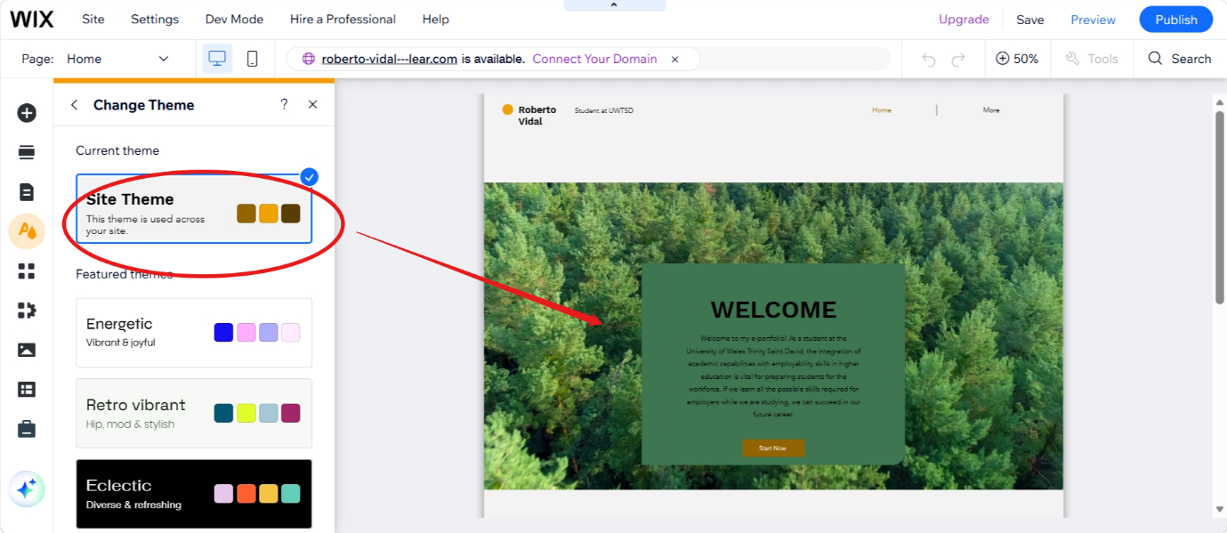
Figure 15. if you want to change your theme you have to go to change theme and then select the one option from different colours suggested there.
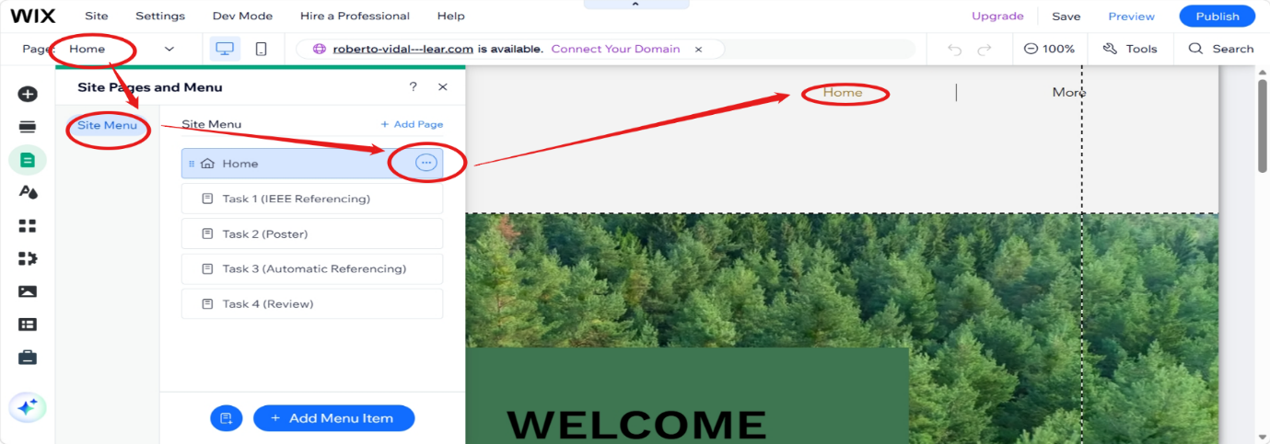
Figure 16. here to adda new site menu or change it, you must go to home, site menu, and then select from the 3 dots the option to rename or add a new one.
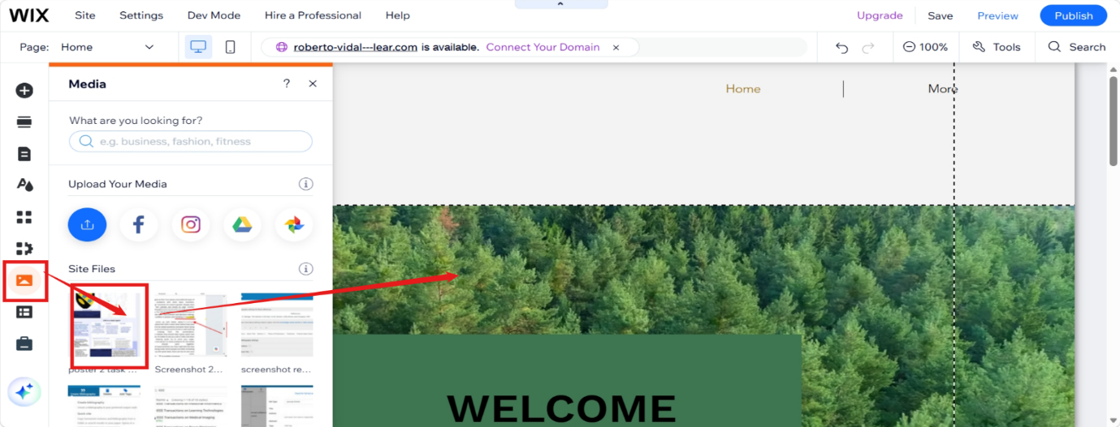
Figure 17. here you can choose in media the option to download your poster that you created for your task 2 and place it in your portfolio.
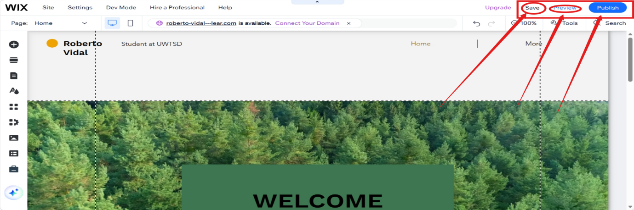
Figure 18. after you completed and edit all your design in your e-Portfolio you must save it. Choose the option preview to see how it will look like live, then publish it.
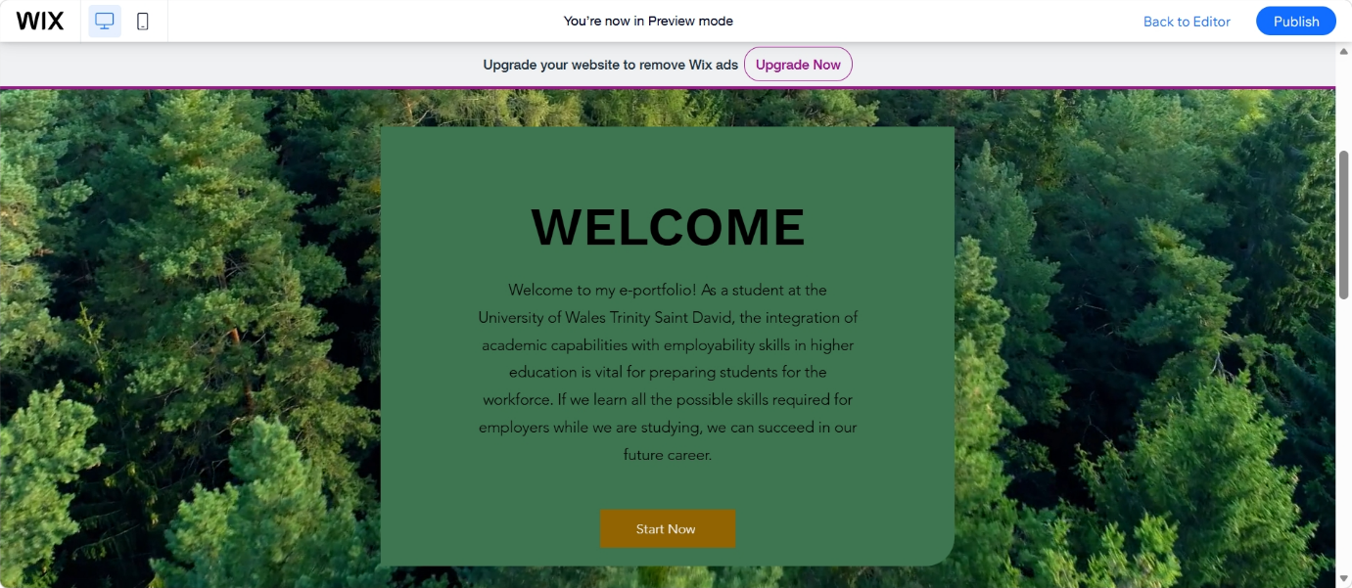
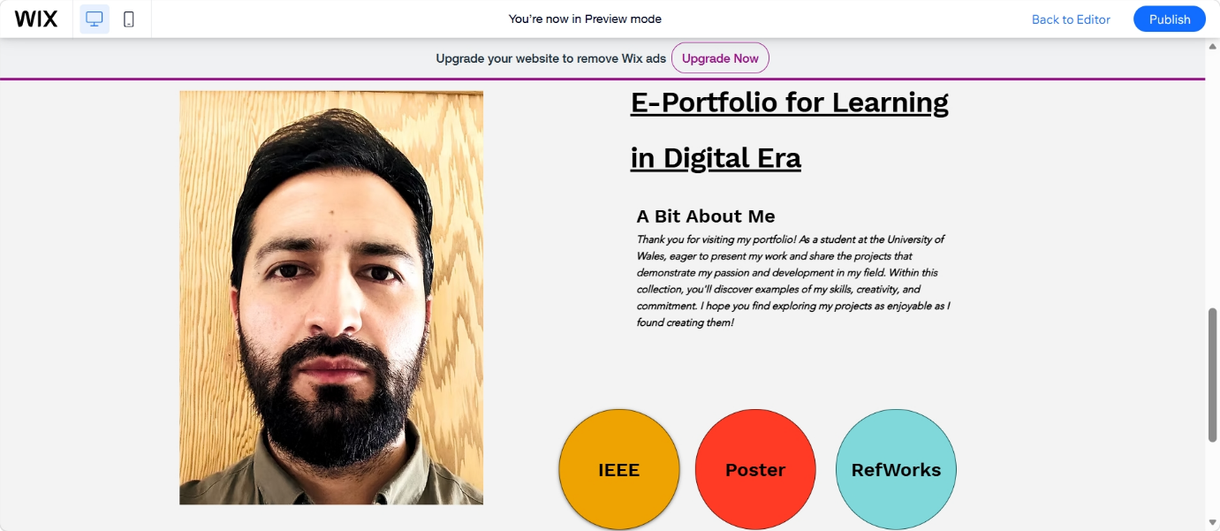
This is the home page of my e-portfolio in WIX.
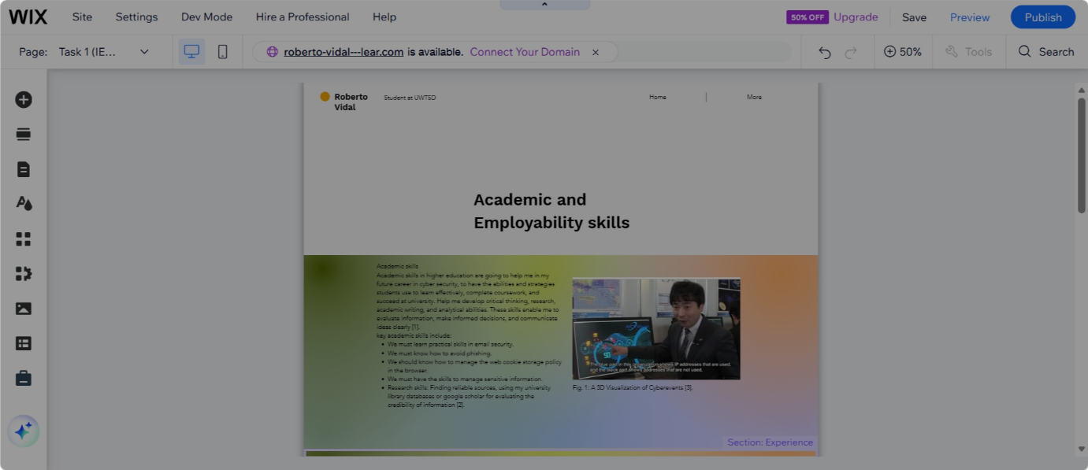
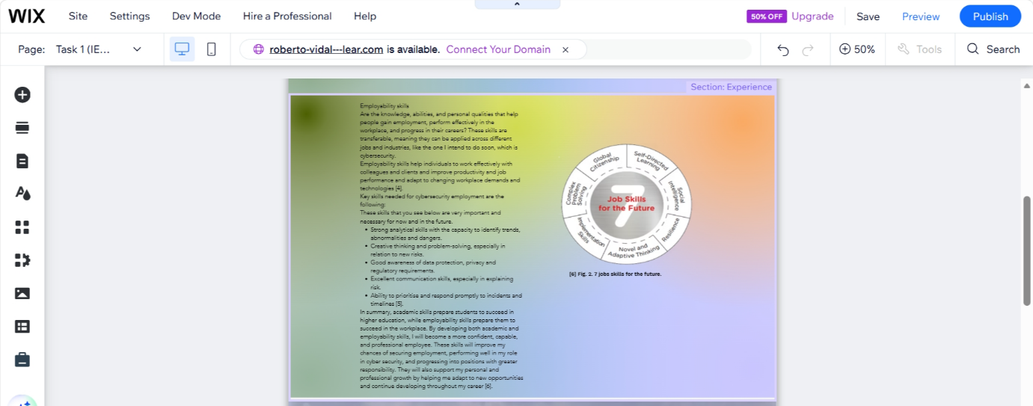
This is the screenshot of my e-portfolio task 1 Academic and Employability skills.

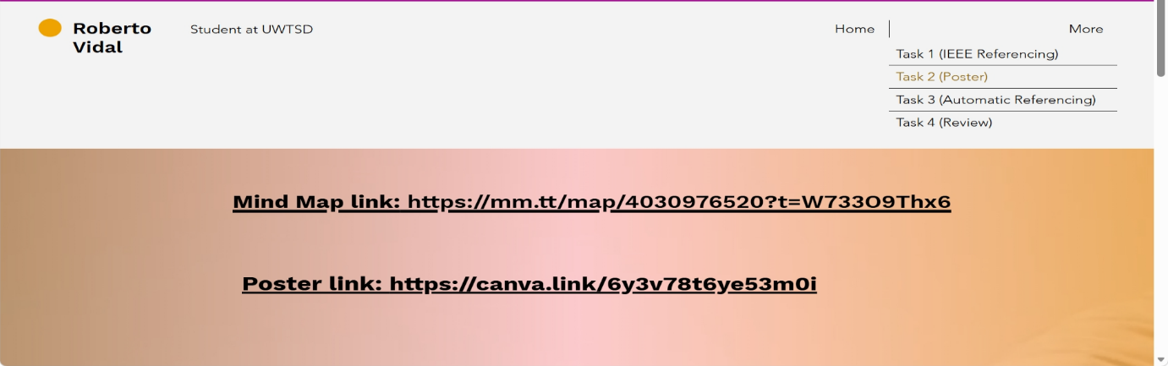
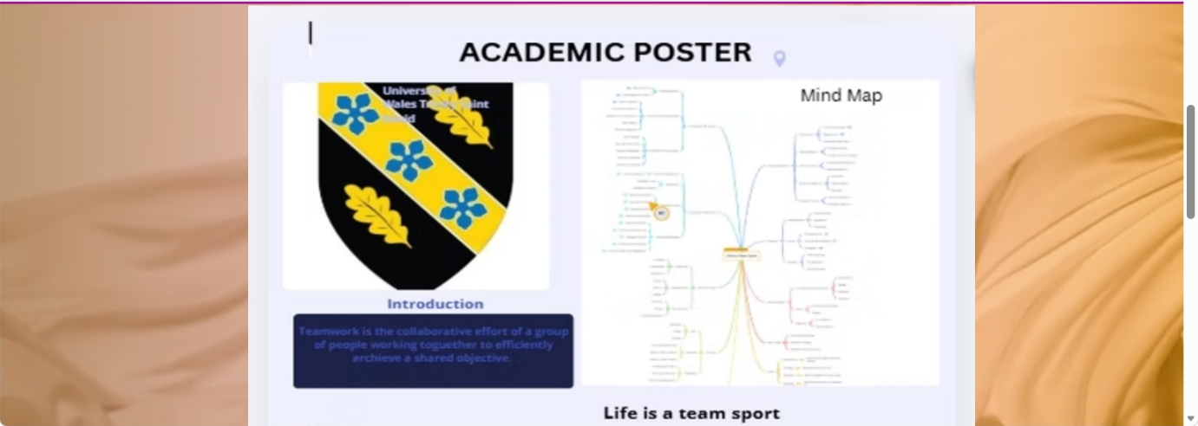
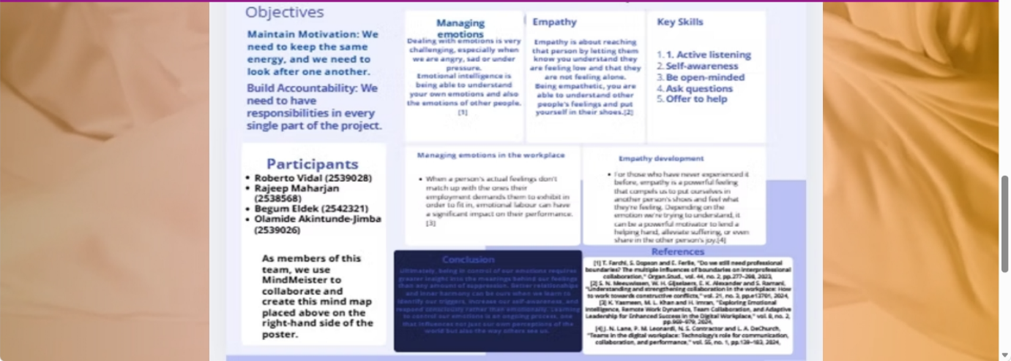
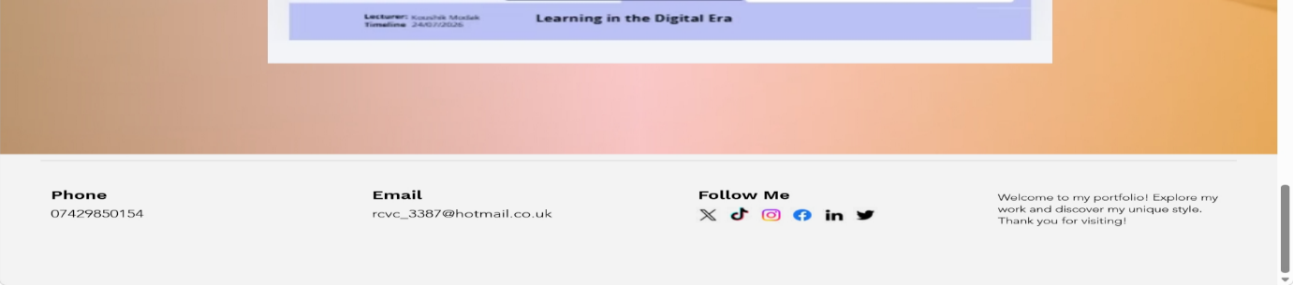
This is the screenshots of my task 2 academic poster and mind map included there.

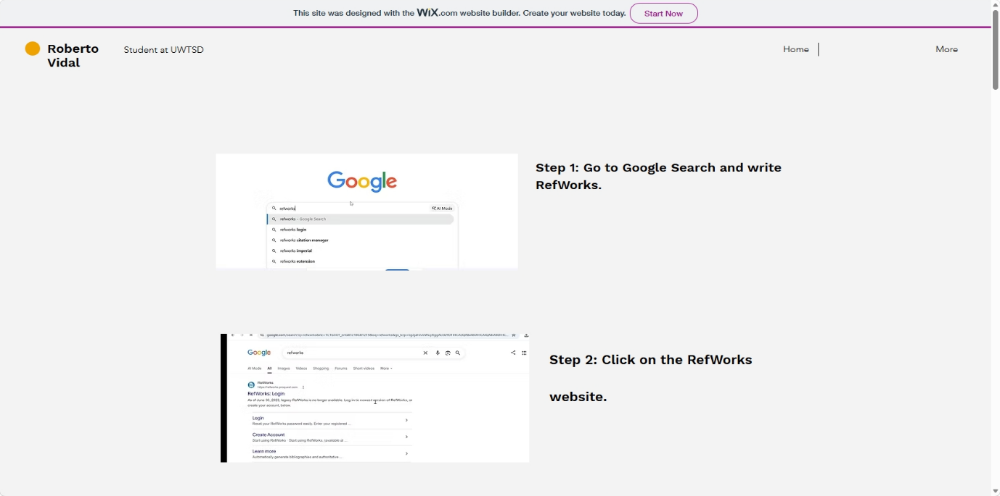
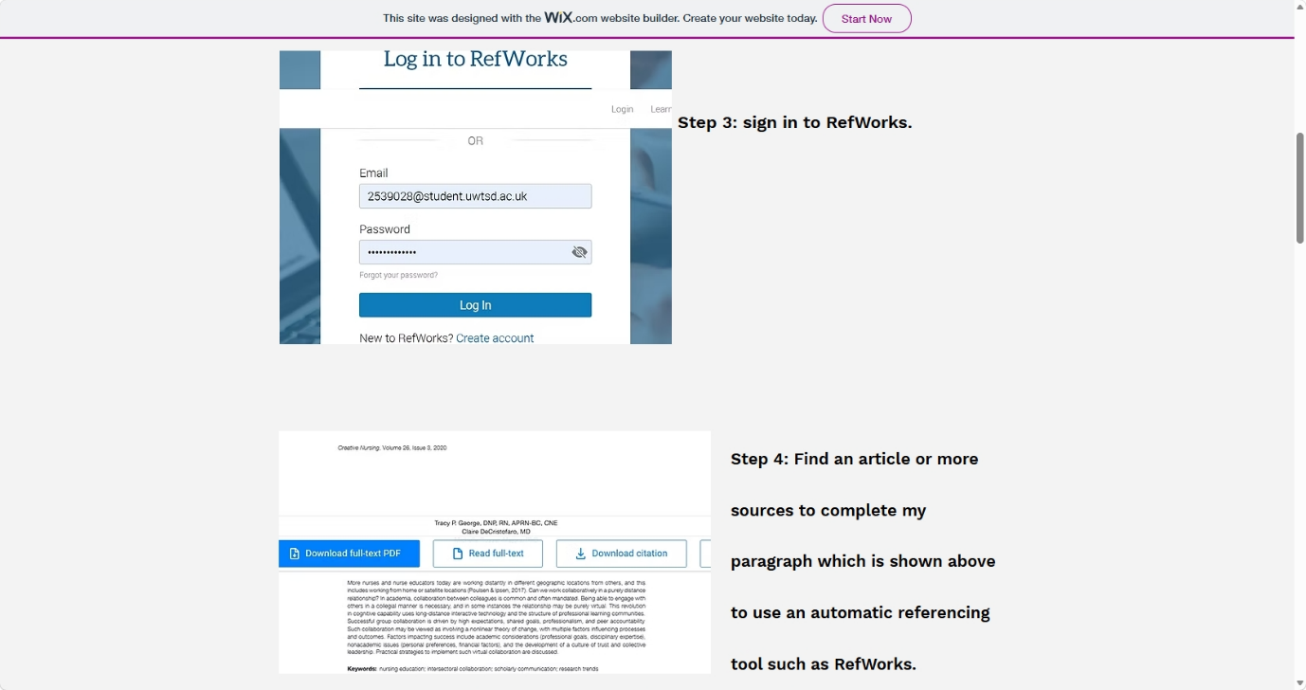
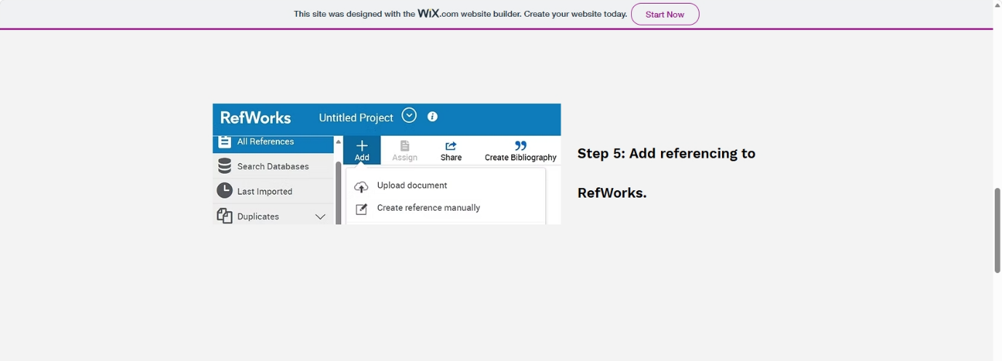
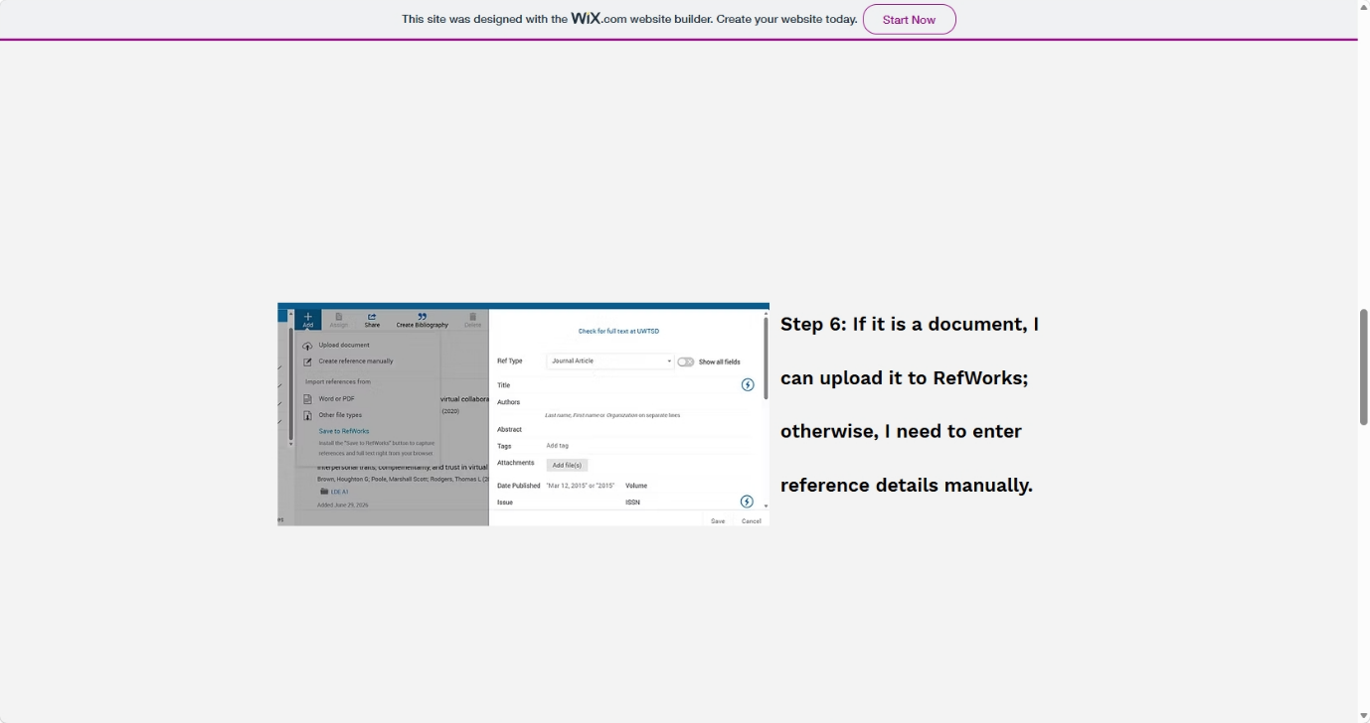
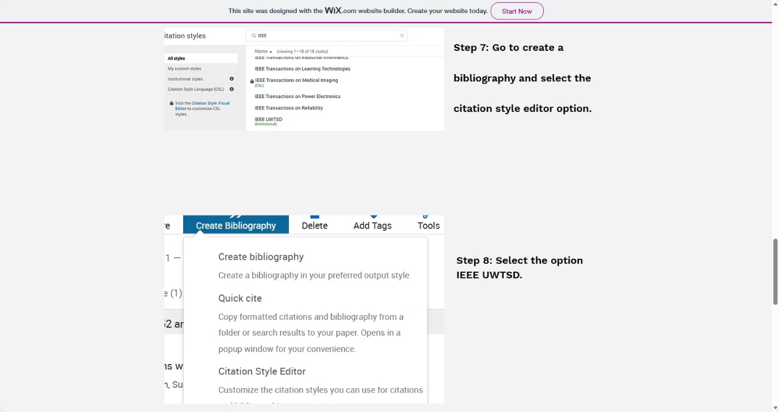
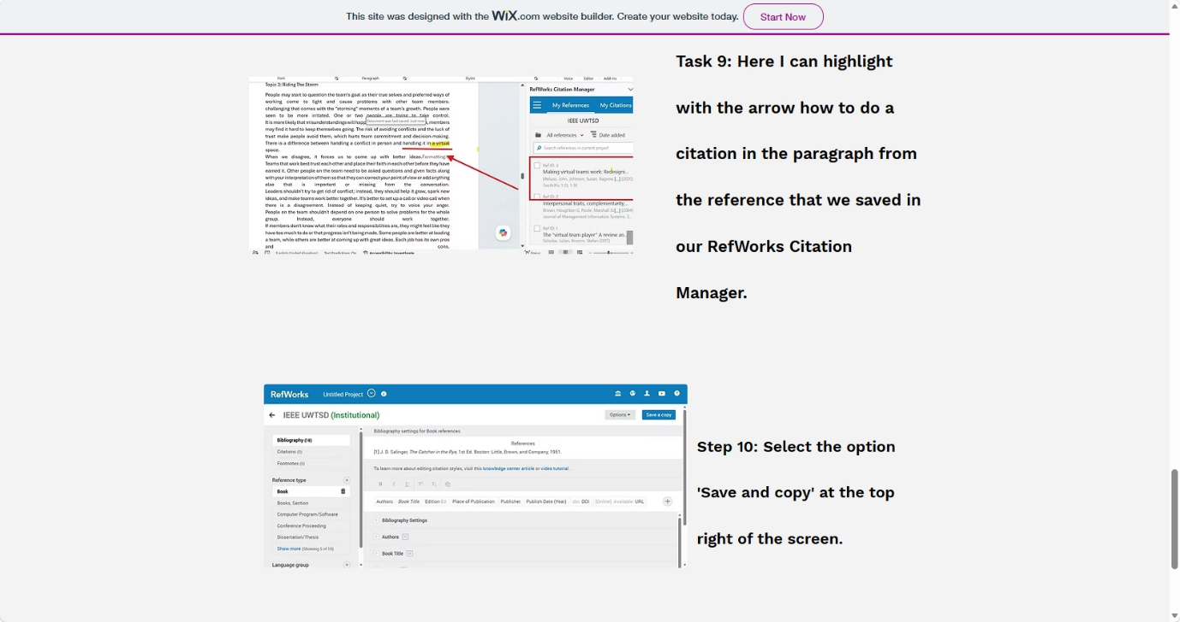
This is the screenshots of my e-portfolio task 3 automatic reference.

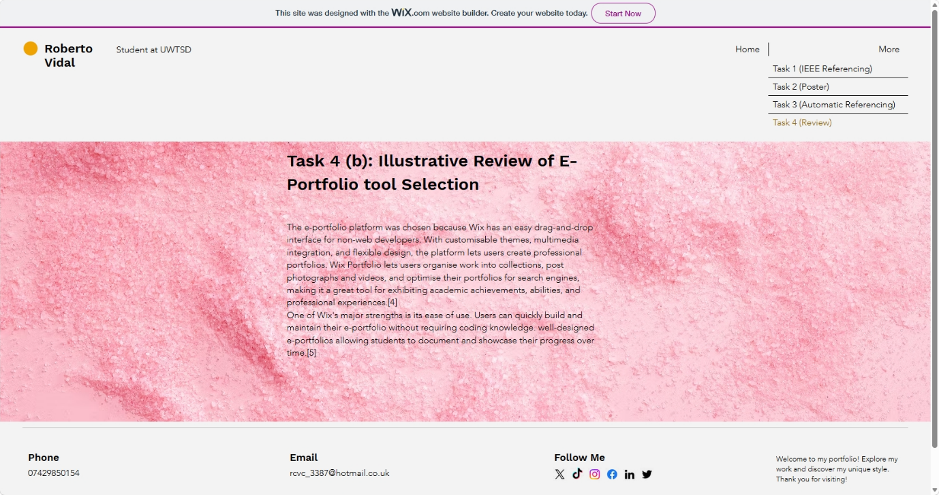
This is the screenshot of my e-portfolio task 4 illustrative review.

Task 4 (b): Illustrative Review of E-Portfolio tool Selection
The e-portfolio platform was chosen because Wix has an easy drag-and-drop interface for non-web developers. With customisable themes, multimedia integration, and flexible design, the platform lets users create professional portfolios. Wix Portfolio lets users organise work into collections, post photographs and videos, and optimise their portfolios for search engines, making it a great tool for exhibiting academic achievements, abilities, and professional experiences.[4]
One of Wix's major strengths is its ease of use. Users can quickly build and maintain their e-portfolio without requiring coding knowledge. well-designed e-portfolios allowing students to document and showcase their progress over time.[5]

Conclusion
I learned important academic and tech skills that will help me in my future studies and career growth during this learning experience. I was able to cite sources more accurately and consistently after learning the IEEE style.
Using RefWorks for automatic reference management also made the process of citing sources faster and more accurate.
I also learned how to make an effective academic poster by using principles of organization, visual communication, and clear content presentation. Using the Mind Meister website to make a mind map helped me organise my thoughts, see how ideas are related, and plan projects in a clear and organised way.
Using the Wix website maker to make an e-portfolio also let me show off my work, accomplishments, and skills in a professional way online.
Overall, these things have helped me get better at academic writing, research, using technology, and talking to people. Using IEEE referencing, RefWorks, Mind Meister, and Wix has taught me a lot and given me real-world experience that will help me with future schoolwork and getting ready for my job.

References

Task 1 Sources

[1] | B. Millis, Cooperative Learning in Higher Education, New York: Routledge, 2023.
[2] | Xiaoyu Li; Mohd Mahsan Bin Awan, “Weley,” 16 February 2026. [Online]. Available: https://onlinelibrary.wiley.com/doi/abs/10.1111/ejed.70490. [Accessed 06 July 2026].
[3] | G. Markowsky, L. Markowsky, “Visualizing Cybersecurity Events,” 2013. [Online]. Available: https://www.researchgate.net/profile/George-Markowsky/publication/256841733_Visualizing_Cybersecurity_Events/links/02e7e523e604642ddc000000/Visualizing-Cybersecurity-Events.pdf. [Accessed 21 July 2026].
[4] | Stuart Rosenberg,Ronald Heimler; Elsa‐Sofia Morote, “Basic employability skills: a triangular design approach,” Emerald Insight logo, 10 02 2012.
[5] | Alammari A, Sohaib O, Younes S, “Developing and evaluating cybersecurity competencies for students in computing programs,” PeerJ Computer Science, 17 January 2022.
[6] | Vlachopoulos, D.; Pachni Tsitiridou, O, “Preparing University Graduates for the Labour Market Through Employability Skills Development and University–Industry Collaboration,” MDPI, 11 March 2026.
[7] | Cooperative Education Workbook, “Open Library,” [Online]. Available: https://ecampusontario.pressbooks.pub/fanshawecoopworkbook/chapter/7-job-skills-for-the-future/. [Accessed 06 July 2026].
[8] | OpenAI, “ChatGPT,” [Online]. Available: https://chatgpt.com/. [Accessed 06 July 2026].
[9] | The London Interdisciplinary School, “The London Interdisciplinary School,” 28 August 2025. [Online]. Available: https://www.lis.ac.uk/stories/future-job-skills. [Accessed 06 July 2026].

Task 3 Sources:
[1] J. Meluso, S. Johnson and J. Bagrow, "Making virtual teams work: Redesigning virtual collaboration for the future," vol. 1, no. 1, pp.1–14, 2020.
[2] H. G. Brown, M. S. Poole and T. L. Rodgers, "Interpersonal traits, complementarity, and trust in virtual collaboration," J.Manage.Inf.Syst., vol. 20, no. 4, pp.115–138, 2004,
[3] J. Schulze and S. Krumm, "The “virtual team player” A review and initial model of knowledge, skills, abilities, and other characteristics for virtual collaboration," vol. 7, no. 1, pp.66–95, 2017,

