Report:
Evaluation and Analysis of Emission Control Components

Course:
Emission Control & Diagnosis
(M5X02202)

Author:
Dion Billing
(1701657)

Contents
Table of Figures 2
Introduction 3
Components 4
Catalytic Converter 4
EVAP 5
EGR 6
Secondary Air Injection 7
PCV 8
Air / Fuel Ratio 10
Euro 6 12
Conclusion 14
Bibliography 15

Table of Figures
Figure 1 12
Figure 2 12
Figure 3 13

Introduction
The following report will include the different components brought in over the years to make vehicles more economic and pump out less emissions. These components include; Catalytic Converter, EVAP, EGR, SAIR, PCV as well as how air/fuel ratios gave changed over the years. Along with the component information will be the correct means of testing each one to ensure that they are in order.
Along with the components will be the different Euro Standards that have been placed and updated over the years from Euro 2 through to Euro 6 along with information about the next update (Euro 7). Tests were conducted with two engines from the Euro 2 and Euro 3 era to compare the differences in readings in some components. This is to see how different emission control modules work under different regulations. The test was also conducted so that the correct equipment can be identified to be used appropriately, as well as realising the symptoms. With the symptoms the fault can be diagnosed and the correct way of fixing the issue can be resolved.

Components

Catalytic Converter
According to the Department of Transport the catalytic converter is ‘the most important part of a cars’s emission control system’ (Department for Transport, 2018). The catalytic converter can be found between the exhaust manifold and the exhaust itself. The basic operation of the catalytic converter is as the exhaust gasses such as Hydro Carbons and Carbon Monoxide travel through it the precious metals inside the cat which include: platinum, palladium and rhodium. These metals then oxidise said gases and they are converted to H₂O and CO₂ (Hillier, 2014). However, the catalytic converter doesn’t really work effectively until between 300°C and 350°C (Hella , n.d.). Within a vehicles’ control system, the catalytic converter works alongside lambda sensors (O₂ Sensors). The lambda sensors measure the level of oxygen before and after the catalytic converter to see if the metals inside are working. Before the euro emission standards became increasingly stricter there only used to be one lambda sensor which was pre-catalytic converter, this was just to ensure the engine was using the correct air/fuel ratio for different engine conditions. Until a few years ago it was the same until manufacturers produces a post cat lambda as well. The post cat used to compare oxygen levels with the pre-cat to ensure that the catalytic converter was working efficiently.
To test if the catalytic converter was working the first test that should be conducted is to test the post cat lambda sensor. To conduct this test, you would need an oscilloscope and the tolerances of the lambda sensors. Using these to pieces of equipment you would test the lambda and see if there are irregularities. (Bosch Automotive, n.d.) However the EGR system only works in defined points when the engine is running.

EVAP
The basic principle of the EVAP systems also known as evaporative-emissions control system is that intercepts and collects fuel vapours from the fuel tank. This is so the vehicle complies with legislation around the evaporative loss emissions. EVAP systems will only be found on petrol fuelled engines as the boiling point for diesel is so high that it shouldn’t be an issue. The EVAP system begins with a vent line from the fuel tank into a carbon canister, from the canister the vent line follows into the regeneration valve and the intake manifold. When the pressure in the fuel tank increases due to increase in ambient temperature or the return of the heated fuel in the engine the vapor of the fuel travels through the vent line and into the carbon canister. From here the carbon which is activated only allows the air to escape into atmosphere. The fuel vapours are absorbed into the canister and stored. When the intake manifold has a lack of pressure or a vacuum occurs, the regeneration valve opens allowing fresh air to travel through the carbon canister and into the intake manifold. While travelling through the canister the fresh air picks up the absorbed fuel vapours and takes them into the combustion process. This process is called a carbon-canister purge. There is a limit as to how much of the vapour the activated carbon can store, to ensure that there is always some room for the fuel vapours to be absorbed the ECU activates the system allowing it to regenerate at regular intervals (Bosch Automotive, n.d.).
The EVAP doesn’t particularly contribute highly to the combustion emission regulations; however, it is mainly been introduced so that the vehicle passes the evaporative losses regulations. Most modern-day vehicles must go through very in-depth testing such as a Hot Soak, Diurnal Test and Urban Drives. This is to see if the vehicles comply with the regulations. The requirements to pass the vehicle upon testing is that the canister cannot emit more than 2.0 grams of hydrocarbons, or if t=it hasn’t given out more than 5000ppm of hydrocarbons through the vent (Giorgio Martini, 2012).

EGR
EGR is an exhaust gas recirculation system. This system allows exhaust gasses to recirculated back into the intake manifold and then back into the combustion chamber. This is done via a pipe connecting the exhaust and the inlet manifold, due to the pressure difference between the two areas the spent gasses travel back into the inlet manifold. Usually there is an electronically controlled valve to allow a certain amount of air through into the manifold to control the reduction in combustion temperature. The spent gasses are then sent back into the combustion chamber with the clean air/fuel mixture, the combustion temperature is reduced as the returned exhaust gasses to not particulate in the combustion process hence gives out no additional energy. This is done to reduce the peak combustion temperature, which in turn drops the overall temperature dependant untreated NO_{x} emissions (Bosch Automotive, n.d.).
EGR is only used under certain engine operating conditions such as cruising on the motorway. This is because the driver will not notice the difference while cruising as the rpm is barely affected in this condition. However, when idling the valve is fully closed as the idle speed would alter, causing the engine to run inefficiently as well as the driver hearing the difference in the idle speed potentially thinking there is an issue with the engine (Hillier, 2014).

Secondary Air Injection
Secondary Air Injection is another system brought into the mix for modern vehicles to bring the emission levels down to a legal quantity. The main objective of the secondary air injection system is to heat the catalytic converter up at a faster rate than without it, this is so it can work within its temperature range faster to maximise its efficiency. As mentioned above in the Catalytic Converter section the temperature range it works most efficiently is 300°C and 350°C. It gets up to this temperature range faster through adding more ambient air with high oxygen content into the exhaust system, this creates an exothermic reaction. SAIR is most commonly used during the warm up phase of an engine where Hydrocarbons and Carbon Monoxide are more prominent, upon start-up it usually runs for around 100 seconds (Hella , n.d.). The additional oxygen source causes the hydrocarbons and carbon monoxide to react in a secondary reaction, which in turn produces additional heat energy (commonly known as afterburning) (Pierburg, n.d.). This in turn heats up the exhaust gasses travelling through the catalytic converter which heats the cat up at a faster rate. The heat up of the catalytic converter means that when the engine has warmed up and the air/fuel ratio has become leaner when the NO_{x} is being produced. The catalytic converter is already up to operating temperature to work how it should and reduces the cars’ overall emissions.
There are two ways that the secondary air injection can be supplied. One is passive and the other is active. In the passive system a timed valve is used, the valve opens and closes when reacting to the fluctuations in pressure in the exhaust pipe which creates a vacuum in the exhaust pipe drawing more air in. The active system works in a slightly different manor. This system uses a pump which allows for better accuracy and control. The active system is used up until the lambda sensors are up to temperature once the lambda sensors are heated up the whole system is shut down all the way back to the combination valve just in case the hot exhaust gases damage the electrical components including the pump behind it.

PCV
Similarly, to the EVAP system the Positive Crank Ventilation system (PCV) was brought in to prevent vapours being expelled into atmosphere. The basic principle of a PCV system is that it uses manifold vacuum to draw in the vapours from the crankcase into the intake manifold through the PCV valve. The vapour is then mixed in with the air/fuel mixture and it goes into the combustion chamber to be burnt off. (Filter Manufacturers Council, n.d.)
There are two types of PCV systems, an open system and a closed system. The main difference between the two systems is the way that the air is induced into the crankcase. The open system uses a vented oil cap. This works well at drawing air into the crankcase and removing vapours, until the vapor excess begins to increase. The vapor levels need to stay minimised throughout if this was to work effectively as a pollution reduction component. A later improved closed PCV draws the air in from the air filter housing not the vented oil cap. This means that the excess vapours that leave the vented pipe will lead into to the air filter housing which means its more likely to be re-introduced into the intake manifold. This increases the efficiency of the system and works far better than the open system at reducing pollution levels. (Filter Manufacturers Council, n.d.)
The PCV valve is a crucial part in this system. Its job is to meter the flow of vapours leading from the crankcase into the intake manifold. The valve is a one-way valve allowing the air to flow from the crankcase into the intake manifold, this is because there is a risk that if the flow was reversed the engine could backfire and cause severe damage to the internals. The valve will open and close when required to allow more air to pass or restrict the airflow (Filter Manufacturers Council, n.d.).
Not servicing your PCV system can end up in a very expensive repair job. If all the ventilation pipes and pathways for the oil are not checked and neglected the oil will become contaminated and take the consistency of sludge rather than liquid. This means that the components that require the lubrication are lacking and will either rust or overheat in the process. If the PCV system isn’t working optimally the vapor will be inaccurately measured giving off the wrong data which will alter the air/fuel ratio. (Filter Manufacturers Council, n.d.)

According to Bosch on Gasoline Engine Management the best way to find a leak in your PCV system is to measure the idle speed while the PCV is open. You look at the idle speed of the vehicle and check it up against the manufacturer’s recommendation of idle speed. If the difference between the too is much larger than expected, then you can assume that there is a leak in the system. From here you then target the leak and repair appropriately (Bosch, 2006).

Air / Fuel Ratio
Air to fuel ratio has been a key point in fuel emissions since the very beginning. Changing the air/fuel ratio can change several things about how the engine is running and what emissions it is giving out. The ideal ratio for running the vehicles engine at the optimum range is 14.7 parts of air to one part of fuel burnt, this ratio is called the stoichiometric ratio (Haynes, n.d.).
Over the years the vehicles engine management system has been using the lambda sensor to calculate if the ratio has been too rich or too lean when the engine is running. The very basic systems only checked for the stoichiometric ratio also known as ‘Lambda 1’. It is only the pre-cat sensor that adjusts the fuel mixture the post lambda only checks if the cat is working as it should. Stoichiometric ratio is hardly ever used only upon idling and slow cruising, any throttle input will make the air/fuel ratio richer as the ECU has it mapped in its system (Hillier, 2014). Anything lower than lambda 1 can be determined as a rich mixture and everything above can be determined as a lean mixture (Bosch Automotive, n.d.).
On more modern vehicles where, direct injection SI engines are becoming more and more popular. The main reason for this is the stratified charge that they can apply. Stratified charge is a system where an air/fuel mixture of lambda 1 sits very close to the spark plug and ignites this in turn ignites the much leaner gas surrounding the rest of the chamber allowing for a leaner burn overall (Bosch, 2006).
To test to see what the air/fuel ratio is you could test at the pre-cat lambda sensor. As stated above this is the one that sends the oxygen level data back to the ECU which will tell it the air/fuel ratio in voltage due to the zirconium piece which gives off a small voltage when introduced to two oxygen levels. The range of voltage at which the lambda sensor works is between 0.1v and 0.9v (Hillier, 2014). According to Hella there are two main ways of testing your air fuel ratio. You could either use a multimeter or an oscilloscope. You should keep the engine revs at 2,500 RPM for better results and put the earth cable on a good earth and the positive cable piggybacking the lambda wire dependant on what type it is the wire colour may vary. On the multimeter a voltage of between 04.v and 0.6 should appear and once the engine is up to temperature the voltage should vary between 0.1 and 0.9v. the oscilloscope should be set at 0.5Hz to 4Hz and the voltage on both set between 1v and 2v (Hella , n.d.).
Another way of testing the air/fuel ratio is the four-gas emission analyser. This test is arguably the quickest way to see if the air/fuel ratio is working at lambda 1. The way the testing equipment works is like that of an exhaust emission test. It is connected to the exhaust pipe while the engine is running at optimal temperature and connected to the testing equipment will be a dedicated computer that will give out the lambda reading. The test is conducted over a period of 60 seconds to gather solid information and you then remove the disturbance variable and you should get the lambda’s original value. However, this test only determines if the lambda control is working (Hella , n.d.).

Euro 6
The latest of the Euro Emission Standard Legislation arrived on September 1st, 2014. The main objective of the latest standards was to reduce the level of NO_{x} that diesel engines were producing in particular (RAC, n.d.).
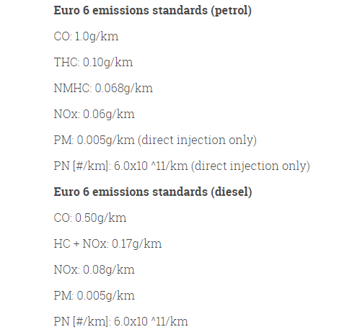
Figure 1

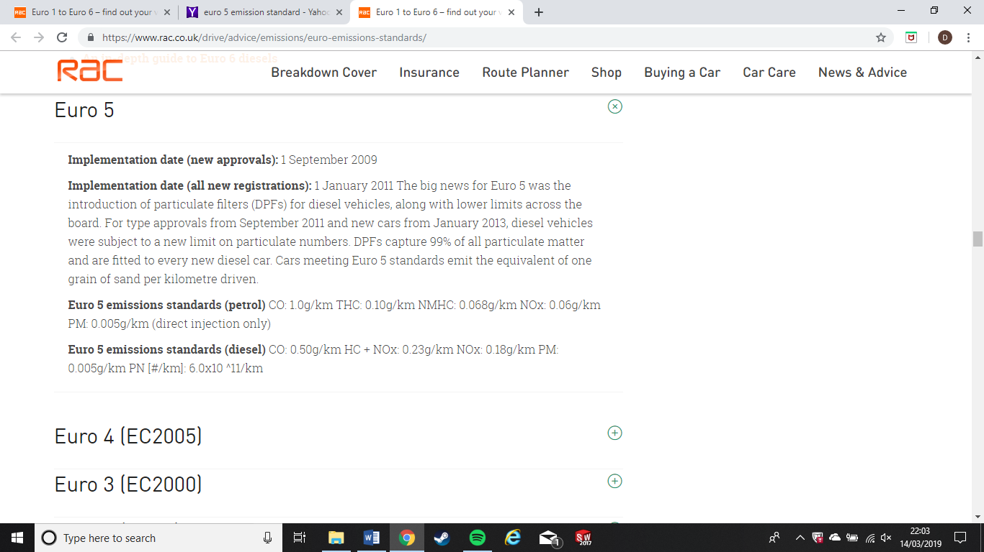
Figure 2

As you Can see above there is a comparison between the Euro 5 and Euro 6 emission regulations. As you can see the everything is the same apart from the NO_{x} level requirement in diesels have more then halved. This was mainly down to the fact that London itself was creating too much pollution with the taxis, vans, lorries and busses etc. To tackle this problem according to Auto Express LEVC have brought out a plug-in electric London taxi to reduce vehicle emissions (Allen, 2017). Also, since 2016 London have also introduced electric busses to improve air quality (Transport For London, 2016).
The system tested was a ford system that complied with Euro 3 and 4 emission regulations.

The primary research engine was a ford engine referring to the euro 3 standard regulation. The euro 3 emission parameters are noted below:
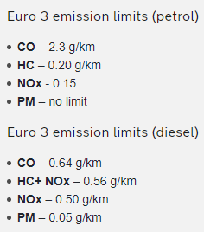
(The AA, 2017)
Figure 3

If you compare the CO levels in the picture above to Figure 1 you will see that the CO level requirements has decreased from 2.3 g/km to 1.0 g/km. Carbon monoxide is produced when one of the cylinders receive a richer mix than stoichiometric ratio or a poor quality mixture (Hillier, 2014). One of the many ways to bring the level of CO down from the euro 3 standards to euro 6 is to apply a direct injection system to modern vehicles.
According to Volkswagen their direct injection system while using the direct injection system they can use modes of lambda 1.6 and 3 in stratified charge and lambda 1.55 in homogenous lean mode. This allows for a lower heat loss through cylinder walls due to the combustion taking place right next to the spark plug which improves thermal efficiency. Due to the higher pressure at the point in which the fuel is injected the fuel injectors will have to be improved to inject the fuel at a higher psi than inside the chamber. This may be a costly feature to introduce but will improve fuel efficiency overall and cut down the CO levels (Volkswagen, n.d.)
Although the direct injection lowers the CO levels in the emissions test, due to the heat the lean mixture produces in the chamber NO_{x} are being produced to levels which will not comply with the euro 6 regulations. Volkswagen have a solution for this which is a NO_{x} Storage catalyst. It stores the majority of the NO_{x} produced during the lean homogenous and stratified charge modes and once full it goes into regeneration mode which converts the NO_{x} into Nitrogen (Volkswagen, n.d.).

Conclusion
In conclusion to this report all the components above have contributed significantly to help vehicles pass the emissions standards tests. Engineers are still finding ways to improve these systems and come up with new systems that can also contribute towards reducing emission levels. Although from petrol and diesel engines can never emit zero emissions the cars of today are significantly better than the cars of previous decades. However, the components that are on vehicles today are getting more and more complex to resolve if they have an issue and in turn more expensive. Eventually they will become rather easy to fix as technology advances but at this stage they are still relatively expensive.
In the future the development of the fossil fuelled cars will advance to get them as low as possible which will be in tandem with electrical cars which are now beginning to become a prominent feature on the roads. The development that has gone into electrical and hybrid vehicles over the years has now started to show with cars such as the McLaren P1 showing that hybrid systems can work at the very top end of the automotive spectrum. Tesla have also been mass producing their range of vehicles are becoming a common feature on the roads. They have also announced that the Model Y will exceed 300 miles on a single charge which means there’s a very bright future with electrification of vehicles (Korosec, 2019)

Bibliography
Allen, L., 2017. New 'TX' electric London Taxi priced at £55,599, s.l.: Auto Express.
Bosch Automotive, n.d. Automotive Handbook. 7th Edition ed. s.l.:Wiley .
Bosch, 2006. Gasoline Engine Management. 3rd ed. Chichester: Wiley.
Department for Transport, 2018. Catalytic converters: advice on type approval and legal requirements for suppliers and manufacturers. [Online]
Available at: https://www.gov.uk/government/publications/catalytic-convertors/catalytic-converters-advice-on-type-approval-and-legal-requirements-for-suppliers-and-manufacturers
[Accessed 27 Febuary 2019].
Filter Manufacturers Council, n.d. Positive Crank Ventilation, s.l.: Filter Manufacturers Council.
Giorgio Martini, U. M. M. R. A. M., 2012. Review of the European Test Procedure, s.l.: European Commission.
Haynes, n.d. What is Air/Fuel Ratio, s.l.: Haynes.
Hella , n.d. Secondary Air Injection, s.l.: Hella.
Hillier, J., 2014. Engines and Engine Technology. Sixth Edition ed. s.l.:Oxford University Press.
Korosec, K., 2019. The Tesla Model Y is a 300-mile range Model 3 doppelganger coming in fall 2020, s.l.: Tech Crunch.
Pierburg, n.d. Secondary Air System, s.l.: Motor Service.
RAC, n.d. [Online]
Available at: https://www.rac.co.uk/drive/advice/emissions/euro-emissions-standards/
[Accessed 14 March 2019].
The AA, 2017. Limits to improve air quality and health, s.l.: The AA.
Transport For London, 2016. Mayor unveils first fully electric bus routes for central London, London: Transport For London.
Volkswagen, n.d. Direct Petrol Injection System with Bosch, s.l.: Volkswagen.

