

Global Business Environment
Assessment 1 (Task 1)

Module Code: LCBB4005
Lecture Name: Dr. Rexon Nting
Student Name: Marlon Alexander Ortiz Gavilanes
Student ID: 2132604
Date of Submitted: 28th November

Contents
Introduction…………………………………………………………………………………4
brief of introduction of Ecuador as a selected country…………………………………….5
Theories of Business Environment…………………………………………………….……5
PESTEL Analysis……………………………………………………………………………6
Porter’s Fives Forces Model…………………………………………………………………9
The opportunities and Challenges face by Sports Direct……………………………………11
Different Barriers experienced by foreign businesses in Ecuador……………………….….12
Recommendation for appropriate strategies…………………………………………………13
Conclusion…………………………………………………………………….………….…13
References……………………………………………………………………………………14

List of figures
Figure 1 GDP: Annual Growth Rate……………………………………...……...………….6
Figure 2 Porters five forces model ……………………………………...……...…………...7

INTRODUCTION
International business is defined as production, sales and transaction activities that are allowed in any region or border of the world thanks to globalization so that companies have the opportunity to share their products to all parts of the world (Czinkota, Ronkainen, & Moffett, 2011).
This report deals with the expansion of Sports Direct, one of the stores best known for selling sports products and clothing, located in the United Kingdom. The company intends to expand its stores (Wolfe & Werhane, 2017). The project is about moving to a developed country like Ecuador. The research analyzes the current situation, possible circumstances or problems that may arise, changes in business environments that can influence global companies, and difficulties that can affect the smooth running of the business. Additionally, taking into consideration all the data, some strategies are proposed that the company could adopt to be successful in the country.

A brief introduction of Ecuador as a selected country
Ecuador has a population of 18,041,000 people and is a developing country. It is ranked sixty-seventh in the world and has one of the lowest densities of population (World Bank, 2022). The country is divided into three geographical regions; the coast, the mountains, and the east, and has twenty-four provinces. Due to of its numerous civilizations and cultural variety, as well as its diversified population of individuals from various racial and religious backgrounds, the country attracts the interest of international investors. As a multiparty republic with a single legislative chamber, the country is governed under a unitary system, which combines capitalism and socialism. Ecuador is a nation with an abundance of natural resources that could be utilized to develop the economy of the nation. Consequently, establishing a firm abroad aid in boosting that country’s economic growth (Britannica, 2022).

Theories of Business Environment
There is the possibility that Sports Direct develops its commercial activity in Ecuador. The business environment is defined as the set of all internal and external aspects, including personnel, customers, suppliers, and owners, as well as government actions, technological innovation, social and market trends, and economic changes, that determine the success of this expansion. These variables will impact business operations in many ways. Therefore, before moving the Sport Direct company to Ecuador, it is important to think about these aspects (O'Sullivan, 2020).
The business environment of Ecuador is analyzed using a variety of models.

PESTLE Analysis
PESTLE analysis is a strategic planning analytical method used to evaluate the potential effects that legal, political, economic, social, and technical aspects may have on a project. Before beginning a project, a business must take the environment into consideration to identify possible risks and external impacts (APA, Rastogi, & Trivedi, 2016).
Political Factor.
Ecuador has had years of political instability and severe effects from the 2020 pandemic. In 2021 Guillermo Lasso entered as Ecuador's president and campaigned on tax reforms aimed at promoting growth, lowering import tariffs, and eliminating income tax. 2% for small, medium, and medium-big sized companies. He also promised to double oil production and mining concessions (June, Beittel, Rachel, Martin 2022). This would be wonderful news for the organization since it would have to pay less when exporting items from the United Kingdom to Ecuador and would be free from paying the tax.

Economic.
Currently, the region is still recovering from the COVID-19 pandemic's effects. Price increases and disruptions in world trade are likely to lead to increased debt in Latin America. According to the Central Bank, overall losses in 2020 would reach USD 16.3 billion, accounting for 16.6% of GDP (GDP). This has led to negative results, increasing poverty and extreme poverty. Furthermore, as a result of the conflict between Russia and Ukraine, oil prices and inflation are expected to rise while the economy would decline.
The crisis is also affecting Ecuador's exports to Europe and Asia. According to local media, international businesses have already suffered losses of up to USD 2.5 million per week, raising concerns about the companies' long-term viability and the widespread loss of employment as the situation worsens (White, 2022).
This factor is significant, although is shown negatively, has been seen that since the pandemic the region went throughout 2020 until today Ecuador has been recovering, and is expected to continue improving. As a positive point, the corporation may create new opportunities for unemployed individuals and even provide courses and training to help its employees achieve a better life and work in the future.
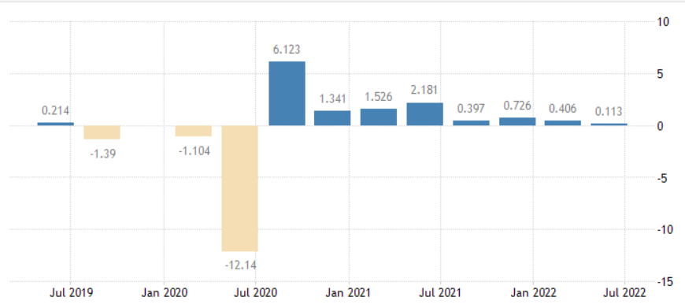

Figure 1 GDP: Annual Growth Rate
Source: (Tradingeconomics.com, 2022)

Social
Social and sociocultural factors include the population's shared attitudes and beliefs. These elements include Ecuador's population growth, age, demography, social status, interests, preferences, and others. Despite the low levels of the economy that the country presents, it is one of Latin America's most consumerist regions, with food, clothing, and footwear consumption predominant (Revelo, 2017). The population is mostly between the ages of 24 and 54, with young people between 26 and 33 being more likely to conduct online shopping (Santos, 2018). Based on these findings, the company would be successful owing to pricing flexibility, and it may require a great online marketing campaign to attract young people since are more inclined to purchase online.

Technological
Businesses are becoming more technologically advanced. This factor considers the rate of innovation and technological advances that may have an impact on a market or industry. For instance, customer service, internet purchasing, innovative distribution channels, manufacturing, and logistics. Ecuador, like many other nations, has joined the world of technology, with an increasing number of people owning and using smartphones, tablets, computers, etc. Statistics show that 77.8% of the population utilizes the Internet (Simon, 2021). The launch of Sports Direct into the country, along with a few other technical developments like as online purchases, instalment payments, and social media marketing campaigns, among others, would make Ecuador a slightly less undeveloped nation.

Environmental
Due to the effects of global change on the earth and the serious side effects that it can have in the long term, the vast majority of countries decided to take some measures and regulations to stop it. Therefore, Ecuador has established a legal framework, which dictates that it is the responsibility of people to produce, exchange and consume goods and services in a socially and environmentally responsible manner.
This point would not be a problem for the brand since Sports Direct adapts to any regulation in order to help the system. Additionally, for years has been supporting a campaign on its website where assists and advice individuals on how to save the environment. Besides, all the companies that the organization deals with have sustainability goals, such as using recycled textiles and materials to create shoes, packaging made from recycled materials, and cutting carbon emissions significantly (O'Sullivan, 2020).

Legal Factors
It is one of the most essential aspects that influence the final decision making of international businesses. The legal factor involves copyright, regulations, requirements, the legal system, data protection, etc. (Turan, Akman and Turan, 2022).
The advantage is that Ecuador does not have as many limitations and restrictions for foreign corporations as other developing countries. Sports Direct will follow by the country's laws and regulations, such as the $2000 minimum capital requirement, health and safety standards, and business regulations (Quevedo, 2017).

PORTERS FIVE FORCES MODEL
It is a strategic method that assesses and identifies environmental factors that may have an impact on the business (Bruijl, & Gerard 2018). On the following point, a corporate strategy for the business will be developed with the aid of an analysis of the Ecuadorian sports products sector.
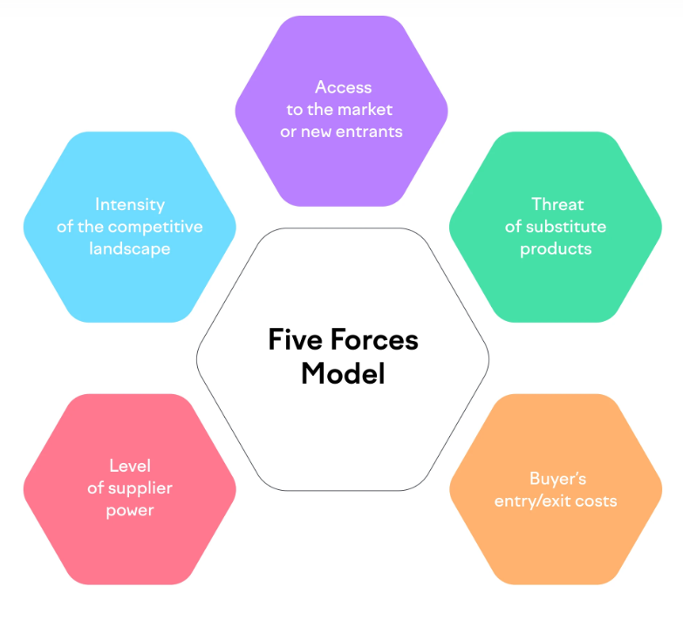
Figure 2: Porters five forces model
Source: (https://www.knowledgiate.com/)

Rivalry among existing companies
Sports Direct would enter Ecuador with a different concept and strategy than its opponent, which would be innovative for customers and advantageous for the company to immediately increase its market share (Wolfe, & Werhane, 2017). Marathon Sport, the main rival, is a sportswear company with a similar concept to Sport Direct. However, due to the nation's economy and the high cost of its products, not everyone can afford brand name products.

Buyer’s bargaining power
The influence with which consumers can negotiate reduced prices is measured by their buying power. Due to the economic level of the country, Ecuadorians do not have as much bargaining power as others. If the company has a regular’s customers, would be easier to maintain the same prices and this will increase the profitability of the industry (Ramírez, and Araujo, 2016)
Supplier’s bargaining power
When the suppliers have more negotiating power, they may set prices higher and make a profit that exceeds average. Considering the variety of companies Sports Direct operates with, there should be a problem with this as there are more supplier options (O'Sullivan, 2020).
Threat of new entrants
Profitable markets attract new competitors, undermining the advantage. At that point, profitability will begin to fall rapidly unless there are substantial and credible barriers to entry, such as licenses, economies of scale, capital needs, or government regulations. For certain companies it would seem that rules, taxes and currency exchange plans push the government into the sixth estate. In this case, Sports Direct is a company that sells sports clothing and footwear, so it does not require new technologies or inventions to start operations in Ecuador (Kemp, 2021). As a result, it is highly likely that additional entrepreneurs will want to establish businesses in this country.
Treat of substitute products
Customers are more likely to move to alternatives in the face of increased prices when there are near substitutes for an item in the market. Sport Direct sells athletic goods like apparel and shoes, although these things can be constructed of any number of different materials. Because there are now so many different methods to create the product, there is less chance that consumers will find a substitute, which will lead to higher profits (Wolfe, & Werhane, 2017).

The Opportunities and Challenges Face by The Sports Direct
Sports Direct may encounter a range of chances and difficulties when conducting business in Ecuador. Here is an explanation of the available opportunities:
Simply Entry Regulation
Ecuador's economy is weak; therefore, the government is eager to attract international investors to improve it. As a result, has taken measures like lowering barriers, providing rental facilities, and facilitating entry for international businesses to conduct business in the country. Moreover, the local government has prioritized the investment of international companies; therefore, Sports Direct would benefit from the protection of intellectual property, purchase of real land and development in commercial areas (Kemp, 2021).
Affordable skilled human resources
Considering that Ecuador is a small country in terms of population compared to other nations, the number of human resources trained and committed there is impressive. More and more young people are interested in studying business and want to venture into business. One of the best ways to start is by networking with foreign companies for employment opportunities. For each position within the company, such as accounting and human resources, qualified personnel with a minimum of studies are needed; however, for jobs such as cashier, cleaner, etc. Is not needed previous experience or study (June, Beittel, Rachel, Martin, 2022).
Growing Market
Ecuador has 18,041,000 inhabitants. The market in Ecuador is projected to expand by 18.58% annually in 2022, according to the B2C e-commerce study for the second quarter of 2022. The B2C e-commerce business in Ecuador has a track record of growth in the medium and long term which looks promising, so most of the market share will thrive (World Bank, 2022).
Technological Advancement
Despite being a developing nation with a limited budget for technology, Ecuador ranks 86th in the world in technological advances. As a result, manufacturing processes are considerably simpler, faster, and more efficient than they would be with manual labor, increasing productivity and making companies more competitive. These developments significantly increase the confidence of international companies in Ecuador's technology. Before settling on a business plan, Sports Direct should carefully consider all the issues raised above, while maintaining corporate responsibility and cultural sensitivity.
A management tool called corporate governance serves as the body in charge of developing and monitoring compliance with standards within an organization. Its objective is to improve the financial position of a company, its ability to achieve objectives and its ability to develop. According to Transparency International, difficulties can also arise from bribery and corruption. Ecuador is ranked 126 out of 137 nations, which is not a favorable position for the nation (Vinueza, & Gallardo, 2017).

Different Barriers experienced by Foreign Business in Ecuador
Several things are categorized as entrance barriers that restrict foreign companies from setting up shop in the nation. The upfront cost is one of the most frequent impediments. Businesses must have a minimum amount of money to open their doors in the nation, but in the case of Sport Direct, this is not a roadblock. Another impediment that creates distinctions between international and local businesses is fiscal policy. Foreign businesses are required by Ecuador to pay taxes solely from Ecuadorian sources. Additionally, the nation said that all businesses, foreign or domestic, will pay taxes based on their income, ranging from 25% to 30% (June, Beittel, Rachel, Martin, 2022).

Recommendation for Appropriate Strategies
One of the key strategies for business success is to make smart marketing strategies and investments. We also know that there are several different cultures in the nation, therefore the business must adapt to all of this, or it will have a negative effect on the way its products are sold.
Also, it's critical to remember the value of building strong customer connections for a business to successfully advertise across the country and increase sales. Since many young people are progressing in the business world and in their education, the market of young employees in Ecuador can help the company. The process of innovation and technical advancement, and the various production methods of ecological materials is a key selling point (June, Beittel, Rachel, Martin, 2022).

Conclusion
In conclusion, several external studies, and analyses, including PESTEL and Porter's Five Forces, were required to lead to the movement of the Sport Direct company in Ecuador. As a result, Sports Direct will benefit from business opportunities in Ecuador. However, the company may also face difficulties that it can solve effectively if it implements the proper plans and planning. A solid marketing plan will also contribute to the success of the company in the country.

References
APA, Rastogi, N. I. T. A. N. K., & Trivedi, M. K (2016). ‘PESTLE technique–a tool to identify external risks in construction projects. International Research Journal of Engineering and technology.
Britannica. (2022). Ecuador | History, Map, Population, Economy, & Facts. [online] Encyclopedia Britannica. Available at: https://www.britannica.com/place/Ecuador [Accessed 23 November 2022].
Bruijl, D., & Gerard, H. T. (2018). The relevance of Porter's five forces in today's innovative and changing business environment. Available at SSRN 3192207.
Czinkota, M. R., Ronkainen, I. A., & Moffett, M. H. (2011). International business. Wiley.
Garcia, C. (2013) Article. Economics, psychology and buying behavior. Pure Marketing. Economic conduct.
Grundy, T. (2006). Rethinking and reinventing Michael Porter's five forces model. Strategic change, 15(5), 213-229.
June, S. Beittel, Rachel L. Martin. (2022). Ecuador: An overview. Congressional Research Service.

Kemp, S. (2021). Digital 2021: Ecuador. Datare portal. [online]. Available at: https://datareportal.com/reports/digital-2021-ecuador

McClellan, J. L. (2016). EXPLORING THE CULTURAL FOUNDATIONS OF LEADERSHIP IN ECUADOR. Journal of International Business Disciplines, 11(1).
Santos Zambrano, N. (2018). Jóvenes profesionales ecuatorianos prefieren comprar por internet. En red. [online]. Available at: https://www.enred.ec/jovenes-profesionales-ecuatorianos-prefieren-comprar-por-internet/
O'Sullivan, M. (2020). The divided workforce: Zero hours work at Sports Direct. In Case Studies in Work, Employment and Human Resource Management (pp. 105-110). Edward Elgar Publishing.
Ramírez, S. y Araujo, A. (2016) El Comercio. P 19.
Reddy, B. V. (2018). The Fat Controller: Slimming Down the Excesses of Controlling Shareholders in UK Listed Companies. Oxford Journal of Legal Studies, 38(4), 733-763.

Revelo Ron, O. (2017). El comportamiento del consumidor ecuatoriano desde la perspectiva psicológica. Repositorio pucesa.

Rivadeneira, M. C. (2014). ESPOL, rumbo a la elite mundial. Focus: ESPOL Revista Institucional, 22–23.
Turan, B.,Akman, M. and Turan, F. (2022). SWOT/PESTLE analysis. Gemi ve Deniz Teknolojisi.
Quevedo, T. 2017. Doing Business in Ecuador. Thomson Reuters Practical Law.
Vinueza, S., & Gallardo, V. (2017). Impacto de las TIC en la Educación Superior en el Ecuador. Revista Publicando, 4(11-1), 355-368. Recuperado de https://revistapublicando.org/revista/index.php/crv/article/viewFile/530/pdf_357 [ Links
Walsh, C. (2007). Interculturality and coloniality of power. Another thought and position from the colonial difference. The decolonial turn. Reflections for an epistemic diversity beyond global capitalism, 47-62.
White, D. (2022). Ukraine conflict causes soaring debt and increases poverty and inequality across Latin America and the Caribbean. International care. Available at: https://www.care.org/news-and-stories/press-releases/ukraine-conflict-causes-soaring-debt-and-increased-poverty-and-inequality-across-latin-america-and-the-caribbean/

Wolfe, R. W., & Werhane, P. H. (2017). Claire Jenkins: Non-Executive Director, Sports Direct International plc: Breaking Boundaries. In Global Women Leaders. Edward Elgar Publishing.
World Bank. (2022). Ecuador Overview: Development news, research, data | World Bank. [online] https://www.worldbank.org. Available at: https://www.worldbank.org/en/country/ecuador [Accessed 22 November 2022].

