JOB ADVERTISEMENT, JOB DESCRIPTION & PERSON SPECIFICATION
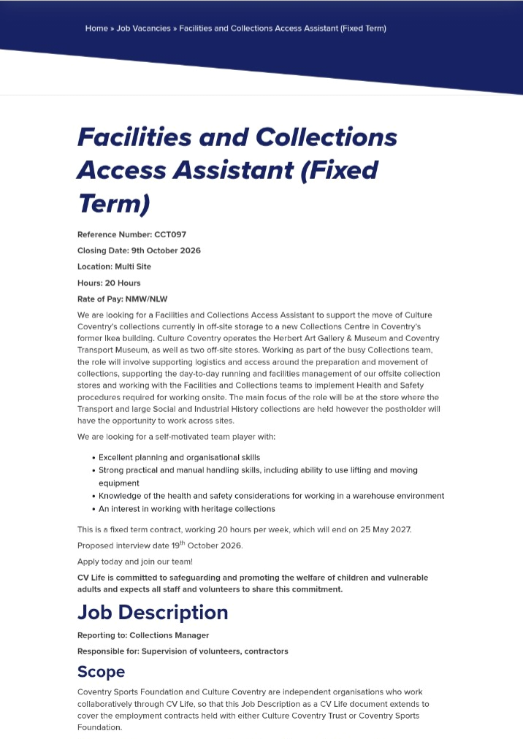

JOB DESCRIPTION & PERSON SPECIFICATION
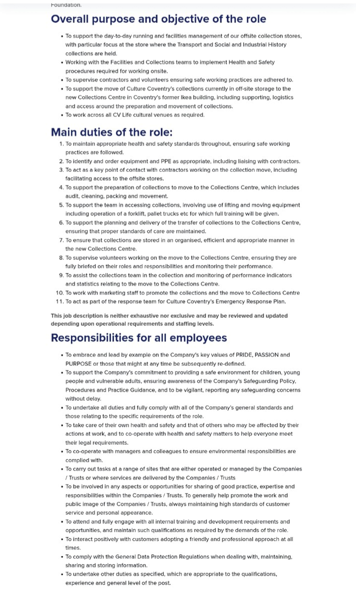 | 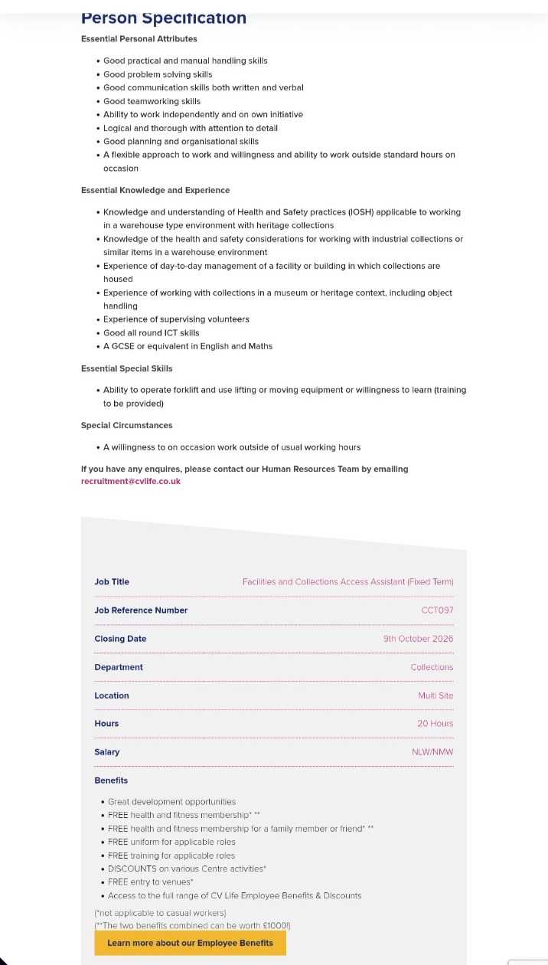

TETIANA KRYVORUCHKO
Birmingham, UK | +44 7392 954946 | takriskaypro@gmail.com
Target role: Facilities and Collections Access Assistant, Culture Coventry (CCT097)
PROFESSIONAL PROFILE
Organised and adaptable professional with over seven years of experience in film and television production, including complex scheduling, logistics, team coordination and documentation. Currently developing skills in archaeology and cultural heritage through independent historical research, archival study and specialist learning. Interested in applying transferable operational skills while gaining direct experience of museum collections, their storage, care and documentation.
KEY SKILLS
Planning and scheduling • Logistics and operational coordination • Accurate records and reporting • Teamwork and stakeholder communication • Practical problem-solving • Independent research • Microsoft Office and Google Workspace
RELEVANT HERITAGE & ARCHAEOLOGICAL EXPERIENCE
Independent Historic Landscape Research, Glasshampton, Worcestershire, 2026
Recorded historic structures and landscape features through photography, field notes and location records; compared observations with historical maps and documentary sources.
Independent Archival Research, Howard Carter Archive materials, 2026 - Present
Began independent research using historical archive materials associated with the Griffith Institute, Oxford. Research remains in progress.
Archaeological Geophysical Survey, Uley, Gloucestershire, 16 October 2026
Fieldwork scheduled for 16 October 2026; participation and specific activities to be verified after the event.
PROFESSIONAL EXPERIENCE
CEO, Great People, April 2026 - Present
Responsible for company management, development and promotion strategy, partnerships, and planning and delivery of events.
Project and Event Collaboration, Great People, 2025 - March 2026
Supported project and event coordination, including participants, partners and operational arrangements.
Founder & Event Producer, Libellé Luxe, 2024 - 2026
Developed and organised events, coordinating venues, partners, logistics and participant communication. Project concluded in 2026.
Second Assistant Director / Casting Roles, Film & Television, Ukraine, 2017 - 2023
Prepared production estimates and filming schedules; coordinated actors, locations, movements and breaks; maintained reports and supported casting and production operations.
Cinema Host / Customer Service, ODEON Cinemas, UK, 2023 - 2025
Supported daily venue operations and responded to customer needs in a busy public-facing environment.
EDUCATION & PROFESSIONAL DEVELOPMENT
University of Wales Trinity Saint David, Business Skills for the Workplace, Level 4, In progress
University “Ukraine”, Management studies, 2001 - 2004
Egypt Exploration Society, Member, lectures and Egyptology study, 2026 - Present
Inter TV Channel, Kyiv, Film & Television Production Training, 2018
LANGUAGES
Ukrainian - Native, Russian - Fluent, English - Professional working proficiency, Italian - Basic

COVER LETTER
Tetiana Kryvoruchko
Birmingham, UK
takriskaypro@gmail.com
+44 7392 954946

6 October 2026

Recruitment Team
Culture Coventry Trust / CV Life
Herbert Art Gallery & Museum, Jordan Well
Coventry CV1 5QP

Re: Facilities and Collections Access Assistant (CCT097)

Dear Recruitment Team,

I am writing to express my interest in the Facilities and Collections Access Assistant position at Culture Coventry. I am currently developing my knowledge and practical experience in archaeology and cultural heritage, and I am particularly interested in understanding how historical objects are documented, stored, protected and made accessible for future generations.

My professional background includes over seven years in film and television production, where I worked in scheduling, logistics, casting and team coordination. My responsibilities included preparing production estimates, organising filming schedules, coordinating people and locations, and maintaining operational reports. Since April 2026, I have also been CEO of Great People, with responsibility for company strategy, partnerships and event organisation. These experiences have strengthened my organisational skills, attention to detail and ability to respond to changing operational requirements.

I understand that this role involves supporting the relocation of museum collections to a new Collections Centre, including object handling, packing, storage and documentation. I believe my experience coordinating complex operations and maintaining accurate records would be transferable to this work. I would welcome the opportunity to develop specialist skills in safe collections handling and storage, following established procedures and guidance from experienced colleagues.
Alongside my professional work, I have been developing my interest in cultural heritage through independent historical landscape research in Worcestershire, archival research using Howard Carter Archive materials, and Egyptology studies. These activities have strengthened my interest in the practical responsibilities involved in preserving historical evidence.
I would welcome the opportunity to contribute my organisational experience, willingness to learn and commitment to careful working practices to the Culture Coventry team. Thank you for considering my application. I look forward to the opportunity to discuss my suitability for the position.

Yours faithfully,
Tetiana Kryvoruchko

