CertHE ASSIGNMENT SPECIFICATION
SCHOOL OF HOSPITALITY & TOURISM MANAGEMENT
Student name: | Amina Begum | Student number: | 1906348
Programmes: | CertHE International Hotel Management
Module: | Food & Beverage Operations | Module Level (4, 5, 6): | 4
Module code: | BMIH4002 | Contribution to Overall  Module Assessment (%): | 25%
Lecturer: | Ryan Peters Kathryn Roberts  Samantha Birdsell | Internal Verifier: | Melissa John
Assignment Title: | Student Journal (Learning Log)  Minimum 750 words (+/- 10%) | Assignment No: | 1 of 3
Hand Out Date: | w/c 20th September 2021 | Submission deadlines: Return date of provisional marks & written feedback: | 21st October 2021  18th November 2021

LEVEL 4 – Student Journal
Student Name:  Student Number: | Module:  Lecturer:

Topic of choice: Food Safety Fundamentals (The 4C’s) | Date Completed:
To maintain a healthy, hygienic and safe food practice it is essential to incorporate the fundamental principles of foods safety and hygiene in the entire process of cooking. Last week in our class lectures, we had discussed the various health and safety aspects of the foods, as well as the fundamental principles that we need to maintain while cooking. In the process of cooking, cooking is a significant part, while other activities need to be effectively taken care of, as well equally emphasise (Shaw, 2018). Regarding the fundamentals of food safety, we have learned about the 4C’s that stands for the fundamental principles of food safety. The 4C’s stand for– Cleaning, Cooking, Cross-contamination and Chilling.
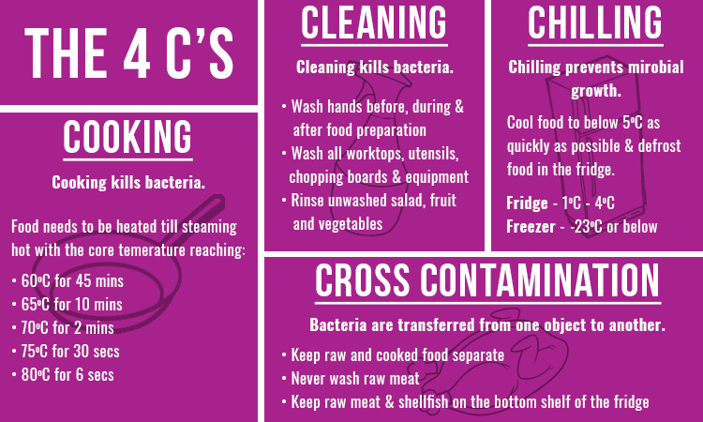
Figure 1: The 4C's of Food Hygiene
Source: (Cho and Seok, 2019)
Cleaning is the very essential part of food safety and also one of the key factors of maintaining hygiene in the kitchen. Before starting the process of cooking, the kitchen surfaces must be entirely cleaned and well cleaned so that there is a lesser chance of germs out there on the surfaces that can impact food safety. From the study of Lee (2012), it was found that, whoever is in charge of the kitchen and going for a cooking process, the person should make sure that cleaning and disinfecting of the equipment are done between every task of the cooking. With the purpose to eradicate the germs and disinfecting the items, detergents and washing liquids should be used that works off better in disinfecting. But it is also important to keep notice that, the detergents, bleaches and other types of liquids that are used to clean the kitchen surfaces and equipment are well washed off so that these do not transmit to the vegetables, meats or in the dishes.
The next C that we had learned about was Cooking, which is the core part of the cooking process in the kitchen. While cooking, the recipes and labelled instructions need to be followed accordingly and do not over-heat the items. Cho and Seok (2019) stated in their paper that, it is okay and good to experiment with the cooking items going off the regular instructions, but it is also important to navigate what is going on to complete the cycle of the cooking. Before starting the cooking process, the oven should be pre-heated and about the uses of burners, ovens, heaters and other electric devices precautions needs to be taken to ensure kitchen safety. Along with the safety measures, the cook should be careful about the fact that all the necessary ingredients are available and they are properly kept so that in terms of needs they can be used easily (Healey, 2016). Once the dishes are ready, the food needs to be kept covered and keep away from dust places.
After the cooking, the next C stands for Cross-contamination which is very important in the cooking process. We discussed in the classroom the fact that the contamination of the food can turn into bad food poisoning that can be prevented by good hygiene in the kitchen, as well as the off-the kitchen (Paulsen and Bauer, 2017). Food poisoning can happen by the attack of harmful bacteria to the foods, that can spread from the hands, clothes or the kitchen equipment or utensils resulting in cross-contamination of the foods. To take safety measures in this regard, Zhao (2017) had suggested that raw foods should be kept separate from the foods or dishes that are already prepared and ready to eat. While touching the raw foods, such as meats, vegetables, fish etc. hands need to be well washed off and disinfected so that there are no chances of cross-contamination. The ready dishes should be avoided to keep on the plates or bowls that were used to keep the raw items.
The final C of the food safety fundamentals that we had learned about was Chilling, which was the process of storing the ready dishes to eat later. In the process of chilling, hot foods or the dishes that directly came out of the burners or oven should not be kept directly to the freezer. Once the food is cold, it should be chilled between the 0° to 5° Celsius, and if kept in the refrigerator the temperature might be kept between 3° to 4° Celsius (Choi, 2012). In the chilling process of the frozen foods, the foods should be frozen with the minimum of time it was turned outside of the freezer, and if the food is necessary to defrost, proper instructions need to be followed.

REFERENCE LIST
Cho, S. and Seok, D. 22019. Food Safety Culture Assessment of Home Meal Replacement Manufacturer. Journal of Food Hygiene and Safety, 34(4), pp.380–387.
Choi, J. 22012. Standardization of Identification-number for Processed Food in Food-traceability-system. Journal of Food Hygiene and Safety, 27(2), pp.194–201.
Healey, J. 22016. Food safety. Thirroul, N.S.W.: The Spinney Press.
Lee, A. 22012. Food Allergy, a Newly Emerging Food Epidemic: Is the Current Regulation Adequate? Journal of Food Hygiene and Safety, 27(4), pp.325–331.
Paulsen, P. and Bauer, A. 22017. Game meat hygiene: food safety and security. Wageningen: Wageningen Academic Publishers.
Shaw, F. 22018. The importance of food safety and hygiene. Journal of Food: Microbiology, Safety & Hygiene, 03.
Zhao, T. 22017. Editor Note: Journal of Food: Microbiology, Safety & Hygiene. Journal of Food: Microbiology, Safety & Hygiene, 02(03).

