Component 2 - Research Report
Student Name: Adrian Alex Jeleriu
Student Number: 2133188
Lecturer Name: Chuen Leung
LCHS4002_BIRM
Digital Skills and Research Methods.

Contents
1. Introduction 3
2. Research design 3
2.1. Research Question 3
2.2. Method 4
2.3. Ethical Considerations 4
3. Results 5
4. Discussion 7
5. Conclusion 8
6. Reference List 8
7. Appendix A – A blank copy questionnaire. 9

Introduction

Technology and digital sources are used everyday and practice in all levels of learning institutions (Romein et al.,2020).Technology is used in every institutions by people who are working in different areas which is making the job easier and efficiencient. ​
Covid 19 Pandemic in 2020 had a big impact and changes had to be made in many institution and specially in education ,teachers ,lecturers and students have to learn and do online classes instead of face-to-face sessions. (Volkov et al.,2022).​
Education had to change by using technology and students together with their lecturers had to carry on by developing and adapting to a new type of learning in order to avoid and minimize the spreading of the new virus. (Villegas-Ch et al.,2021).​ Some of the universities and schools tried to use a different approach on teaching by bringing together student on online platforms as well as face to face classes by splitting them in half and half.
Universities adapted to the new and ‘forced’ implemented situation of the pandemic by developing and using different digital tools to collaborate and helping the students to go further with their studies without having to stop or suspend them because of the new virus.
There are different digital tools and platforms that the universities and students adopted in order to have the possibility to collaborate​ like MS Teams, Zoom, WhatsApp, Messenger groups, etc.
In this research we will try to identify the most popular and most used digital tool by students in UWTSD to collaborate.​

Research design

Research Question
Definition of research represents the social science which can take many forms and is guided by different objects. Some research aims for prediction and explanation while others search for understanding (Alvesson 2013).
A very important step in any research is the question of the research, this can go deeper in to the knowledge of all research and usually can be as valuable as an answer.
During the Digital Skills and Research Methods Module several questions have been advertised for the students to choose answers on which basis a research project will examine how technology is used to collaborate at UWTSD.
`Which digital tool is most used by students at UWTSD to collaborate together? ` was the chosen question by Group F. Based on this question Group F have considered that they can develop an evidence to show the knowledge obtained during this module and implicit to find out the answer of the question.

Method
During this research a quantitative research method has been elaborated, headed by Anamaria Sdrabau and Adrian Alex Jeleriu on students at University of Wales Trinity Saint Davies based on online survey.
Quantitative research is the numerical representation and manipulation of observations for the purpose of describing and explaining the phenomena that those observations reflect. (Sukamolson 2007) Moreover, Creswell (1994) has given a very concise definition of quantitative research as a type of research that is `explaining phenomena by collecting numerical data that are analysed using mathematically based methods (in particular statistics).'
As it has been mentioned higher, because of the recent events with Pandemic, technology is being more used than ever by everyone including students in order to try and avoid contacting the virus. One of the main reasons of the online survey was to try to be ethical when it came to protection of other students health. Due to recent developments and issues caused by the pandemic people tend not to have enough confidence and no longer trust each other, this being as mentioned higher that a interview based survey or a hard copy survey can be harder to obtain in a considerable time or quantity needed for the research.
Questions for this survey have been created on a online platform ( MS Forms ) and sent through email to other students at UWTSD. Survey questions were based on the research question reflecting answers needed for the research.

Ethical Considerations
`Ethics is a system of moral principles or standards governing conduct` (Rani 2012). To obtain trust and solve the problem in the research you have to use ethics methods. The most significant and vital content of a study is ethics. Every researcher must maintain ethics on the whole study project. Ethics in research defines guidelines for conducting professional research. It also teaches and regulates researchers to ensure that they follow a strict code of ethics when conducting research (Hasan 2021).
During this research the participants was not harmed in any way whatsoever​. It was respect them dignity especially because was an online survey and all participants have the opportunity to answer the question ​whenever they like.
Protection of the privacy of research participants was maintain and also mention at the beginning of survey questionary and also the most important aspect was confidentiality of research data. All resources and data collected was carefully stored ​in secure places.

- Results
`Research Result means any tangible or intangible result developed, acquired or reduced to practice in the course of the Research Project, including, without limitation, any invention, technical information, data, know-how and materials that relate to the purpose of the Research Project.`(Dictionary)
The following paragraphs sown the results of data collected:
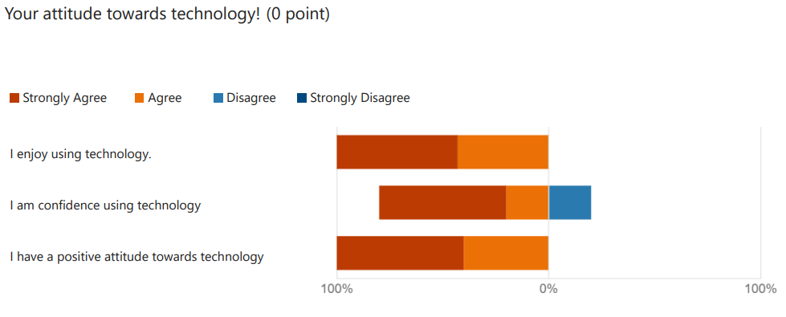
- Answers to the first question shown that student at the University have a very good and positive attitude towards technology.
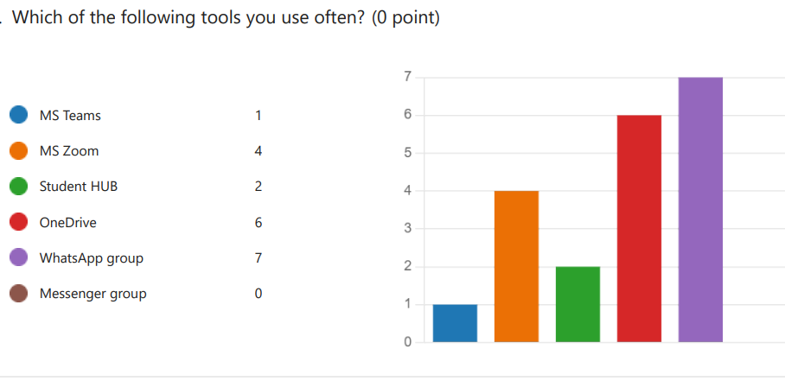
- As was probably expect one of the most used tool to communicate by student is WhatsApp, they semes to consider at being an efficient an easy application in the current days.
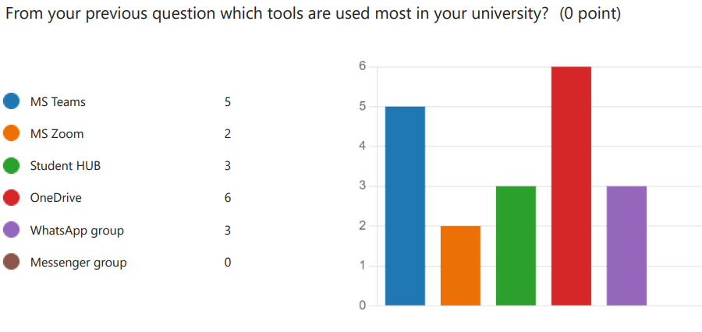
- One Drive sems to be one of the most used digital tool by student in UWTSD to collaborate according to the results of data collected.
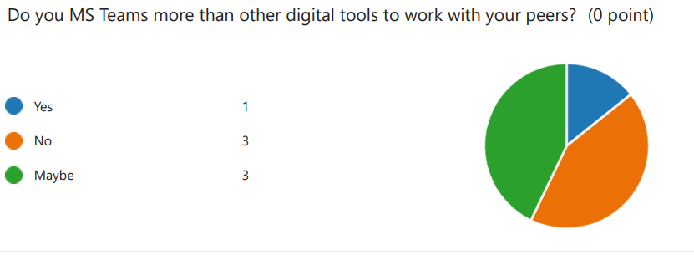
- An equal number of students are not using MS teams or are undecided and one student in favour of this tool.
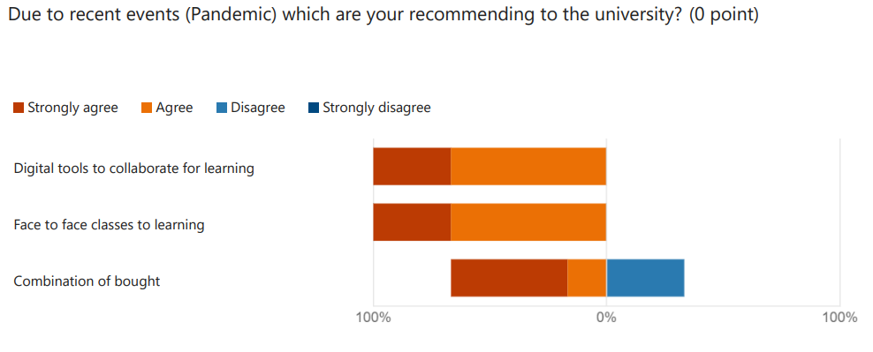
- Last question was created because of the Pandemic events. Students it semes to Agree in equal number in favour in online classes and face to face classes

Discussion
Although some digital tools are more popular than the others, each individual will choose a digital tool suitable for his/her own needs.
That was the hypnotises aim on the beginning of research and according to the data collected it result to confirm it.
Technology is in continued developing and increasing speed, design, efficiency, etc and individuals are having a variation of tools to choose when about communication or collaborate.
As per questions used at the online survey al after data collection, the student at the university are confident using technology and also happy that they have option to choose the most suitable one for them.
According with data collected, student are in favour of WhatsApp group for collaborate and communicate with other as personal option, but when about learning in University and collaborate with other they chose One Drive the most used tool.
When is about MS Teams, tools used by university to collaborate with student especially Pandemic when classes were advertising to be online rather face to face, students are less in favour and equal denied or undecided. Collected this date appears to be a bit impossible to take a conclusion regarding the utility of MS Teams for student involve in the survey.
Also was mention an additional query regarding Pandemic and the changes make because of that and student sems to be the same in equal measurements in favour of face to face learning or just online learning and very small in the favour of a combination of bought.
As have been discuss earlier, because the variety that technology have, individuals can chose the suitable option for them.

- Conclusion
Technology is part of people life and implicit a student life, without technology and online sources life will be more difficult and time will be sped differed. Technology can be found in every domain and cand adapt to the individuals needs and make them job more easy and efficient.
In conclusion of the research is sems that the answer to the question is One Drive, however was discuss in the hypotheses that also have been confirm that individuals are more likely to choose the tools that are more suitable for them because of the variety existing in the technology.

- Reference List

Alvesson, M. and Sandberg, J., 2013. Constructing research questions: Doing interesting research. Sage.
Creswell, J.W., Research Design: Qualitative & Quantitative Approaches, London: SAGE Publications,1994
Hasan, N., Rana, R.U., Chowdhury, S., Dola, A.J. and Rony, M.K.K., 2021. Ethical considerations in research. Journal of Nursing Research, Patient Safety and Practise (JNRPSP) 2799-1210, 1(01), pp.1-4.
Rani, R. and Sharma, R.K., 2012. Ethical Consideration in Research. International Journal of Nursing Education, 4(1).
Romein, C.A., Kemman, M., Birkholz, J.M., Baker, J., De Gruijter, M., Meroño‐Peñuela, A., Ries, T., Ros, R. and Scagliola, S., 2020. State of the field: digital history. History, 105(365), pp.291-312.​
Sukamolson, S., 2007. Fundamentals of quantitative research. Language Institute Chulalongkorn University, 1(3), pp.1-20.
Volkov, A., Rishko, Y., Kostyukhin, Y., Sidorova, E., Boboshko, D., Savinova, D. and Ershova, V., 2022. Using Digital Tools to Teach Soft Skill-Oriented Subjects to University Students during the COVID-19 Pandemic. Education Sciences, 12(5), p.335.​
Villegas-Ch, W., Palacios-Pacheco, X., Roman-Cañizares, M. and Luján-Mora, S., 2021. Analysis of educational data in the current state of university learning for the transition to a hybrid education model. Applied Sciences, 11(5), p.2068.​
<a href="https://www.lawinsider.com/dictionary/research-result">Research Result Definition | Law Insider</a>

- Appendix A – A blank copy questionnaire.



