MSc Software Engineering and AI
Advanced Statistical Programming – component 1
Rabeya Begum
2209407
Dr Aliyu Sambo
27th February 2026
University of Wales Trinity St David – Quay place

Contents
Alien Colony Resource Management Simulation – Documentation Report 3
Introduction 3
Task 1 3
Task 2 - Documentation 3
Task 2A – Generate Production Data 3
Task 2B – Total Production per Station 4
Task 2C – Detect Production Anomalies 6
Task 2D – Identify Peak Productivity Days 7
Task 2E – Calculate Efficiency Score 9
Task 2F – Code Presentation 10
Task 2.2 - Reflection 11
Conclusion 11
Appendix 12

Figure 1 - Production Data 4
Figure 2 - loop structure 4
Figure 3 - Production per Station 5
Figure 4 - Total Production 6
Figure 5 - Detect Production Anomalies 7
Figure 6 - Anomaly Detection Logic 7
Figure 7 - Peak Productivity Days 8
Figure 8 - Peak Productivity Determination 9
Figure 9 - Efficiency Score 10
Figure 10 - Efficiency Score Calculation 10

Alien Colony Resource Management Simulation – Documentation Report

Introduction
The report describes the creation of a simulation system that models production management in an imagined alien colony, using the R programming language. The aim of the assignment was to produce synthetic operational data for six stations and four worker teams across a period of thirty sols, or days, and then explore that data using loop based programming alone. High level aggregation functions were deliberately set aside so that the focus remained on understanding and applying iterative logic.
The work involved generating the data, calculating totals for each station, detecting unusual patterns, identifying the days with the highest productivity, and developing a method for scoring efficiency. The report outlines how each stage was approached, how the code was checked and refined, and offers reflections on the challenges faced and the lessons learned throughout the project.

Although the primary focus of this assignment was iterative programming, the dataset also offered an opportunity to reflect on broader statistical reasoning and the variability inherent in simulated operational data.

Task 1
See code in appendix.

Task 2 - Documentation

Task 2A – Generate Production Data
How the Code Works
The production dataset was created using three nested loops that iterated through sols one to thirty, stations one to six, and teams one to four. For every combination, the daily output was computed using the formula BaseOutput + (station × 3) + (team × 2), with an added random variation between −5 and +5 to mimic environmental fluctuations. All results were stored in pre‑allocated vectors and later merged into a dataframe called production_data, ensuring that all 720 sol–station–team combinations were represented.

To confirm the dataset was generated correctly, the first ten rows were printed and reviewed, showing that both the structure and calculated values aligned with expectations. The output formula provided a consistent baseline while incorporating the effects of station and team attributes, and the random adjustment introduced realistic variability like that seen in operational settings.

$$Output=BaseOutput+(Station×3)+(Team×2)+RandomNoise$$

Testing
To check that the dataset had been generated correctly, I confirmed that the dataframe contained seven hundred and twenty rows and four columns. I then displayed the first ten rows to make sure the values followed a sensible pattern and that the output figures looked varied rather than uniform.

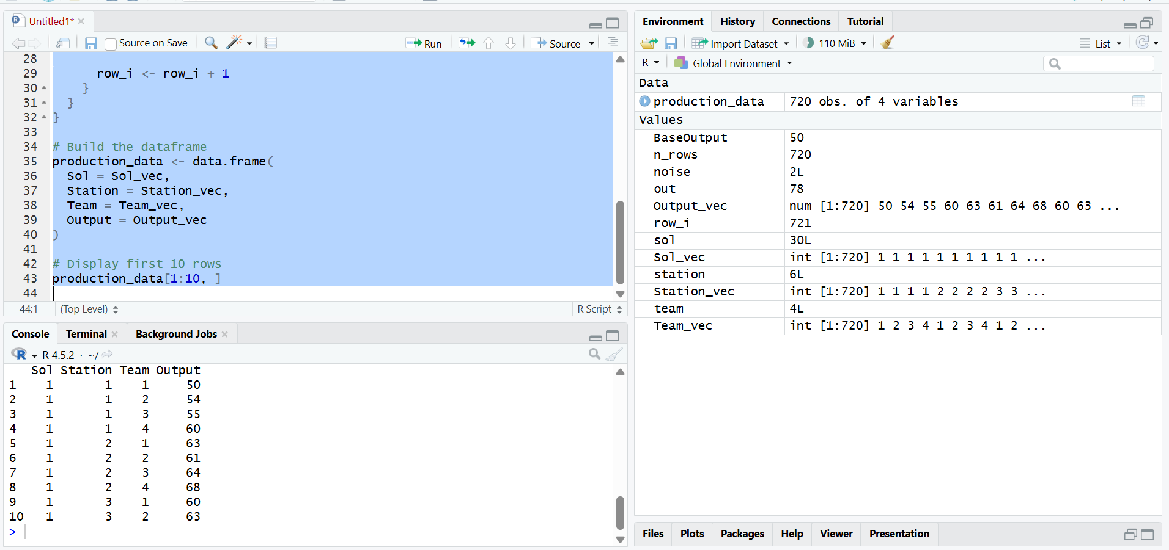
Figure 1 - Production Data

Flowchart
The flowchart illustrates the structure of the nested loops used to build the dataset. It sets out the sequence from iterating through sols, stations, and teams to calculating the output for each combination and storing the results.

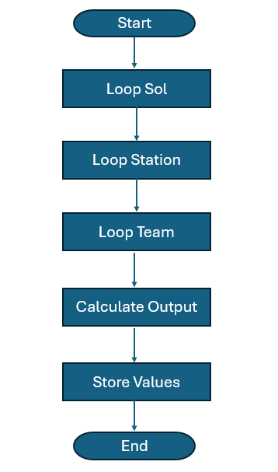
Figure 2 - loop structure

Task 2B – Total Production per Station
How the Code Works
A data frame called station_totals was generated to record the total output for each station. The outer loop cycled through stations one to six, while an inner loop scanned every row of production_data. Whenever a row matched the station currently being processed, its output value was added to an accumulating total. Once all rows had been evaluated, this total was stored in the data frame before moving on to the next station. The final table contained six entries, and the totals followed a consistent pattern, confirming that the loop‑based method worked correctly without relying on built‑in aggregation tools.

Testing
I checked that the resulting dataframe contained six rows, one for each station. The totals increased in a logical pattern, which was expected because higher station numbers contribute more to the output through the calculation used earlier.

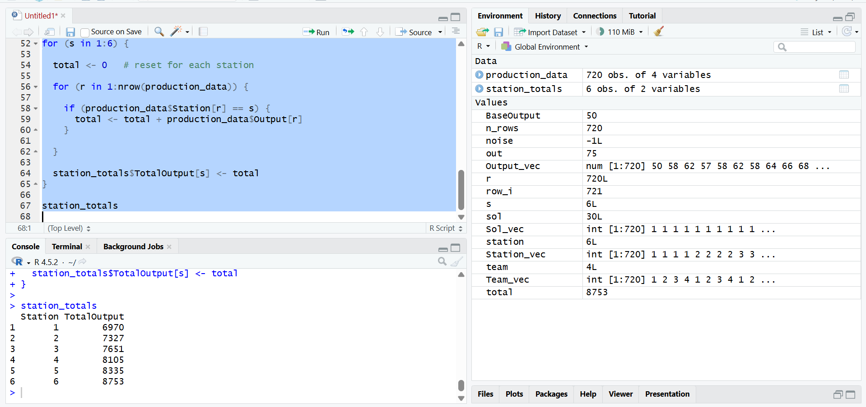
Figure 3 - Production per Station

Flowchart
The flowchart outlines the sequence used to calculate each station’s total production. It shows the program selecting a station, scanning all rows in the dataset, adding the relevant output values, and then storing the final total before continuing to the next station. This loop based method ensures that every station’s production is calculated correctly without relying on built in aggregation functions.
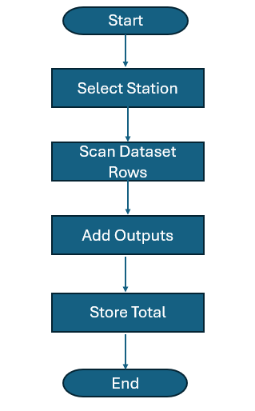
Figure 4 - Total Production

Task 2C – Detect Production Anomalies
How the Code Works
Daily production anomalies were detected by first computing the average output for each station using nested loops. For every sol–station pair, the outputs from all four teams were summed and divided by four to obtain the daily mean. A second loop then compared each team’s output with this average, marking an entry as TRUE in the Anomaly column if the deviation exceeded ten per cent, and FALSE otherwise. These results were stored in a separate dataframe named anomalies, and the first ten TRUE cases were inspected to confirm that the detection logic operated correctly.

Testing
To verify that the method behaved as intended, the first ten rows marked TRUE were printed and manually inspected. This check confirmed that the ten per cent deviation rule had been applied correctly and that the anomaly detection logic produced sensible results.

While the ten per cent threshold was selected as a simple rule-based criterion, in real-world statistical practice anomaly detection would typically be informed by measures of dispersion such as standard deviation or interquartile range. A statistically grounded threshold would allow deviations to be evaluated relative to the natural variability of the dataset rather than a fixed percentage. This highlights the difference between deterministic rule-based detection and inferential statistical approaches that account for distributional behaviour.
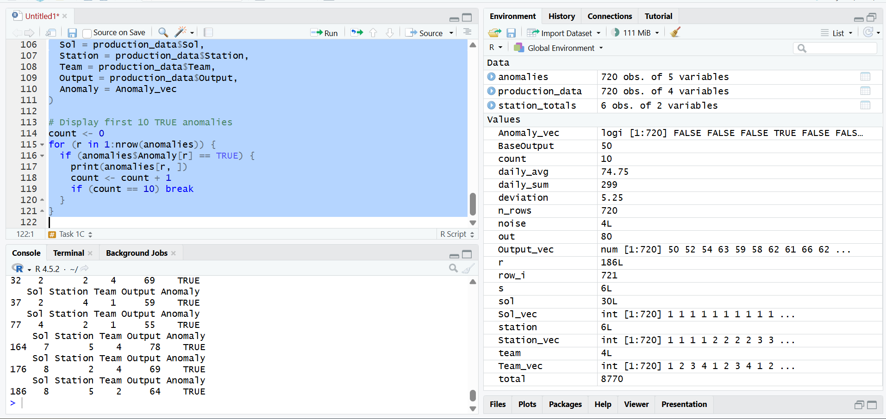
Figure 5 - Detect Production Anomalies

Flowchart
The flowchart outlines the logic behind the anomaly detection process. It shows the calculation of the daily average, the comparison of each team’s output, and the decision point that determines whether a value is marked TRUE or FALSE based on the ten per cent threshold.

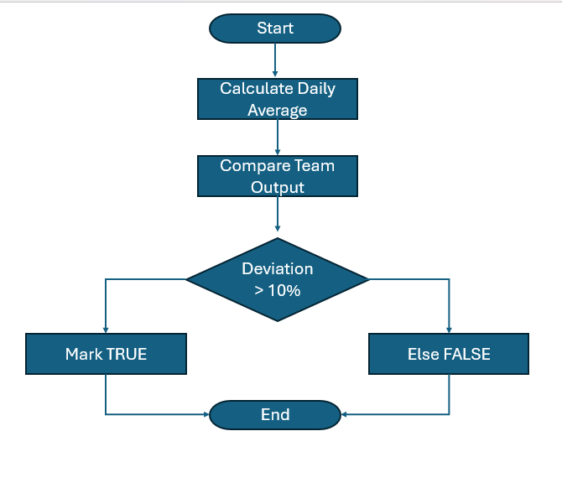
Figure 6 - Anomaly Detection Logic

Task 2D – Identify Peak Productivity Days
How the Code Works
Peak productivity days were determined using nested loops that evaluated each station across all thirty sols. The outer loop cycled through the six stations, while an inner loop iterated over each sol. For every station–sol pair, the outputs from the four teams were summed to produce a daily total, which was then compared with the current maximum. When a higher value was identified, both the maximum output and the associated sol were updated. After all sols had been examined, the highest‑performing day and its output were recorded in the peak_days dataframe. This method enabled the identification of each station’s most productive day without relying on built‑in aggregation functions.

Testing
To verify that the logic operated correctly, the resulting peak_days dataframe was examined to ensure it contained six entries, one for each station. The peak totals were reviewed to check that they followed a reasonable pattern, with higher‑numbered stations generally producing larger outputs, as expected from the underlying formula. This manual inspection confirmed that the loop‑based calculations and comparisons had been applied accurately.

Although the highest‑productivity day was identified deterministically through direct comparison, further statistical analysis could assess whether these peak values differ significantly from the station’s average daily production. Techniques such as confidence intervals or hypothesis testing could be used to determine whether the observed peaks represent genuine performance improvements or simply random fluctuations introduced by the simulated noise component.

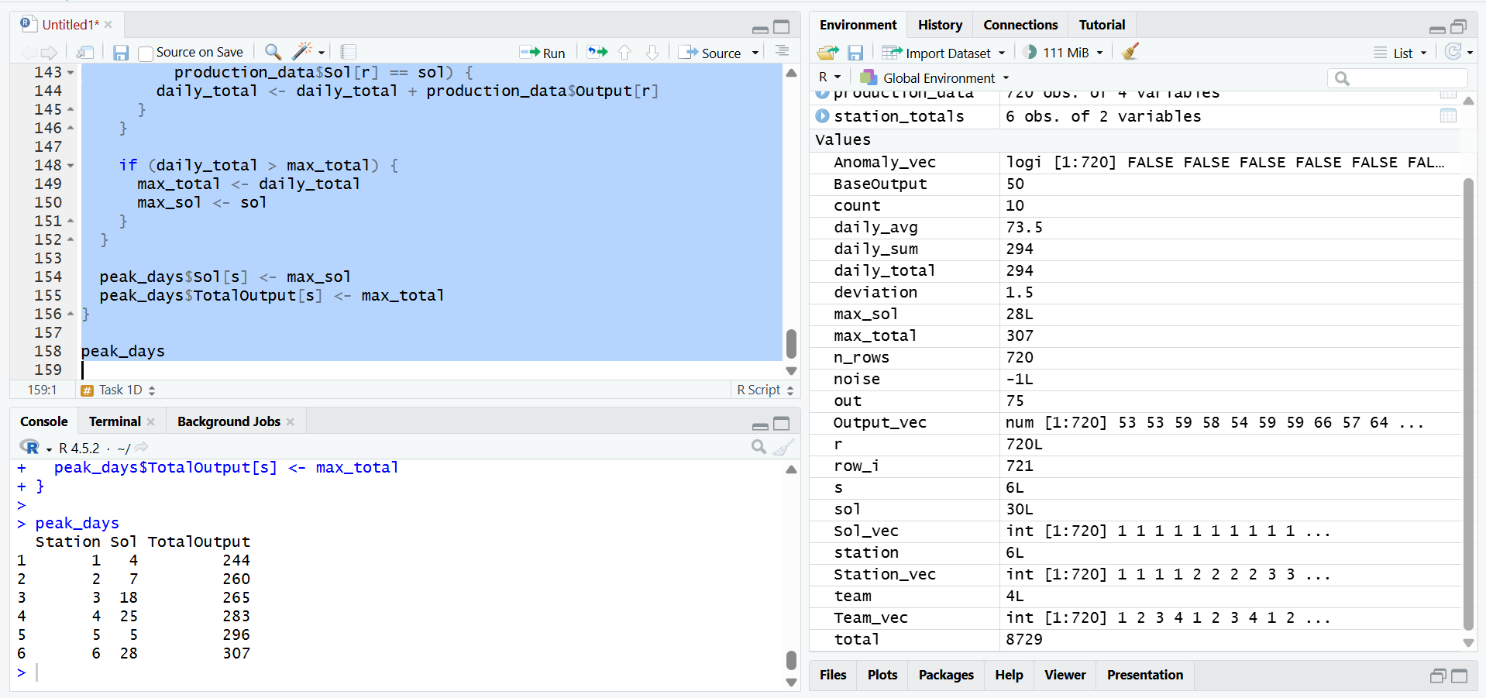
Figure 7 - Peak Productivity Days

Flowchart
This flowchart outlines the procedure used to determine the highest‑productivity day for each station. It begins by assigning an initial maximum value, then cycles through each sol to compare daily totals and update the stored result whenever a larger value is identified. The process concludes once all stations have been assessed and the peak days have been recorded.

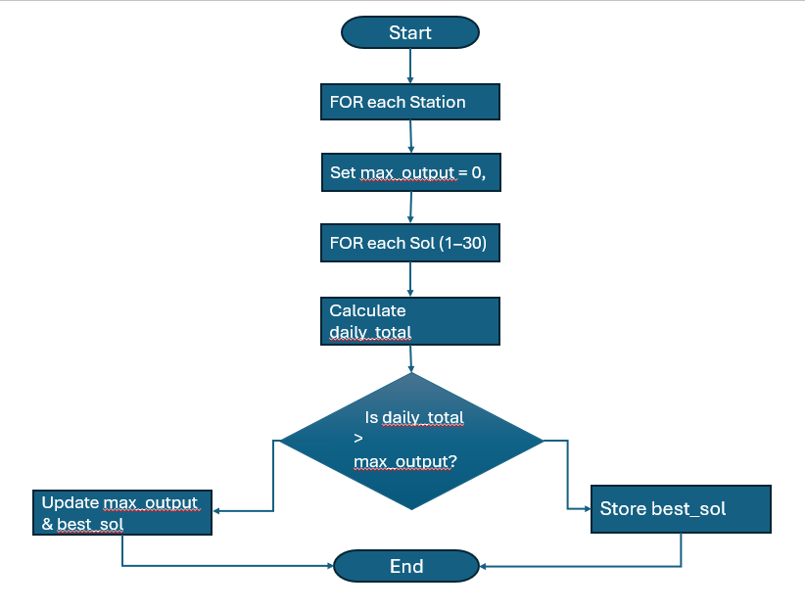
Figure 8 - Peak Productivity Determination

Task 2E – Calculate Efficiency Score
How the Code Works
An efficiency score was computed for each entry in the dataset using the formula Output ÷ (Station + Team). A vector was created to store these values, and a loop processed the dataset row by row, calculating the denominator from the station and team numbers before dividing it into the output. Once all rows had been evaluated, the completed vector was added to production_data as a new column titled EfficiencyScore. The first ten rows were reviewed, and several values were checked manually to verify that the calculation had been applied correctly and produced reasonable results

$$EfficiencyScore= \frac{Output}{(Station+Team) }$$
Testing
To check that the calculation had been applied correctly, I manually verified the first two rows with a calculator. The results matched the expected values, which confirmed that the loop and formula were functioning as intended.

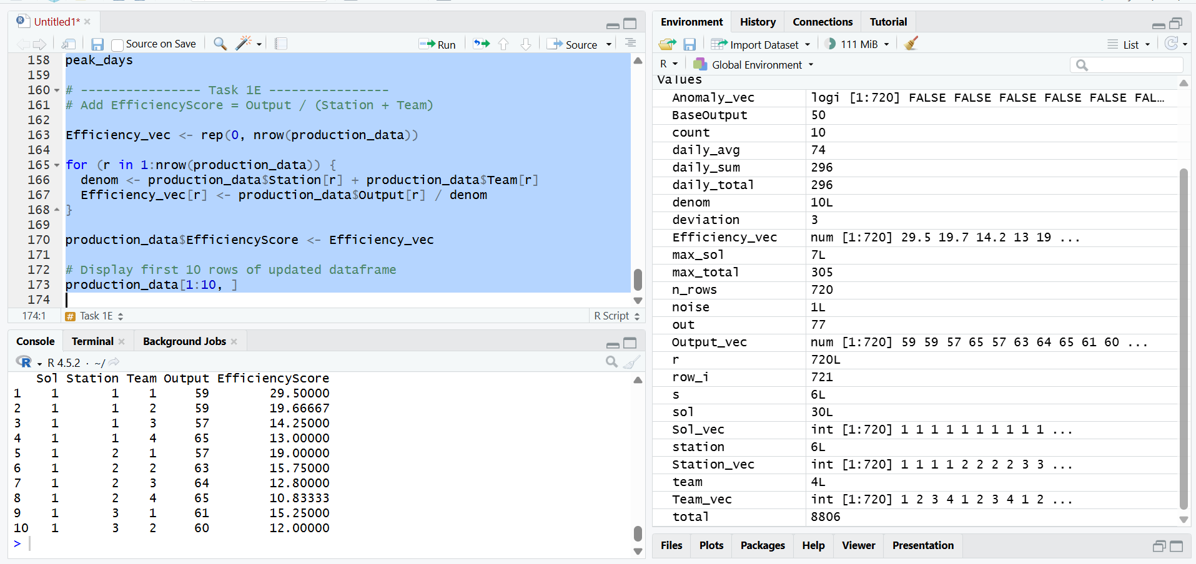
Figure 9 - Efficiency Score

Flowchart
This flowchart presents the sequence followed to compute the efficiency score for every entry in the dataset. It shows how each row is processed in turn, the efficiency formula is applied, and the resulting value is stored before moving on to the next record. The procedure ends once all rows have been evaluated and the new efficiency column has been added to the dataset.
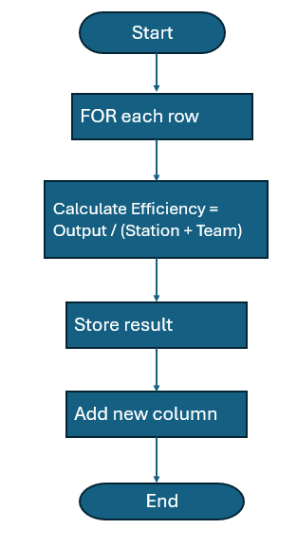
Figure 10 - Efficiency Score Calculation

Task 2F – Code Presentation
The script was organised with clear section headers and descriptive comments placed before each task to outline its purpose and the reasoning behind it. Indentation and spacing were kept consistent throughout the loops and condition statements, which made the structure of the program straightforward to follow. I chose variable names such as production_data, station_totals, and peak_days because they are meaningful and immediately convey their role in the script, which helps to avoid confusion.

All tasks were arranged in a logical order within a single file, with data generation completed before any analysis took place. This made the flow of execution easier to understand and simplified the debugging process. Presenting the script in this way improves its maintainability and allows other readers to grasp the logic quickly and verify the behaviour of the code.

Task 2.2 - Reflection
One of the main challenges in this assignment was developing confidence with nested loops, especially in the anomaly‑detection and peak‑productivity tasks. At first, it was easy to lose track of which loop controlled which variable. Breaking the logic into smaller, structured steps helped me understand the flow more clearly. Another difficulty was completing all calculations without built‑in aggregation functions, which required careful attention to loop ordering and data‑processing logic.

Working through this project strengthened my understanding of iterative programming, data‑frame manipulation and logical conditions in R. It also deepened my appreciation of the difference between descriptive and inferential statistics. The tasks focused on totals, averages and rule‑based anomaly detection, but I recognise that techniques such as hypothesis testing, confidence intervals and measures of variability would support more robust conclusions. Building confidence with these methods will help me move beyond identifying patterns and begin evaluating their statistical significance and reliability.

I also gained a clearer sense of the value of incremental testing. Validating small sections of code made errors easier to detect and correct. The project further improved my ability to explain technical processes and formulae clearly in written documentation.

If I were to approach this task again, I would create flowcharts earlier in the development process and use comments more consistently. I would also test smaller subsets of the dataset before running the full simulation, as this would streamline debugging and improve efficiency.

Generative AI tools were used only to support my understanding of programming concepts and to check general grammar. All coding logic, structural decisions and the final written content were produced and reviewed independently by me in full compliance with the assignment requirements.

Conclusion
Overall, the alien colony simulation successfully generated and analysed synthetic production data using loop-based programming techniques. This assignment helped me strengthen my understanding of loops, conditional logic, and structured coding in R. It also showed me the importance of careful testing, clear documentation, and writing readable code. The skills I gained from this project will be useful for future programming and data analysis tasks.

Appendix

BaseOutput <- 50

# 30 * 6 * 4 = 720 rows total
n_rows <- 30 * 6 * 4

# Pre-allocate vectors (faster + cleaner)
Sol_vec <- integer(n_rows)
Station_vec <- integer(n_rows)
Team_vec <- integer(n_rows)
Output_vec <- integer(n_rows)

row_i <- 1

# Nested loops to fill the dataset
for (sol in 1:30) {
for (station in 1:6) {
for (team in 1:4) {

noise <- sample(-5:5, 1) # random integer noise between -5 and 5
out <- BaseOutput + (station * 3) + (team * 2) + noise

Sol_vec[row_i] <- sol
Station_vec[row_i] <- station
Team_vec[row_i] <- team
Output_vec[row_i] <- out

row_i <- row_i + 1
}
}
}

# Build the dataframe
production_data <- data.frame(
Sol = Sol_vec,
Station = Station_vec,
Team = Team_vec,
Output = Output_vec
)

# Display first 10 rows
production_data[1:10, ]

# Task 1B: Total Production per Station

station_totals <- data.frame(
Station = 1:6,
TotalOutput = rep(0, 6)
)

for (s in 1:6) {

total <- 0 # reset for each station

for (r in 1:nrow(production_data)) {

if (production_data$Station[r] == s) {
total <- total + production_data$Output[r]
}

}

station_totals$TotalOutput[s] <- total
}

station_totals

# ---------------- Task 1C ----------------
# Detect Production Anomalies

Anomaly_vec <- rep(FALSE, nrow(production_data))

for (sol in 1:30) {
for (s in 1:6) {

# Step 1: calculate daily sum for this station + sol
daily_sum <- 0

for (r in 1:nrow(production_data)) {
if (production_data$Sol[r] == sol &&
production_data$Station[r] == s) {
daily_sum <- daily_sum + production_data$Output[r]
}
}

daily_avg <- daily_sum / 4 # 4 teams

# Step 2: mark anomalies
for (r in 1:nrow(production_data)) {
if (production_data$Sol[r] == sol &&
production_data$Station[r] == s) {

deviation <- production_data$Output[r] - daily_avg
if (deviation < 0) deviation <- -deviation # manual abs

if (deviation > 0.10 * daily_avg) {
Anomaly_vec[r] <- TRUE
}
}
}
}
}

anomalies <- data.frame(
Sol = production_data$Sol,
Station = production_data$Station,
Team = production_data$Team,
Output = production_data$Output,
Anomaly = Anomaly_vec
)

# Display first 10 TRUE anomalies
count <- 0
for (r in 1:nrow(anomalies)) {
if (anomalies$Anomaly[r] == TRUE) {
print(anomalies[r, ])
count <- count + 1
if (count == 10) break
}
}

# ---------------- Task 1D ----------------
# Identify Peak Productivity Days (max total output per station)

peak_days <- data.frame(
Station = 1:6,
Sol = rep(0, 6),
TotalOutput = rep(0, 6)
)

for (s in 1:6) {

max_total <- -999999
max_sol <- 0

for (sol in 1:30) {

daily_total <- 0

for (r in 1:nrow(production_data)) {
if (production_data$Station[r] == s &&
production_data$Sol[r] == sol) {
daily_total <- daily_total + production_data$Output[r]
}
}

if (daily_total > max_total) {
max_total <- daily_total
max_sol <- sol
}
}

peak_days$Sol[s] <- max_sol
peak_days$TotalOutput[s] <- max_total
}

peak_days

# ---------------- Task 1E ----------------
# Add EfficiencyScore = Output / (Station + Team)

Efficiency_vec <- rep(0, nrow(production_data))

for (r in 1:nrow(production_data)) {
denom <- production_data$Station[r] + production_data$Team[r]
Efficiency_vec[r] <- production_data$Output[r] / denom
}

production_data$EfficiencyScore <- Efficiency_vec

# Display first 10 rows of updated dataframe
production_data[1:10, ]

