Advanced Computational Methods: M6X0048
Motion Simulation & FEA
Tutor: Andrew Harrison

Emma Bergson P148476
16 August 2020

Contents
1 Introduction 2
2 Methodology 2
2.1 Creating the Solidworks Model 2
3 Results 3
3.1 Finite Element Analysis 3
3.1.1 20° Blade Angle 3
3.1.2 25° Blade Angle 4
3.2 30° Blade Angle 5
3.3 Comparison 6
4 Conclusion 7
5 References 8

Figure 1. Side, Isometric and Front view of Model 3
Figure 2. Side view of flow trajectories, 20° 4
Figure 3. Isometric view of trajectories, 20° 4
Figure 4. Top down view of flow trajectories, 20° 5
Figure 5. Side view of flow trajectories, 25° 5
Figure 6. Isometric view of trajectories, 25° 6
Figure 7. Top down view of flow trajectories, 25° 6
Figure 8. Side view of flow trajectories, 30° 7
Figure 9. Isometric view of trajectories, 30° 7
Figure 10. Top down view of flow trajectories, 30° 8

Table 1. Data from FEA flow simulation, 20° 8
Table 2. Data from FEA flow simulation, 25° 9
Table 3. Data from FEA flow simulation, 30° 9

Introduction
The accuracy available through Computer Aided Design (CAD) has become standard for any type of engineering drawing and 3D design (Simmons, 2012). With design technology increasing insurmountably over the past few years, new opportunities to stretch CAD programmes such as Solidworks are becoming more apparent and using the FEA tool during the design cycle improves quality (Prokos, 2019).
With the cost of 3D printing technology reducing dramatically over the past few years using a programme such as Solidworks in the product development process can help produce a physical model of a prototype effortlessly (Solidworks, 2020).
This project looks into the design of a wind turbine and uses a wind tunnel to display how a flow of 4m/s affects the turbine as a whole and just the blades. The blades were set at 20°, 25° and 30° angles to show different flow trajectories and how they affect the stress of the turbine blades.

Methodology

Creating the Solidworks Model
The Solidworks model was produced from following a YouTube tutorial by Tim Callinan (Callinan, 2016). It was built in the size of a model easily produced by a 3D printer but can easily be upscaled.
The average wind speed for Britain over the past decade has been very stable averaging out at 8.55knots or 4.4 m/s (Tieso, 2020). Most small wind turbines have a cut in speed between 2.5 to 4.5m/s (Pullen, 2020). Using this information, a decision to do FEA at 4m/s was made.
The turbine was placed in a wind tunnel (also developed from a description on a YouTube tutorial) and the blades were set at three angles, 20°, 25° and 30° which were analysed in that order using a flow trajectories simulation.
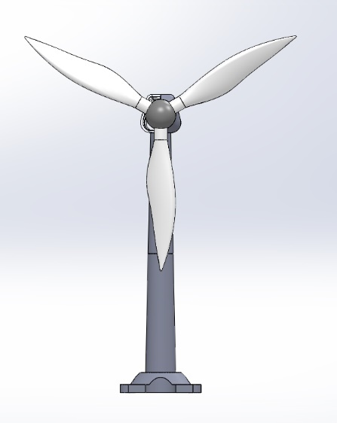
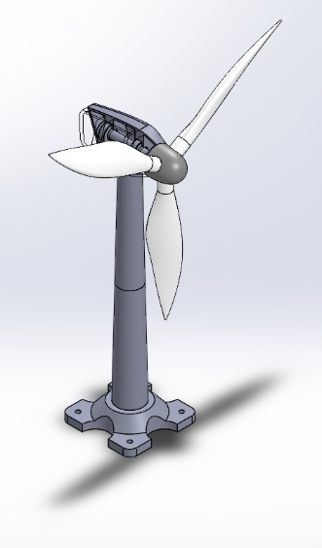
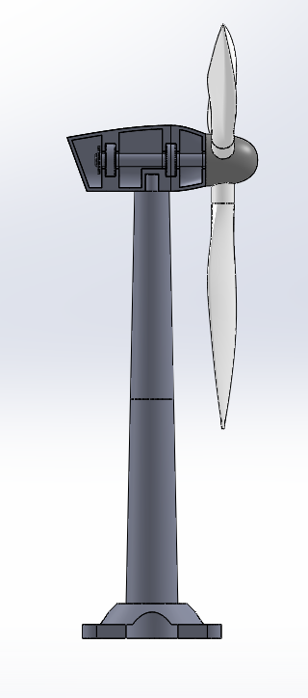
Figure 1. Side, Isometric and Front view of Model

Results

Finite Element Analysis

20° Blade Angle
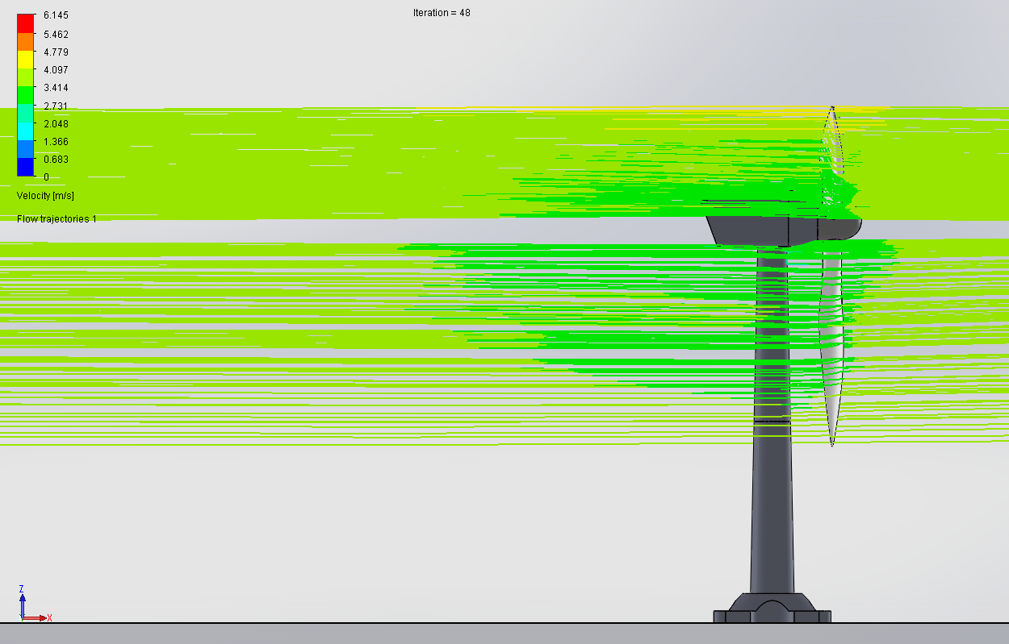
Figure 2. Side view of flow trajectories, 20°

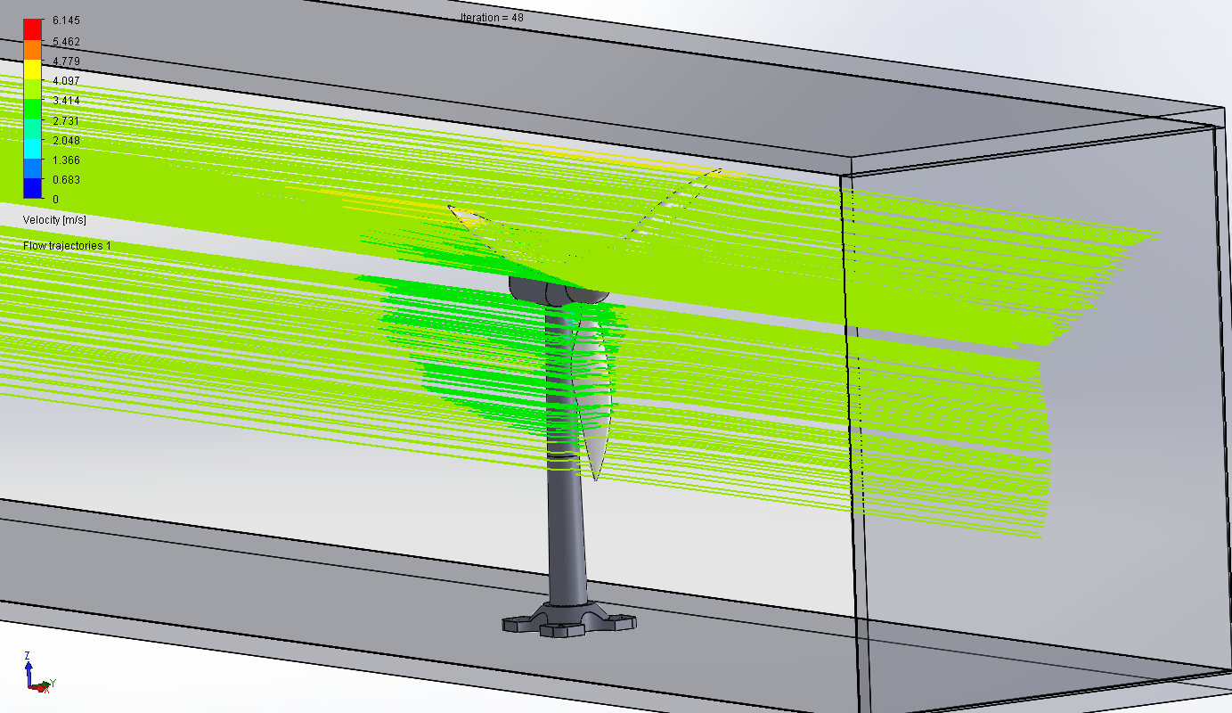
Figure 3. Isometric view of trajectories, 20°
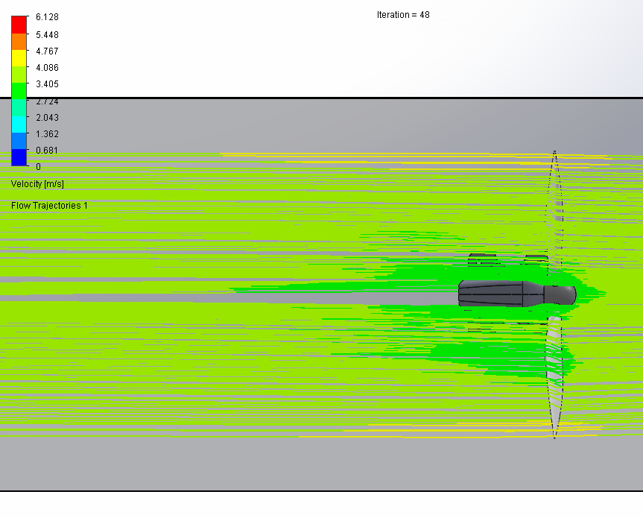
Figure 4. Top down view of flow trajectories, 20°

25° Blade Angle
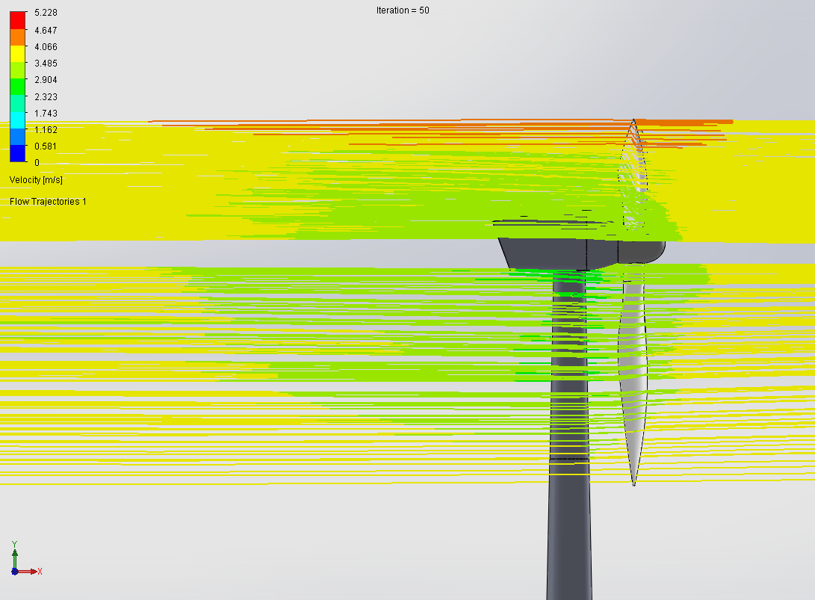
Figure 5. Side view of flow trajectories, 25°

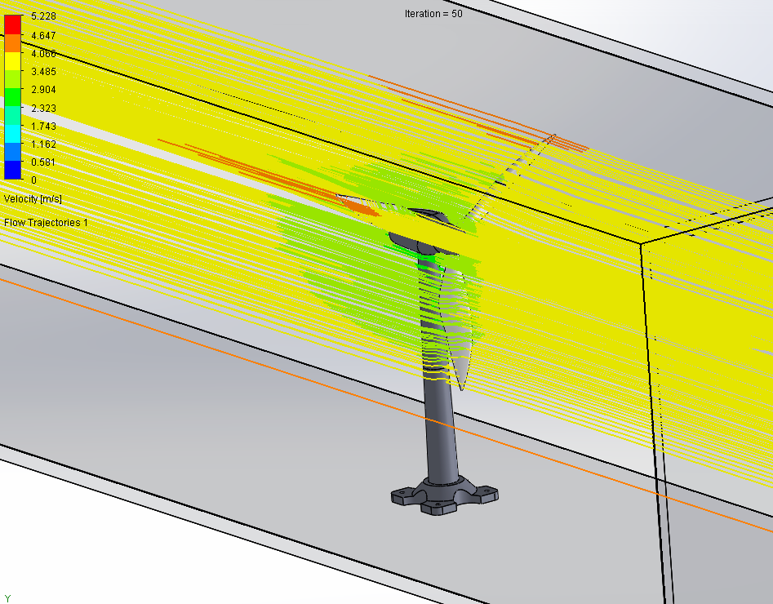
Figure 6. Isometric view of trajectories, 25°
.
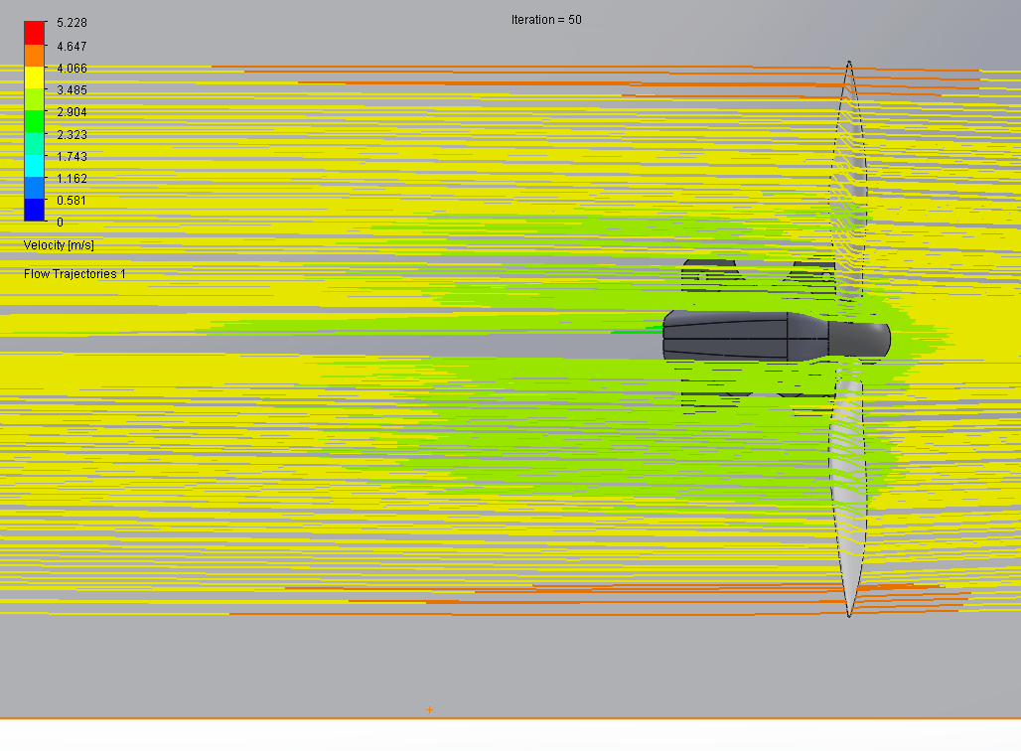
Figure 7. Top down view of flow trajectories, 25°

30° Blade Angle
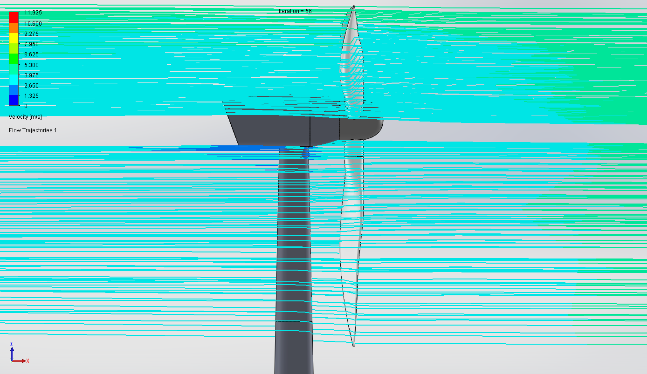
Figure 8. Side view of flow trajectories, 30°
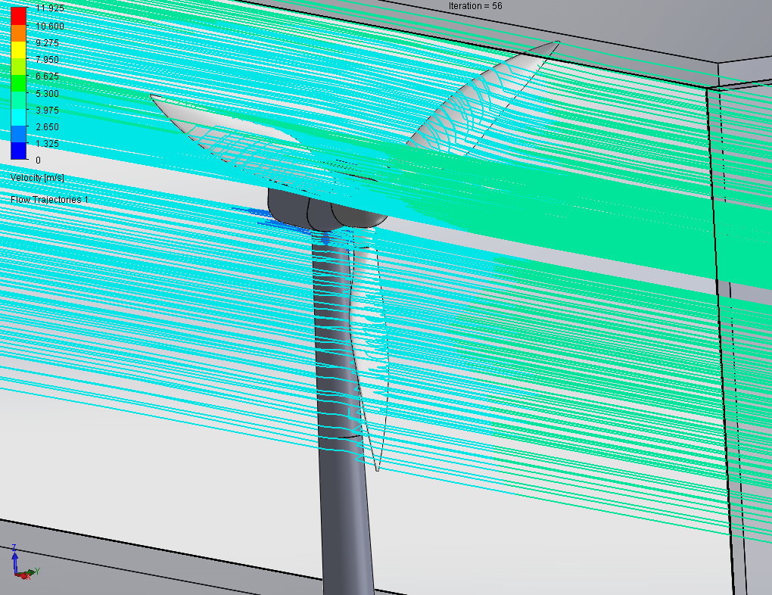
Figure 9. Isometric view of trajectories, 30°

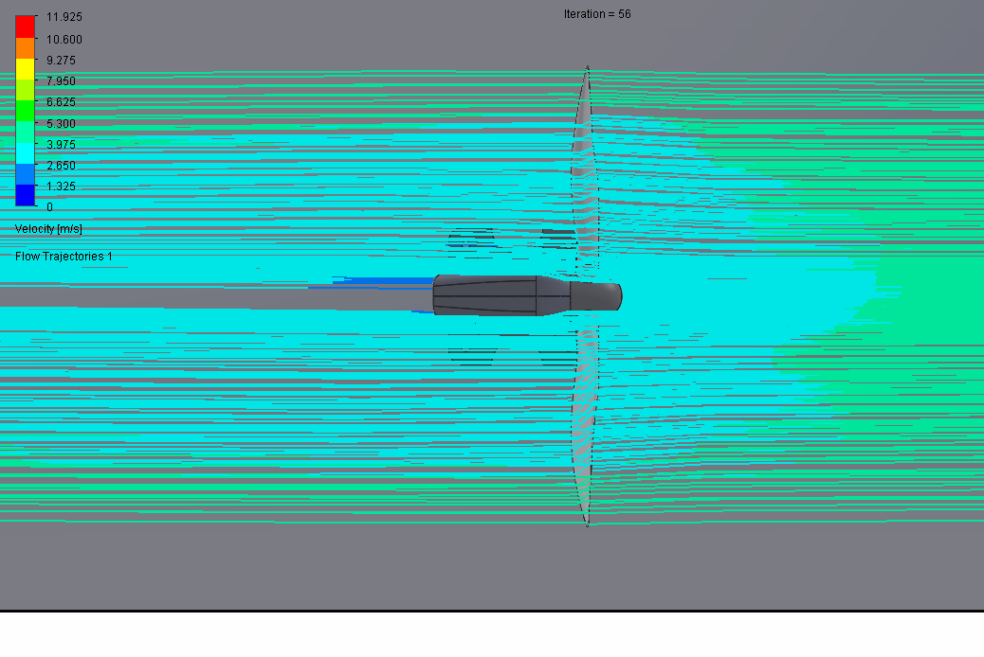
Figure 10. Top down view of flow trajectories, 30°

Comparison
Tables 1 – 3 below display data gathered from the flow trajectories simulation.
Table 1. Data from FEA flow simulation, 20°
Goal Name | Unit | Value | Averaged Value | Minimum Value | Maximum Value | Delta
GG Minimum Velocity 1 | [m/s] | 0.00 | 0.00 | 0.00 | 0.00 | 0.00
GG Average Velocity 1 | [m/s] | 4.00 | 4.00 | 4.00 | 4.00 | 0.00
GG Maximum Velocity 1 | [m/s] | 6.18 | 6.15 | 6.02 | 6.20 | 0.18
GG Force (X) 1 | [N] | -6.62 | -6.63 | -6.64 | -6.62 | 0.03
GG Force (Y) 1 | [N] | 0.08 | 0.07 | 0.00 | 0.12 | 0.04
GG Force (Z) 1 | [N] | 0.00 | -0.02 | -0.16 | 0.02 | 0.18
GG Minimum Shear Stress (X) 1 | [Pa] | -0.13 | -0.13 | -0.13 | -0.12 | 0.01
GG Average Shear Stress (X) 1 | [Pa] | -0.04 | -0.04 | -0.04 | -0.04 | 0.00
GG Maximum Shear Stress (X) 1 | [Pa] | 0.00 | 0.00 | 0.00 | 0.00 | 0.00
GG Torque (X) 1 | [N*m] | -0.33 | -0.36 | -0.89 | 0.22 | 1.10
GG Torque (Y) 1 | [N*m] | -61.55 | -61.66 | -62.02 | -61.44 | 0.58
GG Torque (Z) 1 | [N*m] | 51.21 | 51.16 | 50.94 | 51.28 | 0.34
Iterations [ ]: 48
Analysis interval: 21

Table 2. Data from FEA flow simulation, 25°
Goal Name | Unit | Value | Averaged Value | Minimum Value | Maximum Value | Delta
GG Minimum Velocity 1 | [m/s] | 0.00 | 0.00 | 0.00 | 0.00 | 0.00
GG Average Velocity 1 | [m/s] | 4.00 | 4.00 | 4.00 | 4.00 | 0.00
GG Maximum Velocity 1 | [m/s] | 5.28 | 5.21 | 5.04 | 5.28 | 0.11
GG Force (X) 1 | [N] | -6.40 | -6.40 | -6.42 | -6.39 | 0.03
GG Force (Y) 1 | [N] | 0.09 | 0.09 | 0.04 | 0.14 | 0.04
GG Force (Z) 1 | [N] | -0.04 | -0.05 | -0.11 | -0.02 | 0.09
GG Minimum Shear Stress (X) 1 | [Pa] | -0.08 | -0.08 | -0.08 | -0.08 | 0.00
GG Average Shear Stress (X) 1 | [Pa] | -0.04 | -0.04 | -0.04 | -0.04 | 0.00
GG Maximum Shear Stress (X) 1 | [Pa] | 0.01 | 0.05 | 0.01 | 0.21 | 0.03
GG Torque (X) 1 | [N*m] | -0.90 | -0.90 | -1.44 | -0.46 | 0.47
GG Torque (Y) 1 | [N*m] | -59.23 | -59.20 | -59.40 | -59.05 | 0.35
GG Torque (Z) 1 | [N*m] | 49.82 | 49.78 | 49.61 | 49.96 | 0.35
Iterations [ ]: 50
Analysis interval: 21
Table 3. Data from FEA flow simulation, 30°
Goal Name | Unit | Value | Averaged Value | Minimum Value | Maximum Value | Delta
GG Minimum Velocity 1 | [m/s] | 0.00 | 0.00 | 0.00 | 0.00 | 0.00
GG Average Velocity 1 | [m/s] | 4.01 | 4.01 | 4.01 | 4.01 | 0.00
GG Maximum Velocity 1 | [m/s] | 5.51 | 5.45 | 5.31 | 5.51 | 0.19
GG Normal Force (X) 1 | [N] | -3.15 | -3.14 | -3.15 | -3.14 | 0.01
GG Normal Force (Y) 1 | [N] | 0.08 | 0.08 | 0.05 | 0.12 | 0.03
GG Normal Force (Z) 1 | [N] | 0.00 | 0.02 | -0.02 | 0.08 | 0.04
GG Minimum Shear Stress (X) 1 | [Pa] | -0.18 | -0.20 | -0.22 | -0.18 | 0.01
GG Average Shear Stress (X) 1 | [Pa] | -0.04 | -0.04 | -0.04 | -0.04 | 0.00
GG Maximum Shear Stress (X) 1 | [Pa] | 0.04 | 0.04 | 0.04 | 0.04 | 0.00
GG Torque (X) 1 | [N*m] | -0.67 | -0.54 | -1.03 | 0.05 | 0.56
GG Torque (Y) 1 | [N*m] | -69.71 | -69.65 | -69.75 | -69.49 | 0.27
GG Torque (Z) 1 | [N*m] | 60.15 | 60.20 | 60.10 | 60.32 | 0.07
Iterations [ ]: 56
Analysis interval: 21

From the visual flow trajectories displayed in figures 2-10, it looks like something went wrong with the flow simulation for the 30°, however, looking at the data gathered in excel the figures look okay.

Conclusion
The blades set to 20° appear to be the best angle to set the blades at.

References
Callinan, T. (2016). Solidworks - Wind Turbine. Retrieved 11 2019, from https://www.youtube.com/watch?v=eDm7F28350Q
Prokos, C. (2019, January 11). Introduction to SOLIDWORKS Simulation Webinar: What is Finite Element Analysis? Retrieved January 11, 2020, from www.fisherunitech.com: https://www.fisherunitech.com/blog/introduction-solidworks-simulation-webinar-finite-element-analysis
Pullen, T. (2020). Wind Turbines Guide. Retrieved August 2020, from https://www.homebuilding.co.uk/advice/wind-turbines-guide
Simmons, C. H. (2012). Manual of Engineering Drawing: Technical Product Specification and Documentation to British and International Standards (4th ed.). Butterworth-Heinemann.
Solidworks. (2020, January 11). The Future of 3D Printing, Expert Opinions, Trends, and Forecasts of Additive Manufacturing. Retrieved from www.solidworks.com: https://www.solidworks.com/sw/resources/future-3d-printing.htm
Tieso, I. (2020). Annual average wind speed in the United Kingdom (UK) from 2001 to 2019(in knots). Retrieved August 2020, from https://www.statista.com/statistics/322785/average-wind-speed-in-the-united-kingdom-uk/#:~:text=Annual%20average%20wind%20speed%20in%20the%20United%20Kingdom,%20%208.4%20%209%20more%20rows%20

All CAD drawings can be found at the link below.
https://uowtsd-my.sharepoint.com/:f:/g/personal/jbergson_148476_student_uwtsd_ac_uk/Eu1YgfmWoXRNvJa9jGmihEMBQCaPpc-GEKXrH0Z6jtdWbg?e=Sj4ywh

