ECGE5002P: Changemakers: Building your Personal Brand for Sustainable Employment. An e-portfolio and a Zander Letter.

Part A

Personal Development Plan

My task is to reflect about myself, which is something I do not do regularly. In order to help myself to identity such strengths, weaknesses, skills, and qualities, I have looked at three tests developed by theorists to help me build my personality profile.

Strengths and Intelligences
The first test I completed was Gardner’s Multiple Intelligence quiz. My results show that bodily-kinaesthetic intelligence and interpersonal intelligence are my strengths. Bodily-kinaesthetic intelligence or ‘body smart’ indicates that I have great ability to use my body to communicate effectively, and process information through movement, gestures, and facial expressions. Interpersonal intelligence or ‘people smart’ is the ability to effectively interact with and understand others. People who mark high in this intelligence are usually known for their advanced communication skills and their ability to assess the thoughts and feelings of others (IDRlabs, 2022). Individuals with this kind of importance are also advanced in creating personal relationships with those around them (Cherry, 2022). Both intelligences are relatable to my strengths as I identify myself as someone with advanced communication skills, and work in a setting where all types of communication is paramount, especially through non-verbal communication as many individuals I work with are non-verbal. I also enjoy creating positive relationships with those around me, built on trust and fun.

Weaknesses
After studying the skills inventory to help identify my strengths, I came across a few weaknesses that require work in order to better my opportunities. The biggest weakness I feel I need to work on is staying motivated for things that are not of my particular interest, and my concentration levels during these situations. In order to develop these weaknesses, I will start by work on eliminating distractions and taking regular short breaks (Chia, 2021). I will plan to do my work in a quiet space away from work and home, so there are no distractions. I will also plan short break that I can work towards, which will help me to concentrate more during this time.

Opportunities
I completed the Princeton Review test, that once completed gives you results of possible career options best suited for your styles and interests. Interests are defined as types of activities you will need within your career to stay motivated, and styles define the strengths you will bring to those particular careers. The result of the test was red (expediting) for interests, and green (communicating) for styles. As a result, the possible careers for red individuals include hands on/problem solving responsibilities and careers that involve practical activities. Those identified as having green styles prefer to work in settings where they can perform their duties in an ‘outgoing’ way. They also tend to be talkative, competitive and thrive in team-orientated environments (TPR Education, 2022).

I then completed the Holland Code Quiz, that is a system to match personalities to work opportunities or career paths to best suit you. Holland identified six attributes that an individual could be. My results show that I am best suited to a ‘social’ work environment, where people seem to satisfy their needs through teaching or helping others. These individuals like to work with people and are drawn to seek close relationships with others. These people see themselves as patient, empathic, and having interpersonal skills. Whereas others see these people as nurturing and extroverted. The careers matched for these types of individuals include social work, behaviour management, various teaching roles or special education (Rogue Community College, 2022). After identifying the opportunities that are best suited to me, I realised that I am already going in the right direction. One of Covey’s 7 Habits of Successful People state to start with end in mind. After the experience of being a learning support assistant in a special school, I realised that I wanted to have a career that involved working in a teaching environment (Covey, 2017).

Career Goal
What is your long-life career goal? Make sure you use SMART
To become a teacher in primary education or special education.

Current Situations | Specific Career Goals | Skills Gap | Actions | Timeframe
What professional development activities are you already undertaking? | Goals divided down into more manageable steps. | What skills, knowledge or resources do you need to achieve the career goal(s)? | What actions will you take to address each skill gap? | When will you complete this?
Currently completing Inclusive Education Foundation Degree: Year 3 | Complete Inclusive Education Foundation Degree: Year 3 | Communication skills  Self-management skills  Motivation  Organise my time  Research skills | Watch each lecture and complete relevant note taking.  Research in depth for each module.  Complete each module to the best of my ability.  Manage my learning environment.  Use my support network. | May 2023.
 | Advance onto BA Inclusive Education Degree course and complete. | Be well informed.  Organise my time.  Correct books / resources.  Develop writing skills.  Research the course. | Read. Investigate. Ask.  Keep to deadlines.  Ask people I know who have previously completed the course for information.  Use my support network.  Request time off work for lectures. | September 2024.
 | Postgraduate Certificate in Education (PGCE). | To pass the previous two degrees with sufficient grades.  Commitment. | Request a secondment from work to complete this course.  Use my support network.  Apply for the course at the closest university. | September 2025.

A professional CV

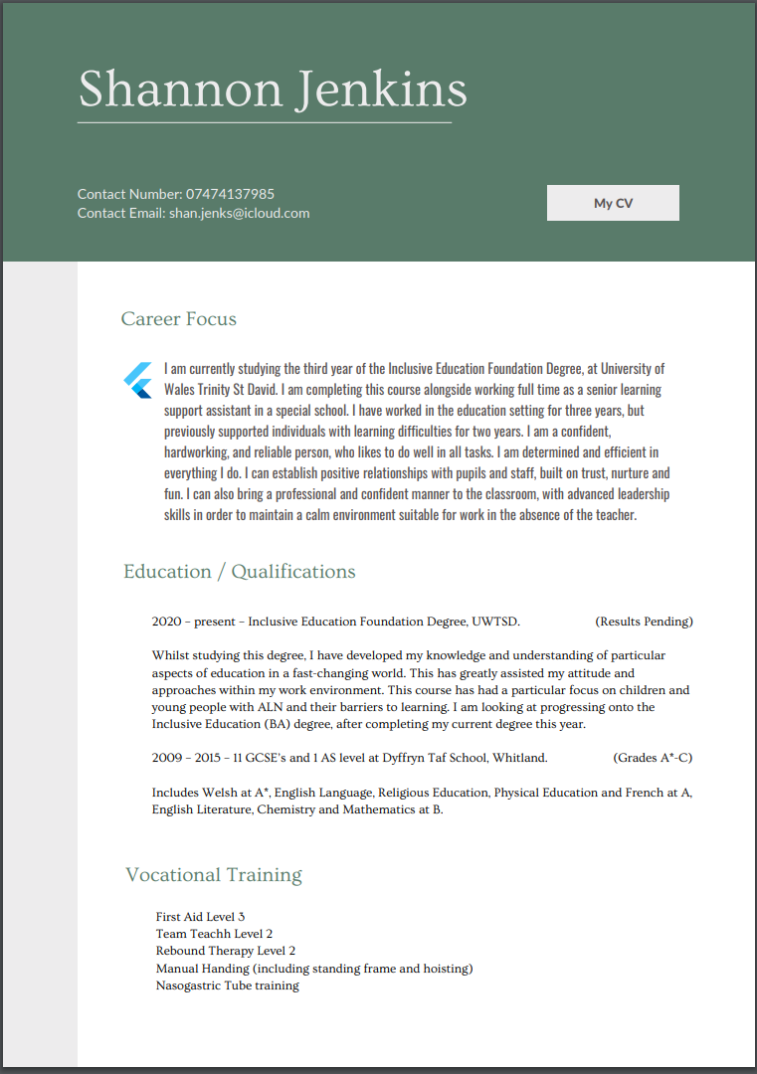
https://www.canva.com/design/DAFP3ytNkAc/0sZ8ROe3fCwvCDrU-6Ebow/view?utm_content=DAFP3ytNkAc&utm_campaign=designshare&utm_medium=link&utm_source=homepage_design_menu
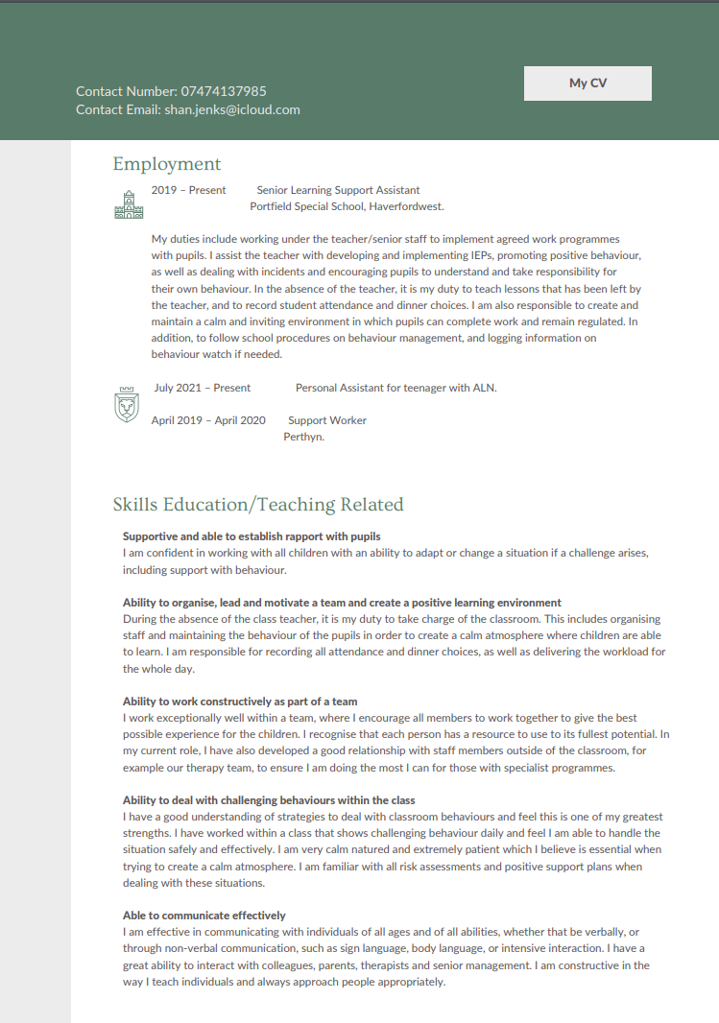
Part B: A Zander Letter

Dear Shannon, I got a first in the Inclusive Education Foundation Degree because it was something I truly desired. I developed a great amount of self-motivation in order to find the time to complete a considerable amount of research to gain higher academic achievements for each module. Dweck’s growth mindset theory is the belief that intellectual ability can be developed, and that a growth mindset can lead to greater resilience and academic achievement (Yeager & Dweck, 2020), p.1270). In order for me to achieve a first, I knew I needed to prioritise a lot of study time to develop my intellectual ability and the depth of my work. This meant I had to miss out on other things in my life that I usually prioritise, like exercise. Dweck states that “it’s not intelligence, talent or education that sets successful people apart. It’s their mindset, or the way they approach life’s challenges” (Dweck, 2017).

Other skills I identified that helped me achieve my first are having good planning skills, knowing when to stop, and keeping calm. By having good planning skills, it enabled me to have a clear plan and structure to complete assignments, which left minimal space for risks and consequences. I developed a mindset where I would set the deadline for my assignments to be done the week before the actual deadline date. This gave me room to proofread and edit my assignment, but also meant I was not stressed or under pressure to get it done last minute. I realised that to achieve a higher grade, I had to enjoy what I was learning and writing about. I developed a positive outlook on each assignment and chose to research the parts that interested me most, even if it meant more work. Another way I developed a positive attitude was to know when to stop and not force myself to do the work, otherwise it would become a negative chore.

Growth mindset is based on the belief that your basic qualities are something you can cultivate through or change through experience and application. The belief that qualities can be changed creates a passion for learning (Dweck, 2017). During my time studying, I developed qualities and habits that would ensure I would achieve my grade. I learnt that I needed to be more proactive with my learning. Covey states that to be proactive is more than just acting. It involves being responsible for yourself because we have the ability to consciously choose how we respond to a situation (Connelly, 2020). I began my studies with my end goal in mind, which was to be a teacher. I also understood that I needed to have a logical progression and prioritise the things I needed to do first. This collates with Covey’s theory, that states one habit of successful people is to put first things first (Covey, 2017).

Something I overcome during my time studying was that I did not attend many lectures. This is something I seen as a problem as I was never present to ask questions on the spot, but I did not let this become something that would hold me back. I ensured I prioritised time each week to watch back the lectures and utilised the group to ask any questions. I produced notes for each lecture in logical order, in order to make it easier to refer back (Oxford Royale, n.d). I recognised that I had a particular strength in encouraging myself to keep going when things seemed tough. As stated in the skills inventory, “Keep going skills enable you to sustain action” (See Appendix 1).

I utilised my evaluating skills, which include getting the best from past experiences to learn and to make better plans for next time (See Appendix 1). I used these skills to reflect back on previous assignments in order to better my performance in the future. I evaluated the comments left by the tutor and used these to my advantage. With reference to the skills inventory, a lot of my strengths are listed under the doing skills, which are defined as skills of the present. I have excellent time management skills which is evident in both my personal and academic lifestyle. It is my meticulous attention to detail and self-discipline which brought me great success in my studies (See Appendix 1).

Reference List
Cherry, K. (2022) Gardner’s Theory of Multiple Intelligences. Available at: https://www.verywellmind.com/gardners-theory-of-multiple-intelligences-2795161 (Accessed: 13th October 2022).

Chia, S. (2021) Improve your focus and concentration: 15 ways to build your skills. Available at: https://www.betterup.com/blog/15-ways-to-improve-your-focus-and-concentration-skills (Accessed: 22nd October 2022).

Connelly, M. (2020) Stephen Covey: 7 Habits Model. Available at: https://www.chanSge-management-coach.com/stephen-covey.html (Accessed: 23rd October 2022).

Covey, S.R. (2017) The 7 Habits oh Highly Effective People. New York City: Simon and Shuster.

Dweck, C. S (2017) Changing the way you think to fulfil your potential. 6th Ed. London: Robinson.

Griffiths, H. (2022) Reflective Models and Reflective Writing. [PowerPoint]. (Accessed: 23rd October 2022).

Hall, M. (2022) CVs and PDPs. [PowerPoint]. (Accessed: 20th October 2022).

Hill, T. (2022) Professional Development Plan Template (with Completed Examples). Available at: https://www.seoptimer.com/blog/professional-development-plan-template/ (Accessed: 27th October 2022).

IDR Labs (2022) Multiple Intelligence Test: Based on the work of Howard Gardner, Ph.D. Available at: https://www.idrlabs.com/multiple-intelligences/test.php (Accessed: 09th October 2022).

Oxford Royale (n.d) 14 Ways to Improve Your Grades if You’re Underperforming. Available at: https://www.oxford-royale.com/articles/improve-underperforming-grades/ (Accessed: 23rd October 2022).

Rogue Community College (2022) A Brief Description of the Holland Environmental Typology. Available at: https://www.roguecc.edu/Counseling/HollandCodes/typologies.asp (Accessed: 22nd October 2022).

Spruce, C. (2020) A Personal Development Plan (PDP) Guide & Template. Available at: https://www.highspeedtraining.co.uk/hub/personal-development-plan-template/ (Accessed: 27th October 2022).

TPR Education (2022) Career Quiz. Available at: https://www.princetonreview.com/quiz/career-quiz#!quizresult_7713728 (Accessed: 28th October 2022).

Yeager, D. & Dweck, C. (2020). What can be learned from growth mindset controversies? American Psychologist 75(9) 1269-1284. https://psycnet.apa.org/doiLanding?doi=10.1037%2Famp0000794
Appendices
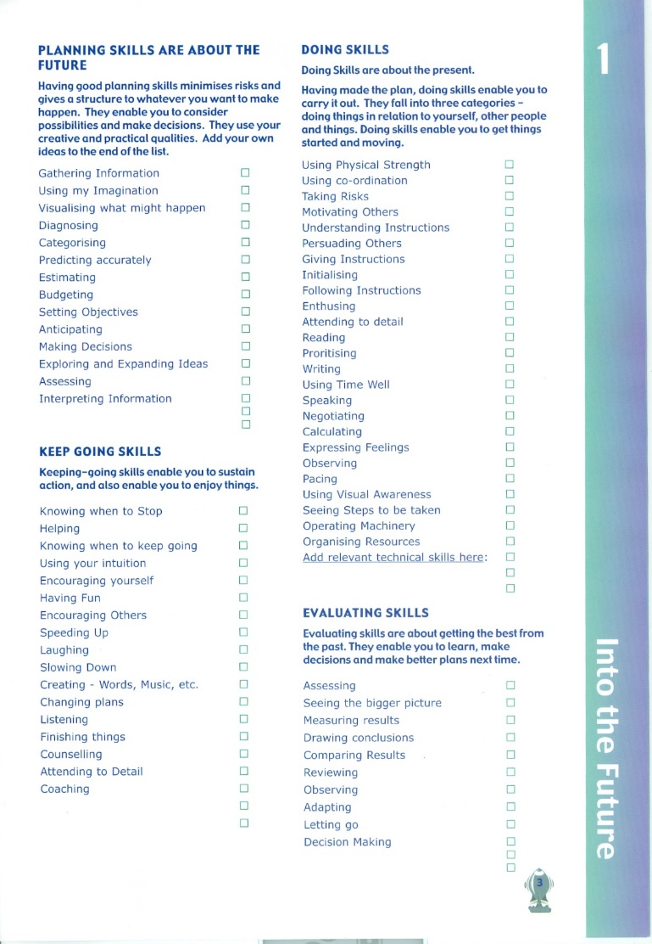
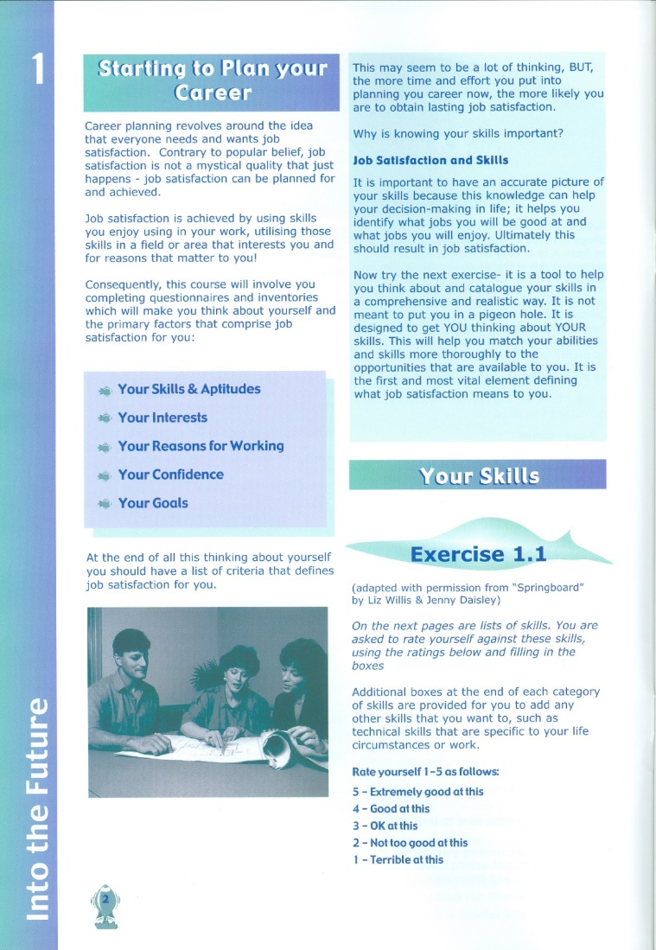
Appendix 1


