IMPACT OF VIRTUAL LEARNING ENVIRNOMENT (VLE) – MOODLE

DIGITAL SKILLS AND RESEARCH METHODS

Jaime David Rojas Garcia
2125624
Koushik Modak
University of Wales Trinity Saint David
2022-2023
Contents
ABSTRACT 2
RATIONALE 3
RESEARCH OBJECTIVES 3
LITERATURE REVIEW 3
WHAT IS VIRTUAL LERINING ENVIRONMENT? 3
HISTORY OF VLE 4
WHAT IS VLE USED FOR? 4
VLE DURING COVID-19 5
USE OF VLE IN UWTSD 5
WHAT IS MOODLE? 5
RESEARCH METHODOLOGY 6
METHODOLOGY 6
TYPE OF RESEARCH 6
PRIMARY AND SECONDARY DATA 7
PRIMARY DATA 7
SECONDARY DATA 7
DATA COLLECTION PROCESS 7
RESULTS AND FINDINGS 8
CONCLUSION 12
REFERENCES 13
APPENDIX 1 14
QUESTIONNAIRE: IMPACT OF VIRTUAL LEARNING ENVIRONMENT 14

ABSTRACT

This report aims to analyze the impact of the Virtual Learning Environment (VLE). This research will be focused on Moodle, and this will be studied with primary and secondary data.

RATIONALE

The purpose of this report is to study the effect of VLE, specifically the Moodle of University of Wales Trinity Saint David on students of Certificate of Higher Education Skills for the workplace.

RESEARCH OBJECTIVES

The objectives of this research are to analyze how students from UWTSD feel about:
- effectiveness of the Moodle
- suggestions of changes to the platform.
- The usage of the Moodle.
- Are the students getting positive or negative impact from the Moodle?

LITERATURE REVIEW

WHAT IS VIRTUAL LERINING ENVIRONMENT?

“A virtual learning environment (VLE) in educational technology is a web-based platform for the digital aspects of courses of study, usually within educational institutions. They present resources, activities, and interactions within a course structure and provide for the different stages of assessment. VLEs also usually report on participation; and have some level of integration with other institutional systems.”
(Wikipedia Contributors, 2019)
In this case, we will study the Moodle platform of UWTSD.
A learning environment is a place where exists an interaction between people and the learning material, for example: reading a book and discussing it in a classroom is a learning environment; the book on its own would be the material for learning, and discussion about it with other people in a classroom is the environment.
“A VLE is a place which is based in a network platform which is an academic support from an institution like colleges or universities. This allows a social interaction between students, teachers and academic material to study.”
(Pierre, D.S, Paraskevi, S. Virtual Learning Environments. 2002)

HISTORY OF VLE

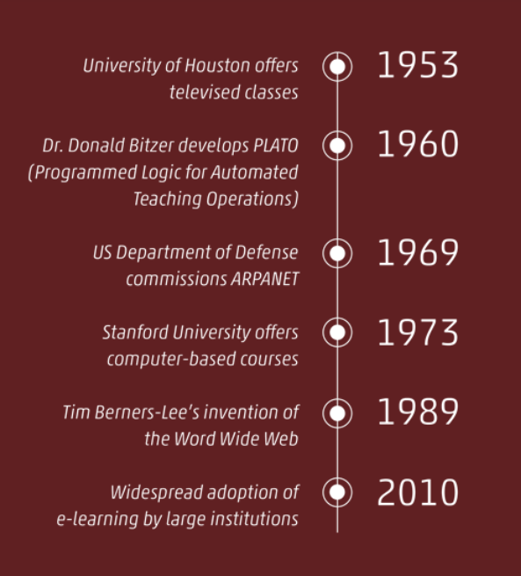
Back in the 1840s, teachers started to send students homework via post. In 1953, in Houston (USA) happened the first TV classes. In 1960, there were created machines that provided teaching assistant support. In 1969, the internet as we know was created.
In 1973, students began to take computer-based lessons, and in the following decades, software and games were created to deliver academic support.
In 1989 was de invention of The World Wide Web. In 2010 almost all the academic institutions were using e-learning materials, and VLE were more usual and interactive (Firefly, n.d.).
(Firefly, n.d.)

WHAT IS VLE USED FOR?

“A VLE combines a number of elements such as content management; curriculum and assessment; learner engagement; administration of learner information; communication tools; collaboration tools; and real-time (live) teaching elements. The tools and elements available will depend on the platform chosen.”
(Learning Ladders Education, n.d.)
VLE is used to deliver academic content between teachers and students. Students can submit assignments and tasks. The content changes depending on the students development and their progress. VLE allows students to track their grades, letters, and progression. VLE gives organization to the materials, this permit students to find every material needed with easy access. Teachers can give tests through VLE and learners can complete them at their own time preference or when they feel ready.
Learners can access their VLE through their mobile devices such as laptops, phones, tablets, etc. They can find useful tools such as forums, chats, emails, or blogs where they can interact with other students and teachers. (Parallels Remote Application Server Blog - Application virtualization, mobility and VDI, 2021)

VLE DURING COVID-19

Many institutions have removed their in-person lessons to bring online teaching. After the global pandemic caused by the Covid-19, every university in the world had to shut down and have managed to deliver lessons online. Moving from a conventional educational environment to an online system was not easy, but everyone worked fast to not stop teaching (Adnan, M, and Anwar, K, 2020). This action has made the usage of VLE more common than we think.

USE OF VLE IN UWTSD

“Moodle is our Virtual Learning Environment (VLE). This is the place to go for all the learning resources for your modules, including lecture recordings, reading lists, lecture slides and handouts, as well as module handbooks. It is also where you can submit your assignments and coursework.”
(digitallearning.uwtsd.ac.uk, n.d.)
Learning online in UWTSD is possible because lessons were handed via Microsoft Teams, where students could attend the meetings and listen to the teachers' explanations. The Moodle is a platform where we could find all the lectures materials, videos, and PowerPoint slides, we can also submit assignments via Turnitin which is a tool that allows detecting plagiarism.

WHAT IS MOODLE?

“Moodle is a platform for online learning that enables you to create online courses, add assignments, and keep an eye on your students’ progress. It also allows to communicate with the students and encourage communication between them in forums and discussions.”
(Explore the eLearning world with us, 2020)
In this report, we will study the impact of Moodle on students of the UWTSD.

RESEARCH METHODOLOGY

METHODOLOGY

To do this part of the assessment I created a questionnaire of seven questions:
- Do you find this platform useful?
- How difficult is the Moodle to understand?
- How hard is to access the Moodle?
- Would you change something from the Moodle?
- What is the biggest difference between studying in the Moodle than in the campus?
- Would you like to view recorded lessons in the Moodle?
- How many times per week do you visit the Moodle?
This questionnaire was sent to 21 students of UWTSD of Certificate of Higher Education Skills for the Workplace level 4.

TYPE OF RESEARCH

This survey contains questions with open-ended answers, close-ended answers, yes/no and liker-scale questions. This makes this research a mixed method study because it will contain data that can be quantitative and qualitative.

PRIMARY AND SECONDARY DATA

PRIMARY DATA

In this research, the primary data is the information I will get from the responses made by the students of Certificate of Higher Education skills for the workplace of the UWTSD. Every answer will contain information, that later in the results and findings will be analyzed and explained. In this case, is data that is gotten from a survey (Public Health Research Guide: Primary & Secondary Data Definitions Home COVID-19 Myths, misinformation Primary Data Sources Primary & Secondary Data Definitions Secondary Data Sources Websites Databases Creating Infographics Sample Poster Presentations, n.d.)

SECONDARY DATA

In this research the secondary data is the information that we already have, the one someone else found earlier. In this case, I found interesting a study made by Christine Davies & Lowri Harris (2016) about VLE in UWTSD about the engagement of its usage. The outcome of that research was that students were engaged with VLE and that lecturers and tutors have a big impact on promoting their resources on these platforms.
In this study, we want to know the impact of Moodle on students, how they use it, how often, and what suggestions for changes they have.

DATA COLLECTION PROCESS

To do this research I created a form (Appendix 1) via Office, I passed it to a Microsoft Teams group where there were about 400 students, and out of those I received 21 responses. This form was done to protect personal data from any of the students, so I cannot tell if they were men or women, and also, I cannot assure their age range, but for sure they are all at least 18 years old, and they are studying at the University of Wales Trinity Saint David, and they are doing Certificate of Higher Education Skills for the Workplace. And probably, some of them have never used VLE before in their lives.

RESULTS AND FINDINGS
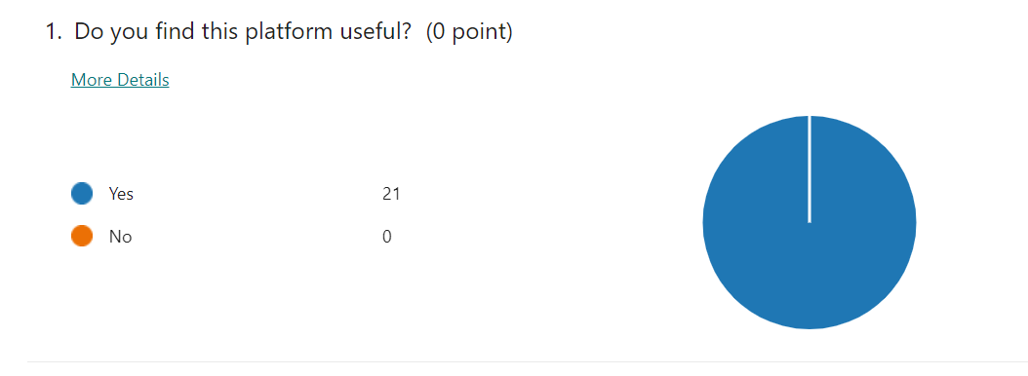

In the first question I wanted to ask the students roughly if they found the Moodle useful. A 100% of them consider that the Moodle is useful. This was a simple question to answer.
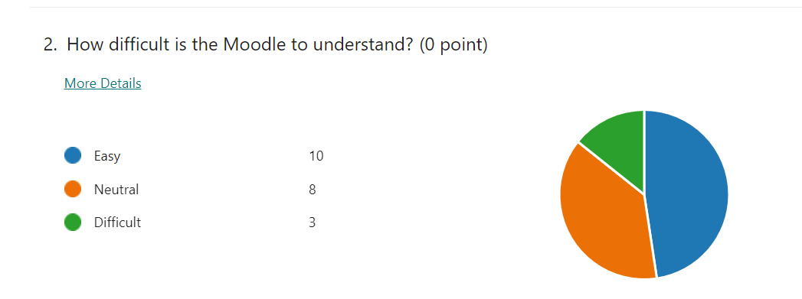

The second question of the survey was about how difficult was the Moodle to understand. Most of them (48%) consider that the Moodle is easy, 38% of the students think that the Moodle is neutral to understand, which leads me to think that these students can understand it better with more engagement. And 14% of the students believe that the Moodle is difficult to understand. Going back to what I said in the Data collection process (the above point) this makes me think that probably these can be students that have never used VLE before.

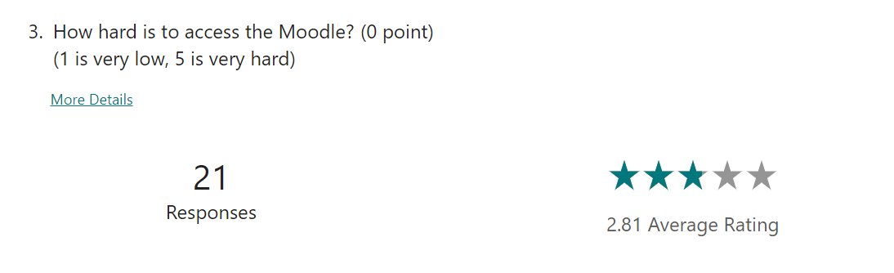
The third question of the survey was to rate how accessible is the Moodle. By comparing questions 2 and 3 I realize that the average rating of how accessible the Moodle is, is quite neutral and a bit harder like the question 2, in which most of the students think that the Moodle is neutral-easy to understand.
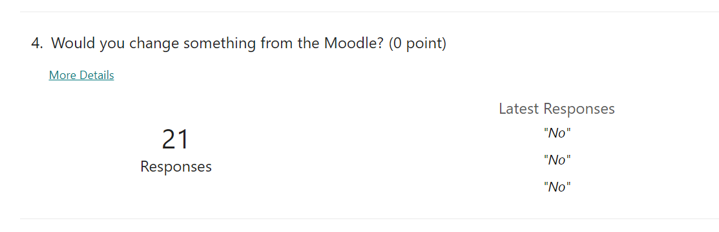
In question number 4, I wanted to understand what people would do to change the Moodle to make it easier, to understand the point of view of those who would think the Moodle is difficult to understand and that is hard to access. Most of them answered “NO” which makes me think that these were the ones they find easy to understand the Moodle and not hard to access,
At this point, I wanted to analyze what people who believe is difficult think: I have 3 different responses to my question:
Student number 1 answered: that would make It easier
Student number 2 answered: yes
Student number 3 answered: no

This makes me think there is a lack of commitment from the students because they have the chance to say what would they do to change the Moodle to make it easier, but they have not mentioned anything clear.
Besides, I can see there are some of the students, who answered the Moodle was neutral to understand who proposed some changes:
Student 4: would add more details about the assessments
Student 5: would add reminders notifications to the calendar
Student 6: would make easier links for draft submissions.
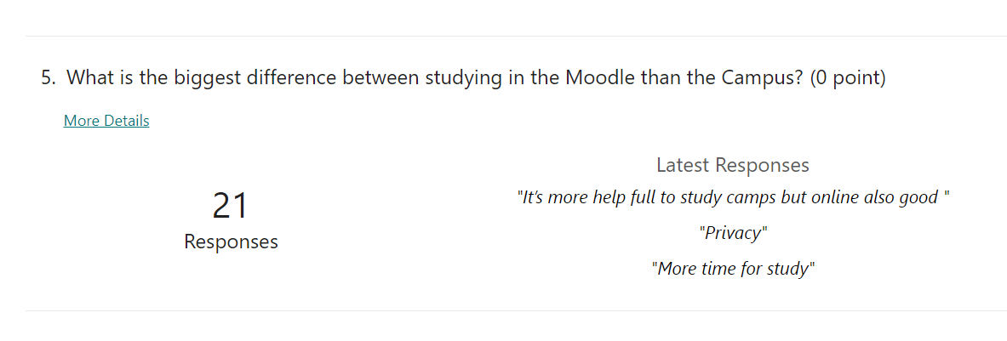
As I mentioned before I consider that the students who think the Moodle is neutral, could fully understand it with more commitment. But the ones who think is difficult are not clrear in what they would do to make it easier to understand.

Question number 5 is an open-ended question. The purpose of this question is to evaluate what students see as different when studying online than in the Campus.
Some students agree that studying in the Campus is better because is more understandable and there is better communication with lecturers, but other students agree that studying online gives more flexibility and comfort.
And other students just made short answers like: “big (difference)”, privacy, time, easy.
The students that agree that studying in the Campus is better because there is better communication with lecturers, made me think of Christine Davis & Lowri Harris (2016) when mentioned that engagement on VLE depends a lot on tutors and teachers.
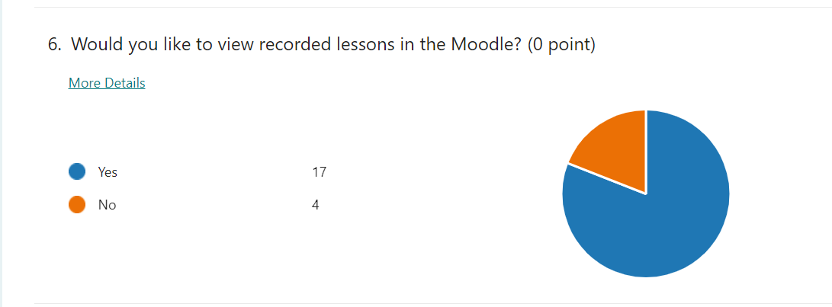
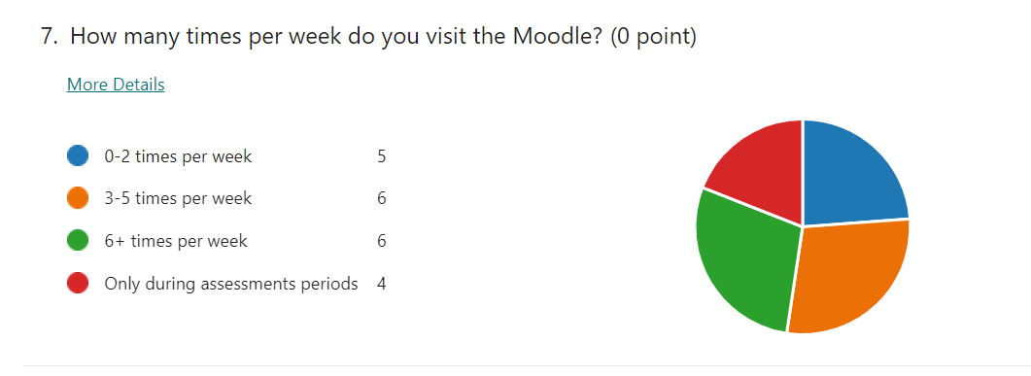
Question 6 was a simple yes/no question. Here I wanted to study if students would find useful to view again lessons from the lectures and have this material accessible for them. 81% of the students said they would like to view recorded lessons in the Moodle, but a 19% do not want to.

The last question, number 7, had the purpose to analyze how often students visit the Moodle, in this question, I realized that there is a lot of difference in terms of usage of the Moodle, some people find enough to just visit the Moodle 0-2 times per week, others 3-6 and more, and some others find enough to just visit the Moodle during assessments periods. Maybe to review material, or just to submit their assignments.

CONCLUSION

The outcome of this research is that despite VLE being a common concept nowadays, there are still people that do not have a full understanding of its usage and its capabilities. In UWTSD, students know what the Moodle is, and even if they think it is a useful platform some of them find it difficult to understand and access. This can be for many reasons (eg, lack of training, lack of IT knowledge, and some others things…). I agree with Christine Davies & Lowri Harris (2016) and consider that the engagement of the students with the Moodle depends a lot on how lectures explain it.
I would suggest on the induction day do a quick presentation on what the Moodle is, how to access and some of the quickest and most useful links we can find there.

REFERENCES

- Wikipedia Contributors (2019). Virtual learning environment. [online] Wikipedia. Available at: https://en.wikipedia.org/wiki/Virtual_learning_environment (Accessed on: 17 April 2022)
- Pierre Dillenbourg, Daniel Schneider, Paraskevi Synteta. Virtual Learning Environments. 3rd Hellenic, Conference ”Information & Communication Technologies in Education”, 2002, Rhodes, Greece. pp.3-18. ffhal-00190701 (Accessed on: 17 April 2022)
- Firefly. (n.d.). What is a Virtual Learning Environment (VLE)? [online] Available at: https://fireflylearning.com/what-is-a-virtual-learning-environment-vle (Accessed on: 19 April 2022)
- Parallels Remote Application Server Blog - Application virtualization, mobility and VDI. (2021). The Key Characteristics and Benefits of a Virtual Learning Environment. [online] Available at: https://www.parallels.com/blogs/ras/virtual-learning-environment/ (Accessed on: 19 April 2022)
- digitallearning.uwtsd.ac.uk. (n.d.). Digital Learning and Teaching. [online] Available at: https://digitallearning.uwtsd.ac.uk/digital-learning.html (Accessed on: 20 April 2022)
- M. Adnan & K. Anwar / Journal of Pedagogical Sociology and Psychology, 2(1), 45-51 (Accessed on: 20 April 2022)
- Explore the eLearning world with us. (2020). The 15-Minute Guide for Teachers on Moodle. [online] Available at: https://www.ispringsolutions.com/blog/getting-started-with-moodle#:~:text=Moodle%20is%20a%20platform%20for (Accessed on: 22 April 2022)
- Public Health Research Guide: Primary & Secondary Data Definitions Home COVID-19 Myths, misinformation Primary Data Sources Primary & Secondary Data Definitions Secondary Data Sources Websites Databases Creating Infographics Sample Poster Presentations. (n.d.). [online] Available at: https://cdn.ymaws.com/www.safestates.org/resource/resmgr/connections_lab/glossary_citation/Primary__Secondary_Data_Defi.pdf (Accessed on: 24 April 2022)
- Christine Davies & Lowri Harris (2016) Engaging professional learners using the Virtual Learning Environment (VLE): a case study from social care. Wales Journal of Learning and Teaching in Higher Education 2016, Volume 1, Number 1, 60-65 pp ISSN 2396-7285 (online) Edited by Simon K. Haslett & Caroline B. (Accessed on: 27 April 2022)

APPENDIX 1

QUESTIONNAIRE: IMPACT OF VIRTUAL LEARNING ENVIRONMENT
* Required
- Do you find this platform useful? *
Yes
No
- How difficult is the Moodle to understand? *
Easy
Neutral
Difficult

- How hard is to access the Moodle?
(1 is very low, 5 is very hard) *

https://forms.office.com/Pages/DesignPageV2.aspx?prevorigin=NeoPortalPage&origin=NeoPortalPage&subpage=design&id=-REPTm4EBUWcu… 1/2 03/05/2022, 13:38 IMPACT OF VIRTUAL LEARNING ENVIRONMENT
- Would you change something from the Moodle? *

- What is the biggest difference between studying in the Moodle than the Campus? *

- Would you like to view recorded lessons in the Moodle? *

Yes
No
- How many times per week do you visit the Moodle? *
0-2 times per week
3-5 times per week
6+ times per week
Only during assessments periods

This content is neither created nor endorsed by Microsoft. The data you submit will be sent to the form owner.
 Microsoft Forms

