  Component One: Student Journal (learning log). | Student No: | 2230719
 | Module Title: | Hotel Administration & Front Office Operations
 | Module Code: | BMIH4004
 | Lecturer: | Natalie Brailsford
Summary of My Learning
The front desk is an important part of how things are set up in a hotel. I worked at Premier INN as the front desk manager for a while. We know from real-life examples that the front desk has many smaller areas, each with its own set of chores (Bardi, 2011). Many different types of people work at the front desk. Some of them are ticket managers, cashiers, desk clerks, and bell staff lift workers. Some jobs can only be found at certain hotels since front desk staff at smaller or more specialised hotels may need to do a lot of different tasks. For many front desk jobs in the hotel business, PMS software is used because it makes it easy to keep track of tasks. The PMS program is very useful because it helps you figure out how the whole hotel works. This could help people better organise their time, make money, and work more efficiently overall (Sturman et al., 2011). Some front desk jobs can now be done automatically, thanks to progress in technology. This makes work easier and faster for everyone. Technology has made it possible for managers to make quick decisions. One more thing was added to see how well someone can talk to others.
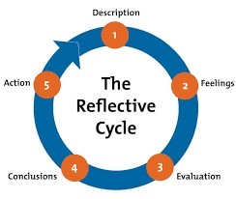
Personal reflection using Gibbs reflective cycle:

Description:
I worked at Premier Inn, so I know how crucial it is for front desk workers to interact well with clients to develop a positive connection. At the Premier Inn hotel, I learn how to handle difficulties, which is vital for front desk staff (Sturman et al., 2011). There is a lot of work at the front desk, and there are some unanticipated problems. The front desk staff must be able to quickly help guests in such situations.
Feelings
As someone who enjoys interacting with others on a regular basis, I have decided to work at the front desk. To the best of my knowledge, those who work at the front desk are responsible for interacting with a large number of customers as they enter and go. At the time, I was the manager of the front desk at the Premier Inn hotel, and I used to believe that it was my responsibility to ensure that the front desk operated efficiently on a daily basis. In the past, I was able to perform my duties in an appropriate manner. Occasionally, when I am in charge of other individuals who are working at the front desk, there are instances in which things do not go according to the plan. It was difficult for several of the folks I met to arrive at work on time. I do my best to assist them in managing their time because I was not very good at it myself.
Evaluation
The Front Desk's jobs include getting guest information and putting it away, setting up room amenities for guests, and making sure everyone is happy with their stay. The front desk was set up, and its system was made to make it easy to sell guests goods and services (Hammer, 2018). I've learned front desk management's daily chores. To increase visitors, check-in and check-out may be streamlined. After these kinds of check-ins are done, normal practice may tell the front desk staff to quickly get guest relations workers to help guests with their bags and show them to their rooms.
Conclusion
The Front Office can only tackle some of the organisation's issues. I realised that even the best front office staff can't always fix a company's underlying issues. I've realised how crucial verbal and nonverbal communication is in the service industry. During my hotel stay, I felt content and delighted when my first encounter with someone was a compassionate individual who listened intently and helped us get along. Front-desk communication that works effectively and promptly matters. Communication is the key!
Action plan
The strain of working in the front office is something I have experienced myself. I have been in this circumstance. When guests arrived at the hotel, it was my responsibility to greet them, inquire about their requirements, provide them with a tour of the hotel's amenities, emphasise the property's distinctive selling points, and provide customised attention. I am not very adept at managing my time well or thinking critically, and that is the only thing I am missing. After a certain amount of time has passed, I shall enhance these abilities (Hammer, 2018).
Time Frame: 6 months
Component Two
Contribution to Overall Module Assessment: 25%
Trip Advisor Review Response 150 words +/-10%
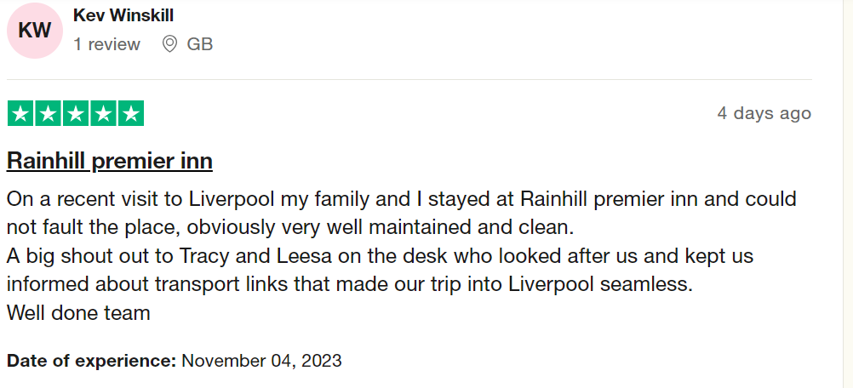

Dear Important Customer,
Hi there. Thank you very much for your help. We're glad you picked our hotel. At the heart of everything we do is putting the customer first. Our hotel's primary objective is to provide our esteemed visitors with superior accommodations and service. To make service great all over the world by giving every hotel guest a great time every time. The hotel we are in wants to meet the needs of business visitors, groups, and tourists. We are very excited, committed, and caring about everything we do because our company is all about new ideas and giving people what they are looking for. Our business knows how important it is to put together a group of smart, motivated, and excited people in order to get a good return on investment. We appreciate you taking the time to communicate with us. Could the situation now improve? It gives us great pleasure to see you. We appreciate you investing your time in reviewing our services.

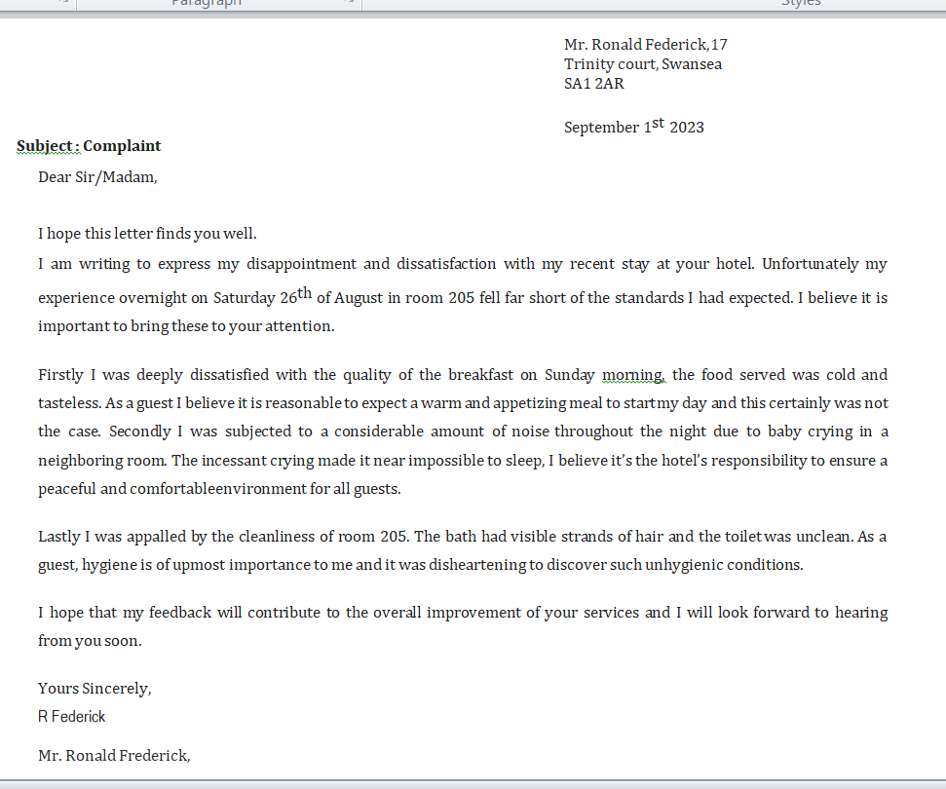
A screenshot of the referenced Trip Advisor review was used.

Letter of complaint response 500 words +/- 1-%
Sincere greetings, Donald Ronald Federick,
We place a high value on each and every one of the guests who choose to stay at the Premier Inn hotel. We entirely comprehend the level of annoyance that you feel regarding the service that you had at our hotel. It is stated in your email that when you went to check in, the reserved rooms that you had requested throughout the check-in process were not available. The Premier Inn is grateful that you choose to stay with us. In the event that your stay has resulted in any problems, the managers will want to apologise for any problems that have occurred. It is possible to get in touch with Premier Inn through the vast majority of the Global Distribution System (GDS) channels. There is a possibility that you are under the impression that the additional noise in your living area is the consequence of your noisy neighbours who are causing disruptions in their own rooms. This is the beginning of the process of resolving the existing issues. Because of the enormous advancements in insulation that have been made over the years, it is now possible for walls and floors to better retain heat. Please accept my apologies, but in order to verify if the property is equipped with noise-reducing windows, curtains, ceiling panels, and tiles, I require additional information from you or a text message from you. Premier Inn was the one who came up with the idea of the movable bedroom. If the hotel were able to successfully handle both the noise from the outside and the disruptions on the lower level, then it would be possible to resolve both of these difficulties. Building changes are carried out in order to obtain an even higher level of noise reduction than can be considered required. Some examples of this include the installation of double glazing on all four sides of the windows and the addition of acoustic linings to the walls and ceilings. Additional staff members are employed to clean the guest rooms and restrooms in order to ensure that the establishment remains clean. They will be responsible for changing the linens and towels, ensuring that there is sufficient ventilation in the room, and putting everything back where it belongs by returning everything to its original location. It is sufficient to clean up the trash in the lavatory. A wide variety of appliances, such as slow cookers, multicores, toaster ovens, heating plates, and hot warming trays, are available for the purpose of preserving the temperature of food. In addition, I talk to the cook about ways in which the cuisine might be improved. After then, the complainant asserts that calling the front desk did not result in their room being moved regardless of how many times they called. Due to the fact that we are still unhappy about how terrible things were at that time, we wish that we could have done more that evening to make things better for you. For that, we sincerely apologise. In light of the fact that your stay was not to your liking, we would like to offer you a coupon for $100 that you can apply against your subsequent stay at the Premier Inn. Our expectation is that your subsequent visit will be even more pleasurable than we had expected it would be. We look forward to seeing you soon and show you all the new and better amenities that we have added to our hotel.
Sincerely,
Alin Stefanescu
Manager (Front Desk)
Premier Inn Hotel
Component Three
The series of steps that a hotel and its guests take when they get to know each other is known as the "guest cycle." The Guest Cycle can be split into four main steps based on the jobs and depths of interactions (Crimp, 2019). We can divide the process we're talking about into four steps, which are shown below: A trip has four parts: before the trip, during the trip, after the trip, and after the trip's end (Crimp, 2019).
The people who work at the front desk need to know how to take care of guests and keep track of their money while they are staying. To give great customer service, the front desk staff must fully understand how the hotel works. A neat way to run the front desk is to use the Guest Cycle (TESONE, 2010).
Element 1 – Pre-Arrival
The selection process that visitors undergo prior to their intended stay is a crucial component of the guest cycle (Tewari, 2009). Several factors may influence a guest's selection of a hotel. These characteristics are influenced by several factors, such as Ad campaigns, recommendations from friends and colleagues, previous experiences, business affiliations, reservations made via travel agencies, loyalty programmes, proximity to the location, brand names, and business connections.
After the hotel ticket agent approves the order, it is entered into the hotel's computer system. Creating this ticket record is the first stage in the hotel guest cycle. Patrons holding this ticket will be able to indulge in a personalised lodging experience since the hotel will provide services that are specifically suited to each individual's precise tastes. The hotel utilises ticket data to assign rooms based on clients' choices, so providing sufficient coverage of their stay expenses (Jayanti, 2023).
Reservations primarily aim to ensure the availability of a room for guests upon their arrival. However, they may also assist in facilitating prompt service. Prior to their arrival, travellers choose accommodations. Visitors have the option to choose a hotel for their stay by considering several factors such as previous experiences, advertisements, recommendations from acquaintances, geographical proximity, business affiliations, travel agency reservations, the reputation of the hotel, and loyalty programmes (Baloglu, 2022).
Element 2 – Arrival
Upon arrival, visitors are required to register and are then assigned accommodations. Upon the guest's arrival, the hotel promptly initiates commercial transactions with them (Baloglu, 2022). Front desk personnel provide information on hotel pricing and promotions.
Prior to commencing the check-in or registration process, front desk personnel must verify the status of visitors' bookings. Front desk employees have the potential to earn additional income from both scheduled bookings and spontaneous arrivals.
During the check-in process, you must provide your registration card or any other relevant documents. At the front desk, you may create and complete an information card to document crucial details. The registration card should include explicit instructions for invoicing, details about tickets, the count of people and children residing in the property, address information, non-resident documents and visas, comprehensive personal information, and payment card details. Guests are required to complete a registration card in order to ensure that both the tourist and the hotel owner get legal advantages.
The registration procedure is considered complete after the payment method and intended departure date has been verified and authorised. Upon request, guest service colleagues and managers will escort guests to their respective rooms (&NA;, 2022). If not, they may provide them with a room key and instructions on locating their room. Upon check-in, guests are provided with a Registration card, often referred to as a "Reg." card. The front desk is able to obtain the required information by utilising this card. The registration card to encompass critical data, including payment instructions, the number of occupants (including children and guests), the address, specific information regarding the passport and visa of any foreigners, comprehensive personal data, and credit card particulars. To ensure that both the tourist and the hotel may use certain legal advantages, it is necessary to get the guest's name on the registration card (Jayanti, 2023).
Element 3 – Duration of stay
Front desk personnel serve as representatives of the hotel while it is operational. Front-desk professionals are responsible for responding to inquiries and overseeing the day-to-day activities of a hotel. Front desk personnel are required to promptly and accurately respond to client inquiries (Akasia & Sandy, 2023). We provide a proactive level of service that goes above what visitors anticipate. This enhances customer loyalty towards the property. Restaurant, travel desk, phone, and internet expenditures impact the financial records of the hotel. The complaints are documented by the Front Office. Front desk staff must verify guest accounts and credit limits. The front desk personnel shapes visitors' perceptions of the hotel. Front desk staff answer questions and represent the property. Reps educate and assist visitors. Front desk staff must answer visitors' questions and requests quickly and honestly. The front desk staff provides proactive service to meet client expectations. Guest loyalty will rise. Ensuring security is of utmost importance while accommodating visitors (Akasia & Sandy, 2023). Protecting cash and possessions is crucial. Staff at the front desk are responsible for administering safe deposit boxes, property, emergencies, and visitors' belongings in accordance with hotel operating procedures. Companies and hotel clients may make payments for travel, internet, dining, and telephone services. These expenses are predominantly attributable to front-office operations. Providers of visitor information and amenities. Front desk guest service must be prompt and effective. The primary objective of the front desk crew is to anticipate and surpass the demands of the customers (Akasia & Sandy, 2023).

Element 4 – Departure
Accounting and guest services end after departure. Check-out involves paying bills, giving over keys and leaving the hotel. At the front desk, staff advise guests of room availability and notify the cleaning team upon departure. Property management software updates hotel room status (Sari et al., 2022).
During this time, hotel guests are asked for feedback. The guest services and accounting visitor cycle ends with the exit. Guests must return their keys and pay for expenditures upon leaving. After guests leave, the cleaning team adjusts room availability. Hotels may automate room status updates using property management software (Sari et al., 2022).

References
&NA;, M. (2022) ‘Eli Lilly and Company’s Tadalafil [Cialis] 2.5mg and 5mg have been approved by the US FDA for once-daily oral dosing to treat erectile dysfunction.’, Inpharma Weekly, NA;(1621), p. 22. doi:10.2165/00128413-200816210-00056.
Akasia, N.E. and Sandy, S.R. (2023) ‘Peran front desk agent Dalam Menangani Keluhan Tamu di front office Aston Jember hotel & conference centre’, Jurnal Pariwisata dan Perhotelan, 1(1), p. 7. doi:10.47134/pjpp.v1i1.1896.
Baloglu, S. (2022) ‘Dimensions of customer loyalty: Separating friends from well-wishers’, The Cornell Hotel and Restaurant Administration Quarterly, 43(1), pp. 47–59. doi:10.1177/0010880402431005.
Bardi, J.A. (2011) Hotel Front Office Management. Hoboken, USA: Wiley.
Crimp, M. (2019) ‘When we have sufficiently tortured each other’, When We Have Sufficiently Tortured Each Other [Preprint]. doi:10.5040/9780571373352.00000005.
Hammer, J. (2018) Revenue superstar!: The simple rules of hotel revenue management. Lieu de publication non identifié, USA: Johan Hammer.
Jayanti, J. (2023) ‘Hotel Guest Rooms’, Hotel Housekeeping Management [Preprint]. doi:10.23912/9781911635543-5505.
Sari, N.P., Pantiyasa, I.W. and Purnantara, I.M. (2022) ‘Analisis Pola Kerjasama Reservation, reception, Dan Room Attendant Dalam Penanganan Tamu check-in Dan Check-out Di Hotel Sheraton bali kuta resort’, Jurnal Ilmiah Pariwisata dan Bisnis, 1(11), pp. 3209–3226. doi:10.22334/paris.v1i11.227.
Sturman, M.C., Corgel, J.B. and Verma, R. (2011) The Cornell School of Hotel Administration on hospitality: Cutting edge thinking and practice. Hoboken, UK: John Wiley & Sons.
TESONE, D.V. (2010) Principles of Management for the Hospitality Industry. Edinburgh, USA: ROUTLEDGE.
Tewari, J.R. (2009) Hotel Front Office: Operations and Management. New Delhi, India, Delhi: Oxford University Press.

