A Comparative Analysis of Adidas' International Marketing Strategy in Germany and India


University Logo:
Programme: MBA
Module: International Marketing: Principles and Practices (LCMB7026)
Assignment Title: A Comparative Analysis of Adidas' International Marketing Strategy in Germany and India
Student Name: Namirabanu Nuruddin Gulam Delawala
Student ID: 2526407
Lecturer Name: Dian Mayasari (Birmingham)
Word Count: 5000
Submission Date: 24th July 2026
Table of Contents
Section 1: International Marketing Report 4
1. Introduction 4
2. Company Overview of Adidas 4
3. Comparative Market Analysis: Germany and India 5
3.1 PESTEL Analysis of Adidas in Germany and India 5
3.2 Hofstede Cultural Analysis 8
4. Comparative Analysis of STP Strategies 10
4.1 Segmentation 10
4.2 Targeting 11
4.3 Positioning 12
5. Comparative Analysis of Adidas Marketing Mix (7Ps) 12
5.1 Product 12
5.2 Price 13
5.3 Place 14
5.4 Promotion 14
5.5 People 15
5.6 Process 16
5.7 Physical Evidence 16
6. Market Entry Strategy Analysis in India 17
7. Ethical Issues in Adidas Marketing Strategy 18
8. Recommendations for Future International Marketing Strategies 19
9. Conclusion 19
Section 2: Reflective Account Using Gibbs Reflective Cycle 21
10. Reflection Using Gibbs Reflective Cycle 21
10.1 Description 21
10.2 Feelings 21
10.3 Evaluation 22
10.4 Analysis 22
10.5 Conclusion 23
10.6 Action Plan 24
References 25

Section 1: International Marketing Report

1. Introduction
In the globalised world, organisations involved in any business activities that would like to gain growth and competitive advantage have made international marketing an essential part of their marketing strategy. It involves global planning, relating to pricing, promotion and distribution, products and services across national boundaries, influenced by economic, political and legal differences and culture (Holtbrügge and Schuster, 2024). A firm can use world marketing strategies to make the appropriate adjustments to its marketing program in diverse marketing environments and/or to specific consumers to become more competitive in the world market. It is a brand that everyone in the world is familiar with, and as an athletic apparel and ‘sportswear' giant, Adidas pioneers its products and its brand also have a pretty solid reputation globally. Its wide-associate product portfolio ranging from footwear to clothing and sports goods, made the promotion of the Company happen in many countries and facilitated its customer base to diversify widely (Chen, 2023). The aim of this report is to explore and grasp the introduction of Adidas into the international market and the marketing mix that was introduced in two countries (Germany and India). Adidas' home market is Germany; India is a key added growing territory with potential. The report will be carried out using comparative technique to determine the extent to which the environment has affected Adidas in marketing its activities and the influence of culture on its business in the international aspects.

2. Company Overview of Adidas
The founders of Adidas were Adi Dassler from the city of Herzogenaurach, Germany, in 1949. It has grown into one of the world's largest sportswear manufacturers that provides sporting goods, sports equipment, accessories and sportswear. Adidas has a presence in more than 160 nations and its items are sold around the globe in its stores, online shops and partnerships (Pratama and Hisjam, 2022). The company's goal is to be the world's biggest sports brand for innovation, sustainability and introducing high performing products into the lives of athletes and consumers. It's about trailing for a better future by sport and it has a clear vision of respecting the environment and social responsibility, values and attitudes. Adidas is among the top leading sporting goods brands in the world and is compared with other sporting goods brands such as Nike and Puma. The firm's marketing efforts, product development, and branding strategies play a crucial role in their success. Adidas' international market plays an important role in its development and is essential to its success (Caputo et al., 2022). Growth is a chance for the company to increase revenues, expand brand recognition, and expand from one market to another. Therefore, it is crucial to understand such country-to-country variances in the marketplace so that they can have effective marketing strategies in various countries.
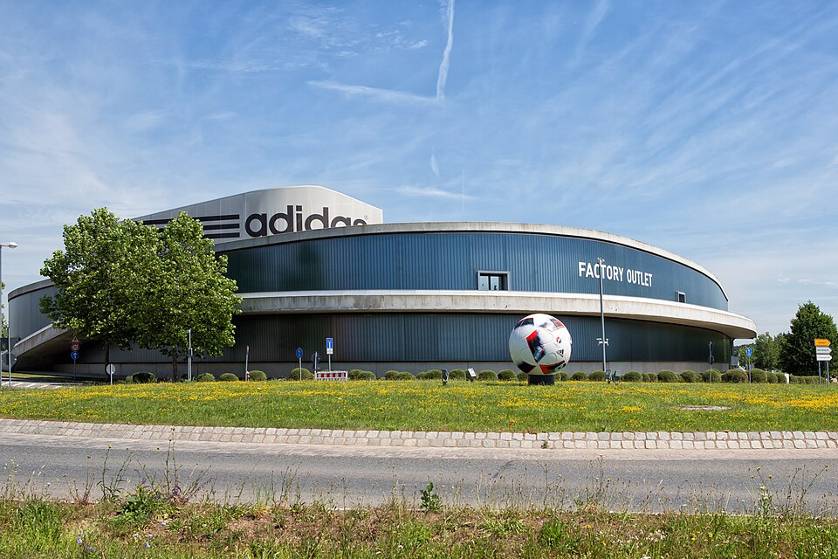
Figure1: Adidas global headquarters Herzogenaurach Germany
(Source: Caputo et al., 2022)

3. Comparative Market Analysis: Germany and India

3.1 PESTEL Analysis of Adidas in Germany and India
A PESTEL analysis can help to identify the external forces which affect Adidas' operations and is an integral part of their marketing strategies in Germany and India. It is important to appreciate the difference between the developed economy and the fast-growing developed market for Adidas to market successfully (Jaufenthaler et al., 2023). Assessing the differences between these two is critical for an organisation like Adidas to undertake successful foreign marketing.
Table 1: PESTEL Analysis
Factor | Germany | India | Implications for Adidas
Political | Germany enjoys a stable political system, transparent governance, and strong support for international trade within the European Union. | India is politically stable but experiences regulatory complexity and varying policies across states. Government initiatives such as “Make in India” encourage manufacturing investment. | Adidas benefits from predictable business conditions in Germany, while in India it must adapt to changing regulations and government policies.
Economic | Germany has a high-income economy with strong consumer purchasing power and mature retail markets. | India is one of the fastest-growing economies with a large middle-class population and increasing disposable income. However, income inequality remains significant. | Adidas can position premium products in Germany, whereas in India it must balance premium branding with affordability to reach wider consumer segments.
Social | German consumers value quality, sustainability, health, and sports participation. There is a strong preference for environmentally responsible brands. | India has a young population, increasing interest in fitness, and growing awareness of international fashion and sports brands. | Adidas can emphasise sustainability in Germany and focus on youth-oriented, aspirational marketing in India.
Technological | Germany possesses advanced technological infrastructure, high internet penetration, and sophisticated digital retail systems. | India has experienced rapid digital transformation, supported by widespread smartphone adoption and growth in e-commerce platforms. | Adidas can strengthen omnichannel retailing in both markets while leveraging mobile commerce opportunities in India.
Environmental | Environmental protection is a major concern in Germany, with consumers demanding sustainable production and recyclable products. | India faces environmental challenges including pollution and waste management, while sustainability awareness is increasing among consumers. | Adidas must continue promoting sustainable products and environmentally friendly manufacturing practices in both markets.
Legal | Germany maintains strict labour laws, consumer protection regulations, and intellectual property enforcement. | India has evolving legal frameworks related to consumer protection, taxation, labour regulations, and foreign investment. | Adidas must ensure compliance with differing legal requirements and protect its brand assets across both markets.
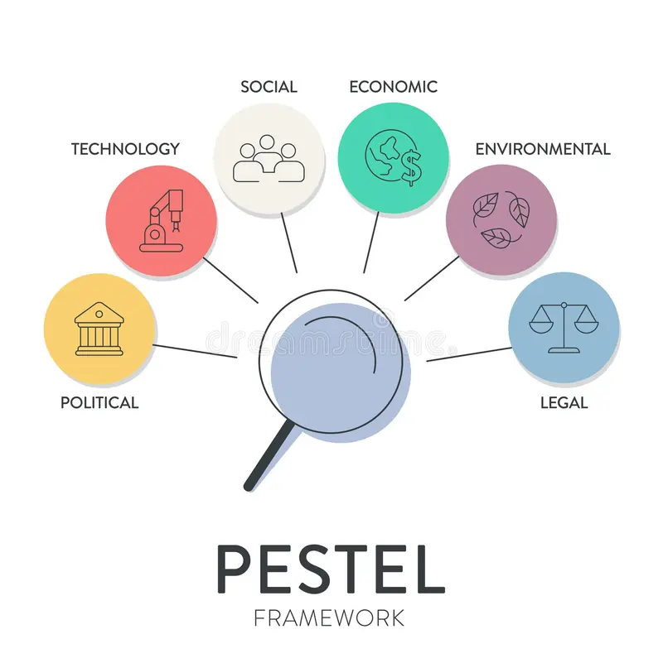
Figure 2: PESTEL analysis framework infographic business strategy
(Source: López‐Pérez et al., 2025)
PESTEL analysis reveals that the environmental differences do not merely characterize two markets, but also have an impact on the international marketing strategy of Adidas. Germany's political stability and the high purchasing power and tough environmental laws allow Adidas to aim for a premium position, which focuses on innovation, sustainability and advanced sports technology. This is why Adidas can differentiate their product rather than competitively price it – consumers are willing to pay more for a high quality product. In contrast, India's rapidly expanding economy has much more complex markets and provides a great growth potential. The income inequality and regional regulations, together with the price sensitivity, require Adidas to be flexible in marketing the product so that it can offer different priced products without compromising the high-end marketers image of the product. As ecommerce continues to boom and smartphone usage is on the rise, Adidas is putting a large emphasis on its digital marketing campaign and omnichannel retail strategy to appeal to younger consumer bases. These environmental factors are likely to play a significant role since the same marketing strategy would be more appropriate in one country than the other. Instead, Adidas' strategy is to "glocalise" which means to have a standard global brand and apply local market-specific pricing, promotion, product mixes and distribution. This flexibility will give Adidas the competitive edge, as it will enable the company to serve the demand of local consumers without impacting on its global positioning.

3.2 Hofstede Cultural Analysis
Hofstede’s cultural dimensions framework provides valuable insights into consumer behaviour and cultural differences between Germany and India, helping Adidas adapt its marketing strategies effectively.
Table 2: Hofstede Cultural Analysis
Dimension | Germany | India | Marketing Implications for Adidas
Power Distance | Low | High | German consumers value equality and transparency, while Indian consumers are generally more accepting of hierarchy and authority.
Individualism vs Collectivism | Highly individualistic | More collectivist | Marketing in Germany should emphasise personal achievement, whereas campaigns in India can highlight family, community, and social connections.
Masculinity | High | Moderately High | Both cultures value success and achievement, making performance-oriented branding effective.
Uncertainty Avoidance | High | Moderate | German consumers prefer reliability and detailed product information, while Indian consumers are generally more adaptable to change.
Long-Term Orientation | High | High | Consumers in both countries appreciate innovation, durability, and long-term value.
Indulgence | Relatively High | Moderate | German consumers are more likely to engage in leisure-oriented consumption, while Indian purchasing decisions are often influenced by social considerations.
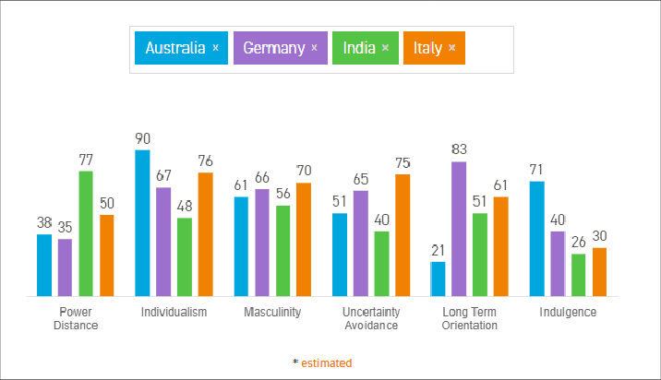
Figure 3: Germany vs India Hofstede cultural dimensions comparison
(Source: Dobbelstein and Lochner, 2023)
Through Hofstede's approach it becomes clear that cultural differences have a significant impact on the marketing communications, branding and customer engagement strategies of Adidas. Germany's low power distance and high individualism makes it easy for adidas to stress individual achievement and product performance and technological innovation in their advertising, as people like to see their own success and have factual information. This could help consolidate Adidas' brand positioning as a quality brand and help improve perceptions of quality. However, India is a more collectivist culture and has a higher power distance. As a result, Adidas are keen on community, family values and inspirational role models in their celebrity endorsements and sports ambassadors that include leading cricketers. They are campaigns that create more emotional connection and build the consumer's trust in the brand in a society that cherishes relationships. This cultural awareness will allow Adidas to customise their promotion messages while keeping the brand’s message and identity. This cultural adaptation is important for gaining competitive advantage, as the marketing campaign is more relevant to the local customer, thus enabling them to be more engaged with the brand, more loyal to the brand and more willing to purchase it. However the over localisation can diminish the global brand consistency and Adidas will be required to control the leveling up of the brand and adjust to various markets.

4. Comparative Analysis of STP Strategies

4.1 Segmentation
Segmentation is when the market is split into various segments of customers according to similarities in their needs, characteristics and purchasing behaviour. For the effective service towards customers in the countries of Germany and India Adidas practice demographic, geographic, psychographic and behavioural segmentation. Demographic Segmentation is based on age, gender, income and occupation. The target audience of sport fans and fitness fans in the middle to high-income class of Germany dominates the market of Adidas. The company caters to a wider customer base of young adults, students, working professionals and the rising middle class in India (Sekliuckiene and Rybakovas, 2023). Geographic segmentation is related to geographic markets. In Germany Adidas retail network development starts early and widely, and is located in urban and suburban areas. The adidas brand is active in Bubber urban/suburban areas where an early development of retails network has taken place in Germany. The business has a strong presence in major cities of the country such as Delhi, Mumbai, Bengaluru and Kolkata and has been taking a gradual step on to the smaller cities later. Adidas adopts multi-variable segmentation as there are significant differences in consumers' behaviour in Germany and India. The segmentation in Germany is based on premium athletes, fitness enthusiasts and environment friendly consumers, which enables the company to launch innovative and sustainable products with high margins. Adidas can address higher-priced and emerging middle-class consumers in India because of its wider segmentation of the demographics and income groups. This approach extends the market reach with the same brand visibility. But by providing a wide variety of customer segments, marketing expenses rise and there is the potential for brand confusion.
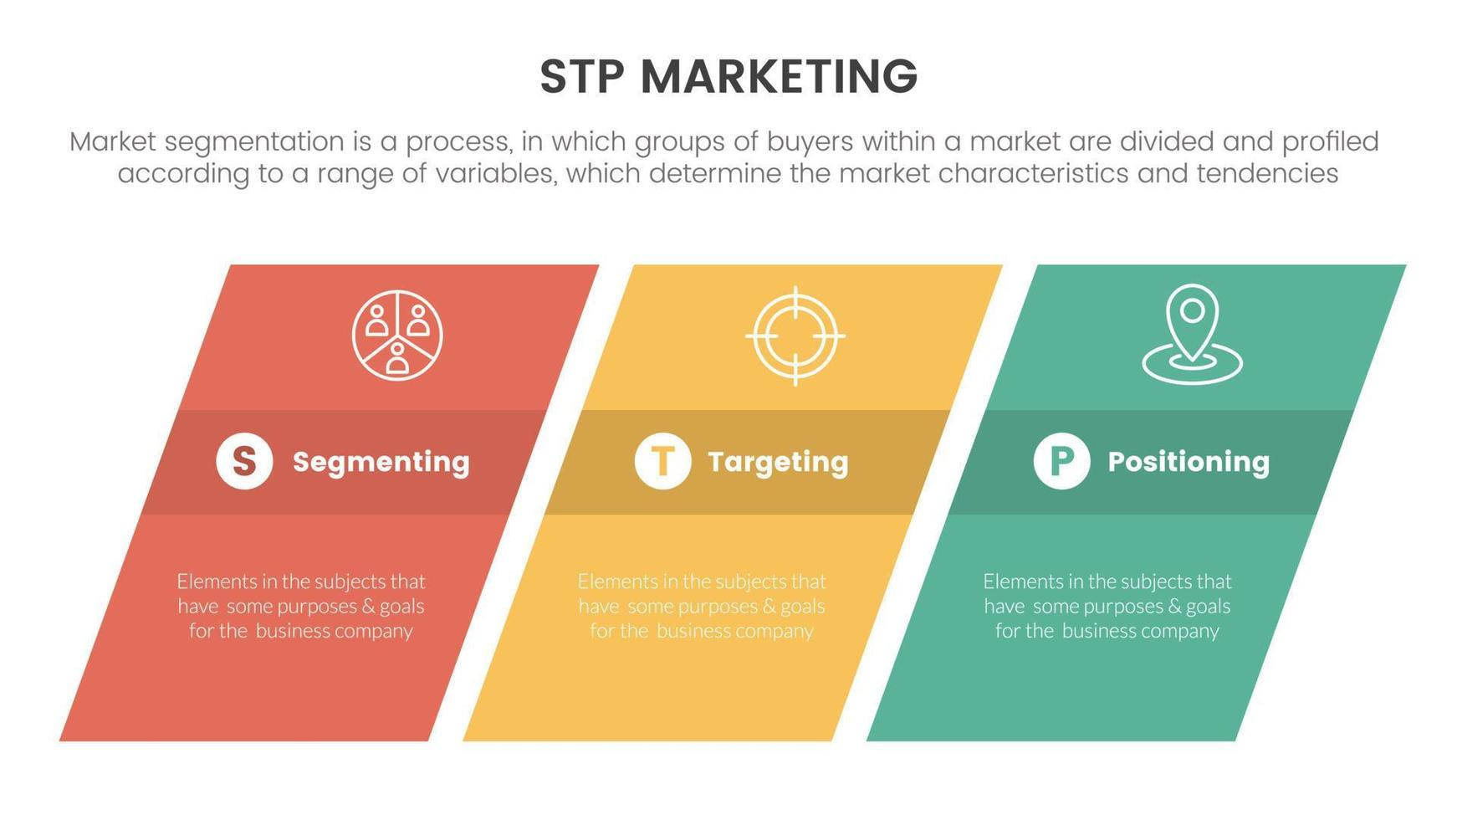
Figure 4: STP marketing model segmentation targeting positioning
(Source: Alagarsamy et al., 2024)

4.2 Targeting
Adidas uses a differentiated targeting strategy, which suits the needs and preferences of the consumers in Germany and India. The target groups are: Sports players, sports fanatics, Sports persons, Health-conscious people and Consumers who look for value in higher quality products which are more focus on athletes in Germany. The company is very interested in those that actively engage themselves in sport activities such as Football, Running, Outdoor etc. German consumers also have a high purchasing power and demand higher prices for technologically complex and ecologically-minded products. As a result, when in pursuit of this market, Adidas stresses on quality, innovation and environmental responsibility (Alagarsamy et al., 2024). The Adidas brand mostly caters to the young, urban, professional, fitness geeks and the rising middle class in India. The brand also targets those customers who believe that international sports-wear brands are where they get such things as updated lifestyles and a socially-dramatized appearance. As in India, different industries lead different lifestyles and Adidas have to deal with disparate groups with products that appeal to different customers, who may be purchasing for their value for money or their spending power. Infact, digital marketing is playing a significant role along with the use of celebrity endorsements and sports personalities tie-ups to bring the Indian consumer on board (Haq et al., 2025). Adidas uses a differentiated targeting strategy since the needs of their consumers are not the same in each of the countries they operate in. With the premium and mid-priced product ranges in India and the premium products in Germany, Adidas has optimised penetration of the market and not lost its high-end global brand name. This will help it achieve competitive advantage by attracting more customers and diversifying its market. But over-targeting can lead to higher overheads and marketing costs.

4.3 Positioning
Positioning indicates the position of a brand in the minds of consumers when compared to its competitors. Adidas has a ‘standardised’ brand identity, which is modified according to local market conditions and indicated by a proper positioning. In Germany, ADIDAS is perceived as a high-quality line of sportswear and represents innovation, quality, sustainability and original sports heritage. New products are often marketed on their advanced technology, their quality and their environmental awareness, all being attributes of German consumers (Ibragimova et al., 2026). Adidas is identified as a worldwide acknowledged lifestyle and sports-wear brand exhibiting an excellent mix of performance, fashion and standing in India. It has an aspirational stance with the celebrities it endorses, through sports, via the advertising that is digitally accessible to younger audiences. Adidas speaks to individuals that value sportsmanship as well as contemporary fashion. Adidas adopts different positioning messages depending on the countries and the expectations of consumers, aiming to establish itself as a premium global sportswear brand in both countries. Germany focuses on innovation, engineering excellence and sustainability, while India focuses on performance, fashion and lifestyle and aspirational branding. This positioning is another way to reinforce brand differentiation from competitors like Nike, Puma and so on. However, this is difficult as too much localisation may lead to a loss of Adidas' brand image around the world.
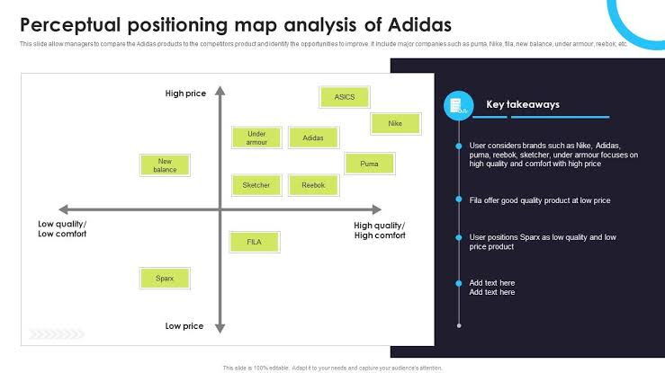
Figure 5: Positioning map of adidas India and Germany
(Source: Ibragimova et al., 2026)

5. Comparative Analysis of Adidas Marketing Mix (7Ps)

5.1 Product
Adidas is implementing a policy known as “product strategy”—which means they promotional sale of standardised products in the markets outside and localised and adapted products within the target market. Adidas in Germany puts a particular emphasis on sportwear of high quality, technologically advanced shoes and sustainable collections that are are produced using recycled materials (Haq et al., 2025). Consumers care about the performance, sustainability and the durability of the product, which translates into the importance of innovation and sustainability aspects when choosing a product. For high quality sports goods, Adidas has a wider range of its product portfolio in India to cater to the price sensitive market segment which are lesser in price. The company also introduces new products in line with fashion trends prevalent in their target segments as well as their growing fascination with fit. Both products have one thing in common: Adidas' dream of being an established brand and quality in both areas is fulfilled. Still, there are differences in the range of products offered and the cost of the product launched according to the consumer purchasing power (Williams, 2024). Through considering cultural values and different preferences for sustainability in Germany and raised levels of life-style orientated consumption in India, ADIDAS will be able to predict its customer's needs and take product-development and marketing decisions based on these analyses which will satisfy not only their expectations, but will enhance the brand's global presence at the same time. Adidas has taken a product adaptation approach, as there are many different preferences and buying power among the customers in Germany and India. This enhances customer satisfaction and increases the competitiveness by way of local responsiveness. However, the more products are adapted, the more complicated the production will become and more costly will be inventory costs.

5.2 Price
For example, Adidas football jerseys cost about ₹8,000 in Germany versus ₹5,000 in India, reflecting market conditions. The Adidas brand radiates in Germany a sportswear image with high-quality products and innovations. The sportswear marketer has high quality products, innovations and sustainability: Adidas has an image in Germany (Alqatan, 2025). The German consumer is a good customer who is likely to pay a premium price for brands he/she knows works well. Adidas takes a flexible attitude towards pricing in India. The company keeps on maintaining the image of a top brand by also supplying goods to different market sections, which reaches to a bigger market. The entry level and mid-range products can offer some of Adidas' clout to deal with price-scrutinized competition. Seasonal discounts and on-line promotions are also typical methods to draw consumers in. Similarity from both markets is the importance of brand quality perceived value. However, there are significant variations in the level of price adaptation (Zia and Tabassam, 2025). Another important factor is the pricing and positioning of products as economic differences and incomes of consumers would compel Adidas to set a high cost in Germany and low cost in India and accordingly position a product. Adidas is applying value based pricing in the India market to maximize profit in a different economic situation, and premium pricing in the Germany market, to achieve the same. This approach can help a product become more popular in the market, but can lead to grey marketing and impact consumer perceptions of the fairness of the market.
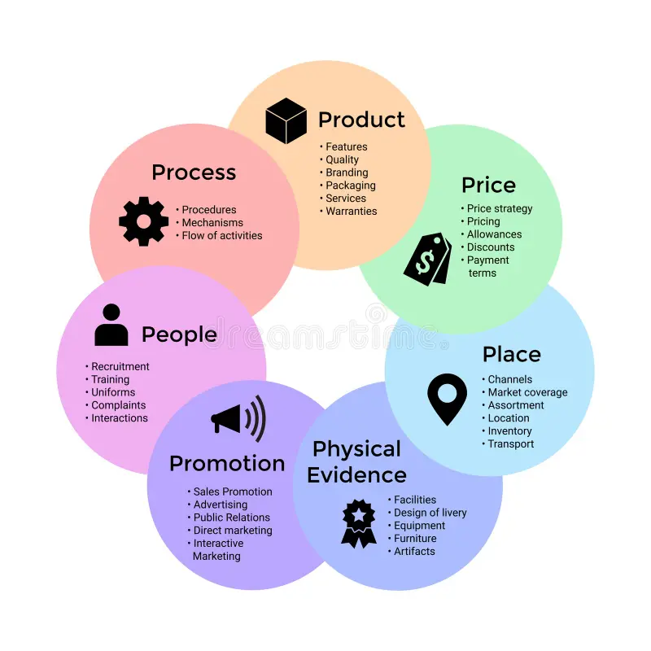
Figure 6: 7Ps marketing mix
(Source: Alqatan, 2025)

5.3 Place
Adidas has taken a grand scale distributive approach, focusing on a local, regional and global level. Products are sold in stores with brands, but also in the Department Stores, sports shops or more sophisticated e-commerce shops in Germany (Chugaiev, 2022). It has a high-level logistics system, and has guaranteed the high availability and delivery rate of products. Adidas has a combination of exclusive Adidas brand stores, franchise stores, multiple brands, shopping malls and fast-growing e-commerce channels in India (Maheshwari et al., 2024). The company has specifically focused on strengthening the brand in the online realm, to appeal to consumers in urban and semi-urban areas. The common theme is that it is a combination of offline and online distribution, through an 'omnichannel' strategy. However, some variations are taken into account due to geographical variation and the infrastructure of markets. Germany has a developed retail sector whereas India needs a wide channel belt to cater to regional differences as well as for consumer's accessibility (Zaheer and Sandhu, 2022). In both markets, technology, technological use, urbanization and economic development are important factors in the distribution strategy for Adidas. The multi-channel marketing approach of Adidas makes it easier for consumers and more accessible in the market. But, having a large brick and mortar presence and a digital option demands a significant investment and supply chain management, especially in India's vast geographical market.

5.4 Promotion
Promotion is an important part of Adidas' international marketing strategy. Germany's sport performance, innovation, sustainability and brand heritage are wrapped up in promotional activities. On many occasions, Adidas has backed with its sponsorship, professional sports teams, sportsmen, and big sporting occasions to bolster its standing as a prime sports brand. In digital campaigns there is a particular focus on social sustainability and technological improvements in the products (Pan et al., 2023). The provision of youth engagement campaigns, celebrity endorsements and influencing/elevated marketing and social media promotions are more prevalent in India. Cricketers, sportsperson and entertainers are hired by Adidas to boost the brand's recognition and attraction among the Youth. In addition, the company carries out relevant campaigns to the culture that the people can relate to. Both countries display similarities in the application of Integrated Marketing Communications in helping to ensure that Adidas is consistent with its brand (Haq et al., 2025). However, there are preferences and differing habits to take account of among the collective. The Indian consumers are more emotive, driven by celebrity associations and aspirational lifestyles while information-based advertising that provides focus on quality and sustainability, appeals to German consumers. Moreover, the culture and society emphasize an immense effect on adidas promotions strategies. However, the local promotions can enable Adidas to resonate with different segments of consumers more effectively, without losing its global brand voice. However, with too much celebrity can come too much trouble for a campaign, if there's any controversy surrounding the endorsement.
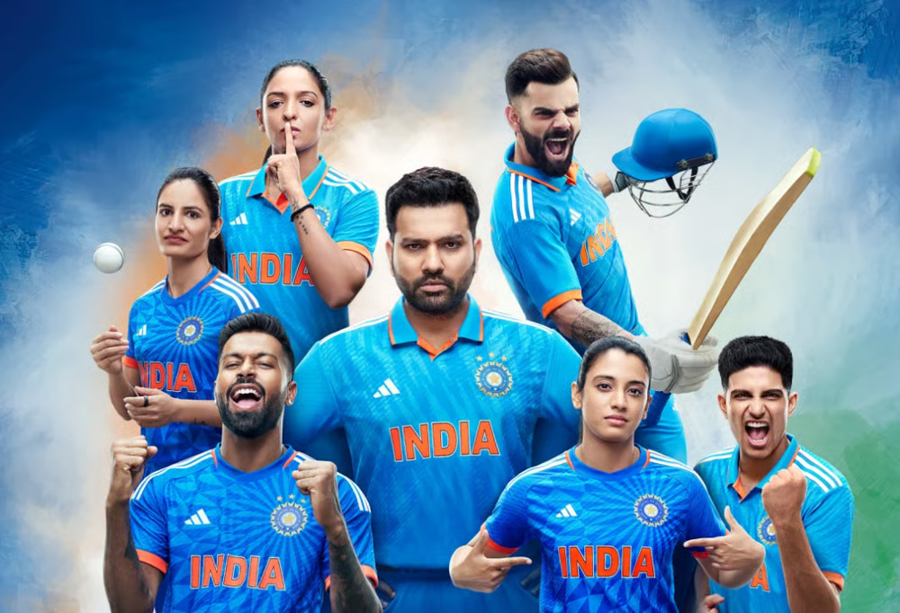
Figure 7: Adidas cricket ambassador advertisement
(Source: Haq et al., 2025)

5.5 People
People are key to Adidas' services and the customer experience. The company's German subsidiaries continue to invest a great deal in the training of employees, product knowledge and quality of service. The role of the staff involved is to have extensive product knowledge and offer professional services to those demanding a sportswear product which is performance based. In the same way, Adidas has been concentrating on customer engagement and customer relationship building, as it has done in India where they prioritize selling more products to their customers (Zaheer and Sandhu, 2022). Employees learn to engage with a wide range of customers and relate to them with any of the product lines and their respective price ranges. Customer satisfaction is specially boosted via people skills in the Indian retail outlet. Both countries have what in common Adidas' commitment to providing quality customer service and maintaining the integrity of the brand. However, differences in expectations and employee interactions due to cultural differences. German consumers focus on efficient and professional services with the right product information and in India, a preference base approach with personalisation was followed (Bhatia and Sisodia, 2023). These cultural factors have an impact on recruitment and training, as well as service delivery practices. Adidas knowledge of the personal needs and adjusting their personnel technique therefore shines an emphasis on customer loyalty and shopping experiences in both markets. The bottom line is that if they are knowledgeable about their products and services from end to end, it will have a positive effect on the customer's experience, and help promote brand loyalty from an efficiency point of view. However, ensuring a service quality standard in several international markets is not easy, due to the different cultures and operation of each market.

5.6 Process
Adidas uses an effective operation process in order to be consistent, and provide maximum satisfaction to customers in all countries around the world. Processes are focused on technological integration, inventory management, online order fulfilment and seamless customer service in Germany. The Advanced Digital system has helped retail to run more efficiently and provide a more impressive customer experience. Adidas has introduced similar systems of operation in India by tailoring to the market (Mondal and Giri, 2025). It is for this reason that its emphasis on high-speed supply chain management, e-commerce fulfilment, and customer service is its major success factors in meeting the concept "living with the customers" and with the demands it must meet. Further efforts would be needed to control regional variability and varying infrastructure situations. Adidas' focus on optimizing operations and service is the main commonality. Process adaptations have to be made due to the different maturity stages of the markets, set-up of logistics, etc. Efficient operations are underpinned by Germany's infrastructure development progress whilst in India, processes need to be made more flexible to accommodate geography and economic diversity. The adaptations provide Adidas a way to ensure effective services standards to their customer base and to meet the demands of their local markets. This is because technology enhances the workflows, thus efficiency and satisfaction with the customer. Any advanced digital system, however, is an on-going investment and can be more challenging to install in a less advanced geographic area.

5.7 Physical Evidence
Physical evidence is made up of all the tangible factors that influence consumers' perception of the Adidas brand. German Adidas shops reflect freshness, environmentally friendly stores and quality. The brand's professional, performance-based image is further enhanced by the modern store’s layout and structure, interactive presentation of products, use of environmentally friendly materials, cutting edge electronic solutions (Pálffy, 2025). Adidas also strives to create modern stores in India, with a focus on topping with features of local consumers. Stores highlight brand visibility, product accessibility and interesting shopping experiences. Its utilization as a visual merchandising tool for customer perception of product quality and authenticity, is becoming common, particularly the use of digital screens, as a way to provide your customers with promotional marketing and product branding. Global branding is the same across both marketplaces: logos, global store design, packaging and even giving the store's visual identity is the key (Sridhar, 2024). However, due to consumer preferences and the retail environment, there are variations in the format of the stores and the merchandising they employ. While Germans prefer straightforward and efficient store design, Indians may prefer more dynamic and engaging layout and deals. Then the cultural norms and economic context will be focused on how the physical environment will be represented at Adidas and how Adidas would ensure a global image of its brand. Overall, the design of the modern store is well-suited to Adidas' brand image and is likely to be more enjoyable and memorable for shoppers. The standards for the store throughout the world, however, make up the operational costs.

6. Market Entry Strategy Analysis in India
Adidas' decision to enter into the Indian market can be explained by the Uppsala model of internationalisation – which suggests that the internationalisation of firms steps towards foreign markets when they gain knowledge about the market and uncertainty decreases. Before going head-to-head with local brands, Adidas embarked on a strategy of distributors and franchisees to get a better grasp of the local market conditions, regulatory environment, and consumer preferences to reduce financial risks. With the growing knowledge of the market and customers' needs, Adidas has increased its dedication by investing in unique brand stores, strengthening its distribution channels and improving the e-commerce system. This slow growth is in line with the stages of the Uppsala Model (Jain, 2025). This solution was implemented by Adidas rather than exporting as it would have given limited control over pricing, customer experience and brand positioning in the very competitive and culturally diversified market. In a similar vein, licensing was seen as less suitable as this could well have compromised not only the quality control, but the brand image and IP rights of Adidas, making it less of a high-end global brand. As they increased their level of direct investment, Adidas' operational control increased, as did the level of control over the customer and their needs in the local market (Roy Bhattacharjee et al., 2023). This would have involved greater financial investment and business risk, but would have provided a sustainable competitive advantage as it would strengthen the brand presence, ensure consistency of quality and help to support the growth of one of the world's fastest growing sportswear markets for the long term.
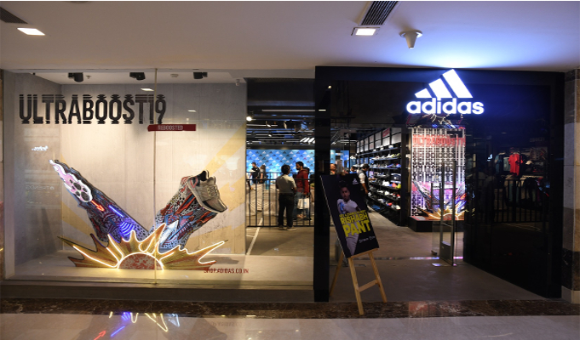
Figure 8: Adidas store India shopping mall Adidas retail store India
(Source: Roy Bhattacharjee et al., 2023)

7. Ethical Issues in Adidas Marketing Strategy
The challenge to manage labour in Adidas' global supply chain is one of the key ethical issues that Adidas is facing to deal with. Both the question of "fair wages" at the factories belonging to Adidas' subsidiary companies and the benefits of its staff have been on the spotlight as Adidas is a multinational corporation who buys products from various countries. Increased transparency and accountability are expected from the production process by stakeholders (Sharma et al., 2025). To address these concerns, the brand Adidas put in place it's various supplier monitoring programmes, working conditions and sustainable efforts to improve the working conditions. The labour question is an issue that impacts a wide aspect of Adidas's global supply chain. In Germany, the consumers know about social responsibility when they are buying something; otherwise there could be a loss of consumer confidence in the unethical working environment or unfair wages. A loss of consumer trust can have a negative impact on Adidas' global brand image, it can lead to a lack of consumer loyalty and cause them to move to rivals who have more favorable ethical image. A lack of ethical practices within supply chains can lead to greater regulatory attention, risk and uncertainty for investors in the years ahead. Therefore, Adidas should maintain and enhance their audits of suppliers, transparency and independent monitoring of suppliers in an ethical manner. Ethical Management of the supply chain can have a positive impact in building trust amongst the components of the chain and can support the sustainability of the brand value and its supply chain, thereby creating sustainable competitive advantage for that brand.
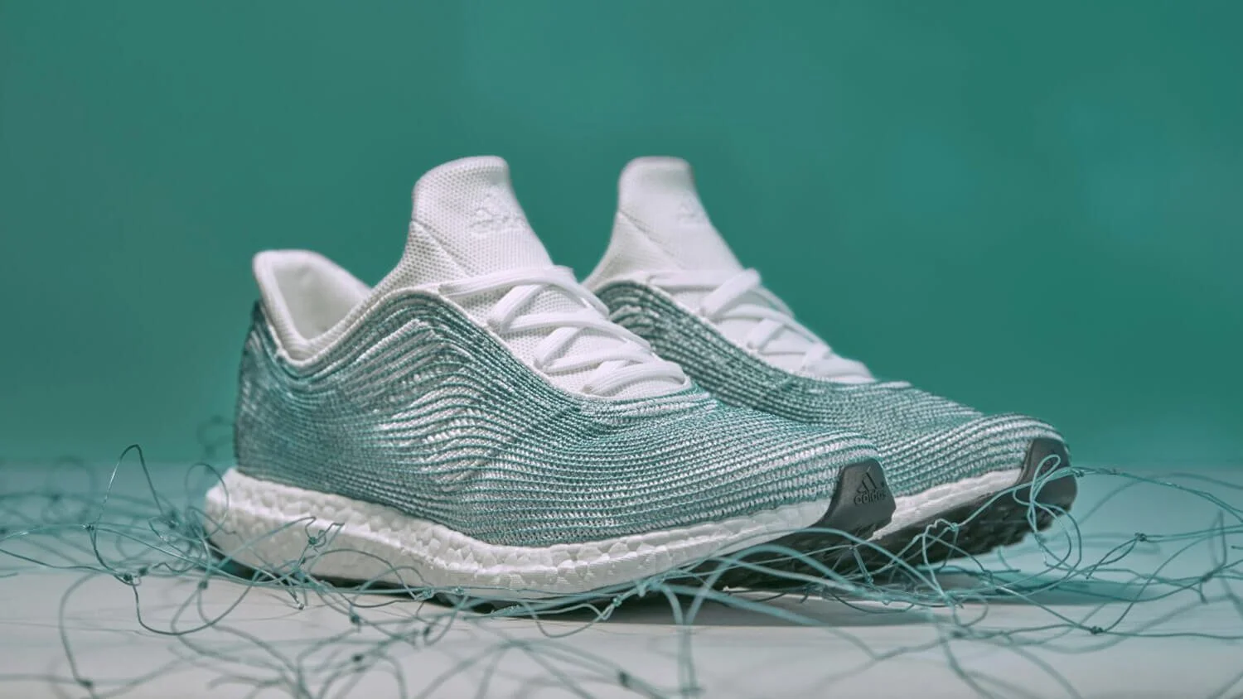
Figure 9: Adidas sustainability recycled materials sustainable sportswear
(Source: Sharma et al., 2025)

8. Recommendations for Future International Marketing Strategies
1. Expand AI-driven personalised digital marketing: Adidas should enhance the application of AI for customization of marketing messages in Germany and India. They differ a lot, and those differences in the preferences of consumers influence the need for personalised communication. The company needs to leverage customer data analytics, make use of AI-powered product suggestions and provide local language digital material to enhance customer interaction. This strategy should increase online sales, customer satisfaction and deepen customer loyalty.
2. Increase sustainable product development: Adidas should push for more sustainable products as the consumer is more and more influenced by sustainability – especially in Germany. The use of more recycled materials, better production techniques and clear sustainability reporting should be used. This will help establish the brand reputation, customer trust and provide a long term competitive advantage.
3. Continue adapting products to local markets: Adidas should further customise its product offering to suit the different purchasing power and preference in the two countries, Germany and India. The company should launch product lines in the markets, while maintaining the quality standards worldwide. This will make them more satisfied customers, gain more market share and be more profitable.
4. Strengthen ethical supply chain monitoring: The supplier monitoring should be improved, since it is directly linked with ethics and consumer trust and brand reputation, which Adidas should improve. Independent supplier audits and regular compliance reviews and transparency reporting are recommended. This will help to reduce reputational risk, gain stakeholder trust and achieve long-term sustainable business success.

9. Conclusion
This report establishes how well Adidas is successful with adaptation to different economic societies, the culture and the competitive environment in India and Germany, respectively by marketing the product internationally. The concept of “marketing mix” and the right approaches to market entry illustrate the importance to grasp how to operate with a coordinated brand in keeping with market trends, but thinking locally.

Section 2: Reflective Account Using Gibbs Reflective Cycle

10. Reflection Using Gibbs Reflective Cycle

10.1 Description
There are different methodologies that are used to analyse Adidas' market entry strategy and marketing mix and these methodologies can take a comparative study of Germany and India into consideration. The initial research was conducted to identify compatible academic journals, reports from the companies and industry publications and market data relating to products marketing and Adidas in the international context. Information was collected regarding its past, current market position, their intention to expand into the foreign market and their methods of marketing in both countries. The technique of data collection involved PESTEL analysis to analyse external environmental factors, Hofstede's cultural dimensions to analyse cultural differences and the 7Ps marketing mix framework and STP to analyse the marketing strategy. Relevant and credible information was then obtained from a variety of Academic and Industry sources providing both secondary and primary. They advanced comparative analysis to find out the similarities and differences between the approaches of Adidas in different countries, Germany and India.
Data gathered were arranged into organised sections, which correlated well with the criteria of the assessment while preparing the report. The results were analysed critically to assess the effect of the economic, cultural and market conditions on Adidas decision for international marketing. Once this report had been completed, it was then reviewed for logical flow, and for academic writing standards and consistency with regard to referencing. This systematic approach allowed us to build up a total analysis of Adidas' marketing strategies in the international market.

10.2 Feelings
So, firstly, I was curious and interested in what went on at Adidas because it is known world over and is strong in the world of international trade. I thought that it would be useful to make comparisons between Germany and India to gain an insight into how multi-national corporations have tailored their marketing strategies to various settings. I was also concerned with the amount of information that was available and how to choose the most relevant information. I gained confidence with the application of theories and frameworks of international marketing as research continued. Deep understanding of these cultural, economic and environmental differences between the two countries was achieved through comparison and analysis of the same, which brought clarity and understanding of the complexity involved in carrying out business operations in global regions. An issue that did present itself was the translation of too much information and maintaining the comparisons within parameters of this report's objectives. However, I felt good about the report as I continued to work through it as the results were obviously very much about the need to adjust marketing approaches to local market and consumer needs.

10.3 Evaluation
There were some successful aspects to the assignment. The use of recognised international marketing models, such as PESTEL, Hofstede's cultural dimensions, STP and 7Ps marketing mix, was a positive one. The use of these frameworks provided the framework for the analysis of Adidas' activities as well as separate it from a description-based report. This comparison between Germany and India was helpful in a more effective understanding of the significance of the market condition in a strategic decision-making process. A range of sources used was a positive point as it enhanced the credibility and depth of the analysis. Both developed and emerging markets studies provided a comprehensive understanding of the global marking issues and opportunities.
However, there were certain issues which arose during the study. One of the biggest problems encountered was the vast amount of information that is available on Adidas, and their decision as to what was most important for an objective report. This was no easy task, either, because there was some difficulty in securing the requisite word-count while at the same time being brief, analytical and critical. Besides, the understandings of the economic and cultural situations of two nations should be done carefully to protect potential oversimplification. Despite this, all targets set in the end-of-report were met and important marketing insights into international marketing practices were achieved.

10.4 Analysis
Ideas of international marketing and its impact on change the approach of the business in different market scenario were extensively inculcated in learner's mind through the assignment. During research experience I was able to see in practice that achieving success in international marketing depends on an organization's sensitivity towards the local market and its adaption to it, yet maintaining its uniformity with respect to brand name in each country and in each individual market. In this way, the corporate based Adidas have managed to keep their identity in every country where they operate with only minimal changes required for the new markets and consumers' expectations. It was evident that using PESTEL was clear that political, economic, social, technological, environmental and legal factors have influence on the functioning of business. External environment can be opportunities or challenges for multinational companies - India vs. Germany. This is a reflection of the impact of culture on consumer behaviour and marketing communications, which was captured by Hofstede's other cultural elements. An understanding of individualism, power distance and uncertainty avoidance would help inform the understanding of varying marketing messages that must be communicated between countries based on reputation differences.
This STP framework provided me with a lot of detail on what Adidas defines as market segments, how are they choosing the customers and, not to forget, in which segment they want to position the product. I learnt about the significance of learning consumer's attribute and his/her buying attitudes for better segmentation and targeting of consumers. Further, 7Ps marketing mix analysis has shown that it is important to assist in combining aspects of product, price, place, promotion, people, process and physical evidence in the right combination to meet the needs of the local market. The assignment also helped to enhance my research capabilities, critical thinking and analysis abilities. I was not just taught Adidas' activities; I was educated through the prism of analysing the strategic decisions and their impact in different market situations. The practical experiences fostered the understanding on why the use of evidence is important to inform decision making within international marketing management and adapting all related strategies.

10.5 Conclusion
These are some of the main messages that have surfaced out of this experiential process in international marketing and academic research. I learned that it was good to get a “feel” of the environment and culture of each market before deciding upon market strategies to be implemented when operating a successful functioning multinational. The frameworks, that were used, like PESTEL, Hofstede, STP and the 7Ps proved to be useful to grasp the information about international business operations. This assignment also helped my critical thinking skills to develop when it comes to information and my knowledge in how to apply theory in the real world. The main thing that I learned is that in any kind of marketing and another process of changing as per the consumer taste and also at the same time it is on par with the global competitive advantage and has its global brand image.

10.6 Action Plan
I will be introducing changes to the way I use a proper research process in the future - by using more time in evaluating sources and organising my data at the beginning of a research project. Additionally, I will be further enhancing my critical analysis skills focusing more on how effective my organization's strategy has been, as opposed to describing tasks and activities. I will strengthen the quality of reports by incorporating a greater diversity of academic journals and industry reports with further supporting evidence for the arguments. I will also make a research writing to proofreading plan to manage my time. The enhancements will facilitate the ability to create in-depth analytical, and academically sound reports for future years.

References
Pratama, A.Z. and Hisjam, M., 2022. Comparative Study of Global Business Strategy: Lessons Learned from Excellent Sports-wear Companies (Nike and Adidas). In Proceedings of the International Conference on Industrial Engineering and Operations Management Istanbul, Turkey (pp. 3062-3071). https://ieomsociety.org/proceedings/2022istanbul/561.pdf
Caputo, F., Fiano, F., Farina Briamonte, M. and Sorrentino, M., 2022. Born brothers, born global: multiple possible faces of the internationalization path. Journal of knowledge management, 26(9), pp.2395-2415. https://www.emerald.com/jkm/article/26/9/2395/270086
Jaufenthaler, P., Koll, O., Lude, M. and Prügl, R., 2023. Country differences in family firm reputation: An exploration in Germany, India, and the United States. Family Business Review, 36(4), pp.352-374. https://journals.sagepub.com/doi/abs/10.1177/08944865231192339
López‐Pérez, G., García‐Sánchez, I.M., Giménez, V. and Zafra‐Gómez, J.L., 2025. Comparative Analysis of Corporate Environmental Performance in Terms of Eco‐Innovation: Developing a Dominance Index (DMI) Approach. Corporate Social Responsibility and Environmental Management, 32(5), pp.7119-7145. https://onlinelibrary.wiley.com/doi/abs/10.1002/csr.70077
Shahzad, K., Aslam, S. and Javaid, A., 2023. Determining competitiveness of Pakistan sports goods industry using revealed comparative analysis. International Journal of Management Research and Emerging Science, 13(2). https://www.academia.edu/download/104629776/236.pdf
Dobbelstein, T. and Lochner, C., 2023. Factors influencing purchase intention for recycled products: A comparative analysis of Germany and South Africa. Sustainable Development, 31(4), pp.2256-2277. https://onlinelibrary.wiley.com/doi/abs/10.1002/sd.2504
Sekliuckiene, J. and Rybakovas, E., 2023. The quest for regionalization of global value chains in a pandemic global business environment. Engineering Economics, 34(2), pp.230-239. https://www.inzeko.ktu.lt/index.php/EE/article/view/31640
Alagarsamy, S., Mehrolia, S. and Paul, J., 2024. Masstige scale: An alternative to measure brand equity. International Journal of Consumer Studies, 48(1), p.e12873. https://onlinelibrary.wiley.com/doi/abs/10.1111/ijcs.12873
Haq, U.N., Khan, M.M.R., Khan, A.M., Hasanuzzaman, M. and Hossain, M.R., 2025. Global initiatives for industry 4.0 implementation and progress within the textile and apparel manufacturing sector: a comprehensive review. International Journal of Computer Integrated Manufacturing, 38(12), pp.1637-1662. https://www.tandfonline.com/doi/abs/10.1080/0951192X.2025.2455655
Williams, J., 2024. Consumer behavior analysis in the age of big data for effective marketing strategies. International Journal of Strategic Marketing Practice, 6(2), pp.36-46. https://ir-library.ku.ac.ke/bitstreams/359933ac-a9a6-4148-9c66-75578e046695/download
Alqatan, A., 2025. Corporate responses to boycott movements: impact on accounting and financial performance in the Middle East. International Journal of Islamic and Middle Eastern Finance and Management, 18(2), pp.360-380. https://www.emerald.com/imefm/article/18/2/360/1244245
Maheshwari, M., Gupta, A.K., Gaur, P., Tiwari, N. and Goyal, S., 2024. Corporate Social Responsibility in the Global Business World: A Conceptual, Regulatory, and Illustrative Framework. Apple Academic https://www.taylorfrancis.com/books/mono/10.1201/9781003411000/corporate-social-responsibility-global-business-world-meenu-maheshwari-ashok-kumar-gupta-pragya-gaur-nupur-tiwari-shobhna-goyal
Zaheer, M. and Sandhu, M.R.S., 2022. Exploring knowledge acquisition and sharing strategies: a qualitative study from Pakistan football industry. International Journal of Management Research and Emerging Science, 12(2). https://www.researchgate.net/profile/Rizwan-Sandhu/publication/361764761_International_Journal_of_Management_Research_and_Emerging_Sciences_Exploring_Knowledge_Acquisition_and_Sharing_Strategies_A_Qualitative_Study_from_Pakistan_Football_Industry/links/62c41a00a81be51e40906c20/International-Journal-of-Management-Research-and-Emerging-Sciences-Exploring-Knowledge-Acquisition-and-Sharing-Strategies-A-Qualitative-Study-from-Pakistan-Football-Industry.pdf
Bhatia, N. and Sisodia, S., 2023. A Comparative Study of Consumer Perceptions and Purchase Intentions of Sustainable and Non-sustainable Luxury Apparel Brands. Delhi Business Review, 24(2), pp.41-49. https://www.delhibusinessreview.org/V24n2/dbr_v24n2e_p41-49_print.pdf
Mondal, C. and Giri, B.C., 2025. A comparative analysis of greening policies and CSR efforts in a government-led sustainable supply chain across different channel powers. International Journal of Business and Globalisation, 39(2), pp.200-225. https://www.inderscienceonline.com/doi/abs/10.1504/IJBG.2025.143912
Pálffy, Z., 2025. A Novel Approach to the Operationalization of Corporate Local Embeddedness: Cultural Perspectives on Narratives as Indicators. European Journal of Interdisciplinary Studies, 17(1). https://www.researchgate.net/profile/Zsuzsanna-Palffy-2/publication/392309163_A_Novel_Approach_to_the_Operationalization_of_Corporate_Local_Embeddedness_Cultural_Perspectives_on_Narratives_as_Indicators/links/683d814c8a76251f22eaf315/A-Novel-Approach-to-the-Operationalization-of-Corporate-Local-Embeddedness-Cultural-Perspectives-on-Narratives-as-Indicators.pdf
Sridhar, D., 2024. Protection of trademarks from dilution: A comparative analysis of the United States, United Kingdom, and India. Jindal Global Law Review, 15(2), pp.589-614. https://link.springer.com/article/10.1007/s41020-024-00232-4
Jain, V., 2025. Why Pakistan forges ahead and India lags behind? Analysis of sports equipment exports in global context. Millennial Asia, 16(4), pp.555-583. https://journals.sagepub.com/doi/abs/10.1177/09763996231191735
Roy Bhattacharjee, D., Kuanr, A., Malhotra, N., Pradhan, D. and Moharana, T.R., 2023. How does self-congruity foster customer engagement with global brands? Examining the roles of psychological ownership and global connectedness. International Marketing Review, 40(6), pp.1480-1508. https://www.emerald.com/imr/article/40/6/1480/177491
Sachar, D., Arora, R., Yadav, S. and Aashima, 2026. Integrating Green Marketing with AI and Machine Learning: A Data-Driven Approach to Sustainable Consumer Segmentation and Business Innovation. In Green To Gold: Marketing Strategies for a Sustainable Future (pp. 279-308). Cham: Springer Nature Switzerland. https://link.springer.com/chapter/10.1007/978-3-032-10212-6_14
Zaheer, M. and Sandhu, R.S., 2022. International Journal of Management Research and Emerging Sciences. International Journal, 12(2), pp.71-101. https://www.academia.edu/download/98506685/185.pdf
Zia, M.H. and Tabassam, A., 2025. A Critical Analysis of the Strategic Implications of Globalization on Business Performance: Evaluating Opportunities, Challenges, and Adaptive Strategies. Social Science Review Archives, 3(1), pp.1995-2008. https://policyjournalofms.com/index.php/6/article/view/510
Zafar, H., Siddiqui, F.A. and Khurshid, M.S., 2025. Exploring the influence of brand authenticity on consumer behavior: Insights from generation Y consumers in Pakistan. The Critical Review of Social Sciences Studies, 3(1), pp.761-781. https://thecrsss.com/index.php/Journal/article/view/186
Chugaiev, O., 2022. The European Union’s Soft Economic Power Assessment: A Comparative Analysis. Studia Politicae Universitatis Silesiensis, (34), pp.47-66. https://www.ceeol.com/search/article-detail?id=1085712

Pan, Z., Wang, K., Wang, Y. and Zhao, R., 2023, June. An Analysis of Puma’s Global Marketing in the COVID-19 Era. In Proceedings of the 6th International Conference on Economic Management and Green Development (pp. 35-49). Singapore: Springer Nature Singapore. https://link.springer.com/chapter/10.1007/978-981-19-7826-5_4
Chen, J., 2023, September. An In-depth Comparative Analysis of Adidas’ Marketing Strategies and Market Comparison in the Chinese Market. In 2023 International Conference on Management Innovation and Economy Development (MIED 2023) (pp. 344-351). Atlantis Press. https://www.atlantis-press.com/proceedings/mied-23/125991551
Holtbrügge, D. and Schuster, T., 2024, April. The Internationalization Strategy of adidas. In The Internationalization of Firms (pp. 21-44). Nomos Verlagsgesellschaft mbH & Co. KG. https://www.nomos-elibrary.de/document/download/pdf/uuid/ef58d90f-e6dc-39ae-b744-10896afd72b3#page=21
Sharma, A., Sharma, T. and Garga, P., 2025, November. From Waste to Worth: A Case Study Analysis of Circular Economy Practices in Leading Global Companies. In 2nd International Conference on Sustainable Business Practices and Innovative Models (ICSBPIM-2025) (pp. 841-853). Atlantis Press. https://www.atlantis-press.com/proceedings/icsbpim-25/126017592
Ibragimova, N., Kharisov, V. and Sunaeva, G., 2026, March. Transformation of the fashion industry in the context of digitalization. In AIP Conference Proceedings (Vol. 3390, No. 1, p. 070006). AIP Publishing LLC. https://pubs.aip.org/aip/acp/article-abstract/3390/1/070006/3382827

